Craig Harding (2200075)

ECAD6007: Appendices
Student Number: 2200075
Word Count for Appendices: Equivalent to 1,000
Date of Submission: 3rd of November 2022

OBSERVATION / FIELD NOTES
1
 | 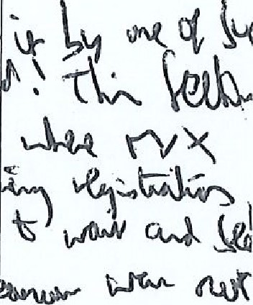
  Record
  Date and time, year group: | 
  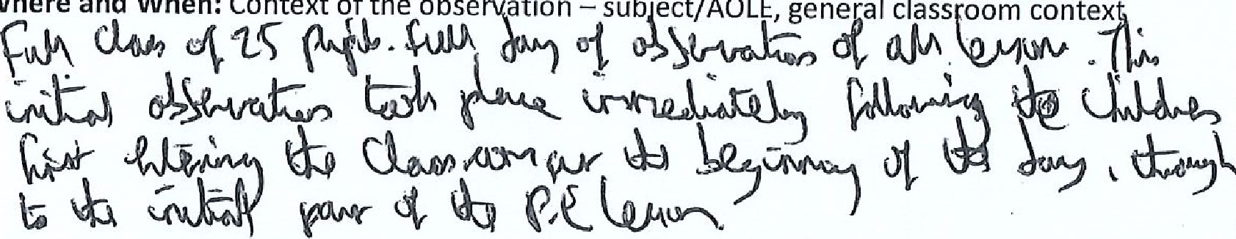
  Where
  and
  When:
  Context
  of
  the
  obse
  ation
  —sub'ect/AOLE,
  gene
  al
  class
  oom
  contex
  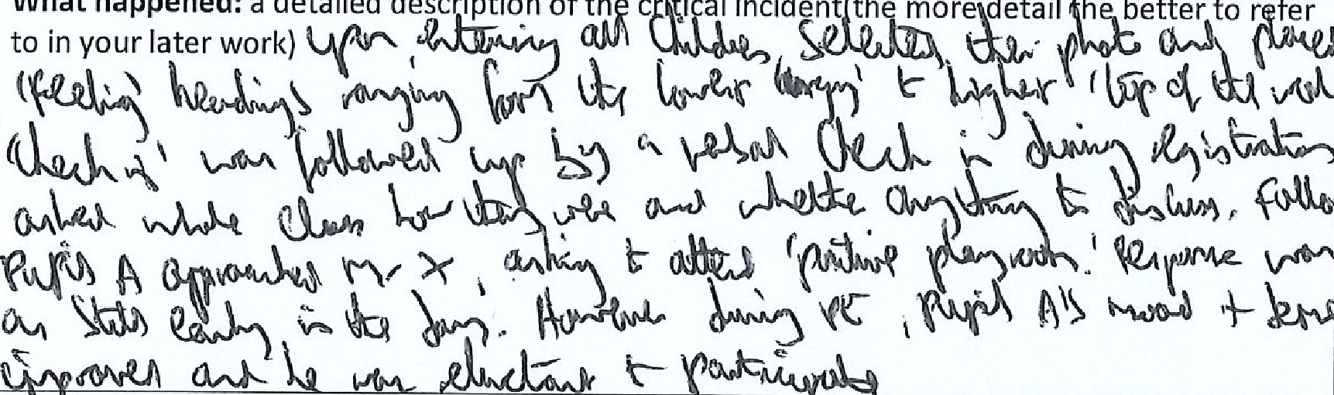
  What
  happened.
  a
  detailed
  description
  of
  th
  c
  •ti
  al
  incident
  the
  more
  detail
  h
  better
  to
  r
  fer
  y
  scLQAkÄ
  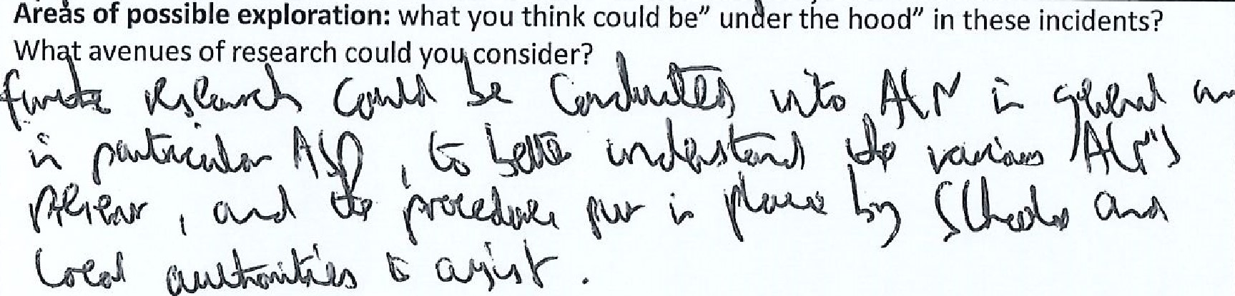
  s
  Notes: any details you can note (is it a busy environment, is it after lunch, are there lots of 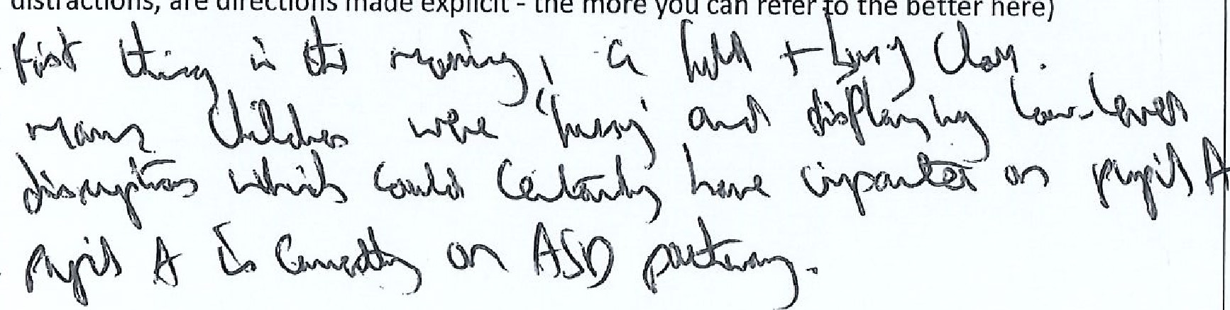distractions, are directions made explicit - the more you can refer o the better here)
Record 2 – AFL Strategies
Date and time, year group: t (C) 
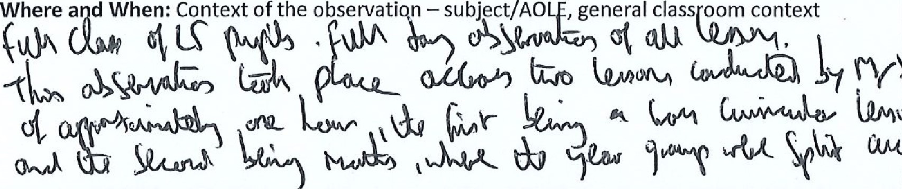
What happened: a detailed description of the critical incident(the more detail the better to refer
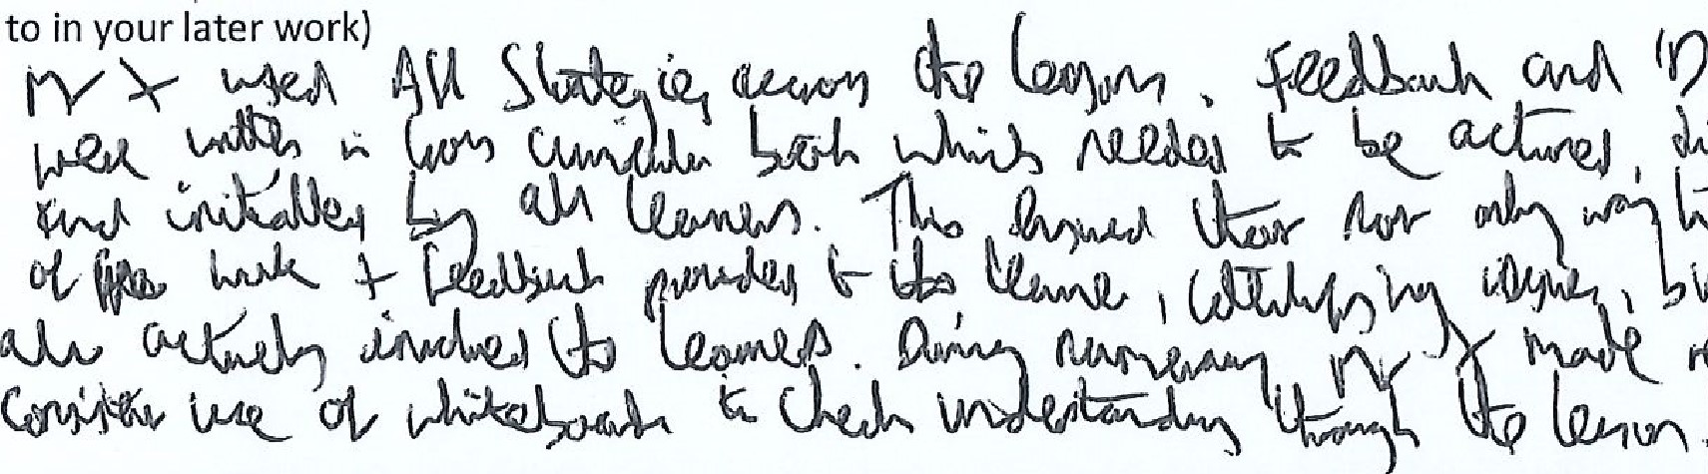
Areas of possible exploration: what you think could be" under the hood" in these incidents?
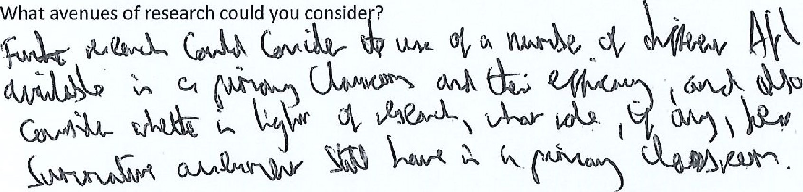
Notes: any details you can note (is it a busy environment, is it after lunch, are there lots of distractions, 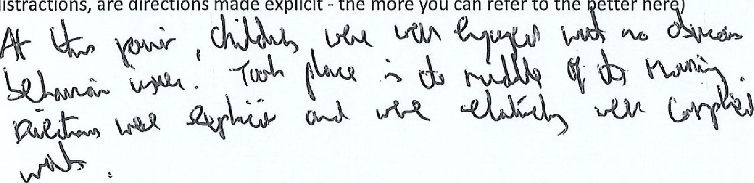are directions made explicit - the more you can refer to the etter her )


