  Image classification using Artificial Neural Networks |   Module: L7 – Application of Machine Learning  Module code: ACCA7025  Lecturer: Dr Aliyu Sambo  Student name: Nadejda Toma  Student ID number: 2232920  Submission deadline: 17th July 2026

Table of Contents

Abstract 2
1. Introduction 2
2. Related Work 2
2.1 Artificial Neural Networks 2
2.2 Recurrent Neural Network Use Case 3
2.3 Convolutional Neural Network Use Case 3
2.4 CNNs for Plant Disease Classification 4
3. Workflow Methodology 6
3.1 Dataset 6
3.2 Pre-processing 7
3.3 Experimental Design 8
3.4 Evaluation 9
4. Results 10
4.1 Comparison of the Four CNN Models 10
4.2 Final Test Performance 12
5. Discussion and Recommendations 13
6. Conclusion 14
References 15
Appendix 16

Abstract

This study developed and compared four CNN models for classifying five plant disease classes. The models were improved step by step through added depth, data augmentation, dropout and learning-rate tuning. The final model achieved 93.35% validation accuracy and 93.87% test accuracy. The results show that a carefully tuned CNN can recognise plant disease patterns well, although some confusion remained between healthy and scab leaves.

1. Introduction

Plant diseases can reduce crop quality and cause financial losses when they are not identified early. Visual checks are still useful, but they depend on experience and may be difficult when symptoms are small or similar. CNNs can support this process by learning patterns such as spots, lesions, colour changes and damaged leaf areas [1].
This report develops an image classifier using five classes from the Plant Pathology 2021 resized 512 × 512 dataset. It first considers suitable uses of RNNs and CNNs, then compares four CNN configurations. The main aim is to identify whether changes in model depth, augmentation and training settings can improve performance on unseen images.

2. Related Work

2.1 Artificial Neural Networks

An Artificial Neural Network learns by passing information through connected layers. Each artificial neuron receives input values, multiplies them by numerical weights and adds a bias. The result is then passed through an activation function. This step is important because it allows the network to learn non-linear patterns rather than only simple relationships [2].
During forward propagation, the input moves from the first layer towards the output layer. The prediction is then compared with the correct answer through a loss function. A large loss means that the prediction is far from the correct label. Backpropagation works in the opposite direction. It calculates how each weight contributed to the error, and an optimiser updates these weights to reduce future loss. Adam is commonly used because it adapts the size of parameter updates and usually converges faster than basic gradient descent. Even so, its results still depend on the learning rate and the structure of the network. Research on modified Adam methods also shows that optimisation influences both convergence speed and generalisation, rather than simply reducing training loss [3].

2.2 Recurrent Neural Network Use Case

Recurrent Neural Networks are mainly designed for ordered and sequential information. They pass a hidden state from one step to another, which allows earlier observations to influence later predictions [4]. This makes them useful when time matters.
Agriculture provides several suitable examples. A sequence of temperature, humidity and soil-moisture readings could be used to predict disease risk. An RNN could also examine the development of symptoms across several days or combine historical weather records with crop-health measurements. In these situations, the order of the data is meaningful. A sudden rise in humidity after several warm days may matter more than the same values presented in a random order.
In this study, the current task is different. Each leaf image is classified as an independent example. The model does not receive a sequence showing how the same leaf changed over time. No earlier image must be remembered before the next image is processed. An RNN could still be forced to process image pixels as a sequence, but this would ignore the natural two-dimensional structure of the image and add unnecessary complexity. For this reason, an RNN is useful as an agricultural forecasting tool, but it is not the most suitable choice for this classification problem.

2.3 Convolutional Neural Network Use Case

Convolutional Neural Networks are designed to learn spatial patterns from images. Small filters move across an image and respond to local features. Early layers may identify edges, colour changes and simple shapes. Deeper layers combine these features into more meaningful structures, such as spots, lesions, damaged tissue or powder-like areas on a leaf [2].
This hierarchical learning is particularly useful for plant disease classification. A disease may not be recognised by one isolated pixel. It may instead appear as a repeated texture, a coloured border around a lesion or a combination of shape and surface damage. Pooling layers reduce the spatial size of feature maps and help the model focus on important patterns. CNNs also offer some robustness when a symptom appears in a slightly different position, although they are not completely invariant to changes in scale, lighting or viewpoint [5].
The main weakness is that deeper networks can learn the training images too closely. When this happens, training accuracy continues to rise while validation performance remains weak. Dropout and data augmentation can reduce this problem by making memorisation more difficult. Dropout temporarily deactivates part of the network during training, while augmentation creates changed versions of existing images. Both approaches encourage the model to learn patterns that are more likely to generalise [6], [7].

2.4 CNNs for Plant Disease Classification

Recent research generally reports strong results for CNN-based plant disease classification, but the strongest accuracy figures must be interpreted carefully. Ali et al. combined several large pretrained networks, including DenseNet and EfficientNet models, and reported 99.89% accuracy on PlantVillage [8]. Their ensemble benefited from image enhancement and class balancing, but it was also much more complex than a single CNN and used a dataset with largely controlled image conditions.
Ojo and Zahid focused more directly on the workflow. They tested preprocessing and imbalance-handling methods before classification [9]. Their best pipeline combined image sharpening, CLAHE, GAN-based resampling and ResNet-50, producing 97.69% accuracy and a 97.62% F1-score. This shows that performance depends not only on the classifier, but also on how the data are prepared. However, the additional preprocessing and generated samples make the pipeline harder to reproduce and may not be necessary for every dataset.
Table 1 compares selected studies and highlights the differences in architecture, data preparation, reported performance and practical limitations.

Table 1. Comparison of Selected Plant Disease Classification Studies
Study | Architecture | Dataset | Main technique | Reported performance | Main limitation
Ali et al. | Ensemble of pretrained CNNs | PlantVillage | Image enhancement and class balancing | 99.89% accuracy | High complexity and controlled images
Ojo and Zahid | ResNet-50 | Plant disease dataset | CLAHE, sharpening and GAN resampling | 97.69% accuracy, 97.62% F1-score | Complex preprocessing pipeline
Pacal et al. | Systematic review | Multiple datasets | Review of deep learning methods | Strong CNN performance across studies | Dataset bias and limited field testing
Ramanjot et al. | Systematic review | Multiple datasets | Review of classification methods | CNNs commonly outperform traditional ML | Weak external validation in many studies

Systematic reviews reach a similar conclusion. CNNs are highly effective at recognising visual disease symptoms, yet repeated weaknesses remain. These include class imbalance, controlled backgrounds, limited external testing and poor transfer to field images [1], [10], [11].
Even that, existing studies often focus on large pretrained architectures, complex preprocessing pipelines or controlled datasets. Less attention is given to how a simpler CNN improves through a transparent sequence of changes. This study addresses that gap by comparing four progressively modified models under the same dataset and data split.

3. Workflow Methodology

Figure 1 presents the complete workflow followed in this study, from dataset selection and preprocessing to model comparison and final evaluation.
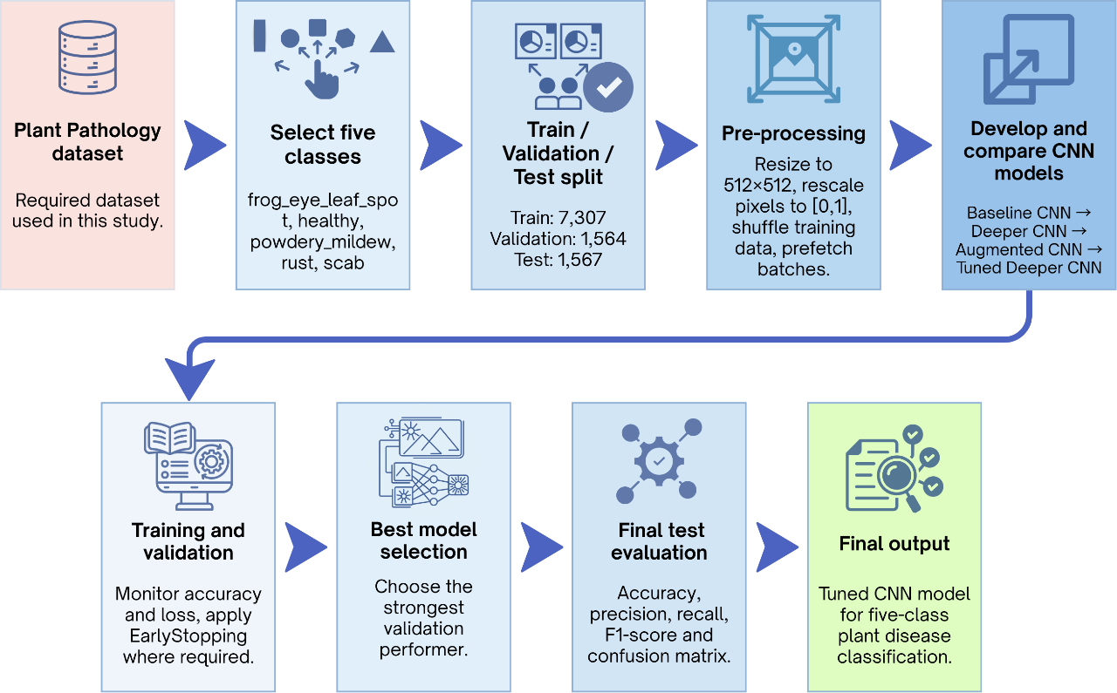
Figure 1. CNN Image Classification Workflow

3.1 Dataset

The experiments used the required Plant Pathology 2021 resized 512 × 512 dataset. The original collection contains several labels and mixed-disease combinations, but this study used only the five classes with the highest number of suitable images. Table 2 presents the number of images used for training, validation and final testing.

Table 2. Dataset Split
Dataset split | Number of images | Purpose
Training | 7,307 | Model learning
Validation | 1,564 | Model comparison and best-epoch selection
Test | 1,567 | Final evaluation on unseen images
The class order was fixed as frog_eye_leaf_spot, healthy, powdery_mildew, rust and scab.
Integer labels were used because each image belonged to one of the five classes. A batch size of 32 was selected. This offered a practical balance between training speed and memory use. A larger batch may have required more GPU memory, while a very small batch could have made training slower and less stable.
The dataset was not perfectly balanced. For example, the test set contained 500 scab images but only 126 powdery mildew images. This difference matters because a model can appear accurate while performing better on larger classes. Plant disease studies often face this problem, as some diseases are naturally easier to collect than others [9], [1]. For this reason, the final evaluation did not rely on accuracy only.

3.2 Pre-processing

All images were loaded at 512 × 512 pixels, matching the resolution of the supplied dataset. Keeping this resolution preserves small details such as leaf spots, damaged edges and powder-like textures. These details may be important for separating visually similar diseases. But larger images also increase training time and model complexity, so the choice involved a clear trade-off.
Pixel values were rescaled from the original range of 0–255 to 0–1. This created a more consistent numerical range and helped the optimiser update the network weights more smoothly. The training dataset was shuffled so that the model did not repeatedly see the classes in the same order. In contrast, the test dataset was loaded with shuffle=False. This was necessary because predictions had to remain aligned with the correct labels when producing the classification report and confusion matrix.
TensorFlow prefetching was also applied. While the GPU processed one batch, the next batch could be prepared in advance. This did not change the images or improve accuracy directly, but it reduced unnecessary waiting time during training.
Data augmentation was introduced only in the later experiments. Random horizontal flips, small rotations and zoom changes created slightly different versions of the training images. The purpose was not to create new diseases. It was to help the model understand that the same symptom may appear at a different angle or position. Augmentation is widely used to reduce memorisation and improve generalisation, especially when image collections are limited [6]. Still, transformations were kept moderate because strong rotations or cropping could remove useful disease features.

3.3 Experimental Design

Four CNN configurations were developed in stages. Each experiment introduced controlled changes based on the behaviour of the previous model. Table 3 summarises the four experimental configurations and shows the main change introduced at each stage of model development.
Table 3. Experimental Configurations
Model | Convolutional blocks | Augmentation | Learning rate | Dropout | Maximum epochs | Early  Stopping | Main change
Baseline CNN | 2 | No | Adam default | 0.5 | 10 | No | Initial model
Deeper CNN | 3 | No | Adam default | 0.5 | 30 | Yes | Added depth and EarlyStopping
Augmented CNN | 3 | Yes | 0.0003 | 0.5 | 40 | Yes | Added augmentation and a lower learning rate
Tuned Deeper CNN | 4 | Yes | 0.0002 | 0.4 | 40 | Yes | Added depth and further tuning

The first model acted as a baseline. It used two convolutional blocks and showed whether a simple CNN could learn the task. Its validation performance remained low, while training accuracy continued to rise. This gave a clear sign of overfitting.
The second model added a third convolutional block and EarlyStopping. The deeper structure could learn more complex features, while EarlyStopping prevented training from continuing when validation loss stopped improving. This model improved validation accuracy, but the gap between training and validation results still increased after the best epoch.
The third experiment kept three convolutional blocks but added data augmentation and reduced the learning rate to 0.0003. Its training and validation curves stayed close, and both losses decreased more stably. This suggested that the model was learning features that transferred better to unseen images rather than simply remembering the training data.
The final model added a fourth convolutional block, used a lower learning rate of 0.0002 and reduced dropout from 0.5 to 0.4. This was a controlled change rather than a complete redesign. The aim was to increase feature-learning capacity while keeping regularisation and stable optimisation. Research shows that optimisation settings can influence both convergence and generalisation, not only training speed [3].
Global Average Pooling was tested to reduce the number of parameters, but the model performed much worse. For this reason, the Flatten layer was kept. Although it made the network larger, the model could still be trained effectively using the Google Colab GPU and produced much stronger classification results.
Adam was used in all experiments because it adapts parameter updates during training and is practical for deep image models [3]. The baseline used the default learning rate. Later models used smaller values to reduce unstable updates as networks became deeper.

3.4 Evaluation

Training and validation accuracy were recorded to show how learning developed across epochs. Training and validation loss were also important because accuracy alone may hide growing model confidence in incorrect predictions.
The validation set was used to compare configurations and identify the best epoch. It was not treated as final evidence of performance because it influenced model selection. The test set remained separate until the final tuned model had been chosen.
The final evaluation included test accuracy, precision, recall, F1-score, and a confusion matrix. Precision showed how often each predicted disease label was correct. Recall showed how many real examples of each class were detected. F1-score balanced both measures. The confusion matrix then showed exactly which diseases were mixed up. This wider evaluation was necessary because multiclass results can be misleading when class sizes differ [12].

4. Results

4.1 Comparison of the Four CNN Models

The four experiments showed a clear improvement as the model was developed. Table 4 summarises the best training and validation results obtained by the four CNN configurations.

Table 4. Best training and validation results across the four CNN configurations.
Model | Best epoch | Training accuracy | Validation accuracy | Validation loss
Baseline CNN | 5 | 60.12% | 54.16% | 1.1040
Deeper CNN | 6 | 65.14% | 65.73% | 0.8890
Augmented CNN | 40 | 78.72% | 80.05% | 0.5398
Tuned a deeper CNN | 39 | 94.14% | 93.35% | 0.2111

The baseline CNN achieved its best validation accuracy of 54.16% at epoch 5. After this point, training accuracy continued to rise and reached approximately 90.90%, while validation accuracy remained close to 54%. Validation loss also increased from 1.1040 at the best epoch to 1.6771 by epoch 10. This gap shows that the baseline learned the training images too closely and did not generalise well (see Figure 2).

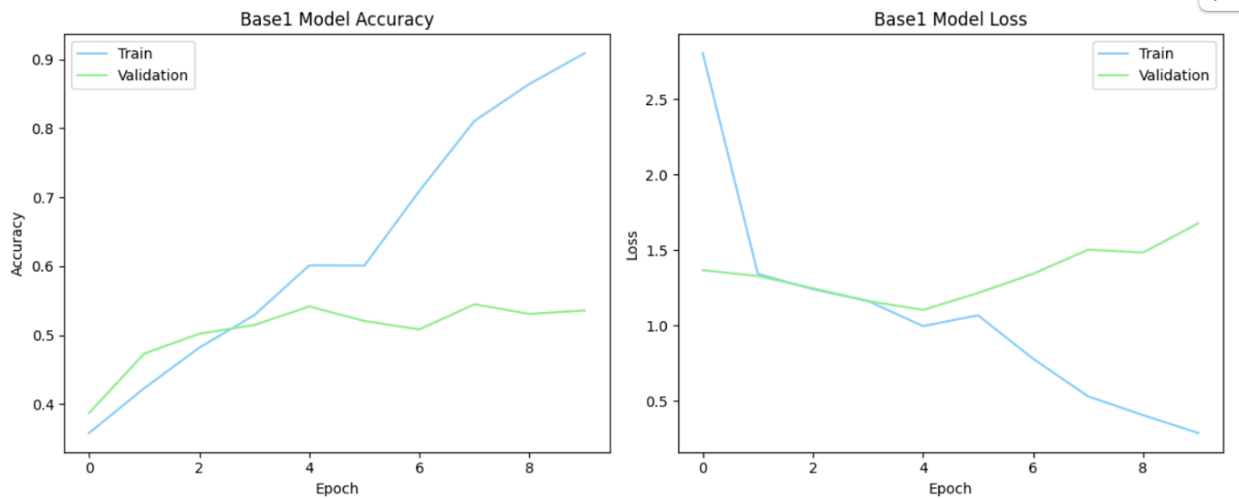
Figure 2. Training and validation performance of the baseline CNN.

The deeper CNN improved validation accuracy to 65.73% at epoch 6. Adding a third convolutional block helped the model learn more detailed features. However, the later training epochs again showed a growing difference between training and validation performance. EarlyStopping was therefore useful because it returned the model to its best state instead of keeping the weaker final epoch.
Data augmentation produced a larger improvement. The augmented CNN reached 80.05% validation accuracy, with a validation loss of 0.5398. Its training and validation curves stayed much closer together. This suggests that flips, rotations and zoom changes made memorisation more difficult and encouraged the model to learn more general disease patterns [6].
The tuned deeper CNN achieved the strongest validation result. Its best performance appeared at epoch 39, with 94.14% training accuracy, 93.35% validation accuracy and a validation loss of 0.2111. As shown in Figure 3, the training and validation curves remained relatively close, which indicates that the model improved its learning capacity without creating the large generalisation gap seen in the baseline.
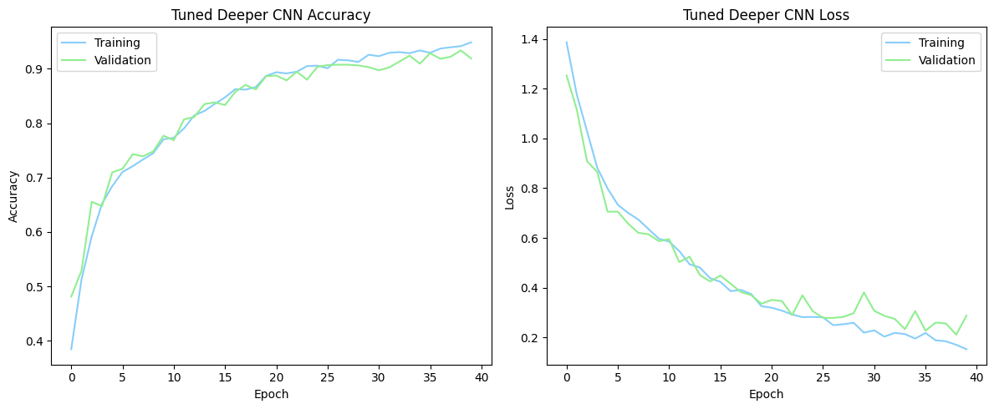
Figure 3. Training and validation performance of the tuned deeper CNN.

The final model was then evaluated on the separate test set. It achieved 93.87% test accuracy, with a macro F1-score of 93.61% and a weighted F1-score of 93.89%. Figure 4 presents the class-level precision, recall and F1-score results.

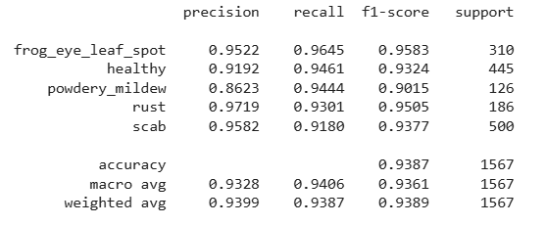
Figure 4. Precision, Recall and F1-Score Results for the Tuned Deeper CNN

4.2 Final Test Performance

The tuned deeper CNN was evaluated once on the separate test set of 1,567 unseen images. It achieved 93.87% test accuracy, a macro F1-score of 93.61% and a weighted F1-score of 93.89%. The close relationship between validation and test performance suggests that the selected model generalised well.
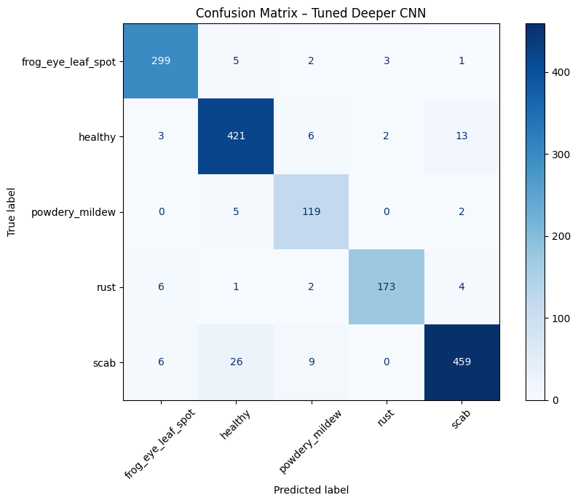
Figure 5. Confusion matrix for the tuned deeper CNN on the five-class test set.

Performance was strong across all five classes. Frog-eye leaf spot achieved the highest F1-score at 95.83%, followed by rust at 95.05%. Powdery mildew had the lowest precision, at 86.23%, although its recall remained high at 94.44%. This means that most real powdery mildew cases were detected, but a small number of images from other classes were also given this label. Reporting precision, recall, and F1-score was important because accuracy alone can hide differences between classes of unequal size [12].
The confusion matrix (see Figure 5) showed that 1,471 of the 1,567 images were classified correctly. The largest error involved scab and healthy leaves, where 26 scab images were predicted as healthy. This may reflect mild symptoms or leaf areas where scab marks were small and visually close to healthy tissue.
Additional screenshots showing the complete development, training and evaluation process are included in the Appendix.

5. Discussion and Recommendations

The result is encouraging because the model performed almost the same on validation and test data. This means that the high accuracy was not only caused by memorising the training images. The model was able to recognise disease patterns in unseen images, which was the main aim of the experiment.
The confusion between healthy and scab leaves is also important. In practice, early disease symptoms may be small and easy to miss, even for a trained model. For this reason, the system should not be treated as a complete replacement for human judgment. It would be more useful as a support tool that helps farmers or specialists identify suspicious leaves more quickly.
The model worked well on the selected dataset, but real field images may include shadows, damaged leaves, mixed backgrounds and different camera angles. Future testing should therefore use more natural images. Explainability methods such as Grad-CAM could also show which areas of the leaf influenced the prediction and make the result easier to trust.

6. Conclusion

The study showed that CNN performance improved when the model was developed in clear stages. The baseline model overfitted quickly, while augmentation and careful tuning produced more stable results. The final CNN achieved 93.87% accuracy on unseen test images and performed well across all five classes. Although it cannot replace expert judgement, it could support faster plant disease screening. Future work should test the model on more natural field images and explore methods that explain which leaf areas influenced each prediction.

References

[1] S. A. A. Qadri, N. Huang, T. M. Wani and S. A. Bhat, "Advances and challenges in computer vision for image-based plant disease detection: a comprehensive survey of machine and deep learning approaches," vol. 22, pp.2639–2670, 2024,
[2] M. Krichen, "Convolutional neural networks: A survey," vol. 12, no. 8, pp.151, 2023,
[3] M. Reyad, A. M. Sarhan and M. Arafa, "A modified Adam algorithm for deep neural network optimization," vol. 35, no. 23, pp.17095–17112, 2023,
[4] I. D. Mienye, T. G. Swart and G. Obaido, "Recurrent neural networks: A comprehensive review of architectures, variants, and applications," vol. 15, no. 9, pp.517, 2024,
[5] G. Rangel, J. C. Cuevas-Tello, J. Nunez-Varela, C. Puente and A. G. Silva-Trujillo, "A survey on convolutional neural networks and their performance limitations in image recognition tasks," vol. 2024, no. 1, pp.2797320, 2024,
[6] K. Alomar, H. I. Aysel and X. Cai, "Data augmentation in classification and segmentation: A survey and new strategies," vol. 9, no. 2, pp.46, 2023,
[7] Z. Liu, Z. Xu, J. Jin, Z. Shen and T. Darrell, "Dropout reduces underfitting", in International Conference on Machine Learning, pp. 22233–22248.
[8] A. H. Ali, A. Youssef, M. Abdelal and M. A. Raja, "An ensemble of deep learning architectures for accurate plant disease classification," vol. 81, pp.102618, 2024,
[9] M. O. Ojo and A. Zahid, "Improving deep learning classifiers performance via preprocessing and class imbalance approaches in a plant disease detection pipeline," vol. 13, no. 3, pp.887, 2023,
[10] I. Pacal et al., , "A systematic review of deep learning techniques for plant diseases," Artif.Intell.Rev., vol. 57, no. 11, pp.304, 2024,
[11] Ramanjot et al., , "Plant disease detection and classification: A systematic literature review," vol. 23, no. 10, pp.4769, 2023,
[12] G. Zeng, "Invariance properties and evaluation metrics derived from the confusion matrix in multiclass classification," vol. 13, no. 16, pp.2609, 2025,

Appendix

Base1 Model
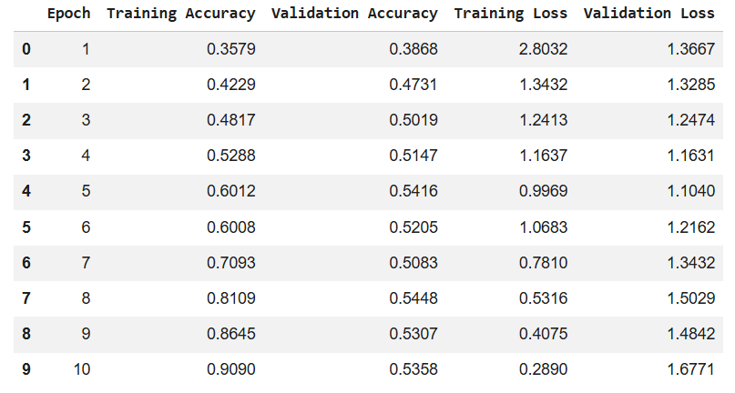
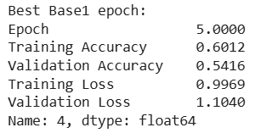

Model 2
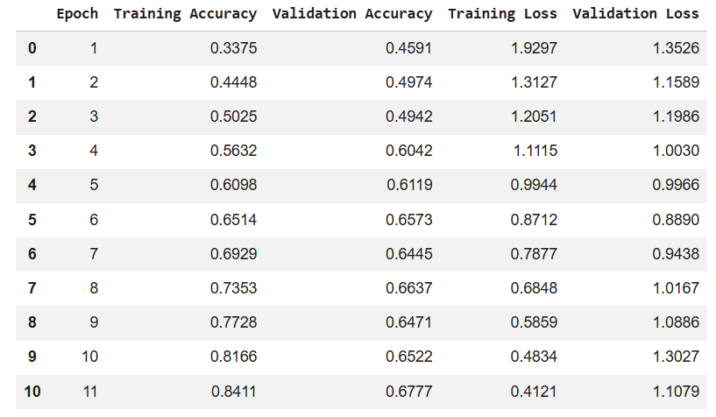

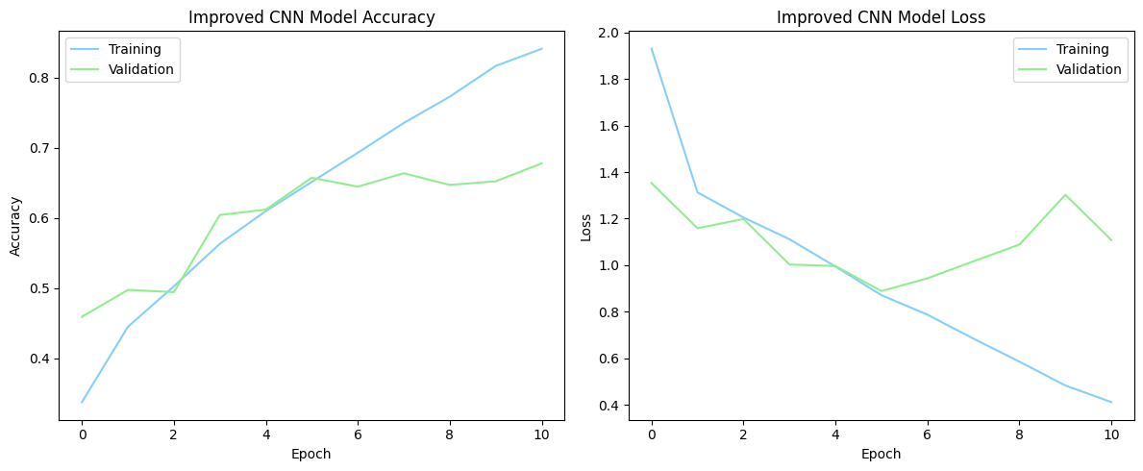
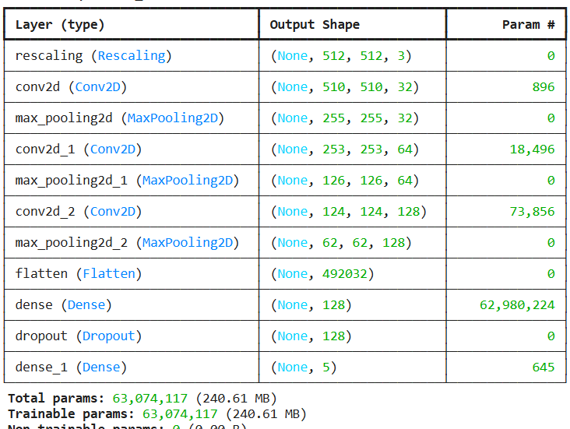

Augmen
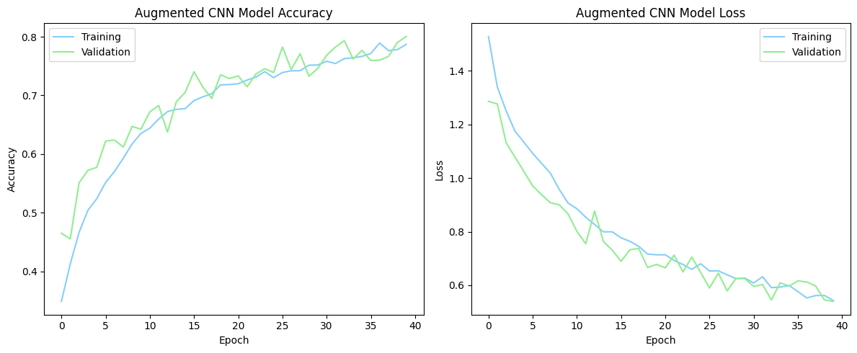
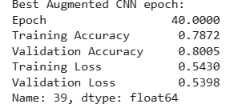

Last one


