Carly Butler Task 2

Introduction
“Calling all Workforce Advisors”
Hywel Dda UHB has a number of external factors impacting on its ability to deliver its strategy for a ‘Healthier Mid & West Wales’ (HDUHB, 2025)
The tool we are using to understand the current context we are in is the PESTLE tool. PESTLE is a strategy tool to assist with a bird’s eye view of the environment we are in (Makos, 2024), this helps us consider the political, economic, social, technological, legal and environmental factors that are impacting on HDUHB. CIPD (2025a) notes the value of using PESTLE factors to consider, strategy, workforce planning as well as a marketing plan, product release and organisational change.
This poster considers the current Technological and Environmental impacts on HDUHB and what we can do to address these as we strategise for the future as HR professionals (CIPD, 2025a).

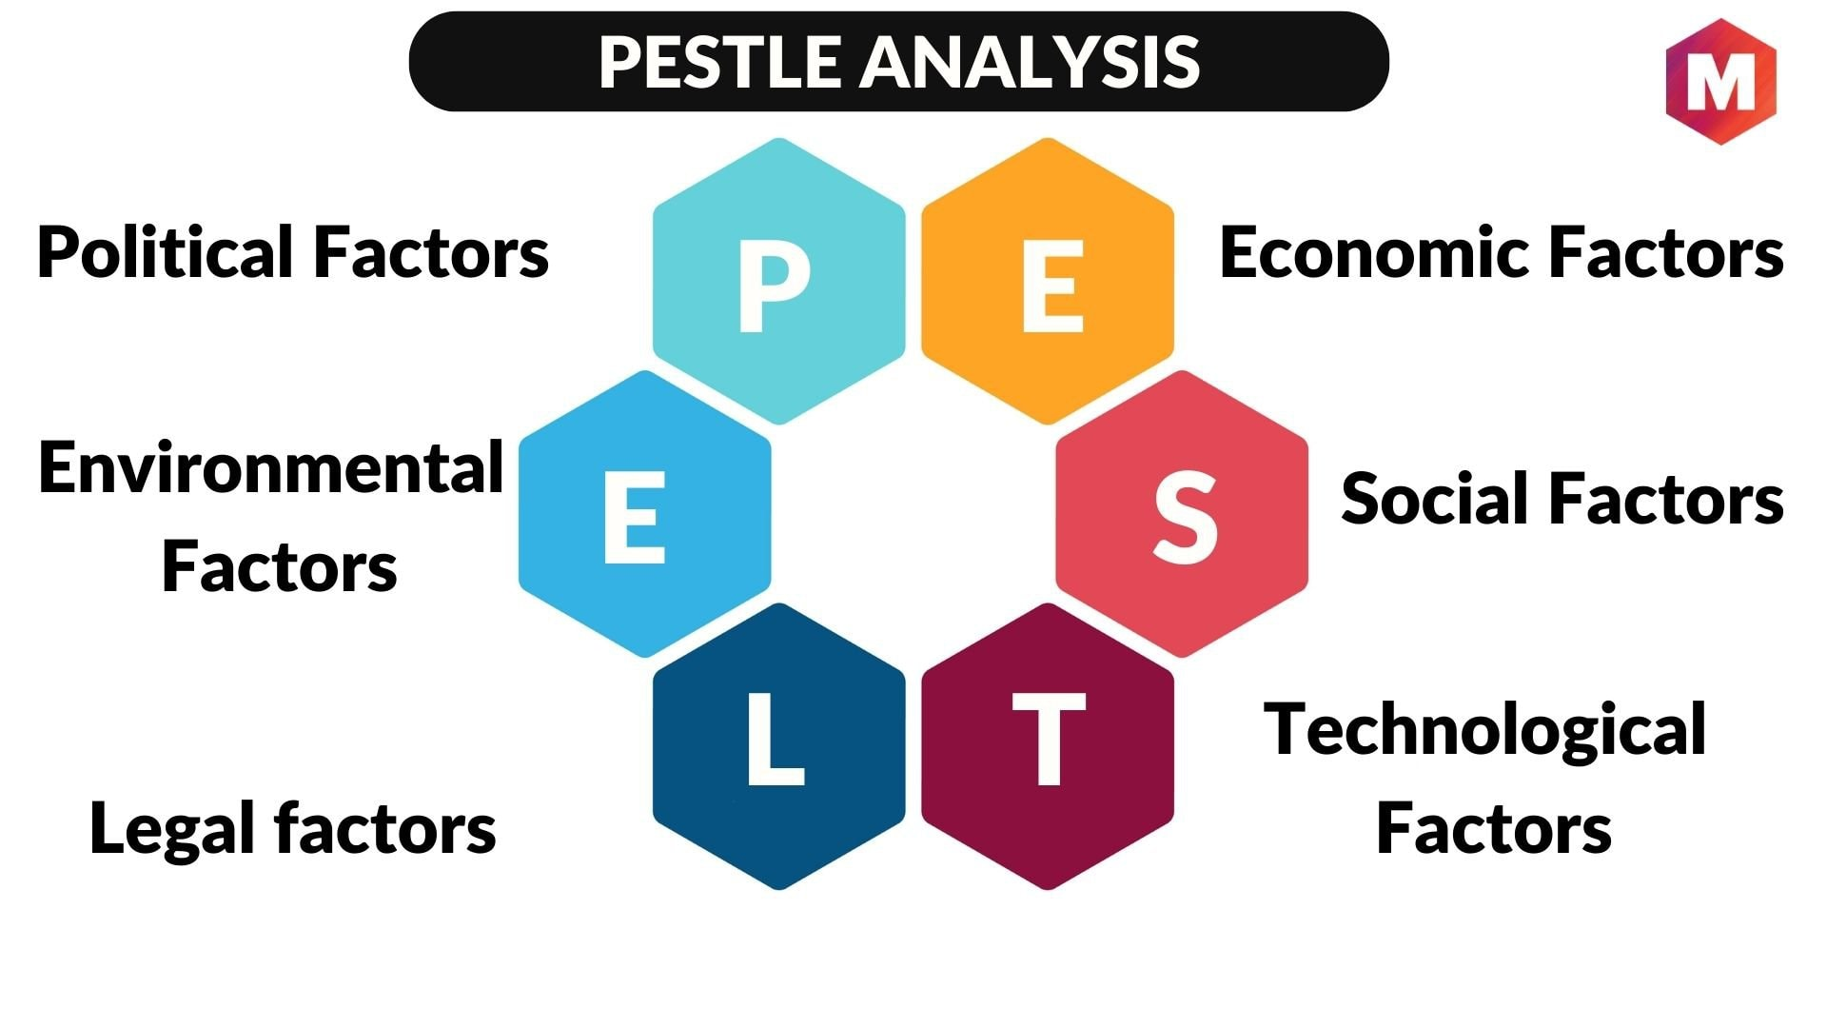

Technological
Technology and the development of AI specifically is already impacting healthcare in a huge way from General practice to skin analytics the reach could be far and wide across the NHS (NHS, 2023/2025).
But how do we train our employees? What skills do they need now to be ready for what’s to come? HDUHB have encouraged the use of AI for structuring letters and internal communications. This requires stringent rules around governance and confidentiality (Buijis et al., 2024, pp. 9-10). As HR professionals we may want to take a leaf from JP Morgan who have started to use AI to assist in Performance Reviews, though Danny Mortimer (CIPD, 2025b) concedes this is good for the form but not for the conversation as manager input is essential for good performance management, this is where HR professionals ‘really add value’.
We must ensure there are the correct safeguards in place to ensure information governance rules are adhered to and confidentiality is maintained. The World Health Organisation (WHO, 2025) raise this question of who is responsible when AI makes mistakes. Dr Natasha Azzopardi-Muscat (WHO, 2025) says we are at ‘a fork in the road’ when it comes to how AI benefits us in terms of patient care and helping exhausted nurses. Or do we end up compromising on confidentiality and privacy for our staff and patients alike?
These uses can only increase as the technology improves. As Edmund Jackson (Tedx talks, 2024) states on AI sepsis detection as well as an administrative wrap around for whole hospitals, hugely decreasing numbers of deaths.
Sharma (2025) states the importance of using AI wisely in these areas, when top robotics companies have developed tools for surgery that have not been adequately monitored, he notes them starting to ‘re-identify anonymised data’, this risk needs to be considered and mitigated as we move forward into the future.
NHS England (2025a) reports AI analytics helping to diagnose Covid-19, help with secondary dermatology, retinal screening. And more recently the 111 line have been trialling it’s use for triaging patients allowing for staff resource to be better used in the patient care or nuances.

Environmental
Taking care of the world around us and being aware of the impact we have on it has long been top of the agenda for the UK. As a Healthboard we are considering the impact the UK laws and also social norms that are developing may have. As well as this we must consider the sustainability of the use of PPE and single use plastics within our healthcare settings (Sheikh-Sobeh, 2022) and arguably most importantly, the impact of our carbon footprint (NHS, 2025b).
The NHS has committed to being net zero by 2040, the first healthcare setting to do so (NHS England, no date b). However NICE (no date) reports that NHS England’s carbon footprint equates to the of the whole of Croatia!
Conversely emissions are down 14% in the last 5 years. The NHS report states the focus on the carbon footprint is the highest priority as this will impact the surrounding environment, the health of those living in that environment and ultimately will mean providing more healthcare for those impacted by it.
Despite a 27% increase in activity, the carbon footprint of health and social care has reduced by 19% since 2007. (NHS, 2019) This is great news for the NHS strategy to be net zero by 2040. Newcastle on Tyne Hospitals (NHS foundation trust) started to look at this a few years ago when they introduced board-based bins for pharmaceutical waste in order to get to a ‘segmented approach’ towards waste disposal, as well as cost savings and changing the landscape when it comes to single use plastics in clinical waste disposal (Supply Chain NHS, 2019).
We must also consider the impact environmental changes are having on our healthcare settings, not just locally but on a global scale. The rise of heatwaves, flooding, air and noise pollution and increased waste being created are all contributing to some of the growing health conditions (neurological, cardiovascular) and deaths that our healthcare system deals with daily (NICE, 2022).

The future ……
With technological advancements comes risk but the NHS is looking to the future, considering how we mitigate those risks and take responsibility for its regulation and the safety for its users (NHS England, 2023/2025), as HR professionals we must lead the way in HDUHB with careful governance, training and guidance for our dedicated staff so they can go confidently into these new arenas.
HDUHB must be stepping confidently into this net zero era for the NHS. Innovation here is key, as we have seen from Newcastle on Tyne (Supply Chain NHS, 2019). We want to be committed to these new ideas, though they may initially come at a cost, there will be long term savings and benefits beyond our own current understanding. For further reading search Net Zero NHS.

References for Task 2 - Infographic
Buijis, E., Maggioni, E., Mazziotta, F., Carrafiello, G. and Lega, F. (2024) Artificial Intelligence: Why and How it is Revolutionizing Healthcare Management. Emerald Publishing Limited.
CIPD (2025a) PESTLE analysis. Available at: PESTLE analysis | CIPD (Accessed: 21/11/25).
CIPD HR People Pod. (2025b) Ep.36 Value of the Profession, Employment Rights Bill, AI performance reviews [Vodcast]. Available at: HR People Pod – Ep 36: Value of the profession | Employment Rights Bill | AI performance reviews (Accessed: 7/11/25).
Hywel Dda University Health Board (no date) Healthier Mid and West Wales. Available at: Healthier mid and west Wales - Hywel Dda University Health Board (Accessed: 21/11/25).
Makos, J. (2024) What is PESTLE analysis. Available at: What is PESTLE Analysis? (Free Template) (Accessed: 21/11/25).
NICE (no date) Sustainability. Available at: Sustainability | NICE (Accessed: 22/11/25).
NHS (no date a) Clinical Waste Disposal: Reducing Single Use Plastic within the NHS. Available at: Case-Study-Clinical-Waste-Disposal-Reducing-Single-Use-Plastics-In-The-NHS-20-December-2019-T3.pdf (Accessed: 13/11/25).
NHS (no date b) Delivering a net zero NHS. Available at: Greener NHS » Delivering a net zero NHS (Accessed: 15/11/25).
NHS (2025a) Five years of a greener NHS: Progress and a look forward. Available at: NHS England » Five years of a greener NHS: progress and forward look (Accessed: 14/11/25)
NHS (2023/2025) Artificial Intelligence (AI) and Machine Learning. Available at: NHS England » Artificial intelligence (AI) and machine learning (Accessed: 21/11/25)
NHS Supply Chain (2025b) Reducing carbon impact through supplier collaboration. Available at: Reducing Carbon Impact Through Supplier Collaboration » NHS Supply Chain (Accessed: 19/11/25).
Sharma, A. (2025) 'AI governance examples - successes, failures and lessons learned', Relyance AI, 4th February. Available at: AI Governance Examples—Successes, Failures, and Lessons Learned | Relyance AI (Accessed: 21/11/25).
Sheikh-Sobeh, N. (2022) 'Two years on: tackling the environmental impact of PPE', Royal College of Surgeons of England, 8th June. Available at: Two years on: tackling the environmental impact of PPE — Royal College of Surgeons (Accessed: 8/11/25).
Tedx Talks (2024) How AI can heal healthcare. 21/10/24. Available at: How AI can heal healthcare | Edmund Jackson | TEDxNashville (Accessed: 26/11/25).
World Health Organization (WHO) (2025) Is your doctor's AI safe? Available at: Is your doctor’s AI safe? (Accessed: 21/11/25).

