TITLE: DO GAMBLING COMPANIES PURPOSELY TARGET VULNERABLE PEOPLE?

MATTHEW ALEXANDER SIMONS

1704660

Submitted in partial fulfilment of the requirements for the degree of BA (Hons)
University of Wales Trinity Saint David, Swansea

Word count: 6144

Wednesday 11th December 2019

Table of contents

Contents | Page number
Image list | 3
Abstract | 4
Introduction | 4
The origins of gambling and its digital renaissance:  - Online bingo, preserve of the fairer sex  - Sports betting: anytime and anywhere | 4  6  9
The beginning of the end: are the vulnerable no longer allowed to be targeted by betting companies? | 13
Gambling addictions | 16
Gaming companies: the wolf in sheep’s clothing | 18
Conclusion | 19
Bibliography 21

Image list

- Still image from Sun Bingo’s 2019 advertising campaign ‘Are you gonna bingo?’ (Sun Bingo, 2019)

- Still from Mecca Bingo’s 2017 advert ‘Meccarena’. (Meccabingo, 2017)

- This graph shows the age shift in people who play online bingo from 2016 to 2017. (Whichbingo, 2018)

- Still from Mecca Bingo’s 2017 advert ‘Meccarena’. (Meccabingo, 2017)

- Graph showing how often online bingo players play for money. (Topratedbingosites.co.uk, 2018)

- The above graph compares how boys and girls are exposed to
- gambling adverts. (Gambling Commission, 2018)

- Image showing Fun88 on the front of a Newcastle United shirt. (The Times, 2018)

- Hudderfield’s kit being worn in a friendly match. (Independent, 2019

- Young people displaying a brand of lager (Telegraph.co.uk, 2007)

- Image revealing Paddy Power’s true intentions for Huddersfield Town FC’s kit. (Gambling Times, 2019)

- Still-image from Epic Games’ popular video game Fortnite, showing ‘loot-boxes’ that can be purchased. (BBC, 2019)

Abstract

Gambling is a popular yet controversial activity that has its roots in Ancient China. Drawing from the popularity of gambling and the contents of the industries advertisements, I aim to definitively confirm that gambling companies are purposely targeting vulnerable people in order to increase revenue. I compare the gambling industry to the tobacco and alcohol industries and compare the similarities and differences in how legislation has affected them. This dissertation also highlights gambling’s shift from the tangible to the intangible, as I explain the industries shift from ‘bricks and motor’ to the digital age of the present day. I also highlight how gaming companies indoctrinate children into gambling and the exchanging of real currency for fake pseudo-currencies.

Introduction

In this dissertation, my aim is to uncover whether gambling companies intentionally target vulnerable individuals to take part in gambling.
The term ‘vulnerable’ typically encompasses those who are elderly, minors, the disabled, living in poverty and those living with addiction(s). Vulnerable people often do not have the same opportunities that other more fortunate groups in society hold and in some cases can be easily led and easily influenced.
Gambling is an incredibly popular activity that almost needs no introduction. I believe that there is a direct correlation with gambling advertisements and the vulnerable becoming addicted.
I believe that my research into this topic will hold great value, as I do not only wish to conform my theory, but also expose the way in which these gambling companies prey on the vulnerable.
I aim to uncover the origins of gambling and its transition to the digital age. I shall be focusing on online bingo and sports betting as they are incredibly popular in the UK. I will also be comparing legislation that has been placed upon similar industries to gambling such the regulation of tobacco and alcohol advertisements. I will also be investigating case studies of individuals who have succumbed to gambling addictions as well as looking at how gambling is morphing into a hobby rather than a ‘vice.’

The origins of gambling and its digital renaissance

The Oxford English Dictionary describes gambling as ‘the activity of playing games of chance for money and of betting on horses.’ This definition has evolved over time so that the emphasis is no longer on the betting of horses, but more so on online gaming. The earliest evidence of gambling can be traced back to Ancient China; stone tiles from this period have since been discovered, which are believed to have been used in a rudimentary game of chance.

‘The Chinese ‘Book of Songs’ makes reference to “the drawing of wood” which suggests that the tiles may have formed part of a lottery type game. We have evidence in the form of keno slips which were used in about 200bc as some sort of lottery to fund state works – possibly including construction of the Great Wall of China.’ (Taylor, 2019)

It is clear that although the Ancient Chinese methods of gambling were primitive, the lottery system they used is almost identical to the system that operates in most of the western world today. This system allows prospective gamblers to put forward money in the hopes of multiplying their stake; the proceeds go towards aiding government projects and schemes.

Gambling is an incredibly popular activity, with a recent survey providing that 45% of the United Kingdom’s population participated in any form of gambling in 2017. (Gamblingcommission.gov.uk, 2019) This activity gives the participant a surge of adrenaline when they take part in gambling. This spike of energy is often present in the participant’s brain, even when they are actively losing. A leading psychologist at Nottingham Trent University, Mark Griffiths, confirmed that gambling itself has an effect on one’s adrenaline and endorphins, regardless of whether the participant is successful or not;

"Even when you’re losing while you’re gambling, your body is still producing adrenalin and endorphins." (Mark Griffiths, 2019)

According to Mark Griffiths, the feeling of euphoria is heightened when an individual experiences a win during gambling, having previously suffered a loss. As it has been proved that an individual participating in gambling experiences increased emotion regardless of the result, then it cannot come as a surprise that individuals can become so easily addicted to gambling.

Societal advances in Internet accessibility and the prevalence of smart phones have enabled individuals to engage in many forms of gambling from the comfort of their own homes or whilst travelling. This means that those who participate in gambling are able to experience the euphoric high that this activity brings more easily due to the game being more accessible. This goes in hand with the fact that unlike a casino, users can access online gambling websites at anytime of the day, meaning that they can feed their desire to gamble with increased ease. Anyone can access these websites, thus gambling companies can easily take advantage of those who are naïve to the world of gambling and its consequences. A previous survey estimated that by 2018, around 40% of gambling that takes place internationally would be online. This has led ‘bricks and mortar’ bookmakers, such as Ladbrokes, to incorporate technology into their storefront so that members of the public can participate in online games and gamble with people from all around the world.

‘It is evident that technology has influenced gambling by increasing convenience for mobile customers so that gambling is accessible at all times. This expectation from customers validates the need for betting shops to factor mobile gambling into their shops now. Casino betting kiosks are a secure, user friendly and flexible option for betting shops and casinos to accelerate their offering to customers. Digital betting kiosks are ideal for the casino and gambling industry with customizable options available – a receipt printer or cash drawer can be installed securely for example.’ (imageHOLDERS, 2019)

The customisable options on the game machines can give the participant a bespoke gambling experience, which is exclusive to them. The familiarity of each game’s layout will make the user more comfortable when gambling with their own money, meaning that they are more likely to engage regularly. Regularity in the gambling world can often lead to an unhealthy obsession with the game.

Online bingo, preserve of the fairer sex

Different types of gambling attract and target different types of people. Online sports’ betting seems to be popular with middle-aged people, with males aged between 45 and 56 being the peak demographic. Contrastingly, gambling machines often found in bookmakers seem to be more popular with the younger generation. (Newgrove, 2019)

The 2010 Gambling Prevalence Survey reported that there are only two sectors of gambling where women gamble more than men; online bingo and scratch cards.

‘For a woman bingo is the perfect way to unwind and relax. There is perhaps no other game that offers women the dual perks of socialization and jackpot wins. Bingo is popular with women because of its social connection. Playing bingo let’s women meet other like-minded people in social settings. Often bingo is the focal activity in a gathering or party. Women often organize bingo parties for their friends.’ (Bingostreak, 2018)
The average age of a woman who plays online bingo at least once a day is between 45 and 65. (Bingopower, 2011) The survey undertook by Bingo Power has highlighted that the percentage of women over the age of 75 and who play bingo at least once a day on these gambling websites has risen from 52% in 1992 to 65% in 2010. This percentage would naturally include a large amount of widows. In fact, 52% of women aged between 75 to 84 are widowed. (Hahn et al., 2011) A survey conducted by ‘Independent Age’ has also provided that a fifth of females aged 75 plus are living below the poverty line, which represents a staggering quarter of all women aged 75 and over. (Independentage, 2016)
It is clear to see from these figures that vulnerable people are actively using online bingo websites. However, in order to determine whether online bingo companies are, in fact, targeting the vulnerable, the promotional material used by these companies needs to be closely analysed.

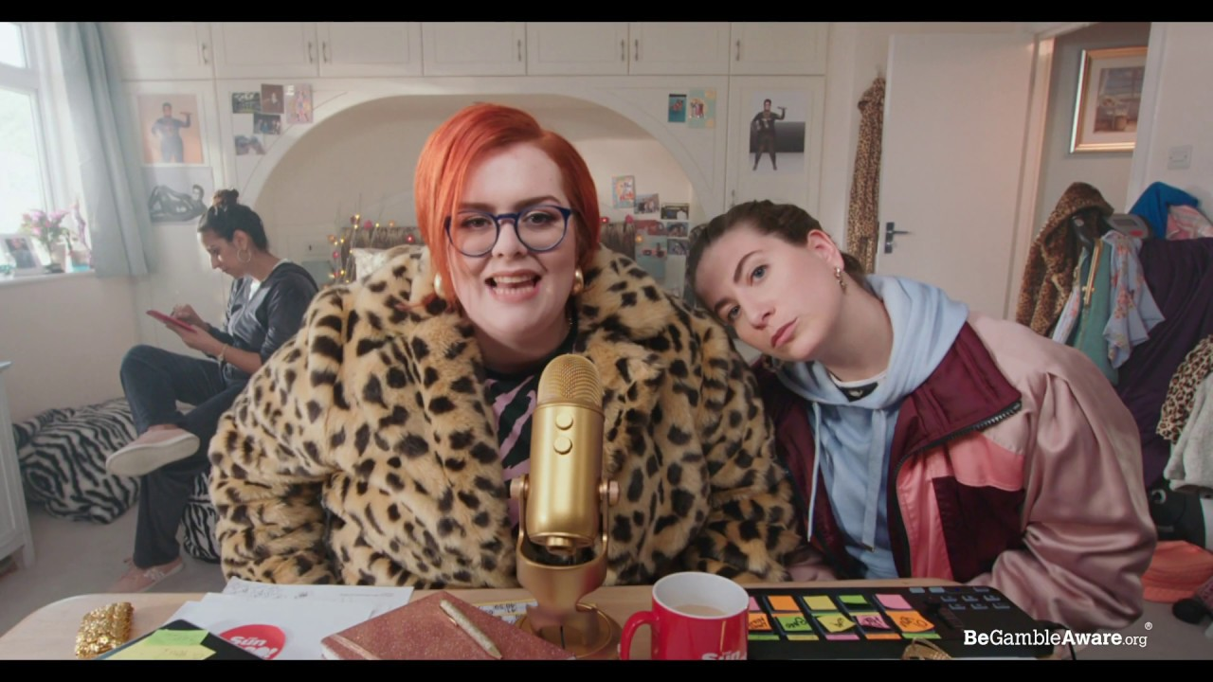
Still image from Sun Bingo’s 2019 advertising campaign ‘Are you gonna bingo?’ (Sun Bingo, 2019)

The above image is a still from Sun Bingo’s 2019 advertising campaign ‘Are you gonna bingo?’. The 30 second advertisement shows two women making an online show entitled ‘The “are you gonna bingo” show’. In the advert, the two protagonists use colloquial language that is relatable to young people and has been popularised by reality TV stars such as the Kardashian family. For a relatively short advertisement, there are many different layers to look at. First of all the two female protagonists of this advert are relatively young; this quite clearly shows that the advert’s target demographic is young women. The language and mannerisms used by the characters in this advert allude to the fact that they are from a working class background. The woman to the right of the frame is wearing a shell-suit, which was particularly popular with the working class in the 1990’s. (Macmillandictionary.com, n.d.)


It is clear that Sun Bingo is targeting working class young women due to the way in which the protagonists are depicted in this advert. Sun Bingo marketing their services to younger working class people isn’t inherently targeting vulnerable people. However, it has been shown that 21% of women are in fact living in poverty (Wbg.org.uk, 2018), therefore it can be said that Sun Bingo could be indirectly targeting their adverts towards the vulnerable, by making young working class women their target audience. Sun Bingo is also guilty of making a solitary activity seem like a social one by portraying the two protagonists as having a good time together. It seems like Sun Bingo are trying translate the camaraderie of bingo halls onto a digital stage. Sun Bingo is not the only company to try and recreate the social aspect of bingo halls in their advertisements; Mecca Bingo released an advert on the 26th December 2017 that depicts women playing online bingo while dancing to a parody of Los del Rio’s 90’s hit song ‘The Macarena’. One could argue that the date in which this advert was released is a predatory tactic deployed by Mecca Bingo. 16 per cent of Britons – which is equivalent to 7.9 million people fell behind on their finances in January 2018 due to over-spending at Christmas. (National debt line, 2018). Mecca Bingo’s decision to air the advert on the 26th December 2017 was an attempt to get people to gamble in the hopes of winning money to ease the financial stress that Christmas brought upon them.
Still from Mecca Bingo’s 2017 advert ‘Meccarena’. (Meccabingo, 2017)

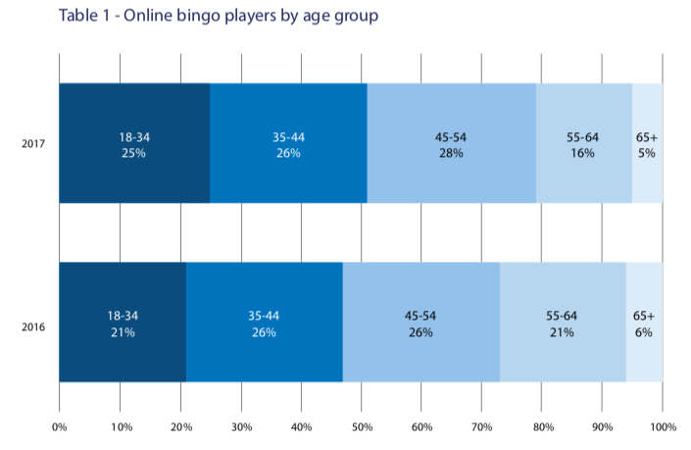

This graph shows the age shift in people who play online bingo from 2016 to 2017. (Whichbingo, 2018)

The above graph shows the age shift in people who play online bingo. Over half of those who play online bingo are now under the age of 44; what was once a game that was seen to be exclusively for older women, is now a firm favourite for the younger generation. However, the above graph does not support the notion that online bingo companies target vulnerable people. In fact, less over 75’s are playing online bingo every year.

While online bingo companies may not actively target vulnerable people, they do however promote unhealthy gambling habits and blur the lines between real currency and credit that cannot be withdrawn. As seen in the adjacent still-image from a Mecca Bingo advert, the viewer is encouraged to receive the £5 bonus that Mecca Bingo so generously offer by playing everyday. This attempt at garnering brand loyalty can make people play compulsively multiple times a week, as shown in the below figures.
Still from Mecca Bingo’s 2017 advert ‘Meccarena’. (Meccabingo, 2017)

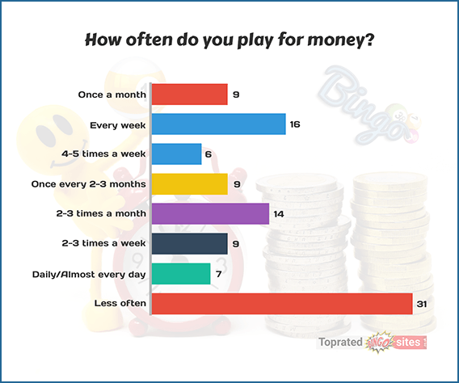
The adjacent figures show that 31% of online bingo players actually play less than once a month, yet 7% of people play for money every single day. It is abundantly clear that online bingo companies feed off the minority of people who play for money multiple times a week and in fact, vigorously encourage it. These companies place a heavy emphasis on the customer playing everyday to receive their bonus. It is tragically clear that online bingo companies have duped a minority of their customers into exchanging their sovereign currency for bonuses that cannot be withdrawn.
Graph showing how often online bingo players play for money. (Topratedbingosites.co.uk, 2018)

Sports betting: anytime and anywhere

The emergence of relatively new technology such as smartphones and tablets has made it easier for the roughly 4,000,000 people who bet on sports each year to gamble. (Gamblingcommission.gov.uk, 2019) Due to online betting now becoming available in application form, betting on sports is no longer constrained to ‘bricks and mortar’ bookmakers and is available 24 hours a day, 7 days a week.
In some instances, remote betting may be more convenient for the customer; however, it does make it harder to control and regulate underage betting. While companies like Bet365 and Sky Bet do have measures in place to unequivocally confirm that the person starting an online account with them is over 18, the safety methods and precautions stop as soon as the account is authorized. In fact, a recent Gambling Commission report claims that 6% of people aged between 11 to 16 have used a parent or guardians account to place a bet, either with or without the parent or guardians permission. (Gamblingcommission.gov.uk, 2018)
‘Young people continue to be exposed to gambling advertising via a variety of channels, with 66% having ever seen gambling adverts on TV, 59% on social media and 53% on other websites. In addition to adverts, 49% had seen or heard TV or radio programmes sponsored by a gambling company, and 46% had seen gambling sponsorships at sports venues (including on players’ shirts). Some 7% of young people who had seen such adverts or sponsorships claimed that this had prompted them to gamble when they were not otherwise planning to. More than one in ten 11-16 year olds (12%) follow gambling companies on social media such as Facebook, YouTube and Instagram.’ (Gamblingcommission.gov.uk, 2018)
The above statistics show that not only are children being exposed to gambling advertisements, but that they are also actively interacting with them, by following and engaging with the gambling companies on social media. Children of this age bracket are particularly vulnerable to being drawn in by online advertisements, especially if they are already actively participating in online games. Not only that, but they may also not be fully aware of the inner workings of gambling, and just how severe the consequences can be by placing money in the form of a ‘bet’ on a game. According to the Gambling Commissions 2018 report, within a week 14% of people aged between 11 and 16 had spent their own money on online betting. These figures are even more startling when compared with the amount of people aged between 11 and 16 who were reported to have smoked within a week-long period, which stands at just 4%. (Gamblingcommission.gov.uk, 2018)
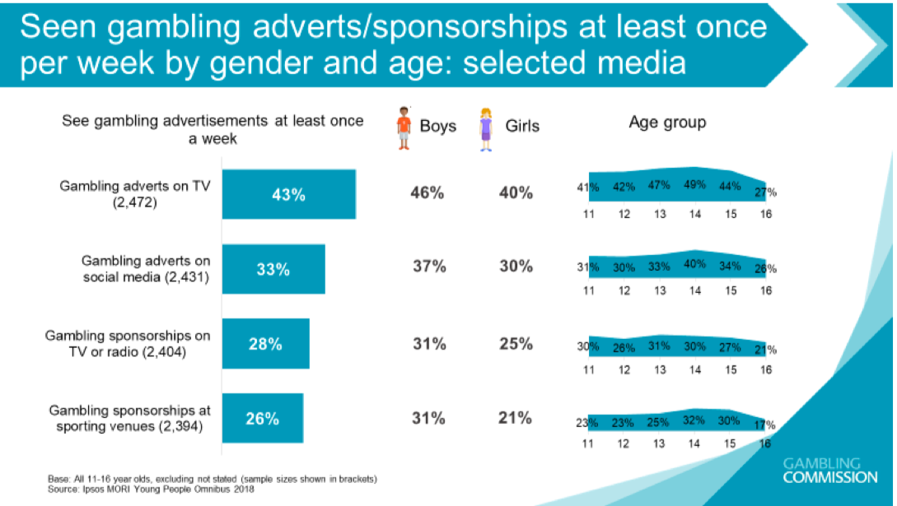
As previously stated, the younger generation are becoming increasingly exposed to betting, which is an activity stereotypically associated with adults.
The above graph compares how boys and girls are exposed to gambling adverts. (Gambling Commission, 2018)

Football is incredibly popular with young people in the United Kingdom, with 42% of people aged 16 to 24 supporting more than one football team. (talkSPORT, 2018)
As opposed to football, horse racing has always been synonymous with gambling and betting, as mentioned previously in the Oxford English Dictionary’s definition of gambling. However, with the rise in popularity of football, it can be questioned as to whether horse racing still holds the title as the most popular sport linked to betting.

‘Until recently the answer to this question would have been horse racing. The sport has always gone hand-in-hand with betting, particularly so in the time when betting shops were at peak of their popularity.
That was also the case when online betting started to emerge. The sport had the highest number of customers, the highest number of professional traders and the highest liquidity.
Yet, that has declined somewhat in recent years, largely due to the pull of in-play betting offered in football markets. As things stand, football is by far the most popular sport, with the industry making £580.5 million in profit through wagers placed on football events via the Internet between 2015 and 2016, which equates to approximately 37% of all online bets.
Horse racing came in second with £345.75 million, or 22%.’ (Goal Profits, 2018)

The statistics above provide evidence of the fact that football is now the leading source of online sports betting, with horse racing following behind. In 2018, one in six football clubs received sponsorship money from betting companies. (Bbc.co.uk, 2019)

It is not just football clubs who are profiting from online betting companies. Internationally renowned football player Wayne Rooney was the bi-product of a deal between Derby County Football Club and their primary shirt sponsor and online bookmaker, 32Red. (Bbc.co.uk, 2019) A term of the contract between the three parties required Mr Rooney to adopt the player number ‘32’ in homage to the company 32Red.

As Wayne Rooney is such a popular sporting icon among young football fans, the advertisement for the online bookmaker 32Red on his shirt has thus been able to reach the younger generation with increased ease. This can, in turn, influence the younger generation to participate in gambling as it is being advocated by a known sporting idol. The younger generation may not question their influenced participation in gambling, as they are vulnerable to the high-risk notion of the game, which can have potentially detrimental implications.


In 2018, the UK Advertising Standards Authority investigated four online betting companies for the alleged targeting of children by promoting games such as ‘Santa Paws’ and ‘Fairy-tale Adventure’ that seemed likely to appeal to children. (Ft.com, 2018) One of the companies investigated by the UK Advertising Standards Authority is an online betting company that hails from China, called Fun88. The Chinese company is the main sponsor for the football club Newcastle United in a deal that is worth 8 million pounds a year. (BBC News, 2017) Children may see their heroes wear the shirt emblazoned with the gambling companies insignia and start interacting with the brand on social media or even using a parent or guardians account to bet or play games as
previously stated.
Image showing Fun88 on the front of a Newcastle United shirt. (The Times, 2018)

Children are not the only group of vulnerable people that are being targeting by these online bookmakers. The Swedish bookmaker LeoVegas was fined £627,000 in 2018 for sending promotional material to 1,894 people who had previously opted out. (Ft.com, 2018) Some of the people who had opted out of receiving promotional material from LeoVegas may have been recovering addicts, who would have been tempted to relapse by the self-proclaimed ‘King of Mobile Casino’. It is abundantly clear that this was a clear and obvious attempt by LeoVegas to try and claw back customers who may have departed from gambling due to a previous addiction.
The predatory nature of LeoVegas and companies alike is highlighted by the fact that most online gamblers bet using loans. (Rogan, 2018) This statistic displays that not only are people losing money because of the veracious behaviour exhibited by these companies, but are also getting into debt. This could see gamblers placing even more outlandish bets to try and get out of financial hole that was, itself, caused by gambling.

A conflict of interest can also be highlighted with some bookmakers having parent or sister companies that report sports news. An example of this would be SkyBet and it’s relation to the intentionally renowned news-source, Sky News. This conflict of interest was highlighted when the Columbian international James Rodriguez was expected to transfer to footballing giants Manchester United in May 2017. (The Independent, 2017) Sky News reported on the story as if it were a ‘done-deal’ and SkyBet reduced the odds on the player making his move before suspending betting altogether. The deal, however, did not go through. Despite there being no evidence to prove that Sky News manufactured the story, speculation will always arise when there is such a dubious link between bookmakers and the news. Even though Sky News now only own a 20% stake in Sky Bet, the online bookmaker still retains the name Sky to make themselves seem more attractive to the betting community as Sky is such a well renowned company. In turn, this could mean that more vulnerable people will engage with bookmakers such as Sky Bet, as it is a company they are familiar with and can trust. This is juxtaposed with the idea that the vulnerable are more likely to engage in gambling due to not being fully aware of the implications of the game, however they may still be conscious of choosing to gamble with a highly regarded company.
Sky News is a company that 98% of people in the UK have heard of and only 17% of people have a negative opinion on. (Yougov.co.uk, 2019)

The beginning of the end: are the vulnerable no longer allowed to be targeted by betting companies?

The Industry Group for Responsible Gambling confirmed that a ban on betting adverts being shown during the commercial breaks of televised sports would be implemented during the summer of 2019. (Barber, 2018) The IGRG decided to do this after being faced with a large portion of the public being concerned about the amount of gambling advertisements that appear in commercial breaks.
‘IGRG chair John Hagan said the industry was responding to public concerns about the amount of gambling advertising on television before the watershed.
He added: "We believe that this is itself a watershed moment as we strive to provide the ever safer gambling environment which gambling consumers and the wider public expect, and which is so important to the future success and sustainability of our industry."’ (Racingpost.com, 2018)
The above quote by the head of the IGRG, John Hagan, makes the removal of betting adverts seem like more of an act of self-preservation rather than a measure to protect the vulnerable. The IGRG may have analysed what has happened to the smoking industry since the advertising of tobacco products was banned, and decided to concede showing gambling adverts during sports broadcasts as a way of seeming responsible to governing bodies and the general public. (Kasza et al., 2011)

Not only has the inability to advertise tobacco products negatively affected the tobacco industry, the inability to visually merchandise cigarettes in shops due to the 2015 Tobacco Display Ban has caused a 17% drop in the number of children who smoke. (Theguardian.com, 2018) There is no reason why the same strict measures imposed on the tobacco industry would not gather the same results if applied to the gambling industry.


In 2007, the logos of alcohol companies were removed from children’s football kits. (Telegraph.co.uk, 2007) The change was made due to the drinks industry relenting due to enormous external pressure from the general public, as children were seen as walking advertisements for alcohol. The situation with betting on football kits mirrors the alcohol controversy almost exactly. Nine premier league football clubs signed a deal to ensure that betting sponsors would not be displayed on their junior kits in accordance with the IGRG’s code. (Hughes, 2018) However, problems have arisen due to Bournemouth FC’s junior kits only going up to age 13. This means that minors aged between 14 and 18 years old will still be displaying the logo of the club’s sponsor, MansionBet, as the children would have to wear an adult kit for sizing purposes.
Young people displaying a brand of lager (Telegraph.co.uk, 2007)

While children may not be the target market for both alcohol and betting, the reluctance to stop using children as walking billboards indicates that these industries could have been depicted as grooming children to associate their favourite club with their brand. This can lead to the brand almost being synonymous with the football club.


In July 2019, Paddy Power launched an advertising campaign, which saw them release a football kit for their newly acquired partner Huddersfield Town FC that displayed Paddy Power’s logo in an obnoxious manner. The kit was met with outrage; after just one friendly match where the players wore this new design, the real kit was released.
Hudderfield’s kit being worn in a friendly-match. (Independent, 2019)

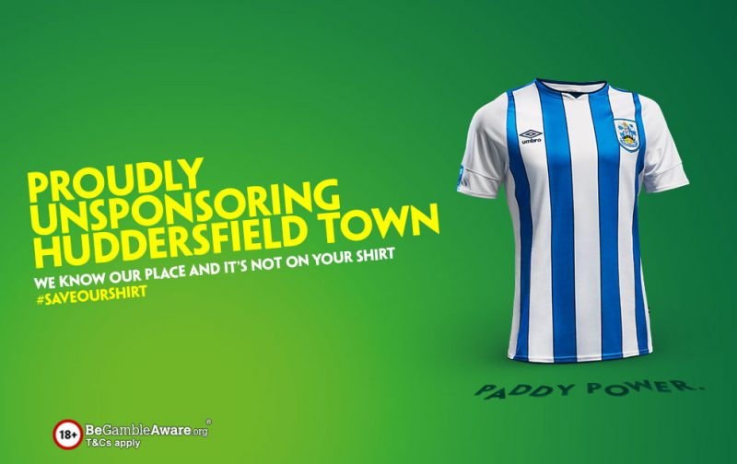
Image revealing Paddy Power’s true intentions for Huddersfield Town FC’s kit. (Gambling Times, 2019)

Paddy Power revealed the first football kit to be a stunt by posting the above image to the online social media website, Facebook. Paddy Power then started an online campaign by using the hash-tag ‘Save our shirt’ to protest against betting companies ruining the sanctity of football shirts.

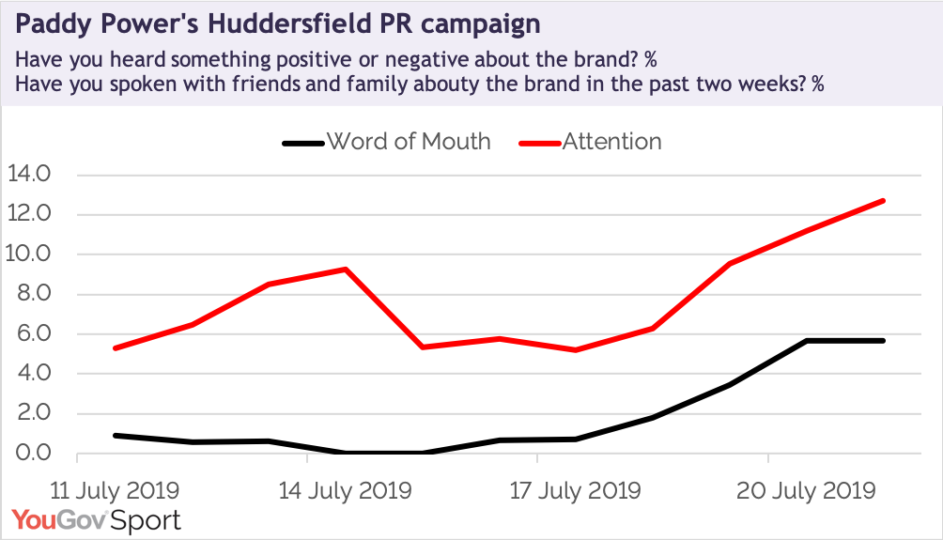

‘As you can see from the chart above, the campaign has certainly got the brand noticed among the general public. The number of people telling us that they have heard something (positive or negative) about Paddy Power over the past 11 days has increased significantly. The chart also shows that the campaign has got more people talking about the brand to friends and family’ (Yougov.co.uk, 2019)

Paddy Power have not only managed to gain more exposure because of this stunt, they have also managed to seem like a shining beacon of light in the gambling industry by taking measures against themselves. It would be naïve to think that Paddy Power took this measure out of genuine concern for the sanctity of football. Not only did the Irish bookmaker gain more attention and publicity, it also could have been implemented as a way of self-regulating themselves and the gambling industry as a whole, in an effort to avoid the strict regulations that the alcohol industry has been met with by various governing bodies. While not being able to showcase their logo’s on kits may seem like it would hinder Paddy Power’s ability to market themselves to the general population and the vulnerable alike, the empty space shown on the shirt may serve as a subconscious reminder of Paddy Power’s stunt.

In February 2019, the Advertising Standards Agency implemented new rules to protect children from gambling advertisements.
The new standard stated that they:
- ‘Prohibits online ads for gambling products being targeted at groups of individuals who are likely to be under 18 based on data about their online interests and browsing behaviour;
- Extensively list unacceptable types of content, including certain types of animated characters, licensed characters from movies or TV and sportspeople and celebrities that are likely to be of particular appeal to children, and references to youth culture; and
- Prohibits the use in gambling ads of sportspersons, celebrities or other characters who are or appear to be under 25; and
- Adds to existing guidance on the responsible targeting of ads, covering all media (including social networks and other online platforms’ (ASA.org.uk, 2019)

The above measures clearly indicate a desire to extinguish the amount of children that are targeted by gambling companies, by stopping the companies appealing to the interests of children. These measures come one year after the aforementioned Fun88 was investigated for its predatory marketing tactics.

Gambling addictions

A 2015 report by the UK Gambling Commission has stated that the number of British over-16s who are ‘problematic’ gamblers has risen by a third in 3 years, suggesting that roughly 430,000 people suffer from a serious gambling habit in the United Kingdom alone. (Gamblingcommission.gov.uk, 2015)

Before looking at whether or not gambling companies actively target these vulnerable addicts, it first needs to be understood how these individuals become addicted to gambling in the first place.

‘A hot topic in the conversation about gambling is social gambling. This is where players take to social media platforms like Facebook to play games, with or without real money. Dr Griffiths explains that such a popular site as Facebook was always going to appeal to operators hoping to expand their player base. By using free games as a stepping-stone, operators have been able to guide players towards paid, real money games on their sites. The addition of paid perks, accessories and enhancements is also a money-spinner for operators. Free games also allow players to familiarise themselves with a game, making it more likely that they will feel confident enough to play for real. All human beings will abandon an activity if there isn’t reinforcement or reward – that’s true for all things from exercise to friendships. This reaction is exploited all the while someone is gambling but a small percentage of gamblers are unable to disentangle themselves, so to speak, from the pursuit of that reinforcement and this is where gambling becomes a problem.’ (Griffiths, 2018)

The above passage theorises that gambling companies lure prospective gamblers into their business by tempting them with free games. The free games allow the customer to familiarise themselves with the mechanics of the game and gain confidence in their ability to win. The line between free games and games requiring payment is then blurred, and customers can find themselves losing money without them even realising. It seems like gambling companies purposely ‘muddy the waters’ between real currency and fake currency, in the form of ‘free spins’ to earn more revenue. Although this is an unethical business tactic, it is not expressly targeting vulnerable people.

In August 2012, an Ohio-born American by the name of Scott Stevens committed suicide. (Rosengren, 2016) Stevens, who became addicted to gambling after a trip to Las Vegas with his wife and kids, managed to win a jackpot on a fruit machine. He then continued to gamble after being made redundant from his job for embezzlement. After Stevens gambled away all of his money, losing 4.8 million dollars in one year, he took his own life. Scott Stevens was a far cry away from the vulnerable people mentioned previously. He had a master’s degree in Business and Finance from the University of Rochester in New York and worked his way up the ranks to become Chief Operating Officer at a steel company, earning a six-figure salary. (Rosengren, 2016) Deciding who was to blame for his passing, if any-one, is a complex issue. Looking at his life objectively, he seemed to have everything a person could desire: wealth, a family and multiple holidays a year. Yet Stevens still felt the need to compulsively gamble his hard-earned money away. It could be argued that it is entirely Stevens’ fault, as nobody forced him to gamble in the first place and he had every opportunity to stop gambling. However, it could also be argued that he was simply a victim of a system that is designed to entice and take over ones life.
Parallels between this case and Dr Mark Griffiths theories can be found, with Griffiths theorising that gambling companies attempt to make individuals addicted to gambling by offering free games. Although the casino machine that was the catalyst for Stevens’ addiction was not free, it still allowed him to familiarise himself with the machine’s mechanics, and gave him a sense of confidence when he won, adding to his hubris. Stevens’ vulnerability was more nuanced and harder to spot than the aforementioned cases. Something inside of Stevens compelled him to gamble, despite already having what many would call a ‘picture-perfect life’. This weakness made him the perfect target for the casino’s carefully calibrated system to prey on his weakness. Even though Scott Stevens took his own life, the Bellagio Casino has metaphorically got blood on its hands and should be held responsible.
Casinos such as the Bellagio in Las Vegas are known to give free hotel suites to people who are more likely to spend large amounts of money in their casinos. (Bloomberg.com, 2018) This starkly contrasts with the way in which online betting companies target people, as they seem to lean towards the working class side of the spectrum rather than the wealthy, white-collar individuals who are targeted and courted by casinos.

In 2017, four gambling companies were subject to investigation from the Advertising Standards Authority for online adverts placed by ‘affiliates’ who are paid to direct web-traffic to online gambling companies. (Davies and Sweney, 2017)

‘One of the ads, which appeared on three websites, referred to “William” who was “£130,000 in debt after having to sell the house and continue to pay out of pocket for his wife’s cancer-related medical bills their insurance wouldn’t cover”.
“William took to Facebook one night in the hospital lobby to update his friends and family on his wife’s health,” it continued. “A little tired and admittedly a bit repressed, William stumbled upon an ad for Sky Vegas.
“With little to no money to spend he admits he laughed and almost scrolled past it until he saw they were offering a promotion that would reward him with £10 free at the Jackpot 7 game, which at over £700,000 was too hard to pass up.”
The ad, which the ASA said “targeted vulnerable people” stated that “William” had won “over 30 times his annual salary in a single spin,” adding that “his debt and financial worries came to an abrupt end”.’ (theguardian.com, 2017)

It is irrefutable that the affiliate of these gambling companies was targeting vulnerable people with its promotional material. People who find themselves in similar horrific situations to the fictitious ‘William’ may use this advertisement as justification and encouragement to start gambling.
The uncertainty however, lies with whether or not these gambling companies knew that their affiliate was using such a predatory tactic to try and garner more customers. The four gambling companies were, in-fact, benefiting from the advertisement that the affiliate had made, but that alone can not be used as conclusive proof that they orchestrated the advertisement.

Gaming companies, the wolf in sheep’s clothing

Video games have become an irreplaceable part of world-culture and the industry is now valued at 120 billion US dollars. (Business Insider, 2019) With new technology paving the way for better and more immersive games, new game mechanics are being released to the public that are almost identical to gambling found online and in casinos.

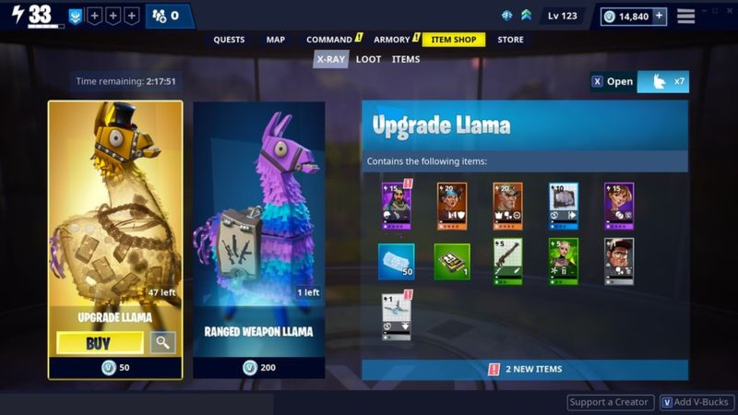

Still-image from Epic Games’ popular video game Fortnite, showing ‘loot-boxes’ that can be purchased. (BBC, 2019)

Loot-boxes (sometimes referred to as loot-crates) are essentially treasure chests that offer the user a chance at acquiring in-game items that are incredibly rare and would take countless hours to unlock without loot-boxes. These loot-boxes are purchased and not earned, meaning that the user has to spend real money in order to get a chance at unlocking intangible items.

The whimsical art style and colourful pallet used by Epic Games in the above image points to children being their target market. In fact, 53% of their users are aged between 10 to 25 years old. (Business of Apps, 2019)

Loot-boxes are not just limited to the game Fortnite. This years edition of Electronic Arts’ annual football video-game FIFA has already gathered 10 million players (Schaffner, 2019) and one of the games core mechanics is the purchase of ‘player packs’ that are bought and not earned.

When purchasing these loot-boxes, an intermediary currency is used before real, sovereign currency is exchanged for the loot-box. For example, one cannot just simply but a loot-box in the game Fortnite, they must exchange their currency for ‘V-bucks’, which then give the user the ability to buy as many loot-boxes as the amount of ‘V-bucks’ they possess allows. This muddying of the water between real currency and pseudo-currencies is purposely confusing and is reminiscent of the aforementioned theory by Dr Mark Griffiths. It is abundantly clear that children are the target demographic for these games, and although few children have their own bank accounts on which to draw money from, they are using their parents’ financial resources, who may not be as technologically literate as them. One child spent £550 in three weeks, with the parents of the child only being aware of the purchases made when their bankcard was declined upon their own attempt to make a purchase. (BBC News, 2019)

Under threat of legislation, Nintendo, Microsoft and Sony have announced plans to disclose the odds of receiving particular items on all games that use loot boxes. (Forbes.com, 2019) The fact that none of the three companies published odds on their loot-boxes indicates that they purposely tried to entice and mislead people. This move by the three companies brings to mind the aforementioned IGRG and their decision to remove themselves from television pre-watershed. Both are acts of self-perseveration as loot-boxes have been banned from Belgium as of 2018, due to being deemed to be ‘in violation of gambling legislation’. (BBC News, 2018)

Conclusion

It is apparent from my extensive research on the gambling world that gambling companies do in fact purposely target vulnerable people. Gambling companies do this to boost revenue and therefore make more money, as vulnerable people are less likely to fully understand or care about the full ramifications of gambling, thus they are more willing to participate on a regular basis.
Gambling companies do not target vulnerable people for the sole purpose of making them gamble. My research has shown proof that these companies aim to create a positive relationship with these people by becoming synonymous with their favourite football team and even by appearing ethical. From the outset, this seems like a very customer-friendly way of handling business, but my research shows that these companies have nefarious intentions, and want to appear friendly in order to make vulnerable people become addicted to gambling.
My research has also concluded that games companies such as Electronic Arts groom children to become more open about gambling as well as muddying the waters between real currency and pseudo-currency.
While vulnerable people are being target by gambling companies, my research shows that the emphasis of this is mainly on children. The gambling companies have an intricate yet horrifying agenda, which is to affectively secure the next generation as their prime, present and future customers to ensure there is always a steady profit. By doing this, they are procuring their customers trust and loyalty for potentially the next seventy years.

Bibliography

Online articles

Age, I. (2019). The overlooked over-75s: poverty among the ‘Silent Generation’ who lived through the Second World War. [online] Independent Age. Available at: https://www.independentage.org/policy-research/research-reports/overlooked-over-75s-poverty-among-silent-generation-who-lived [Accessed 2 Nov. 2019].

Baraniuk, C. (2019). Why gamblers get high even when they lose. [online] Bbc.com. Available at: https://www.bbc.com/future/article/20160721-the-buzz-that-keeps-people-gambling [Accessed 23 Nov. 2019].

Barber, B. (2018). Industry confirms voluntary ban on gambling ads to begin next summer | Horse Racing News | Racing Post. [online] Racingpost.com. Available at: https://www.racingpost.com/news/industry-confirms-voluntary-ban-on-gambling-ads-to-begin-next-summer/357377 [Accessed 1 Dec. 2019].

BBC News. (2017). Newcastle United reveal new sponsor. [online] Available at: https://www.bbc.co.uk/news/uk-england-tyne-39926698 [Accessed 1 Dec. 2019].

BBC News. (2018). Video game gambling banned in Belgium. [online] Available at: https://www.bbc.co.uk/news/technology-43906306 [Accessed 15 Nov. 2019].

BBC News. (2019). 'The kids emptied our bank account playing Fifa'. [online] Available at: https://www.bbc.co.uk/news/technology-48908766 [Accessed 1 Dec. 2019].

Bbc.co.uk. (2019). Gambling sponsorship in football: Do you think it should be banned? - CBBC Newsround. [online] Available at: https://www.bbc.co.uk/newsround/49293904 [Accessed 10 Nov. 2019].

Bingo Streak. (2018). Why is it That for a Woman Bingo is Far More Popular?. [online] Available at: https://www.bingostreak.com/woman-bingo [Accessed 1 Dec. 2019].

Bingopower. (2019). Women Love Bingo and the Demographics of Bingo Players. [online] Available at: https://www.bingopower.com/guide/women-love-bingo/ [Accessed 2 Dec. 2019].

Bloomberg.com. (2018). Bloomberg - Are you a robot?. [online] Available at: https://www.bloomberg.com/news/features/2018-09-04/secrets-of-las-vegas-s-exclusive-high-roller-cosmopolitan-sweet [Accessed 9 Nov. 2019].

Business Insider. (2019). The $120 billion gaming industry is going through more change than it ever has before, and everyone is trying to cash in. [online] Available at: https://www.businessinsider.com/video-game-industry-120-billion-future-innovation-2019-9?r=US&IR=T [Accessed 9 Dec. 2019].

Business of Apps. (2019). Fortnite Usage and Revenue Statistics (2019). [online] Available at: https://www.businessofapps.com/data/fortnite-statistics/ [Accessed 29 Nov. 2019].

Davies, R. and Sweney, M. (2017). Betting firms could be fined over ads 'targeting vulnerable people'. [online] the Guardian. Available at: https://www.theguardian.com/media/2017/sep/13/betting-firms-ads-asa-ladbrokes-888-skybet-casumo [Accessed 2 Dec. 2019].

Gamblingcommission.gov.uk. (2015). [online] Available at: http://www.gamblingcommission.gov.uk/PDF/survey-data/Gambling-behaviour-in-Great-Britain-2015.pdf [Accessed 1 Dec. 2019].

Gamblingcommission.gov.uk. (2018). [online] Available at: https://www.gamblingcommission.gov.uk/PDF/survey-data/Young-People-and-Gambling-2018-Report.pdf [Accessed 1 Dec. 2019].

Gamblingcommission.gov.uk. (2019). [online] Available at: https://www.gamblingcommission.gov.uk/PDF/survey-data/Gambling-participation-in-2018-behaviour-awareness-and-attitudes.pdf [Accessed 29 Nov. 2019].

Gamblingcommission.gov.uk. (2019). [online] Available at: https://www.gamblingcommission.gov.uk/PDF/survey-data/Gambling-participation-in-2018-behaviour-awareness-and-attitudes.pdf [Accessed 1 Dec. 2019].

Goal Profits. (2018). The (Insane) Facts & Figures Fuelling the Betting Industry. [online] Available at: https://www.goalprofits.com/facts-figures-betting-industry/ [Accessed 1 Dec. 2019].

Griffiths, D. (2018). Dr Mark Griffiths on Gambling Psychology - RightCasino. [online] RightCasino UK. Available at: https://www.rightcasino.com/news/dr-mark-griffiths-on-gambling/ [Accessed 1 Dec. 2019].

Hughes, V. (2018). Football clubs sell children's kits featuring gambling sponsorship. [online] bestbettingsites.uk. Available at: https://www.bestbettingsites.uk/news/society/football-clubs-continue-to-sell-childrens-kits-featuring-gambling-sponsorship.html [Accessed 8 Nov. 2019].

Macmillandictionary.com. (n.d.). shell suit (noun) definition and synonyms | Macmillan Dictionary. [online] Available at: https://www.macmillandictionary.com/dictionary/british/shell-suit [Accessed 13 Nov. 2019].

Newgrove. (2019). Customer Profile Characteristics For The Betting Industry. [online] Available at: https://newgrove.com/customer-profile-characteristics-for-the-betting-industry/ [Accessed 15 Nov. 2019].

Rogan, A. (2018). Most online gamblers bet using loans. [online] Thetimes.co.uk. Available at: https://www.thetimes.co.uk/article/most-online-gamblers-bet-using-loans-mfn3vfkjt [Accessed 1 Dec. 2019].

Rosengren, J. (2016). How Casinos Enable Gambling Addicts. [online] The Atlantic. Available at: https://www.theatlantic.com/magazine/archive/2016/12/losing-it-all/505814/ [Accessed 9 Nov. 2019].

talkSPORT. (2018). Staggering number of young football fans support more than one team. [online] Available at: https://talksport.com/football/419143/nearly-half-of-16-24-year-olds-in-the-uk-support-at-least-two-football-teams/ [Accessed 1 Dec. 2019].

Taylor, I. (2019). The History of Gambling - Complete Gambling History Timeline. [online] Gambling.net. Available at: https://www.gambling.net/history/ [Accessed 20 Nov. 2019].

Telegraph.co.uk. (2007). Drinks logo ban on children's replica kits. [online] Available at: https://www.telegraph.co.uk/news/uknews/1553504/Drinks-logo-ban-on-childrens-replica-kits.html [Accessed 1 Nov. 2019].

The Independent. (2017). Sky Sports reports and Sky Bet reacts: The story of Rodriguez's non-transfer. [online] Available at: https://www.independent.co.uk/sport/football/news-and-comment/james-rodriguez-real-madrid-to-manchester-united-transfer-sky-news-bets-gambling-a7741021.html [Accessed 1 Dec. 2019].

The Independent. (2018). Millions of Britons start 2018 with huge Christmas debt. [online] Available at: https://www.independent.co.uk/news/business/news/christmas-spending-debts-credit-card-payments-loan-british-people-britons-household-incomes-a8138251.html [Accessed 23 Nov. 2019].

Topratedbingosites.co.uk. (2018). Bingo Player Survey 2018/19 | Demographics and Playing Habits Analysed. [online] Available at: https://www.topratedbingosites.co.uk/insights/news/bingo-player-uk-survey/ [Accessed 1 Dec. 2019].

Wbg.org.uk. (2018). [online] Available at: http://wbg.org.uk/wp-content/uploads/2018/08/FINAL-Female-Face-of-Poverty.pdf [Accessed 1 Dec. 2019

Whichbingo.co.uk. (2018). [online] Available at: https://www.whichbingo.co.uk/wp-content/uploads/2018/07/WhichBingo-Online-Bingo-Annual-Report-2018.pdf [Accessed 30 Oct. 2019].

Yahoo.com. (2018). Yahoo is now part of Verizon Media. [online] Available at: https://www.yahoo.com/lifestyle/actually-came-okurr-cardi-b-180000078.html?guccounter=1&guce_referrer=aHR0cHM6Ly93d3cuZ29vZ2xlLmNvbS8&guce_referrer_sig=AQAAAGHm2RKi9b4_ziOEykZWW5njsDELuBHhp2nE4-R2BiAaRymabJiGmWpZ9gPUW7CZUNwhcG3HceUzpxYxw-8--Nmjri5Me5643l3rkcq-4K0vsTKsXtkqFhT7PRWojhS8xyhnSwo2HcxOWo6FbcVLu8dlwQu2IEE8zzPYAGSk3La3 [Accessed 1 Dec. 2019].

Yougov.co.uk. (2019). Paddy Power sponsorship stunt powers up consideration for brand | YouGov. [online] Available at: https://yougov.co.uk/topics/sport/articles-reports/2019/07/25/paddy-power-sponsorship-stunt-powers-consideration [Accessed 13 Nov. 2019].

Yougov.co.uk. (2019). YouGov. [online] Available at: https://yougov.co.uk/topics/media/explore/tv_channel/Sky_News [Accessed 18 Nov. 2019].

Images and videos

Gambling Times (2019). [image] Available at: https://www.thegamblingtimes.com/wp-content/uploads/2019/07/Huddersfield_Reveal-800x504.jpg [Accessed 1 Dec. 2019].

Independent (2019). [image] Available at: https://static.independent.co.uk/s3fs-public/thumbnails/image/2019/07/19/09/Huddersfield-wore-the-prank-kit-in-a-friendly-vs-Rochdale-.jpg?w660 [Accessed 13 Nov. 2019].

Mecca Bingo (2017). [video] Available at: https://www.youtube.com/watch?v=PVZs1fzyq_0&feature=emb_logo [Accessed 1 Dec. 2019].

Sun Bingo (2019). https://lbbonline.com/news/the-worlds-first-sun-bingo-vlog-is-here-to-ask-are-you-gonna-bingo/. [image].

The Times (2018). https://www.thetimes.co.uk/imageserver/image/methode%2Fsundaytimes%2Fprod%2Fweb%2Fbin%2Fc02054ac-0386-11e8-9830-aa0ac4f2bc04.jpg?crop=2667%2C1500%2C0%2C0&resize=685. [image].

Journals

Hahn, E., Cichy, K., Almeida, D. and Haley, W. (2011). Time Use and Well-Being in Older Widows: Adaptation and Resilience. Journal of Women & Aging, 23(2), pp.149-159.

Kasza, K., Hyland, A., Brown, A., Siahpush, M., Yong, H., McNeill, A., Li, L. and Cummings, K. (2011). The Effectiveness of Tobacco Marketing Regulations on Reducing Smokers’ Exposure to Advertising and Promotion: Findings from the International Tobacco Control (ITC) Four Country Survey. International Journal of Environmental Research and Public Health, 8(2), pp.321-340.

Books

Ashton, J. (1968). The history of gambling in England. New York: B. Franklin.

Bromley, D. and Anderson, G. (2012). Vulnerable People, Vulnerable States. Hoboken: Taylor and Francis.

Gainsbury, S. (2012). Internet gambling. New York: Springer.

Healey, J. (2011). Gambling problems. Thirroul, N.S.W.: Spinney Press.

Thompson, E. (2016). Making of the English Working Class. Open Road Media.

Wilcox, C. (n.d.). Gambling addiction.

