Aysha Islam 2413041 BMHP5014 COMPONET 2

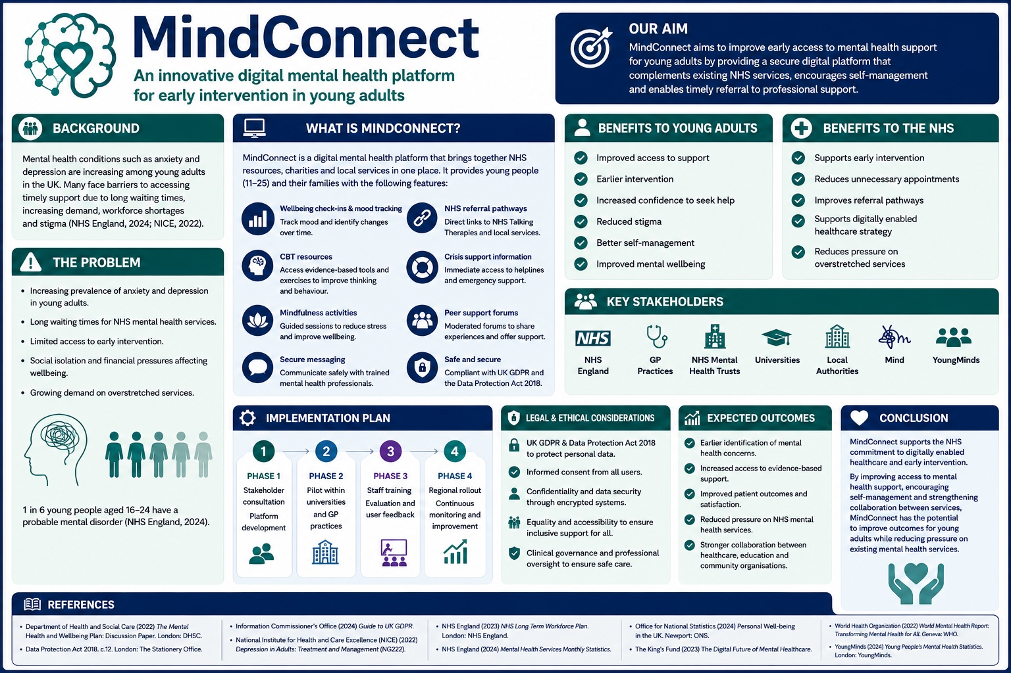
A Digital Mental Health Support Platform to Improve Early Access to Mental Health Support for Young Adults
Mental health has become one of the most significant public health challenges facing the United Kingdom, with increasing numbers of young adults experiencing anxiety, depression and other common mental health conditions. The growing prevalence of mental ill health has placed considerable pressure on health services, resulting in increased demand for timely and effective support. According to NHS England (2024), referrals to mental health services continue to rise, highlighting the need for innovative approaches that improve access to care and promote early intervention. The Department of Health and Social Care recognises that providing support at the earliest opportunity can improve recovery, enhance wellbeing and reduce the likelihood of mental health conditions becoming more severe. Furthermore, the National Institute for Health and Care Excellence (NICE, 2022) recommends evidence-based interventions that encourage early identification and treatment to achieve better long-term outcomes. As a result, developing innovative solutions that improve access to mental health support for young adults is increasingly important in meeting current healthcare demands and promoting positive mental wellbeing.
MindConnect is an innovative digital mental health support platform designed to complement existing healthcare services rather than replace professional clinical care. The platform integrates AI-supported wellbeing check-ins, delivered under appropriate clinical oversight, to help identify changes in a user’s mental wellbeing and encourage timely access to appropriate support. In addition, MindConnect provides evidence-based self-help resources, signposts users to NHS mental health services through clear referral pathways, and facilitates moderated peer support to promote social connection and reduce feelings of isolation. By combining digital technology with person-centred care, the platform aims to improve access to early intervention, encourage proactive self-management and support young adults in seeking help before their mental health deteriorates. This report will critically examine the proposed innovation, evaluate its potential to improve mental health outcomes for young adults, and consider how it aligns with current NHS priorities for digitally enabled healthcare, early intervention and person-centred mental health services (NHS England, 2023; Department of Health and Social Care, 2022; National Institute for Health and Care Excellence (NICE), 2022).
Mental health challenges in the United Kingdom have become increasingly prevalent, particularly among young adults, with anxiety and depression representing two of the most common mental health conditions experienced by this age group. Several factors have contributed to this rise, including academic pressures, financial insecurity associated with the increasing cost of living, social isolation and uncertainty about future employment opportunities (Office for National Statistics, 2024). University students are especially vulnerable, as they often experience significant psychological stress while balancing academic expectations, employment and personal responsibilities. In addition, many young adults continue to experience the lasting social and emotional effects of the COVID-19 pandemic, which has increased feelings of loneliness and reduced opportunities for social interaction (World Health Organization, 2022).
At the same time, demand for mental health services has continued to increase, placing considerable pressure on the National Health Service (NHS). NHS England (2024) reports sustained growth in referrals to mental health services, resulting in longer waiting times and delays in accessing appropriate treatment. Workforce shortages, increasing service demand and limited financial resources have further challenged the NHS’s ability to provide timely interventions (The King’s Fund, 2023). Delayed access to support can allow mental health conditions to deteriorate, increasing the likelihood that individuals will require more intensive and costly interventions in the future.
These challenges demonstrate the need for innovative approaches that complement existing mental health services by improving early access to support. Digital health technologies have the potential to reduce barriers to care by providing accessible, flexible and person-centred interventions that encourage individuals to seek help before their mental health deteriorates. This aligns with current NHS priorities to expand digitally enabled mental health services and promote earlier intervention to improve health outcomes while reducing pressure on overstretched healthcare services (National Institute for Health and Care Excellence, 2022; Department of Health and Social Care, 2022).
The impact of poor mental health extends beyond the individual and has significant consequences for families, healthcare services, educational institutions and the wider economy. For individuals, untreated mental health conditions such as anxiety and depression can reduce quality of life, impair educational attainment and work performance, and increase the risk of developing more severe and long-term mental health problems (National Institute for Health and Care Excellence (NICE), 2022). Families may also experience emotional distress, increased caring responsibilities and financial pressures while supporting relatives with mental health needs (World Health Organization, 2022). Furthermore, the increasing prevalence of mental ill health places considerable pressure on the National Health Service (NHS), contributing to rising referral rates, extended waiting times and growing demands on an already limited workforce (NHS England, 2024).
The wider social and economic impact is equally significant. Employers experience increased sickness absence, reduced productivity and higher staff turnover associated with poor mental health, while universities face growing challenges in supporting student wellbeing, which can negatively affect academic achievement, retention and progression (Department of Health and Social Care, 2022). These challenges demonstrate that mental health is not solely a healthcare issue but one that affects society as a whole. Consequently, investment in preventative approaches and early intervention is increasingly recognised as a cost-effective strategy for improving long-term outcomes and reducing demand on statutory services (The King’s Fund, 2023). Innovations such as MindConnect have the potential to complement existing mental health provision by promoting early identification of mental health concerns, improving access to appropriate support and encouraging individuals to seek help before their conditions deteriorate. By facilitating timely intervention and self-management, digital innovations can contribute to improved wellbeing while supporting the NHS’s long-term ambition to deliver more accessible, person-centred and digitally enabled mental health services (NHS England, 2023).
MindConnect is an innovative digital mental health platform designed to enhance, rather than replace, existing mental health services by providing young adults with accessible, evidence-based support to promote positive mental wellbeing. The platform combines digital technology with person-centred care to encourage early intervention, improve self-management and facilitate timely access to professional services. One of its key features is a mood tracker with daily wellbeing check-ins, enabling users to monitor changes in their mental health over time and identify potential concerns at an early stage. Early identification of deteriorating mental wellbeing is recognised as an important factor in improving recovery and reducing the need for more intensive interventions (National Institute for Health and Care Excellence (NICE), 2022).
To promote resilience and self-management, MindConnect provides evidence-based Cognitive Behavioural Therapy (CBT) exercises, guided mindfulness activities and psychoeducational resources that support users in developing practical coping strategies. These interventions are consistent with NICE recommendations, which advocate evidence-based psychological approaches as effective treatments for common mental health conditions, including anxiety and depression (NICE, 2022). The platform also enables users to securely communicate with appropriately trained mental health professionals and provides direct links to NHS Talking Therapies and other local mental health services, ensuring individuals can access further support when required (NHS England, 2024).
Recognising the importance of continuity of care, MindConnect includes appointment reminders, personalised wellbeing plans and immediate access to crisis support information, encouraging engagement with treatment and reducing barriers to accessing services. In addition, moderated peer support forums provide a safe and supportive environment where young adults can share experiences, reduce feelings of social isolation and develop supportive social connections. Research has shown that peer support and digital mental health interventions can improve engagement, reduce stigma and encourage individuals to seek help earlier (World Health Organization, 2022). By integrating digital innovation with professional oversight, MindConnect supports the NHS vision of delivering more accessible, person-centred and digitally enabled mental health services while improving outcomes for young adults (Department of Health and Social Care, 2022; NHS England, 2023).
The successful implementation of MindConnect requires a collaborative, multi-agency approach involving key stakeholders across the health, social care and education sectors. NHS England would play a central role in supporting the integration of the platform within existing digital mental health services and ensuring that it aligns with national priorities for improving access to early intervention and digitally enabled care (NHS England, 2023). General Practitioner (GP) surgeries and NHS Mental Health Trusts would be responsible for referring appropriate patients to the platform, monitoring its effectiveness and ensuring that individuals requiring specialist intervention are directed to the most appropriate services. Universities would also be important partners, as they are well placed to promote the platform through student wellbeing services and encourage early engagement among young adults, a population that is at increased risk of experiencing common mental health conditions (Department of Health and Social Care, 2022). Local authorities would support implementation by linking MindConnect with community-based mental health initiatives and social prescribing services, helping to address wider determinants of mental health and wellbeing. In addition, voluntary organisations such as Mind and YoungMinds could contribute by providing evidence-based information, awareness campaigns and peer support resources, helping to reduce stigma and encourage help-seeking behaviours. Working collaboratively across these organisations would support the successful implementation of MindConnect, improve continuity of care and contribute to the NHS’s long-term objective of delivering accessible, person-centred and integrated mental health services (National Institute for Health and Care Excellence (NICE), 2022; World Health Organization, 2022).
The implementation of MindConnect must comply with the requirements of the UK General Data Protection Regulation (UK GDPR) and the Data Protection Act 2018 to ensure that users’ personal and sensitive health information is managed safely and ethically. As the platform processes special category data relating to individuals’ mental health, all information must be collected, processed and stored lawfully, fairly and transparently, with users providing informed and explicit consent before any personal data is recorded (Information Commissioner’s Office (ICO), 2024). Robust cybersecurity measures, including encrypted data storage, secure authentication processes and regular system monitoring, should be implemented to minimise the risk of unauthorised access or data breaches. In addition, users must be informed about how their information will be used, who will have access to it and their rights to access, amend or delete their personal data in accordance with UK data protection legislation (Data Protection Act 2018). Ensuring compliance with these legal requirements not only protects user confidentiality but also promotes trust and confidence in digital mental health services, which is essential for encouraging engagement and supporting the successful implementation of MindConnect (National Institute for Health and Care Excellence (NICE), 2022).
The growing prevalence of mental health conditions among young adults highlights the need for innovative approaches that improve access to timely, effective and person-centred support. MindConnect has been proposed as a digital platform that complements existing NHS mental health services by bringing together evidence-based self-management resources, clear referral pathways and links to statutory and voluntary sector organisations within a single accessible platform. By encouraging early intervention and improving access to appropriate support, the innovation has the potential to enhance mental wellbeing, reduce barriers to care and strengthen collaboration between healthcare providers, educational institutions and community organisations (National Institute for Health and Care Excellence (NICE), 2022; Department of Health and Social Care, 2022). Looking ahead, MindConnect could be further developed through ongoing service evaluation, enhanced personalisation and improvements to digital accessibility, ensuring that it continues to meet the changing needs of young adults while supporting safe, evidence-based care. In line with the NHS commitment to digitally enabled healthcare, innovations such as MindConnect have the potential to improve patient outcomes, reduce pressure on overstretched mental health services and contribute to a more integrated and sustainable approach to mental healthcare delivery (NHS England, 2023; World Health Organization, 2022).
Reference List
Data Protection Act 2018. c.12. London: The Stationery Office.
Department of Health and Social Care (2022) The mental health and wellbeing plan: Discussion paper. London: Department of Health and Social Care.
Information Commissioner’s Office (2024) Guide to UK GDPR. Available at: https://ico.org.uk/for-organisations/uk-gdpr-guidance-and-resources/ (Accessed: 5 July 2026).
National Institute for Health and Care Excellence (NICE) (2022) Depression in adults: Treatment and management (NG222). London: NICE.
NHS England (2023) NHS Long Term Workforce Plan. London: NHS England.
NHS England (2024) Mental Health Services Monthly Statistics. London: NHS England.
Office for National Statistics (2024) Personal well-being in the UK. Newport: Office for National Statistics.
The King’s Fund (2023) The digital future of mental healthcare. London: The King’s Fund.
World Health Organization (2022) World mental health report: Transforming mental health for all. Geneva: World Health Organization.
YoungMinds (2024) Young people’s mental health statistics. Available at: https://www.youngminds.org.uk/about-us/reports-and-impact/

