UNIVERSITY OF WALES TRINITY SAINT DAVID
LONDON CAMPUS
Assignment 2
Learning in the Digital Era
Module Name: Learning in the Digital Era
Module Code: ACCA 4025

Student Name: Hebun AY
Student ID: 2519282
Group: 1

Lecturer’s Name: Koishik Modak
https://www.youtube.com/watch?v=asivEieiXWA

Table of Contents
Introduction 1
Main Body 2
Conclusion 8
References 9

Introduction

This report accompanies a video presentation that focuses on self-evaluation, a professional development plan using SMART goals, and a topic summary related to lifelong learning in the digital era. The purpose of this report is to briefly outline the content of the presentation and support the video-based assessment.

Main Body
The main content of this assessment is presented in the accompanying video presentation. The video covers self-evaluation, reflective practice, professional development planning, and a topic summary supported by relevant academic sources.

Video Link: https://www.youtube.com/watch?v=asivEieiXWA
Slide 1 COVER PAGE
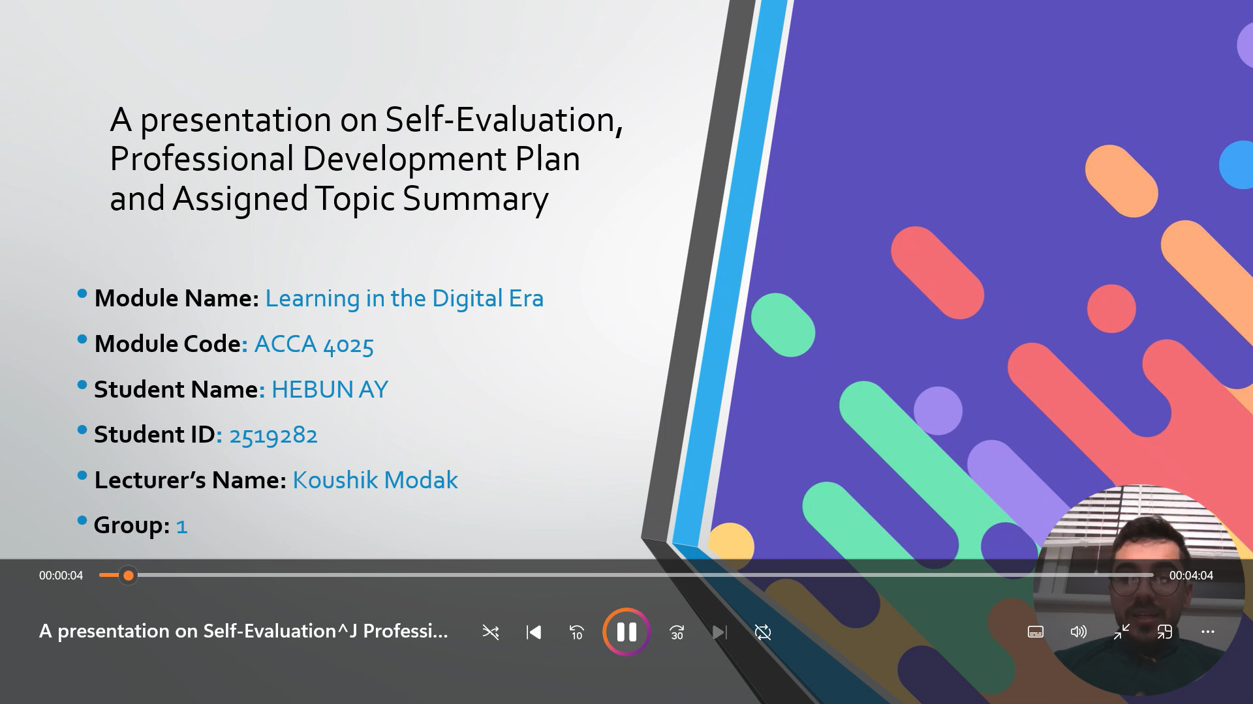
Slide 2 CONTENTS

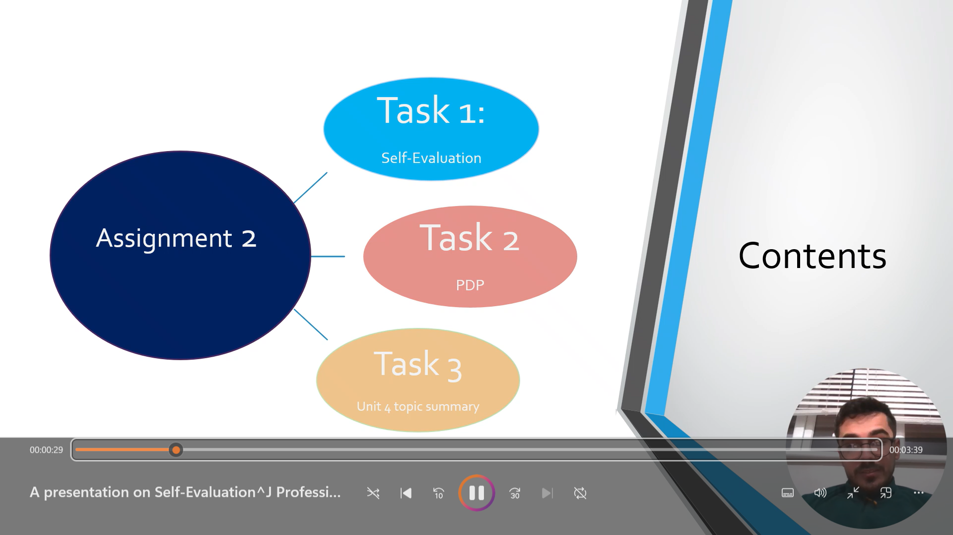
Slide 3 INTRODUCTION
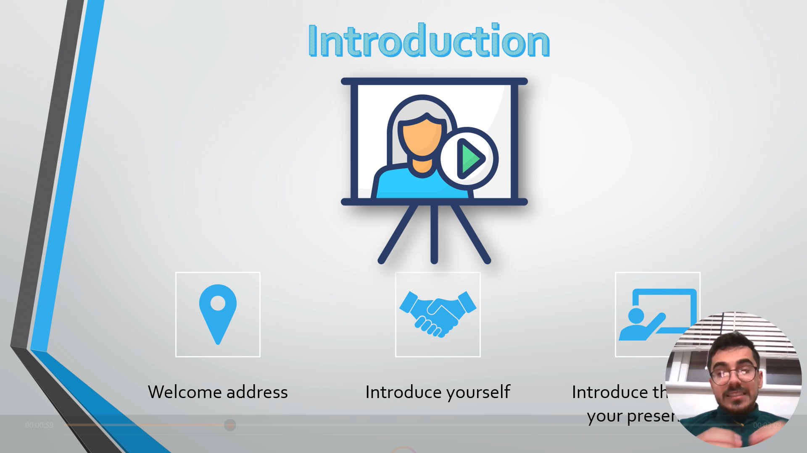

Slide 4 MAIN BODY
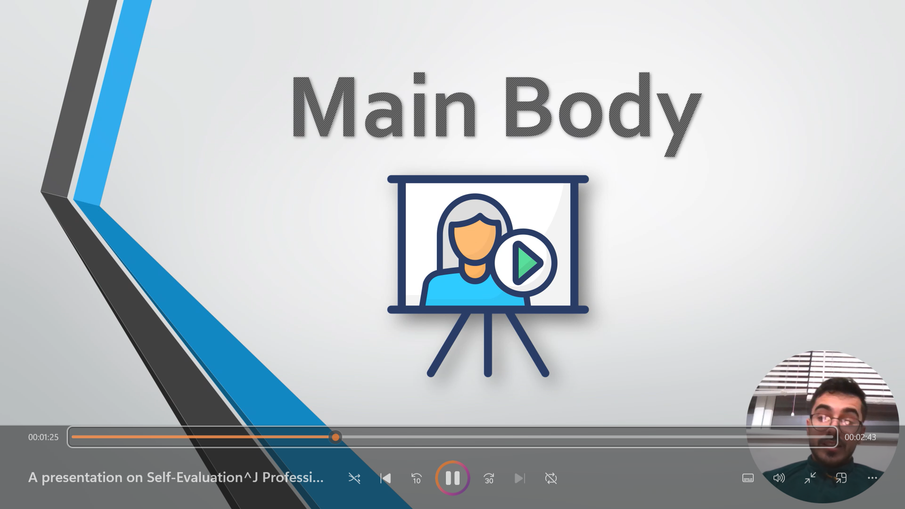

Slide 5 GIBB’s REFLECTIVE MODEL
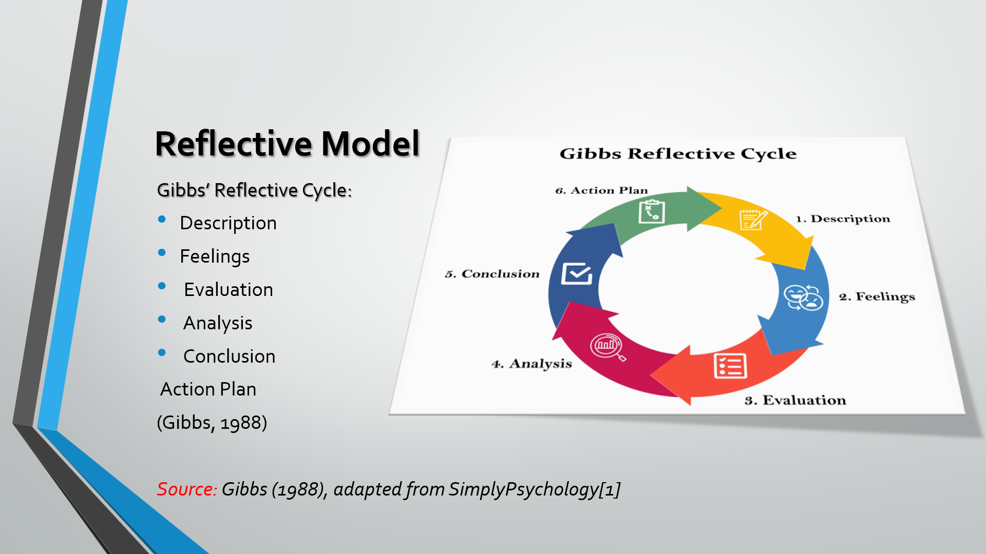
Brief explanation: Gibbs’ Reflective Model provides a systematic approach to reflection by guiding learners through stages that move from experience to action. In Assignment 2, this model is applied to reflect on my learning experiences, personal strengths, and areas for development, allowing me to evaluate my progress and set realistic SMART goals. Using this structured reflection supports continuous improvement and helps link academic learning with professional development (Gibbs, 1988).

Slide 6 TASK 1: SELF EVALUATION
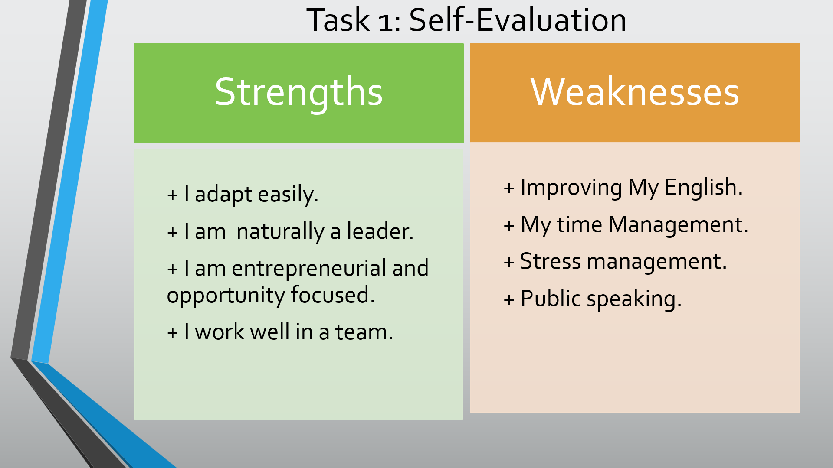
Brief explanation: This self-evaluation is based on my individual SWOT analysis, focusing on my personal strengths and areas for improvement. My strengths, such as adaptability, leadership skills, and teamwork, support my academic and professional development. At the same time, identifying weaknesses including English language development, time management, and public speaking allows me to recognise areas that require improvement and targeted action for future growth.

Slide 7 TRAITS GAINED FROM THE SELF EVALUATION
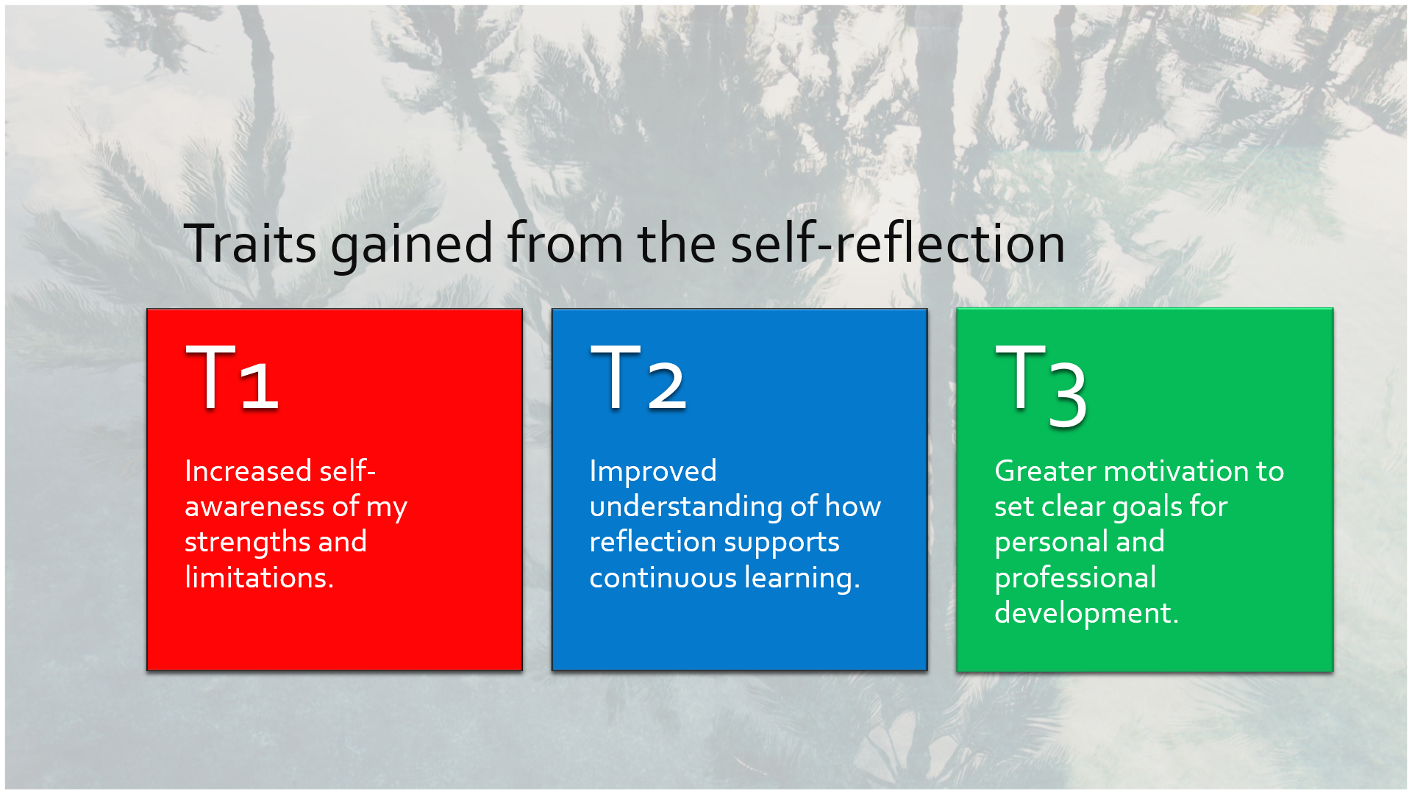
Brief explanation: Through the self-evaluation process, I developed a stronger awareness of my personal strengths and limitations, which helped me better understand myself as a learner. Reflecting on my experiences improved my understanding of how continuous reflection supports long-term learning and development. In addition, this process increased my motivation to set clear and realistic goals for my personal and professional growth.
Slide 8 PROFESSIONAL DEVELOPMENT PLAN
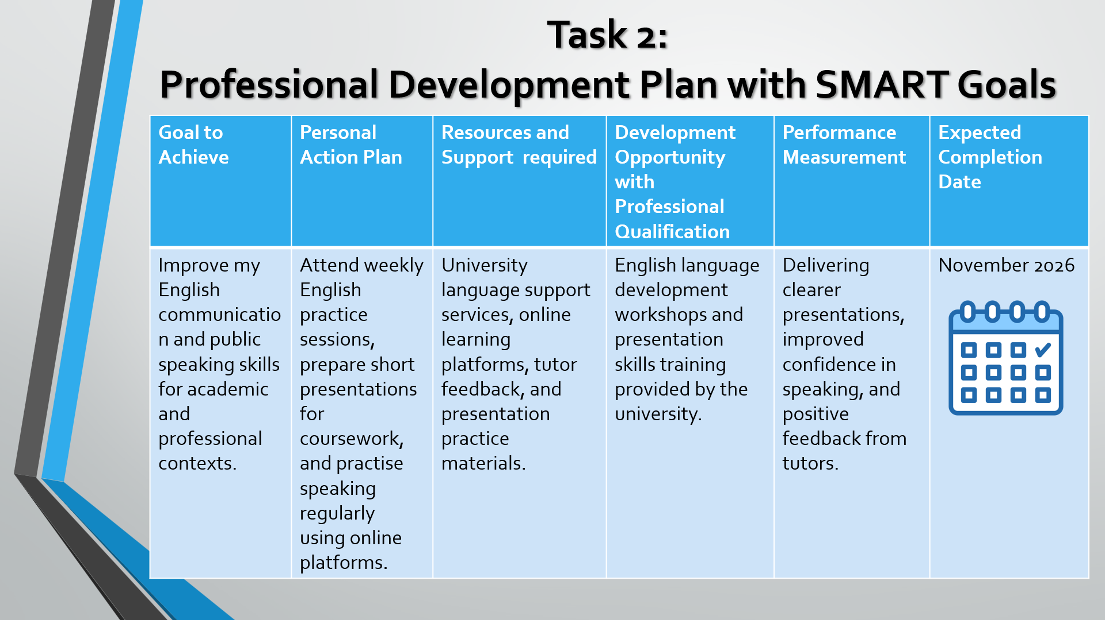
Brief explanation: This professional development plan uses a SMART goal approach to improve my English communication and public speaking skills. The goal is supported by clear actions, available learning resources, and measurable outcomes to ensure continuous academic and professional improvement.

Slide 9 UNIT 4 TOPIC SUMMARY
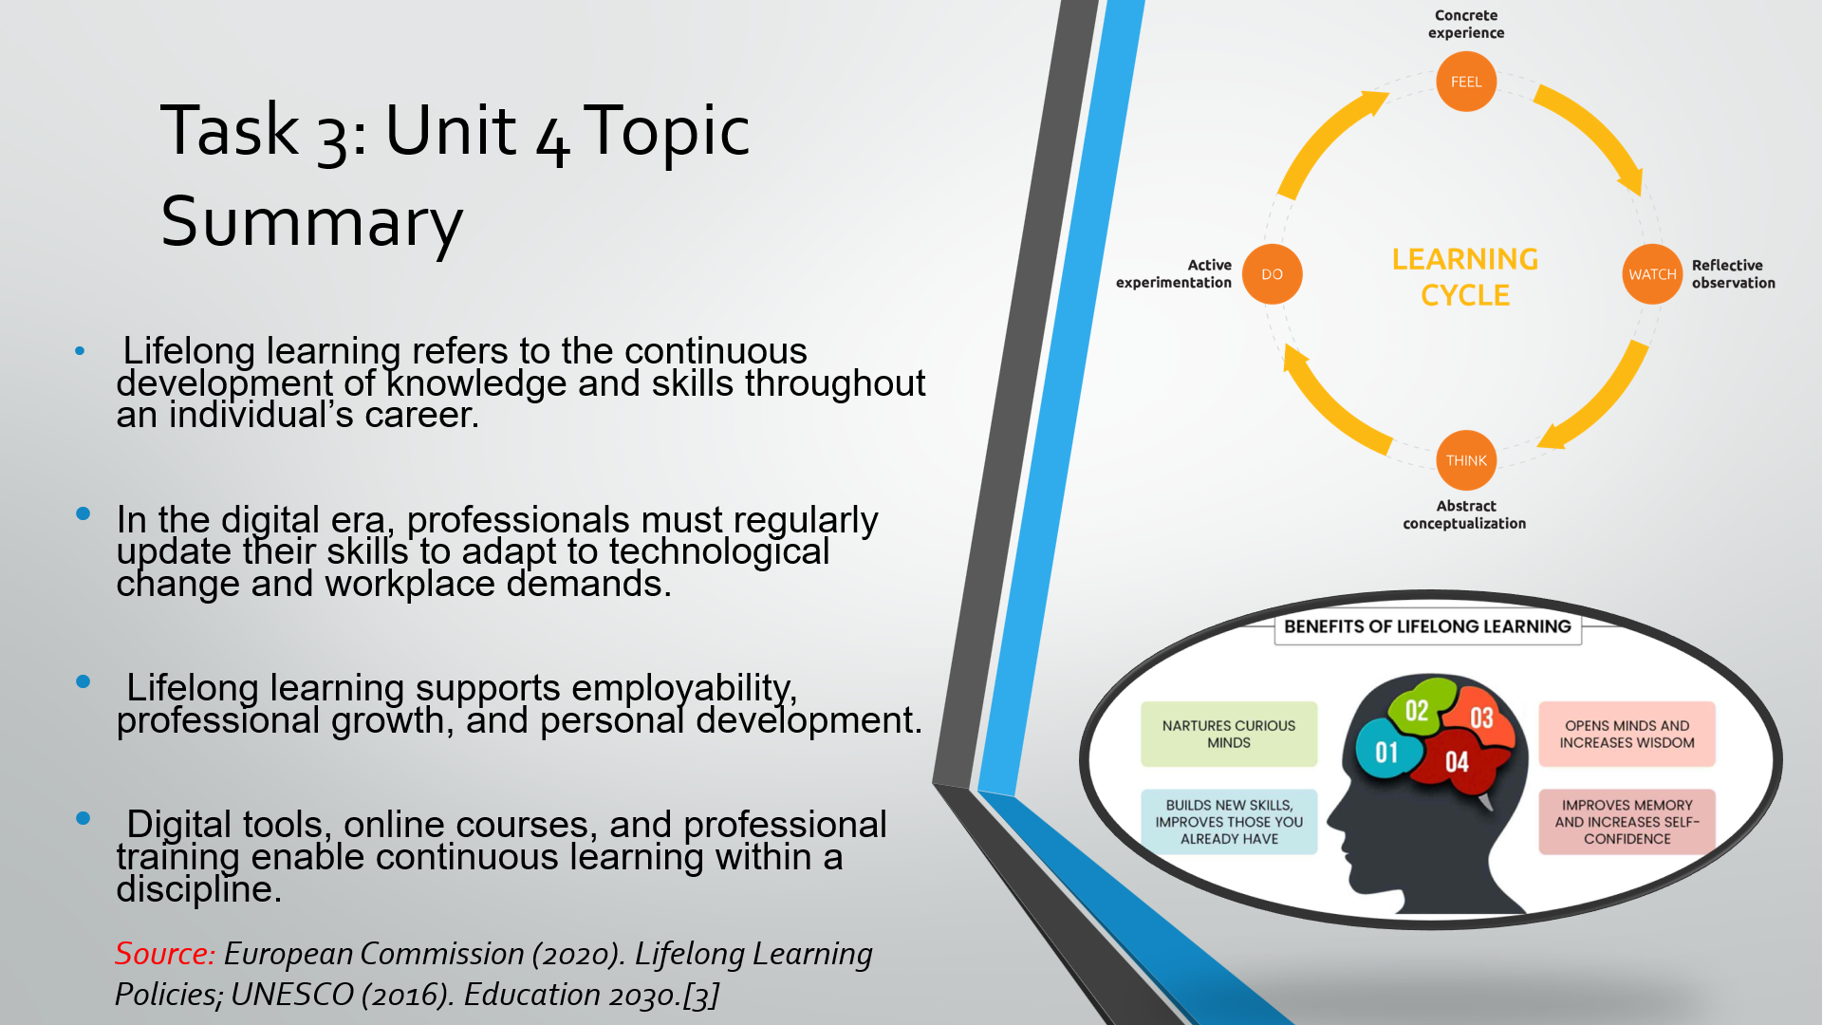
Brief explanation: This topic summary focuses on lifelong learning as a key concept in the digital era. It highlights the importance of continuous skill development to adapt to technological change, enhance employability, and support long-term personal and professional growth.

Slide 10 CONCLUSION
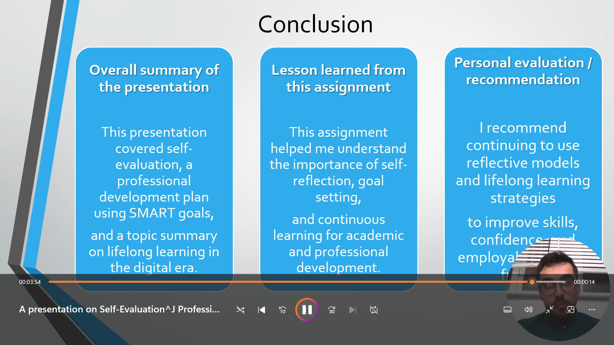
Brief explanation: In conclusion, this assignment brought together self-evaluation, a professional development plan, and a topic summary on lifelong learning. It demonstrated how reflection and SMART goals can support continuous personal and professional development in the digital era.
Slide 11 REFERENCES
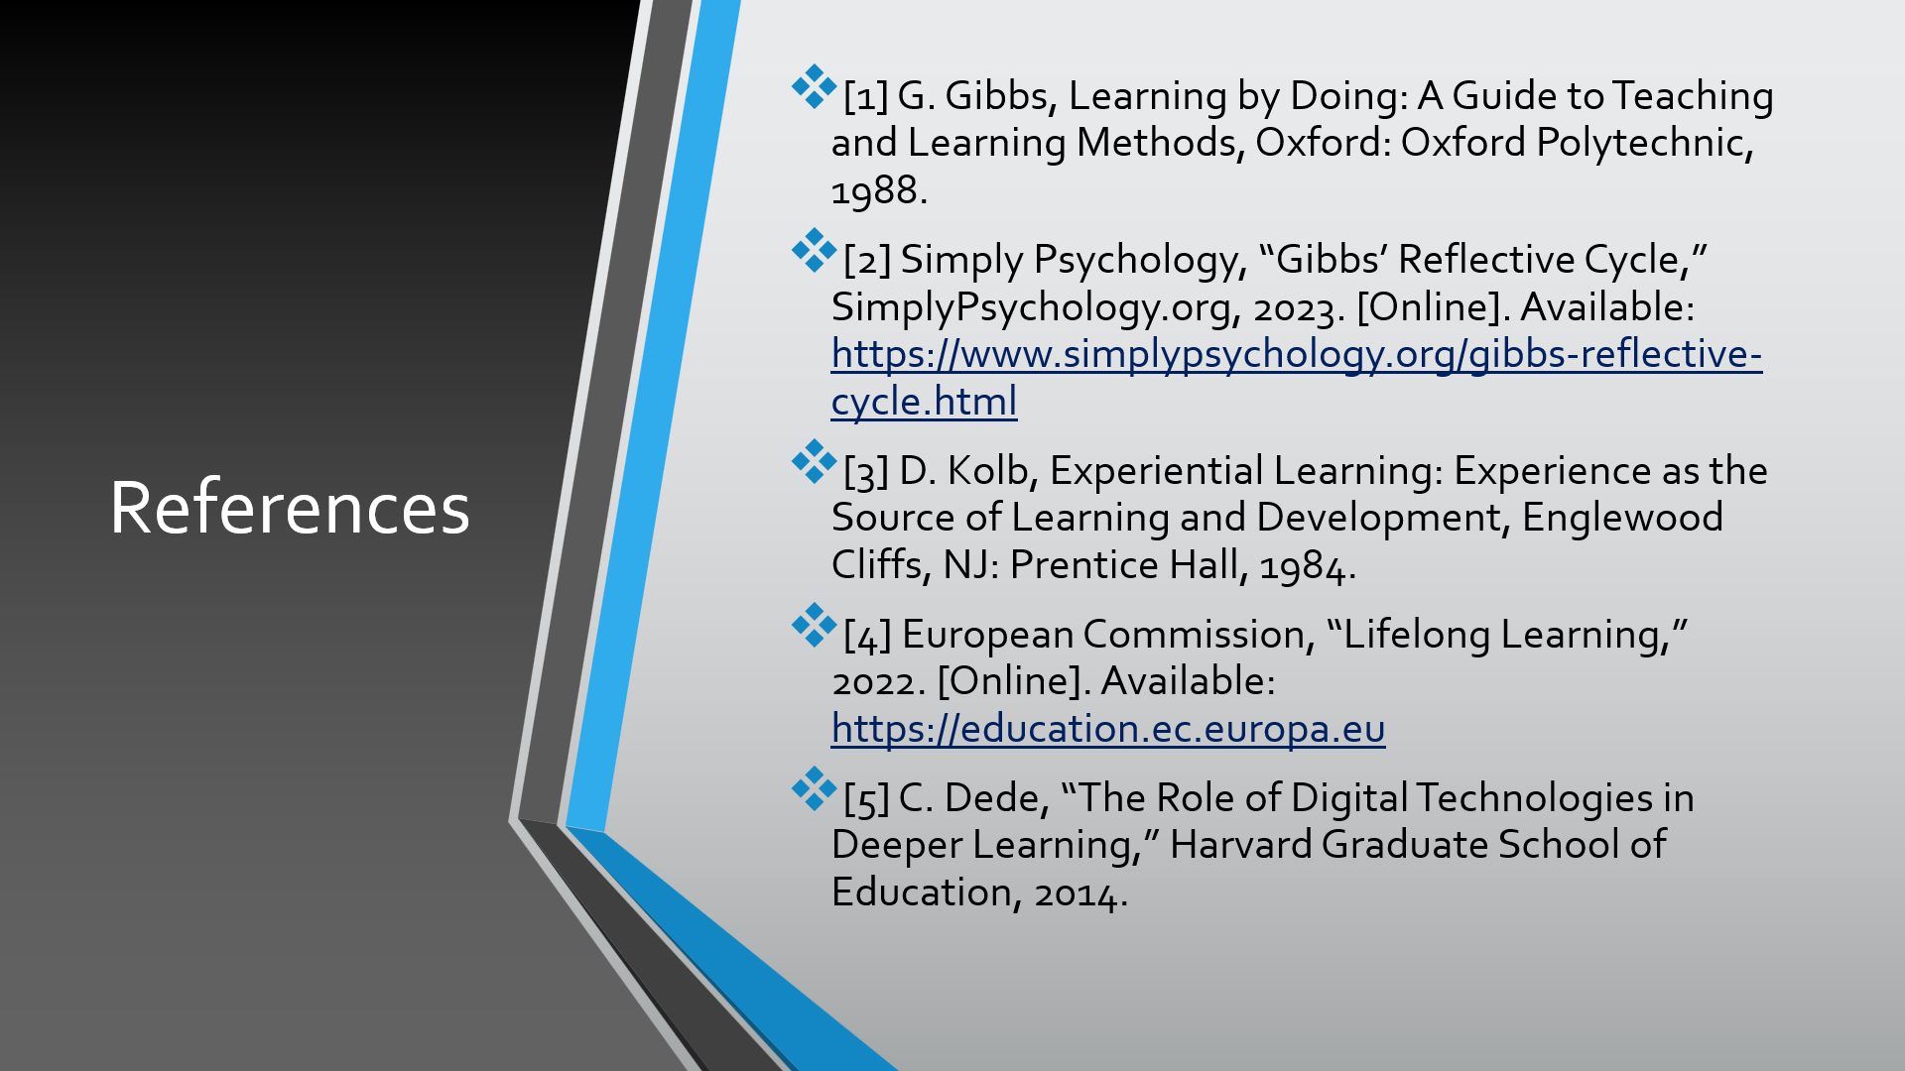

Conclusion
In conclusion, this report has demonstrated the importance of self-evaluation, structured goal setting, and lifelong learning for personal and professional development. By using reflective models and SMART goals, it highlights how continuous learning can support adaptability and employability in the digital era.

References
- [1] G. Gibbs, Learning by Doing: A Guide to Teaching and Learning Methods, Oxford: Oxford Polytechnic, 1988.
- [2] Simply Psychology, “Gibbs’ Reflective Cycle,” SimplyPsychology.org, 2023. [Online]. Available: https://www.simplypsychology.org/gibbs-reflective-cycle.html
- [3] D. Kolb, Experiential Learning: Experience as the Source of Learning and Development, Englewood Cliffs, NJ: Prentice Hall, 1984.
- [4] European Commission, “Lifelong Learning,” 2022. [Online]. Available: https://education.ec.europa.eu
- [5] C. Dede, “The Role of Digital Technologies in Deeper Learning,” Harvard Graduate School of Education, 2014.

