Name: Muhammad Kamran Khan
Student No: 2428180
Module: Personal Development in Health and Social Care
Assignment Title: Component 2
Module Code: LCHS4009
Lecturer: Farrah Islam
Contents Page

Cover page …………………………………………………………………. 1
Contents Page …………………………………………………………….. 2
Task 1 ……………………………………………………………………….. 3
Task 2 ……………………………………………………………………….. 6
Task 3 ………………………………………………………………………... 9
References ………………………………………………………………….. 11
Task 1
Introduction
The position of a Critical Care Transport Assistant (CCTA), also known as a Paramedic Assistant, entails providing support to paramedics during the transportation of high-acuity patients between various healthcare facilities. This role necessitates a robust clinical awareness, effective communication skills, adaptability, and the capacity to perform under pressure. Currently, as I pursue my Level 4 Health and Social Care studies, this position is in alignment with my long-term aspiration of building a career in emergency and pre-hospital care. This action plan will outline the skills necessary for the role, pinpoint my strengths, emphasize my areas for development and outline strategies for enhancing these skills, in addition to potential interview questions and their corresponding responses.
Key Skills Required and How I Meet Them
1. Communication Skills
Effective communication is crucial for conveying patient information, assisting families, and collaborating within a multidisciplinary team (NHS, 2023). Throughout my Health and Social Care course, I have improved my written and verbal communication abilities, which include creating care plans, reflective accounts, and participating in group discussions. I hold confidence in interacting with service users in a composed and empathetic manner, which is vital when assisting anxious patients during transfers.
2. Teamwork and Collaboration
The role of the CCTA necessitates a strong partnership with paramedics, nurses, and physicians. Throughout my course, I have engaged in various group projects that demanded collective responsibilities and cooperative problem-solving. This experience has enhanced my capacity to function effectively within a team, actively listen, and provide constructive contributions.
3. Understanding of Basic Clinical Procedures
Although I have not yet attained clinical qualifications, my Level 4 Health and Social Care course has equipped me with an understanding of infection control, safeguarding, risk assessment, and fundamental vital sign monitoring. These transferable competencies are beneficial for fulfilling the practical aspects of the role, including the preparation of equipment, the supervision of patient monitoring, and assurance of safety.
4. Ability to Stay Calm Under Pressure
Emergencies and urgent transfers necessitate resilience and the capacity to stay composed. My practical experience when delivering a presentation enhanced my capability to handle stressful circumstances while upholding professionalism and empathy.
5. Physical Fitness and Manual Handling
Critical care transport can be physically demanding. I am undertaking manual handling training and maintain a good level of fitness, which will allow me to aid in patient transfers.
Identified Skill Gaps:
Despite my strengths, I have recognized two significant skill gaps that I need to further develop: Mathematics and English literacy.
Mathematics
Critical Care Transport Assistants might need to compute timings, perform basic measurements, or analyse numerical data, including monitoring charts. Although I am confident in numerical calculations, particularly with fractions and ratios, it is somewhat restricted in regards to not having a formal qualification. This limitation could delay my capacity to achieve a job interview.
English
While I am capable of effective communication, grammar, professional writing, and the organization of formal documents, I lack the basic qualification required to present at interviews. I am aware that high-quality written communication is crucial for the completion of patient record forms and report writing (Skills for Health, 2020).
Personal Development Plan (PDP)
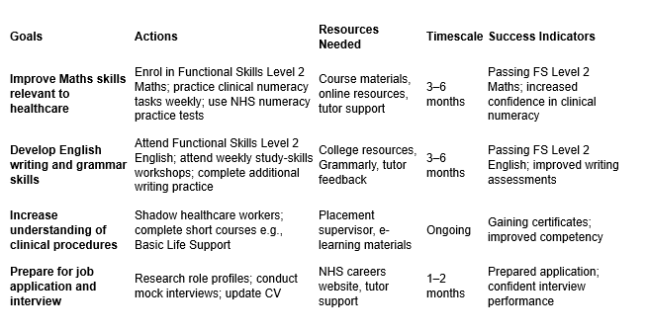
By following this plan, I aim to improve my academic and practical abilities so that I can meet the demands of the CCTA role effectively.
Three Possible Interview Questions and Model Responses
- What motivates you to pursue a position as a Critical Care Transport Assistant?
I have a strong commitment to assisting patients during their most vulnerable times. My Level 4 Health and Social Care course has equipped me with an understanding of the significance of delivering high-quality care and fostering teamwork, which I aspire to implement in a fast-paced pre-hospital setting. The role of CCTA will provide me with practical experience, enhance my clinical knowledge, and allow me to make a substantial contribution to patient safety during transfers.
2. In what manner would you approach a stressful or emergency situation?
I maintain my composure by concentrating on the task at hand and adhering to established procedures. Throughout my voluntary placements, I have encountered instances where service users exhibited distress. I remained calm, offered reassurance, communicated effectively with my colleagues, and prioritized safety. In emergency scenarios, I would adhere to the paramedic's directives, uphold professionalism, and assist in ensuring a safe and effective response.
3. What measures are you implementing to enhance your competencies for this position?
I am presently finalizing my Functional Skills qualifications in Mathematics and English to improve my precision in documentation and numerical skills. Additionally, I am engaging in further health-related training, including manual handling and online NHS learning modules. These actions reflect my dedication to ongoing development and preparedness for the duties associated with the role.
Conclusion
This personal action plan defines the competencies necessary for the position of Critical Care Transport Assistant and illustrates how my Level 4 Health and Social Care course has prepared me with pertinent strengths. Additionally, it highlights areas that require enhancement and offers a systematic approach for tackling these challenges. By implementing these measures, I aspire to cultivate the confidence, knowledge, and skills essential for a successful application and effective performance in this fulfilling healthcare role.

Task 2
Introduction
Problem-solving constitutes a vital competency in health and social care practice, enabling professionals to navigate complex and high-pressure scenarios while making safe, informed decisions. The environment is often unpredictable, necessitating that staff are equipped to address challenges such as the deterioration of service users or barriers within the organization. Utilizing structured problem-solving techniques offers a systematic approach to analysing issues and determining solutions. This report will concentrate on three commonly employed methods: brainstorming, the Five Whys technique, and the fishbone (Ishikawa) model.
Importance of Problem-Solving in Health and Social Care
Effective problem-solving is essential for delivering high-quality and safe care, empowering practitioners to recognize risks, comprehend underlying causes of issues, and implement measures that prevent harm. Skills for Care (2022) designates problem-solving as a fundamental competency for social care, highlighting the necessity for workers to engage in critical thinking, adapt to various challenges, and apply evidence-based reasoning.
Problem-solving is connected to patient safety. NHS Improvement (2018) states, structured problem-solving techniques enable organizations to collect insights from incidents, determine the reasons, and endorse modifications that diminish the chances of future harm. Proficient problem-solving serves the interests of service users and enhances organizational learning fostering a culture of safety.
Brainstorming as a Problem-Solving Technique
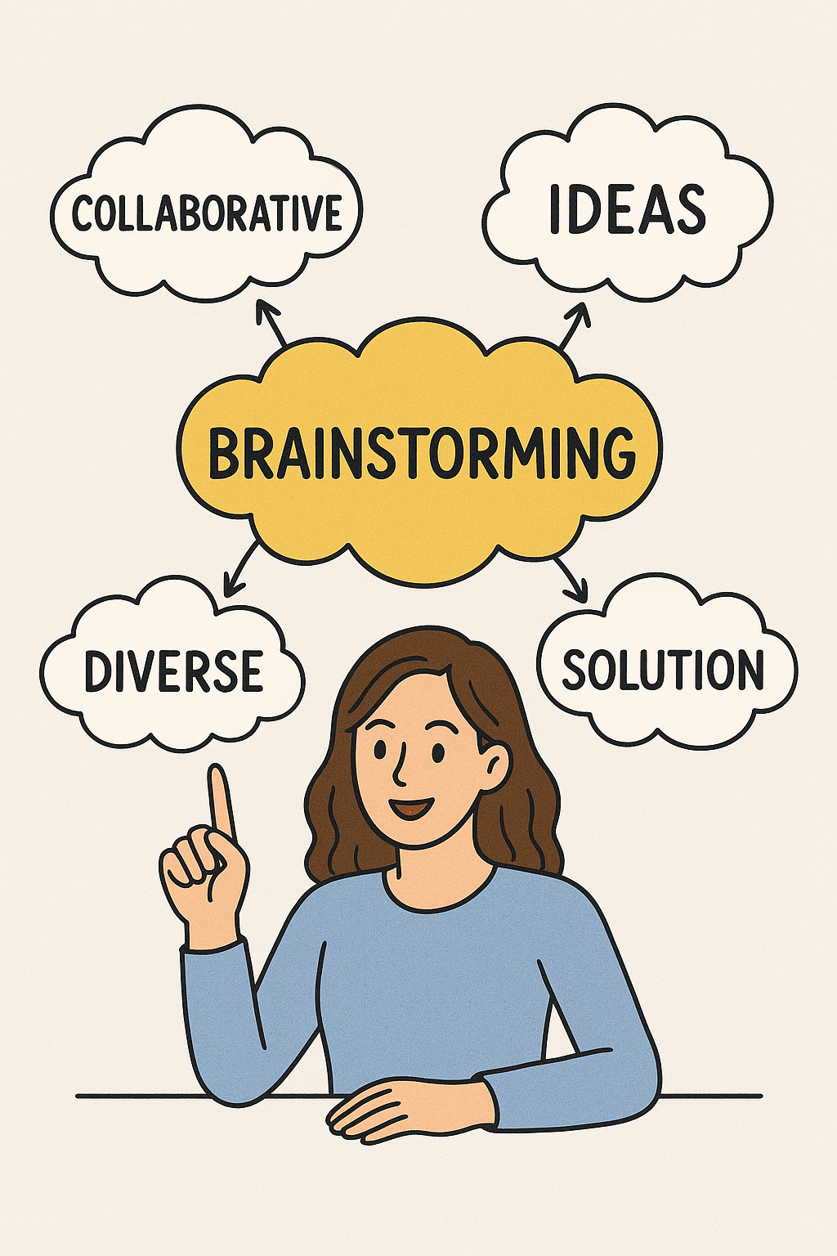
Brainstorming represents a collaborative strategy aimed at producing a spectrum of ideas prior to reaching a solution. This is frequently employed in multidisciplinary meetings, reflective sessions, and team-oriented quality enhancement initiatives. This promotes equal participation in idea generation, enabling staff to investigate various perspectives and experiences.
NHS England’s Quality Improvement tools highlight the significance of collecting diverse opinions when addressing care-related challenges, indicating that group brainstorming facilitates a deeper understanding of problems, encouraging solutions catering to the needs of both staff and service users (NHS England, 2021).
(Canva.com, 2024)
Brainstorming is beneficial in health and social care, where intricate issues demand contributions from nurses, social workers, therapists, and care assistants.
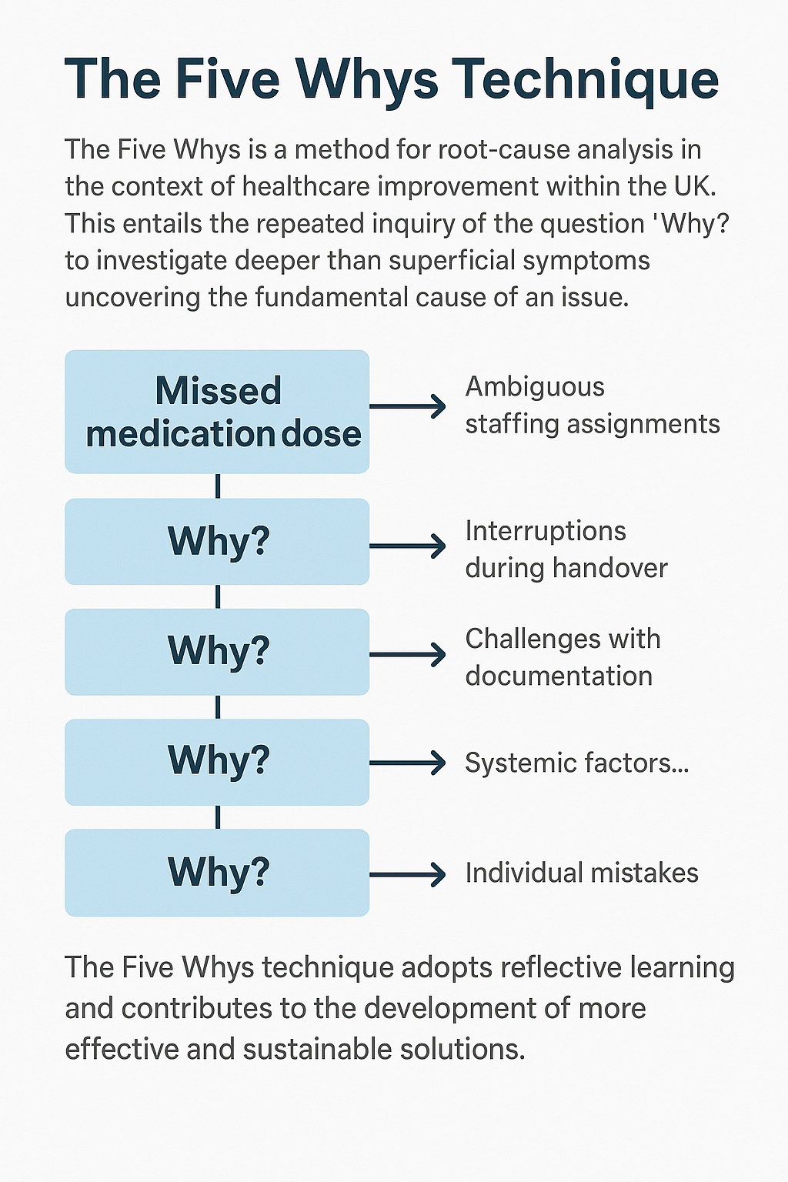
The Five Whys Technique
The Five Whys is a method for root-cause analysis in the context of healthcare improvement within the UK. This entails the repeated inquiry of the question "Why?" to investigate deeper than superficial symptoms uncovering the fundamental cause of an issue. According to NHS Improvement (2018), the Five Whys technique is advised for the examination of patient safety incidents, enabling teams to comprehend systemic factors alongside concentrating on individual mistakes.
For instance, in the event of a missed medication dose, employing the Five Whys could uncover issues such as ambiguous staffing assignments, interruptions during handover, or challenges with documentation. This method adopts reflective learning and contributes to the development of more effective and sustainable solutions.
(Miro, 2025)
Fishbone (Ishikawa) Model
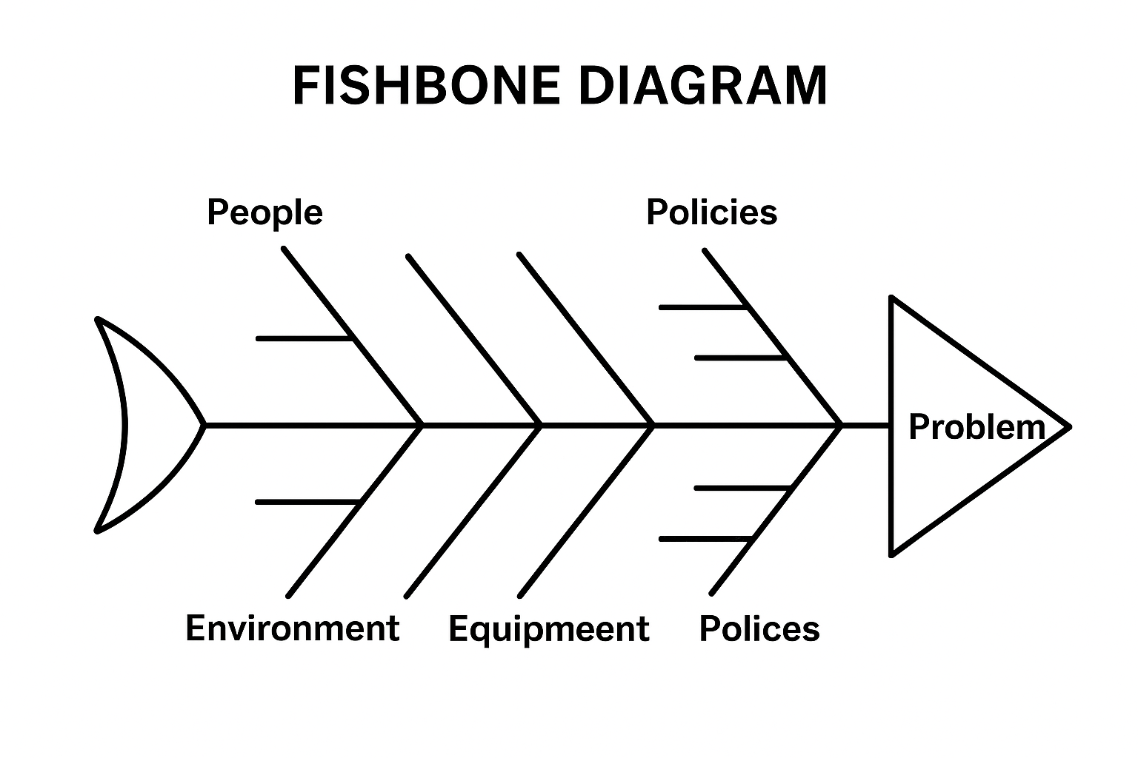
The fishbone diagram, offers a systematic visual approach for investigating the potential causes of an issue. It organizes contributing elements, encompassing individuals, processes, environments, equipment, and policies. According to NHS England (2021), the fishbone diagram serves as an effective tool for quality enhancement, assisting teams in deconstructing intricate problems and pinpointing which factors exert (Canva, 2024) the most considerable impact on an issue.
In the context of health and social care, this technique is often employed during quality improvement initiatives, safeguarding assessments, and service evaluations. It enables practitioners to conduct a comprehensive analysis of the problem and fosters a more methodical strategy for formulating solutions.
Conclusion
Effective problem-solving is an essential competency for professionals in health and social care, playing a vital role in ensuring safety, enhancing services, and promoting person-centred care. Utilizing structured techniques such as brainstorming, the Five Whys, and the fishbone diagram enables practitioners to analyse issues thoroughly, comprehend root causes, and formulate significant enhancements. These methodologies foster collaboration, reflective practice, and evidence-based decision-making. By strengthening problem-solving skills, we ultimately improve outcomes for service users and facilitate ongoing advancement throughout the sector.
Task 3
Introduction
The ERA model (Experience, Reflection, Action) serves as a structured framework facilitating reflective practice by enabling individuals to scrutinize their experiences, assess performance, and devise strategies for improvement (Rolfe et al., 2011). Within health and social care, engaging in reflective practice is crucial for professional growth, aiding practitioners in refining their skills, enhancing decision-making capabilities, and delivering high-quality care. By employing the ERA model, this reflection provides a critical evaluation of my Component 1 presentation, consisting of a SWOT analysis presented through PowerPoint slides. It delves into my thoughts, emotions, performance, potential areas for enhancement, whilst integrating verbal feedback received from my lecturer.
Experience
For the presentation, I developed PowerPoint slides to depict the strengths, weaknesses, opportunities, and threats associated with a specific scenario. Before the assessment, I experienced a mix of confidence and anxiety. I was assured of my grasp of SWOT analysis yet apprehensive about addressing and speaking without depending on handheld notes.
During the presentation, I concentrated on articulating each point with clarity and detail. Nevertheless, I became aware that I was often diverting my gaze to the slides rather than interacting with the audience. My slides served their purpose but following the session, my lecturer provided verbal feedback, suggesting that I enhance the presentation's engagement level, incorporate varied fonts, colours, and images, memorize additional content, and improve my eye contact. Emotionally, I felt a sense of relief that the presentation had concluded, yet I was also frustrated by my inability to deliver it as effectively as I could have.
Reflection
Reflecting on my experience, I acknowledge that although I possessed a solid understanding of the SWOT analysis, my method of delivery diminished the overall effectiveness of my presentation. As noted by Rolfe et al. (2011), the ERA model prompts individuals to analyse what transpired and the reasons behind it, thereby fostering a deeper comprehension and learning from experiences. My dependence on referring to the slides constantly delayed my ability to engage with the audience, and the lack of visual appeal in my slides made it more challenging to maintain the audience’s attention.
Feedback from my lecturer regarding engagement, slide aesthetics, memorization, and eye contact pointed out specific areas that need enhancement. Tufte (2006) asserts that successful presentations utilize visuals to complement, rather than detract from, the core message; straightforward slides featuring uniform fonts, suitable colour palettes, and pertinent images enhance clarity and audience involvement. Furthermore, Reynolds (2011) highlights that sustaining eye contact and projecting confidence are crucial for establishing a connection with the audience and exhibiting professionalism. In light of these insights, I now realize that effective preparation must encompass not only mastery of content but also practice in delivery and thoughtful slide design.
Action
Utilizing the action phase of the ERA model, I have pinpointed several strategies to enhance my future presentations. Initially, I will engage in more thorough rehearsals of my presentation to commit key points to memory and minimize dependence on the slides (Race, 2014). This approach will enable me to sustain eye contact with the audience, as advised by my lecturer.
I will revamp my slides by employing additional fonts, suitable colour palettes, and significant visuals. This is in accordance with Tufte’s (2006) recommendation that slides should facilitate comprehension rather than inundate viewers with excessive text.
I will practice delivering my presentation in front of peers or by recording myself to assess my body language, vocal tone, and overall engagement. Reynolds (2011) indicates that practicing delivery can bolster confidence and enhance the connection with the audience.
Lastly, I will actively seek preliminary feedback on both slide design and presentation delivery from peers or tutors, ensuring that any necessary improvements are made prior to the assessment. By adhering to these strategies, I aspire to elevate both the delivery of content and the visual effectiveness of my future presentations.
Conclusion
Utilizing the ERA model allowed me to engage in a critical reflection of my SWOT presentation. This experience underscored the significance of not just comprehending the material but also presenting it with confidence, captivating the audience, and employing visually attractive slides.
Feedback from my lecturer offered valuable insights into aspects that require enhancement, such as memorization techniques, maintaining eye contact, and improving slide aesthetics.
The application of the ERA model has facilitated the creation of a structured plan aimed at refining my presentation abilities, thereby fostering my development as a professional in health and social care.
References
Canva. (2024). Free customizable fishbone diagram templates | Canva. [online] Available at: https://www.canva.com/graphs/templates/fishbone-diagram/ (Accessed: 11 November 2025).
Canva.com (2024). Free and Customizable Health Templates. [online] Canva. Available at: https://www.canva.com/templates/?query=health [Accessed 12 Nov. 2025].
Miro (2025). Welcome to Zscaler Directory Authentication. [online] Miro.com. Available at: https://miro.com/templates/the-5-whys-canvas-template/ [Accessed 17 Nov. 2025].
NHS England (2021) Quality improvement tools. Available at: https://www.england.nhs.uk (Accessed: 12 November 2025).
NHS Improvement (2018) Learning from patient safety incidents: Root cause analysis toolkit. London: NHS Improvement.
NHS Institute for Innovation and Improvement (2008) Quality and Service Improvement Tools: Fishbone analysis. Coventry: NHS Institute for Innovation and Improvement.
NHS (2023) NHS Careers: Ambulance Team Roles. Available at: https://www.healthcareers.nhs.uk (Accessed: 11 November 2025).
Race, P. (2014) The Lecturer’s Toolkit: A Practical Guide to Assessment, Learning and Teaching. 4th edn. London: Routledge.
Reynolds, G. (2011) Presentation Zen: Simple Ideas on Presentation Design and Delivery. 2nd edn. Berkeley, CA: New Riders.
Rolfe, G., Freshwater, D. and Jasper, M. (2011) Critical Reflection in Practice: Generating Knowledge for Care. 2nd edn. Basingstoke: Palgrave Macmillan.
Skills for Care (2022) Core skills for care workers. Leeds: Skills for Care.
Skills for Health (2020) Core Skills Framework: Communication and Documentation in Healthcare. Skills for Health.
Thompson, S. (2021) Essential Skills for Healthcare Support Workers. London: Learning Matters.
Tufte, E. (2006) The Cognitive Style of PowerPoint. Cheshire, CT: Graphics Press.

