Module : BMSS5007
Developing your Professional Profile

Modiwl : BMSS5007C
Datblygu eich Proffil Proffesiynol



Asesiad / Assessment :
E-portfolio prep for CPD / Work

Gan / By: Ollie George

Arweinydd Modiwl / Module lead : Heddwen Davies

- CV
Ollie George
Cartrefle, Crymych, Pembrokeshire, SA413RU | Mobile: 07495662756 email: olivergeorge138@outlook.com
Profile
Fy enw i ydi Ollie. Rwy'n rhedwr pellter gydag uchelgais o gyrraedd fy uchelgais fel rhedwr proffesiynol ar sail ryngwladol. Ar ochr fy ngyrfa rhedeg, rwy'n mwynhau gweithio yn yr awyr agored, megis gwaith fferm, a thir. Yn ogystal â hynny, mae gennyf angerdd am gynorthwyo pobl mewn angen, trwy godi arian am elusennau gyda fy sgil o redeg. A gweithio gyda nifer o bobl o bob natur unigryw i gyflawni eu targedau ffitrwydd. Fel person, rwy'n feddylgar iawn gyda bwriad o weithio'n ddiwyd ac yn greadigol yn unigol ac fel tîm.
Key Skills
- Cymdeithasu a Cyflwyno
- Gwaith Tim
- Meddwl Creadigol a Gritigol
- Meddylgar
Work experience
- Gwaith tir a choginio (Fferm Dyfed Shire Horse)
- Coginio/gweinyddu (Crwst Caffi)
- Gwaith Tir (Pembrokeshire Sunflower/Pumpkin Farm)
- Gwaith Tir am gymdogion
- Hyfforddi sesiwn ymarfer (Rhys Harries Fitness Coaching)
- Hyfforddi Sesiynau rhedeg am athrawon (Ysgol Y Preseli)
- Hyfforddi Sesiynau Ffitrwydd (Prifysgol y Drindod Dewi Sant)
Education
Astudiais Lefel A yn Ysgol Y Preseli (2022) gyda gradd;
- Addysg Gorfforol – Distinction * - Sept 2020 – June 2022
- Saesneg Llenyddiaetg – C – Sept 2020 – June 2022
- Celf a Dylunio – Ffotograffiaeth – A* - June 2022
Prifysgol Cymru Dewi Sant y Drindod
- YMCA Level 2 Certificate in Gym Instructing – 14 March 2023
- YMCA Level 3 Diploma in Personal Training (Practitioner) – 12 June 2023
- Sports Exercise and Science BcS - 2023
Interests & hobbies
- Uchelgais am fod yn rhedwr pellter hir
- Y ddiwylliant o’r 70au a 80au
- Gwaith tir (Groundwork/Groundskeeping)
- Weithgareddau dygnwch (Rhedeg/Seiclo/Notion etc.)
- Ffotograffiaeth
- Coginio/Pobi

- Llythyr cais

Oliver Morgan George,
Cartrefle, Crymych, Pembrokeshire
Olivergeorge138@outlook.com
07495662756,
(Sir/Madam)
Epinal Way,
Loughborough,
LE11 3TU,

16th October 2023

Annwyl Syr/Madam,

Rwy’n ysgrifennu atoch parthed swydd fel Cogydd gyda’ch cwmni Elite Athlete Centre. Yn bersonol, mae gen i ddiddordeb yn natur y swydd hon oherwydd y profiad ar gwybodaeth byddai’n medru derbyn am ddefnyddio maeth, ar sail gwyddoniaeth, i gefnogi anghenion yr athletwyr ac i sicrhau dilyniant yn eu perfformiad.

Wrth ddod o gefndir chwaraeon o redeg pellter hir, rwy'n gyfarwydd gyda'r elfennau hanfodol o danwydd yn drylwyr er mwyn gynorthwyo amser ymadfer a datblygu perfformiad. I gryfhau fy mherthnasedd i'ch swydd, mae gennyf blas o fwynhad mewn coginio cynhyrchion sy'n addas tuag at anghenion chwaraeon fel rhedeg. Rwy'n brofiadol iawn yn y maes o goginio o bersbectif rhedwr, gan ddefnyddio fy nealltwriaeth hyderus o maetholiaeth chwaraeon i gefnogi fy mharatoad am gystadlu ac i sicrhau ymadfer digonol heb sôn am fy nhreuliad yn y cwrs Chwaraeon a Gwyddoniaeth Ymarfer Corff (BSC), sydd yn tanlinellu fy arbenigrwydd yn y maes.

Mewn ystyriaeth ohonof i fel person sydd yn alluog i gyflawni'r disgwyliadau'r swydd, rwy'n feddylgar iawn am sut i ddatrysu problemau a gyflawni anghenion pobl, megis fy sgiliau cymdeithasu a thrafod. Yn ogystal â hynny, mae gennyf sgiliau arweinyddiaeth a'r gallu i gydweithio fel tîm i addasu i sefyllfa gan ystyried fy mhrofiad o gyflawni'r Wobr Dug Caredin lefel Arian fel tîm. Mewn adlewyrchiad o fy mhrofiadau gwaith yn esbeduriaeth ac fel hyfforddwr personol, mae gennyf galluogrwydd i greu perthynas positif gyda phobl o wahanol gefndiroedd a naturoedd. Er mwyn gynorthwyo'r profiad o gydweithio a'r posibilrwydd o lwyddo yn y dasg benodol, megis sicrhau boddhad y cwsmeriaid a helpu athletwr i gyflawni eu targedau ffitrwydd.

Wrth gael fy magu ar fferm, mae gennyf ddealltwriaeth pur o'r pwysigrwydd o facsimeiddio'r ffynonellau leol ac organaidd o gynhyrchion addas am athletwyr. Mae hyn o fudd i gynaliaedwyaeth yr amgylchedd ac am iechyd yr athletwyr, megis fy mhrofiad o gynaeafu llysiau ar 'Pembrokeshire Pumpkin Farm' i greu cynhyrchion iachus ac addas am fy mherfformiad fel rhedwr.

O ran technoleg berthnasol i'r maes, rwy'n hyderus iawn yn defnyddio rhaglenni fel 'Microsoft Word', 'PowerPoint' a ' Excel' etc., mewn adlewyrchiad o fy nhreuliad yn addysg, er mwyn ddod o hyd i faterion cost a threfnu anghenion gwaith. Gan sôn am faterion hunan gwerthuso, rwy'n bob amser yn agored i ddatblygu fy nealltwriaeth a chyfrifolaeth yn y maes, trwy ymgymryd mewn ymarfer dyfodol, cyfarfodydd gweithle, astudio am gymhwyster(au) a'r angen i hunan asesu ble bo angen.

Rwy'n ddiolchgar iawn i chi am ystyried fy nghais i ymuno a’ch gweithle, ac hyderaf byddai’n brofi’n gweithiwr gwerthfawr i’ch busnes. Gobeithio byddai’n clywed yn ol oddi wrthoch yn fuan.

Yr eiddoch yn gywir,
Ollie George

- Datganiad Focws

Fy enw i ydw Ollie, ac o oed ifanc roeddwn bob amser yn meddu'r uchelgais o fod yn rhedwr pellter hir ar sail broffesiynol. I geisio llwyddo i gyflawni fy mhrif fwriad yn fy ngyrfa, mae ymroddiad, wrth gwrs, yn sylfaenol tuag at lwyddiant a chredaf bod hyn yn gryfder sy’n rhan o fy mhersonoliaeth.

O ran cryfderau eraill trwy fy nghyfnod o gystadlu, rwy'n parhau i gystadlu mewn nifer o gystadlaethau ar safon raddol uwch, megis y llwyddiant o gynrychioli Cymru yn y bencampwriaeth rhedeg mynydd (Trail De Guerledan) yn Brittany, Ffrainc. Yn ychwanegol, rwy'n ar hyn o bryd yn astudio yn Brifysgol Cymru Y Drindod Dewi Sant, yn y cwrs, Chwaraeon a Gwyddoniaeth Ymarfer Corff (BSC), sy'n berthnasol iawn i fy natblygiad fel rhedwr, gyda chredyd i'r cefndir ffisioleg (ACSM 2021). Hefyd, budd arall i ystyried yw'r mynediad gennyf i amgylchiadau ymarfer amrywiol i ymarfer ynddo, o redeg ar fynyddoedd i gyfleusterau ffitrwydd yn y brifysgol.

Ar ochr fy ngyrfa rhedeg, rwy'n hefyd yn meddu mwynhad o goginio amrywiaeth o fwydydd i hyrwyddo fy mherfformiad fel rhedwr ac yn gyffredinol am bobl eraill. Yn adeiladu ar y pwynt hwn, fel teulu buaswn yn cael y cyfle o agor siop fferm, yn hysbysebu cynhyrchion sydd wedi ei fynhonnellu'n organaidd a lleol. Ond, er gael diddordeb llwyr yn y pwysigrwydd o maetholiaeth am sicrhau ansawdd dda yn berfformiad, does gennyf gefndir cyflawn o ddealltwriaeth yn faetholiaeth. Mewn adlewyrchiad o hynny, hoffwn ganolbwyntio ar y rhodfa hon, er mwyn gynorthwyo'r ansawdd o fy mherfformiad a fydd yn profi llwyddiant yn fy ngyrfa yn y tymor hyr. Fel anghenion o hyfforddi, byddwn yn ystyried ymgymryd mewn cwrs hylendid bwyd, i amlygu fy nealltwriaeth o faeth a fydd o fudd i fy ngyrfa rhedeg. Hyderaf bydd hyn helpu fi i gael y wybodaeth i gynhyrchu cynhyrchion a fydd yn addas i’r cyhoedd yn eu'n siop fferm.

Yn ôl targedau SMART (Appendices 3) o ennill cymhwyster hylendid bwyd, byddwn yn llwyddiannus trwy gyflawni'r cwrs sydd hefyd yn ffyrdd o fesur fy nilyniant, megis graddau yn y cyfamser. O ran bod yn gyfleus, mae'r nifer o gyrsiau i gael yn rhad neu hyd yn oed am ddim, ac weithiau maent yn rhithiol sy'n hefyd yn fwy cyfleus. I brofi elfennau realistig, byddwn yn medru cychwyn y cwrs mewn amser digonol a gosod cyfnod penodol a fydd yn caniatáu fi i gwblhau’r cwrs yn drylwyr heb ofid.

O bersbectif rhedeg (Appendices 4), y brif nod ar dymor byr bydd llwyddo i daro amser gorau o 32 munud am y 10K. I wneud yn sicr os rydyn wedi llwyddo, bydd angen gwblhau amser rhwng 31:50 a 32:00. Er mwyn i fesur y nod, byddwn yn cadw nod o'r datblygiad o'r amserau yn arwain tuag at y dyddiad targed. I gyflawni'r amser, byddwn yn sicrhau bod y cynnig yn cael ei berfformio ar lwybr fflat i leihau effaith ar yr amser. Ystyria'r targed yn realistig gan y ffaith, mae fy amser gorau ar hyn o bryd ydy 33:40, felly bydd 2 mlynedd i daro'r amser yn ddigonol (Runner’s World 2023). Bydd terfyn amser am y targed hwn, yn cael ei drefnu ar Fis Medi 2025.

Word count : Tua 1,200

Appendices

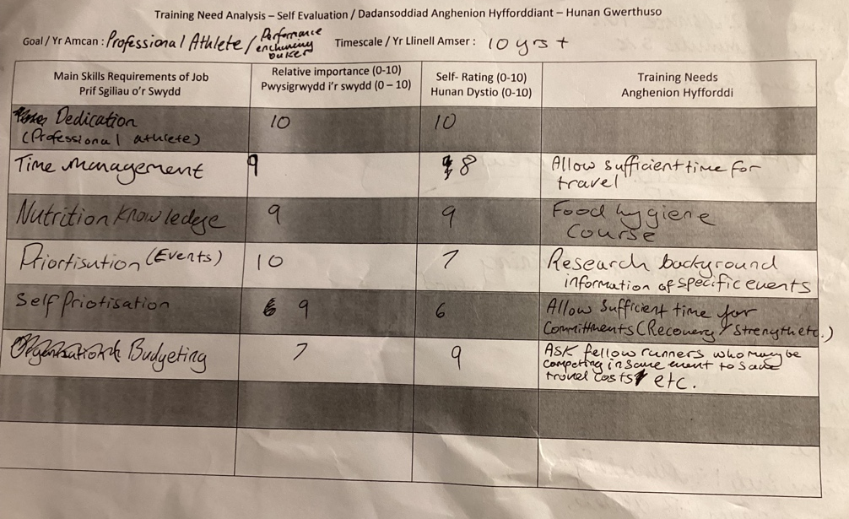
- Appendices 1

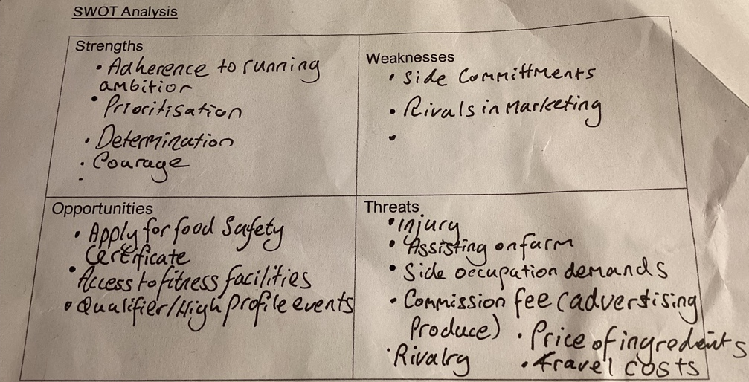
- Appendices 2

- Appendices 3

Targedau Smart: Datblygu Dealltwriaeth o Faetholiaeth

Byr (2 Mlynedd): Mynychu Cwrs Glendid Bwyd
S – Llwyddo trwy gwblhau’r cwrs
M – Gyflawni graddau dda yn arwain at lwyddiant yn y cwrs
A – Cyfleus o ran pris rhad / am dim ac yr opsiwn o gwblhau yn rhithiol
R – Mae’n realistig, wrth I fi gadael amser digonol I gyflawni
T – Gyflawni y gwrs yn erbyn Mis Ebrill

- Appendices 4

Targed SMART: Gyflawni Amser Gorau o 32 Munud Am y 10K

S – Llwyddo I gyflawni amser rhwng 32:30 a 32:00
M – Datblygiad o amserau y 10K ar gydol y 2 flynedd
A – Sicrhau mae’n gael ei gyflawni ar llwybr fflat
R – Mae’n realistig oherwydd ar hyn o bryd mae fy amser gorau yw 33:40, felly mae 2 blynedd yn ddigonol
T – Gyflawni erbyn Medi 2025

- Appendices 5


Job Description

Job Title: Performance Head Chef (Elite Athlete Centre (EAC)

Reports to: Head of Venues

Set in the heart of Loughborough University’s world-leading sports facilities, this new, purpose-built facility will provide an inspiring, high-performance environment for athletes, businesses and fitness enthusiasts.

The nutritional philosophy of the EAC is to provide a world class, flexible, performance nutrition food service in a purpose-built environment: enabling elite athletes to meet their individual dietary needs. The menu and environment will serve as a vehicle to educate and empower athletes to make appropriate choices in order to achieve their individual nutritional goals, ultimately enhancing health, recovery and performance.

The successful candidate will be required to work closely with performance nutritionists from elite and professional sports to ensure that this philosophy is aligned. The chef will be responsible for ensuring that the menus and recipes adhere to the presentation, taste and performance needs of the guests.

Due to the affluent location of the café and restaurant, our customers expect a world class standard of food and customer service interaction from the chef. The successful candidate will be required to engage with athletes and guests at the live cooking station during meal service to ensure that their needs are met, as well as running cooking demonstrations throughout the year.

Duties and Responsibilities

Customer Service

- The delivery of an exceptional dining experience every time to customers throughout all catering areas.

- To be the figure head of the restaurant and to take the lead in guest interaction, relating to matters of food, cooking, nutrition, service and customer experience.

- To adhere to the customer absolute standards.

- To maintain a close and effective communication link with the customers and service users. To work with performance nutritionists to ensure their athlete’s needs are met throughout their stay.

- Ability to quickly build rapport with customers, athletes and staff.

- To collaborate with the Sales team in new business development and to maintain the existing client base alongside agreed marketing strategies.

Standards (quality) – practices and procedures

- Sourcing local, fresh, high-quality produce suitable for an elite performance culture.

- Providing recipe information to service users and the performance nutritionist.

- Ensuring excellent high standards of taste and presentation at every single meal service.

- Be approachable and willing to modify recipes and meals to meet individual athlete and guest needs.

- To work alongside the performance nutritionist to develop menus based on the nutrition strategy and philosophy.

- Be up to date with food allergy legislation and be able to provide information of allergens in all meals and advise guests accordingly.

- To work to Imago kitchen/HACCP standards.

- Effectively menu plan for the forthcoming business, produce buffet menu and produce menus on request from clients.

- Receiving and checking goods delivered by external suppliers and reporting shortages to the suppliers and accounts department.

- Ability to be flexible to all parts of the business.

- To adhere to the safeguarding of property within the kitchen by ensuring the proper use and storage of keys and an effective procedure for locking doors, windows and cupboards. Suspicious circumstances should be reported immediately to the Manager.

- To carry out any reasonable request made by the Senior staff you are responsible to.

Team Management

- To ensure compliance with established Human Resources procedures in all areas relating to employment.

- To manage the duties of all subordinate personnel.

- To ensure compliance with established Human Resources procedures in all areas relating to employment.

Training & Development

- To be committed and work to Investors in People standards, ensuring that you are aware of the business objectives and understand your role in achieving them.

- To attend all staff training workshops and put into practice all new skills learnt.

- To train all new members of staff in Imago practices and procedures and the food and nutritional philosophy of the EAC.

Finance – sales and costs

- Constantly appraising stock levels and to enable food orders to reflect the level of stockholding

- Stock-taking in accordance to finance / purchasing period calendar

- Maintain food & labour cost to agreed budgets

- Calculation of the cost of required food and ingredients to deliver performance dining as per agreed menus.

Communication

- To liaise with the manager and other members of staff, with regards to the days’ business needs

- To relay customer feedback, positive or negative to the manager and Sales team

- To attend weekly course requirements meeting

- To maintain a close and effective communication link between departments and other Imago sites

Environment

33. To adhere to the Imago environmental policy and endeavour to minimise single use plastics and disposable goods.

Health and Safety

- To undertake precautions to ensure the safety of others as well as oneself. Also ensure implementation of cleaning and housekeeping schedules ensuring that adequate standards of cleanliness and hygiene are maintained throughout the operation complying to statutory regulations, i.e. food hygiene, HACCP, COSHH and Health and Safety.

- To ensure that equipment is maintained correctly to prolong its working life and efficiency

- Requisitioning materials for use in the kitchen, checking them and ensuring their proper and secure storage before being issued for use

- To train and enforce the fire evacuation procedures

The list of duties is not exhaustive and may be varied from time to time according to changing demands.

It is essential that all employees adopt a flexible attitude towards their work, the duties involved and the hours of work in order that the demands of the EAC can be met. It is important that all staff are willing to work elsewhere if required by Imago

PERSON SPECIFICATION

Job Title: Head Chef (EAC)
 | Essential | Desirable | Stage to be Assessed
Experience | Previous experience of catering within sports environments  Previous experience of customer management and working in a customer  focused environment  Previous experience of working in a nutrition lead  business  Worked to at least sous chef grade  Worked and maintained five rated EOH standard | Work as a Head Chef or  Catering Manager  Previous experience of catering for athletes and/or working in a sporting environment
Skills and abilities | Some knowledge of the performance nutrition needs of elite athletes and an  interest/willingness to learn  Excellent communication  and organisational skills  Ability to build rapport with guests, athletes and staff quickly  Excellent interpersonal skills and willingness to work  alongside nutritionists  A passion to cater for athletes and professional sports teams  Ability to work on own initiative and make appropriate decisions | Excellent catering industry  knowledge  Familiar with Microsoft Office, Powerpoint and front house electronic systems  Worked within a quality  driven environment

Proven leadership and teamwork skills

Proven customer care skills

Able to innovate
Evidence of good financial
management

To understand and implement quality processes
Training | A willingness to undertake further training as and when required  A willingness to adopt new procedures as and when  required  Recognise customer service training  Evidence of operational expertise  To be able to demonstrate recent personal development
Education/  Qualifications | Good understanding of the  English language  GCSE or equivalent English and Mathematics  NVQ or equivalent 1 and 2  Food hygiene level 3  Nutrition level 3 | Advanced food hygiene  First Aid  NVQ or equivalent 3, 4 and  5
Equality and  Diversity | Evidence a good working knowledge of equal opportunities and  understanding of diversity in the workplace
Other | Passion for performance nutrition and interest in sport

Stages in assessment:

1= application form
2= selection tests
3= interview

Head Chef / Job Specification
Updated June 2018

Llyfryddiaeth
- ACSM (2021) ACSM’S Guidelines for Exercise Testing and Prescription (Accessed on: 08/11/2023)
- Runner’s World (2023) How to run your perfect 10K Available at: https://www.runnersworld.com/uk/training/a760084/the-perfect-10k/ (Accessed on: 07/11/2023)
- IMAGO VENUES (2018) Performance Head Chef (Elite Athlete Centre(EAC) Available at: https://vacancies.lboro.ac.uk/jobdesc/REQ180512.pdf (Accessed on: 07/11/2023)
- Innes, J. (2016) The CV book: how to avoid the most common mistakes and write a winning CV Available at: https://www-vlebooks-com.ezproxy.uwtsd.ac.uk/Product/Index/697396?page=0&startBookmarkId=-1 (Accessed on: 07/11/2023)

