Juan Xu
Dr Jessica Clapham
Key Issues in Linguistics (HPEN7004)
24th, Nov. 2023
Assignment 2
An assessment of “English language learners’ use of self-regulatory strategies for foreign language anxiety in China”

Krashen’s theory of “Affective filter hypothesis” (1983, pp.124-136) proposes that the affective filter has a significant impact on learners’ language learning success: positive emotions like strong motivation, self-confidence, and relaxed mood contribute to learners’ successful language acquisition while negative emotions, like fear, shyness, stress, anxiety, boredom, lack of motivation and self-confidence, etc. tend to cause a higher affective filter that decreases the efficiency of learners’ second language acquisition. Foreign language anxiety (FLA) is generally defined as “a special complex of feelings, self-consciousness, beliefs, and behaviors in connection with English language learning resulting from the distinct learning process” (Horwitz et al., 1986, p. 128), is extensively considered to be a negative affective variable that scares the learners and causes high affective filter in their exercise of input and output of language, greatly reducing learners’ efficiency in their L2 acquisition (Arnold, 2005; Horwitz, 2001). Therewith, a substantial of studies have concentrated on the possible causes and feasible methods and strategies that can help students alleviate their FLA, such as Kralova’s psycho-social training (2017), Shams’ computerized pronunciation practice (2005), and Naagahashi’s cooperative learning techniques (2007), etc. which have been verified with positive effect. However, most of the studies just value the role and influence of instructors and other agents, paying little attention to learners’ self-regulation for FLA. As we all know "the learner’s contribution is at the heart of the language learning process" (Breen, 2004). Oxford (1990) claimed that learners’ adoption of some affective strategies to “adjust emotions, motivations, and attitudes” from their own perspective also plays an essential role in their language learning process. Therefore, follow-up research has been carried out to study learners’ self-regulatory strategies covering cognition, affection, behaviors, etc. to coordinate their learning process by regulating their anxious feelings (Paris & Paris, 2001, pp.89-101). Based on this, it is hypothesized that students can regulate their own English learning process by scheduling, programming, and assessing metacognition to alleviate their anxiety and better comprehend the emotional dimension of their L2 learning through social interaction with others. However, currently, the question of how learners make use of different self-regulation strategies to deal with FLA in a wide range of L2 self-regulatory processes still remains unresolved. Given the impact of SLA and the importance of learners’ own regulation in the processes of coping with the challenge of negative anxiety (Bown & White, 2010), this research aims to investigate how Chinese EFL students adopt various self-regulation strategies to combat FLA. Specifically, the study is expected to expound two questions:
1. How do Chinese English students adopt self-regulation strategies to confront FLA?
2. What are the differences between students with distinct FLA levels in the use of regulation strategies?
The methodology of this research involves the participants, instrumentation, procedure, and data analysis. This empirical research was conducted among 753 college students from 7 universities in central China. These participants were from 21 intact EFL classes with different majors. Concerning the instrumentation, two questionnaires were carried out to measure students’ different FLA degrees in their English learning as well as the tactics they employ to deal with it by using the Chinese version of the 33-item FLCAS (Foreign Language Classroom Anxiety Scale) created by Horwitz (1986). The 5-point Likert scale was employed, ranging from never true or almost never true of me to always or almost always true of me, to evaluate the students’ degree of anxiety. The higher scores students get, the higher anxiety they suffer in their English learning. Then a new scale generated with the combination of deductive (information was collected through interviews with students) and inductive (theoretical input obtained from research areas covering learning strategy, self-regulation learning, and cognitive therapy) approaches was employed to detect the common regulation strategies students usually use for FLA. In specific, first, two semi-structured focus group interviews, concerning students’ understanding of anxiety in English learning, strategies frequently employed to tackle FLA, and their stance upon FLA, were carried out respectively with students of different grades and majors to obtain firsthand materials of their adoption of FLA self-regulation strategies. Following the interviews, a primary pool of 40 items investigating students’ self-regulation strategies for FLA was created, likewise with the use of the 5-point Likert scale. The higher scores students get for a specific strategy, the higher frequency of the strategy they adopt.
The procedure of this research consists of pilot study and large-scale investigation. First, the primary new scale was piloted on 300 students from five classes in a university to check its validity and reliability. Finally, 286 valid copies were conserved for analysis. Cronbach’s Alpha was adopted to check the validity and reliability of the questionnaire and determined the 31-item scale for its acceptable reliability. Then with the questionnaire formed by incorporating the newly generated self-regulation strategy scale for FLA, the improved Chinese version of FLCAS, and students’ detailed data such as gender, grade, and major, a large-scale investigation was conducted among 770 undergraduates from 21 intact classes in 7 universities in Hubei province of China during the normal class time, abiding by ethical standards.
Altogether, 753 valid questionnaires were left for analysis. Then SPSS 20 was used to code and analyze the 753 questionnaires. First Exploratory Factor Analysis (EFA) and Confirmatory Factor Analysis (CFA) were used to identify the component structure of the newly regulation strategy scale for FLA. Then the descriptive data involving the values of mean, standard deviation, maximum, and minimum were obtained to generally get the picture of students’ use of self-regulation strategies for FLA. Finally, a General Linear Model (GLM) univariate procedure was employed to detect the differences in the adoption of strategies among students with different FLA levels. The results are as follows.
First, with the employment of EFA and CFA, six factors for FLA self-regulatory strategy scale were identified, including Avoidance Strategy (AVS), Cognitive Strategy (CS), Metacognitive (Management) Strategy (MMS), Affective Strategy (AS), Social Strategy (SS), and Metacognitive (Appraisal) Strategy (MAS). Cronbach’s alpha was used to validate the reliability of the six factors. Second, regarding the students’ employment of regulation strategies for FLA, the result of the five-point Likert scale showed that the frequency of students’ use of strategies for FLA is medium (mean frequency was 2.891), suggesting that students can take the initiative to adopt some strategies to alleviate their anxiety in the process of English learning. Among the six strategies, CS is the most preferred choice with the highest frequency (mean value is 3.478), followed by MAS (mean value is 3.166). AS (mean value is 3.155) and MMS (mean value is 2.954) are medium-used. In comparison, students adopt AVS (mean value is 2.256) and SS (mean value is 2.364) very infrequently (See Table 3). Third, with regard to the distinctions in the use of self-regulation strategies for FLA. According to the benchmarks proposed by Xiao and Wong (2014), this research divided students into three anxiety groups—high anxiety(above110)group, mild anxiety(90-110)group, and low anxiety(below 90) group—based on their scores in 33-item FLCAS. The results found that among the 753 students, more than 2/3 of students (521 students) belonged to either high anxiety group (229 students) or mild anxiety group (292 students) in their English learning, showing the universality of FLA among college students in their English learning. Regarding the employment of regulation strategies by students with different FLA levels, it can be seen that students’ frequency of use of the four strategies including MMS, CS, MAS, and SS reduced with the increasing level of anxiety (See Table 4). That is to say, the higher anxious they are, the less frequently they use the four types of strategies, and vice versa. With regard to AVS, on the contrary, students with high anxiety used it most frequently and students with low anxiety used it least frequently. Concerning AS, students with mild anxiety employed it most frequently while low and high-anxiety students were the same with medium frequency. In general, students with mild anxiety demonstrated the highest frequency of using self-regulatory strategies, followed by students with low anxiety and high anxiety. Meanwhile, GLM univariate procedures were adopted to detect the different impacts of the three anxiety levels on students’ choosing strategies for FLA and found that students in the high-anxiety group adopted AVS greatly more frequently than those in mild and low anxiety groups; as for MMS, CS, MAS, and SS, students in high-anxiety group employed them substantially less frequently than those in other two groups; while students with mild anxiety demonstrated dramatically higher frequent use of AS than those in the other groups. As far as the overall strategy use is concerned, there were dramatic differences between students with high anxiety and mild anxiety. It was obvious that the mild anxiety group performed the most frequent adoption of strategies (See Table 5).

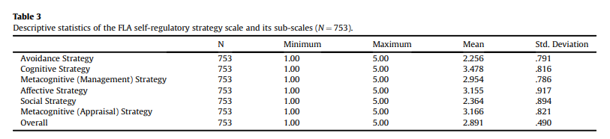
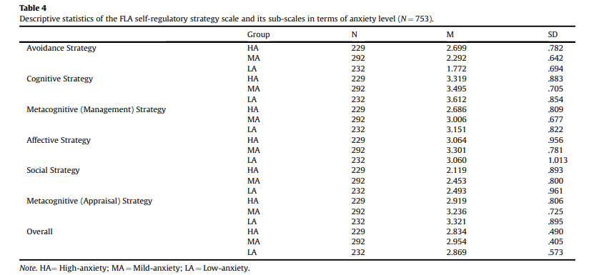
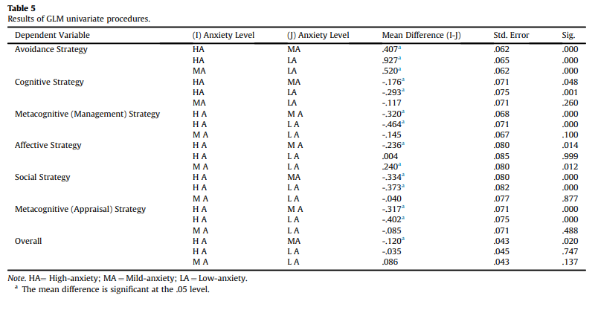
From the results of the research, it can be concluded as follows. In the first place, this research showed that generally students used self-regulatory strategies to a medium degree, and specifically CS, MAS, and AS were their preferences to address their anxiety in the process of English learning. Besides, students’ use of AVS with the least frequency demonstrated that they can take proactive measures to deal with anxiety instead of negatively avoiding it in English learning, clearly suggesting that as active agents, learners can manage, regulate, and control the affective influence in their language learning process. All of these correspond to the statement of individual agency in Bandura’s social cognitive theory (1989) that learners are people with human agency who actively engage in constructing the terms and conditions of their own learning (Lantolf & Pavlenko, 2001). In this research, most students’ use of cognition-related strategies shows that as active individual agencies, they can be aware of the fact that self-motivation, self-encouragement, the enhancement of self-confidence, and positive beliefs about language learning significantly contribute to easing anxiety in their L2 acquisition. Further, they enable themselves to appropriately adopt some strategies related to cognition, affection, and behaviors to regulate and relieve their anxious emotions so that they can better gain acquisition in their language learning. In the second place, with regard to the effect of students’ anxiety levels on their choice of regulation strategies, it turned out that students’ frequency use of four types of strategy (including MMS, CS, MAS, and SS) reduced as students’ anxiety levels increased. This shows that learners with less anxiety in language learning tend to better control their emotions in different learning environments. At the same time, as their anxiety levels increased, students performed more significantly frequently use of AVS, which supported the argument that learners who feel higher anxious about language learning are inclined to bear irrational emotions, fail to control their impulses, and become less successful than others (Broidy, 2005). Additionally, the study also found that students with mild anxiety were prone to adopt affective strategies most frequently, suggesting that they prefer a direct and proactive way to deal with anxiety instead of other cognitive or social ways. The results again verify the rationality of Krashen’s “Affective filter hypothesis”. Learners with clear and positive motivation and moderate anxiety will have low affective filters, pushing the comprehensible language input to smoothly enter their acquisition mechanism device and accelerating the process of language acquisition. On the contrary, high anxiety will lead to high affective filters which will form obstacles in the brain preventing language input from entering the language acquisition device, thus failing to produce language acquisition. In this study, students in the low-anxiety group tended to adopt positive and effective strategies like MMS, CS, MAS, and SS most frequently to alleviate their anxiety and reduce their affective filters in their second language acquisition; while high anxiety increased students’ affective filters driving them to adopt the negative strategy—AVS most frequently which may be detrimental to their language acquisition and even increase their anxiety. Finally, the results of the research also support the previous hypothesis that learners, as the subjects of English learning, are capable of taking the initiative to regulate their learning process through some effective strategies and understanding the affective dimension of L2 learning through interacting with others to confront anxiety. Therefore, as significant others, teachers are supposed to be sensitive to the trace of anxiety shown by students, encourage them to adopt some effective self-regulatory strategies, and provide them with external support to minimize the negative effects of anxiety. All in all, this empirical study provides practical significance for relieving college students’ FLA in foreign language teaching by reporting Chinese college students’ use of self-regulatory strategies for FLA as well as the impact of FLA levels on their regulation.
Admittedly, there also existed some limitations in this research. First, the participants were chosen from 7 universities in the center of China, whose performances don’t represent the overall phenomenon among students in China, so the general applicability of the results is still to be discussed. Second, this research mainly uses quantitative methods to analyze the data concerning students’ adoption of strategies within a specific time. We know that the construct of anxiety is not static but dynamic which may affect students’ employment of different strategies, so much deeper research with both quantitative and qualitative methods will be needed from a dynamic perspective. Last but not least, this research fails to report the effectiveness of students’ use of different regulatory strategies. Therefore, further follow-up studies are needed concerning assessing if learners’ employment of regulatory strategies results in a satisfactory effect.

Bibliography

Arnold, J. (2005) Affect in language learning. Beijing: Foreign Language Teaching and Research Press.
Bandura, A. (1989) ‘Human agency in social cognitive theory’. American Psychologist, 44(9), pp.1175-1185. Available at: https://doi.org/10.1037/0003-066X.44.9.1175
Bown, J., & White, C. J. (2010) ‘Affect in a self-regulatory framework for language learning’. System, 38(3), pp. 432-443. Available at: https://doi.org/10.1016/j.system. 2010.03.016
Breen, M. (2014) Learner contributions to language learning: New directions in research. New York: Routledge.
Broidy, M. (2005) ’Emotional intelligence: personality, gender and cultural factors‘(Unpublished doctoral dissertation). NJ: Fairleigh Dickinson University.
Dewaele, J.-M. (2015) ‘On emotions in foreign language learning and use’. The Language Teacher, 39(3), pp. 13-15. Available at: https://doi.org/10.37546/JALTTLT39. 3-3
Garrett, P., & Young, R. F. (2009) ’Theorizing affect in foreign language learning: An analysis of one learner’s responses to a communicative Portuguese course‘. The Modern Language Journal, 93(2), pp.209-226. Available at: https://doi.org/10.1111/j.1540-4781.2009.00857.x
Horwitz, E. K., Horwitz, M. B., & Cope, J. A. (1986) ’Foreign language classroom anxiety‘. The Modern Language Journal, 70(2), pp.125-132. Available at: https://doi.org/10.2307/327317
Horwitz, E. K. (2001) Language anxiety and achievement. Annual Review of Applied Linguistics, 21, pp.112-126. Available at: https://doi.org/10.1017/S0267190501000071
Krashen, S. D., & Terrell, T. D. (1983) The natural approach: language acquisition in the classroom. Oxford: Pergamon Press.
Kralova, Z., Skorvagova, E., Tirpakova, A., & Markechova, D. (2017) ‘Reducing student teachers’ foreign language pronunciation anxiety through psychosocial training’. System, 65, pp.49-60. Available at: https://doi.org/10.1016/j.system.2017.01.001
Lantolf, J. A., & Pavlenko, A. (2001) ‘Second Language Activity theory: Understanding language learners as people‘. In M. P. Breen (Ed.), Learner contributions to language learning, pp.141-158. Harlow, UK: Longman.
Nagahashi, T. L. (2007) Techniques for reducing foreign language anxiety: Results of a successful intervention study. Akita City: Akita University Press.
Oxford, R. L. (1990) Language learning strategies: What every teacher should know. New York: Newbury House/Harper & Row.
Oxford, R. L. (2015) ‘Emotions as the amplifier and the primary motive: Some theories of emotion with relevance to language learning’. Studies in Second Language Learning and Teaching, 5(3), pp.371-393.
Paris, S., & Paris, A. (2001) ’Classroom applications of research on self-regulated learning‘. Educational psychologist. London: Routledge
Shams, A. N. (2005) ’The use of computerized pronunciation practice in the reduction of foreign language classroom anxiety‘(Unpublished doctoral dissertation). Tallahassee: Florida State University.
Xiao, Y., & Wong, K. F. (2014) ‘Exploring heritage language anxiety: A study of Chinese heritage language learners’. The Modern Language Journal, 98(2), pp. 589-611. Available at: https://doi.org/10.1111/modl.12085
Yan Guo, Jinfen Xu & Xudong Liu (2018) ’English language learners’ use of self-regulatory strategies for foreign language anxiety in China‘. System, 76, pp.49-61. Available at: https://doi.org/10.1016/j.system.2018.05.001

