University of Wales Trinity Saint David
Wales Institute of Science and Art


Modelling Industrial Control Systems in MATLAB
Control Technology ACMA6001

Joseph Carpanini
2211043
July 2025
Contents
1 Introduction 2
1.1 Aims 2
1.2 Objectives 2
2 Background 3
2.1 PID general background 3
2.2 Cruise control standards 3
3 PID tuning 4
3.1 Method 4
3.2 Results and analysis 4
4 Time step impact 6
4.1 Method 6
4.2 Results and analysis 6
5 Signal delay impact 8
5.1 Method 8
5.2 Results and analysis 8
6 Number of Bits impact 9
6.1 Method 9
6.2 Results and analysis 9
7 Conclusion 10
8 References 11
9 Controller Code 12

Table of Figures
Figure 1 - Tuned Results 5
Figure 2 - 0.1s Time Step 7
Figure 3 - 0.2s Time Delay 8

Introduction

Aims
The aim of this project is to design, tune, and evaluate a digital PID controller for a cruise control system using MATLAB. The objective is to simulate a realistic control loop that considers digital implementation constraints, including signal quantisation, communication delays, and fixed sampling rates. The system must ensure accurate tracking of the driver’s desired speed while remaining stable and efficient under various digital limitations.

Objectives
- To develop a working simulation of a cruise control system using a discrete-time PID controller.
- To tune the controller gains to achieve zero steady-state error and acceptable response.
- To assess how sampling time, signal resolution (bit depth), and delay affect the system’s performance.
- To reflect on how these factors impact real-world implementation.

Background

PID general background
PID (Proportional-Integral-Derivative) control is one of the most common feedback strategies used in engineering due to its straightforward structure and robust performance. The proportional term reacts to the current error, providing an immediate corrective response. The integral term accumulates past errors to eliminate steady-state offset, while the derivative term predicts future error trends to dampen overshoot and improve stability.
In digital systems, PID controllers are implemented using discrete approximations and updated at fixed intervals. This introduces additional factors such as sampling time, quantisation noise, and time delays, which must be carefully considered during design and tuning. According to Åström and Hägglund (2006), successful digital PID control relies not only on proper gain selection but also on accounting for system limitations.

Cruise control standards
Modern automotive cruise control systems are subject to strict performance and safety requirements. These systems must maintain vehicle speed with high precision, respond promptly to changes in demand, and avoid abrupt or unsafe actuator movements.
International standards like ISO 15622:2018 (Adaptive Cruise Control Systems) define functional and performance requirements for automotive cruise control, including steady-state accuracy, transient behaviour, and fail-safe conditions. The standard emphasises driver comfort, minimal overshoot, and smooth speed adjustments as critical aspects. ISO 26262 also outlines safety requirements for automotive electronic systems, including the robustness of feedback control under fault conditions (ISO, 2018a; ISO, 2018b).
In practical terms, a well-designed cruise control system should maintain the target speed within a narrow tolerance (typically ±1–2 km/h) and avoid overshooting, which could result in speeding violations or reduced safety. Therefore, real-world cruise control systems must not only be accurate but also predictable and consistent in their behaviour under varying road and load conditions.

PID tuning

Method
The PID controller was implemented in a MATLAB simulation using a discrete-time model with a fixed sampling time of 0.01 s. The controller receives input from a simulated vehicle velocity sensor and driver demand signal, both of which are encoded and decoded using 16-bit resolution. The output is a control signal applied to the vehicle's throttle/brake actuator, also encoded before transmission.

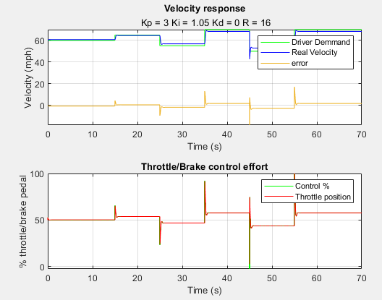
Figure 1 - Tuned Results
Initial gain values were selected based on trial-and-error testing, focusing on stability and accuracy. The final tuned parameters were:
Proportional gain (Kp) = 3
Integral gain (Ki) = 1.05
Derivative gain (Kd) = 0
These gains were chosen to ensure a balance between fast rise time, low overshoot, and zero steady-state error. The integral term played a key role in eliminating offset, while the proportional term provided adequate responsiveness.

Results and analysis
The tuned controller showed strong performance under nominal conditions. The vehicle speed closely tracked the driver’s demand with minimal delay and no steady-state error. The control effort remained smooth and within acceptable limits, avoiding actuator saturation.
Minor overshoot was observed during transitions, which, in real vehicles, could lead to temporary speeding. Further refinement—such as introducing a derivative term—could help reduce overshoot without sacrificing response time.
The results highlight the trade-offs involved in PID tuning. Higher proportional gain improves responsiveness but increases the risk of overshoot. A stronger integral term eliminates error but can cause oscillations if too aggressive. In real-world systems, tuning must account for actuator limits, passenger comfort, and energy efficiency, not just tracking accuracy.

Time step impact

Method
The sampling time, or control update rate, was varied to investigate its effect on system performance. Sampling times tested included:
0.01 s (baseline)
0.05 s
0.10 s
0.20 s
The PID gains remained constant to isolate the effect of sampling time alone. Each configuration was evaluated based on speed tracking, control smoothness, and overall stability. These time steps were selected based on recommendations from control engineering literature, which suggest that a system should be sampled at least ten times faster than its dominant time constant (Ogata, 2010).

Results and analysis
At 0.01 s, the system delivered fast, stable responses with precise tracking. At 0.05 s, performance remained acceptable, though with slightly slower responses and marginally increased overshoot.
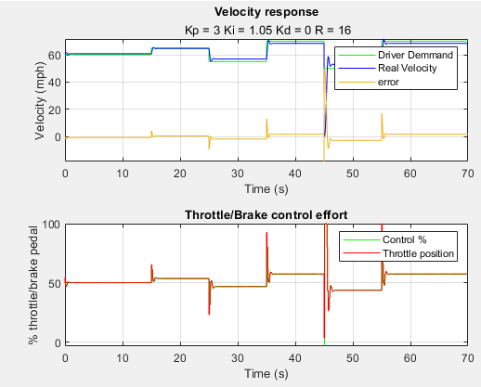
Figure 2 - 0.1s Time Step
At 0.10 seconds, control responsiveness decreased noticeably. The system still reached the target velocity but showed increased oscillation and slower correction of errors after step changes. Although the overall shape of the response remained acceptable, it was less smooth than with the default 0.01-second interval. At 0.20 seconds, performance degraded significantly. The vehicle lagged behind the driver’s demand, and the control commands became jerky and inefficient. Throttle and brake signals showed delayed transitions, leading to visible lag in the velocity response.
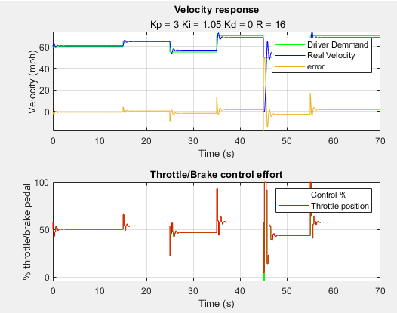
Figure 3 - 0.2s Time Delay

These results show that a shorter sampling time improves controller performance by enabling quicker error correction. However, very short intervals increase processing demands and communication overhead. In embedded systems, sampling times must be balanced to avoid overloading the processor while ensuring adequate responsiveness (Franklin et al., 2015).

Signal delay impact

Method
To simulate communication latency, a delay was introduced between the controller output and actuator input. Delay values tested:
0.00 s (baseline)
0.05 s
0.10 s
0.20 s
The PID controller remained unchanged, and the effects of increasing delay were observed through system stability and tracking accuracy. The delay values were based on studies of typical network-induced latencies in automotive systems, such as those documented by Zhang et al. (2001) and in CAN network evaluations (Bosch, 2012).

Results and analysis
With no delay (0.00 s), the system was highly responsive and stable. At 0.05 s, a small delay was noticeable, but performance remained acceptable. The vehicle tracked speed changes with a slight lag, and control effort was slightly less efficient.
At 0.10 s, the impact became more significant. The vehicle overshot more frequently, and oscillations appeared in both velocity and control signal. At 0.20 s, the system approached instability, with slow response, erratic control effort, and difficulty maintaining the setpoint.
Network-induced delays are common in distributed control systems. As Zhang et al. (2001) note, delays degrade phase margin and can destabilise feedback loops. In real-world systems, delays must be compensated with robust control strategies, such as predictive control or adaptive gain scheduling.

Number of Bits impact

Method
Signal resolution was varied by changing the number of bits used for encoding and decoding signals:
4 bits
8 bits
12 bits
16 bits (baseline)
20 bits
The PID gains and sampling time were held constant. The aim was to observe the impact of quantisation error on system performance. These bit depths were selected based on the common range of ADC (Analogue-to-Digital Converter) resolution in automotive systems, as discussed in Goodwin et al. (2001) and sensor hardware datasheets (Texas Instruments, 2023).

Results and analysis
With 16 and 20 bits, the system operated smoothly. The vehicle accurately tracked demand, and control signals were stable. At 12 bits, minor deviations and control jitter appeared, though performance remained acceptable.
At 8 bits, significant quantisation effects emerged. The vehicle speed became jagged, and the control effort showed rapid switching. At 4 bits, the system performed poorly, with erratic behaviour, overshoot, and reduced stability.
Quantisation error acts like noise, especially at low bit depths. It reduces accuracy and can introduce non-linear effects in the control loop (Goodwin et al., 2001). Practical systems typically use at least 10–12 bits to ensure balance between resolution and data bandwidth.

Conclusion

The PID controller tuned with Kp = 3, Ki = 1.05, and Kd = 0 achieved good performance under nominal conditions, tracking driver speed demand with minimal steady-state error and acceptable overshoot. Testing revealed that sampling times shorter than 0.05s maintained stability and accuracy, while longer intervals degraded performance. Delays greater than 0.10 s introduced oscillations and slowed system response, highlighting the importance of minimising communication latency in real-world applications.
Signal resolution was also critical. Systems with fewer than 10 bits exhibited unstable or erratic behaviour due to quantisation noise. A minimum of 12 bits was found necessary to balance performance and data efficiency. These findings support common automotive practices, where resolutions of 12–16 bits are standard.
Overall, the project highlighted the importance of balancing controller performance with practical digital implementation limits. Key considerations such as ISO-compliant response, processing load, and actuator smoothness must be addressed in real automotive control systems to ensure both functionality and safety.

References

- ISO (2018a) ISO 15622:2018 - Intelligent transport systems — Adaptive cruise control systems — Performance requirements and test procedures. Geneva: International Organization for Standardization.
- ISO (2018b) ISO 26262:2018 - Road vehicles – Functional safety. Geneva: International Organization for Standardization. Åström, K.J. and Hägglund, T. (2006) Advanced PID Control. Research Triangle Park, NC: ISA.
- Franklin, G.F., Powell, J.D. and Emami-Naeini, A. (2015) Feedback Control of Dynamic Systems. 7th edn. Pearson Education.
- Zhang, W., Branicky, M.S. and Phillips, S.M. (2001) 'Stability of networked control systems', IEEE Control Systems Magazine, 21(1), pp. 84–99. doi:10.1109/37.898794.
- Goodwin, G.C., Graebe, S.F. and Salgado, M.E. (2001) Control System Design. Prentice Hall.
- ISO 15622:2018. Intelligent transport systems - Adaptive cruise control systems - Performance requirements and test procedures. International Organization for Standardization.
- ISO 26262:2018. Road vehicles – Functional safety. International Organization for Standardization.
- Ogata, K. (2010) Modern Control Engineering. 5th edn. Harlow: Pearson Education.
- Robert Bosch GmbH. (2012) CAN Specification Version 2.0. Available at: https://www.bosch-semiconductors.com

Controller Code
function [controlout, error] = Controllerzz...
(demand,velocity,P,I,e_vec,j,Ts,sim_step,control,D)
%This is a PID controller
% controlout = control signal phys
% error = diff between demand and vel (phys (mph))
error = demand-velocity;
%% P part
P_part = error*P;
%% I part
persistent Prev_I_part
if j>1
prev = e_vec(j-(Ts/sim_step));
else
prev=control;
Prev_I_part = prev;
end
I_part =(((error+prev)./2).*(Ts)+Prev_I_part).*I;
%% D part
D_part = ((error-prev)/Ts)*D;
%% output
controlout = P_part+I_part+D_part;
%% Limits
m_ControlSig = -100;
M_ControlSig = 100;
if controlout<m_ControlSig
controlout=m_ControlSig;
end
if controlout>M_ControlSig
controlout=M_ControlSig;
end
end

