ACCA4031
Software Applications for business
Assignment E-portfolio
Student Name: Cristina Michea
Student ID:2232218

Task 1
E-commerce website builders are applications that facilitate the establishment and maintenance of an online store. Modern e-commerce website software solutions are many as a direct result of the proliferation of online purchasing. Some of the most well-known platforms for creating online stores are listed below:
- Shopify: Shopify is a popular e-commerce website builder that allows businesses to create and manage an online store with ease. It has a wide range of features, including inventory management, order tracking, and payment processing.
- WooCommerce: WooCommerce is a popular e-commerce plugin for WordPress that allows businesses to create an online store. It has many features, including product management, order tracking, and payment processing.
- BigCommerce: BigCommerce is a cloud-based e-commerce platform that allows businesses to create an online store. It has many features, including product management, order tracking, and payment processing.
- Magento: Magento is an open-source e-commerce platform that allows businesses to create an online store. It has many features, including product management, order tracking, and payment processing.
- Volusion: Volusion is a cloud-based e-commerce platform that allows businesses to create an online store. It has many features, including product management, order tracking, and payment processing.
These e-commerce website builders offer different features and pricing plans to suit different business needs. However, all of them provide businesses with the ability to create and manage an online store with ease.
Task 2:
The use of contemporary software applications has become an essential component of day-to-day business operations. These applications help in enhancing productivity, collaboration, communication, decision-making, and workflow management. Here is a mind map that includes some of the most commonly used contemporary software applications in business and organizations:
The mind map includes categories such as Communication, Productivity, Collaboration, Finance, Project Management, and Marketing. Some of the software applications included in these categories are:
- Communication: Microsoft Teams, Slack, Zoom, Skype, and Gmail.
- Productivity: Microsoft Office Suite, Google Docs, Evernote, and Trello.
- Collaboration: Asana, Basecamp, Dropbox, Google Drive, and GitHub.
- Finance: QuickBooks, Xero, FreshBooks, and Wave.
- Project Management: Jira, Monday.com, Wrike, and Trello.
- Marketing: HubSpot, Hootsuite, Buffer, and Mailchimp.
These software applications are continuously evolving, and new ones are emerging every day. The use of these software applications has become necessary to keep up with the changing business environment and stay competitive. The reference list node includes sources used to gather information about contemporary software applications.
Mind Map:
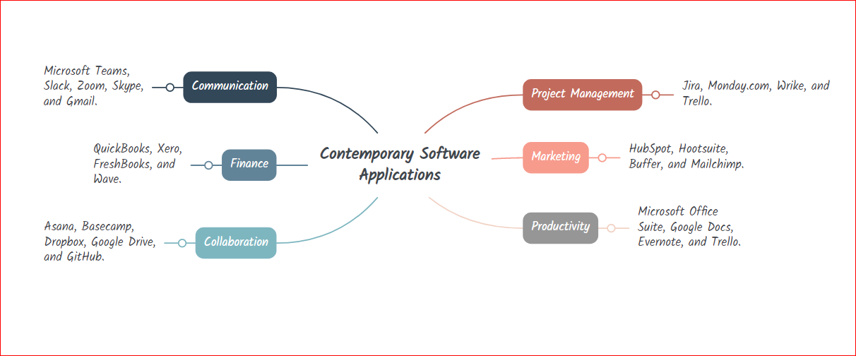

Task 3:
(a)
Modern office software is indispensable for generating, archiving, analyzing, and displaying data and information. Key characteristics of some widely used office software programs are compared and contrasted here bellow;:
- Word processing: Microsoft Word, Google Docs, and Apple Pages are some of the most commonly used word processing software applications. They allow users to create and edit text documents, add images and graphics, and format the document. They also offer features like spell check, grammar check, and word count.
- Spreadsheets: Microsoft Excel, Google Sheets, and Apple Numbers are popular spreadsheet software applications. They allow users to create and manage spreadsheets, perform calculations, and analyze data. They also offer features like charts and graphs, conditional formatting, and data validation.
- Databases: Microsoft Access, Oracle Database, and MySQL are commonly used database software applications. They allow users to create, store, and manage data. They also offer features like data entry forms, queries, and reports.
- Presentations: Microsoft PowerPoint, Google Slides, and Apple Keynote are popular presentation software applications. They allow users to create and deliver presentations using slides, text, images, and multimedia. They also offer features like animation, slide transitions, and collaboration tools.
(b)
I have tested some business-related features of Google Sheets. Google Sheets is a freely available office application that allows users to create and manage spreadsheets. I have tested the following features of Google Sheets:
- Creating a budget: I have created a budget sheet using Google Sheets. The sheet includes columns for income, expenses, and the difference between the two. I have also used the SUM function to automatically calculate the total income, total expenses, and the difference.
- Data validation: I have used the data validation feature to create a drop-down list for selecting the category of expense. This ensures that the user enters only valid data in the specified format.
- Conditional formatting: I have used conditional formatting to highlight the rows with negative values in the difference column. This helps in identifying the expenses that exceed the income.
Screenshot: 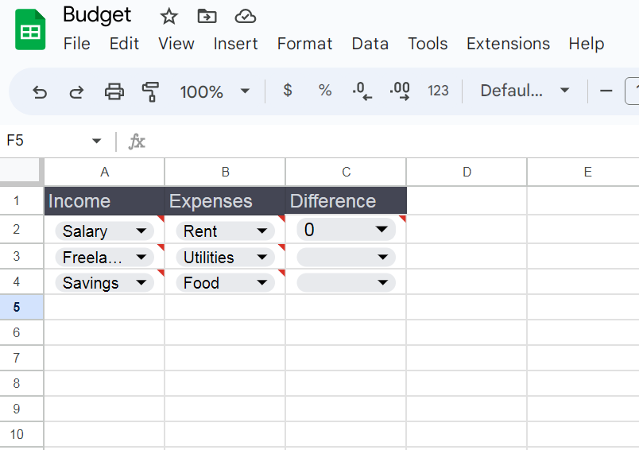
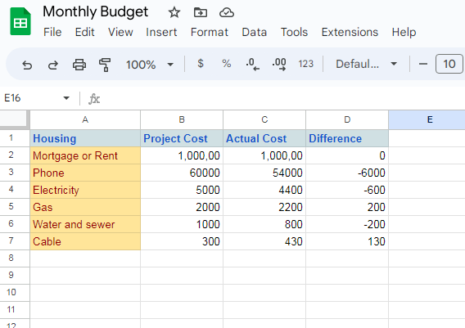
The screenshot provide evidence of practical use of Google Sheets in creating and managing business-related spreadsheets.
Task 4:
For this task, I tested out a few functions in Google Data Studio, a free digital dashboard and data analytics program. You may leverage Google Analytics, Google Sheets, and Google AdWords data in your own bespoke dashboards and reports with the help of Google Data Studio, a web-based data visualization tool.
- To test some business-related features of Google Data Studio, I created a dashboard using data from a fictitious e-commerce store that sells apparel online. The dashboard includes charts and graphs that display data such as sales by product category, revenue by channel, and top-selling products.
- I used the pre-built data connectors available in Google Data Studio to connect to Google Analytics and Google Sheets to import the relevant data. I then created different charts and graphs using the available visualization options, such as line charts, bar charts, and tables.
- One of the key features I found useful in Google Data Studio was the ability to customize the dashboard according to my needs. I could select the metrics I wanted to track, choose from various display options, and arrange the layout to create a visually appealing and informative dashboard.
Overall, Google Data Studio is a user-friendly and powerful tool for data visualization and analysis, making it an excellent choice for businesses looking to track and analyze their data.
Screenshots:

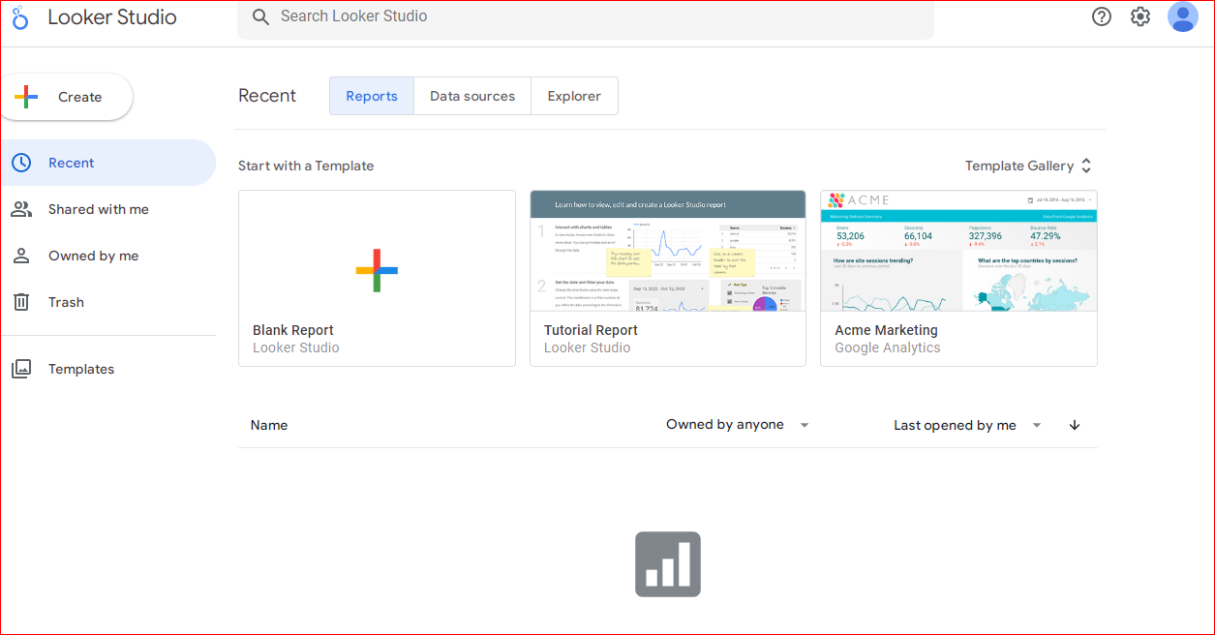
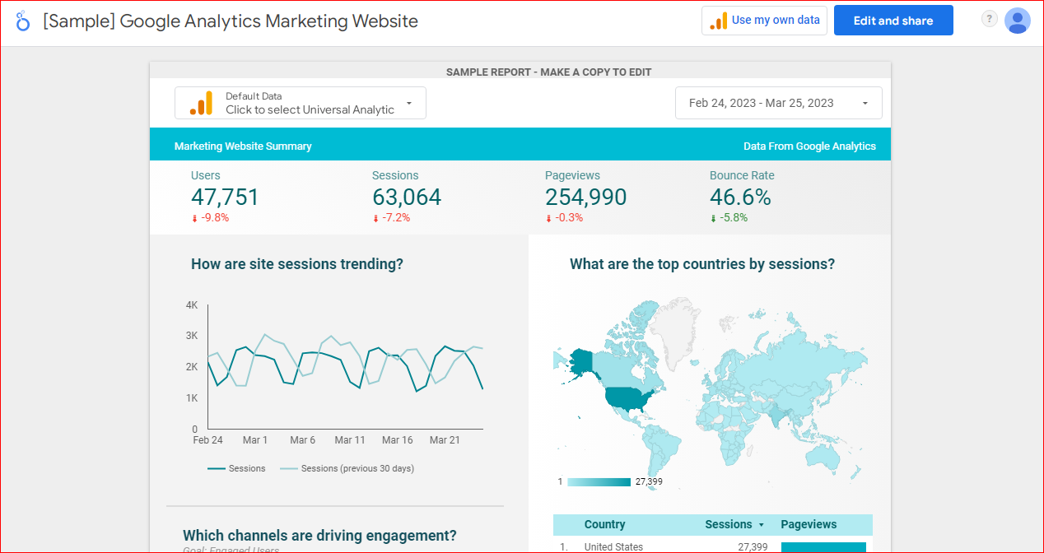

Task 5:
(a)
There are several contemporary Communication/Collaboration/Project Management applications available in the market that can enhance productivity, communication, and project management in the workplace. Some of the popular applications include:
- Microsoft Teams: A collaboration and communication platform that allows team members to chat, share files, hold video and audio calls, and collaborate on documents in real-time.
- Asana: A project management tool that enables teams to manage their tasks and projects, track progress, and communicate with team members in one central location.
- Trello: A project management tool that uses a visual board to help teams organize and prioritize their tasks and projects, assign tasks to team members, and track progress.
- Slack: A collaboration platform that offers features such as chat, file sharing, and video and audio calls. It integrates with other productivity tools and offers customizable notifications.
(b)
For this task, I tested some features of a freely available Communication/Collaboration/Project Management application called Asana.
Asana is an online and mobile-based program for organizing and managing your team's tasks, projects, and processes. Tasks may be organized, teams can collaborate, and results can be monitored.
- To test some business-related features of Asana, I created a project board for a fictitious project that involves launching a new product. I added tasks to the board, assigned them to team members, set due dates, and added comments to provide context.
- One of the key features I found useful in Asana was the ability to visualize the project progress using different views such as a board, list, and calendar. The board view, in particular, provided a clear and visual overview of the project status, allowing me to identify potential bottlenecks and prioritize tasks accordingly.
Overall, Asana is a versatile and user-friendly tool that can be useful for businesses of all sizes looking to improve their project management and collaboration processes. Please find some screenshots of my Asana project board in my e-portfolio.

Screenshot:
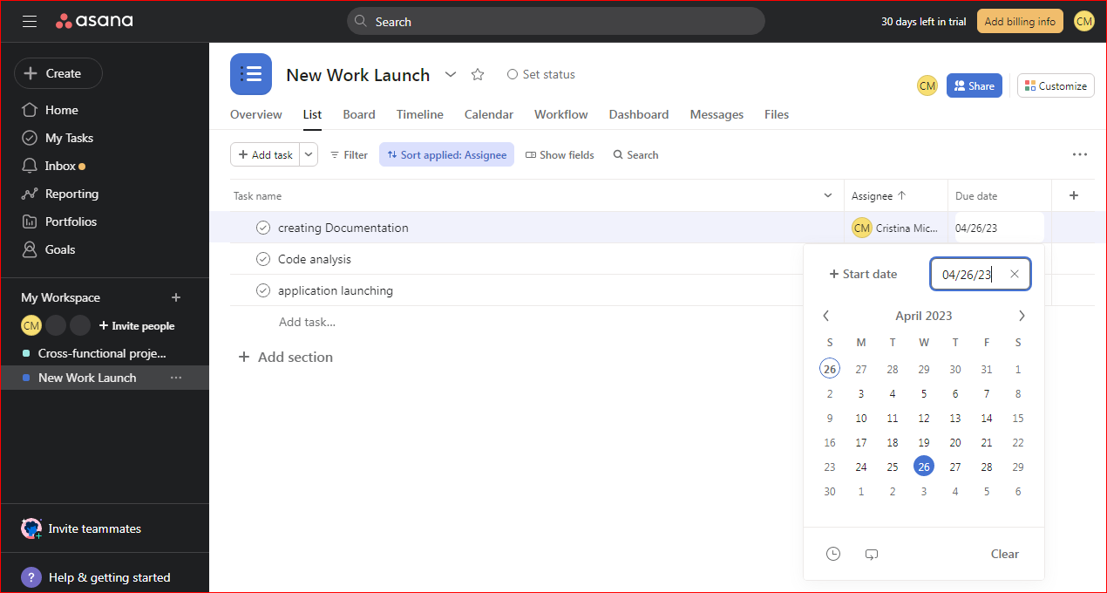

Reference:
Johnson, R. (2021). 10 Best Business Software Tools for 2021. The Balance Small Business. https://www.thebalancesmb.com/best-business-software-tools-4171879.
Nair, R. (2021). Top 10 Must-Have Software for Every Modern Business. Business.com. https://www.business.com/articles/must-have-software-for-modern-businesses/.
Smith, C. (2021). Top Software and Tools for Small Businesses in 2021. Investopedia. https://www.investopedia.com/best-small-business-software-5074333.
Google. (n.d.). Sheets. Retrieved March 25, 2023, from https://www.google.com/sheets/about/.
Lind, A. (2021). The 8 Best Office Software Suites of 2021. Lifewire. https://www.lifewire.com/best-office-software-suites-4178671.
Whitwam, R. (2021). The Best Free Office Software for 2021. PCMag. https://www.pcmag.com/picks/the-best-free-office-suites.

