

LCMB7024: MARKETING MANAGEMENT
Student’s Name- santok mulu godhaniya
Student’s ID- 2504925
Programme- Master of Business Administration
Lecturer- Taonga Kaonga Sobere-Snithers(Birmingham)
Assignment title- Marketing Environment Analysis
Module No- LCMB7024
Word Count- 2581

Table of Contents
Task 1: Marketing Environment Analysis 4
1.1 Introduction 4
1.2 Natural Environment Analysis 5
1.3 Political-Legal Environment Analysis 8
1.4 Conclusion 8
Task 2: Strategic Growth and Competitive Positioning 9
2.1 Introduction 9
2.2 Application of the Ansoff Matrix 9
2.3 Achieving Competitive Advantage through Differentiation 10
Environmental Differentiation 10
Technology Leadership 11
2.4 Sustainable Marketing Strategy 11
Corporate Branding 11
Integrated Marketing Communications 12
Customer Value Proposition 12
2.5 Strategic Benefits and Potential Risks 12
2.6 Conclusion 13
Task 3: Critical reflection on the use of AI 14
References 16

Short Form | Full Form
AI | Artificial Intelligence
BHP | Broken Hill Proprietary (BHP Group)
FY2024 | Financial Year 2024
USD | United States Dollar
US$ | United States Dollar
EV | Electric Vehicle
EVs | Electric Vehicles
ESG | Environmental, Social and Governance
DRI | Direct Reduced Iron
USA | United States of America
EU | European Union
RE | Renewable Energy
CC | Carbon Capture
IMC | Integrated Marketing Communications
IEA | International Energy Agency
UNCTAD | United Nations Conference on Trade and Development
PDF | Portable Document Format
UK | United Kingdom

Task 1: Marketing Environment Analysis

1.1 Introduction
The metals and mining sector is essential to providing some of the minerals humans need for economic development and the moving towards a low-carbon economy and is a key contributor to global growth (Sun et al. 2024). But the industry is also seen as being one of the most carbon intensive industries in the world, accounting for around 25% of emissions by the World's 12,000 largest companies (Ge et al. 2024). To meet growing public demand for corporate sustainability, governments, investors and consumers are asking mining companies to achieve environmental results, and at the same time ensure profits and profitability.
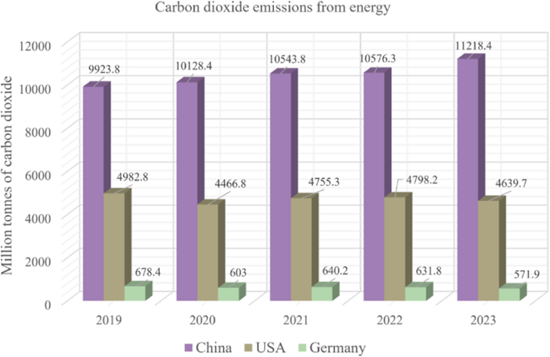
Figure 1: Strategies toward carbon neutrality
(Source: Hou et al., 2025)
To meet this challenge BHP Group's response has been to invest heavily in developing lower carbon technology and projects in the field of renewable energy and sustainable mining practices. During FY2024, BHP had revenue in the region of USD 55.7 billion and operates in over 90 countries (BHP, 2024). The actors that play a role in the external marketing environment of the company have a significant influence on the company's change toward lower-carbon products, especially the Political-Legal and Natural Environment. These elements will provide the framework towards understanding where BHP is going and how it gets there, which will be crucial when viewing foreseeable future growth opportunities and threats amongst its competitors.

1.2 Natural Environment Analysis
The most important external marketing environment actor about BHP's movement towards lower carbon emissions is The Natural Environment (BHP, 2023). A primary pressure is caused due to the 2050 agenda aimed at decarbonising the world. Globally, 8% of greenhouse gas emissions come from steel production and 7% from the mining industry. This kind of process depends heavily on raw materials such as iron ore supplied by mining firms (Climate Action Tracker, 2024). As a result of this, the environment is becoming an indicator of increased demands on mining companies to lower their carbon footprint and to promote cleaner industrial processes. BHP has responded with its plan to attain the net zero operational emissions by 2050, and it has dedicated over US$4 billion to decarbonisation projects and low carbon technologies (BHP, 2026).
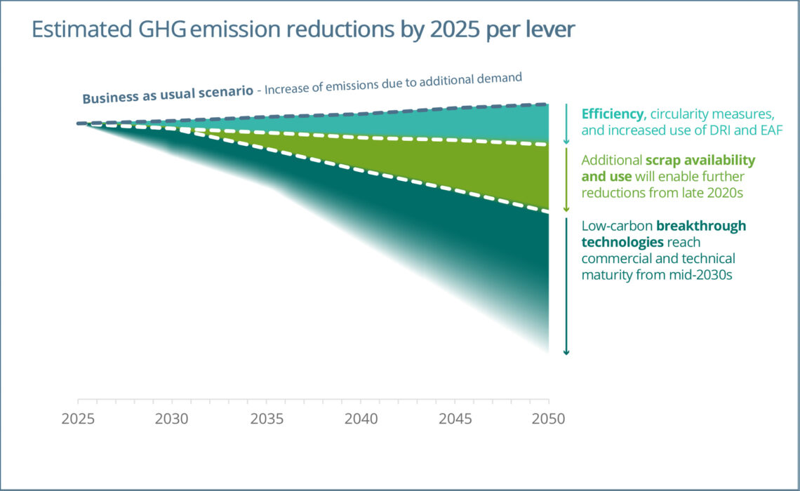
Figure 2: Climate change and the production of iron and steel
(Source: World Steel Association, 2022)
In addition, climate change has brought new opportunities such as the demand for critical minerals, which play a key role in renewable energy systems. Global electronics demand for copper is forecast to grow by around 40% by 2040 and total world demand for nickel by over 65%, thanks to the headlong charge in electric vehicle production (UNCTAD, 2025). In the case of EVs, for instance, the amount is about 80 kilograms of copper, whereas in a conventional vehicle, the need is about 20 kilograms (EV Reporter, 2026). Eco-efficiency is now clearly becoming a major consideration for institutional investors, their customers and the government in assessing business partners (Caprian et al. 2023). The ESG investment (Environmental, Social and Governance) assets have topped US$30 trillion, with sustainability credentials as one of the vital factors to consider in investment decisions (Broadridge, 2026).
On the other hand, the negative environmental record could lead to reputation loss, investor withdrawal and impact the market desirability (Ahn et al. 2025). As such, BHP's sustainability projects are so much more than just operational efficiency; they are powerful marketing techniques that strengthen their brand and connect with their stakeholders. New technologies, like green hydrogen-based steel making processes for instance, are not yet cost-effective; in this case, the price of green steels could be up to 20% to 40% more than traditional steel making processes (Griffin and Hammond, 2021). Furthermore, some decarbonisation technologies such as Hydrogen-based Direct Reduced Iron (DRI) using shaft furnaces might not be commercially viable on a long term basis. BHP has to go the middle way between shareholders' expectations of the company's profitability and return on investment alongside sustainability goals.
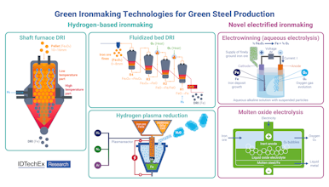
Figure 3:A Comparative Overview of Hydrogen-Based and Electrified Ironmaking Pathways for Green Steel Production
(Source: Idrissov, 2025)

1.3 Political-Legal Environment Analysis
The Political-Legal Environment has been instrumental in influencing BHP's transition towards lower carbon products, in addition to pressures from the environment. The level of regulation, policy and reporting requirements that governments around the world are increasing is tailored to promote the pace of decarbonisation and environmental sustainability.
Emerging, one of the important developments has been the growth of carbon reduction policies. For now, over 70 different countries have adopted a net-zero emissions goal, and carbon pricing instruments account for some 24% of emissions (United Nations, 2025). These rules impose stricter obligations on mining companies, and make investment to cleaner technologies more attractive. For BHP ensuring compliance to environmental legislation is a strategic imperative and not merely a legal obligation.
Opportunities also exist with regards to government support of sustainable innovation. Funding programs for the development of the green industry have been established by leading economies like Australia, the USA and the EU (Europa, 2024). The European Green Deal, for instance, wants to stimulate more than €1 trillion in sustainable investments by 2030 (European Commission, 2019). Any such programs offer BHP a favorable environment for its investments in renewable energy (RE)-powered mining applications, carbon capture (CC) technologies, and green steel partnerships. Enabling potential access to government incentive schemes can lower investment costs as well as help to promote sustainable goals.

1.4 Conclusion
From a marketing environment perspective, the Natural Environment and Political-Legal Environment are the two main external actors that are considered to be influential to BHP's evolution towards lower carbon products. Sustainability is a major opportunity because of concerns for the environment, climate change and rising demand for critical minerals and the rising expectations of stakeholders with respect to environmental responsibility. At the same time, government regulations, sustainability policies and trade mechanisms foster innovation while introducing compliance obligations and involvement complexity.The government, meanwhile, has its own agenda of enabling innovation, and of adding compliance obligations and complexity to the way that business is done. All these environmental factors offer both opportunities and challenges that will guide BHP in their future marketing efforts and will form the basis of a selection of a proper growth strategy using the Ansoff Matrix.

Task 2: Strategic Growth and Competitive Positioning

2.1 Introduction
The environmental analysis identified: climate change stresses and growing sustainability requirements and demand for critical minerals are reshaping the competitive dynamics of the mining industry (Radebe and Chipangamate, 2024). The developments provide BHP with strategic opportunities as well as challenges. The organisation needs a growth strategy that makes decarbonisation and environmental sustainability more compatible with its performance and competitiveness, to ensure it remains competitive on a long-term basis, in light of worldwide decarbonisation. Organisations can choose from different strategies outlined in Ansoff's Matrix which include market penetration, market developments, product development or diversification.

2.2 Application of the Ansoff Matrix
While market penetration is all about growing sales of products in established markets, this could be an option that does not offer much room for sales growth as BHP are well versed in the market-set for key commodities. Market Development would require new geographical markets but as demand continues to grow more from a sustainability requirement than geographical expansion. As mines involve high capital investment and exposure, it may not be the most effective method to achieve sustainable growth through diversification. The projections in the industry are that demand for copper could grow by around 40% by 2040 and for nickel by over 65% were exceedingly positive (UNCTAD , 2025).
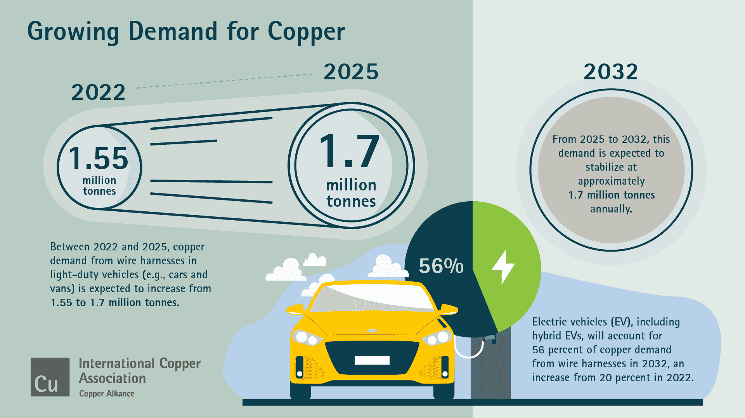
Figure 4: Copper: The Material of Choice for Vehicle Manufacturers
(Source: International Copper, 2025)
BHP's carbon reduction capabilities in renewables and electric vehicles will become even more important as hasty expansion of the renewable energy infrastructure industry and the proliferation of electric vehicle manufacturing takes place worldwide (BHP, 2025). The solutions could range from low-carbon iron ore products to carbon-neutral Copper production to renewable energy enabled mining and sustainable nickel solutions catered to the EV manufacturers (Malik et al., 2025). The company have already committed over USD 400 million to partnerships and collaborative research with big steel producers for steel decarbonisation (BHP, 2021). The investments reflect BHP's innovation ambition and heading toward its decarbonisation targets because it's investing in new products to deliver these benefits.

2.3 Achieving Competitive Advantage through Differentiation

Environmental Differentiation
Environmental differentiation is one of the best opportunities for BHP to be competitive. As more industrial customers look to the supplier to help meet their own carbon reduction goals, the need for a partner that can help is on the rise (Carbon Direct, 2025). BHP can stand out from its rivals that are still using traditional production methods by providing lower carbon iron ore, visibility into emissions and products that are carbon neutral certified. For customers, the carbon emissions of the material purchased can enhance their sustainability and reduce their carbon footprint while meeting environmental regulatory compliance requirements and building sustainable stakeholder relationships (Hathat et al. 2024).

Technology Leadership
The use of digital technologies, artificial intelligence and automation is in the process of transforming operational efficiencies that decrease environmental impacts (Gandía et al. 2025). Such autonomous haulage systems, predictive maintenance technologies and systems using artificial intelligence for energy management have proven to lower fuel usage in the range of 10-20% (Andrew and Olaniran, 2025). Moreover, sophisticated analytics can enhance resource utilisation, reduce waste materials production and maximize energy use efficiency in the mining industry.
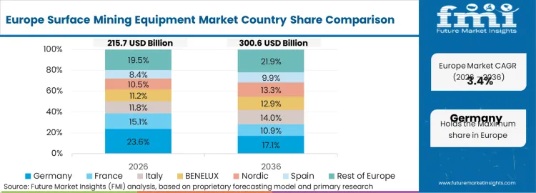
Figure 5: Surface Mining Equipment Market
(Source: Future Market Insights, 2026)

2.4 Sustainable Marketing Strategy

Corporate Branding
Corporate branding should best align BHP as a world class brand for responsibility in mining and moving towards energy transition materials. In turn, good sustainability practices can boost the brand, build better stakeholder relationships and governments, and attract investors and customers (Prakash, 2024). In today's market where many of the decisions being made are considering the ESG and corporate reputation plays an important part in the strategy.

Integrated Marketing Communications
A consistent approach used by BHP should be integrated marketing communications (IMC) for consistency when communicating with the various parties. A perfect communication should be shared in the annual sustainability reports, investor presentations, on digital platforms, through public relations campaigns and industry conferences (Gutterman, 2020).

Customer Value Proposition
There is a proposed value proposition for BHP that is:
- Providing the world's necessary supplies at much reduced carbon price, leading the world towards a sustainable future (Roser, 2021).
- This value proposition involves functional benefits, sustainable environmental impact and creation of societal benefits.
- It places BHP in a new class, not only as a mining company, but as a positive force for the decarbonisation of the world, as well.

2.5 Strategic Benefits and Potential Risks
- Firstly, projections for the future demand of lithium are over more than 400% by 2040, and copper and nickel demand are also projected to grow significantly (IEA, 2025).
- Second, investors could gain greater confidence in companies with strong ESG ratings and might achieve value premiums of 10-20% (Chau, et al. 2025).
- Third, environmental differentiation is an obstruction to entry as competitors may not have the ability to replicate BHP's technological and financial resources and investments in sustainability.
In the initial phase or stages of implementation, the adoption rate can be affected by customers' reluctance to buy from sustainable products that are more expensive. Strategic partnerships, government funding programmes, planned implementation approaches and longer-term customer contracts involving a sharing of value chain costs and benefits, can help reduce these risks.
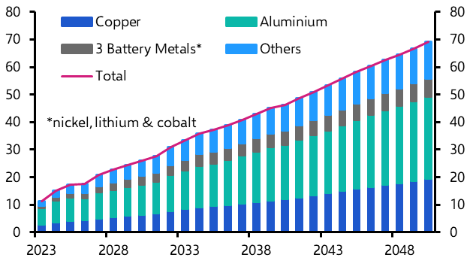
Figure 6: Metals be the green transition
(Source: Capital Economics, 2024)

2.6 Conclusion
The company believes it can meet current demand in the market while simultaneously creating innovative sustainable products that are used in a variety of applications from semiconductors to renewable energy infrastructure, all while relying on critical minerals. The strategy, coupled with BHP's differentiation strategy, technological innovation and communications work on sustainability, has resulted in BHP being able to deliver sustainable competitive advantage, as well as helping to meet the decarbonisation targets of the global community. While the implementation potential has financial and technological risks, the strategic "what it brings to BHP" is much greater and enables the company to grow and contribute to the global economy that is becoming more sustainability focused.

Task 3: Critical reflection on the use of AI
a. Tool disclosure
This report was made using the aids of Artificial Intelligence (AI) as a research-support tool. Accordingly, AI was utilized for research support, information summarization, proofreading tasks, and the report was structured, analyzed critically, and the final arguments were derived by the author, following the guidelines of the university. AI tools such as ChatGPT and Microsoft Copilot were used to find academic sources related to sustainable development, to summarise sustainability reports, to compare the environmental criteria and to enhance language clarity (Ray, 2023). Users do not have access to the AI to produce the final submission themselves, making sure that the assessment requirements are met.
b. Critical evaluation of AI output
In order to ensure the reliability of the AI-generated outputs, an evaluation process was added. The information generated by AI has been validated with peer-reviewed journals, company sustainability reports, government reports and industry reports. Special consideration was made for the numerical data and emissions as well as the sustainability commitments as they are sometimes incorrect or outdated (Al Kez et al., 2022). There were several cases of AI delivering data without source information or an invalid publishing date. The issues were resolved by referring to the original texts and substituting claims for evidence-based information. The verification process reduced the chances of experiencing hallucinations and further enhanced credibility of the report.
c. Contribution analysis
The journal’s contribution was very different from the contribution of AI. Enabling information retrieval and initial exploration and improvement of topic and language. The "organization of the marketing theoretical application" and the "environmental analysis" on the other hand were developed independently as well as the strategic recommendation for the focal company - BHP. All analysis and the decision of what conclusions should be drawn in the critical discussion on the Natural Environment, Political-Legal Environment and competitive positioning was done by the author and are not the result of AI generated conclusions. Hence, AI was not used as a decision-making tool, but it was used to assist with the research.
There are a number of ethics and professional questions to ponder when using AI for marketing analysis signals. Clarity is an issue here as AI must be clearly identified and the user must note it. One of the other issues is this possibility of bias in the AI training data that affects the outputs and recommendations. Too much AI use might also lessen critical thinking and independent analysis skills that are crucial for postgraduate education for students and professionals. In addition, if not verified with proper accuracy, AI-generated content may lead to incorrect business decisions (Mueller et al. 2025). Thus, with regard to responsible application, humans are the ones who will need to have a look and verify the sources as well as take accountability.
d. Ethical and professional reflection
In general, AI was found to be useful in enhancing research effectiveness and information handling. However, the event revealed the need for critical analysis, standing up and ethical responsibility in the process of adoption of AI throughout the marketing analysis processes. A healthy synergy is best achieved in which AI plays a supporting role to knowledge discovery, while interpretation, analysis, and decision-making are pursued by human experts.

References
Ahn, S., Cho, T.S. and Cho, C.K. (2025). Stock Market Reaction to Environmental Performance: The Role of Organizational Reputation as an Interpretive Lens. Organization & Environment, 38(3), pp.440–470. https://journals.sagepub.com/doi/10.1177/10860266251347359.
Al Kez, D., Foley, A.M., Laverty, D., Del Rio, D.F. and Sovacool, B. (2022). Exploring the sustainability challenges facing digitalization and internet data centers. Journal of Cleaner Production, 371(371), p.133633. https://www.sciencedirect.com/science/article/pii/S0959652622032115
Andrew, P. and Olaniran, O. (2025). Integrating Autonomous Haulage Systems for Improved Productivity and Reduced Environmental Impact in Open-Pit Mines. Available at: https://www.researchgate.net/publication/398454046_Integrating_Autonomous_Haulage_Systems_for_Improved_Productivity_and_Reduced_Environmental_Impact_in_Open-Pit_Mines [Accessed 4 Jun. 2026].
BHP (2021). BHP partners with JFE to address decarbonisation in the steel industry. BHP. Available at: https://www.bhp.com/news/media-centre/releases/2021/02/bhp-partners-with-jfe-to-address-decarbonisation-in-the-steel-industry [Accessed 4 Jun. 2026].
BHP (2023). Climate Change 2023 C0. Introduction. Available at: https://www.bhp.com/-/media/documents/environment/2023/cdp-2023-submission-not-graded.pdf [Accessed 4 Jun. 2026].
BHP (2024). Annual report 2024. Available at: https://www.bhp.com/-/media/documents/investors/annual-reports/2024/240827_bhpannualreport2024.pdf [Accessed 4 Jun. 2026].
BHP (2025). Copper Critical | BHP. Bhp.com. Available at: https://www.bhp.com/about/coppercritical [Accessed 4 Jun. 2026].
BHP (2026). Climate Transition Action Plan. Available at: https://www.bhp.com/-/media/documents/investors/annual-reports/2021/210914_bhpclimatetransitionactionplan2021.pdf [Accessed 4 Jun. 2026].
Broadridge (2026). ESG and sustainable investment outlook: $30 trillion by 2030 on the way to net zero. Available at: https://www.broadridge.com/_assets/pdf/esg-white-paper.pdf [Accessed 4 Jun. 2026].
Capital Economics (2024). How metals-hungry will the green transition be? | Capital Economics. Capitaleconomics.com. Available at: https://www.capitaleconomics.com/publications/industrial-metals-focus/how-metals-hungry-will-green-transition-be [Accessed 4 Jun. 2026].
Caprian, I., Iulita, B. and Trushkina, N. (2023). ECO-EFFICIENCY AS A PHILOSOPHY OF MODERN BUSINESS IN THE CONDITIONS OF GLOBAL TRANSFORMATIONS. Green, Blue and Digital Economy Journal, 4(1), pp.1–10. https://www.researchgate.net/publication/370115532_ECO-EFFICIENCY_AS_A_PHILOSOPHY_OF_MODERN_BUSINESS_IN_THE_CONDITIONS_OF_GLOBAL_TRANSFORMATIONS.
Carbon Direct (2025). Supplier engagement strategies to meet scope 3 targets | Carbon Direct. Carbon-direct.com. Available at: https://www.carbon-direct.com/insights/supplier-engagement-strategies-to-meet-scope-3-targets [Accessed 4 Jun. 2026].
Chau, L., Anh, L. and Duc, V. (2025). Valuing ESG: How financial markets respond to corporate sustainability. International Business Review, 34(3), p.102418. https://www.sciencedirect.com/science/article/pii/S0969593125000319.
Climate Action Tracker (2024). Decarbonising steel: national circumstances and priority actions. Climateactiontracker.org. Available at: https://climateactiontracker.org/publications/decarbonising-steel/ [Accessed 4 Jun. 2026].
Europa (2024). The Green Deal Industrial Plan. European Commission. Available at: https://commission.europa.eu/topics/competitiveness/green-deal-industrial-plan_en [Accessed 4 Jun. 2026].
European Commission (2019). The European Green Deal. European Commission. Available at: https://commission.europa.eu/strategy-and-policy/priorities-2019-2024/european-green-deal_en [Accessed 4 Jun. 2026].
EV Reporter (2026). The Role of Copper in Electric Vehicles and the Supply Crunch in India • EVreporter. EVreporter. Available at: https://evreporter.com/the-role-of-copper-in-electric-vehicles-and-addressing-the-supply-crunch-in-india/ [Accessed 4 Jun. 2026].
Future Market Insights (2026). Surface Mining Equipment Market | Global Market Analysis Report - 2036. Futuremarketinsights.com. Available at: https://www.futuremarketinsights.com/reports/surface-mining-equipment-market [Accessed 4 Jun. 2026].
Gandía, J.A.G., Ancillo, A. de L. and Núñez, M.T. del V. (2025). The Role of Artificial Intelligence and Knowledge in Enhancing Corporate Sustainability. Journal of Innovation & Knowledge, 10(5), p.100792. https://www.sciencedirect.com/science/article/pii/S2444569X25001374.
Ge, M., Friedrich, J. and Vigna, L. (2024). Where Do Emissions Come From? 4 Charts Explain Greenhouse Gas Emissions by Sector. World Resources Institute. Available at: https://www.wri.org/insights/4-charts-explain-greenhouse-gas-emissions-countries-and-sectors [Accessed 4 Jun. 2026].
Griffin, P.W. and Hammond, G.P. (2021). The Prospects for ‘Green Steel’ Making in a net-zero economy: a UK Perspective. Global Transitions, 3(1), pp.72–86. https://www.sciencedirect.com/science/article/pii/S2589791821000013.
Gutterman, A.S. (2020). Sustainability Reporting and Communications: An Introduction. ResearchGate. https://www.researchgate.net/publication/351094181_Sustainability_Reporting_and_Communications_An_Introduction.
Hathat, Z.E., Venkatesh, V.G., Raja Sreedharan, V., Zouadi, T., Shi, Y. and Arunmozhi, M. (2024). Stakeholder engagement in carbon reduction engineering: A perspective analysis of production optimization leveraging social-media interactions. Computers & Industrial Engineering, 200, p.110807. https://www.sciencedirect.com/science/article/pii/S036083522400929X.
Hou, M.Z., Luo, J., Huang, L., Beck, H.-P., Mehmood, F., Wang, Q., Wu, X., Wu, L., Yue, Y., Fang, Y., Chen, Q., Guo, Y., Zhang, T., Mao, J., Cai, N., Xiong, Y., Shi, T. and Zhang, R. (2025). Strategies toward carbon neutrality: comparative analysis of China, USA, and Germany. Carbon Neutral Systems, 1(1). https://link.springer.com/article/10.1007/s44438-025-00003-1.
Idrissov, C. (2025). Green Steel: How Hydrogen and Electric Ironmaking Drive Innovation. IDTechEx. Available at: https://www.idtechex.com/en/research-article/green-steel-how-hydrogen-and-electric-ironmaking-drive-innovation/33189 [Accessed 4 Jun. 2026].
IEA (2025). Overview of Outlook for Key Minerals – Global Critical Minerals Outlook 2025 – Analysis - IEA. IEA. Available at: https://www.iea.org/reports/global-critical-minerals-outlook-2025/overview-of-outlook-for-key-minerals [Accessed 4 Jun. 2026].
International Copper (2025). Copper: The Material of Choice for Vehicle Manufacturers - International Copper Association. internationalcopper.org. Available at: https://internationalcopper.org/resource/copper-the-material-of-choice-for-vehicle-manufacturers/ [Accessed 4 Jun. 2026].
Malik, F.H., Ayadi, W., Hussain, G.A., Haider, Z.M., Alkhatib, F. and Lehtonen, M. (2025). Evaluating Carbon Emissions: A Lifecycle Comparison Between Electric and Conventional Vehicles. World Electric Vehicle Journal, 16(5), pp.287–287. https://www.mdpi.com/2032-6653/16/5/287.
Mueller, A., Kuester, S. and von Janda, S. (2025). Socially (un)acceptable errors of AI: Consumer perceptions of different AI-induced errors. Journal of Business Research, 201, p.115673. https://www.sciencedirect.com/science/article/pii/S0148296325004965.
Prakash, S. (2024). Measuring the impact of corporate sustainability on brand growth. Institute of Sustainability Studies. Available at: https://instituteofsustainabilitystudies.com/insights/guides/measuring-the-impact-of-corporate-sustainability-on-brand-reputation-and-growth/ [Accessed 4 Jun. 2026].
Radebe, N. and Chipangamate, N. (2024). Mining industry risks, and future critical minerals and metals supply chain resilience in emerging markets. Resources policy, 91, pp.104887–104887. https://www.sciencedirect.com/science/article/pii/S030142072400254X.
Ray, P.P. (2023). ChatGPT: a Comprehensive Review on background, applications, Key challenges, bias, ethics, Limitations and Future Scope. Internet of Things and Cyber-Physical Systems, 3(1), pp.121–154. https://www.sciencedirect.com/science/article/pii/S266734522300024X.
Roser, M. (2021). The argument for a carbon price. Our World in Data. Available at: https://ourworldindata.org/carbon-price [Accessed 4 Jun. 2026].
Sun, W., Shao, M. and Yang, D. (2024). Role of essential minerals in achieving low-carbon economy and sustainability. Resources Policy, 90, pp.104716–104716. https://www.sciencedirect.com/science/article/abs/pii/S0301420724000837.
UNCTAD (2025). Global Trade Update (May 2025): Focus on critical minerals – copper in the new green and digital economy |. UN Trade and Development (UNCTAD). Available at: https://unctad.org/publication/global-trade-update-may-2025-critical-minerals-copper [Accessed 4 Jun. 2026].
United Nations (2025). For a livable climate: Net-zero commitments must be backed by credible action. United Nations. Available at: https://www.un.org/en/climatechange/net-zero-coalition [Accessed 4 Jun. 2026].
World Steel Association (2022). Climate change and the production of iron and steel. worldsteel.org. Available at: https://worldsteel.org/climate-action/climate-change-and-the-production-of-iron-and-steel/ [Accessed 4 Jun. 2026].

