STRATEGIC CHANGE AND ORGANIZATION (DBA)
(DBA)
1605047
6TH SEPTEMBER 2018

Executive Summary
An internal and external audit market supply for the incorporation of INEOS in the United Kingdom, a business frame work for the expansion of INEOS in the United Kingdom through analytical opportunities to benefit INEOS from highlighted threats that can be evaded and avoided. The strengths and weakness of INEOS can be seen in different functioning areas and linked to the external factors to identify the basic strategies and barriers in the line of business.
In the United Kingdom today, the external market environment for Ineos business is limited due to the post Brexit factors on consumer behaviour, adaptation of change on speed, technology and regulations on environment.
INEOS internal environment reflects on their high innovative strength to innovate and invent magic in all spheres of chemical, fracking gas production, fashionable outdoor clothing (Belstaff) motor vehicles (Landrover) and sport services (football) within the chemical and technological industry. Within this reflection of internal environment, it gives them a positive edge over their competitors which are also seen as their threats.
Recommendation was gotten from the implementation of strategy and formation of analytical theories and frame work like SWOT matrix, Ansoff matrix and potters Generic strategies for the assistance of divisional and actionable recommendation process.
It is however very important and necessary if INEOS can initiate and introduce the production of a well refined and development of sustainable environmental configuration in terms of health, safety, energy and resource innovation of other Ineos chemical products which can be transformed into pharmacological (Drugs) products for human treatment like cancer, since many consumers are becoming more prone to cancer and other health risk the UK has taken active measures on the regulation of companies to intensify the environmental regulations in respect to companies adopting active cleaner energy sources. Furthermore, Ineos can use their distinctive capability to develop ergonomics, simple, good form, and low-priced chemical products and devices for other smaller companies in the same market sector. Thus, further increasing the firm’s market reach.
However, some basic barriers like strategies capabilities, rivalry of competitors, legal threats and risk management needs to be mitigated and put into serious consideration by INEOS following and adopting the appropriate guidelines.
Introduction
Strategy is a common word and in every business terminology or language it deals with the basic understanding of how goals are generally achieved (Clegg et al., 2012, p.4). Strategic management involves a process of assessment in the diversification and application of decision making that guides organizations in their long or short term goals (David and David, 2017). The application of strategic management involves all the business connections and processes like finance, production, development and management.
Strategic management involves all the aims, goals, plans and purpose of an organization in order to quickly identify the market opportunities create a perfect firm network for a competitive log ahead against threat. This is maintained by putting in place the fundamental policies (Lynch, 2015).
This report will critically analyse the internal and external audit of INEOS in United Kingdom in order to create a wide business firm network suitable for analyses. This report is believed to assist INEOS in the United Kingdom with all the strategies needed to expand their market standards and face the challenges from their rivals in the market sector.
INEOS is a chemical company that started small and eventually expanded to become a world leading company in the production of chemical and sales of about $80 billion (INEOS UK, 2018). The company is known for its success in the production of chemicals and oil industry. Jim Ratcliffe the chairman, CEO and founder of INEOS. INEOS was however established in the 1998 and was responsible in buying out inspecs ethylene oxide facility Antwerp Belgium (Taylor and Roger, 1998). The company produces chemicals used for all the production of plastics and plastic materials manufactured in different aspects.

External Audit Analysis
The purpose for this external audit is to analyse suitable goals and opportunities that will be of benefit to INEOS and avoid possible threats on INEOS. The opportunities will be determined by the practical approach of PESTEL framework which will be used for the analysis of the external audit for INEOS in the United Kingdom.
PESTEL ANALYSIS
“PESTEL is also known as political, Economic, Social – Cultural, Technological, Environment and Legal”.
This is used to analyse macro – environmental frame work of organisations to determine its opportunities and potential threats (Johnson et al, 2014). See Fig 1 below.

Figure 1: PESTEL FRAMEWORK
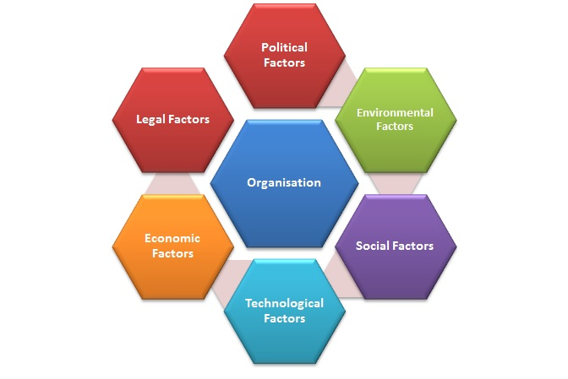
Source: Adapted from Johnson et al., (2014).

Political Factors
Political factors deals with either the state or the federal responsibilities on the enforcement of political conditions (Johnson et al, 2014). However some of the political external factors that are included involves government policies, tax, global trade agreement, political stability or restrictions and industrial regulations. An example of the political factors that could affect INEOS positively or negatively is the issue on the impact of Brexit on business. However in the past years terrorism has been an issue due to political factors and this has affected the nature of business. Tourism in shopping malls, football has also been affected and threatened in the past. However there is now an increase in the consumer protection rites and tax on governmental levies (CIPD, 2017).
The issue of tax can affect INEOS in terms of the Brexit, they may be subjected to restrictions and high tax levy from other EU countries on trade deals and relationship status.

Brexit Impact on Business
In June 2016, the Great Britain voted to leave the European Union (EU). This was an impact on the move by most business icon and people of the Great Britain, however this was also seen as “lull before the storm” (Inman, 2016).
According to the Brexit results between England voting to leave and Scotland voting to remain, this has so far caused confusion in the market sector not only in the UK but also in the European Union. This will go a long way to bring about political instability which will decrease the government finances and affect the market sector (Inman, 2016).
INEOS is in one way or the other also affected by Brexit because of decline in the British pound due to the UKs vote and thus leading to the increment of INEOS product outside the UK. UK’s move to leave EU has already had a huge impact on INEOS chemical products. Despite the talks about Brexit, INEOS which is one of the energy and chemical business in the world presently with a manufacturing site of 67 in 16 countries is still confident with their business strategy despite the Brexit negotiation (INEOS UK, 2014). According to the Chairman and founder of INEOS Jim Ratcliffe, who however happens to be among Britain’s successful industrialists in his comment about the Brexit said that as a business “INEOS supports the common market but however is not in support of a United States of Europe”, Jim went further and said that access is needed for Europe in UKs market which is larger than Russia’s market just as much as Britain needs their products too (INEOS UK, 2014).
However, the vote to leave the European Union also has a big impact the UKs “single market” with the European Union which affects the trading links between the UK and the EU by obstructing the free flow of goods and capital services (Josie cox, 2017). The impact of the UK leaving the European Union will bridge market supply and affect companies like INEOS intrade agreements, employment regulations, flexibility of products and evaluation of currency (Brindad, 2017).
INEOS can however benefit from leaving the single market because this will mean the UK making its own laws, rules and regulations which will go a very long way to benefit companies like INEOS and other companies in the UK.

Economic Factors
Economic factors are macro – economic analysis that aids organizations to understand the economy of the market sector (Jonson et al, 2014). Exchange rate living cost is an aspect that needs to be considered in every business strategy. There is always uncertainties in the economic factors of every business and this runs all the down from the production aspects to the maintenance aspects. Spending’s by consumers is also an important aspects in the economic factor and helps to know the particular products to invest more on.

The impact of exchange rates and currency fluctuations
Currency exchange rate has a great impact on the export price of INEOS and any decline or decrease of foreign currency will affect the market supply of INEOS. The sudden decline of the British pound against the dollar was recorded 18.5% after voting to exit the EU, this has been seen as a “Colossal move for a major currency” (Titcomb, 2017).
Since currency exchange rates impacts on the price of INEOS chemical export, any foreign currency decline against the dollar will be a general issue for INEOS chemical company. The consumer spending habit mounts so much production of goods while the others are said to be declined.
However sometime in 2008, INEOS experienced an adverse economic situation. This economic situation was as a result of a dispute between the industrial relations and Unite the Union over the workforce entitlements pension at the Grangemouth Refinery, this was happening as at the time the company was on the peak of closing down the final salary pension scheme to the new employees. Unite the Union further claimed that the Grangemouth workers were being paid £6,000 below the comparable facilities staff which lead to a 48 hours strike (Doward et al, 2008). This 48 hours strike brought about several controversy and panic in the buying and selling of petrol all over the country leading to the closing of the Forties production pipeline which is one of the third of Britains North Sea oil production (Sunday, 2013). INEOS has however been accused of reducing the cost of wages and termination of pension by introducing new working practices (Doward et al, 2008).
A further decrease in the British pound value will definitely lead to an increase in the price of INEOS products and reducing the value of the products for customers in the UK. INEOS can however employ more experts and retail outlets in the UK at a suitable cost to signify any further fall of the British pound in the future. More of INEOS products can also be introduce into the market supply as an advantage on post – Brexit market on new conservative investors for more profit on foreign investment and stock.
Social – Cultural Factor
These are all the impacts on business such as lifestyle, culture, demographics and income.
Lifestyle is another important aspect in social cultural factor. It includes consumer habits such as attitude, taste, style and preference. Country of region is also another aspect to be looked at in social cultural factor because it tells the particular type of products to be considered by the specified country. Sex and age is also considered as social cultural factor because the age and sex will tell who buys more products and helps in product development and services. Work habits is also necessary and helps in the market supply. From 40-65 years old are regarded as the work force and they all have their work norms and values.

Consumer’s behavioural change in preferences
The behavioural change in consumer’s attitude towards the use of plastics has led to continuous increase in the chemical production of plastics. The rise in the production of plastics is seen as a cultural diversity by different countries. This rising popularity of plastics has increased the production and recycle value. INEOS also produce clothing range which does not really cater for all the sizes and ages of people. However the demographic which has the highest disposable income is within 40-65 year of demographic. More approach of this social cultural factor is investment which is required in the determination of a market research. In some local demographic regions most labour markets resist working in the retail for minimum wage (CIPD, 2017).
Technological Factors
Any technological invention that can either impact a positive or negative factor on a business is known as a technological factor (Thompson et al, 2012). Automation is the recent line-up for every technological frame work. The world has gone far into computerization which makes work easy and faster to manipulate. Technology saves human resources and energy. Online services is also a new technological method for online payments which makes it easy for payments to be made and cashless services. Improvement of technologies by companies gives an added advantage in the business world and tactical strategies need to be observed or the devilment of technological knowhow.

The speed of change and adoption of new technology
The growth and development of technologies has spread rapidly and globally which can be seen as a speed of “change and adoption of new technology”. The quick flow and adoption of new and recent technology have maintained the work flow of the market sector into more rationalised condition and has eradicated function barriers. Consumers has enjoyed the adoption of new technological invention on the market sector due to the choice and competition in different organisations on the market sector (Manca and Ranieri, 2015).
Since INEOS is among the biggest chemical company in the UK that deals in the production of plastics, the basically need to focus more on operational issues in other to enable them achieve their long term goal. Change in technology is always rapid and challenging in the market supply because the impossible may turn around to become highly possible. However technological factor can be broadly seen in two different dimensions. It can be seen as infrastructure and manufacture and these two dimensions can be seen in automation, incentives, cost savings, and improved quality of parts and end products. INEOS should move into a different technology like electric cars, though they are into the fashion industry which is also an advantage for them but they need to try a different technological product like the production of medical equipment’s.

Increase in the level of expenditure on research and development (R&D) by organisation’s rivals
The level of expenditure on R&D by rival organisations provide a glimpse into the investment strategy and shows the firm’s capability to compete and develop long-term cutting-edge devices and software (Hayter, 2017). Investments into R&D usually happens in line with a firm’s general growth as the company invent new products (Mickle, 2017).

Environmental Factors
All the issues that are capable of imposing extra cost or leading to opportunities is seen as environmental factors (Johnson et al, 2015). Environmental restrictions should be giving companies. Government and communities should always tax companies on environmental hazards to reduce environmental risk and health and safety. And big companies like INEOSE should not be centred in the town centre and has to be far from homes to reduce the energy risk.

Intensified Environmental regulations

In the aspect of global environmental policies, the UK has been a leading power in the reduction of environmental issues such as emissions and promote sustainable sources (Walker, 2017). There has been warnings to the UK by the EU on the high level air pollution, this warnings was issued by the European Commission and instructed the UK to follow the EU law on air pollution or face the necessary legal litigations (Neslen, 2017).

This warnings was as a result of big cities in the UK bridging the air pollution law, this cities include a like Birmingham, London, Leads and Glasgow due to emissions from factories, power stations, exhaust fumes and vehicles (Walker, 2017). It is however necessary that the UK government intensify the rules on the environmental regulations and policies in order to reduce the increase rate of pollution by aiding organisations to switch completely to a cleaner energy source (Epstein, 2016). INEOS however handles and impacts a less greenhouse gas effects to the environment on its centres.

Since more products of INEOS need energy power to stay connected, the need for the invention of solar energy products is necessary in order to power most of their machines effectively and make work faster. If INEOS can succeed in this particular invention it will go a long way to satisfy their customers and give them an edge over their rivals.
Legal Factors
Any legal regulation or legislative adjustment/pressure that leads to opportunities of a business is seen as a legal factor (Lynch, 2015). Legal factors are very important in every business to avoid mitigation. The issue on Brexit is seen as legal factors among the EU nationals and needs severe legal aids.

Likely new regulations on trade and product standards
The UKs vote for Brexit may have a very severe consequences on the “single market” breaking down the free flow of trade with the EU (Josie cox, 2017). The vote for Brexit has been seen as an unprecedented move creating uncertainty to the EU since no EU country has ever left the EU (Josie cox, 2017). They may be a great impact on INEOS due to Brexit on the regulation of trade agreements, employment regulations on visas, evaluation of currency and product flexibility (Brinded, 2017). It can also be seen as added advantage on INEOS because Brexit will mean that the UK will definitely be able to make their own laws which might favour INEOS Company on trade deals property rules internationally (Lilico, 2017).

External Audit Matching Using Strategy Formulation Framework
The internal matching of a “firms” skills towards opportunities and threats from the external environment is regarded as a strategy (David and David, 2017). To create a good and effective strategy, the use of double strategy is necessary to match key external and internal factors to assist organization to gain an advantageous rate against their competitors. The matching stage of this strategy will be conducted using two basic frame works which re the “Porters Generic Strategy and the Ansoff Matrix”.
Porter’s Generic Strategies
Strategy helps firms to gain advantage in four different and suitable ways and linking them in terms of scope and strength which are seen as cost leadership, differentiation, cost focus and differentiation focus (Porter, 1985).
FIGURE: PORTER’S GENERIC STRATEGIES
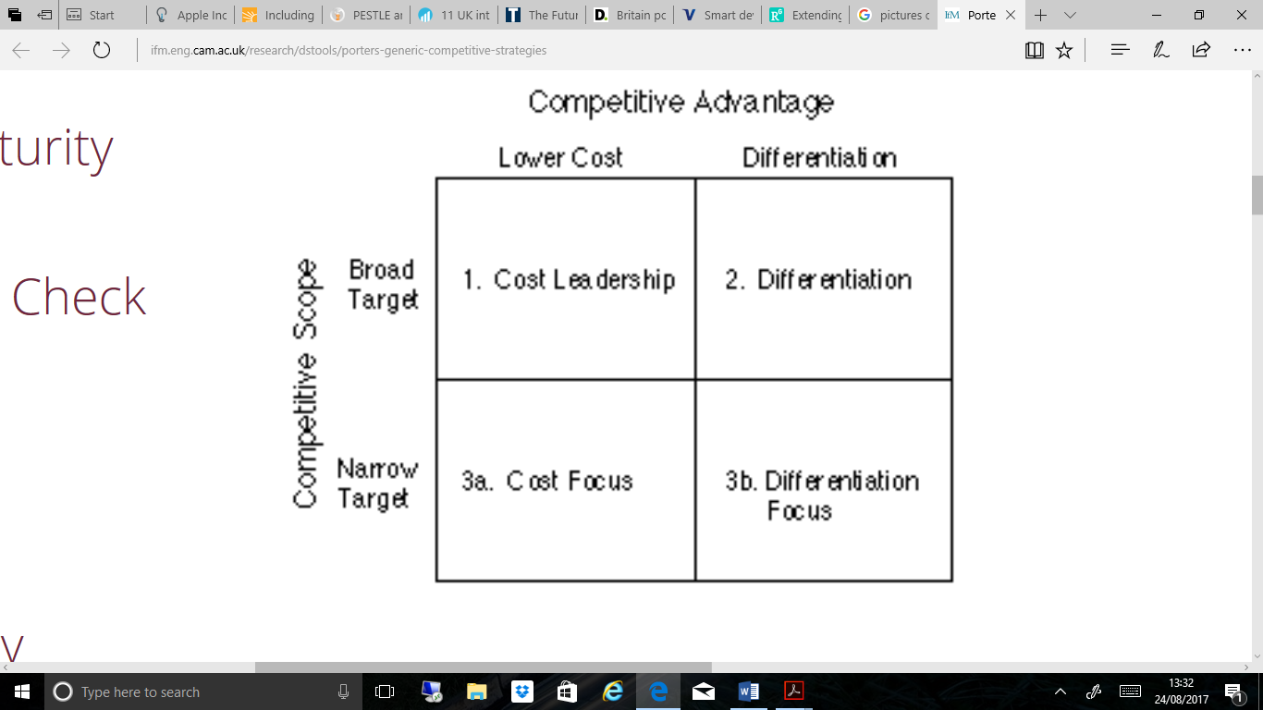
Source: Adapted from Johnson et al., (2014)
According to porter, for every organization to be successful, they have to maintain long – term sustainable edge over their competitors. This can be achieved if organizations have a clear strategy that is channeled towards the value of consumers in order to make it hard for competitors to follow (Porter, 1985). The four generic strategies by Porter will aid in the advantage of SMART strategies to achieve a competitive factor.
- Cost Leadership Strategy
This is the key drive way from high cost to a low cost firm in exploitation of different domain of activity (Tanwar, 2013). It is seen as an important aspect in business strategy. INEOS cost leadership gives them an added advantage over their rivals in the market sector. The dealings with trade and supply is very capital intensive and calls out for cost leadership strategy.
- Differentiation strategy
This is the strategy on price insensitive on customers in the production of sensitive goods and services. Price negotiation is very important and necessary in the development of every business line.

- Focus Strategy/Cost and differentiation
This is the production of goods and services that meets the satisfaction needs of a narrow segment from cost and differentiation perspective (David and David, 2017). Customers need to have quality products of goods supply from their favorite producers.

INEOS Generic Strategy
INEOS generally adopts a differentiation strategy for external and internal environmental audit, this boost and gives them an edge over their rivals in the chemical industry.
“This differentiation generic strategy generally involves producing unique and vital products or services that differentiates the firm from its rivals / competitors and focusing basically on price insensitive customers” (Johnson et al., 2014). Due to the differentiation strategy, INEOS produces unique and distinctive chemical products that stands out in the chemical industry giving an edge above their rivals.
However, INEOS has consistently differentiated itself from their rivals / competitors with special products and service features such as unique plastic products, oil and gas, petrol, high end branding, superior service, elegant engineering design, and efficient product performance, These special products basically makes INEOS to charge higher price for its products and gain loyalty from their users because the customers have generally become strongly attached and glued to the differentiating features of the products. INEOS has high branded products which gives their products high price incentives.
Though, the differentiation strategy INEOS adopts, also differentiates them from its competitors and rivals, INEOS over the past years has successfully established broad and wider market segments thus supporting wider market reach in the business sector. However, for INEOS to efficiently and effectively sustain their differentiation strategy, INEOS must have a consistency to create innovative and cutting-edge technologies via extensive Research and Development (R&D) to maintain competitive edge over their rival or competitors and further broaden and widen their market reach. INEOS can go ahead to research into the medical section by making medical equipment’s, drugs and more research into cancer. All these will help them more in the market sector and give them sustainable edge over their rivals. Since INEOS generally competes in different market segments that are characterized, the company’s other means of strategic direction should be to increase and widen their market reach using strategic intensive methods for business growth and development. Furthermore, for INEOS to always be ahead of their competitors in the chemical industry with differentiation strategy, INEOS must remain spry with product development activities. Therefore, to further identify potential strategic intensive methods for business growth for INEOS, an analysis of the strategic direction INEOS can adopt will be conducted using the Ansoff Matrix.
Focus Strategy (cost and differentiation)
This is an adoption used by organizations for the production of goods and services for the satisfaction of needs in a perspective of cost and differentiation (David and David, 2007). Any firm that adopt the focus strategy normally focuses on “specific niche markets” due to the market processes and customer needs within the market sector from low price or best product differentiation or cost (Johnson et al, 2012). For instance, the UK Office for National Statistics (2017), the UK population as at 2016, “was 65.6 million and projected to reach 74 million by 2039”. And based on this, there has been a constant development in UK healthcare and lifestyles as the population increases which indicates that the population is ageing (Hayter, 2017). “Furthermore, in 2016 in UK, 18% of the people were aged 65 and over, and 2.4% were aged 85 and over (Office for National Statistics, 2017), as a result of the ageing population, the old age dependency ratio (OADR) is increasing. The OADR is the number of people over 65 years old for every 1000 people aged between 16 and 64 years old. In mid-2016 the UK’s OADR was 285” (Office for National Statistics, 2017).
It is generally rare for INEOS to adopt a focus strategy but in a case where they do adopt it, they can do so in affiliation with a differentiation strategy. Due to the increase of ageing population in the UK via the growing niche market in the growth of business, it is possible that INEOS can produce special products with very low priced edition for the ageing population in order to increase their market supply.
Ansoff Matrix
Ansoff Matrix is a corporate strategic framework that is generally used in the market sector for the growth of an organization, it can be seen in four different ways which are market penetration, product development, market development and diversification (Johnson et al, 2014).
FIGURE: ANSOFF BUSINESS STRATEGIC MATRIX
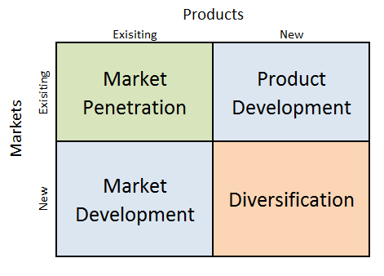
Source: Adapted from Johnson et al., (2014).
The matrix is used basically to seek effectively and intensive strategic direction within four strategic options known as “market penetration, new products and service development, market development and conglomerate diversification” (Clegg et al., 2012).

INEOS Intensive strategic business growth using Ansoff Matrix
Strategies such as the market penetration, product development, market development are all called intensive strategies due to their necessities and important roles in business, product and general firm services in the market sector.
Market Penetration Strategy
This is seen when a firm plans on growing its market share independently using product / service strategies (David and David, 2017). Since market penetration strategy is used by INEOS, they need to focus more on capabilities that requires an increase advertising and sales (Lynch, 2015). INEOS has however sold out successfully products in the current market supply and this is done through licenced media. However, it is possible that INEOS can adapt the market penetration intensive strategy in order to increase their market share using their current product range by increasing the number of salespersons. Social media, newspapers, television adverts and radio adverts is also a vital means by which INEOS can sell their products and services in the market and increase their business popularity.

Development of product
This is an application by managers when they modify their products / services to an increasing market sales (Johnson et al, 2008). INEOS in the past years has applied product development in there services as major strategy for the growth of their business and this yielded a great success through the application of intensive research and innovative development. The product development of INEOS is also seen as a success factor which gives INEOS an advantage over their competitors (Burrell, 2017).
Intensive products development however works well with INEOS differentiation generic strategy to enable them focus more on important and unique products for profit and gain. Due to the focus on firm and unique products, there have been a redevelopment of products by INEOS in order to satisfy their customers better, such products which include sports and fashion products have given them a direct edge over their competitors. However it is very important that INEOS must keep up to date with research and development, they can focus more on their product and try to move into the medicine via the production of medical drugs and research into cancer prevention and therapy.

INEOS Strategy of diversification in the growth of Business by the Use of Ansoff Matrix

Strategy diversification can usually be perceived into 2 parts “related and unrelated diversification” (David and David, 2017, p. 129).
Any organizations value chains that are similar and exists as valuable cross – business strategy to fit the competitive market is seen as a Related Diversification (Thompson and Martin, 2010). INEOS is known as a company that has trades into variety of products which is seen as a success in business such as in chemical, plastic and even the fashion industry.
Internal Audit
Internal audit is generally aimed at achieving the strength and weakness of every organization (David and David, 2017). INEOS will be using SWOT frame work for its internal audit.
Analysis using SWOT frame work
Strength, weakness, opportunities and treats is simply the definition of SWOT, and this framework goes a long way to protect every business strategy (David and David, 2017).
: SWOT FRAMEWORK
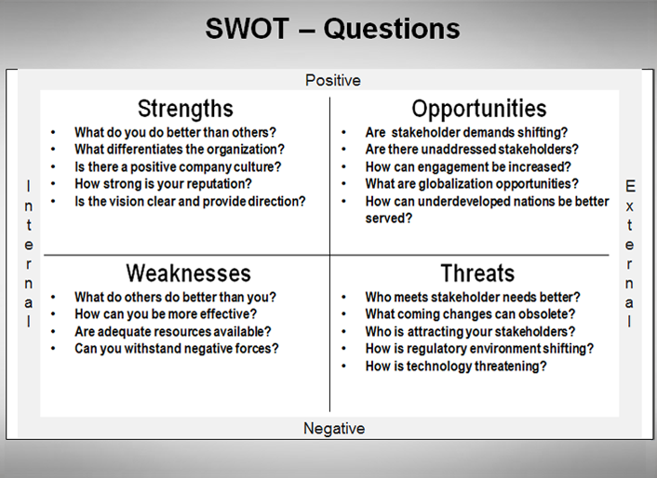
Source: Adapted from (Kotler and Keller, 2015).

INEOS Strength
INEOS (Financial) strength
INEOS has maintained a high level of financial stability in terms of profit and revenue generation and goes a long way to control its investment. They invest a lot in petrol, oil and gas, plastics, fashion and sports and they have got loads of shares which goes a long way to boost their financial level in the overall market and giving them an edge over their rivals and competitors.
Weaknesses
Low level distribution product channels
INEOS has a low level distribution product channel that restricts the business market spread. INEOS uses only limited authorized sellers due to policy that’s encourages product control and wider distribution. INEOS products are popular in the UK but are limited in some other parts of the world and the Brexit issues will be seen as a barrier to them in terms of trading deals between them and othe EU countries.

INEOS Opportunities

Market payments supply increase
The online payment is on the increase in the market sector and this helps to manage income and make purchase of goods and services (Aouad, 2017) However in UK, there have been an increase of mobile transactions this reduces the risk of carrying physical cash (Deloitte, 2016). However these mobile devices are plastic produced by INEOS which generally makes payments easy through quick and fast online transactions in the business secor.

INEOS Threats

Impact of Bexit
The impact of Brexit is seen as a threat on INEOS due to the market trade deals. This will go a long way to affect the relationship between INEOS and other EU companies. With the issue of Brexit, trade deals are limited and relationships are not maintained accordingly which will affect INEOS as a company. They will not maintain relationship of business in the EU and other parts of the world.

Competitive Rivalry increase
Competitive rivalry increase on sales and products can be a threat on INEOS, however INEOS need to invest into different products to give them an edge above their rivals in the market. INEOS should invest into medicine, health and drugs to give them an edge over their competitors. Medical drugs to prevent outbreaks of diseases should be considered and also adequate research on cancer should be made with all these things they really stand a better chance over their rivals.

Fluctuation and exchange currency rates
Due to Brexit, currency fluctuation will be an effect in expenditure of the market sector and multinational companies like INEOS will highly be affected on their generated revenue and profit in the UK. There is a tendency that the British pounds might drop after Brexit. Companies like INEOS will highly be affected if there is fluctuation in currency rates.

Internal Audit Matching Using Strategy Formulation Framework
According to (David and David, 2017), when firms, skills and internal assets are matched together and linked to the sole purpose of opportunities and threads towards the external environment, it is generally regarded as a strategy. Strategy therefor allows companies to gain an advantage on alternative strategy matching of both internal and external factors and the SWOT Matrix will be used as a framework for the matching stage for INEOS in the UK.

The SWOT Matrix
SWOT Matrix (normally called TOWS matrix) is a very important and necessary tool for matching and helps in the analysis of SWOT to identify “strength-opportunities (SO) strategies, weaknesses-opportunities (WO) strategies, strength-threats (ST) strategies, and weaknesses-threats (WT) strategies” (David and David, 2017, p. 251).

THE SWOT OR TOWS MATRIX
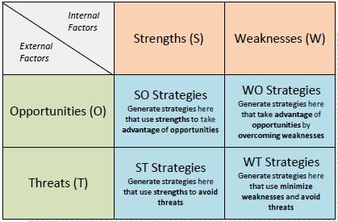
Source: Adapted from Johnson et al. (2014)
This matching process will be applied and used to generate alternative workable strategies for INEOS in UK as illustrated in Table below. The notations key ‘S1, W2, O3, T4’ etc. respectively will be used to analyze the explanation for all chosen alternative strategies.

INEOS SWOT MATRIX
Internal Factors/External Factors
Strength (S)
Weaknesses (W)
- Good financial stability and financial network.
- Connection and relationship between market supply and market sells
- Online market supply for purchase of goods and services
- Innovative level of strength
- Inadequate technological connection
- Increase level of sells in price and production
- Low level of distribution
Opportunities (O)
SO Strategies
WO Strategies
- High level of online payment and sells
- INEOS can follow the horizontal integration process by making online market service competitors for example PayPal rather than producing the plastic used for the technology (S1, O1).
- INEOS can follow product development strategy process by improving technological product in the market sector (S2, S4, O2).
- INEOS can create a partnership with online and Visa Pay as a technological strategy in order to boost integration move (W2, O1).
Threats (T)
ST Strategies
WT Strategies
- Impact of Brexit between the EU and the UK
- Rivalry in the market sector between companies
- Variations in exchange currency.
- Change in consumer preferences of goods and services
- Creation of new technologies in modern market supply.
- Research and development against rivals
It is possible that INEOS can go for “related diversification” and always connect with strategy differentiation and try to focus into the medical sector(S1, S2, S4, T2, T5, T6)
INEOS can always go for product development by transforming and developing their products in an acceptable price.
(W2, T5)

Application of Known Strategic Choice for INEOS
Application of strategy widely moves and changes all the processes in the business sector. This happens due to the application of known strategic choice as a result of adequate goods supply in the market sector to achieve value in business (Adair, 2010).

Barriers

Recent Increasing in strategic abilities
Recent increase in strategic abilities deals with the study of recent technologies in an organization and this generally means an organization investing and taking high level of “risk in project failure” and this can be seen as a barrier for INEOS.

Legal Forces
High market penetration gives a high level of concern towards competition regulatory agencies in connection with the market power. Restrictions like this is generally found in countries to stop organizations from using mergers and acquisitions to achieve or gain powers in market sector (Johnson et al., 2014).
Competition regulation agencies assist in making market penetration and gives high concerns in the market sector because they restrict and prevent organizations from mergers and acquisitions skills (Johnson et al, 2014) In the UK, “the Competition Commission is empowered to guarantee that mergers and acquisitions that account for more than 25% of national market share is made to reduce the value of the market share” (Competition Commission UK, 2017). Restrictions like this can go a long way to cause barrier in the application of known strategic choice.

Risk management on projects
INEOS product developments strategies is exposed to a high level of risk management on projects as a result of changes in projects and general setbacks (Johnson et al., 2014). The issue of Brexit is also an important risk factor that need to be managed adequately. The trade deals and relationship between the UK and EU needs to be maintained.

Rivals Payback
High level market penetration can worsen the product development and increase the chances of competitors in the market sector. (Lynch, 2015). This type of high level competition can cause “price wars or expensive marketing battles that could cost more than any market gains are worth” (Johnson, et al., 2012, p. 227). However, revenge against rivals can be seen as an obstacle.
INEOS however, can reduce these obstacles by applying innovative selling procedures and applying adequate investigation in order to give them an edge over their competitors in the chemical and plastic industry. “INEOS can further overcome these barriers by developing and adopting the five main points of strategic leadership which are: sustaining competitive advantage over time, effectively managing human resource and organization decision, setting ethical standards, developing and effectively communicating the organization purpose and defining and delivering to shareholders” (Lynch, 2015, p. 531).
Furthermore, INEOS can reduce the obstacles by investigating and detecting restrictions of strategic choices before the application development. “Allocating resources wisely, consistently monitoring and controlling the strategic plan and pulling it all together using the balanced scorecard” (Lynch, 2015).

Conclusion
External and internal audit for INEOS is generally used to expand their market supply by using the right analytical frame work to boost and promote the company against rivals and competitors. The issue of Brexit can however create a positive or negative sign for INEOS in regards to their market value. INEOS does not only invest in chemicals and plastics but also do invest fashion and sports which gives them an edge over their rivals and competitors.
However this internal and external framework highlights the threats and opportunities of INEOS and strategic ways of applying these framework. Implementation of current strategies is necessary and important for INEOS in order to prevent barriers against their rivals and necessary guidelines need to be applied.
INEOS has a financial capability of over $60 billion, INEOS is also known for its unique products such as fuels and lubricants, food packaging and adverse construction. The impact of Brexit can affect INEOS in trade deals and relationship between and other EU business partners. However it can also be of advantage to them in terms of them making their own law and policy. Research and development is an important aspect to be considered for INEOS because to need to try different technologies such production of medical equipment and production of medical drugs for the treatment and prevention of diseases. Research and development is also necessary for the INEOS if the can move into research for the treatment and prevention of cancer in medicine.

Recommendations
- INEOS has to understand the faith of Brexit in terms market supply and market deals and always maintain a steady relationship between them and other business partners in trade deals both within and ouside the UK.

- INEOS need to chase development of product by giving rise in the reduction of their sells price in order to keep up with their customers on the aspects of goods and services.

- INEOS can make good use of the post brexit fear and go ahead to introduce new products and sells in the UK market and making new laws and rules to back them up after the Brexit.

- INEOS try other technological system like investing into medicine, drugs and medical equipments
INEOS can go into the production of solar energy in order to boost the power supply of their equipment’s

- INEOS need to invest more on research and development and try new products to give them a higher advantage.

References
Adair, J. (2010) Effective Strategic Leadership: The Complete Guide to Strategic Management. 1st edn. London: Macmillan
Aouad, A. (2017) Mobile Banking Is on The Rise in The UK [online] available from <http://uk.businessinsider.com/mobile-banking-is-on-the-rise-in-the-uk-2017-6> [22 August 2018]

Brinded, L. (2017) ING: Bad Brexit Deal for Britain Could Kick Europe Into Recession [online] available from <http://uk.businessinsider.com/bad-brexit-deal-impact-on-european-and-uk-economy-trade-single-market-2017-4> [10 August 2018]
Clegg, S., Carter, C., Kornberger, M. and Schweitzer, J. (2012) Strategy and Theory. 1st edn. London: SAGE
David, F. and David, F. (2017) Strategic Management: A Competitive Advantage Approach, Concepts and Cases. 16th edn. Boston: Pearson
Deloitte (2016) Britain Poised for Mobile Payments Revolution | Deloitte UK [online] available from <https://www2.deloitte.com/uk/en/pages/press-releases/articles/mobile-payments-revolution.html> [22 August 2018]
Hayter, C. (2017) Overview of The UK Population - Office for National Statistics [online] available from <https://www.ons.gov.uk/peoplepopulationandcommunity/populationandmigration/populationestimates/articles/overviewoftheukpopulation/july2017> [5 September 2018]
Inman, P. (2017) What Would British Business Be Like After Brexit? [online] available from <https://www.theguardian.com/business/2016/jun/18/british-business-after-brexit> [10 August 2017]
Johnson, G., Whittington, R., Scholes, K., Angwin, D. and Regner, P. (2014) Exploring Corporate Strategy: Text and Cases. 10th edn. Harlow: Pearson
Johnson, M., Christensen, C. and Kagermann, H. (2008) Reinventing Your Business Model [online] available from <https://hbr.org/2008/12/reinventing-your-business-model> [6 September 2018]
Josie Cox, Z. (2017) Cost of Brexit: The Impact on Business and The Economy So Far [online] available from <http://www.independent.co.uk/news/business/news/brexit-economy-sterling-currency-investment-cost-impact-business-financial-banks-insurance-retail-a7695486.html> [10 August 2018]
Lilico, A. (2017) How Britain Can Make the Most of Leaving the Single Market [online] available from <https://www.ft.com/content/c938bb10-d71d-11e6-944b-e7eb37a6aa8e> [10 August 2018]
Lynch, R. (2015) Strategic Management. 7th edn. Harlow: Pearson
Manca, S. and Ranieri, M. (2015) "Implications of Social Network Sites for Teaching and Learning. Where We Are and Where We Want to Go". Education and Information Technologies 22 (2), 605-622
Millward, H. and Lewis, A. (2005) "Barriers to Successful New Product Development Within Small Manufacturing Companies". Journal of Small Business and Enterprise Development 12 (3), 379-381
Neslen, A. (2017) European Commission Issues 'Final Warning' To UK Over Air Pollution Breaches [online] available from <https://www.theguardian.com/environment/2017/feb/15/european-commission-issues-final-warning-to-uk-over-air-pollution-breaches> [20 August 2018]
Tanwar, R. (2013) "Porter’s Generic Competitive Strategies". IOSR Journal of Business and Management 15 (1), 11-17
Thompson, J., Scott, J. and Martin, F. (2012) Strategic Management. 7th edn. London: Thomas Rennie
Titcomb, J. (2017) Tablet Sales to Fall for Third Successive Year as PC Market Stabilizes [online] available from <http://www.telegraph.co.uk/technology/2017/01/11/tablet-sales-fall-third-successive-year-pc-market-stabilises/> [18 August 2018]
Walker, P. (2017) UK Unprepared for Exiting Europe's Green Legislation, Says Lucas [online] available from <https://www.theguardian.com/environment/2017/feb/13/uk-unprepared-for-exiting-europes-green-legislation-says-mp> [20 August 2018]
Wieczner, J. (2017) These Are the Fortune 500'S 10 Most Profitable Companies [online] available from <http://fortune.com/2017/06/07/fortune-500-companies-profit-apple-berkshire-hathaway/> [21 August 2018]

