Module code: BMIH5007
Module name: Financial Management for the Hotel Industry
Assignment type: Rework Assignment 1
Business Report - Comparison of Two Hospitality Organisations
Student name: Andreea Catalina Mecic
Student Number: 2215573
Lecturer: Tristan Hawkins
Executive summary
The report will provide comparative analysis of Corinthia and Ibis hotel. The report has discussed market position, revenue generation, CSR commitments and growth potential. Corinthia is luxury hotel brand that have made revenue in 2023 and hold strong market position by providing best services in heritage properties. The report has provided recommendation to Corinthia to expand business and hotel operations in emerging markets. Ibis hotel is the part of Accor group shows that its revenue is increasing and market expanding to the emerging markets for the sustainability and affordability. The hotel is recommended to invest in sustainable and innovative efforts to achieve market leadership.

Table of Contents
1 Introduction 3
2 Overview of the Hotels 3
3 Total revenue 5
4 Market position 7
5 Growth potential 9
6 Financial Commitment to CSR 10
7 Conclusion 11
8 Recommendations 12
9 References 13

Introduction
The hospitality industry is a billion-dollar industry providing various services and activities. Major services provided by the hospitality sector include hotel businesses, tourism services, event planning and travel and transport services. In the hospitality industry hotel business holds a significant place as they are the main service and source of accommodation for tourists and business travellers. Apart from just accommodations these hotels also provide various other services like gym, spa, meeting facilities, clubs and games facilities that attract guests (Camilleri and Camilleri, 2018).
The following business will provide an in-depth analysis and comparison of two major hotels in the hospitality sector that are Ibis Hotels and Corinthia Hotels. The report aims to evaluate the financial performance of the management of both hotels and identify potential areas to analyse the impact on the financial and sustainability of the hotels. The report will provide a comparison of the two hotels in key areas of total revenue generation, growth potential, market position and financial commitment to CSR activities of the Hotels.

Overview of the Hotels
Corinthia Hotel is one the most luxurious and 5-star hotels located in London. The Hotel is famous for its elegance and dignity. It originated as Metro Pole Hotel developed in 1885 and played a significant role for decades. The Hotel was also given services as a government office during World War II. The following building was restored and re-opened in 2011 as Corinthia Hotel having the blend of modern technologies and services with historic remains. The Hotel has large and lavish suites and rooms, dining rooms for a fine dining experience and a huge spa. The Hotel is located near the River Thames and Trafalgar Square is the favourite tourist spot for the visitors who consider comfort along with style and convenience in one of the prominent cities of the world (Corinthia, 2024).
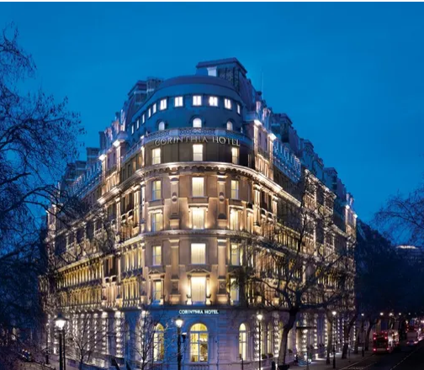
Figure 1Corinthia Hotel
(Source: Corinthia, 2024).
Accor Group is the global brand under which Ibis Hotel operate. The brand is famous for its affordability, comfort and modern accommodations. The Ibis Hotel was initially developed in France in 1974 and has grown to more than 1200 locations around the world (Demirçiftçi and Kızılırmak, 2016). The Accor group aims to provide high-quality and value services and attract travellers who seek luxury under budget. The Ibis Hotel is located in convenient locations like the City centre, near transport hubs and at business locations that attract both leisure and business travellers. The hotel rooms provide a comfortable and functional experience providing essential services like Wi-Fi, cozy beds, and TVs. The brand is committed towards sustainability efforts which is reflected in its eco-friendly services and energy-efficient strategies adopted for the Hotel (all.accor.com, 2024).

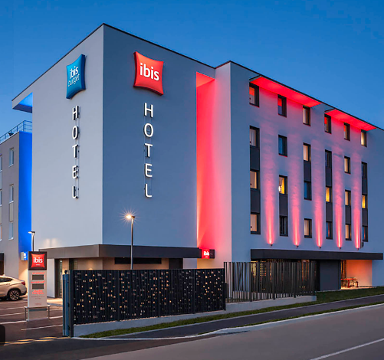
Figure 2 Ibis Hotel
(Source: all.accor.com. 2024a)

Total revenue
Total revenue is considered an essential concept in economics that defines the total money earned by a company by selling goods or services within a given time which could be day, month, week or year. The total revenue is dependent upon the market where goods are produced or sold. Total revenue is the product price of the product and its quantities sold (Hayes et al., 2021).
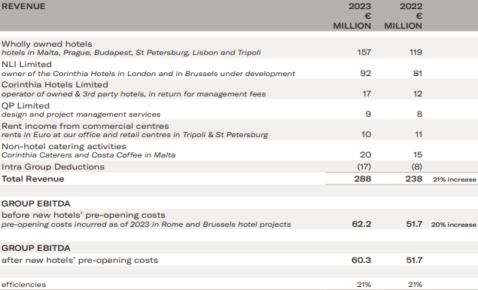
Figure 3 Total revenue of Corinthia Hotel of 2023
(Source: ANNUAL REPORT, 2023)
The total revenue generated for the year 2023 increased from €238.2 million to €287.8 million in year 2022 which shows a total increase of around 21%. The total generated revenue was 107% higher than that of 2019's revenue when the Corinthia Hotel group recovered from the COVID-19 pandemic. While reviewing hotel performance, it is essential to note the financial performance in Russia after the military conflicts between Ukraine and Russia that started in 2022. Despite these conflicts around the Russian market, the hotel group achieved an occupancy level in 2023 with a rise of 73% compared to the occupancy rate of pre-COVID rates. Due to increased revenue, the Corinthia group gains operating results before fair value or depreciation value of €60.3 million with an increase of €8.6 million. In 2023, the Corinthia group experienced an estimated preopening cost of €1.9 million related to the opening cost in Brussels and Rome (ANNUAL REPORT, 2023).
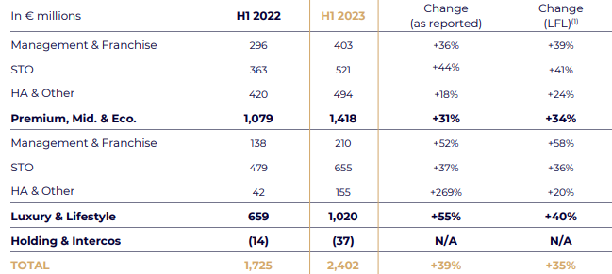
Figure 4 Total revenue of Ibis Hotel of 2023
(Source: ‌ Accor group, 2023)
The first quarter of 2023 shows business recovery with solid business trends in group two divisions. The hotel demanded its leisure and business guests to stay resilient which was visible in improved occupancy rates and rise in room rates. In the first half of 2023, Accor group opened 114 more hotels which represented 14,500 rooms which demonstrated 3.5% net growth in the 1 year. By the end of the year 2023, the Accor group Ibis hotel confirmed net growth between 2% to 3%. The hotel generated total revenue of €2,402 million which is 35% more than like-for-like versus H1 2022. This revenue growth breaks down to a 34% rise in the Premium, Midscale and Economic divisions and 40% for the luxury and lifestyle division (Accor group, 2023).
Comparing the total generated revenue it has been identified the Corinthia Hotel generated more revenue than the Ibis hotel in the year 2023.

Market position
Market share is defined as the percentage of industry sales owned by a particular business. It is the comparison of the total sales of the company with the overall generated sales of the industry (Werden, 2017). The Corinthia Group of Hotel has a prominent presence in the Middle East, Africa and Europe. Corinthia Group has not disclosed its specific market share however, it is known for its exceptional services and high-end room accommodations in the luxury hotel sector. The hotel has significant properties in major cities like London, Malta, and Lisbon that are considered top luxury hotels (Hood, 2018). The market share of Corinthia Group Malta property increased to €61.2 million in 2022 as compared to the total revenue of 2021. The depreciation cost decreased by €1.6 million in the year 2022. The Corinthia Group hotels face intense competition from Four Seasons, Ritz-Crlton and Mandarin Oriental. The hotel focuses on delivering personalized services with a mix of historic and culturally appealing properties that differentiate hotels in luxury hotel sectors. The market position of Corinthia Hotels is defined by the brand reputation and positioning instead of volume providing services to travellers who look for upscale and unique experiences (Corinthia group, 2023).
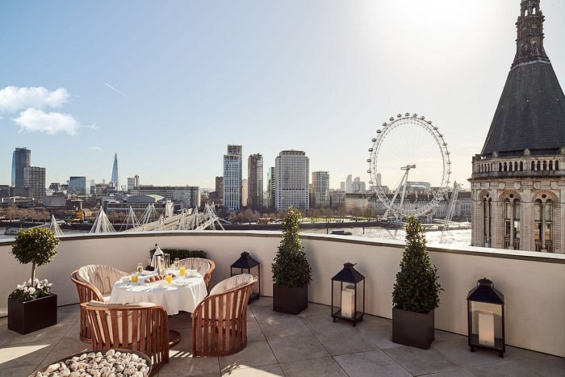
Figure 5 Brand perception
(Source: Corinthia, 2024 a)
Ibis brand is operating more than 1200 hotels globally and is considered a leader in hotel sectors. Accor group include many sub-brands like Ibis style, Ibis Budget and Ibis having prominent positions in the UK and Europe (Chevalier and Mazzalovo, 2021). In the UK Ibis has around 119 properties which defines the popularity of the hotel. The marketing strategy of the hotel aims to expand the hotel and attract customers (Bacari et al., 2021). Some key countries that contribute to the high performance of the hotel based on strong Revenue per available room in the fourth quarter of the UK (14.1%), Southern Europe (Italy 4.2% and Spain 6.2%), Germany (5.2%) and Brazil (2.6%). The continuous growth of the Ibis Hotel shows its share in the market and the hotel has positioned itself as a key player in the hospitality sector (Cheng, 2019).
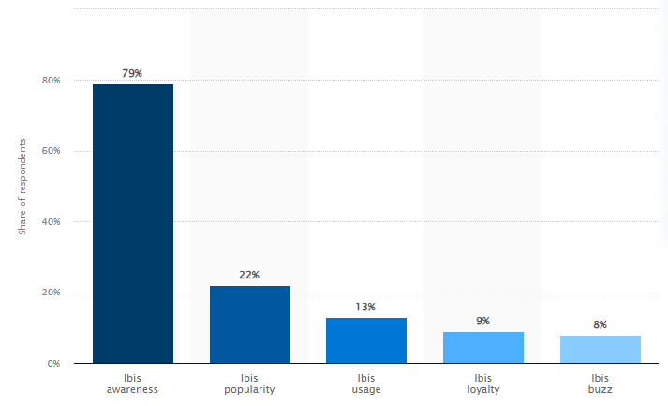
Figure 6 Ibis Brand Profile 2022
(Source: Statista: 2022)

Growth potential
Corinthia Development International (CDI) business comes under the umbrella of IHI. The purpose is to execute and source hotels to provide real estate acquisition opportunities and to carry out projects on the balance sheet of IHI or from investors globally. The CDI business aims to handle all the aspects of these acquisitions including negotiations with vendors, sourcing funds and undertaking environmental, financial and legal diligence, managing hotel operations and coordinating with professional consultants on site for the smooth delivery of Corinthia products (Corinthia. 2024 b). The hotel acquires properties and is working to turn the existing framework of historical architecture into modern contemporary projects to protect the rich heritage property. Corinthia Group is focusing on restoring various hotels and investing huge amounts that as €100 million for the renovation of its architecture. The hotel management is working with local authorities and tradesmen to ensure that buildings are restored and respect hotel heritage (Tritto, 2020). In 2008, Corinthia took over The Crown Estate ownership of the Metropole building and developed it into a modern 21st-century hotel. Corinthia London enjoys spectacular views from the River Thames and is now recognized as the top luxury hotel in the UK. Corinthia London is receiving positive reviews from guests and is ranked as top London hotels (Corinthia, 2023).
Ibis Hotel has substantial growth potential stimulated by various factors. One of the major factors is the increasing demand for reliable and affordable accommodation options and Ibis has positioned itself as a global leader in providing affordability. Travellers looking for affordable options to stay where they can have fun and comfort together which enhances Ibis sales by attracting budget-conscious individuals (Watts and Parks, 2018). Accor Group has a rapid and aggressive expansion strategy that supports Ibis brand growth. Ibis is focusing on opening new hotels in emerging markets as in India as travel and tourism are rising in the country which supports economic growth. The brand is focusing on opening Ibis hotels in India the current focus is to open at leisure and resort destinations (Economic Times, 2020). Ibis is focusing on integrating innovation, new designs, and digital services to attract customers of all ages. Its sustainability commitment also attracts eco-conscious customers. Ibis Hotel has high growth potential due to innovative services, expansion and travel demand.

Financial Commitment to CSR
Corinthia Hotel shows a strong commitment to Corporate Social Responsibilities (CSR) by presenting sustainable development approaches and sustainable practices. The financial practices have developed various charitable projects like providing clean water to more than 45,000 people in various African countries and donation activities during the COVID-19 pandemic. The Corinthia Hotel also provides educational and residential facilities to children in Malta and provides many food donations. The group also involves employees for community development initiatives like for maintenance of parks and arranging cultural activities for the guests and staff (Corinthiagroup, 2024 c).
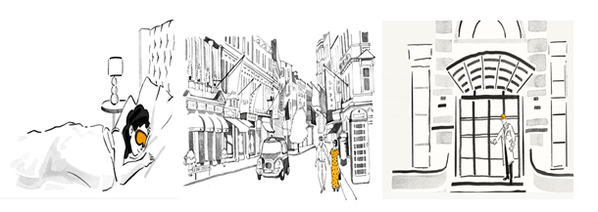
Figure 7 Corinthia CSR activities
(Source: Corinthiagroup, 2024 c).
Ibis Group is demonstrating CSR through its strong financial commitment to various activities. The Accor group has allocated a significant portion of its resources to sustainability efforts and community engagement programs. Carbon emission, energy efficiency and water conservation strategies are the few sustainability initiatives for the Ibis Hotel (Bohdanowicz and Zientara, 2016). Accor group also provide support to communities and engages in social projects. The CSR strategy of Accor is called Planet 21 which highlights its commitment to sustainable development. Ibis Hotel actively participate in CSR activities and these initiatives are focused on health and wellness programs and support environmental well-being for economic growth. The comprehensive approach shows that Ibis does not only focus on societal and economic growth and well-being (Accorgroup. 2016).
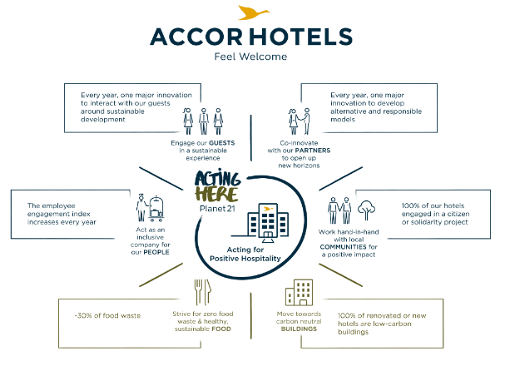
Figure 8 Accor CSR activities
(Source: Accor group. 2016)

Conclusion
The comparative analysis shows the comparison between revenue generation, growth potential, market position and financial commitment to CSR activities by Ibis and Corinthia Hotel. Corinthia Hotel made progress in revenue in 2023 and has a strong market share in Europe. The hotel provides personalized services that differentiate the hotel from others. The CSR activities are focused towards community engagement and sustainable development. On the contrary, Ibis Hotel shows revenue generation in emerging markets and supports sustainability and affordability practices according to the Planet 21 program. Both hotels have strengths in different regions as Corinthia is known for its heritage and luxury while Accor is known for its affordability.

Recommendations
- To improve its market positioning and achieve growth Corinthia should grow its business in emerging markets like Asia and the Middle East. The hotel can use its brand heritage and high-end services to enhance its reputation. The hotel can also target geusts from these regions to fulfill the rising demand for luxury stays generate revenue and achieve global positioning of the brand.
- Ibis should continue its growth in developing markets like India and should invest in digital technologies and innovative practices. These practices allow hotels to attract tech-savvy customers which enhances hotel occupancy rates and positions itself as hotel leaders in budget-friendly hotels.

References
‌Accor group. 2016. [online] Accor – Newsroom. Available at: https://press.accor.com/accorhotels-takes-its-corporate-responsibility-to-the-next-level-with-bold-new-csr-commitments-looking/?lang=en.
Accor group. 2023. 2023 Interim Financial Report. Accor.
all.accor.com. 2024. Ibis Hotels - Brand New Ibis, Brand New Comfort | Accor. [online] Available at: https://all.accor.com/brands/ibis.en.shtml.
all.accor.com. 2024a. ibis Sens. [online] Available at: https://all.accor.com/hotel/7367/index.en.shtml [Accessed 27 May 2024].
ANNUAL REPORT, 2023. Available at: https://www.corinthiagroup.com/wp-content/uploads/2024/05/35624-CORINTHIA-ANNUAL-REPORT-2023_WEB-min.pdf
Bacari, C., Séraphin, H. and Gowreesunkar, V.G., 2021. Sustainable development goals and the hotel sector: Case examples and implications. Worldwide Hospitality and Tourism Themes, 13(1), pp.9-21.
Bohdanowicz, P. and Zientara, P., 2016. CSR-inspired environmental initiatives in top hotel chains. In Tourism enterprises and the sustainability agenda across Europe (pp. 93-120). Routledge.
Camilleri, M.A. and Camilleri, M.A., 2018. The tourism industry: An overview (pp. 3-27). Springer International Publishing.
Cheng, J., 2019. Research and Suggestions on Declining Market Shares of Ibis Budget Hotels. Open Journal of Social Sciences, 8(1), pp.253-261.
Chevalier, M. and Mazzalovo, G., 2021. Luxury brand management in digital and sustainable times. John Wiley & Sons.
Corinthia group, 2023. Financial Statements. Available at: https://www.corinthiagroup.com/wp-content/uploads/2023/06/37547-CORINTHIA-ANNUAL-REPORT-2022_WEB-min.pdf.
Corinthia, 2023. UPLIF TING LI V ES. Available at: https://www.corinthia.com/globalassets/corinthia-global/documents/development/corinthia-development-presentation-may-2023-compressed.pdf.
Corinthia. 2024 a. We Operate. [online] Available at: https://www.corinthia.com/en-gb/development/we-operate/.
Corinthia. 2024 b. We Develop. [online] Available at: https://www.corinthia.com/en-gb/development/we-develop/ [Accessed 28 May 2024].
Corinthia. 2024. Corinthia Hotels | Luxury Hotels | Corinthia.com. [online] Available at: https://www.corinthia.com/?utm_source=RTM%20Media.
Corinthiagroup.com. 2024 c. Overview of our recent CSR activities | Corinthia Group - Owners, Developers & Operators of the Corinthia Hotels and Real Estate Brand. [online] Available at: https://www.corinthiagroup.com/insider/overview-of-our-recent-csr-activities/.
Demirçiftçi, T. and Kızılırmak, I., 2016. Strategic branding in hospitality: Case of Accor Hotels. Journal of Tourismology, 2(1), pp.50-64.
Economic Times, 2020. There is great potential for ibis to grow in India: Sylvain Laroche - ET HospitalityWorld. [online] ETHospitalityWorld.com. Available at: https://hospitality.economictimes.indiatimes.com/news/hotels/there-is-great-potential-for-ibis-to-grow-in-india-sylvain-laroche/74573881 [Accessed 28 May 2024].
Hayes, D.K., Hayes, J.D. and Hayes, P.A., 2021. Revenue management for the hospitality industry. John Wiley & Sons.
Hood, A., 2018. Wellbeing–a macro lens. International Journal of Spa and Wellness, 1(1), pp.100-105.
‌Statista. 2022. Ibis brand profile UK 2022. [online] Available at: https://www.statista.com/forecasts/1335566/ibis-hotels-brand-profile-in-the-uk
Statista. 2022. Ibis brand profile UK 2022. [online] Available at: https://www.statista.com/forecasts/1335566/ibis-hotels-brand-profile-in-the-uk
Tritto, A., 2020. Environmental management practices in hotels at world heritage sites. Journal of Sustainable Tourism, 28(11), pp.1911-1931.
Watts, R. and Parks, Z., 2018. Development of Tourism and Travel Industry. Scientific e-Resources.
Werden, G.J., 2017. Assigning market shares. In Dominance and Monopolization (pp. 147-184). Routledge.

