

UNIVERSITY OF WALES TRINITY SAINT DAVID
Birmingham

Master of Business Administration
International Marketing | Module Code: LCMB7026

Assessment Component : Individual Report
International Marketing Strategy Report
Wizz Air: Market Entry into Vietnam and Indonesia

Student Name: | Zarna Patel
Student ID Number: | 2536013
Programme: | Master of Business Administration
Module: | International Marketing
Lecturer: | Dian
Word Count: | 5498
Submitted on: | 26th Oct, 2026

TABLE OF CONTENTS
PRELIMINARY PAGES
List of Tables 3
List of Figures 3
Abbreviations 4
Company and Organisation Names Mentioned 5
Strategic Models Used 5
TASK 1: INTERNATIONAL MARKETING STRATEGY REPORT
1. Introduction and Brand Profile 6
1.1 Rationale and report structure 6
1.2 Brand profile 6
1.3 Current market position 7
2. Situational Analysis 9
2.1 Selecting the two target markets 9
2.2 PESTLE comparison 10
2.3 Cultural analysis 11
2.4 Implications for standardisation and adaptation 13
3. International STP and Marketing Mix (7Ps) 13
3.1 Segmentation and targeting 13
3.2 Positioning 14
3.3 Marketing mix (7Ps) 15
3.4 Conclusion on STP and mix 17
4. Market Entry Strategy 17
4.1 Theoretical logic 17
4.2 Options appraised 18
4.3 Recommendation 18
4.4 Lessons from Abu Dhabi 19
5. Ethical and Sustainability Considerations 19
6. Conclusion and Recommendations 21
TASK 2: PERSONAL REFLEXIVITY
7.1 Concrete experience: what I did and why 23
7.2 Reflective observation: how my standpoint shaped the analysis 24
7.3 Abstract conceptualisation: how a local practitioner might read it 24
7.4 Active experimentation: what I will do differently 25
REFERENCES
References 26

LIST OF TABLES
Table 1: Wizz Air key indicators, financial year 2026 (12 months to 31 March 2026) 7
Table 2: Country snapshot, Hungary (home), Vietnam and Indonesia 9
Table 3: PESTLE comparison of Vietnam and Indonesia with implications for Wizz Air 10
Table 4: Proposed segments in Vietnam and Indonesia 13
Table 5: Marketing mix (7Ps) for Vietnam and Indonesia compared with the home offer 15
Table 6: Entry mode appraisal for Wizz Air in Vietnam and Indonesia 18
Table 7: Ethical and sustainability issues, mitigation and SDG alignment 21

LIST OF FIGURES
Figure 1: Wizz Air revenue composition and year-on-year change, FY2026 7
Figure 2: Wizz Air’s internationalisation path and the proposed Asian steps 8
Figure 3: Hofstede scores, Hungary (home), Vietnam and Indonesia 12
Figure 4: Illustrative perceptual map, Europe-Asia travel, price against service level 15
Figure 5: Staged entry roadmap with shared stage gates 19
Figure 6: Reflexive account structured on Kolb’s experiential cycle 23

Abbreviations
Short form | Full form
7Ps | Product, price, place, promotion, people, process and physical evidence
A321neo / A321XLR | Airbus A321 new-engine option / extra-long-range variant
ADQ | Abu Dhabi state investment company (partner in Wizz Air Abu Dhabi)
AI | Artificial intelligence
ASEAN | Association of Southeast Asian Nations
CAGE | Cultural, administrative, geographic and economic distance framework
CEE | Central and Eastern Europe
CEPA | Comprehensive Economic Partnership Agreement
CO₂ | Carbon dioxide
EU | European Union
FTA | Free trade agreement
FY | Financial year
GDP | Gross domestic product
GLOBE | Global Leadership and Organizational Behavior Effectiveness project
ICAO | International Civil Aviation Organization
IDR | Indonesian rupiah
JV | Joint venture
PESTLE | Political, economic, social, technological, legal and environmental analysis
SDG(s) | United Nations Sustainable Development Goal(s)
SERVQUAL | Service quality measurement scale
STP | Segmentation, targeting and positioning
UK | United Kingdom
ULCC | Ultra-low-cost carrier
VFR | Visiting friends and relatives
VND | Vietnamese dong
WCED | World Commission on Environment and Development

Company and Organisation Names Mentioned
Name | Description
Wizz Air | Hungarian ultra-low-cost airline group; the focal brand
Wizz Air Abu Dhabi | Former joint venture (Wizz Air 49%, ADQ 51%), closed 2025
Ryanair / easyJet | Larger European low-cost carriers
Vietjet | Vietnamese low-cost carrier
AirAsia | Malaysia-based low-cost carrier group active across ASEAN
Vietnam Airlines | Vietnamese full-service national carrier
Garuda Indonesia | Indonesian full-service national carrier
Airbus | Aircraft manufacturer (A320 family and A321XLR)
ICAO | United Nations agency for civil aviation
European Commission | Executive body of the European Union
Hofstede Insights / The Culture Factor | Publishers of national culture dimension scores
MarketLine | Market research publisher (millennial consumer report)
Google, Temasek and Bain & Company | Authors of the e-Conomy SEA report on digital economies

Strategic Models Used
Term | Meaning
PESTLE | Macro-environment scan: political, economic, social, technological, legal, environmental
CAGE framework | Cultural, administrative, geographic and economic distance between markets (Ghemawat, 2001)
Hofstede, GLOBE, Schwartz | National and individual-level cultural value models
STP | Segmentation, targeting and positioning
Marketing mix (7Ps) | Product, price, place, promotion, people, process, physical evidence
Uppsala model | Incremental internationalisation driven by experiential learning
Eclectic (OLI) paradigm | Ownership, location and internalisation advantages explaining entry mode
Ansoff matrix | Market development: existing product in new markets
Porter’s generic strategies | Cost leadership, differentiation, focus
Resource-based view and dynamic capabilities | Resources and capabilities as sources of advantage
Carroll’s pyramid, stakeholder theory, SDGs | Ethical and sustainability frameworks
Kolb’s experiential cycle | Structure for the reflexive account in Task 2

Task 1: International Marketing Strategy Report

1. Introduction and Brand Profile

1.1 Rationale and report structure
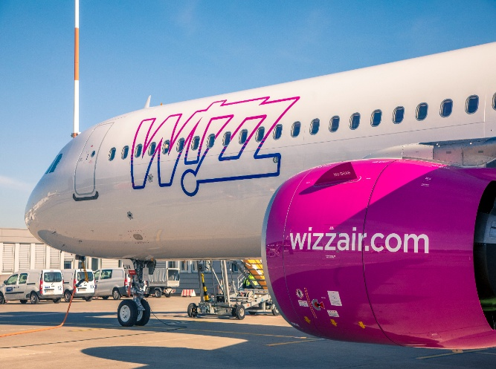
Wizz Air is a revealing case for international marketing because it has grown by replicating one standardised ultra-low-cost carrier (ULCC) model across culturally and institutionally different European markets (Doganis, 2019; Lohmann and Koo, 2013), and has since retreated from its only non-European venture (Xpatloop, 2025). Southeast Asia is among the most contested low-cost regions, shaped by ASEAN liberalisation and strong regional low-cost carriers (Fu et al., 2010; Hanaoka et al., 2014), so it tests whether a standardised model can be adapted without losing its cost advantage. Vietnam and Indonesia are selected because both are large, young and fast-growing ASEAN markets, yet they differ in institutions, which allows a genuine comparison rather than two near-identical cases (Ghemawat, 2007).
Source: The Hotel Journal, 30 January 2026.
The report follows the brief. Section 1 profiles Wizz Air and its market position. Section 2 compares the two markets using PESTLE and cultural frameworks. Section 3 develops the international segmentation, targeting and positioning (STP) and the 7Ps of the marketing mix. Section 4 recommends entry modes, Section 5 evaluates ethics and sustainability against the United Nations Sustainable Development Goals (SDGs), and Section 6 concludes. Task 2 is a personal reflexive account. Evidence combines company disclosures, regulator and multilateral sources and peer-reviewed literature. Judgements that rest on the author’s reasoning, such as segment sizes and perceptual positions, are labelled as such.

1.2 Brand profile
Wizz Air was established in Hungary in 2003 and began flying from Katowice in May 2004 (Wikipedia, 2026). It is headquartered in Budapest, has been listed in London since 2015 and operates an all-Airbus fleet, making it the world’s largest operator of the A321neo (Wikipedia, 2026). Its model matches the ULCC archetype: very low base fares, high aircraft utilisation, secondary airports, point-to-point networks and large ancillary income (Doganis, 2019; Dobruszkes, 2006; Lawton, 2002). Table 1 summarises its position in the year to March 2026.
Table 1: Wizz Air key indicators, financial year 2026 (12 months to 31 March 2026)
Indicator | Value
Passengers | 69.7 million (+10.0%)
Revenue | €5,691.4 million (+8.0%)
Operating profit | €139.7 million (−16.6%)
Net profit | €1.3 million (FY2025: €213.9 million)
Fleet at year end | 262 aircraft (231 a year earlier)
Load factor | 90.7% (FY2025: 91.2%)
Ancillary revenue | €2,530.0 million (+7.6%; about 44% of revenue)
Carbon intensity | 50.6 g CO₂ per passenger-kilometre (FY2025: 52.2 g)
Source: Wizz Air Holdings Plc (2026). Ancillary share is the author’s calculation (2,530.0 ÷ 5,691.4).
Figure 1 shows why cost discipline matters. Ancillary revenue is almost 45% of income, reflecting the unbundling logic through which a headline fare is stripped to the minimum and extras are sold separately (Garrow et al., 2012; Gillen and Morrison, 2003). Yet revenue and passengers grew faster than operating profit, which fell by 16.6%, so growth alone is not delivering returns (Wizz Air Holdings Plc, 2026). Two operational vulnerabilities matter for Asia: reliability, because some aircraft remain grounded for engine inspections (Wikipedia, 2026), and geopolitical exposure, because the company withheld FY2027 guidance citing the Iran conflict and the closure of the Strait of Hormuz (Wizz Air Holdings Plc, 2026).
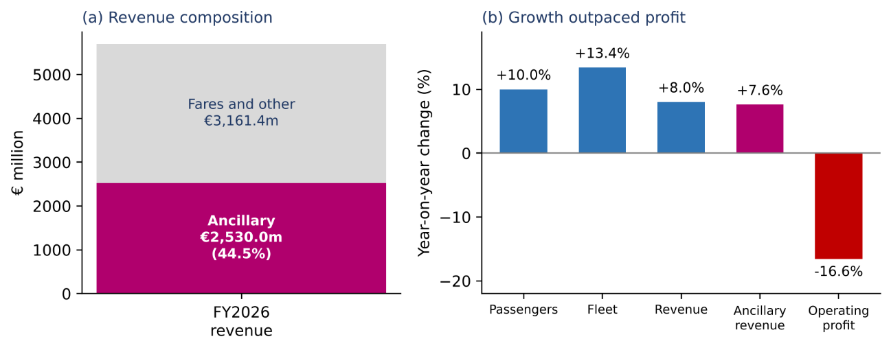
Figure 1: Wizz Air revenue composition and year-on-year change, FY2026
Source: Wizz Air Holdings Plc (2026); chart and ancillary share calculated by the author.

1.3 Current market position
In Porter’s (1980; 1985) terms Wizz Air is a cost leader, a position reinforced by the home-nation conditions of low-cost labour and fast-growing CEE demand that Porter (1990) identifies as sources of national advantage. The wider industry is shaped by ownership nationality rules and bilateral air service agreements, which limit how freely airlines can expand abroad (Hanlon, 2007). Globally it is a follower to Ryanair and easyJet, being Europe’s third-largest low-cost carrier (Wikipedia, 2026), but it positions itself as a leading low-cost carrier in Central and Eastern Europe (CEE), where its growth coincided with EU enlargement and rising incomes (Meyer and Peng, 2005; Wizz Air Holdings Plc, 2026). Its resource-based advantages, understood as valuable, rare and hard-to-imitate resources (Barney, 1991), are cost discipline, fleet commonality, a 90.7% load factor and digital sales capability. The last is increasingly supported by AI-based customer relationship management, which the literature links to performance and competitive advantage (Chatterjee et al., 2021; Mikalef et al., 2021) and which fits the dynamic capabilities view (Teece et al., 1997).
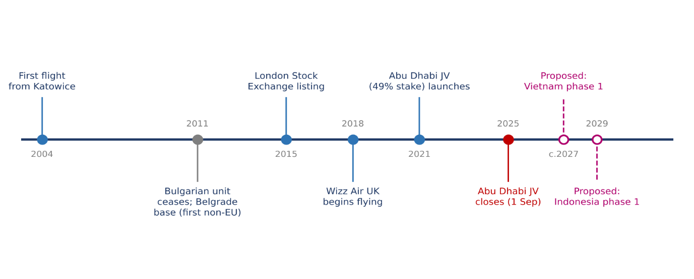
Wizz Air is not a born-global firm, whose international activity starts at or near inception (Oviatt and McDougall, 1994; Knight and Cavusgil, 2004; Rialp et al., 2005). It is better described as a regional multinational that followed an incremental, Uppsala-type path: home and neighbouring markets first, then wider Europe, with commitment rising as experiential knowledge accumulated (Johanson and Vahlne, 1977; Vahlne and Johanson, 2017). Figure 2 traces this path. The Abu Dhabi joint venture, with the state investor ADQ holding 51% and Wizz Air 49%, launched in 2021 and closed on 1 September 2025 after the airline cited aircraft reliability in extreme heat, airspace disruption and regulatory barriers to key markets (Xpatloop, 2025). The group now says its priority is its core markets (Wizz Air Holdings Plc, 2026). Any Asian entry must therefore be justified against that experience and framed as a small, reversible option, not a pivot.
Figure 2: Wizz Air’s internationalisation path and the proposed Asian steps
Source: Wikipedia (2026) and Xpatloop (2025) for historical events; proposed steps are the author’s recommendation (Section 4). Dates for proposed steps are indicative.

2. Situational Analysis

2.1 Selecting the two target markets
Selection used three tests: market attractiveness, institutional feasibility and fit with Wizz Air’s capabilities. On attractiveness, both countries pair large populations with middle-income spending power (Table 2). Vietnam reported a record 83.5 million air passengers in 2025 (Bao Bac Ninh TV, 2026), and Indonesia is an archipelago where air travel substitutes for long surface journeys, which is why low-cost carriers have been central to ASEAN liberalisation (Hanaoka et al., 2014; Forsyth et al., 2006). On institutional feasibility, both restrict foreign airline ownership, which rules out a wholly owned subsidiary (Tuoi Tre News, 2026; ICAO, 2013). On fit, Wizz Air’s ownership advantages are transferable but location advantages differ, so the eclectic paradigm implies different modes (Dunning, 1988; 2000).
Table 2: Country snapshot, Hungary (home), Vietnam and Indonesia
Indicator | Hungary | Vietnam | Indonesia
Population, 2024 (million) | 9.6 | 101.0 | 283.5
GDP per capita, 2024 (current US$) | 23,305 | 4,717 | 4,925
Foreign ownership cap, airlines | Not applicable | 34% (draft decree proposes 49%) | 49%
Trade link with the EU | EU member | EU–Vietnam FTA in force | EU–Indonesia CEPA signed September 2025, awaiting ratification
Domestic flights for foreign carriers | Not applicable | Restricted by ownership rules | Reserved to local carriers (cabotage)
Source: World Bank (2025); Tuoi Tre News (2026); ICAO (2013); European Commission (2020); ASEAN Briefing (2025); Republic of Indonesia (2009). Vietnam’s cap is from news coverage of a draft decree, not final law.
The CAGE framework (Ghemawat, 2001) sharpens the contrast. Culturally, Vietnam is nearer to Wizz Air’s CEE base because of historical links and a diaspora in several CEE countries (Hüwelmeier, 2015), whereas Indonesia is more distant. Administratively, Indonesia is more protective of domestic aviation (Republic of Indonesia, 2009), while Vietnam is consulting on raising its foreign cap from 34% to 49% (Tuoi Tre News, 2026). Geographically, both lie at or beyond the edge of A321XLR range from CEE hubs, which is tested in Section 4. Economically, both are middle-income, so low fares attract but ancillary yield is constrained (Prahalad and Hart, 2002). Thailand was considered, but the aim was institutional contrast within ASEAN, which Vietnam and Indonesia provide. Shenkar (2001) warns that distance measures can mislead, so the comparison is treated as a set of hypotheses to test.

2.2 PESTLE comparison
Table 3 compares the two markets and states what each factor means for Wizz Air, since description without application adds little (Doole and Lowe, 2012). Market-level facts are drawn from the sources cited in each cell.
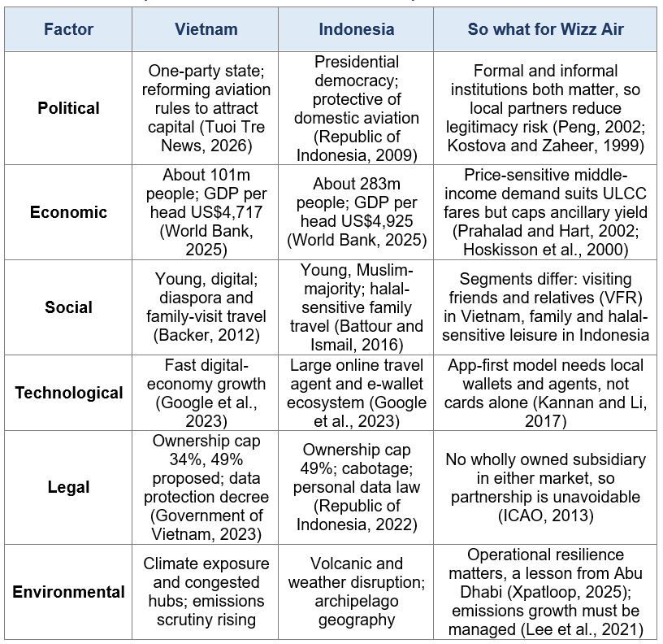
Table 3: PESTLE comparison of Vietnam and Indonesia with implications for Wizz Air
Source: compiled by the author from the sources cited in each cell. Statements about future conditions are the author’s assessment.
Ownership caps are not an anomaly but an expression of the nationality rules that structure the global airline industry (Hanlon, 2007). Three points follow from the analysis. First, the legal row decides the strategy more than any other: because neither market permits control through equity, Wizz Air’s historic route of building bases and owning subsidiaries does not transfer. Second, the institution-based view argues that informal norms, such as relationships and legitimacy, can matter as much as formal rules (Peng, 2002; Scott, 1995), and emerging markets often have ‘institutional voids’ that local intermediaries fill (Khanna and Palepu, 1997). Third, trade and air agreements improve access, such as the EU–Vietnam free trade agreement (European Commission, 2020) and the EU–ASEAN air transport agreement (European Commission, 2022), but they do not remove ownership rules. Political risk also includes safety reputation: Indonesian carriers were on the EU air safety list until 2018 (European Commission, 2018), which may still shape European perceptions of travel there; this is treated as a perception risk to be tested, not a finding. Henisz (2000) shows that constraints on political discretion affect investment, which is why predictable rules matter to Wizz Air’s staged commitment.
The social factor is where marketing most directly bites. Young urban consumers in both countries resemble the experience-seeking, digitally native cohort described in the millennial literature (MarketLine, 2017; Stein, 2013; Parment, 2013; Bolton et al., 2013), although such generational labels risk over-generalising. Diaspora travel is behaviourally distinctive: visiting friends and relatives (VFR) trips are frequent, price-sensitive and often underestimated in demand forecasts (Backer, 2012; Seaton and Palmer, 1997). Halal-compatible travel is an established tourism segment with specific needs (Battour and Ismail, 2016).
Competitive context reinforces these points. Southeast Asian aviation is dominated by regional low-cost carriers that have grown with liberalisation, and the entry of low-cost airlines has historically intensified fare competition and reshaped networks (Hanaoka et al., 2014; Alderighi et al., 2012; Fu et al., 2010). A European entrant therefore faces local competitors with lower cost-to-serve on short sectors, existing customer data and local brand familiarity. Its defensible niche is the long-haul Europe link, where its CEE network, secondary-airport access and diaspora relationships are relevant, and where the competitors are mainly full-service and one-stop carriers rather than local low-cost airlines.

2.3 Cultural analysis
Figure 3 compares Hofstede’s dimensions for Hungary, Vietnam and Indonesia (Hofstede, 1980; Hofstede et al., 2010). Hungary scores high on individualism (80), masculinity (88) and uncertainty avoidance (82). Both targets are strongly collectivist (Vietnam 20, Indonesia 14), have higher power distance (70 and 78) and lower uncertainty avoidance (30 and 48). Collectivism favours group and family offers, referrals and community channels over individually framed price messages (Triandis, 1995; de Mooij and Hofstede, 2010). High power distance makes endorsement by institutions, partners and recognised intermediaries more persuasive. Lower uncertainty avoidance suggests tolerance of no-frills service, yet travellers may still value flexibility when plans involve family obligations.
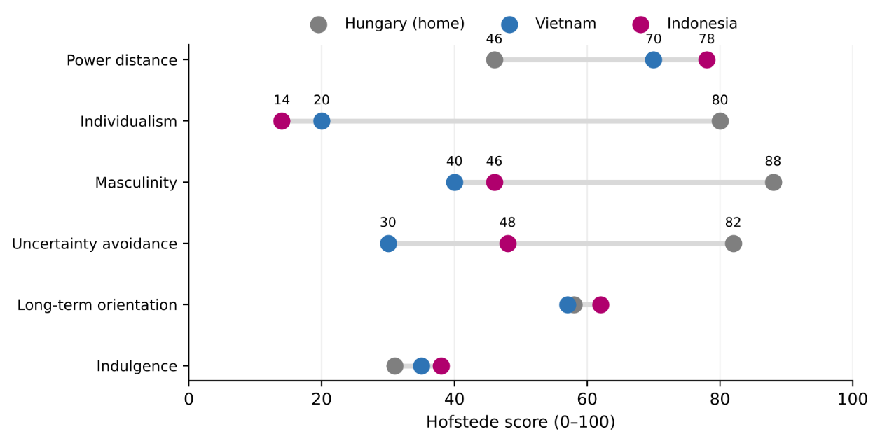
Figure 3: Hofstede scores, Hungary (home), Vietnam and Indonesia
Source: Hofstede Insights (2022) for Vietnam; long-standing Hofstede dataset values for Hungary and Indonesia (Hofstede et al., 2010). Chart drawn by the author.
The two targets also differ. Indonesia has a slightly longer-term orientation (62 against 57), and religion and community life shape consumption more visibly, which affects food, scheduling and communication (Battour and Ismail, 2016). Hall’s (1976) high- and low-context distinction and Hall and Hall (1990) suggest that both markets rely more on implicit, relationship-based communication than Wizz Air’s direct, transactional style, and Trompenaars and Hampden-Turner (1997) point in a similar direction on particularism. Inglehart and Baker (2000) add that traditional values persist alongside economic modernisation, so rising incomes will not simply produce European-style consumers.
The tools have limits. GLOBE offers an alternative with constructs such as in-group collectivism and humane orientation (House et al., 2004), but Vietnam was not among its 62 societies, so Hofstede and Schwartz’s (1994) values are used with caution. Hofstede’s work has been criticised for treating nations as homogeneous and for dated samples (McSweeney, 2002; Tung and Verbeke, 2010), and its evolution is itself acknowledged (Minkov and Hofstede, 2011). This matters here because a later release on The Culture Factor (2026) shows different values for some dimensions, notably lower individualism for Indonesia and different long-term orientation scores for Hungary and Indonesia. The qualitative conclusion, that both targets are far more collectivist than Hungary, is unchanged, but the numbers should be re-checked at submission. Kogut and Singh (1988) show that national culture also influences entry mode choice, which links this section to Section 4.

2.4 Implications for standardisation and adaptation
The two markets are similar in collectivism and power distance, which supports a shared brand idea built around family and value, and different in law, religion and geography, which supports adapted channels, offers and entry modes. This points to a regional, semiglobal approach with a standardised core and an adapted periphery, in line with Douglas and Craig (2011), the regional strategy argument of Rugman and Verbeke (2004), and the integration–responsiveness trade-off in the transnational model (Bartlett and Ghoshal, 1989; Yip, 1989).

3. International STP and Marketing Mix (7Ps)

3.1 Segmentation and targeting
International segmentation groups customers across or within countries on demographic, geographic, psychographic and benefit bases (Wind et al., 1973; Kotler and Keller, 2016; Doole and Lowe, 2012). For a long-haul low-fare product, the relevant literature also stresses that the model is vulnerable if demand is thin, which explains why many earlier long-haul low-cost carriers failed (Morrell, 2008; Whyte and Lohmann, 2015; Wensveen and Leick, 2009). Segments must therefore be large, repeatable and reachable. Table 4 identifies three per market. Sizes are not quantified because no source used reports them; they are hypotheses for primary research.
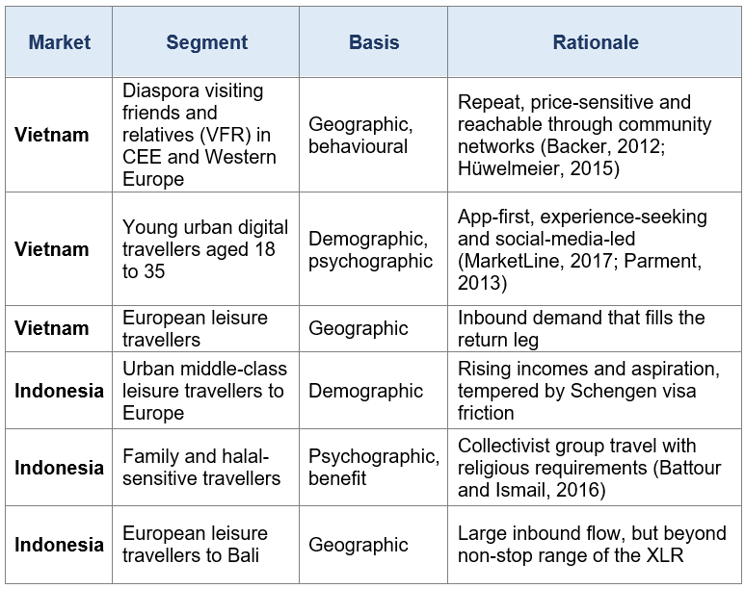
Table 4: Proposed segments in Vietnam and Indonesia
Source: author’s analysis using Wind et al. (1973) and Kotler and Keller (2016); literature as cited in the table.
Targeting follows the criteria of measurability, accessibility and substantiality (Kotler and Keller, 2016). Vietnam uses concentrated targeting of the VFR and young digital segments, because they are identifiable through diaspora networks and digital channels. Indonesia uses differentiated targeting of family and urban leisure segments through a partner, because Wizz Air lacks the local knowledge and rights to serve the whole market alone and faces the liability of outsidership (Johanson and Vahlne, 2009).

3.2 Positioning
The positioning idea is standardised: the lowest-fare, no-surprises way to reach Europe. It is expressed differently in each market, with family connection emphasised in Vietnam and family-friendly, respectful service in Indonesia. Figure 4 shows an illustrative perceptual map against regional low-cost carriers, full-service carriers and one-stop Gulf and Turkish carriers. The coordinates reflect the author’s judgement from public fare and service models, and research on passenger perceptions shows that value-for-money and service expectations differ systematically between low-cost and full-service carriers in Asia (O’Connell and Williams, 2005). The map therefore needs validation with primary data. Wizz Air’s brand equity (Aaker, 1991) in Asia is likely to be very low, so awareness and trust must be built, and entry by low-cost carriers typically intensifies price competition (Alderighi et al., 2012; Pearce, 2012; Graham and Shaw, 2008). A blue-ocean framing (Kim and Mauborgne, 2005) is attractive but should be treated cautiously, because the space is contested by one-stop full-service carriers.
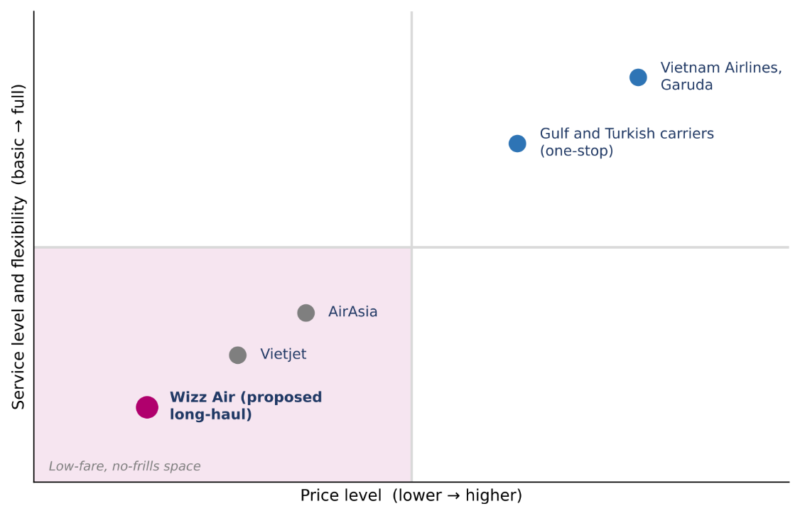
Figure 4: Illustrative perceptual map, Europe-Asia travel, price against service level
Source: author’s judgement, informed by O’Connell and Williams (2005) and public carrier models; positions are illustrative and unvalidated.

3.3 Marketing mix (7Ps)
Table 5 applies the 7Ps for services (Booms and Bitner, 1981) and justifies each adaptation against the home offer. The core product stays standardised because it is the source of cost advantage, whereas elements that touch language, payment, trust and religion are adapted. This reflects evidence that standardisation is more feasible for product and brand than for promotion and distribution (Theodosiou and Leonidou, 2003; Jain, 1989), that most firms use a hybrid (Vrontis et al., 2009), and that performance effects of standardisation depend on context (Samiee and Roth, 1992; Szymanski et al., 1993; Cavusgil and Zou, 1994; Zou and Cavusgil, 2002), against Levitt’s (1983) globalisation thesis.
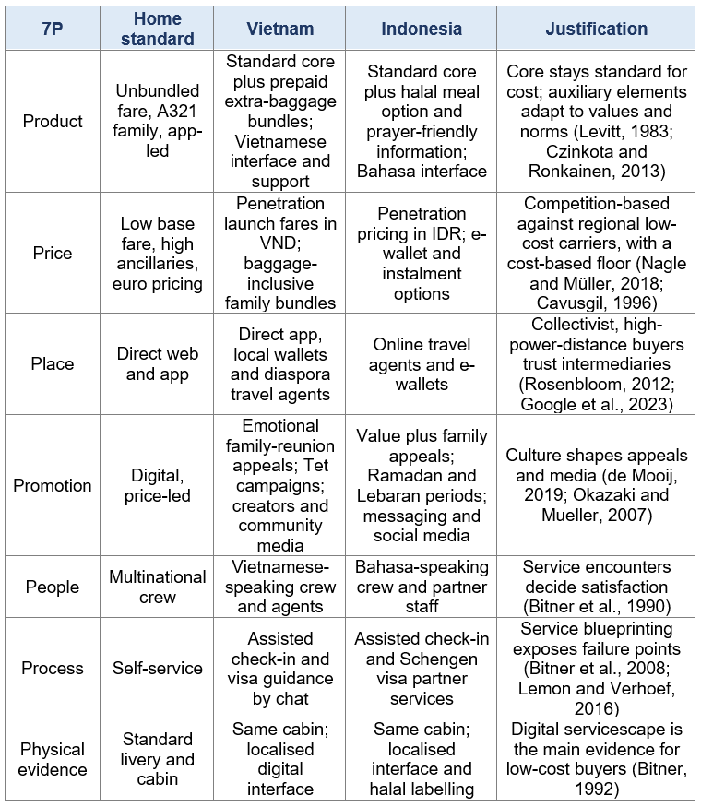
Table 5: Marketing mix (7Ps) for Vietnam and Indonesia compared with the home offer
Source: author’s analysis based on Booms and Bitner (1981), with literature as cited in the table.
In the module’s terms, the core product is safe, on-time transport from A to B; the packaging is the brand name, livery, fare labels and app interface, which must be translated and checked for meaning; and the auxiliary dimension is everything sold around the seat, such as baggage, seat selection, meals and flexibility. The product line is a short ladder of fare bundles whose depth can be matched to income: a basic fare for the price-led, and a bundle with baggage and changes for families. Promotion has a staged objective, awareness first, then trial and repeat, using social media, search and community channels in preference to expensive mass media, with emotional appeals for family reunion and rational appeals for value. Distribution intensity is selective, not intensive, since Wizz Air will sell directly and through a few trusted intermediaries; channel length is short for the app and longer for diaspora agents; and physical distribution means the flight itself, so airport slots, ground handling and aircraft availability are the true logistics constraints. Three comments deepen the table. First, price: with GDP per head under US$5,000 (World Bank, 2025), the fare is the product for many travellers, so penetration pricing is justified by the willingness-to-pay evidence for unbundled service and the bottom-of-the-pyramid logic (Balcombe et al., 2009; Prahalad and Hart, 2002). Because the diaspora segment carries gifts, a pre-paid baggage bundle may convert better than a surprise fee, although this is a hypothesis for testing. Second, place and process: online travel agents, mobile wallets and social commerce are central to Southeast Asian digital consumption (Google et al., 2023), and digital marketing effects depend on channel integration (Kannan and Li, 2017). Third, service quality: the SERVQUAL dimensions of reliability, assurance and empathy (Parasuraman et al., 1988; Zeithaml et al., 1985; Lovelock and Wirtz, 2021) help to set the minimum standard that justifies the low fare in trust-oriented cultures. Airport choice also shapes cost, because low-cost carriers differ from full-service carriers in demand for airport services (Barrett, 2004).

3.4 Conclusion on STP and mix
The strategy is standardised in positioning and product core and adapted in place, promotion and process, where trust, payment and regulation differ most. It sits between the globalisation and adaptation poles, consistent with the semiglobal view (Douglas and Craig, 2011) and with the finding that adaptation should be selective (Vrontis et al., 2009).

4. Market Entry Strategy

4.1 Theoretical logic
Four theories guide the choice. The Uppsala model predicts incremental commitment as experiential knowledge reduces perceived risk, and its revision stresses the liability of outsidership, meaning that exclusion from local business networks can hurt more than foreignness (Johanson and Vahlne, 1977; 2009; Zaheer, 1995). Internalisation theory explains why firms keep control of valuable know-how (Buckley and Casson, 1976). The eclectic paradigm combines ownership, location and internalisation advantages (Dunning, 1988; 2000). Transaction-cost and risk research suggests that cultural distance and uncertainty favour shared-control modes (Anderson and Gatignon, 1986; Kogut and Singh, 1988; Hill et al., 1990; Hennart, 1988). In emerging economies, entry choices also depend on institutions and resources (Meyer et al., 2009) and, in Asia, on alliance formation with local partners (Tse et al., 1997). Ansoff’s (1957) market development strategy, selling an existing product in new markets, describes the strategic intent, while Vernon’s (1966) product-cycle logic helps to explain why a model matured in Europe now diffuses to emerging markets. Decisions should also be staged and reversible, since small-firm and real-options research shows that rational, evolving entry processes outperform one-off commitments (Ahi et al., 2017; Dinu, 2018; Cavusgil et al., 2017).

4.2 Options appraised
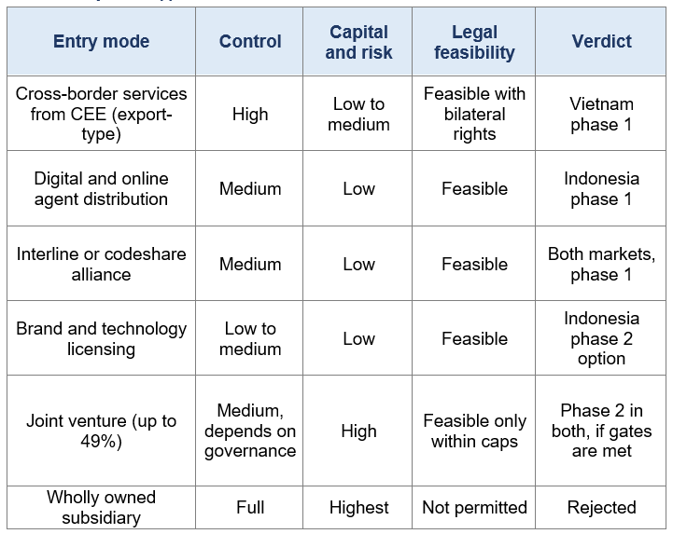
Table 6: Entry mode appraisal for Wizz Air in Vietnam and Indonesia
Source: author’s appraisal using Czinkota and Ronkainen (2013) and Cavusgil et al. (2017); legal feasibility from Tuoi Tre News (2026) and ICAO (2013).

4.3 Recommendation
For Vietnam, begin with scheduled long-haul services from CEE using Wizz Air’s A321XLR aircraft, supported by an interline or codeshare agreement with a local low-cost carrier for onward domestic travel. Wizz Air plans to use all 11 of its A321XLRs on longer-range routes (Wizz Air Holdings Plc, 2026). The distance from CEE hubs to Vietnam is close to the XLR’s range limit and must be validated against payload and winds. Long-haul low-cost operations have a mixed record, so the economics must be proven before commitment (Morrell, 2008; Whyte and Lohmann, 2015). If the proposed 49% ownership cap is adopted (Tuoi Tre News, 2026) and the gates below are met, move to a minority joint venture.
For Indonesia, start with digital and online agent entry. Jakarta and Bali lie beyond non-stop XLR range, so a direct launch would need technical stops that undermine the cost advantage. Build brand awareness and demand data through online travel agents and interline links. Only then consider licensing the brand and revenue-management technology to a local carrier, or a minority joint venture within the 49% cap, since cabotage excludes foreign carriers from domestic flights in any case (Republic of Indonesia, 2009; ICAO, 2013). ASEAN’s open-skies direction supports gradual liberalisation, but national ownership rules remain (Forsyth et al., 2006; ASEAN Secretariat, 2015).
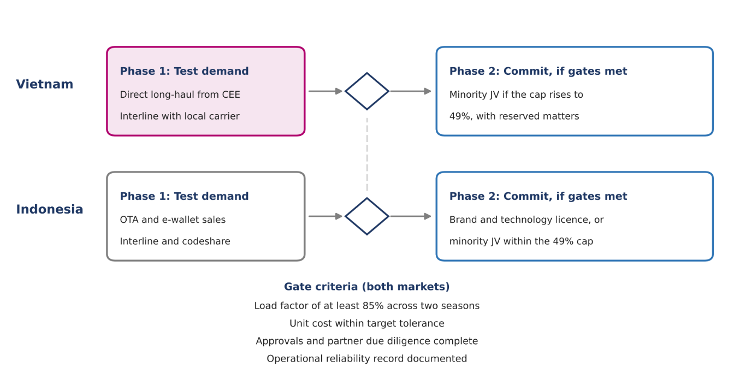
Figure 5: Staged entry roadmap with shared stage gates
Source: author’s recommendation, applying the Uppsala and real-options logic (Johanson and Vahlne, 1977; Ahi et al., 2017). Gate thresholds are proposals for board approval.

4.4 Lessons from Abu Dhabi
The 2021 joint venture put Wizz Air at 49% with a state-backed partner holding control, and it ended with the carrier citing heat-related reliability, airspace disruption and market-access limits (Xpatloop, 2025). Any future joint venture should therefore include reserved matters on brand, safety and pricing, a put option or exit mechanism, and an operational trial of the aircraft in local conditions before commitment. Wizz Air’s stated concentration on core markets (Wizz Air Holdings Plc, 2026) means the Asian plan must remain small enough not to compromise that focus. It is a capital-light option, not a diversification of the core. Three risks should be monitored. Aircraft availability could constrain the plan if engine inspections continue to ground part of the fleet (Wikipedia, 2026). Airspace and fuel-cost shocks linked to the Gulf conflict could change routing economics (Wizz Air Holdings Plc, 2026). And in emerging markets, institutional change can alter entry conditions quickly, so each gate should include a review of the rules as well as the numbers (Meyer et al., 2009; Henisz, 2000).

5. Ethical and Sustainability Considerations
Ethical evaluation uses three lenses from the module: cultural relativism, the justice approach and the SDGs as a global reference (United Nations, 2015; Sachs, 2012). Hunt and Vitell’s (1986) general theory notes that managers judge actions through both rules and perceived consequences, and Carroll’s (1991) pyramid reminds us that legal compliance is a floor, not a ceiling. Integrative social contracts theory separates universal ‘hypernorms’ from locally legitimate norms (Donaldson and Dunfee, 1994), and Rawls’s (1971) justice approach asks whether the least advantaged are treated fairly. Stakeholder thinking requires that passengers, workers, partners and host communities are all considered (Freeman, 1984; Crane et al., 2019). Marketing-specific normative guidance asks firms to avoid harm and to be transparent (Laczniak and Murphy, 2006).
The central tension is climate. Aviation’s contribution to warming is significant and its growth has outpaced efficiency gains (Lee et al., 2021; Gössling and Humpe, 2020). A strategy that stimulates low-fare long-haul demand in two fast-growing markets raises absolute emissions even when emissions per passenger fall. Wizz Air reports 50.6 g CO₂ per passenger-kilometre, down from 52.2 g (Wizz Air Holdings Plc, 2026), and the industry’s long-term goal is net zero by 2050 (ICAO, 2022), yet technology alone is unlikely to close the gap (Peeters et al., 2016). Greenwashing is a second risk. A UK advertising regulator ruling against a rival low-cost carrier’s ‘lowest emissions’ claim shows how comparative environmental claims can be judged misleading (Advertising Standards Authority, 2020), and research explains why firms drift into selective disclosure (Delmas and Burbano, 2011; Lyon and Montgomery, 2015). Brundtland’s (WCED, 1987) definition of sustainable development, meeting present needs without compromising future generations, therefore applies directly to the growth-review trigger proposed below.
Workforce and technology ethics also deserve attention. Low-cost models depend on lean staffing and high utilisation, so recruiting local crew and agents on fair terms matters for decent work, and for service quality, which the services literature links to employee treatment (Bitner et al., 1990; Zeithaml et al., 1985). AI-driven personalisation and dynamic pricing raise fairness questions when different customers see different prices, particularly where digital literacy varies; transparency about how prices are set, and human routes to resolve disputes, are proportionate safeguards (Chatterjee et al., 2021; Mikalef et al., 2021).
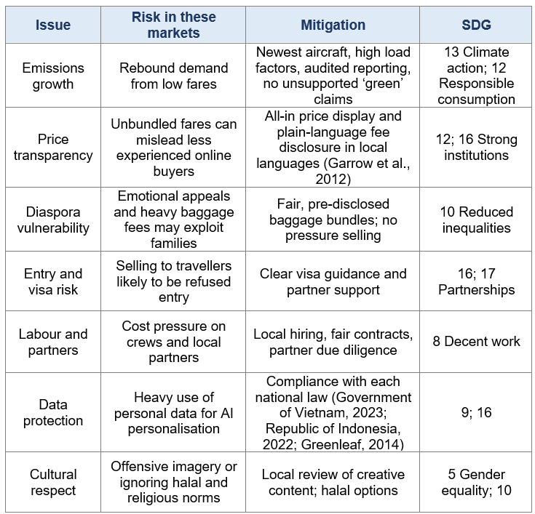
Table 7: Ethical and sustainability issues, mitigation and SDG alignment
Source: author’s analysis; SDG numbers from United Nations (2015).
Cultural relativism supports adapting to halal food and religious calendars, but it cannot justify lower safety, privacy or fee-disclosure standards in a host market; the justice approach suggests one minimum standard applied everywhere, with local adaptation above it. Shared-value thinking (Porter and Kramer, 2011) offers a further angle, since affordable connectivity can support family contact, education and trade and thus SDGs 9 and 10, but the claim must be tested honestly against the emissions cost. Partnership under SDG 17 should be real, treating partners as co-owners of reputation and not only as legal devices to satisfy ownership caps. Overall the strategy performs well on fairness and partnership and poorly on climate, which no marketing adaptation resolves. The board paper should state this openly and commit to reviewing growth if reported emissions intensity stops improving.

6. Conclusion and Recommendations
Wizz Air has a transferable cost and digital advantage, but its Abu Dhabi experience and its stated focus on Central and Eastern Europe mean that Asia should be approached as a staged, reversible option (Wizz Air Holdings Plc, 2026; Xpatloop, 2025). Vietnam and Indonesia are similar in collectivism and power distance, which supports a shared family-and-value brand idea, and different in law, religion and geography, which supports adapted channels, promotion, process and entry mode (Hofstede et al., 2010; Ghemawat, 2001). The recommendations are:
1. Enter Vietnam first with cross-border long-haul services aimed at the diaspora VFR and young digital segments, with an interline partner, and review a minority joint venture only if the ownership cap rises and gates are met.
2. Enter Indonesia second through online agents, e-wallets and alliances, treating licensing or a minority joint venture as a later option.
3. Standardise the core, adapt the periphery: keep the fare model and fleet, and adapt payment, language, trust-building channels, halal options and visa support.
4. Govern partnerships tightly with reserved matters, exit rights and operational trials.
5. Be honest about climate: use audited metrics, avoid green superlatives and set a growth-review trigger.
The main limitation is that segment sizes, prices and perceptual positions are reasoned from public information and need primary research and route-level financial modelling before commitment. Some institutional facts, such as Vietnam’s draft ownership change, may also have moved by the time of reading.

Task 2: Personal Reflexivity
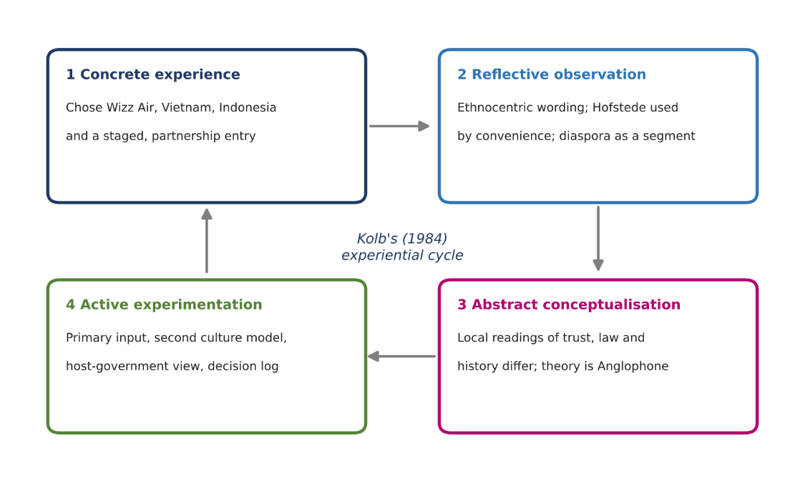
This reflection follows Kolb’s (1984) cycle of concrete experience, reflective observation, abstract conceptualisation and active experimentation (Figure 6), and asks ‘why’ at each decision in the spirit of critical reflexivity (Cunliffe, 2004; Schön, 1983). Gibbs’s (1988) cycle gives a similar structure, and reflection is understood as turning experience into learning (Boud et al., 1985; Moon, 2004). Personal details in square brackets should be completed by the author.

Figure 6: Reflexive account structured on Kolb’s experiential cycle
Source: adapted from Kolb (1984); content is the author’s reflection.

7.1 Concrete experience: what I did and why
I chose Wizz Air because its business model could be analysed concretely and because it forces a hard question: can a standardised ultra-low-cost model travel across cultures? Why not Xiaomi or Tata Tiago? Honestly, because airline economics felt tractable to me and the brief pushed me towards a brand with visible internationalisation decisions. I chose Asia because the module’s emphasis on distance (Ghemawat, 2001) made a contrast with Wizz Air’s European base analytically interesting. That is a preference, not a neutral finding, and I should have said so earlier in the report. Choosing a brand because it is familiar is also a risk: a familiar business model can make assumptions feel like facts.
Why Vietnam and Indonesia, and not Thailand or the Philippines? I wanted two ASEAN countries in the same regional trade context but with different institutions, so that comparison would be meaningful. I recommended staged, partnership-based entry because ownership caps and Wizz Air’s Abu Dhabi exit made a wholly owned approach impossible and a bold approach unwise (Xpatloop, 2025; Tuoi Tre News, 2026).

7.2 Reflective observation: how my standpoint shaped the analysis
I am from India and have a background into the field of management and I am studying in the UK. My vocabulary comes from European and Anglophone business education: PESTLE, Hofstede and Uppsala. Three effects are visible in the report. First, I treated regulation as a constraint to work around, describing ownership caps as barriers. A practitioner in Hanoi or Jakarta may see them as legitimate tools of national development and security. My language places the foreign entrant at the centre, an ethnocentric habit the module warns against (Doole and Lowe, 2012).
Second, I used Hofstede scores to explain consumers even though I know national averages hide regional, generational and class differences (McSweeney, 2002; Tung and Verbeke, 2010). I did so because the scores were available, comparable and expected, and that convenience shaped what I noticed: collectivism and power distance became the story, while diversity within Indonesia’s islands or between northern and southern Vietnam received little attention. Finding that a newer dataset disagreed with the older one reinforced the point. Third, my source base is English-language and mostly corporate, news and academic material from Europe and North America. I could not read Vietnamese or Bahasa regulators’ texts directly, so I relied on translated news coverage for the ownership rules, which means I may have missed nuance. Fourth, I described diaspora travellers as a segment. That is marketing language, but for families it concerns reunion and obligation, and reducing it to a label risks the simplifying outside gaze that Said (1978) describes, even when well meant.

7.3 Abstract conceptualisation: how a local practitioner might read it
A Vietnamese practitioner might argue that trust is built through personal relationships and recognised intermediaries, so a digital-first, low-fare brand is not enough: who vouches for Wizz Air? They might add that a domestic low-cost carrier is already a national success story, so a ‘lowest fare’ claim meets national pride as well as price competition, and they would likely be sceptical of ‘young digital travellers’ as a single group. An Indonesian practitioner would probably start from geography and religion before price. They might ask why a European carrier proposes international connectivity when inter-island flying is the actual market, and read my halal option as a tick-box unless it is designed with Muslim consumers, not for them. They might also find my mention of past safety restrictions on Indonesian carriers stereotyping unless balanced by evidence of improvement. Both might say that the staged partnership approach is the most respectful part of the proposal, because it accepts that local firms hold knowledge outsiders lack (Johanson and Vahlne, 2009).
These readings show the limit of my method. The institution-based view and the liability of foreignness helped me name the problem (Peng, 2002; Zaheer, 1995), but both place the foreign firm at the centre of the story. Reflexivity means recognising that the questions I asked were shaped by where I stand (Johnson and Duberley, 2003).

7.4 Active experimentation: what I will do differently
I will take four actions. First, I will test assumptions with primary input, such as short interviews with practitioners or students from Vietnam and Indonesia, before treating any segment as real. Second, I will pair Hofstede with a second source such as GLOBE or Schwartz (House et al., 2004; Schwartz, 1994) and use regional rather than national data. Third, I will rewrite regulatory discussions from the host government’s perspective, asking what problem a rule is solving. Fourth, I will keep a decision log recording my ‘why’ for each major choice so that preferences can be inspected. To make these actions specific and measurable, as Kolb-based reflection requires, I will complete at least three practitioner interviews and one regional data check before my next market report, and I will compare my positioning claims with at least two primary sources from the host country. The learning is that my analysis was strong on structure and weaker on voice. The reflexive question is not whether my background influenced the report, because it did, but which parts of the argument would survive if a Vietnamese or Indonesian marketer rewrote them.

References
Aaker, D.A. (1991) Managing brand equity: capitalizing on the value of a brand name. New York: Free Press.
Advertising Standards Authority (2020) ASA ruling on Ryanair Ltd. London: ASA.
Ahi, A., Baronchelli, G., Kuivalainen, O. and Piantoni, M. (2017) ‘International market entry: how do small and medium-sized enterprises make decisions?’, Journal of International Marketing, 25(1), pp. 1-21.
Alderighi, M., Cento, A., Nijkamp, P. and Rietveld, P. (2012) ‘Competition in the European aviation market: the entry of low-cost airlines’, Journal of Transport Geography, 24, pp. 223-233.
Anderson, E. and Gatignon, H. (1986) ‘Modes of foreign entry: a transaction cost analysis and propositions’, Journal of International Business Studies, 17(3), pp. 1-26.
Ansoff, H.I. (1957) ‘Strategies for diversification’, Harvard Business Review, 35(5), pp. 113-124.
ASEAN Briefing (2025) EU–Indonesia CEPA: unlocking market access and growth strategies for investors. Available at: https://www.aseanbriefing.com/news/eu-indonesia-cepa-unlocking-market-access-and-growth-strategies-for-investors/ (Accessed: 22 October 2026).
ASEAN Secretariat (2015) ASEAN Economic Community Blueprint 2025. Jakarta: ASEAN Secretariat.
Backer, E. (2012) ‘VFR travel: it is underestimated’, Tourism Management, 33(1), pp. 74-79.
Balcombe, K., Fraser, I. and Harris, L. (2009) ‘Consumer willingness to pay for in-flight service and comfort levels: a choice experiment’, Journal of Air Transport Management, 15(5), pp. 221-226.
Bao Bac Ninh TV (2026) Vietnam’s aviation hits record 83.5 million passengers in 2025 as international travel surges. Available at: https://en.baobacninhtv.vn/vietnam-s-aviation-hits-record-83-5-million-passengers-in-2025-as-international-travel-surges-postid437145.bbg (Accessed: 22 October 2026).
Barney, J. (1991) ‘Firm resources and sustained competitive advantage’, Journal of Management, 17(1), pp. 99-120.
Barrett, S.D. (2004) ‘How do the demands for airport services differ between full-service carriers and low-cost carriers?’, Journal of Air Transport Management, 10(1), pp. 33-39.
Bartlett, C.A. and Ghoshal, S. (1989) Managing across borders: the transnational solution. Boston, MA: Harvard Business School Press.
Battour, M. and Ismail, M.N. (2016) ‘Halal tourism: concepts, practises, challenges and future’, Tourism Management Perspectives, 19, pp. 150-154.
Bitner, M.J. (1992) ‘Servicescapes: the impact of physical surroundings on customers and employees’, Journal of Marketing, 56(2), pp. 57-71.
Bitner, M.J., Booms, B.H. and Tetreault, M.S. (1990) ‘The service encounter: diagnosing favorable and unfavorable incidents’, Journal of Marketing, 54(1), pp. 71-84.
Bitner, M.J., Ostrom, A.L. and Morgan, F.N. (2008) ‘Service blueprinting: a practical technique for service innovation’, California Management Review, 50(3), pp. 66-94.
Bolton, R.N., Parasuraman, A., Hoefnagels, A., Migchels, N., Kabadayi, S., Gruber, T., Komarova Loureiro, Y. and Solnet, D. (2013) ‘Understanding Generation Y and their use of social media: a review and research agenda’, Journal of Service Management, 24(3), pp. 245-267.
Booms, B.H. and Bitner, M.J. (1981) ‘Marketing strategies and organization structures for service firms’, in Donnelly, J.H. and George, W.R. (eds) Marketing of services. Chicago, IL: American Marketing Association, pp. 47-52.
Boud, D., Keogh, R. and Walker, D. (1985) Reflection: turning experience into learning. London: Kogan Page.
Buckley, P.J. and Casson, M. (1976) The future of the multinational enterprise. London: Macmillan.
Carroll, A.B. (1991) ‘The pyramid of corporate social responsibility: toward the moral management of organizational stakeholders’, Business Horizons, 34(4), pp. 39-48.
Cavusgil, S.T. (1996) ‘Pricing for global markets’, Columbia Journal of World Business, 31(4), pp. 66-78.
Cavusgil, S.T. and Zou, S. (1994) ‘Marketing strategy–performance relationship: an investigation of the empirical link in export market ventures’, Journal of Marketing, 58(1), pp. 1-21.
Cavusgil, S.T., Knight, G. and Riesenberger, J.R. (2017) International business: the new realities. 4th edn. Harlow: Pearson.
Chatterjee, S., Rana, N.P., Tamilmani, K. and Sharma, A. (2021) ‘The effect of AI-based CRM on organization performance and competitive advantage: an empirical analysis in the B2B context’, Industrial Marketing Management, 97, pp. 205-219.
Crane, A., Matten, D., Glozer, S. and Spence, L. (2019) Business ethics: managing corporate citizenship and sustainability in the age of globalization. 5th edn. Oxford: Oxford University Press.
Cunliffe, A.L. (2004) ‘On becoming a critically reflexive practitioner’, Journal of Management Education, 28(4), pp. 407-426.
Czinkota, M.R. and Ronkainen, I.A. (2013) International marketing. 10th edn. Mason, OH: South-Western Cengage Learning.
de Mooij, M. (2019) Consumer behavior and culture: consequences for global marketing and advertising. 3rd edn. Thousand Oaks, CA: Sage.
de Mooij, M. and Hofstede, G. (2010) ‘The Hofstede model: applications to global branding and advertising strategy and research’, International Journal of Advertising, 29(1), pp. 85-110.
Delmas, M.A. and Burbano, V.C. (2011) ‘The drivers of greenwashing’, California Management Review, 54(1), pp. 64-87.
Dinu, A.-M. (2018) ‘International market entry strategies’, Academic Journal of Economic Studies, 4(2), pp. 20-25.
Dobruszkes, F. (2006) ‘An analysis of European low-cost airlines and their networks’, Journal of Transport Geography, 14(4), pp. 249-264.
Doganis, R. (2019) Flying off course: airline economics and marketing. 5th edn. Abingdon: Routledge.
Donaldson, T. and Dunfee, T.W. (1994) ‘Toward a unified conception of business ethics: integrative social contracts theory’, Academy of Management Review, 19(2), pp. 252-284.
Doole, I. and Lowe, R. (2012) International marketing strategy: analysis, development and implementation. 6th edn. Andover: Cengage Learning.
Douglas, S.P. and Craig, C.S. (2011) ‘Convergence and divergence: developing a semiglobal marketing strategy’, Journal of International Marketing, 19(1), pp. 82-101.
Dunning, J.H. (1988) ‘The eclectic paradigm of international production: a restatement and some possible extensions’, Journal of International Business Studies, 19(1), pp. 1-31.
Dunning, J.H. (2000) ‘The eclectic paradigm as an envelope for economic and business theories of MNE activity’, International Business Review, 9(2), pp. 163-190.
European Commission (2018) EU Air Safety List: update removing all Indonesian carriers. Brussels: European Commission.
European Commission (2020) EU-Vietnam free trade agreement. Brussels: European Commission.
European Commission (2022) EU-ASEAN Comprehensive Air Transport Agreement. Brussels: European Commission.
Forsyth, P., King, J., Rodolfo, C.L. and Trace, K. (2006) ‘Open skies in ASEAN’, Journal of Air Transport Management, 12(3), pp. 143-152.
Freeman, R.E. (1984) Strategic management: a stakeholder approach. Boston, MA: Pitman.
Fu, X., Oum, T.H. and Zhang, A. (2010) ‘Air transport liberalization and its impacts on airline competition and air passenger traffic’, Transportation Journal, 49(4), pp. 24-41.
Garrow, L.A., Hotle, S. and Mumbower, S. (2012) ‘Assessment of product debundling trends in the US airline industry: customer service and public policy implications’, Transportation Research Part C: Emerging Technologies, 24, pp. 192-205.
Ghemawat, P. (2001) ‘Distance still matters: the hard reality of global expansion’, Harvard Business Review, 79(8), pp. 137-147.
Ghemawat, P. (2007) Redefining global strategy: crossing borders in a world where differences still matter. Boston, MA: Harvard Business School Press.
Gibbs, G. (1988) Learning by doing: a guide to teaching and learning methods. Oxford: Further Education Unit.
Gillen, D. and Morrison, W. (2003) ‘Bundling, integration and the delivered price of air travel: are low cost carriers full service competitors?’, Journal of Air Transport Management, 9(1), pp. 15-23.
Google, Temasek and Bain & Company (2023) e-Conomy SEA 2023: reaching new heights. Singapore: Google, Temasek and Bain & Company.
Gössling, S. and Humpe, A. (2020) ‘The global scale, distribution and growth of aviation: implications for climate change’, Global Environmental Change, 65, 102194.
Government of Vietnam (2023) Decree No. 13/2023/ND-CP on personal data protection. Hanoi: Government of Vietnam.
Graham, B. and Shaw, J. (2008) ‘Low-cost airlines in Europe: reconciling liberalization and sustainability’, Geoforum, 39(3), pp. 1439-1451.
Greenleaf, G. (2014) Asian data privacy laws: trade and human rights perspectives. Oxford: Oxford University Press.
Hall, E.T. (1976) Beyond culture. New York: Anchor Press.
Hall, E.T. and Hall, M.R. (1990) Understanding cultural differences: Germans, French and Americans. Yarmouth, ME: Intercultural Press.
Hanaoka, S., Takebayashi, M., Ishikura, T. and Saraswati, B. (2014) ‘Low-cost carriers versus full-service carriers in ASEAN: the impact of liberalization policy on competition’, Journal of Air Transport Management, 40, pp. 96–105.
Hanlon, P. (2007) Global airlines: competition in a transnational industry. 3rd edn. Oxford: Butterworth-Heinemann.
Henisz, W.J. (2000) ‘The institutional environment for multinational investment’, Journal of Law, Economics, and Organization, 16(2), pp. 334–364.
Hennart, J.-F. (1988) ‘A transaction costs theory of equity joint ventures’, Strategic Management Journal, 9(4), pp. 361–374.
Hill, C.W.L., Hwang, P. and Kim, W.C. (1990) ‘An eclectic theory of the choice of international entry mode’, Strategic Management Journal, 11(2), pp. 117–128.
Hofstede Insights (2022) Country comparison: Vietnam. Available at: https://www.hofstede-insights.com/country-comparison-tool (Accessed: 22 October 2026).
Hofstede, G. (1980) Culture’s consequences: international differences in work-related values. Beverly Hills, CA: Sage.
Hofstede, G., Hofstede, G.J. and Minkov, M. (2010) Cultures and organizations: software of the mind. 3rd edn. New York: McGraw-Hill.
Hoskisson, R.E., Eden, L., Lau, C.M. and Wright, M. (2000) ‘Strategy in emerging economies’, Academy of Management Journal, 43(3), pp. 249–267.
House, R.J., Hanges, P.J., Javidan, M., Dorfman, P.W. and Gupta, V. (eds) (2004) Culture, leadership, and organizations: the GLOBE study of 62 societies. Thousand Oaks, CA: Sage.
Hunt, S.D. and Vitell, S. (1986) ‘A general theory of marketing ethics’, Journal of Macromarketing, 6(1), pp. 5–16.
Hüwelmeier, G. (2015) ‘Postsocialist bazaars: diversity, solidarity, and conflict in the marketplace’, Laboratorium, 7(1), pp. 43–52.
Inglehart, R. and Baker, W.E. (2000) ‘Modernization, cultural change, and the persistence of traditional values’, American Sociological Review, 65(1), pp. 19–51.
International Civil Aviation Organization (ICAO) (2013) Substantial ownership and effective control: working paper presented by Indonesia. ATConf/6-WP/84. Montréal: ICAO. Available at: https://www.icao.int/Meetings/atconf6/Documents/WorkingPapers/ATConf6-wp084_en.pdf (Accessed: 22 October 2026).
International Civil Aviation Organization (ICAO) (2022) Report on the feasibility of a long-term aspirational goal (LTAG) for international civil aviation CO2 emission reductions. Montréal: ICAO.
Jain, S.C. (1989) ‘Standardization of international marketing strategy: some research hypotheses’, Journal of Marketing, 53(1), pp. 70–79.
Johanson, J. and Vahlne, J.-E. (1977) ‘The internationalization process of the firm: a model of knowledge development and increasing foreign market commitments’, Journal of International Business Studies, 8(1), pp. 23–32.
Johanson, J. and Vahlne, J.-E. (2009) ‘The Uppsala internationalization process model revisited: from liability of foreignness to liability of outsidership’, Journal of International Business Studies, 40(9), pp. 1411–1431.
Johnson, P. and Duberley, J. (2003) ‘Reflexivity in management research’, Journal of Management Studies, 40(5), pp. 1279–1303.
Kannan, P.K. and Li, H. (2017) ‘Digital marketing: a framework, review and research agenda’, International Journal of Research in Marketing, 34(1), pp. 22–45.
Khanna, T. and Palepu, K. (1997) ‘Why focused strategies may be wrong for emerging markets’, Harvard Business Review, 75(4), pp. 41–51.
Kim, W.C. and Mauborgne, R. (2005) Blue ocean strategy. Boston, MA: Harvard Business School Press.
Knight, G.A. and Cavusgil, S.T. (2004) ‘Innovation, organizational capabilities, and the born-global firm’, Journal of International Business Studies, 35(2), pp. 124–141.
Kogut, B. and Singh, H. (1988) ‘The effect of national culture on the choice of entry mode’, Journal of International Business Studies, 19(3), pp. 411–432.
Kolb, D.A. (1984) Experiential learning: experience as the source of learning and development. Englewood Cliffs, NJ: Prentice-Hall.
Kostova, T. and Zaheer, S. (1999) ‘Organizational legitimacy under conditions of complexity: the case of the multinational enterprise’, Academy of Management Review, 24(1), pp. 64–81.
Kotler, P. and Keller, K.L. (2016) Marketing management. 15th edn. Harlow: Pearson.
Laczniak, G.R. and Murphy, P.E. (2006) ‘Normative perspectives for ethical and socially responsible marketing’, Journal of Macromarketing, 26(2), pp. 154–177.
Lawton, T.C. (2002) Cleared for take-off: structure and strategy in the low fare airline business. Aldershot: Ashgate.
Lee, D.S., Fahey, D.W., Skowron, A., Allen, M.R., Burkhardt, U., Chen, Q. et al. (2021) ‘The contribution of global aviation to anthropogenic climate forcing for 2000 to 2018’, Atmospheric Environment, 244, 117834.
Lemon, K.N. and Verhoef, P.C. (2016) ‘Understanding customer experience throughout the customer journey’, Journal of Marketing, 80(6), pp. 69–96.
Levitt, T. (1983) ‘The globalization of markets’, Harvard Business Review, 61(3), pp. 92–102.
Lohmann, G. and Koo, T.T.R. (2013) ‘The airline business model spectrum’, Journal of Air Transport Management, 31, pp. 7–9.
Lovelock, C. and Wirtz, J. (2021) Services marketing: people, technology, strategy. 9th edn. Singapore: World Scientific.
Lyon, T.P. and Montgomery, A.W. (2015) ‘The means and end of greenwash’, Organization & Environment, 28(2), pp. 223–249.
MarketLine (2017) Millennial consumers: understanding key trends driving consumer behaviours. Reference code ML00026-009. London: MarketLine.
McSweeney, B. (2002) ‘Hofstede’s model of national cultural differences and their consequences: a triumph of faith – a failure of analysis’, Human Relations, 55(1), pp. 89–118.
Meyer, K.E. and Peng, M.W. (2005) ‘Probing theoretically into Central and Eastern Europe: transactions, resources, and institutions’, Journal of International Business Studies, 36(6), pp. 600–621.
Meyer, K.E., Estrin, S., Bhaumik, S.K. and Peng, M.W. (2009) ‘Institutions, resources, and entry strategies in emerging economies’, Strategic Management Journal, 30(1), pp. 61–80.
Mikalef, P., Conboy, K. and Krogstie, J. (2021) ‘Artificial intelligence as an enabler of B2B marketing: a dynamic capabilities micro-foundations approach’, Industrial Marketing Management, 98, pp. 80–92.
Minkov, M. and Hofstede, G. (2011) ‘The evolution of Hofstede’s doctrine’, Cross Cultural Management, 18(1), pp. 10–20.
Moon, J.A. (2004) A handbook of reflective and experiential learning: theory and practice. London: RoutledgeFalmer.
Morrell, P. (2008) ‘Can long-haul low-cost airlines be successful?’, Research in Transportation Economics, 24(1), pp. 61–67.
Nagle, T.T. and Müller, G. (2018) The strategy and tactics of pricing: a guide to growing more profitably. 6th edn. New York: Routledge.
O’Connell, J.F. and Williams, G. (2005) ‘Passengers’ perceptions of low cost airlines and full service carriers: a case study involving Ryanair, Air Asia and Malaysia Airlines’, Journal of Air Transport Management, 11(4), pp. 259–272.
Okazaki, S. and Mueller, B. (2007) ‘Cross-cultural advertising research: where we have been and where we need to go’, International Marketing Review, 24(5), pp. 499–518.
Oviatt, B.M. and McDougall, P.P. (1994) ‘Toward a theory of international new ventures’, Journal of International Business Studies, 25(1), pp. 45–64.
Parasuraman, A., Zeithaml, V.A. and Berry, L.L. (1988) ‘SERVQUAL: a multiple-item scale for measuring consumer perceptions of service quality’, Journal of Retailing, 64(1), pp. 12–40.
Parment, A. (2013) ‘Generation Y vs. Baby Boomers: shopping behavior, buyer involvement and implications for retailing’, Journal of Retailing and Consumer Services, 20(2), pp. 189–199.
Pearce, B. (2012) ‘The state of air transport markets and the airline industry after the great recession’, Journal of Air Transport Management, 21, pp. 3–9.
Peeters, P., Higham, J., Kutzner, D., Cohen, S. and Gössling, S. (2016) ‘Are technology myths stalling aviation climate policy?’, Transportation Research Part D: Transport and Environment, 44, pp. 30–42.
Peng, M.W. (2002) ‘Towards an institution-based view of business strategy’, Asia Pacific Journal of Management, 19(2–3), pp. 251–267.
Porter, M.E. (1980) Competitive strategy: techniques for analyzing industries and competitors. New York: Free Press.
Porter, M.E. (1985) Competitive advantage: creating and sustaining superior performance. New York: Free Press.
Porter, M.E. (1990) The competitive advantage of nations. New York: Free Press.
Porter, M.E. and Kramer, M.R. (2011) ‘Creating shared value’, Harvard Business Review, 89(1/2), pp. 62–77.
Prahalad, C.K. and Hart, S.L. (2002) ‘The fortune at the bottom of the pyramid’, Strategy+Business, 26, pp. 54–67.
Rawls, J. (1971) A theory of justice. Cambridge, MA: Harvard University Press.
Republic of Indonesia (2009) Law No. 1 of 2009 on Aviation. Jakarta: Government of Indonesia.
Republic of Indonesia (2022) Law No. 27 of 2022 on Personal Data Protection. Jakarta: Government of Indonesia.
Rialp, A., Rialp, J. and Knight, G.A. (2005) ‘The phenomenon of early internationalizing firms: what do we know after a decade (1993–2003) of scientific inquiry?’, International Business Review, 14(2), pp. 147–166.
Rosenbloom, B. (2012) Marketing channels: a management view. 8th edn. Mason, OH: South-Western Cengage Learning.
Rugman, A.M. and Verbeke, A. (2004) ‘A perspective on regional and global strategies of multinational enterprises’, Journal of International Business Studies, 35(1), pp. 3–18.
Sachs, J.D. (2012) ‘From Millennium Development Goals to Sustainable Development Goals’, The Lancet, 379(9832), pp. 2206–2211.
Said, E.W. (1978) Orientalism. New York: Pantheon Books.
Samiee, S. and Roth, K. (1992) ‘The influence of global marketing standardization on performance’, Journal of Marketing, 56(2), pp. 1–17.
Schön, D.A. (1983) The reflective practitioner: how professionals think in action. New York: Basic Books.
Schwartz, S.H. (1994) ‘Beyond individualism/collectivism: new cultural dimensions of values’, in Kim, U., Triandis, H.C., Kâğitçibaşi, Ç., Choi, S.-C. and Yoon, G. (eds) Individualism and collectivism: theory, method, and applications. Thousand Oaks, CA: Sage, pp. 85–119.
Scott, W.R. (1995) Institutions and organizations. Thousand Oaks, CA: Sage.
Seaton, A.V. and Palmer, C. (1997) ‘Understanding VFR tourism behaviour: the first five years of the United Kingdom tourism survey’, Tourism Management, 18(6), pp. 345–355.
Shenkar, O. (2001) ‘Cultural distance revisited: towards a more rigorous conceptualization and measurement of cultural differences’, Journal of International Business Studies, 32(3), pp. 519–535.
Stein, J. (2013) ‘Millennials: the Me Me Me generation’, Time, 20 May.
Szymanski, D.M., Bharadwaj, S.G. and Varadarajan, P.R. (1993) ‘Standardization versus adaptation of international marketing strategy: an empirical investigation’, Journal of Marketing, 57(4), pp. 1–17.
Teece, D.J., Pisano, G. and Shuen, A. (1997) ‘Dynamic capabilities and strategic management’, Strategic Management Journal, 18(7), pp. 509–533.
The Culture Factor (2026) Country comparison tool. Available at: https://www.theculturefactor.com/country-comparison-tool (Accessed: 22 October 2026).
Theodosiou, M. and Leonidou, L.C. (2003) ‘Standardization versus adaptation of international marketing strategy: an integrative assessment of the empirical research’, International Business Review, 12(2), pp. 141–171.
Triandis, H.C. (1995) Individualism and collectivism. Boulder, CO: Westview Press.
Trompenaars, F. and Hampden-Turner, C. (1997) Riding the waves of culture: understanding cultural diversity in business. 2nd edn. London: Nicholas Brealey.
Tse, D.K., Pan, Y. and Au, K.Y. (1997) ‘How MNCs choose entry modes and form alliances: the China experience’, Journal of International Business Studies, 28(4), pp. 779–805.
Tung, R.L. and Verbeke, A. (2010) ‘Beyond Hofstede and GLOBE: improving the quality of cross-cultural research’, Journal of International Business Studies, 41(8), pp. 1259–1274.
Tuoi Tre News (2026) Vietnam ministry proposes easing capital rules, raising foreign ownership cap for new airlines. Available at: https://news.tuoitre.vn/vietnam-ministry-proposes-easing-capital-rules-raising-foreign-ownership-cap-for-new-airlines-103260210160840083.htm (Accessed: 22 October 2026).
United Nations (2015) Transforming our world: the 2030 Agenda for Sustainable Development. A/RES/70/1. New York: United Nations.
Vahlne, J.-E. and Johanson, J. (2017) ‘From internationalization to evolution: the Uppsala model at 40 years’, Journal of International Business Studies, 48(9), pp. 1087–1102.
Vernon, R. (1966) ‘International investment and international trade in the product cycle’, Quarterly Journal of Economics, 80(2), pp. 190–207.
Vrontis, D., Thrassou, A. and Lamprianou, I. (2009) ‘International marketing adaptation versus standardisation of multinational companies’, International Marketing Review, 26(4/5), pp. 477–500.
Wensveen, J.G. and Leick, R. (2009) ‘The long-haul low-cost carrier: a unique business model’, Journal of Air Transport Management, 15(3), pp. 127–133.
Whyte, R. and Lohmann, G. (2015) ‘Low-cost long-haul carriers: a quantitative analysis of their rise and fall’, Journal of Air Transport Management, 42, pp. 159–165.
Wikipedia (2026) Wizz Air. Available at: https://en.wikipedia.org/wiki/Wizz_Air (Accessed: 22 October 2026).
Wind, Y., Douglas, S.P. and Perlmutter, H.V. (1973) ‘Guidelines for developing international marketing strategies’, Journal of Marketing, 37(2), pp. 14–23.
Wizz Air Holdings Plc (2026) Results for the 12 months to 31 March 2026. Available at: https://www.investegate.co.uk/announcement/rns/wizz-air-holdings--wizz/final-results/9612330 (Accessed: 22 October 2026).
World Bank (2025) World Development Indicators: GDP per capita (current US$) and total population, 2024. Available at: https://data.worldbank.org (Accessed: 22 October 2026).
World Commission on Environment and Development (WCED) (1987) Our common future. Oxford: Oxford University Press.
Xpatloop (2025) Wizz Air ends Abu Dhabi operations. Available at: https://xpatloop.com/channels/2025/07/wizz-air-ends-abu-dhabi-operations.html (Accessed: 22 October 2026).
Yip, G.S. (1989) ‘Global strategy… in a world of nations?’, Sloan Management Review, 31(1), pp. 29–41.
Zaheer, S. (1995) ‘Overcoming the liability of foreignness’, Academy of Management Journal, 38(2), pp. 341–363.
Zeithaml, V.A., Parasuraman, A. and Berry, L.L. (1985) ‘Problems and strategies in services marketing’, Journal of Marketing, 49(2), pp. 33–46.
Zou, S. and Cavusgil, S.T. (2002) ‘The GMS: a broad conceptualization of global marketing strategy and its effect on firm performance’, Journal of Marketing, 66(4), pp. 40–56.

