H8H exercise prepositions, adverbs, numbers
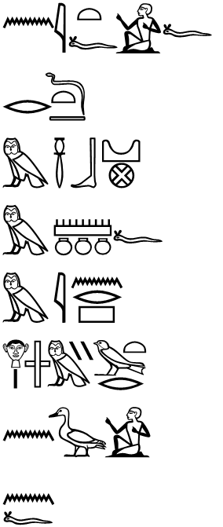 | n jt=f | for his father
 | r D.t | to eternity
 | m AbDw | in Abydos  - m of location
 | m mnw=f | as his monument  - m of identity
 | m jnr | out of stone  - m of substance
 | Hr jmj-wr.t | on the west bank  jmj = Nisbe of m, wr.t (temporal + spatial) greatness – eternity
 | n sA=f | for his son
 | n=f | for him

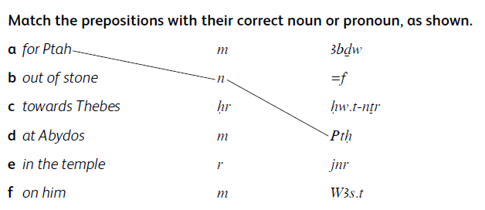

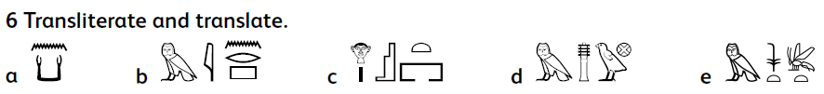
a n kA for the ka-soul; b m jnr out of stone; c Hr s.t on the throne; d m +dw in Busiris;
e m njswt-bjt as a king of Upper and Lower Egypt

