Vehicle Systems - Suspension Analysis
1996 Van Diemen Formula Ford
Asad Naqvi - 1907788
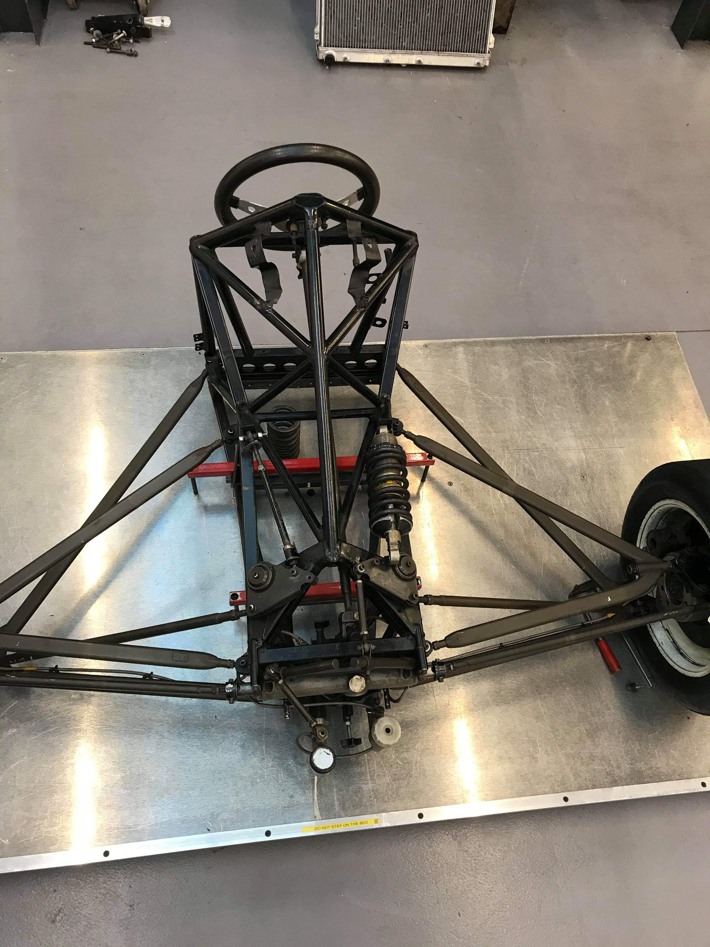

Contents

Figures…………………………………………………………………………………………………………………………………… …..2

1.0 Introduction……………………………………………………………………………………………………………………………3

Equipment……………………………………………………………………………………………………………………………………4
2.0 - vernier
2.1 - engineers square
2.2 - height gauge
2.3 - Wingeo3

Toe Angle …………………………………………………………………………………………………………………………………..5
3.0 - Toe Angle
3.1 - Toe-in
3.2 - Toe-out

Camber Angle …………………………………………………………………………………………………………………………..6
4.0 - Camber
4.1 - Positive Camber
4.2 - Negative Camber
4.3 - Neutral Camber
5.0 - Kingpin inclination
6.0 - Bump steer
7.0 - methodology session-one ……………………………………………………………………………………………….8
8.0 - methodology session-two……………………………………………………………………………………………….10

WIngeo Methodology ……………………………………………………………………………………………………………..13
Wingeo3 - Predicted Results…………………………………………………………………………………………………..14
Locus……………………………………………………………………………………………………………………………………….15
Measured Results …………………………………………………………………………………………………………………..16
Comparing Results………………………………………………………………………………………………………………….17
Suspension leverage……………………………………………………………………………………………………………….18
Spring Rate Calculation…………………………………………………………………………………………………………..19
Wheel Rate/ Equation 1………….....…………………………………………………………………………………………..20
Natural Frequency of Sprung/ Unsprung Mass/ Equation 2-3 ……………………………………..……….21
Conclusion……………………………………………………………………………………………………………………………...22
Recommendations for further study……………………………………………………………………………………….23
Appendices……………………………………………………………………………………………………………………………..24
References………………………………………………………………………………………………………………………………25

Figures

Figure 1.0 - Initial options
Figure 1.1 - Ford GEM file
Figure 1.2 - Table
Figure 2.0 - predicted ride height vs. camber & toe
Figure 3.0 - Locus (roll center) wingeo3
Figure 4.0 - Ride height vs. camber
Figure 5.0 - Predicted vs. toe
Figure 6.0 - Measured camber vs. predicted camber

1.0 - Introduction

This is a detailed report on how to interpret measurements taken from a 1996 Van Diemen Formula Ford. The measurements were taken on the front right-hand side of the formula Ford in the X, Y, and Z-axis. The measurements recorded will then be inputted into Mitchells WinGeo3 to simulate the ‘Fords’ suspension with different toe and camber angles. The measurements that were recorded and the data that was taken from WinGeo3 will be used to generate graphs. These graphs will then be compared and evaluated.

Equipment
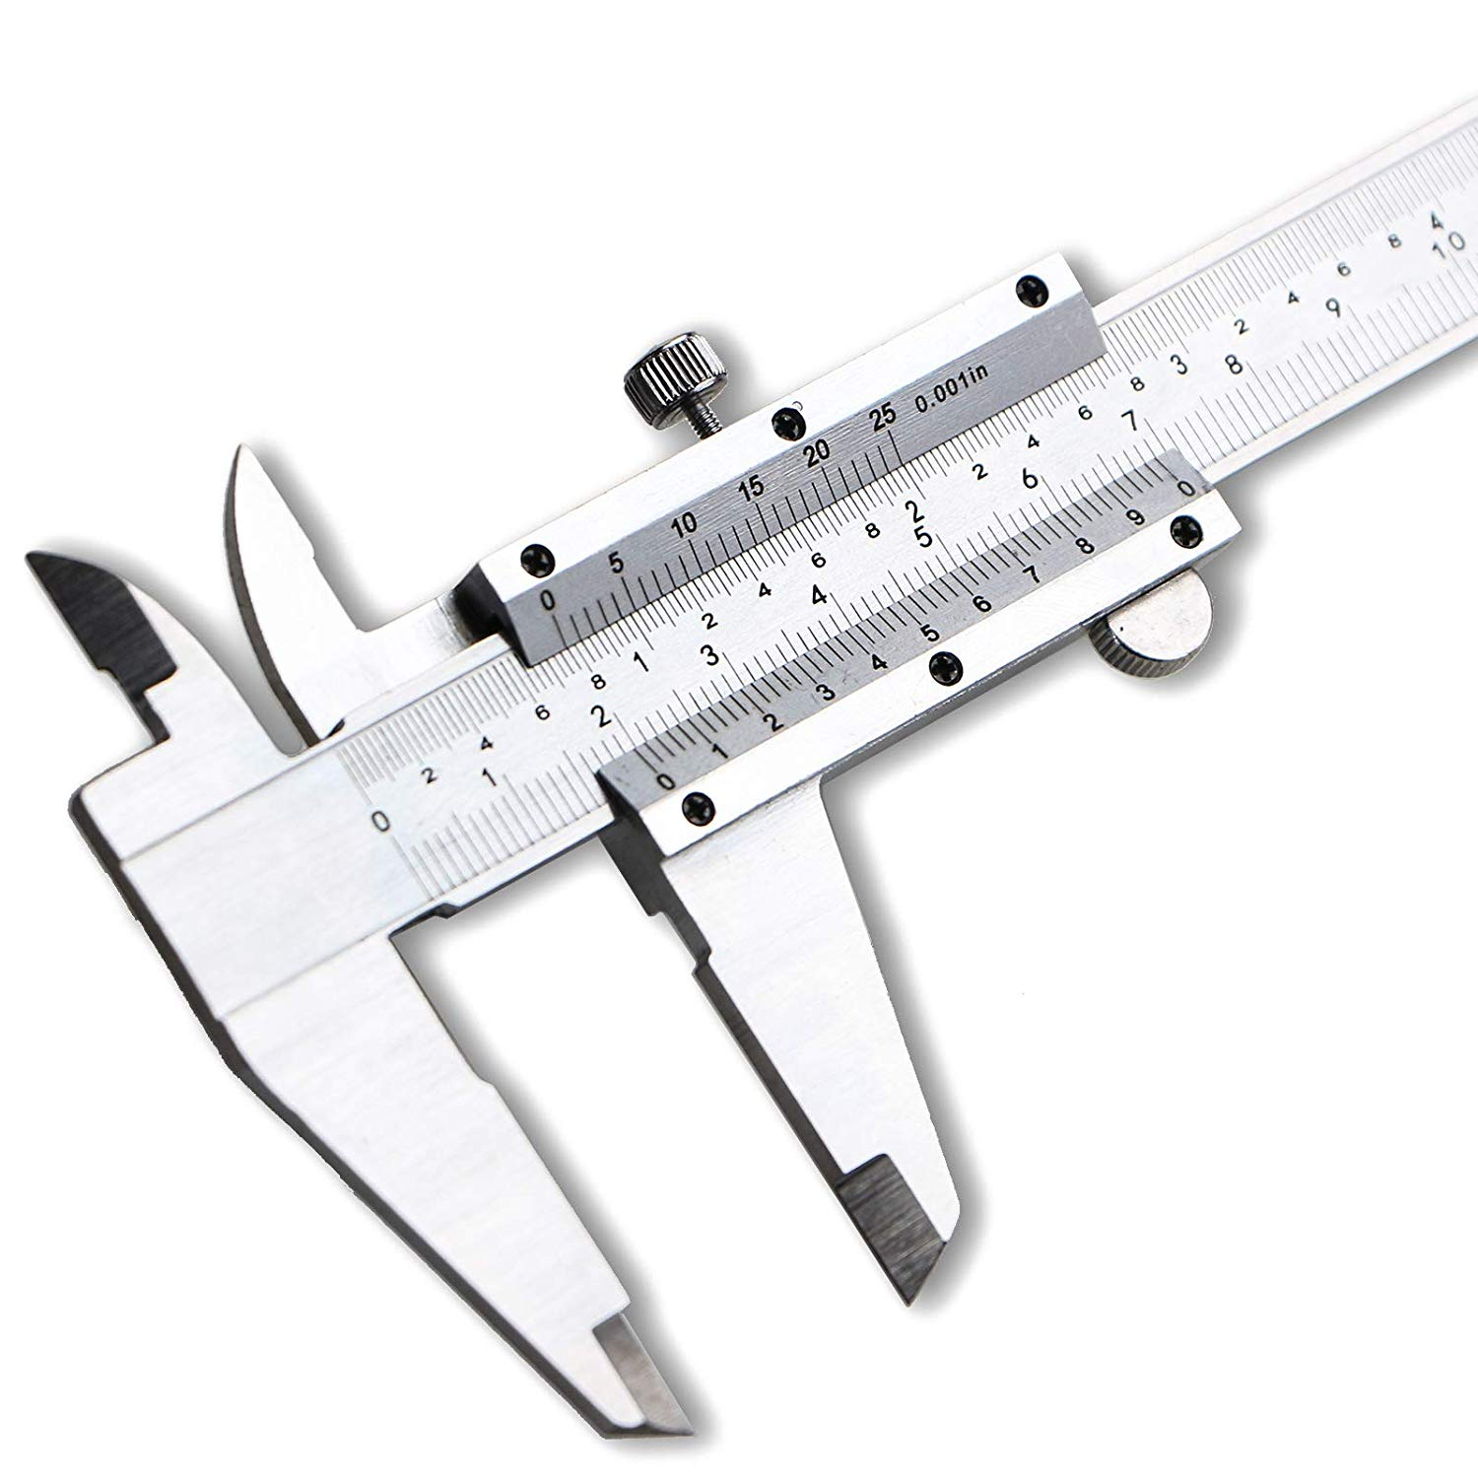
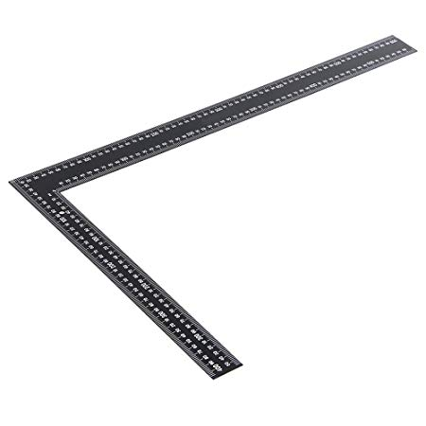
2.0 - As the task at hand was to measure the suspension accurately a ‘vernier caliper’ was used. Vernier caliper can measure accurately to one-thousandth of an inch or one-hundredth of a millimetre. The calliper used to accurately measure the different parts of the suspension was manual however a digital vernier caliper could have been used which may have produced more accurate results.

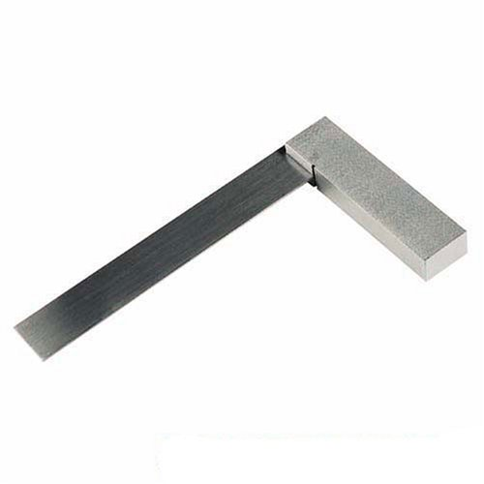
2.1 - An ‘engineers square’ is a metal L-shaped tool used consisting of two parts, the ‘handle’ and the ‘blade’. The blade can be pinned or welded in place at a perfect ninety-degree angle. The square was used extensively through the whole measuring process as it was well suited for the task. The engineer’s square allowed for accurate measurements to be taken from the suspension. This tool was also stood at 90°, this allowed the measurements in the Z-axis to be taken with accuracy.
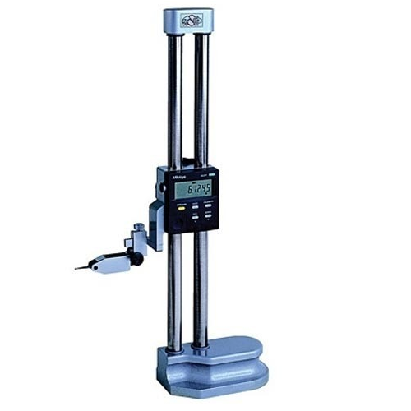
2.2 - As one of the measurements needed to be taken in the Z-axis, a simple machinist rule would not have provided the accuracy needed hence a digital ‘height gauge’ was best suited to take height measurements from the point where the wishbones and steering arm connects to the wheel-hub suspension. The digital height gauge’s accuracy was sufficient for taking the measurements and was best suited for the task.

2.3 - ‘Wingeo3’ is a suspension measuring software used to see the effects of changes to the suspension camber and caster angle along with the toe and scrub amongst other points that are important in manufacturing a robust suspension. The software takes all the parameters of a suspension and puts it through different combinations in ride height, roll and steering input. One of the alternatives for WIngeo3 is ‘OptimumKinematics’. The software is also used in the same manner as Wingeo3.

Toe Angle

3.0 - ‘Toe angle’ on a car refers to the default position of the wheels when the steering wheel is straight. The toe angle on a car can be determined by looking at the car’s wheels from above.
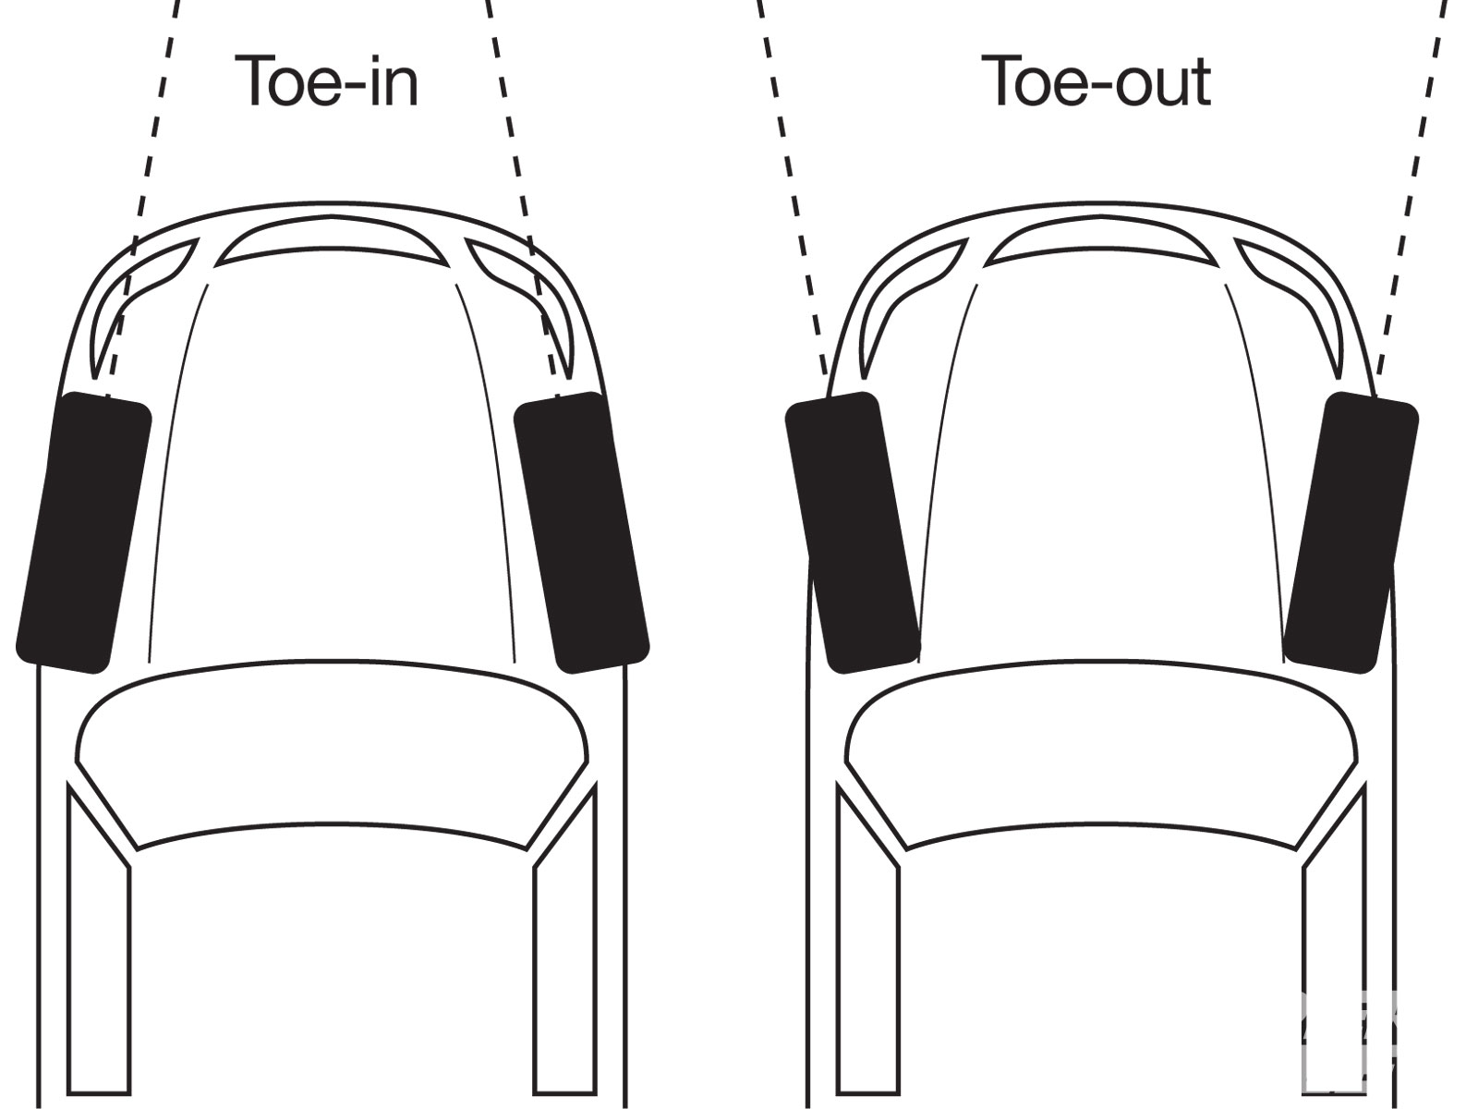
3.1 - Rear-wheel-drive cars will have the front wheels pointed inwards ‘toe-in’ by five to twenty minutes of a degree. This is because under acceleration as the power is being delivered from the back, the front tires will have a slight tendency to point against the center plane of the car so counter excessive tire wear and achieve maximum contact patch the front wheels are pointed to the center plane of the car. Toe-in on the front wheels of a rear-wheel-drive car will increase its stability in the straights and when coming out of turns however the car reacts slower but has more steering from the middle and exit of a turn which in turn smoothes out the car handling and makes it easier to drive.
3.2 - On front-wheel-drive cars, the front wheels are pointed outwards or against the center of the plane of by zero to twenty minutes of a degree, however, the tor-out should never be more than two degrees as that would result in excessive tire wear and inadequate handling in straights. Having the correct toe-out on a front-wheel-drive car is necessary as under acceleration the front tires will have a tendency to turn in towards the center of the plane of the car.

Camber

4.0 - Camber refers to the angle of a vehicle’s wheels and their vertical position as they sit on the surface of the ground or road. Wheel camber is a very important factor when configuring a suspension as it can directly impact the stability and handling of the car as it impacts the tires contact patch. There are two types of camber, positive and negative.
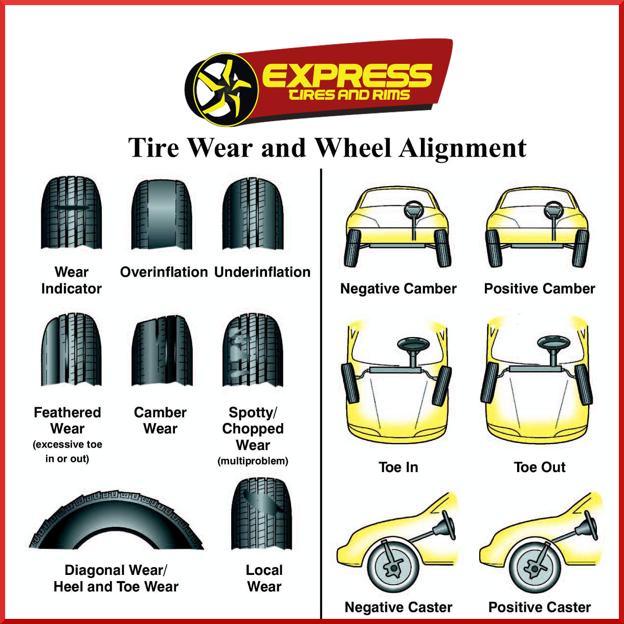
4.1 - To view camber, one can stand in front of a car and if the top of the front wheel is sticking out and the bottom is tucked in then the wheels of the car have positive camber. The advantages of having positive camber are that less effort is needed when steering the car and it also provides extra stability when driving on uneven roads. Positive camber will lead to the outer edge of the wheels to wear quicker compared to the rest of the wheel which is bad economically.
4.2 - To view negative camber one can stand in front of the car and if the front wheels are extruding out at the contact patch compared to the top of the wheel then the car has ‘negative camber’. The advantages of negative camber can be that the car is evenly loaded however without adequate negative camber the tire would load the outer portion of the tire and produce less grip. The disadvantages of negative camber are that the car will lose maximum tire grip when accelerating in a straight line and braking.
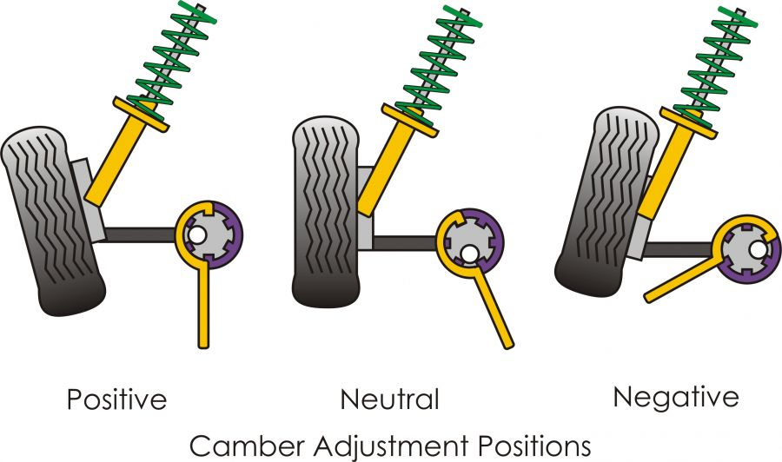
4.3 - Neutral wheel camber is preferential in most cars as it offers the best of negative and positive camber. Neutral camber offers the best contact patch as the car is sitting on the road. The wheel contact path directly impacts the handling and stability of the car and neutral camber allows the whole tire to wear and grip evenly.

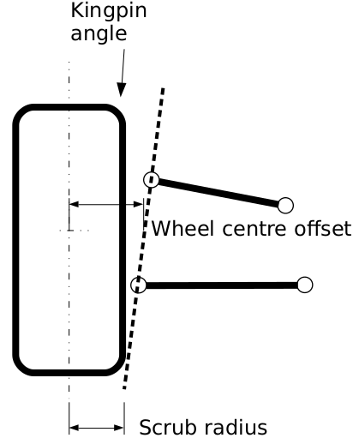
Kingpin Inclination

5.0 - If a straight line is drawn through both ball joints at the wheel hub and through until it hits the ground, the ‘Kingpin Inclination’ is the angle that the ball joint line makes with the ground. The scrub radius is the distance from the ball joint line to the centerline of the tire. Kingpin inclination and scrub radius are directly affected by each other as increasing the kingpin angle will reduce the scrub radius. Increasing the kingpin angle will affect the steering as it will help the center the steering however too large of an angle will lead the tires to lop as the car is steered.

Bump Steer

6.0 - Simply put, bump steer occurs when a car hits a bump and the occurring compression of the suspension results in changes to the steering. When the suspension compresses the forces acting on it also force the tie roads at the front wheels to articulate. The level of change in steer depends on many factors including suspension type and what its setup for i.e. motorsport or automotive. A car built for speed and performance will have a stiffer suspension which may be better as the suspension won’t release its energy in the way up however that energy may be transferred to the driver of the car but changes in steer are mostly down to the speed at which the car was travelling, the angle and height of the bump and also the type of terrain the vehicle is travelling on.

Methodology Session-One Suspension Hardpoints

This session was used to carry out measurements of the inner and outer tie rods. The following are a set of instructions that can be used to replicate the results if done correctly. The chassis of from a 1996 Diemen formula Ford.
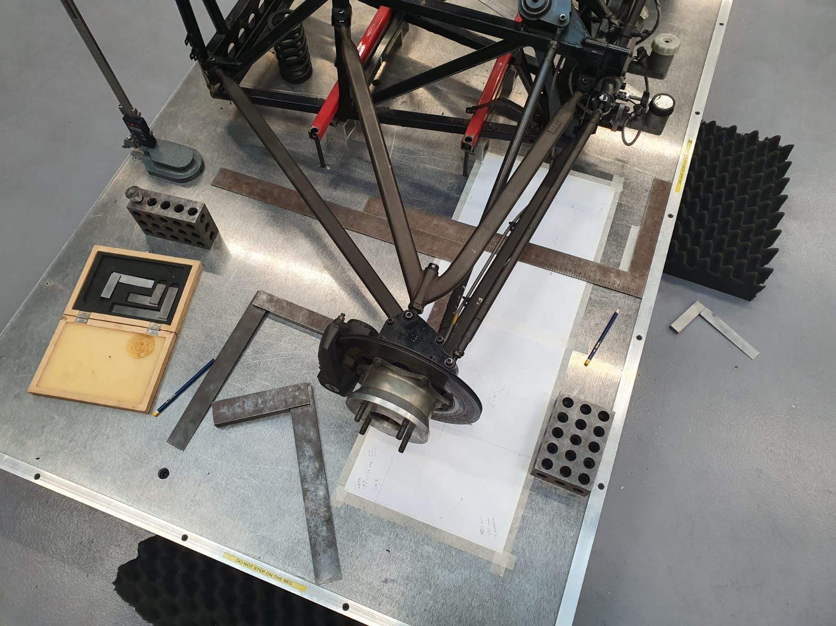
Make sure that the surface underneath the chassis is perfectly flat, tape A3 paper on the surface beneath the chassis, this will allow for measurements to be written down and marks can also be plotted.

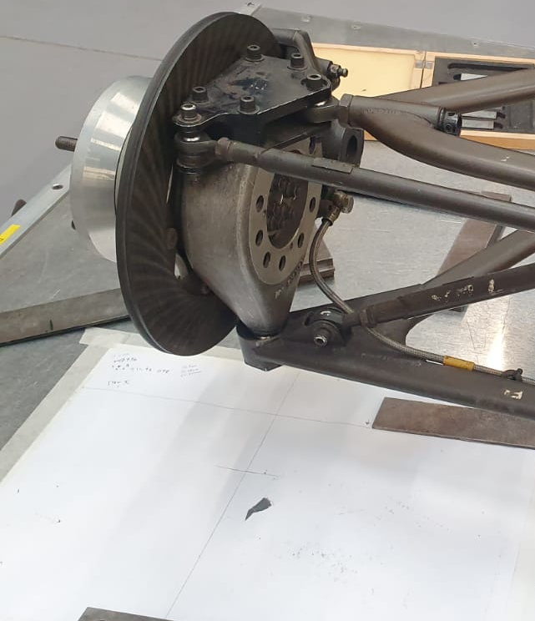

Firstly, locate the centreline of the suspension and mark it on the paper. In order to draw a line for the ‘Y’ axis, draw a horizontal line underneath the steering rod.

Turn the steering wheel until it is exactly in the centreline position and then use a ‘vernier’ caliper to measure the distance between the steering rack so they are equal. Then lock the steering wheel to begin taking measurements.
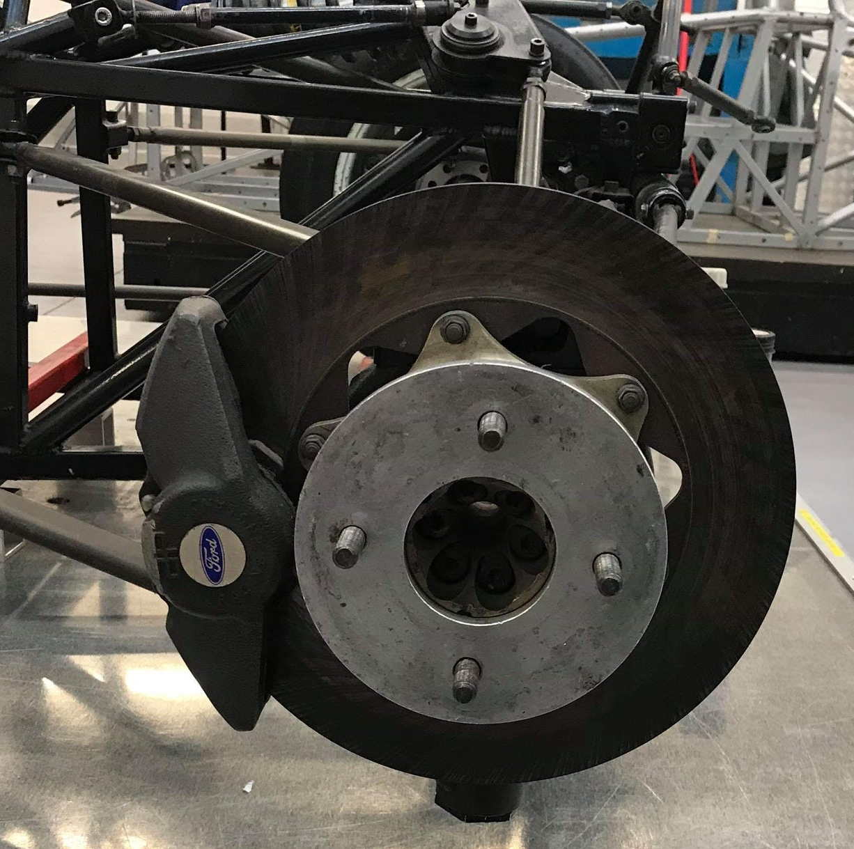
Continuing the vernier caliper, measure the diameter of the wheel hub and divide by two to get half of the diameter.

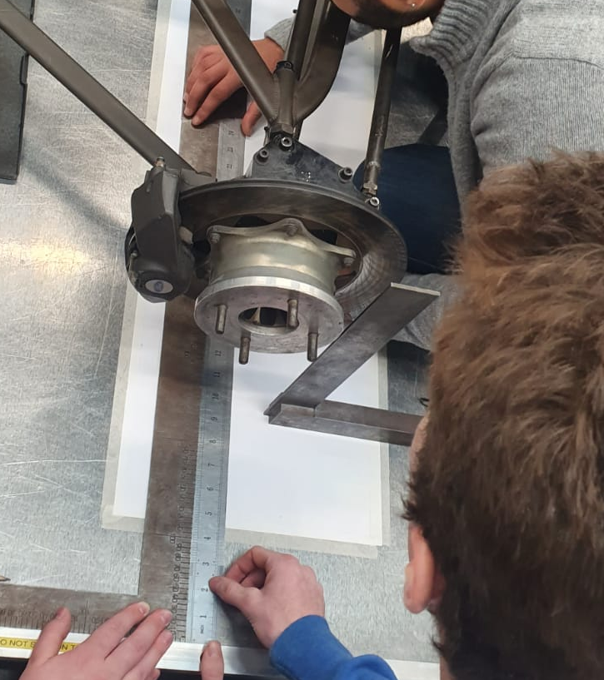
Using an engineers square, lay it flat on the measuring surface and then use a straight rule and line it up against the edge of the engineers square and then draw the x-axis line.

With the engineers square, stand it in a vertical position and place it as close as possible without lifting the base to the exterior tie-rod bolt. Then measure the distance between the bolt and the edge of the square with a vernier caliper, measure the diameter of the bolt and divide by two in order to get the most accurate readings.

To find the Y-axis coordinate, measure the distance between the centre-point of the bolt to the Y-axis we lined up earlier. To find the Z-axis use an engineers block and height gauge. Firstly, take a measurement of the height of the block using the height gauge, then place the height gauge on-top of the block and use it to measure the center point of the bolt, adding up the values which will give the Z-axis coordinate.

Using the same method find the X,Y and Z-axis of the interior tie rods, then enter the measurements taken into Wingeo3 and if all the measurements have been taken properly the software will produce a 3D setup of the suspension.

Methodology Session-Two

The second session was used to carry out measurements of camber changes, wheel travel and bump steer along with the sprung and unsprung mass.
The following are a set of instructions that can be followed to replicate results on the car which is a 1996 Van Diemen Formula Ford.

Remove the damper located at the front of the car and replace with an adjustable rod that is of a correct length.

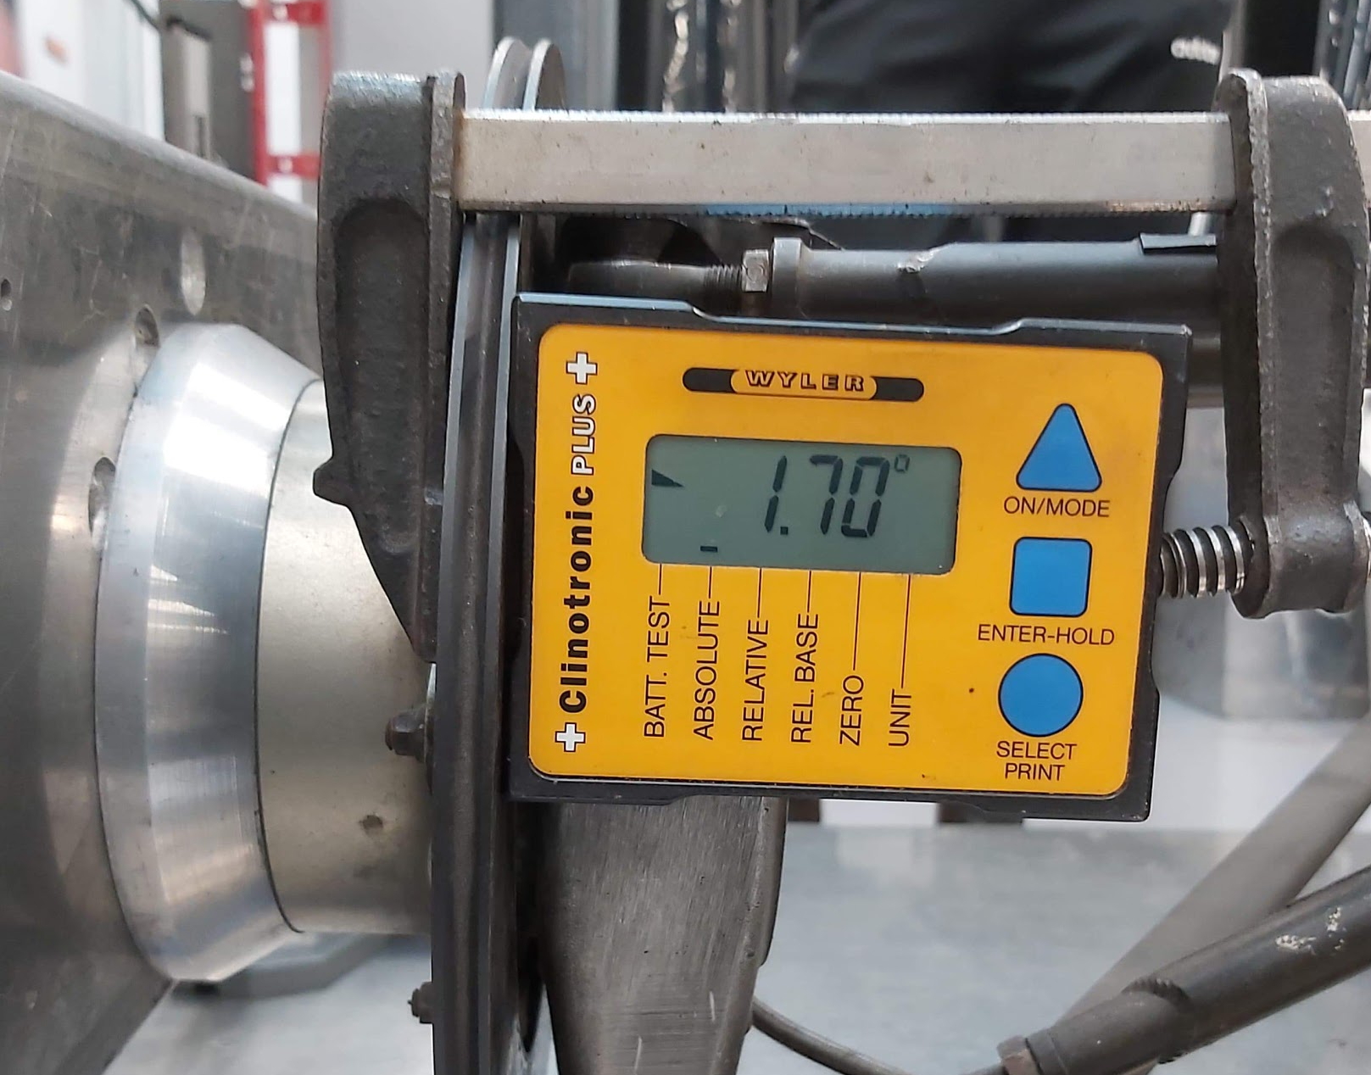
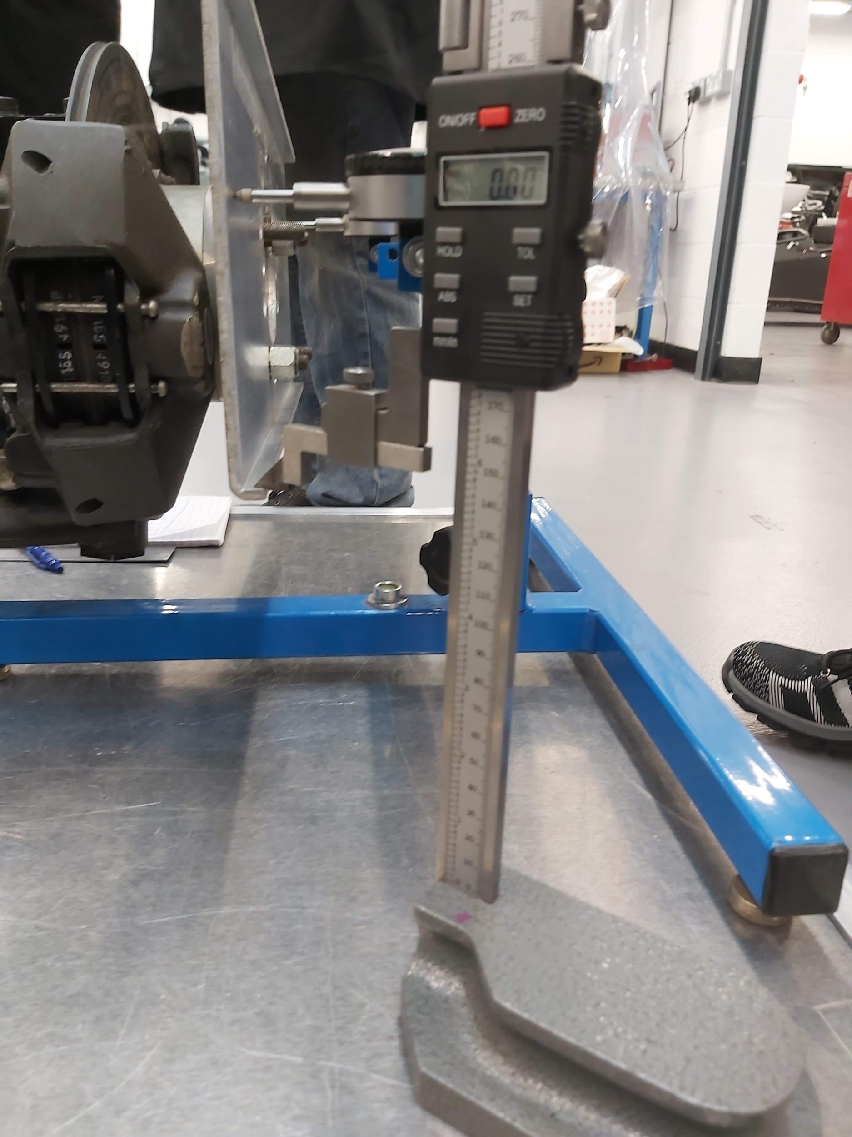
Next, attach an inclinometer to the brake disk however it needs to be at a perpendicular angle and the device should be set to zero. A ‘Wyler Clinometer plus +’ was used as the measuring device. The inclinometer should look something like this when attached.

Find a surface on the wheel hub to measure, move the height gauge needle onto the chosen surface and then zero the height gauge to achieve accurate measurements.
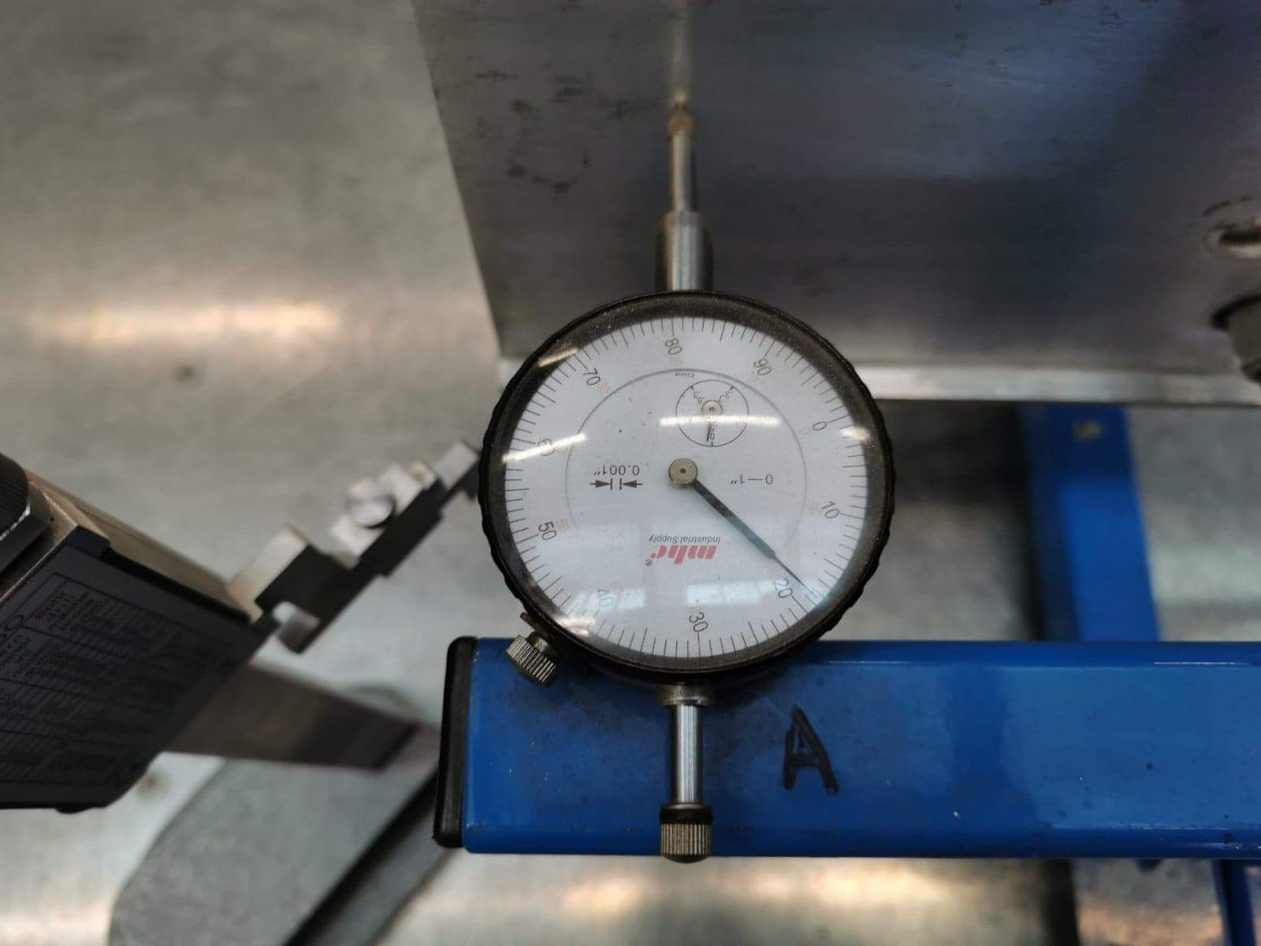

As shown in the picture above attach the plate to the wheel hub. Set DTI gauges to the point where the stop plate and DTI gauge needles are in contact.

The DTI and height gauge setup should look like the following picture.
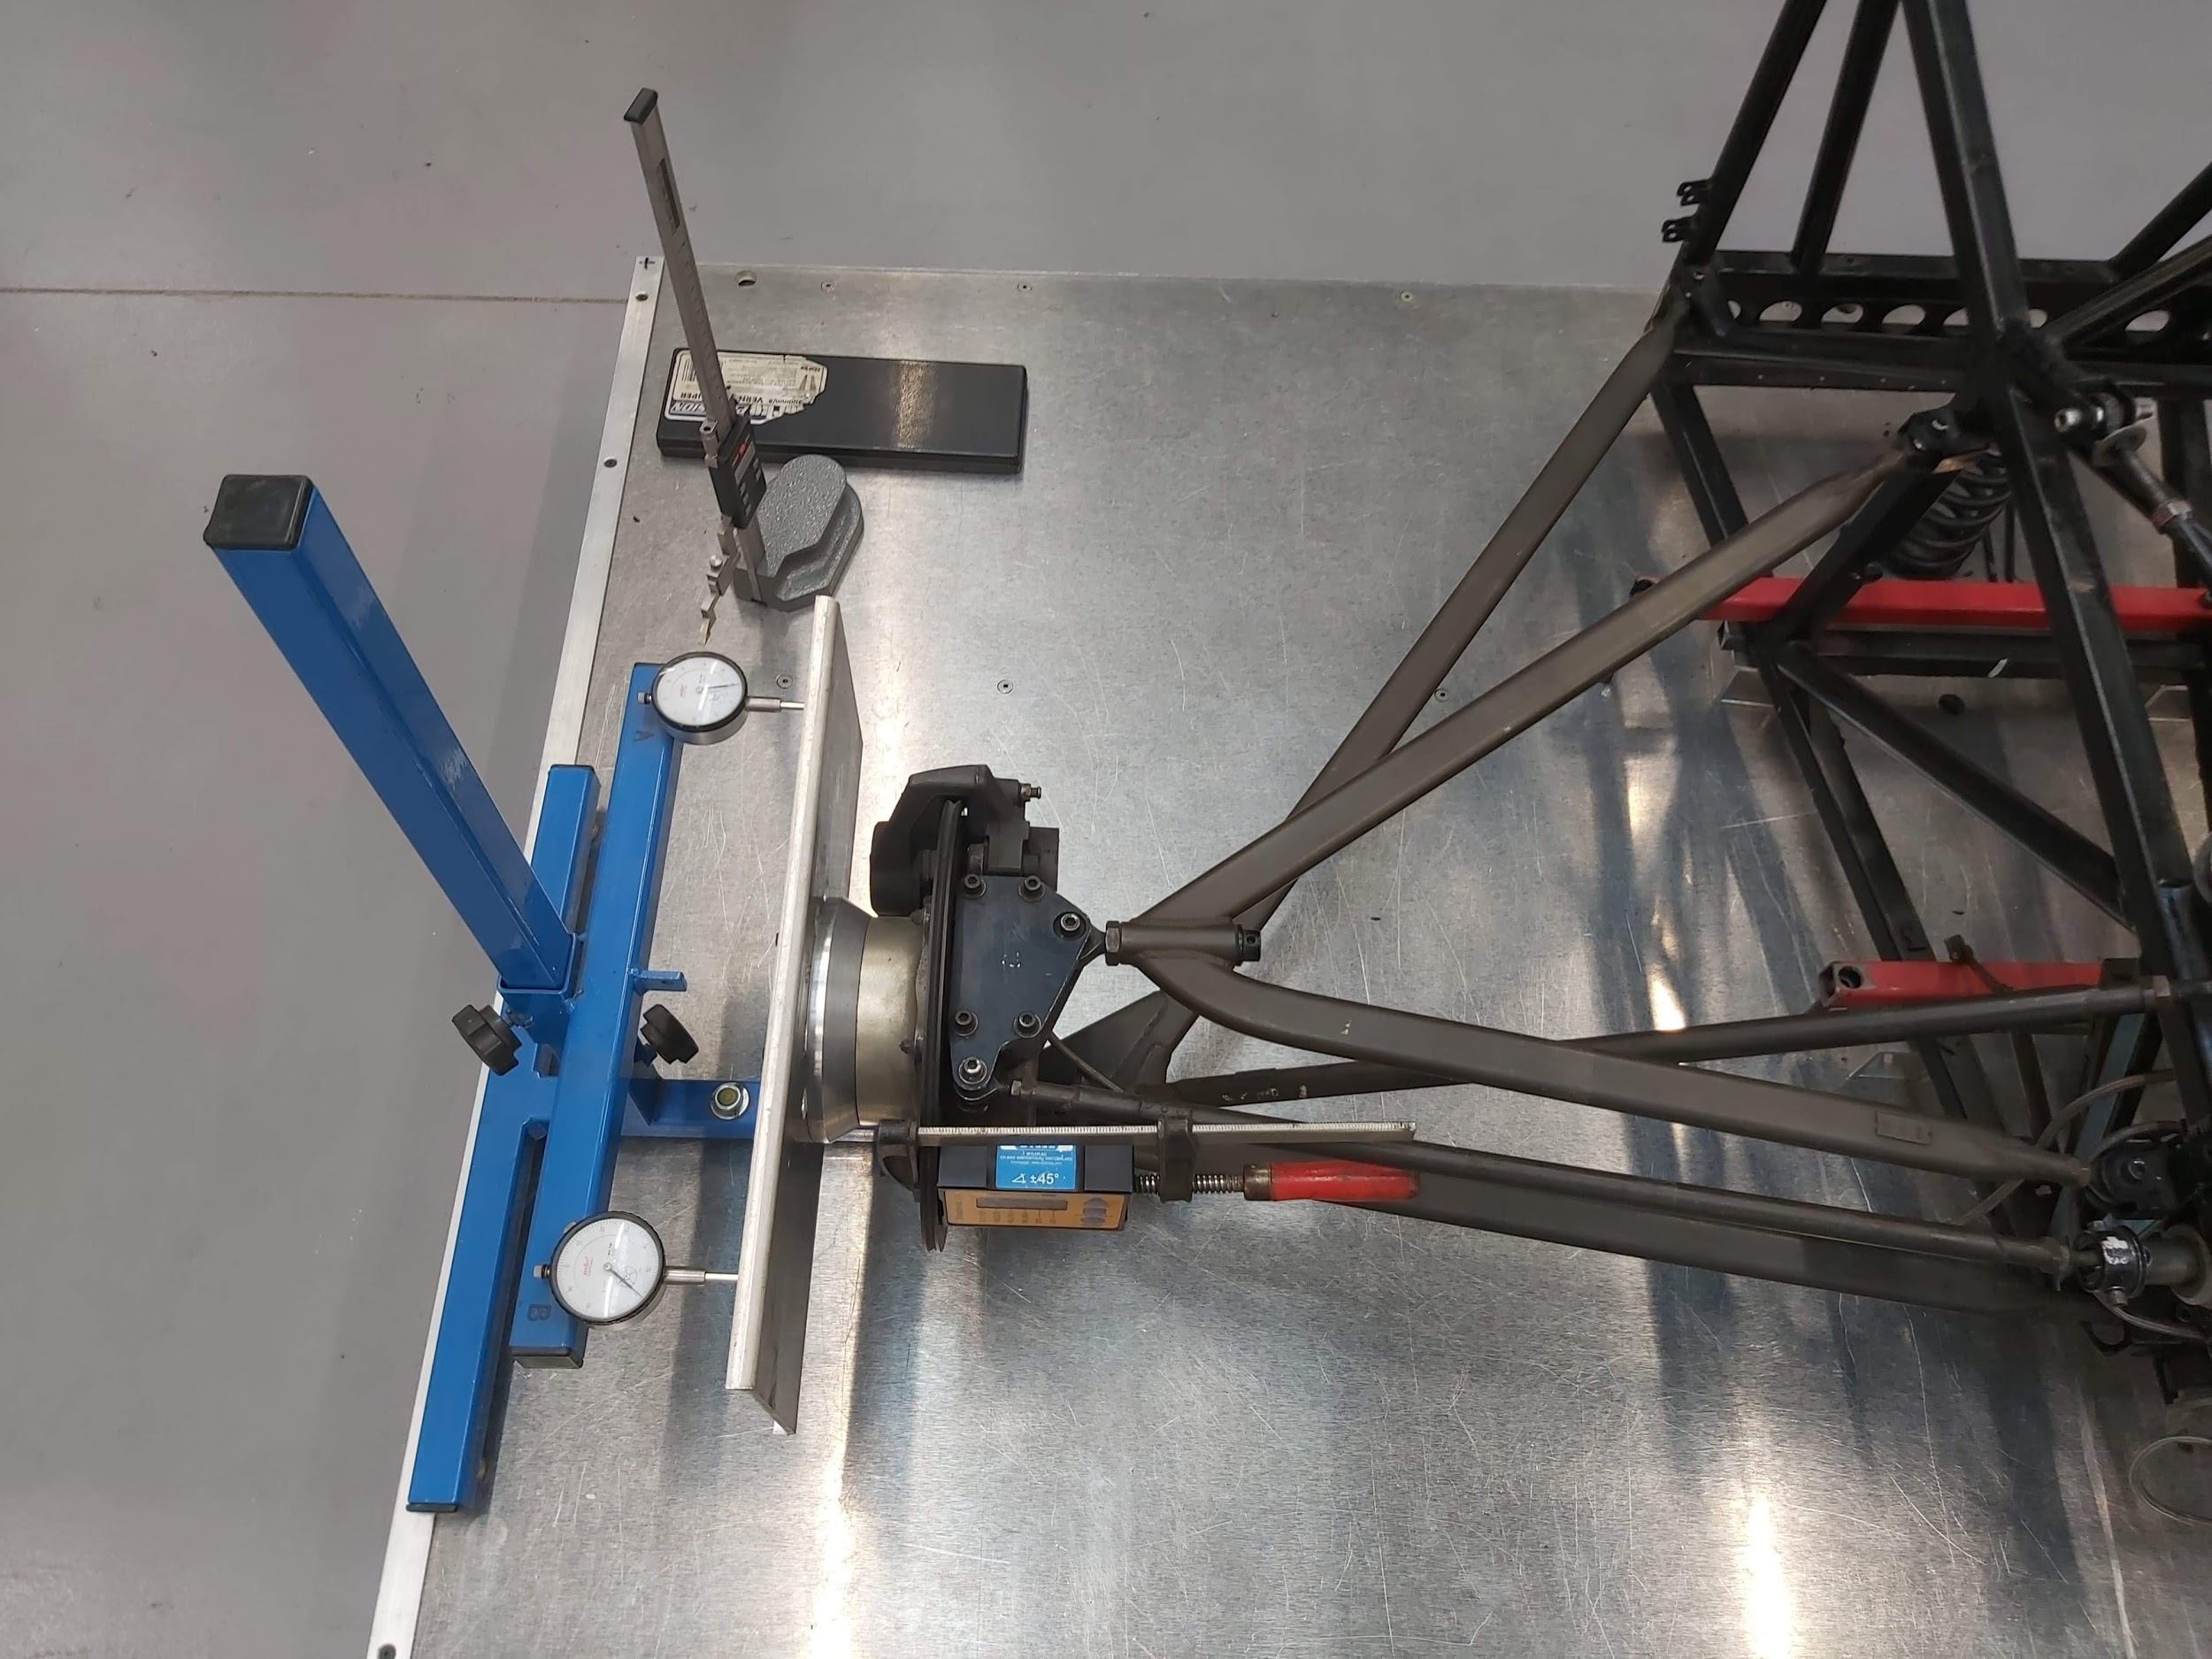

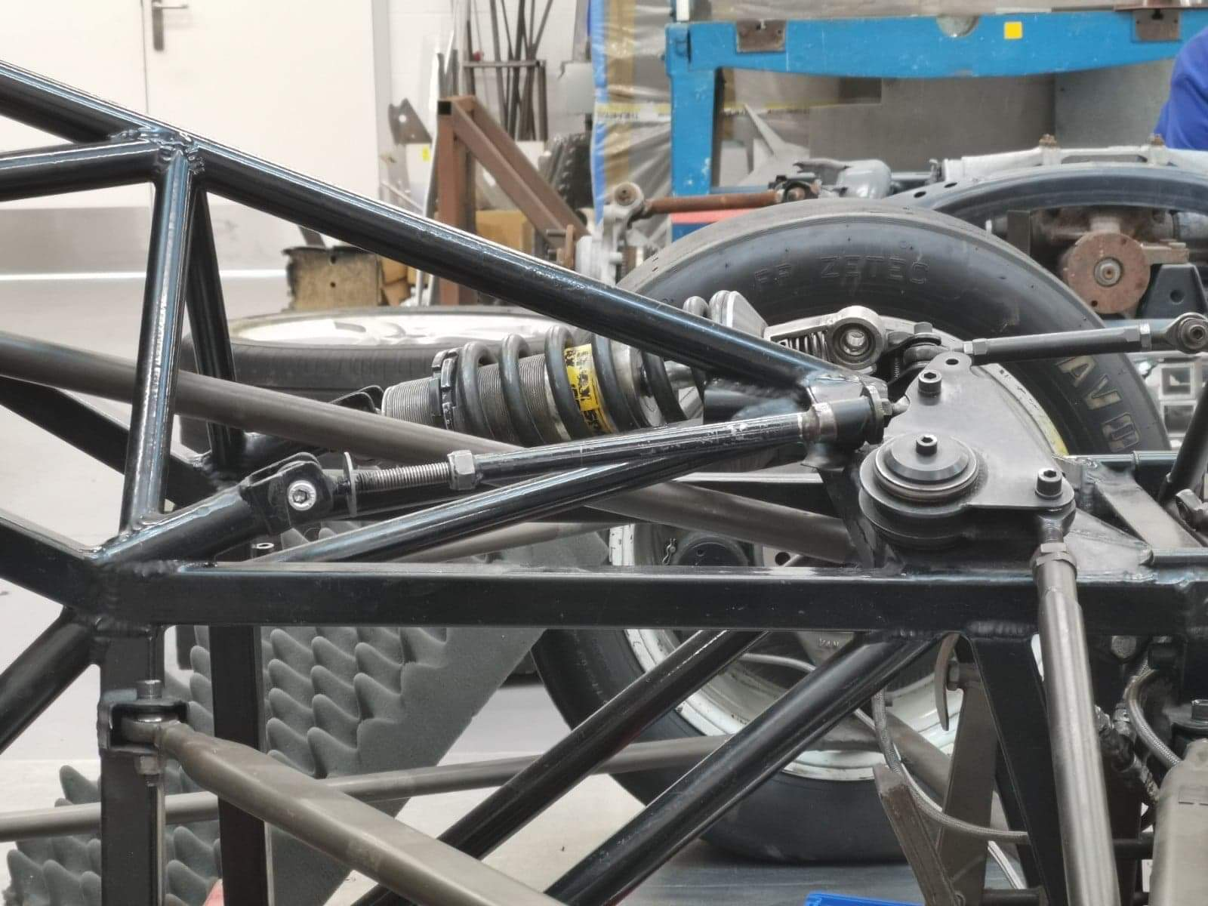
Use a vernier caliper to measure the distance between the adjusting nut and the stop plate on the adjusting rod which will change the reading on the inclinometer and also on the DTI gauges. Take the reading from the DTI gauges and round to the nearest thousand. Then move the needle of the height gauge to the same point on the wheel hub and take readings making sure that the new reading is on top of the zeroed position.

Take ten consecutive readings every two turns of the adjustable nut.
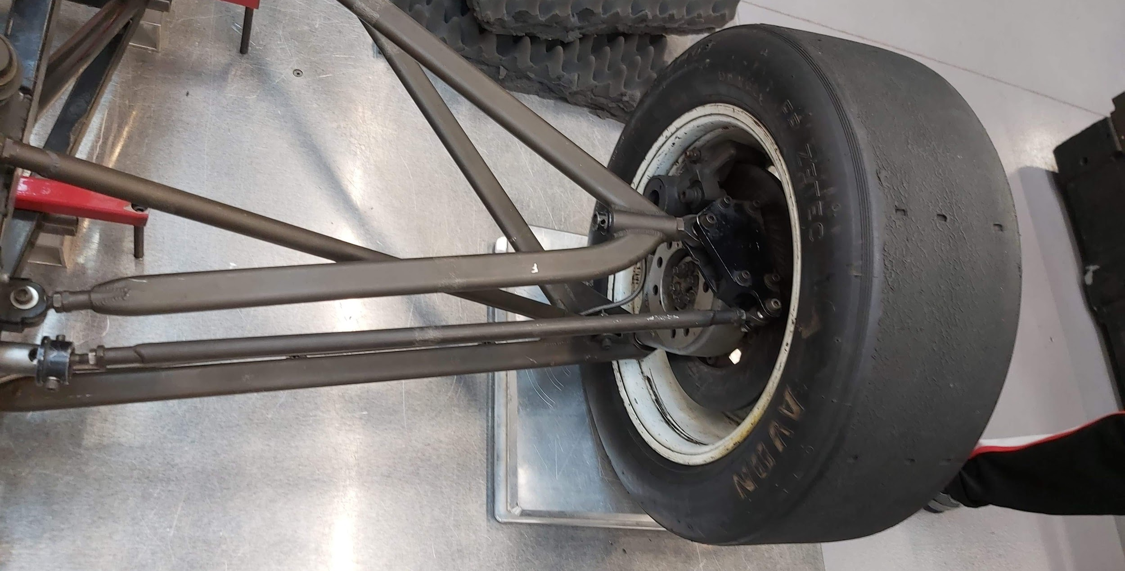
To weigh the sprung mass of the chosen
corner, place a weighing pad underneath the wheel as it’s still attached to the chassis.

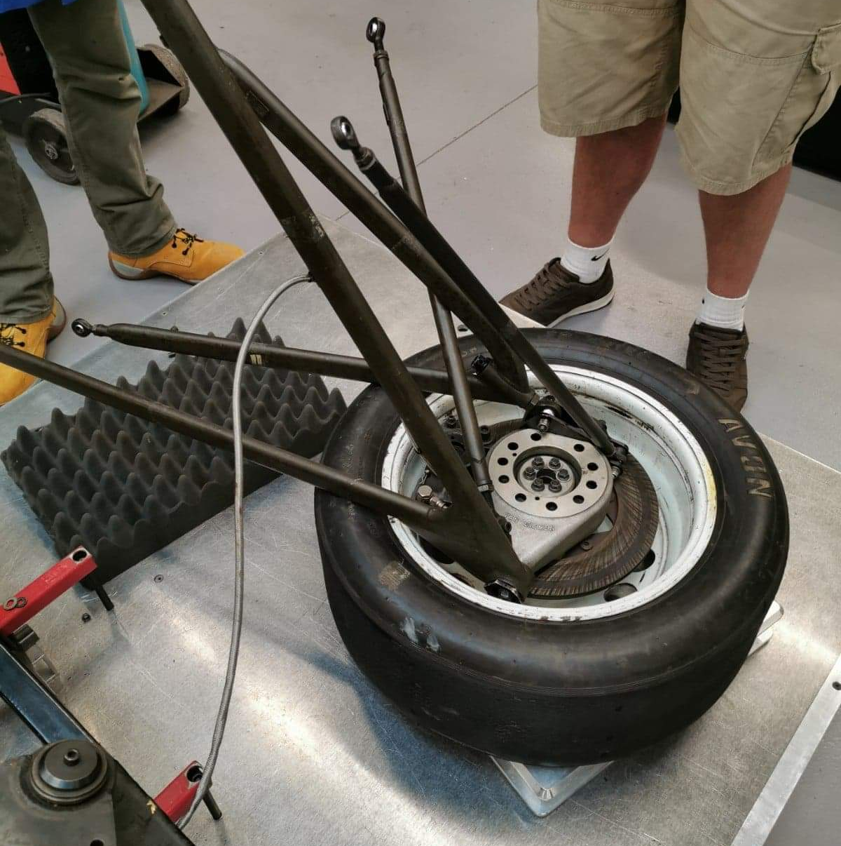

To weigh the unsprung mass of one corner, firstly remove all the bolts holding together the wheel and then put then place it on a weighing scale to measure the weight.

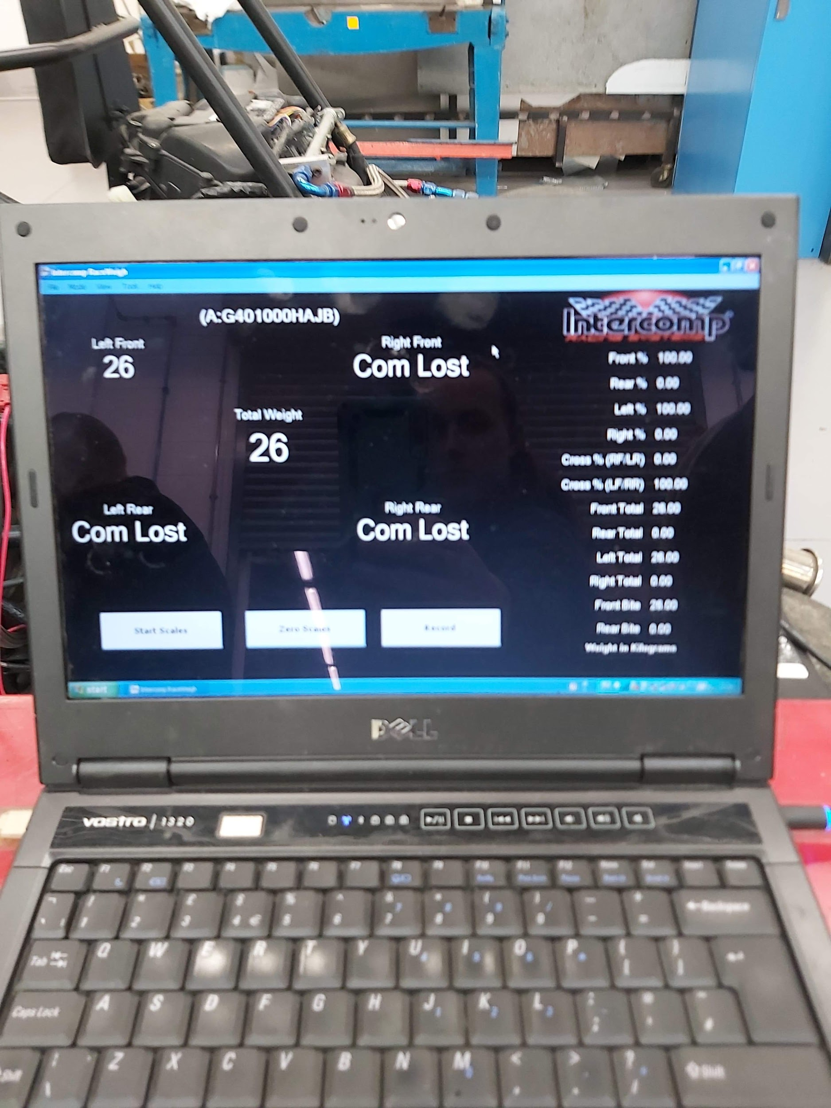

This picture shows the unsprung weight of the corner. The sprung mass was 28kg and the individual corner on its own is 26kg.

WinGeo3 methodology

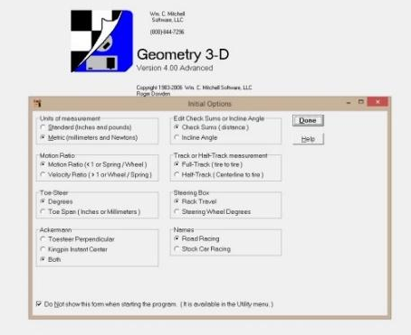
To create a model for the vehicles suspension setup WinGeo3 is used. In this software geometry such as toe and camber can be adjusted. Graphs and tables can be created to show data adjustments.
Figure 1.0
Units of measurement: metric
Motion ratio: velocity ratio
Toe steer: degree
Ackerman: both
Edit checksums or incline angle: checksums
Track or half-track measurement: full track
Steering box: rack travel
names: road racing
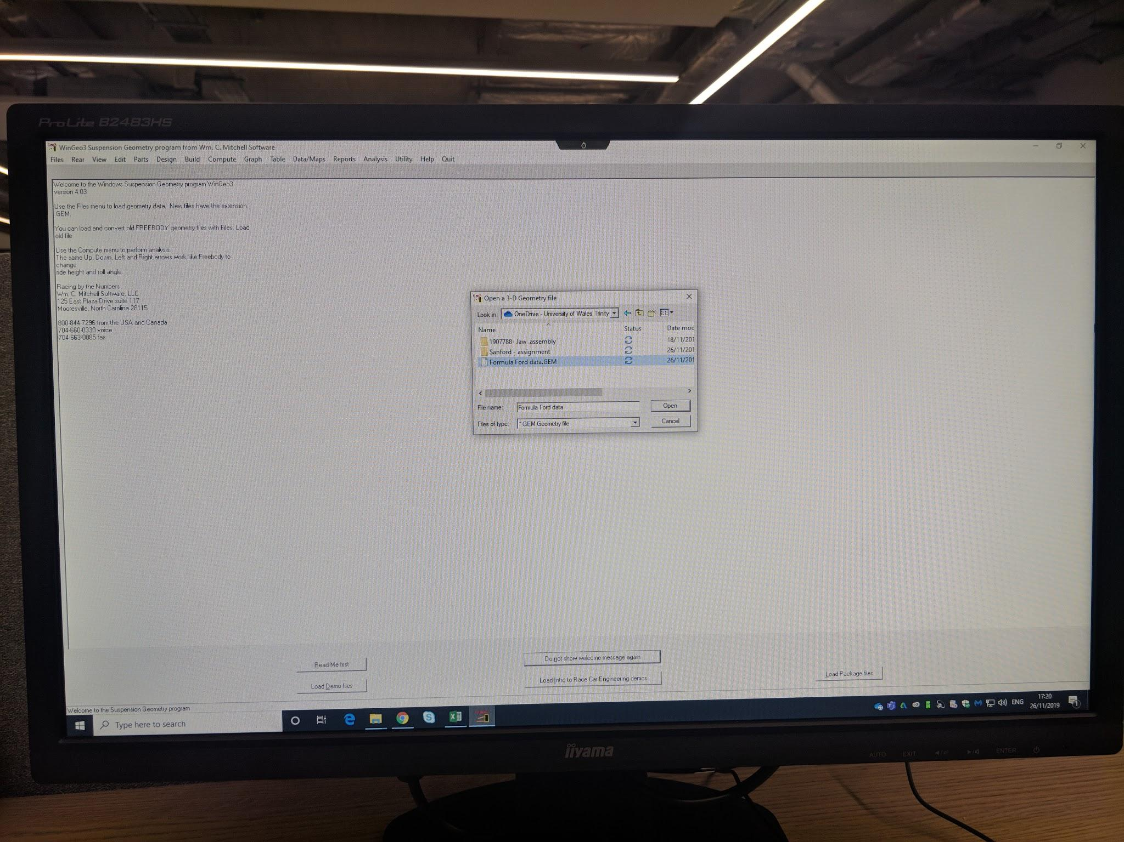

Figure 1.1
Top left corner, click ‘file’ and then open the ford.gem file, once that’s loaded there should be a 3D model of the chassis on the screen. The loaded model was provided and that is the file to which the measurements will be compared to.

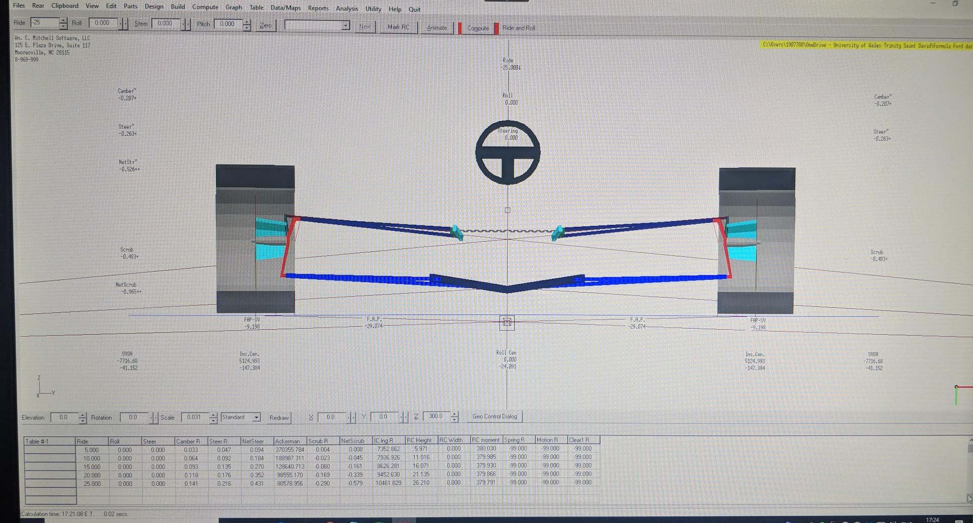
Figure 1.2

On the menu bar, click on ‘table’ and then ‘show table’ which should bring up an excel type sheet below the model. In the top left corner, click on ‘ride’ and then proceed to change the ride height from +25 to 0 and then down to -25 in five-millimetre increments.

Wingeo3 - Predicted Results

WINGEO3 PREDICTED RESULTS
Ride Height | Camber R | Steer R
-20 | -0.16 | -0.206
-15 | -0.116 | -0.152
-10 | -0.075 | -0.099
-5 | -0.036 | -0.049
0 | 0 | 0
5 | 0.033 | 0.047
10 | 0.064 | 0.092
15 | 0.093 | 0.135
20 | 0.118 | 0.176
25 | 0.141 | 0.216
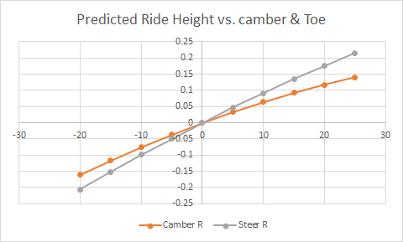
Figure 2.0
This graph shows the predicted ride height vs. camber & toe. According to Wingeo3, the software predicts that the change is linear.

Locus

Having a balanced roll centre is very important because it directly impacts the car handling and changes under cornering forces as the vehicle rotates around this space. When working on a suspension one should consider that the roll center is not too far away from the centre of gravity (COG)of the vehicle. Having the roll center close to COG will reduce body roll and the opposite is true and the roll entre is distant in relation to the center of gravity on the vehicle.
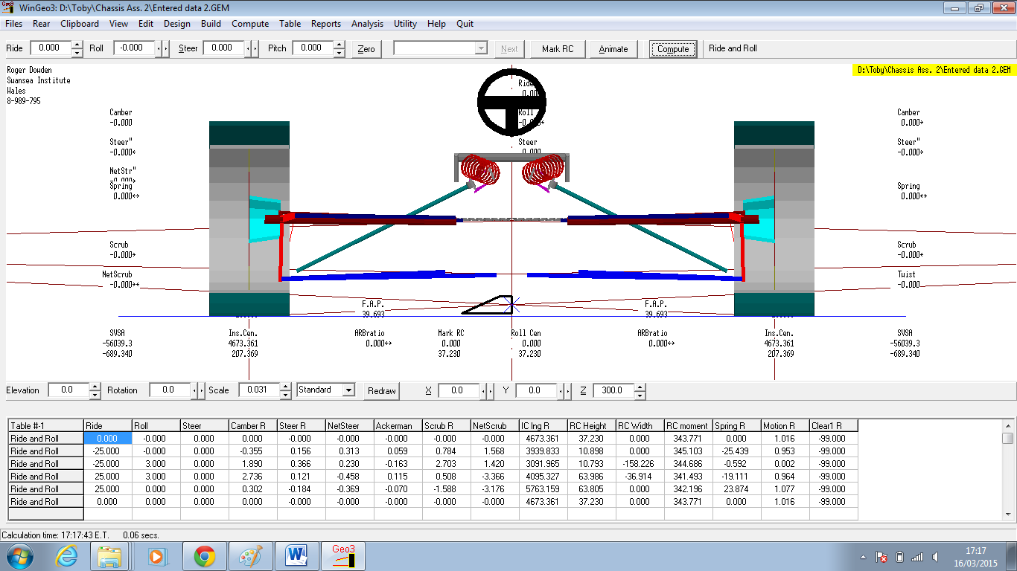
Figure 3.0

In order to produce the locus under ‘table’ click ‘show’ enter the ride height and degrees of roll. A small triangle should show up in the center to show the locus.

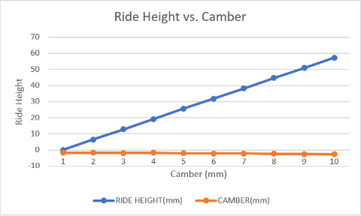
Measured Results

RIDE HEIGHT(mm) | CAMBER(mm)
0 | -1.7
6.42 | -1.78
12.79 | -1.86
19.26 | -1.74
25.64 | -2.02
31.93 | -2.11
38.3 | -2.23
44.67 | -2.35
50.86 | -2.5
57.24 | -2.67

Figure 4.0 - The above graph shows ten incremental changes in ride height and camber. The data shows the ride increasing every step and the camber is getting smaller.

Comparing results
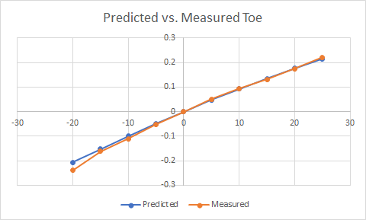
Figure 5.0

As can be seen from the graph, the predicted and measured toe are very similar. This is due to accurate measurements and shows how the wingeo3 software is great for suspension setup visualisation.

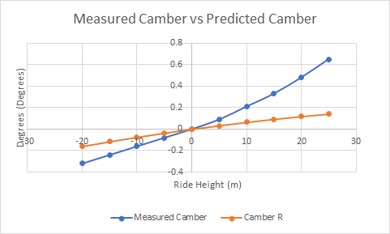
Figure 6.0

The graph with the biggest difference between the measured and predicted results is the camber vs. ride height graph. As can be seen from the graph the measured camber forms a linear line whereas the measured camber is a lot more unpredictable.
Ride Height mm | Damper Length | Change in spring length from start position.
0 | 46.5 | 0.1in
6.42 | 44.1 | 0.2
12.79 | 41.3 | 0.3
19.26 | 38.4 | 0.4
25.64 | 35.1 | 0.5
31.93 | 32.1 | 0.6
38.3 | 29.2 | 0.7
44.67 | 26.1 | 0.8
50.86 | 23.3 | 0.9
57.24 | 20.1 | 1.0

Suspension leverage (SL)
Max ride height/ initial damper length-final damper length
57.24/(46.5-20.1) = 26.4
57.24/26.4= 2.17

Spring Rate
In order to calculate the spring rate first place the spring into a compressor and compress it in 0.1 inch increments. As shown, the results were converted into mm and Newton. The graph shows a linear line where the force needed to compress at every increment increases.

Spring rate calculation
Force / Compression (mm)
352lbs/25.4mm = 13.85/2.2(kg) = 6.29kgx9.81(g) = 61.79N/m x1000 = 61795.27n/mm

Inch compressed | mm | lbs | Newton
0.1 | 2.54 | 0 | 0
0.2 | 5.08 | 32 | 142.34
0.3 | 7.62 | 71 | 315.82
0.4 | 10.2 | 112 | 498.20
0.5 | 12.56 | 151 | 671.68
0.6 | 15.02 | 191 | 849.61
0.7 | 17.58 | 231 | 1027.53
0.8 | 20.32 | 271 | 1205.46
0.9 | 22.86 | 311 | 1383.39
1 | 25.4 | 352 | 1565.77
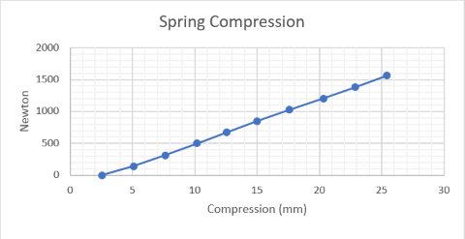

Wheel rate (kw)
Equation 1. Kw = Ks / SL^2
61795.27 / 2.17^2 = 13123.1N/m

Ride | DTI: Reading-A (1000) | DTI:Reading-B  (1000) | Toe steer angle° (A-B) x 180 /Span(13:7/16) x 3.142
0 | 0 | 0 | 0
6.42 | 21 | 3 | 0.07673
12.79 | 40 | 10 | 0.12789
19.26 | 57 | 13 | 0.18758
25.64 | 70 | 14 | 0.23874
31.93 | 82 | 14 | 0.28990
38.3 | 91 | 13 | 0.33253
44.67 | 97 | 10 | 0.37090
50.86 | 102 | 5 | 0.41354
57.24 | 106 | -2 | 0.46043
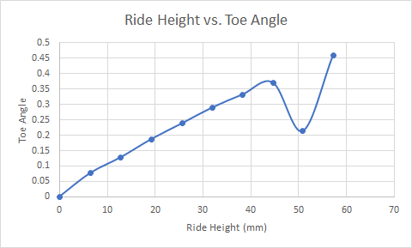
As can be seen from the graph, the line is increasing every increment however as seen by the dip at the 50.86mm ride height, the line takes a dip. This is down to human error.

Ride Height | Measured Camber (Degrees) | Measured Toe (Degrees) | Zeroed Camber (Degrees) | Zeroed Toe (Degrees)
0 | -1.7 | 0 | 0.32 | -0.24
6.42 | -1.78 | 0.0767 | 0.24 | -0.16
12.79 | -1.86 | 0.1279 | 0.16 | -0.11
19.26 | -1.94 | 0.1876 | 0.08 | -0.05
25.64 | -2.02 | 0.2387 | 0 | 0.00
31.93 | -2.11 | 0.2899 | -0.09 | 0.05
38.3 | -2.23 | 0.3325 | -0.21 | 0.09
44.67 | -2.35 | 0.3708 | -0.33 | 0.13
50.86 | -2.5 | 0.2131 | -0.48 | -0.03
57.24 | -2.67 | 0.4604 | -0.65 | 0.22

Sprung mass = 425+70=495kg/4=123.75kg - 123.75kg - 26kg = 97.75kg
Sprung mass of car without bodyweight = 425-(26x4kg) =321
Unsprung mass of corner detached from body = 26kg
Equation 2. Natural frequency of sprung mass F = $\frac{1}{2π}√\frac{kw}{ms}$= 1.844Hz
Equation 3.
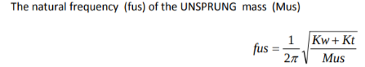
Fus = 16.19hz

Conclusion

This report has covered many aspects of a chassis and how it behaves. The report has covered the equipment that was used during the process and how suitable the piece of equipment was for the task and also alternatives. Topics such as camber & toe angle and ride height have been covered how slight differences in their values affect the car’s handling. The report has methodically laid out how to measure the chassis of a 1996 Van Damien Formula Ford. The report has also covered the roll center (locus) of the vehicle and how that affects the handling as well. The report also shows how to calculate the suspension leverage, spring rate and wheel rate. The report talks about the sprung and unsprung mass of the vehicle and lays out how to calculate them as well.

Considering the measured results and predicted results are quite close, this means that the initial measurements taken had been very good and also points out wingeo3 ability to be a good software that provides accurate visualisation of the changes in i.e. camber, toe angle and ride height.

Recommendations for further study

- Use digital vernier caliper for more accurate results
- Use wingeo3 more for better understanding of software
- Take physical notes during workshop tutorials
- Repeat results to verify accuracy
- Get someone to proofread for grammatical errors and structure

Appendices

Spring rate calculation
Force / Compression (mm)
352lbs/25.4mm = 13.85/2.2(kg) = 6.29kgx9.81(g) = 61.79N/m x1000 = 61795.27n/mm

Wheel rate (kw)
Kw = Ks / SL^2
61795.27 / 2.17^2 = 13123.1N/m

Sprung mass = 425+70=495kg/4=123.75kg - 123.75kg - 26kg = 97.75kg
Sprung mass of car without bodyweight = 425-(26x4kg) =321
Unsprung mass of corner detached from body = 26kg
Natural frequency of sprung mass F = $\frac{1}{2π}√\frac{kw}{ms}$= 1.844Hz

Fus = 16.19hz

References

BOSCH, R. (2018). BOSCH AUTOMOTIVE HANDBOOK. 10th ed. WARRENDALE: SAE SOC OF AUTOMOTIVE ENG, p.933.

Hillier, V. (2012). Hillier's fundamentals of motor vehicle technology. 6th ed. Oxford University Press, p.393.

http://www.optimumg.com/software/optimumkinematics

Hillier, V. (2012). Hillier's fundamentals of motor vehicle technology. 6th ed. Oxford University Press, p.395.

BOSCH, R. (2018). BOSCH AUTOMOTIVE HANDBOOK. 10th ed. WARRENDALE: SAE SOC OF AUTOMOTIVE ENG, p.935.

