Title page

Name: Zachury Shane Jassi
Student id: 2017021
Lecture name: Dr Obinna Nkwocha
Module name: developing workplace critical thinking
Module code: BMSW 5101
Assignment title: How individuals’ beliefs, attitudes, and values impact on workplace behaviour.

Contents
Title page 1
Introduction 3
Maslow’s hierarchy of needs 3
Brief background of Maslow and how his theory was developed 3
Main assumptions of Maslow’s theory 4
Criticisms of Maslow’s theory 5
Relevancy and usefulness of Maslow’s theory 6
Summary of Maslow’s theory 8
References 9
My reflection on the module and critical thinking 11
Introduction 11
Topics taught in class which resonated with me 11
My reflection of mentioned topics 12
References 13

Introduction
This report will cover a detailed critical evaluation of the management theory Maslow’s hierarchy of needs. Assessing whether the theory is relevant and useful in today’s world. The report will cover an introduction to Maslow, identifying the reasons Maslow created his theory, main assumptions of the theory, a detailed critic on the management theory creating a discussion on where the theory may be or may not be useful and appropriate. Highlighting workplace environments, where the theory may work well.

Maslow’s hierarchy of needs

Brief background of Maslow and how his theory was developed
Abraham Harold Maslow 4/1/1908 – 6/8/1970 known as an influential American psychologist well-known mostly for creating Maslow’s hierarchy of needs. Maslow was a psychology professor at the Brandeis University, Brooklyn College and Colombia university who founded the school thought known as humanistic psychology (Boeree, 2006). He later went on to develop the hierarchy of needs which is displayed as a pyramid that consists of five main factors identifying and claiming that humas are motivated by increasingly complex needs. Maslow is thought to be the tenth most cited psychologist of the 20th century (McLeod, 2018).
Maslow’s concept hierarchy of needs was developed and first came about in the 1943 article he produced called "A Theory of Human Motivation" along with his book Motivation and Personality. Indicating that people are motivated to satisfy their most very basic needs before reaching more complex needs in the theory’s pyramid and so on (Selva, 2019).
Maslow was inspired to create his theory (Maslow’s hierarchy of needs) because of the dissatisfaction he encountered with some of the other leading phycological theories during this period in time (Kremer and Hammond, 2016). Maslow thought that the Freud’s theory of psychoanalysis had concentrated more on the negative view of human life. Maslow also suggested that Behaviourism was also too mechanical and did not include important factors like inner thoughts, freedom, and feelings. Whereas humanistic psychology was more concentrated on the goodness people have and provided a greater positive method to human psychology (Selva, 2019). Maslow wanted a more peaceful vision of human psychology.

With great research from other self-actualised people Maslow’s aim was to create a model in form of a structure to help people to realise themselves allowing them to be aware and help towards achieving self-actualisation (Mathes, 1981). Maslow’s theory greatly contributes to the study of motivation and human behaviour. Maslow’s purpose for designing the theory hierarchy of needs was to help people, for example, organizations and schools understand how humans intrinsically and extrinsically partake in behavioural motivation by using the titles physiological, safety, belonging and love allowing organizations to understand and satisfy the needs of the students or persons working for them (Mathes, 1981).

Main assumptions of Maslow’s theory
Maslow’s hierarchy of needs theory indicates that humans have a great need for self-achievement, self-actualisation, and fulfilment and such needs affect the way humans behave, the theory proposes that human needs are continuously changing. Both intrinsic and extrinsic motivation apply to Maslow’s theory of needs (Osemeke and Adegboyega, 2017). Maslow claims that when one set of needs are satisfied a person then thinks about meeting the next set of needs. Maslow indicates that satisfaction is achieved by progressing up the 5-level pyramid claiming that once a person has achieved their (basic needs) which consist of physiological needs and safety needs. They then seek to progress further up the pyramid and achieve (physiological needs) which are social needs and self-esteem needs then finally onto (self-fulfilment needs) which is self-actualisation. These 5 human needs that Maslow states can also be split up into two sections (deficiency needs) and (growth needs) (Kremer and Hammond, 2016).
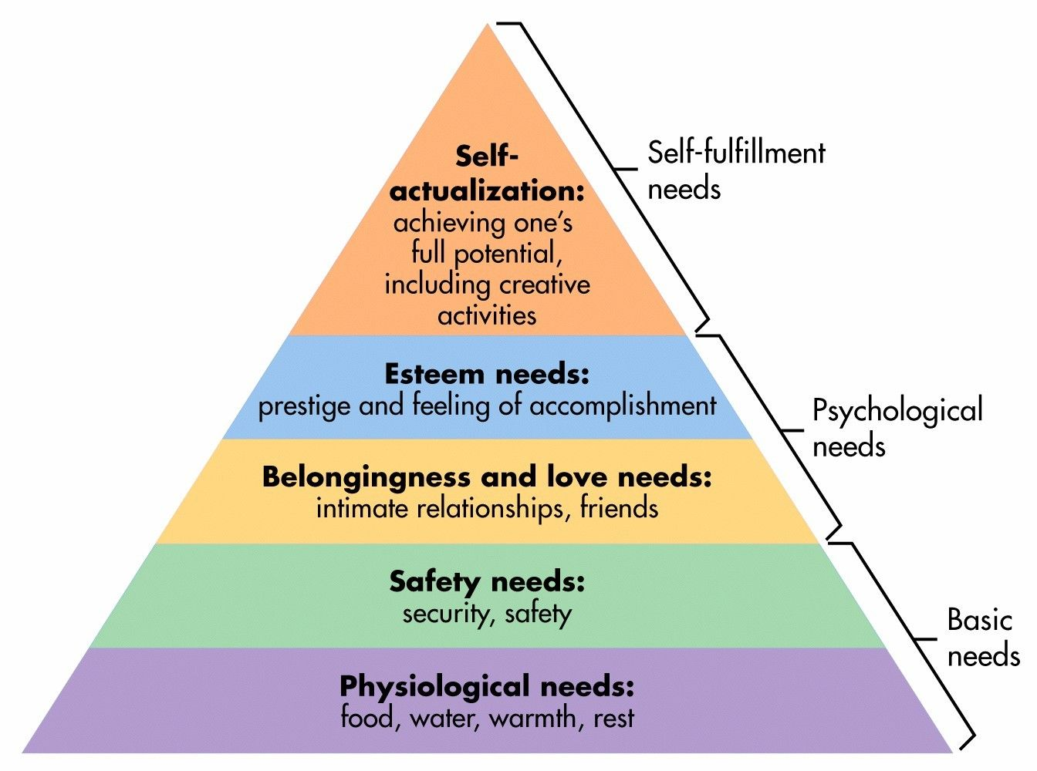
(McLeod, 2018)
Physiological needs consist of basic survival needs for example food, water, warmth, clothes, and sleep. Maslow suggests that these basic requirements are the most vital as these needs are essential for humans to survive (javved, 2012). Further stages in the pyramid are secondary until these needs are satisfied. Once physiological requirements are reached, and the person is satisfied they seek to progress to safety needs which consist of family, work, health, and personal security. Having a sense of safety and security allows a person to move to the next level which is social needs. Social needs consist of social life, family, friendship, and feeling connected as it is essential for a human to feel loved and accepted by others. The next level on Maslow’s hierarchy is esteem needs. Esteem needs consist of respect, identity recognition, freedom, and strength. At this level it is important for a human to feel valued, respected, and appreciated by others which in return can make a person feel a sense of purpose. Lastly, once all other levels of the hierarchy have been accomplished the next level a person would seek is self-actualisation which consists of the wish to be the best one can be, developing potential, and personal growth (G. Benson and P. Dundis, 2003).

Criticisms of Maslow’s theory
According to McClelland an author who criticises Maslow’s theory he speaks about how in reality a human doesn’t tend to work individually up through Maslow’s hierarchy’s levels claiming that some people are less structured with how they satisfy their own needs, for example, the need for self-esteem might be more important to a person rather than their social needs leading them to create their own structure of the hierarchy. Arguing that a person’s background or position in life or the situation they may be in could change their needs and different people will have their own individual needs as humans have different ideas of self-actualization, for example, some people may seek self-actualization in their work whereas others may seek self-actualization in other areas in life (Osemeke and Adegboyega, 2017).
A Further main issue with Maslow’s hierarchy of needs is that there is no accurate way to measure the theory. It is difficult to assume when a person is satisfied enough on a level of the hierarchy and how satisfied one needs to be to be able to progress further up the hierarchy (Boeree, 2006).

A further weakness on Maslow’s theory is that it may not apply or may not be able to be used worldwide. It is said that Maslow only considered a small amount of people when developing his theory of needs. Making it more difficult to apply the theory in different cultures and workplaces as the terms in the theory self-esteem and security may have diverse factors for different cultures or different countries in the world. It’s believed that the research Maslow conducted was taken from wealthy countries making the theory only applicable in such wealthy countries (Winter, 2016). Making the theory less useful in today’s workplaces. Maslow developed the hierarchy of needs in the year 1943 and although the theory still may be applicable in some workplaces the needs Maslow’s stated where based on research from period in time (The Happy Manager, n.d.). people of today (millennials) may have a different view of their wants and needs regarding the workplace, for example, people of today may not want to follow old procedures at work and new easier ways of working have been developed with a more relaxed approach for workers in the workplace. Another negative aspect of the theory that may not apply to all workers or workplaces is the social part as not every human being is alike, and some people may not choose to be as social as others or look to build social relationships whilst at work. Another negative factor of Maslow’s theory that can affect workplaces is that the hierarchy cannot accurately be measured therefor workplaces implementing the theory on their workforce may not be able to affectively recognise when one level of needs has been satisfied enough for employees to be able to advance further up on the hierarchy’s pyramid (Kunchala, 2017).

Relevancy and usefulness of Maslow’s theory
Maslow’s theory is highly useful and used as a motivational tool in many of today’s workplaces allowing companies to understand the needs of employees and how to motivate their employees at different stages their employees may possibly be at (Project-management-skills.com, 2010). It is essential for employers to motivate their staff to a high-level. Motivated staff are said to perform better in the workplace and enjoy the job role they are doing more which then would highly increase performance in the workplace and have a positive effect on their quality of work. By doing this the company can ensure job satisfaction for their employees which Will help boost company moral and help the company to perform better and reach targets, for example, the number of sales required per month. The safety needs and physiological needs of the theory can support employers to understand and consider the type of environment they should provide for employees and the basic needs needed for an employee whilst at work allowing the company to successfully provide such environments to meet employee needs which in return would possibly increase time keeping and could help improve attendance for employers. By breaking down Maslow’s hierarchy of needs it allows a company to critically assess the structure they provide for their employees and ensure all employee needs are being met. Also, employers can use Maslow’s hierarchy pyramid to assess and work out where their company could be going wrong and rectify their mistakes by ensuring each stage of the hierarchy is being met and employees are being motivated to a high standard (Winter, 2016).
Step one in Maslow’s theory is physiological needs (basic needs) companies could use this part of the structure to understand the very basic needs of a human being and then be able to provide those basic needs by ensuring, for example, employees have a decent amount of breaks throughout working hours and have access to things like a toilet, washroom, and a kitchen to eat and drink in during their breaktimes and a suitable place to work and most importantly a decent amount of pay which motivates most people to work. The second step on the hierarchy (safety needs) can guide employers in providing a safe working environment by providing relevant PPE, good security which in return will help the employee to feel safe and to know that their safety is important whilst at work. Thirdly on Maslow’s hierarchy is the love and belonging stage where employers can use this stage to guide themselves in providing a good work life balance for their employees and creating things like team building activities to help build workforce relationships creating a sense of belongingness. The fourth stage of Maslow’s hierarchy can enable employers to understand and fulfil the esteem needs of their employees as at this stage recognition is an important factor for a human being and essentially boosts employees to feel and understand their personal growth. Finally on Maslow’s hierarchy is the self-actualisation stage where employers can use this stage to identify and help implement opportunities for their workers to advance and reach their full potential at work (G. Benson and P. Dundis, 2003).
Maslow’s theory is highly applicable in the fast-food industry, for example, by a company suppling a free meal at break times, and in most cases a free uniform and a good rate of pay the company is fulfilling the physiological needs of the employees, staff working in teams and different departments helps to build workplace relationships as the workers share the same goal. Also providing teambuilding activities will also boost social and belonging factors. Most fast-food company’s use performance reviews. Performance reviews can allow a worker to see how they are progressing and help them to further develop their skills as well as receiving praise and feedback resulting in the company fulfilling esteem needs. Most fast-food industries engage in training courses and skill building for employees creating a way employees can self-actualize (Vinney, 2018). I believe Maslow’s hierarchy would be highly useful in retail and food type businesses allowing companies to motivate and implement Maslow’s framework on their employees. A good example of a company that successfully implements Maslow’s theory is Tesco. Tesco use Maslow’s theory to motivate their workforce, for example, they fulfil security needs by providing their staff with contracts of work and pensions and illness procedures and also give staff opportunity to join a union, thus, fulfilling a sense of belonging they also implement group and teamworking throughout their company. Tesco offer their staff personal development plans which can help staff to assess weaknesses and progress. They also undertake career meetings with staff and offer management programs allowing staff to reach their full potential whilst working for the company thus fulfilling self-actualization (motivational theory in practice at Tesco, n.d.).
Contrary Maslow’s hierarchy isn’t applicable to all workplaces if a person has a job role where they work independently, spending the majority of time at work by themselves. It’s difficult to apply the social steps in Maslow’s theory in their work environment as they may not be able to build relationships with fellow workers due the fact they mostly work alone. Another example of how Maslow’s theory is difficult to apply to all workplaces is some workplaces may not be able to offer an employee the chance to progress in their company or to gain further skills, for example, working in a small shop with no other job positions available. Maslow’s self-actualisation may be difficult and costly for small companies to provide extra training making it difficult for an employee to feel the sense of self actualisation.

Summary of Maslow’s theory
Throughout this report it has been highlighted that Maslow’s hierarchy of needs is a highly used motivational tool for many companies although the theory may not be applicable to every business it can be really useful for companies that can use this theory. Also, the theory can be useful for personal use for a person to assess what motivates them and what level of needs they might be at or may be trying to achieve and to also know when the appropriate time is to move up the hierarchy based on fulfilling the needs on the current level. I believe Maslow’s theory will continue to be as useful in today world as it has been for many years. As Maslow’s hierarchy can be applied to many people/places, for example, schools and colleges. I believe because of the usefulness of Maslow’s theory and the success rates the theory provides it will continue to be used in for many more years to come.

References
Boeree, D. C. G., 2006. personality theories, s.l.: Shippensburg University.
Avalible at abraham-maslow.pdf (middletownautism.com)
G. Benson, S. and P. Dundis, S. (2003). Understanding and motivating health care employees: integrating Maslow’s hierarchy of needs, training and technology. [online] pp.315–320. Available at: https://onlinelibrary.wiley.com/doi/full/10.1046/j.1365-2834.2003.00409.x?casa_token=dJZnc7HnhUgAAAAA%3AGCU6WbnlZ5jz5YdOvS-McaoAHacNrctoHbDHOth1KbKbpLxzt-hDzlqaY2O61i1QHzsgW1mS_iV3ecbG [Accessed 8 Apr. 2022].
Javved (2012). Exploring Housing Attributes Selection based on Maslow’s Hierarchy of Needs. [online] science direct, Social and Behavioral Sciences, pp.311–319. Available at: https://www.sciencedirect.com/science/article/pii/S1877042812010774 [Accessed 8 Apr. 2022].
Kremer, W. and Hammond, C. (2016). Abraham Maslow and the pyramid that beguiled business. bbc. [online] 27 Jan. Available at: https://247caregivingproducts.com/lifenow/Maslow_HierarchyOfNeeds_Pyramid_BBC.pdf [Accessed 8 Apr. 2022].
Kunchala, R. (2017). Limitations Of Maslow’s ‘Hierarchy of Needs’ Theory | Merits | Demerits. [online] MBA Help24. Available at: https://www.mbahelp24.com/limitations-maslow-s-hierarchy-needs-theory-merits-demerits/ [Accessed 8 Apr. 2022].
Mathes, E.W. (1981). Maslow’s Hierarchy of Needs as a Guide for Living. Journal of Humanistic Psychology, [online] 21(4), pp.69–72. Available at: https://journals.sagepub.com/doi/abs/10.1177/002216788102100406?journalCode=jhpa [Accessed 8 Apr. 2022].
McLeod, S. (2018). Maslow’s Hierarchy of Needs. [online] simply phycology. Saul McLeod. Available at: https://canadacollege.edu/dreamers/docs/Maslows-Hierarchy-of-Needs.pdf [Accessed 8 Apr. 2022].
Osemeke, M. and Adegboyega, S. (2017). Critical Review and Comparism between Maslow, Herzberg and McClelland’s Theory of Needs. FUNAI JOURNAL OF ACCOUNTING, [online] vol 1(no.1), p.pp 161-173. Available at: https://www.fujabf.org/wp-content/uploads/2018/01/Critical-Review-and-Comparism-between-Maslow-Herzberg-and-McClellands-Theory-of-Needs.pdf [Accessed 8 Apr. 2022].
Project-management-skills.com. (2010). Maslow Theory of Motivation: Applying Maslow’s Hierarchy of Needs. [online] Available at: https://www.project-management-skills.com/maslow-theory-of-motivation.html [Accessed 8 Apr. 2022].
motivational theory in practice at tesco. (n.d.). www.tesco.com: the times 100, p.p 108.
Selva, J. (2019). Abraham Maslow, His Theory & Contribution to Psychology [Upd. 2019]. [online] PositivePsychology.com. Available at: https://positivepsychology.com/abraham-maslow/ [Accessed 8 Apr. 2022].
The Happy Manager. (n.d.). Maslow Motivation Theory | the hierarchy of needs. [online] Available at: https://the-happy-manager.com/tip/maslow-motivation-theory/.
Vinney, C. (2018). Understanding Maslow’s Theory of Self-Actualization. [online] ThoughtCo. Available at: https://www.thoughtco.com/maslow-theory-self-actualization-4169662#:~:text=To%20Maslow%2C%20self-actualization%20is%20the%20ability%20to%20become [Accessed 8 Apr. 2022].
Winter, T. (2016). Praise & Criticism: Hierarchy of Needs (Maslow). [online] blog.dtssydney.com. Available at: https://blog.dtssydney.com/praise-criticism-hierarchy-of-needs-maslow#:~:text=Perhaps%20the%20most%20significant%20criticism%20of%20Maslow%E2%80%99s%20hierarchy [Accessed 8 Apr. 2022].

My reflection on the module and critical thinking

Introduction
This critical reflection will reflect on my learning throughout this module. This reflection will use Driscoll reflective model (1994) (Reflection Model 2 -Driscoll (2007), n.d.). Highlighting a few of the topics that resonated with me and that I enjoyed learning about. Reflecting on how I intend to use such teachings throughout my life.

Topics taught in class which resonated with me
One topic that highly resonated with me from this module was validating evidence. This topic was taught in week 6 of the critical thinking module I was being taught in class. Validating evidence can be known as a critical process where an individual assesses validity of the evidence provided to them and decides an appropriate way to interpret those these findings based on the evaluation they undertake. Most information we receive can be validated for example tv, news, classes, journals, blogs and even rumours and opinions also. There are several factors applicable to when you are evaluating evidence, the argument, support, the questions being asked, is the scenario logical, the evidence provided, and assumptions of the information. I feel this topic was highly useful and helped me to gain a good understanding of how to validate evidence. Another topic I really enjoyed being taught throughout this module was inductive and deductive reasoning. Deductive reasoning can be known as a statement that travels from general speech to a specific ending. Deductive reasoning looks at the logic a statement provides, helping to draw a logical assumption. Inductive reasoning can be known as using a specific statement to draw a general assumption. Inductive reasoning can allow you to draw several solutions to one problem. Inductive reasoning is extremely useful when trying to predict something or if you’re trying to find a pattern in something and can additionally be known as inductive logic. Both inductive and deductive reasoning are highly useful in today’s world for individuals and businesses for things like quantitive researching. Another topic that highly resonated with me throughout the teaching in this module was the topic of beliefs values and attitudes. I believe this was a highly useful topic that was taught. Beliefs can be known as deep feelings an individual may experience leading them to believe something may be true although the beliefs could not be true for example in some cultures people believe black cats to be bad luck. Values can be identified as a degree of importance or worth a person may have towards something or someone. Values can impact the way someone may live their everyday life. Some foundations of a person’s values could be their views on religion, their social and family life, or the job they do. There are many factors which could contribute to a person’s values. Attitude can be described as the way a person may behave or act whilst expressing their beliefs and values and how a person presents their beliefs and values. Beliefs, values, and attitudes are connected. A person’s beliefs and values and can impact their attitude, thus, affecting their behaviour.

My reflection of mentioned topics
The topic validating evidence has allowed me to be able to assess and digest relevant information and make the correct assumptions based on the evidence presented to me, allowing me work out valid evidence against invalid evidence. Helping me to confirm my initial thoughts and feelings regarding a situation I feel this skill will be highly useful for me in many aspects of my life including personal, for example, conversations with family or watching the news to a work environment allowing me to validate evidence provided to me and process the correct information. This topic has shaped my ability to validate and think about evidence more instead of believing the most likely scenario. Inductive and deductive reasoning has highly improved my logical reasoning allowing me to understand the differences of premises and their outcomes allowing me to make a conclusion from a statement whether it be work related or something I’ve been told by a family member. Also giving me the knowledge to spot patterns in logic and think about the event that might follow an action or to guess what might happen next strengthening my assumptions. In the future, I wish to build my own business. I feel my critical thinking has been widened due to learning about inductive and deductive reasoning helping me to determine whether something is true or not. I feel in life and in the career path I wish to take values, beliefs and attitude are extremely important. It is highly essential to be aware of a person’s beliefs and values and to try and understand why a person may act or carry themselves a certain way as we live in a widely diverse world. It’s important to respect another person’s beliefs and values. Understanding a person’s beliefs could help you get along with them whether you agree or disagree with their beliefs allowing you to build relationships with people throughout life. I intend to use these skills and the information I have been taught in business and in general life as I wish to create good relationships with the people I co-exist with and also be able to understand people to the best ability I possibly could. Also, I feel it is important to have a great understanding of this subject in the workplace making sure not to offend any colleges and how to approach situations where people have different beliefs ands values. Also this subject can give me a good idea on figuring out why someone may act a certain way or feel a certain way in different situations and if I understand I can be their to help and support them (Lipman, 1988, p. 39).

References

Chatfield, T. (2017). Critical thinking: Your guide to effective argument, successful analysis and independent study. Sage. Chapter 3.

Reflection Model 2 -Driscoll (2007). (n.d.). [online] Available at: https://www.nottingham.ac.uk/library/documents/academicskillstoolkit/reflective-writing-model-driscoll.pdf [Accessed 8 Apr. 2022].

