
MANAGEMENT eCONOMICS
Assessment 1

May 9, 2023
Name: Porumboiu david
LECTURER : TAYE OSADIYA

Starbucks Corporation, an American multinational chain of coffeehouses and roastery reserves, is a business that I am familiar with. Since its founding in 1971 in Seattle, Washington, the company has expanded to become one of the largest coffeehouse franchises. Coffee, including various espresso-based beverages, drip coffee, and blended beverages such as Frappuccino, is Starbucks' primary product. Additionally, the company offers tea, pastries, sandwiches, and other foods. Starbucks distributes its coffee and tea products in grocery stores and online in addition to its stores. Starbucks' business model is predicated on the creation of a distinctive consumer experience. This includes not only the quality of the products but also the ambiance of the stores and the interactions between consumers and staff. Starbucks seeks to create a "third place" where customers can unwind, socialize, and enjoy a cup of coffee between work and home. Sustainability is another crucial aspect of Starbucks' business strategy. The company has set ambitious goals to reduce its environmental impact, including a pledge to make its stores and operations more energy-efficient, reduce waste, and source more sustainably grown coffee beans. Starbucks is a successful and influential participant in the coffee industry, with a powerful brand and devoted customers.
Coffee is the product I chose because it is something I can relate to very well and because it provides me with an experience each time I ingest it. I make an effort not to exploit it and to always enjoy it. The following factors influence Demand:
- As the price of Starbucks coffee rises, consumers' demand for the product typically decreases. Nevertheless, Starbucks has established a strong brand and consumer loyalty, allowing the company to charge higher prices for its products.
- As consumers' incomes rise, they may be more inclined to spend more on premium coffee products, such as those offered by Starbucks, thereby increasing demand.
- Tastes and preferences of consumers: Tastes and preferences of consumers can fluctuate over time, impacting demand for Starbucks coffee. For instance, if consumers become more health-conscious and avoid high-calorie beverages, the demand for certain Starbucks beverages, such as Frappuccino, may decline.
- The availability of alternative products can also influence the demand for Starbucks coffee. For instance, if a new coffee chain opens in an area that already contains a Starbucks, some consumers may transfer to the new chain, resulting in a decline in demand for Starbucks coffee.
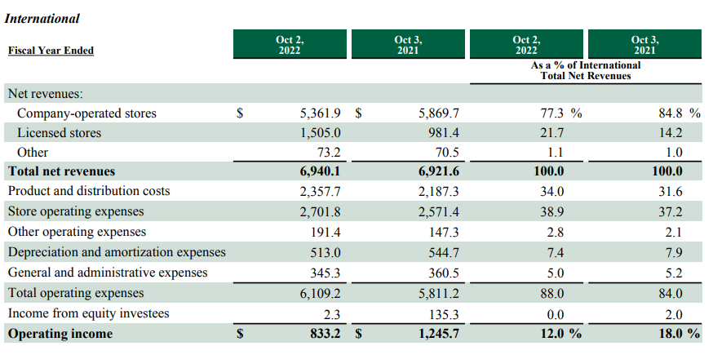
- Starbucks invests significantly in marketing and advertising its products, which can help increase demand by creating brand awareness and promoting the company's unique customer experience.
(Corporation, 2022)
A suitable substitute for Starbucks coffee is any other coffee brand or chain. The price of substitutes has the potential to influence the demand for Starbucks coffee. If the price of substitutes increases, Starbucks coffee could become relatively more affordable, resulting in an increase in demand. Conversely, if the price of substitutes decreases, it could make Starbucks coffee relatively more expensive, resulting in a decline in demand. For instance, if a prominent coffee chain increases the price of its coffee, some consumers may decide to transfer to Starbucks because it may be less expensive. This may enhance the demand for Starbucks coffee. Conversely, if a new coffee chain opens that offers comparable quality coffee at a lower price, it may result in a decline in demand for Starbucks coffee as some consumers transfer to the new chain.
A complementary product may consist of anything typically ingested with coffee, such as pastries, sandwiches, or munchies. Additionally, the price of add-ons can affect the demand for Starbucks coffee. If the price of complements rises, the overall cost of purchasing a cup of coffee and its complement could increase, resulting in a decline in demand for Starbucks coffee. Inversely, a decrease in the price of complements could make purchasing a cup of coffee and its complement more affordable, thereby increasing demand for Starbucks coffee. For instance, if Starbucks raises the price of its pastries, some consumers may be dissuaded from purchasing both coffee and pastries, resulting in a decline in demand for Starbucks coffee. In contrast, if Starbucks offers a discount when coffee and pastries are purchased together, it may increase demand for Starbucks coffee and pastries.
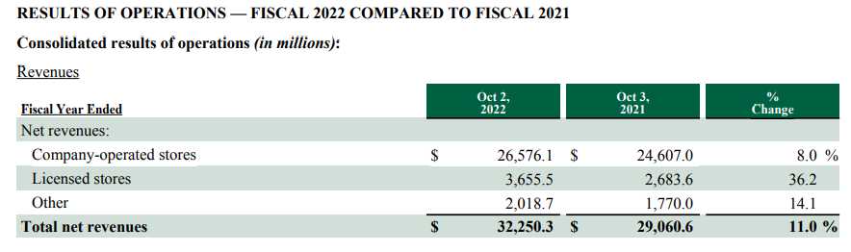
Consumer income can also affect Starbucks coffee demand. Increasing consumer income may result in a rise in demand for Starbucks coffee As consumers may have more discretionary income, they may purchase more expensive coffee. Inversely, if consumer income declines, consumers may have less disposable income to spend on premium coffee, which could reduce demand for Starbucks coffee. For instance, if the economy is expanding and people are earning higher incomes, this may increase demand for Starbucks coffee, as people may be more inclined to spend money on premium coffee. In contrast, if the economy is in a recession and people are earning reduced incomes, this may result in a decline in demand for Starbucks coffee, as consumers may be less inclined to spend on luxury items such as premium coffee.
(Corporation, 2022)
The tastes and preferences of consumers can also influence the demand for Starbucks coffee. As consumer preferences change, the demand for specific varieties of coffee and coffee products may shift. For instance, if consumers begin to favour a specific type of coffee blend or flavor that Starbucks does not offer, this could result in a decline in demand for Starbucks coffee. Conversely, if Starbucks introduces new coffee varieties or flavours that reflect evolving consumer preferences, it may increase demand for Starbucks coffee. The preferences of consumers can also be influenced by social and cultural trends. For instance, if there is a growing trend towards healthier food and beverage options, demand for healthier options at Starbucks, such as sugar-free syrups and non-dairy milk alternatives, may increase.
Price expectations of consumers can also have an effect on the demand for Starbucks coffee. If consumers anticipate that the price of Starbucks coffee will increase, they may opt for less expensive alternatives, resulting in a decline in demand. In contrast, if consumers anticipate that the price of Starbucks coffee will decrease or remain stable, this may result in a rise in demand, as consumers may be more inclined to purchase Starbucks coffee. For instance, if Starbucks announces a price increase on its coffee products, some consumers may seek out cheaper alternatives or reduce their consumption of Starbucks coffee. In contrast, if Starbucks offers a promotion or discount on its coffee products, consumers may be more likely to purchase Starbucks coffee in order to take advantage of the reduced prices.
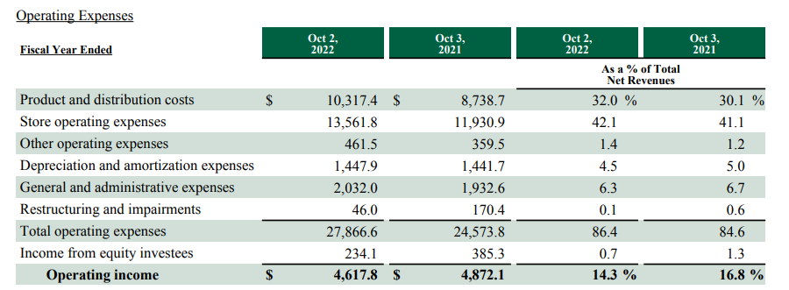
(Corporation, 2022)
Additionally, the demand for Starbucks coffee is influenced by demographics and the number of purchasers. As more people are able to purchase and consume Starbucks coffee, there may be an increase in demand if the number of consumers increases. Utilize the product. Inversely, a decline in the number of consumers may result in a decline in demand for Starbucks coffee. For instance, if the population in an area where Starbucks is located is increasing, more people may be able to visit and purchase coffee from the location, which may increase demand for Starbucks coffee. Conversely, if the population in an area where Starbucks is located is declining, the demand for Starbucks coffee may decrease. Additionally, demographics can influence the types of products that are in demand. For instance, if a certain demographic (such as millennials) is more likely to ingest coffee products, it could result in an increase in demand for Starbucks coffee, as the brand has a strong allure among this demographic.
The point of market equilibrium is when the quantity of Starbucks coffee that consumers are willing and able to purchase at a given price equals the quantity that Starbucks is willing and able to sell at the same price. Currently, there is neither an excess nor a deficiency of coffee, and the market is in equilibrium. The equilibrium of the Starbucks coffee market is susceptible to demand and/or supply fluctuations. For instance, if the demand for Starbucks coffee increases, the equilibrium of the market will transition to a higher quantity and price. In contrast, if demand decreases, the equilibrium of the market will transition to a lower quantity and price. Similarly, if the supply of Starbucks coffee increases (as a result of increased production or reduced production costs, for example), the market equilibrium will transition to a higher quantity and a lower price. In contrast, if supply decreases (e.g., due to a coffee bean shortage), the market equilibrium will transition to a lower quantity and higher price.
Overall, the equilibrium of the Starbucks coffee market is affected by the interaction between demand and supply, as well as a number of internal and external factors, such as consumer preferences, competition, production costs, and raw material availability.
- Availability of substitutes - If there are many close substitutes for Starbucks coffee, this may make demand more elastic, as consumers will have more options from which to choose. This indicates that even a modest increase in the price of Starbucks coffee could cause consumers to move to a competing brand.
- Percentage of income - If the price of Starbucks coffee represents a substantial portion of a customer's income, it may increase demand elasticity. This indicates that even a minor increase in the price of Starbucks coffee could have a substantial effect on a customer's purchasing decision.
- Time period - Demand for Starbucks coffee may be less elastic in the short term, as consumers may be less likely to rapidly transition to a substitute product or alter their purchasing patterns. Demand for Starbucks coffee may become more elastic over time, as consumers have more time to modify their behaviours and contemplate alternatives.
- Necessity - If Starbucks coffee is viewed as a necessity or an essential item, demand may be less elastic, as consumers may be less likely to transition to a substitute product even if prices rise.
- Brand loyalty - If consumers have a strong attachment to the Starbucks brand, demand may be less elastic, as they may be willing to pay a higher price for the product.

Here is how the Substitution Effects and Income Effects influence the Price Elasticity of Demand for the product:
Substitutional Results: If the product or service is considered a luxury as opposed to a necessity, then demand is more elastic because consumers have the option of substituting it with a cheaper alternative or forgoing it altogether. In contrast, if the product or service is regarded as a necessity, demand is less elastic because consumers may be prepared to pay a higher price to maintain their standard of living or satisfy their fundamental requirements. Some consumers with alternative options, such as producing their own coffee at home, may perceive Starbucks coffee as a luxury item. In this situation, demand may be more elastic because consumers have the option to transition to a cheaper alternative or forego the purchase. Conversely, demand may be less elastic for consumers who perceive Starbucks coffee as a necessity or part of their daily regimen, as they may be willing to pay a higher price to maintain their habit.
The proportion of a consumer's income spent on a product or service can also influence the price elasticity of demand. If the product or service represents a considerable portion of a consumer's income, demand is more elastic, as any price change would substantially impact their overall budget. In contrast, if the product or service represents a small portion of a consumer's income, demand is less elastic because any price change would have a negligible effect on their overall budget. For instance, if a consumer's income is relatively low and they spend a significant portion of it on Starbucks coffee, any price increase would have a greater impact on their overall budget, thereby making demand more elastic. In contrast, if a consumer's income is comparatively high and they only spend a small portion of it on Starbucks coffee, then any price increase would have a smaller impact on their overall budget, resulting in less elastic demand.

On the basis of an examination of the elements that impact the demand for the product or service as well as its price elasticity, the pricing strategy that the company ought to implement is contingent upon a number of criteria, including the following:
Prices offered by rivals: If prices offered by competitors are lower, then it is possible that Starbucks will need to reduce their own pricing in order to stay competitive. Demand in the market: If demand is inelastic, then Starbucks may have greater pricing power and may be able to raise their prices without their being a major influence on the amount of demand for their products. On the other hand, if demand is elastic, Starbucks could need to maintain low pricing in order to keep its sales steady. Cost of production: If the cost of manufacturing the good or providing the service goes up, it's possible that Starbucks will have to raise its pricing in order to retain its current level of profitability. Differentiation of the Product If Starbucks can distinguish its product from that of its rivals by using distinctive qualities or characteristics, then the company may have greater pricing power. Brand loyalty: If customers have a strong attachment to the Starbucks brand and consider the things they sell to be necessities, then the corporation may have greater leeway in setting prices for its goods and services. In light of these considerations, Starbucks may choose to implement a pricing strategy that accounts for the level of competition in the market, the level of demand in that market, the cost of production, the level of product differentiation, and the level of customer loyalty. If, for instance, consumer demand in the market is inelastic, Starbucks may choose to raise its pricing in order to achieve the same level of profitability. On the other hand, if there is elasticity in the market's demand, Starbucks may need to maintain its pricing low in order to stay competitive. In the end, the objective of the pricing strategy should be to find a balance between preserving client happiness and loyalty while also sustaining profitability.

References
Adolph, 2023. Demand And Supply Of Starbucks Coffee. [Online]
Available at: https://www.foodsnews101.com/starbucks/demand-and-supply-of-starbucks-coffee/
[Accessed 28 04 2023].
Bussing, M. A., 2022. Starbucks, 2nd Edition. s.l.:s.n.
Corporation, S., 2022. ANNUAL REPORT PURSUANT TO SECTION 13 OR 15(d) OF THE SECURITIES EXCHANGE ACT OF 1934, Washington: Starbucks Corporation.
Goel, S., 2023. The Strategy Story. [Online]
Available at: https://thestrategystory.com/2023/01/12/starbucks-business-model-supply-chain-analysis/
[Accessed 20 04 2023].
Livia Windiana1*, A. B. V. R. K. S. B., 2020. The Effect of Green Marketing toward the Consumers Buying Interest of Starbucks Coffee Mediated By Brand Image. In: HABITAT. s.l.:s.n., pp. 36-41.
Matthew Guzman, 2021. Logit Demand Profit Maximization.
Nithin Geereddy, 2022. Strategic Analysis Of Starbucks Corporation, s.l.: Starbucks Corporation.

