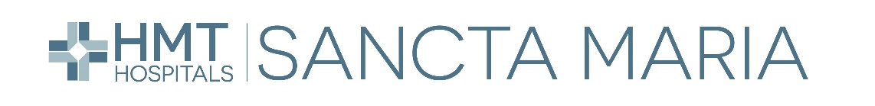

Evaluating the Effectiveness of the Staff Induction Process at Sancta Maria Hospital

Grahame Chapman
0750314
0750314@student.uwtsd.ac.uk
Word Count: XXXX

Table of Contents
Introduction 3
Literature Review 4
Purpose of Inductions 4
Consequences of Poor Inductions 4
Benefits of Socialisation 4
Virtual Onboarding and Artificial Intelligence 5
Methodology 5
Research Report Aim and Objectives 5
Chosen Research Methodology 6
How your research participants were chosen 6
Reliability, validity, and research limitations 7
How the research data was analysed 7
Research Findings 8
Socialisation 9
Time Constraints of Mentors 9
Unclear Structure 10
Use of Technology 11
Leaver Trends 12
Conclusion 14
Bibliography 16
Appendices 22
Appendix A: Focus group email invites sent to participants. 22
Appendix B: Focus group consent form provided to every participant. 23
Appendix C: Focus Group format, questions, and themed responses. 24
Appendix D: 2023 Exit Interview Report – Induction Process 30

Table of Figures

Figure 1: A diagrammatical view of the research process undertaken. 7
Figure 2: Percentage of staff who agree the induction process was organised and engaging. 11
Figure 3: Length of Service of Leavers 12
Figure 4: Number of Leavers from Total Staff Group 13
Figure 5: Leave Reason 13

Introduction
To drive organisational development, ongoing systemic improvements should continually be reviewed to ensure an organisations people practices fit their cultural and operational requirements (Bosley, 2023). With this being considered, this research report focuses on the induction process, an area widely recognised as an influential component in driving engagement and reducing staff turnover (Torrington, et al. 2020).
The research will be conducted at Sancta Maria, a private hospital located in South Wales operating within the healthcare sector that is facing significant challenges to recruitment and retention of clinical staff (Health and Social Care Committee, 2022).
Existing literature clearly establishes the importance of an organisational induction process and predominantly promotes the benefits of a thorough process incorporating compliance requirements and cultural assimilation acknowledged by Bratton and Gold (2017). With its benefits widely accepted, Personio (2023) argues staff inductions are underutilised and there is limited research into the practical consequences of an inadequate induction process within organisations.
Whilst an induction process is currently undertaken at Sancta Maria, it has not been formally reviewed to assess its effectiveness which alongside dwindling completion rates, may suggests an inadequate process (Wilkinson et al. 2019).
This research report therefore aims to analyse the overall effectiveness of the staff induction process at Sancta Maria Hospital and provides an opportunity to explore the organisational impact the current process is having on retention, engagement, and overall organisational performance.
In ensuring an appropriate methodology is adopted, focus groups were selected as the appropriate method of collecting detailed qualitative data. To improve validity a mixed-methodology approach is taken to measure the qualitative data alongside quantitative data collated and analysed from exit interview data obtained over the past twelve months.
My personal interest into this research topic stems from the desire to strive for progressive HR practices to align to the organisation’s strategic objectives. In the healthcare sector specifically improved staff engagement and reduced staff turnover are essential to performance and can both derive from the first step of the employment journey, the induction process.

Literature Review
In support of the objectives of the research project, the review of wider literature will underpin my subsequent research framework and enable the critical analysis of my own research (Leite, Padilha, and Cecatti, 2019). In critically analysing the induction process, several themes have been identified as set out below.

Purpose of Inductions
Current literature indicates two overall purposes of the onboarding process. The first traditional view promoted by ACAS (2015), sets out the legal requirements and general formalities required to ensure new staff are adequately prepared to undertake their role. Taylor and Woodhams (2022) have however more recently recognised that whilst many organisations still conduct ‘routine’ and ‘repetitive’ inductions to meet administrative needs, an increasingly more meaningful purpose of inductions is to utilise it as a tool to drive engagement and organisational performance.
Wilkinson, Armstrong, and Lounsbury (2017) builds on this view establishing that socialisation during onboarding is a significant tool in integrating new staff into workplaces that can promote engagement. It is apparent that the design of an organisation’s induction process can determine whether its purpose is derived from necessary administrative purposes, or with the intention to creating a positive experience (Godinho et al. 2023). This supports the need to identify the perception Sancta staff have of the onboarding strategy to determine whether a shift of design is required (Wilkinson et al. 2019).

Consequences of Poor Inductions
In reviewing the purpose, a significant proportion of literature focuses only on the benefits of a positive induction process, however a growing number of recent sources discuss the adverse organisational effects of a poor induction process. One of the prevalent trends identified is a clear link between onboarding and employee retention (Moss, 2017). Green (2018) further establishes that it is especially prevalent in the healthcare sector where it is suggested as many as 86 percent of new starters decide their future in an organisation within six months of employment.
Many existing published studies on employee retention fail to recognise any links between staff onboarding and retention. Crucially however, Kossivi, Xu and Kalgora (2016) determine that further research is required to draw any direct correlation between the induction process and employee retention. With challenges to staffing within the UK healthcare sector well documented and frequently acknowledged (Office for National Statistics, 2023), it would be pertinent to explore any correlation between onboarding and staff retention within Sancta Maria Hospital.

Benefits of Socialisation
It is suggested throughout various literary sources explore the benefits of dedicating time to connect new staff to an organisations culture and values can have on encouraging engagement and even promote equality and diversity (Prince, 2022). Multiple studies advocate the organisational benefits of encouraging positive socialisation during induction as it supports staff social development and helps assimilate them into their new environment creating positive engagement and in turn, better organisational performance (Klinghoffer, Young, Haspas 2019; Marchington, 2021). With this being considered the extend to which Sancta Maria support the socialisation and engagement of new staff should be scrutinised to support whether it is a beneficial activity.

Virtual Onboarding and Artificial Intelligence
There have been several recently published studies citing the benefits of virtual onboarding and Artificial Intelligence (AI) with Mohdzaini (2021) advocating its application in increasing accessibility, the speed of integration, and overall time efficiencies. A report by Fuhl, (2023) acknowledges that up to 80% of organisations will utilise some for of automation in their recruitment and onboarding process in ‘coming years’ demonstrating the widespread increasing uptake of technology.
Whilst research to date has heavily focused on efficiencies created by AI, Faragher (2023) challenges both the ethical and impersonal nature of AI practice that may be inappropriate depending on an organisation’s strategy and cultural approach. Zhukovska et al. (2021) further questions the long-term benefits of AI integration as there are no long-term studies to determine whether it will improve the overall experience, engagement, or long-term retention of staff.
The analysis of existing literature has identified important key themes and revealed gaps in existing research studies that are explored further in this research report (Efron and Ravid, 2019). Faragher (2017) surmises that widespread failures during the induction processes will affect staff performance and engagement which is highlights the importance of the research at Sancta Maria.

Methodology
In ensuring the quality, integrity and validity of the research, Efron and Ravid (2019) advocate a thoroughly planned design, and analysis methodology for the report as set out below.

Research Report Aim and Objectives
The aim of the research is to Analyse the effectiveness of Sancta Maria’s onboarding process and its impact on completion rates. To achieve the research aim, the following objectives underpin the report:
- Conduct primary research to identify any organisational trends or barriers faced in undertaking the staff induction programme.
- Examine the organisational impact of poor induction rates by reviewing organisational data to determine whether there is a correlation between induction completion rates and staff turnover.
- Identify improvements that can be made to the induction process to improve completion rates, its effectiveness, and to maximise its benefit as an onboarding tool.
- Critically analyse various literary sources to help understand any significant trends identified in the research and whether is supports the requirements to change in the induction programme.

Chosen Research Methodology
Evidence suggests a mixed methodology approach as utilising both qualitative and quantitative research methodologies to increase validity and obtain a holistic data set (Hammond and Wellington, 2021). The study design therefore incorporates both methods by collecting multiple episodes of data to ensure a detailed understanding of the research topic whilst simultaneously reducing the risk of confirmation bias across the objectives (Creswell, 2022).
Focus groups were identified as the most suitable data collection method as open question designs can obtain detailed qualitative data to understand the topic under review (Gov.uk, 2020a). Focus groups enable a detailed understanding of people perceptions and views as opposed to direct interviews or questionnaires which can provide limited opportunity for participants to express honest views which could negatively affect the reliability and validity of the responses (Nyumba et al, 2018).
Consideration was given to alternative research methods such as staff surveys or questionnaires. Evidence suggests however that whilst they are inexpensive to administer, they can offer bias sampling dependant on accessibility, lack detailed answers, and ultimately lead to lower reliability and validity (Management Library, 2022).
Further primary data was also obtained from exit interview survey data to support any themes identified as Peters (2023) promotes the analysis of additional quantitative data through organisational data to vigorously challenge any qualitative data obtained.

How your research participants were chosen
Considering the bearing on validity, ensuring adequate representation across all staff groups was prioritised (Department for Education, 2021). Two focus groups were therefore proposed to ensure rigorous data was obtained to gain both the views of mentors and staff who had undertaken an induction to understand how the process is perceived across different levels within the organisation (Hennink, 2014).
Whilst a purposive approach was taken overall in selecting participants, this only extended to a request for representation from each of Sancta Maria’s ten departments to ensure a proportionate representation was encouraged to avoid the potential for sampling bias (Vazquez, 2021).

Reliability, validity, and research limitations
In conducting the focus groups, limitations are acknowledged as group discussions can enable more dominant participants to dictate discussions which could potentially cause false consensus within the group who may reinforce bias (Nyumba, 2018). The facilitator was therefore responsible for ensuring a dominance effect was limited by probing all participants for their views (Citizens Advice, 2015).
In selecting the number of focus groups, Guest, Namey and McKenna (2016) revealed that 80% of all themes are identifiable from two focus groups. Hennick, and Kaiser (2022) further identified that four to eight discussions would reach information saturation. In this circumstance, facilitating more than two focus groups offered a disproportionate improvement in the quality of results compared to the additional resource cost and time to conduct however these limitations are considered in the analysis of the data.
Finally, ethical challenges were considered when selecting the focus group methodology as it has the potential to impact the validity of the data if not considered. Sim and Waterfield (2019) identify common concerns of open information sharing whereby concerns around consent and confidentiality exist. In considering this, the invite (see Appendix A) and consent form (see Appendix B) outline the purpose, nature, and data reporting methods to mitigate any concerns.

How the research data was analysed
To ensure the appropriate analysis of the data, the focus groups were transcribed immediately after each session to ensure their accuracy, with pertinent points demonstrated in Appendix C. To ensure confidentiality, comments were anonymised whilst pertinent discussion points were recorded for analysis. A thematic analysis was then undertaken to examine the data and identify common themes or patterns (Caulfield, 2019).
Gupta, Shaheem and Prathap (2019) credit the thematic approach with reducing confirmation bias in formulating the analysis and appropriate for qualitative research. In identifying themes for analysis, it provides a logical process to define and set out in the findings section in a concise and coherent format (Gormley, et al. 2019).

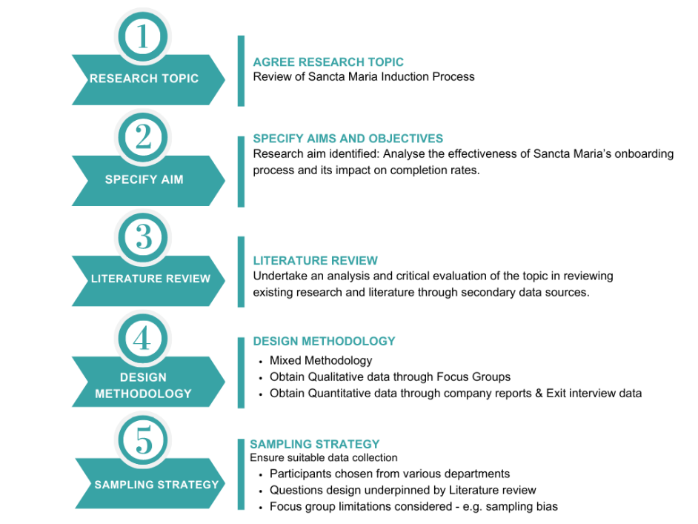
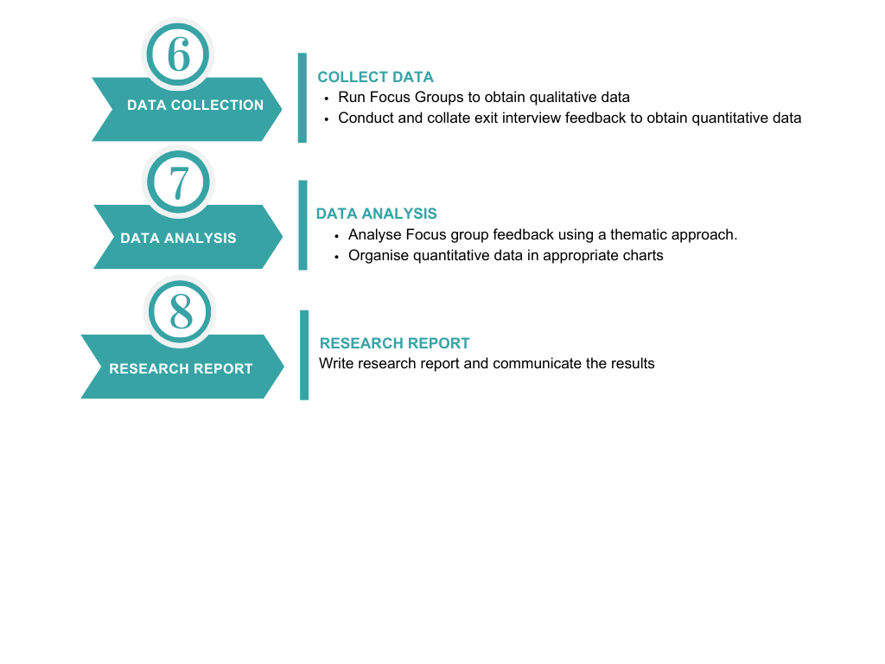
Figure 1: A diagrammatical view of the research process undertaken.

Research Findings
In considering the report objectives, the findings below set out the results and analysis of the overall effectiveness of Sancta Marias induction process. Supported by Nowell. et al (2017), a thematic approach has been taken to methodically set out the key themes identified in the subheadings below. The qualitative data obtained from the focus groups is set out in Appendix C alongside quantitative data obtained from Sancta Maria Exit Interview Report set out in Appendix D.

Socialisation
As identified in the literature review, Frogeli, Jenner, and Gustavsson (2023) advocate the benefits of positive socialisation which is an encouraging trend identified in responses regarding positive socialisation and staff interactions at Santa Maria:
Q2: “Staff are friendly, welcoming, and supportive”
Q4. “Everyone you did meet was friendly and welcoming”
Q10. “Wider team are really supportive and friendly.”
Q12. “Anxieties of being a new member of staff put to ease after meeting colleagues”
These comments are indicative of ‘positive induction experience’ explored during the literature review with positive socialisation advocated by Nunn (2019) as enabling cultural adaptation can subsequently improve knowledge sharing and performance.
There was however a disparity between some mentors and staff responses in reviewing the purpose of the induction process:
Q1. Staff Response “Opportunity to meet colleagues and key staff”
Q1: Staff Response “Ease new starters into the team in a supportive manner”
Q1: Mentor Response “Tick box exercise”
During the focus groups, staff acknowledged the importance of socialisation however this wasn’t reciprocated in all mentor feedback with some seeing the induction process as an administrative task. McCartney (2022) outlines the significant importance of positive induction which is supported in reviewing the 2023 Exit interview data for Sancta Maria which reveals that 61% of staff agree that their induction helped their integration into their teams.

Time Constraints of Mentors
Throughout the focus groups several barriers to the completion of the induction programme were shared, with a predominant trend being the time constraints mentors face preventing the completion of thorough inductions. Time constraints were mentioned several times highlighting a significant issue across both groups:
Q3. “It Can be difficult to get dedicated time with managers after the initial week”
Q3. “Difficulty in guaranteeing time with new starters”
Q7. “Mentors don’t have the time to spend weeks with a new member of staff”
Q11. “Most required improvements relate to the alleviation of time constraints”
This predominantly focused on mentors not having sufficient time to spend with the new starters due to staffing issues or high workloads. Whilst not uncommon in the healthcare sector (RCN, 2019), it doesn’t suggest a thorough process is followed (McCartney, 2022). Whilst this directly identifies a key factor diminishing the completion rates of the induction process, King, Roed, and Wilson (2018) explain that this can also lead to a feelings of abandonment which is unfortunately demonstrated in focus group responses:
Q2: “New starters can feel like they’re chucked in the deep end”
Q7: “Staff can feel isolated without a mentor”
Without formal direction from a mentor, ‘learning osmosis’ can also occur whereby new staff learn behaviours from existing staff (Jones, 2021). A recent workplace learning report by LinkedIn (2020) warns that without appropriate support, it can lead to undesirable traits being developed which would overall affect long term performance within Sancta Maria.

Unclear Structure
Alongside time being a barrier in completing inductions, a further trend affecting its effectiveness is the induction structure perceived by staff and mentors. In reviewing the mandatory forms requiring completion, both the form and supplementary documents provided by HR received positive feedback in achieving their purpose of capturing the completion of an induction:
Q2. “HR and Compliance requirements are structured”
Q3. “The initial HR checklist is good but after this there’s no clear structure or feedback on your role until the 13-week review”
Q10. “Structured HR forms are easy to follow”
Whilst it is positive that staff perceive the mandatory forms as sufficient, Taylor and Woodhams (2022) demonstrates that a modern induction requires more than mandatory compliance initiatives to be met and therefore isn’t evidence alone of a positive induction.
It does however evidence that the staff expect a longer onboarding process compared to the mentors who see the induction process as being concluded once the forms have been completed:
Q11. “More structure needed once initial forms are completed”
Q13. “Starting blocks are great, but the following structure is lacking after the first week”
Whilst checklists and initial orientation can be completed in the first weeks, the full induction process can take months to ensure the new employee to be fully engaged at an organisation (Robert Half, 2016). This demonstrates a disparity between the expectation of staff and the provision offered by mentors which could lead to a less effective induction for starters.
The lack of consistent reviews following the initial week’s induction highlights concerns in the ongoing engagement of new starters:
Q9. “No challenges with the induction forms, but no clarity on the expectations after this”
This is further under pinned by exit interview data whereby a significant proportion of respondents disagree that the induction process was engaging.
Figure 2: Percentage of staff who agree the induction process was organised and engaging.

Use of Technology
Whilst Sancta Maria don’t currently utilise virtual onboarding or AI systems, electronic resources such as training plans and compliance document have been undertaken electronically due to their perceived efficiencies (Craft, 2021). Feedback on increasing automation in the induction process did however achieve mixed results:
Q2: “Isolating when spending a few days completing mandatory E-learning”
Q9: “Would be more valuable initially to understand the role and job duties rather than go through online resources”
Q11: “More electronic resources would be more efficient”
Q13 “Use more online induction programmes that could be more efficient to reduce reliance on staff time”
The answers provided by staff in questions 2 and 9 capture the feeling that online training resources can be laborious, isolating, and ultimately detrimental to their onboarding experience. Mentors’ responses in question 11 and 13 support the use of efficiencies and time saving that could be achieved in this approach.
Whilst there is a proven appetite from mentors to pursue more progressive automated systems, the priority of new starters is to understand their role and duties and therefore the current electronic systems do not meet the requirements of new starters based on their current format. In reviewing virtual onboarding, the importance of developing a collaborative approach to meet the requirements of the staff and organisations to develop adequate systems are a commonly shared concern (Alexander, 2021; Casemore, 2020).

Leaver Trends
As the Focus group data as obtained from existing staff, it was difficult to ascertain from those groups whether the induction process has an impact on staff turnover. In reviewing the exit interview qualitative data however, it demonstrates that a disproportionately high percentage of staff leave within their first year of employment:
Figure 3: Length of Service of Leavers

With 41% of leavers having under on years’ service, the concern is heightened when further examining the number of leavers from within the total number of staff with each length of service.
Figure 4: Number of Leavers from Total Staff Group

This demonstrates that 56% of staff with under one years’ service left Sancta Maria in the past twelve months which is a significant issue for Sancta Maria in not only ensuring adequate service provision, but the additional cost to recruit and retrain new starters on what appears to be a consistent basis (Peters, 2023).
Whilst reviewing the leave reasons provided, there was however no direct correlation between the induction process being a direct reason for leaving.
Figure 5: Leave Reason

Whilst there is therefore no evidence to directly link induction completions and effectiveness with staff turnover within Sancta Maria, Peters (2023) identifies staff disengagement as a significant reason for staff leavers. Given the evidence that managers have insufficient time to dedicate to the induction process, it is possible that a lack of engagement being build it leading to a heightened staff turnover.

Conclusion
Through the research project, the aim has been to analyse the effectiveness of Sancta Maria’s induction process and identify any affect this has on completion rates.
The findings of the primary research aligned to themes that arose in the literary review and supported many of the objectives of the research project. In identify any barriers to the completion of inductions at Sancta Maria, mentor time and an unclear structure were two predominant themes analysed.
Whist the awareness of time pressure in healthcare is not unexpected (Walker, 2022), there is clear evidence the time constraints on mentors is having a detrimental impact on providing a thorough and detailed induction process. These challenges are compounded by an unclear induction structure due to varying expectations of mentors and staff whereby new staff expect an extended process of socialisation and job familiarisation to facilitate and promote engagement in their new role (Chillakuri, 2020). A favourable positive result was however demonstrated within the theme of socialisation which indicates an effective induction in part in line with Social Care Wales (2022) expectations.
In examine the organisational impact of the induction process in line with exit interview survey data, issues of staff retention were clearly brought to light with a significant proportion of staff leaving within one years-service. Whilst there was no direct link drawn to a poor induction process specifically, significant trends of low engagement were revealed which was a gap evidenced in the current induction process and is integral to the employee’s induction experience could ultimately drive higher staff turnover (Sibisi and Kappers, 2022).
Focus groups overall proved an effective method of data collection that enabled the identification of predominant emerging themes for analysis (Pope, 2020). Ethical concerns of obtaining qualitative research were also diligently considered to ensure the consent and confidentiality of participants was ensured to ensure research integrity (Sibinga, 2018).
Reviewing exit interview data also provided vigour to the qualitative data obtained however the project was restricted by only running two focus groups due to the resource cost compared to an online questionnaire. Further focus group would have provided additional qualitative data to analyse and therefore a review of the views of more staff could have added further depth to the analysis (Stewart and Shamdasani, 2015).
Overall, the research demonstrated that the administrative and compliance requirements of the induction process are being satisfied and that it is sufficient in that aspect. However, with organisational benefits to socialisation and engagement being considered, there are improvements that can be made to add more structure and meaning to the process.
It would be useful for Sancta Maria to implement changes to the induction process based on improved engagement strategy and then repeat this study to see if any improvement in staff turnover is demonstrated as this could significantly save reoccurring recruitment costs and ultimately promote better performance with continuity of staff.

Bibliography
ACAS (2015) Starting staff: induction. Available at: https://www.acas.org.uk/sites/default/files/2021-03/Starting-staff-induction.pdf (Accessed: 14 July 2023)
Alexander, A. (2021) ‘Virtual onboarding: lessons from the pandemic’, Public Services Quarterly, 17(3), pp. 208–211. Available at: https://doi.org/10.1080/15228959.2021.1915913 (Accessed: 20 August 2023)
Bosley, A. (2023) Organisational Development. Available at: https://www.cipd.org/uk/knowledge/factsheets/organisational-development-factsheet/ (Accessed: 20 August 2023)
Bratton, J. and Gold, J. (2017) Human resource management: theory and practice. 6th edition. London: Palgrave.
Braun, V. and Clarke, V. (2022) Thematic analysis: a practical guide. London: SAGE Publications
Casemore, D. (2020) Remote onboarding: five tips for the perfect virtual welcome. Available at: https://www.hrmagazine.co.uk/content/features/remote-onboarding-five-tips-for-the-perfect-virtual-welcome (Accessed: 20 August 2023)
Caulfield, J. (2019) How to do thematic analysis: Step-by-Step guide. Available at: https://www.scribbr.com/methodology/thematic-analysis/ (Accessed: 30 July 2023)
Chillakuri, B. (2020) ‘Understanding Generation Z expectations for effective onboarding’, Journal of Organizational Change Management, 33(7), pp. 1277–1296. Available at: https://doi.org/10.1108/JOCM-02-2020-0058
Citizens Advice (2015) How to run focus groups. Available at: https://www.citizensadvice.org.uk/Global/CitizensAdvice/Equalities/How%20to%20run%20focus%20groups%20guide.pdf (Accessed: 30 July 2023)
Craft, A. (2021) ‘Onboarding and Training New Electronic Resources Personnel in Libraries: An Overview of Literature and Resources’, Serials review, 47(4), pp. 182–186. Available at: https://doi.org/10.1080/00987913.2021.1988423
Creswell, J. (2022) A concise introduction to mixed methods research. Second edition. California: SAGE Publishing
Department for Education (2021) Sampling bias and selecting the right sample of participants. Available at: https://user-research.education.gov.uk/-recruiting-participants/sample-bias.html#content (Accessed: 30 July 2023)
Efron, S. and Ravid, R. (2019) Writing the literature review: a practical guide. New York: Guilford Press
Faragher, J. (2017) A third of new starters experience poor onboarding. Available at: https://www.personneltoday.com/hr/third-new-starters-experience-poor-onboarding/ (Accessed: 16 July 2023)
Faragher, J. (2023) Fear of Future? Getting to grips with the AI Skills gap. Available at: https://www.personneltoday.com/hr/ai-skills-gap/ (Accessed: 16 July 2023)
Frögéli, E., Jenner, B. and Gustavsson, P. (2023) ‘Effectiveness of formal onboarding for facilitating organizational socialization: A systematic review’, PloS one, 18(2), pp. 1-17. Available at: https://web-p-ebscohost-com.ezproxy.uwtsd.ac.uk/ehost/detail/detail?vid=1&sid=d67a99d6-be92-4f3d-aea3-cf345a052a70%40redis&bdata=JnNpdGU9ZWhvc3QtbGl2ZQ%3d%3d#AN=161936793&db=aph (Accessed: 18 August 2023)
Fuhl, J. (2023) The changing face of HR: A research report for HR and People leaders. Available at: https://www.sage.com/en-gb/blog/the-changing-face-of-hr/#:~:text=The%20changing%20face%20of%20HR%20is%20a%20research%20report%20that,re%20responding%20to%20the%20changes. (Accessed: 16 July 2023)
Godinho, T. et al. (2023) ‘Onboarding Handbook: An Indispensable Tool for Onboarding Processes’, Administrative sciences, 13(3), pp. 1–21. Available at: https://doi.org/10.3390/admsci13030079
Gormley, G. et al. (2019) Analysig Data: Approaches to thematic Analysis. Available at: https://link.springer.com/chapter/10.1007/978-3-030-26837-4_19 (Accessed: 30 July 2023)
Gov.uk (2020a) Focus group study: qualitative studies. Available at: https://www.gov.uk/guidance/focus-group-study-qualitative-studies (Accessed: 16 July 2023)
Gov.uk (2020b) Mixed Methods Study. Available at: https://www.gov.uk/guidance/mixed-methods-study (Accessed: 16th July 2023)
Green, M. (2017) Healthcare Hiring – getting new employees on board. Available at: https://www.cipd.org/en/knowledge/bitesize-research/healthcare-hiring/ (Accessed: 14 July 2023)
Guest, G., Namey, E. and McKenna, K. (2016) ‘How Many Focus Groups Are Enough? Building an Evidence Base for Nonprobability Sample Sizes.’ Sage Journals, 29(1), pp. 3–22. Available at: https://journals.sagepub.com/doi/abs/10.creating a title for my research report1177/1525822X16639015?journalCode=fmxd (Accessed: 30 July 2023)
Gupta, M., Shaheen, M. and Prathap, K. (2019) Qualitative techniques for workplace data analysis. Pennsylvania: Business Science Reference. Available at: https://doi.org/10.4018/978-1-5225-5366-3
Hammond, M. and Wellington, J. (2021) Research methods: the key concepts. Second edition. London : Routledge
Health and Social Care Committee (2022) Workforce: recruitment, training and retention in health and social care. Available at: https://committees.parliament.uk/publications/23246/documents/171671/default/ (Accessed: 20 August 2023)
Hennink, M. (2014) Writing Focus Group Methods. Available at: https://academic.oup.com/book/11826/chapter/160911340 [Accessed: 30 July 2023]
Hennink, M. and Kaiser, B. (2022) ‘Sample sizes for saturation in qualitative research: A systematic review of empirical tests’. Social Science and Medicine, 292(1), pp 523. Available at: https://www.sciencedirect.com/science/article/pii/S0277953621008558 (Accessed: 30 July 2023)
Jones, A. (2021) Observing and chatting to colleagues helps us gain valuable knowledge. How to make that happen in a post-work pandemic. Available at: https://www.bbc.com/worklife/article/20211004-the-problem-with-losing-osmosis-learning (Accessed: 18 August 2023)
King, V., Roed, J. and Wilson, L. (2018) ‘It’s very different here: practice-based academic staff induction and retention’, Journal of higher education policy and management, 40(5), pp. 470–484. Available at: https://doi.org/10.1080/1360080X.2018.1496516
Klinghoffer, D., Young, C. and Haspas. D. (2019) Every new employee needs an onboarding “Buddy”. Available at: https://hbr.org/2019/06/every-new-employee-needs-an-onboarding-buddy (Accessed: 14 July 2023)
Kossivi, B., Xu, M. and Kalgora, B. (2016) ‘Study on Determining Factors of Employee Retention.’ Open Journal of Social Sciences, 4, pp. 261-268. Available at: https://www.scirp.org/journal/paperinformation.aspx?paperid=66904 (Accessed: 14 July 2023)
Leavy, P. (2020) The Oxford handbook of qualitative research. Second edition. New York: Oxford University Press
Leite, D., Padilha, M. and Cecatti, J. (2019) ‘Approaching literature review for academic purposes: The Literature Review Checklist’, Clinics, 74(1), pp. 1–8. Available at: https://doi.org/10.6061/clinics/2019/e1403
LinkedIn (2020) Workplace Learning Report 2021. Available at: https://learning.linkedin.com/content/dam/me/business/en-us/amp/learning-solutions/images/wlr21/pdf/LinkedIn-Learning_Workplace-Learning-Report-2021-EN-1.pdf (Accessed: 18 August 2023)
Management Library (2022) Overview of Basic Methods to Collect Information. Available at: https://management.org/businessresearch/methods.htm (Accessed: 16 July 2023)
Marchington, M. (2021) Human resource management at work: the definitive guide. Seventh edition. London: Kogan Page
McCartney, C. (2022) Induction. Available at: https://www.cipd.org/uk/knowledge/factsheets/induction-factsheet/#purpose (Accessed: 18 August 2023)
Mohdzaini, H. (2021) Using technology to improve hiring and onboarding. Available at: https://www.cipd.org/uk/views-and-insights/thought-leadership/insight/using-technology-to-improve-hiring-and-onboarding/ (Accessed: 16 July 2023)
Moss, R. (2017) How to improve employee attraction, onboarding and retention. [webinar]. 4 June. Available at: https://www.personneltoday.com/hr/improve-employee-attraction-onboarding-retention-demand-webinar/ (Accessed: 16 July 2023)
Nowell, L. et al (2017). ‘Thematic Analysis: Striving to Meet the Trustworthiness Criteria.’ International Journal of Qualitative Methods, 16(1). Available at: https://doi.org/10.1177/1609406917733847
Nunn, J. (2019) The Social Impact of Workplace Inductions. Available at: https://www.forbes.com/sites/forbestechcouncil/2019/04/09/the-social-impact-of-workplace-inductions/ (Accessed: 18 August 2023)
Nyumba, O. et al. (2018) ‘The use o focus group discussion methodology: insights from two decades of application in conversation’, Methods in Ecology and Evolution, 9(1), pp. 20-32. Available at: https://besjournals.onlinelibrary.wiley.com/doi/full/10.1111/2041-210X.12860 (Accessed: 30 July 2023)
Office for National Statistics (2023) Vacancies and jobs in the UK: July 2023 [Statistical Bulletin] Available at: https://www.ons.gov.uk/employmentandlabourmarket/peopleinwork/employmentandemployeetypes/bulletins/jobsandvacanciesintheuk/latest (Accessed: 14 July 2023)
Patten, L. and Newhart, M. (2023) Understanding research methods: an overview of the essentials. Eleventh edition. New York: Routledge.
Personio (2023) Employee Experience: Are Organisations Underrating the ROI of Employee Onboarding. Available at: https://www.hrgrapevine.com/content/article/are-organisations-underrating-the-roi-of-employee-onboarding-personio (Accessed: 27 August 2023)
Peters, R. (2023) Employee Turnover and Retention. Available at: https://www.cipd.org/uk/knowledge/factsheets/turnover-retention-factsheet/ (Accessed: 14 July 2023)
Pope, C. (2020) Qualitative research in health care. Fourth edition. New Jersey: Wiley Blackwell.
Prince, N. (2022) ‘Transitioning to a virtual onboarding process during the COVID-19 pandemic: An interview with Kat Judd, Vice President of People and Culture at Lucid’, Business horizons, 65(4), pp. 413–416. Available at: https://doi.org/10.1016/j.bushor.2021.03.004
Robert Half (2016) Employee Onboarding: What to do and what not to do. Available at: https://www.roberthalf.co.uk/advice/human-resource-management/employee-onboarding-what-do-and-what-not-do (Accessed: 18 August 2023)
Royal College of Nursing (2019) RCN employment survey reveals nursing staff stretched to breaking point. Available at: https://www.rcn.org.uk/news-and-events/press-releases/staff-survey (Accessed: 18 August 2023)
Sibinga, C.T. (2018) Ensuring research integrity and the ethical management of data. Pennsylvania: IGI Global.
Sibisi, S. and Kappers, G. (2022) Onboarding can make or break a new hires experience. Available at: https://hbr.org/2022/04/onboarding-can-make-or-break-a-new-hires-experience (Accessed: 20 August 2023)
Sim, J. and Waterfield, J. (2019) ‘Focus group methodology: some ethical challenges’. Quality& Quantity, 53 (1), pp. 3003 – 3022. Available at: https://link.springer.com/article/10.1007/s11135-019-00914-5 (Accessed: 30 July 2023)
Social Care Wales (2022) The benefits of a good induction. [Video] Available at: https://socialcare.wales/resources/the-benefits-of-a-good-induction (Accessed: 18 August 2023)
Stewart, D.W. and Shamdasani, P.N. (2014) Focus groups: theory and practice. Third edition. Los Angeles: SAGE.
Taylor, S. and Woodhams, C. (2022) Human resource management : people and organisations. Third Edition. Edited by S. Taylor and C. Woodhams. New York, NY: Kogan Page Inc.
Torrington, D. et al. (2020) Human resource management. 11th edition. Harlow: Pearson Education Limited
Vazquez, E. (2021) ‘What is Sampling Bias +5 Types of Sampling Bias’. Premise Blog, 28 October. Available at: https://www.premise.com/blog/sampling-bias-what-you-need-to-know/ (Accessed: 30 July 2023)
Walker, G. (2022) Immense pressure on health services. Available at: https://www.rcn.org.uk/news-and-events/blogs/immense-pressure-on-health-services (Accessed: 20 August 2023)
Wilkinson, A., Armstrong, S.J. and Lounsbury, M. (2017) The Oxford handbook of management. Online Edition. Oxford: Oxford University Press. https://doi.org/10.1093/oxfordhb/9780198708612.002.0003
Wilkinson, A. et al. (2019) The SAGE handbook of human resource management. Second edition. London: SAGE Publications Ltd
Yeung, M. et al. (2019) ‘“I wasn’t oriented a lot, so I’m essentially learning as I go”: onboarding and transition to practice of new emergency physicians’, Canadian journal of emergency medicine, 21(1), pp. 116–116. Available at: https://doi.org/10.1017/cem.2019.335
Young, J. (2023) Employee Engagement and Motivation. Available at: https://www.cipd.org/uk/knowledge/factsheets/engagement-factsheet/ (Accessed: 18 August 2023)
Zhukovska, M. et al. (2021) ‘Recruitment as a Technology of Effective Attraction and Onboarding of Staff’, Bìznes ìnform (Multilingual ed.), 12(527), pp. 257–262. Available at: https://doi.org/10.32983/2222-4459-2021-12-257-262

Appendices

Appendix A: Focus group email invites sent to participants.
Dear Colleagues.
Thank you volunteering to participate in our focus group to review the induction and onboarding process here at Sancta Maria Hospital. The session will be held on 7th July at 11.45am in the Sancta Maria meeting room.
By participating in this focus group, you will provide us with a valuable insight into your experience of our induction process and provide us with an opportunity to review our process for our future new starters. Your responses are voluntary and no personally identifiable information will be reported. The responses to questions, discussion and comments will be summarised to remove any identifiable data for reporting purposes.
As discussed, your views will not only be important to supporting the future of the Induction process at Sancta Maria but will also be valuable to my current research project for which the results will be anonymised on reported on for academic purposes.
In having representatives from both clinical and non-clinical areas I’m hoping it will encourage a collaborative review of our induction process. If you have any queries prior to the meeting, please don’t hesitate to let me know. I’m hopeful that the discussion will help us in establishing areas of improvement for our inductions to make it a more engaging and positive experience overall going forward.
Enclosed is a consent form that will be required to be completed and returned to confirm your attendance.
Kind Regards
Grahame
Grahame Chapman| People Relations Associate
Sancta Maria Hospital | Lamberts Road | Swansea | SA1 8FD
tel: 01792 989133| ext: 1303
email: Gchapman@hmt-uk.org

Appendix B: Focus group consent form provided to every participant.

FOCUS GROUP CONSENT FORM
Research Project: Sancta Maria Hospital Induction Review
Conducted by: Grahame Chapman (People Relations Associate
Date of Focus Group: 7th July 2023
I agree to participate in the Induction Review Focus Group conducted by Grahame Chapman to aid with the research of the induction process at Sancta Maria Hospital.
The aims and purpose of the project have clearly been set out and are understood.
I am aware and understand the topic to be discussed in the Focus Group
I am aware that no personally identifiable information will be reported and responses to questions, discussion and comments will be summarised.
Data collected will be stored securely and safely in accordance with the Data Collection Act (1998)
I am fully aware that my participation is voluntary, and I can withdraw from the focus group at any point without reason or consequence.

Name …………………………………………….
Signature ……………………………………………
Date …………………………………………….

Appendix C: Focus Group format, questions, and themed responses.
Focus Group Feedback
Staff who have Undertaken the Induction Process
Line Managers Responsible for Conducting the Induction Process

Facilitator: Grahame Chapman | Date: 7th July 2023
- Introductory Points and Principles of the Focus Group:
- Inform participants of the purpose of the focus group discussion.
- Confirm voluntary nature and consent from participants to attend.
- Personal information of participants will be kept confidential. Notes will be taken of feedback received for the purpose of reporting but no reference to personal data will be reported on.
- Explain the benefit of an open discussion to promote discussion, idea sharing, and debate.

Rules & Housekeeping
Request that one person speaks at a time to ensure everyone has an opportunity to share their views.
Respecting the opinion of others and those speaking as everyone’s views are important to consider.
It is important to hear everyone’s ideas and there are no right or wrong answers.
If anyone has any questions on any separate topics, we can discuss them at the end as the focus in this forum is the induction process.
Whilst everyone should be familiar with each other, ask participants to introduce themselves to build confidence in the setting.

Focus Group Questions & Participant Response Themes
Q1. What do you think is the purpose of the Induction Process?
Welcome new staff to the team.
Opportunity to meet colleagues and introductions to key staff.
Give them time to familiarize themselves with Sancta Maria processes and facilities.
Get to understand the work environment, the people, the basics of the role.
Health and Safety requirements, training, fire safety etc.
Overall ease new starters into the team in a supportive manner

Tick box exercises such as accessing policies, complete mandatory forms.
Set out requirements and expectations of the role.
Welcome staff to the team and create a positive experience for them.
Support new starters to settle into their new environment.

Q2. How was your personal experience of the induction process?
Staff are friendly, welcoming, and supportive.
Isolating when spending a few days completing mandatory E-learning
Allocated a mentor however they’re not always available so have to ask other colleagues with queries which can be daunting when you’re new.
Quick process going through the induction checklist but not much structure after that in terms of goal setting or reviews periods for new staff.
Staff are helpful, but lack of consistency as no dedicated buddy meant you have to pick things up as you go along.
Not very structured and new starters can feel like they’re “chucked in the deep end”.

Hard to keep on top of it due to time constraints.
HR and compliance requirements are structured, but personal development is dependent on time.
Feeling of information overload in trying to get through all the requirements in a week.
Hard to ensure staff are supernumerary for the first month due to staffing level.

Q3. Are the requirements/expectations of the induction process clearly conveyed?
100% clear initially as the managers go through the induction forms and ensure everything is set out and understood.
The initial HR checklist is good but after this there’s no clear structure or feedback on your role until the 13 week review.
Can be difficult to get dedicated time with managers after the initial week.

HR and compliance requirements clearly set out.
Difficulty in guaranteeing time with new starters if short staffed to go through requirements in more detail.
Can be hard to define the role expectations as it can take a longer period of time to cover everything and there’s a fear of overwhelming staff.
Further support documents would be useful from HR as a succinct overview of all requirements e.g. Staff Handbook

Q4. What was your experience of meeting colleagues and key staff
No structure to meeting people, just introduced as you come across people but no format.
Introduced to everyone on shift in the department, but wider staff can be missed and if you don’t meet them on your first day you may not be introduced to them.
Everyone you did meet was friendly and welcoming, which was reassuring.
Can be nerve-racking meeting senior managers as there’s no direct introductions made.

Staff are introduced to all colleagues in the team.
Usually shown around the wider hospital to meet other colleagues, however if a shift starts at 7.30am, it may be before the majority of staff start so they may miss the opportunity to meet key staff outside the department.
Don’t always have the time to go back around to make introductions that were missed.

Q5. Was a tour of the building and key areas included in your induction?
Was shown around all departments and areas of the hospital on the first day.
Full overview of your specific area and key areas such as canteen etc.
Wasn’t shown around again after this, so if you’re required to go to another department, it can be daunting.
Didn’t feel it was a very structured tour.

Staff are shown all areas of the hospital and key facilities.
Only shown around the once though and focus is on their specific department after that.

Q6. What are your thoughts on the induction checklist currently used?
Similar to that seen in other organization.
Covers the main administrative points.
General checklist and not department specific.

Does a job in covering the HR and compliance requirements.
Perceived as a box-ticking exercise.
Hard to spend time to complete all points in practice.
Only covers first week and not further development of staff

Q7. To what extend did you have someone the shadow during your induction?
Didn’t have anyone dedicated to shadow which would have been beneficial.
Had to learn duties on the job without someone to shadow.
Sometimes mentors are highlighted, but just one and if they’re on different shifts you may not see them for a while.
Can feel isolated without a mentor.

Usually up to whoever’s on hand to help new starters.
In circumstances where a mentor is arranged, staffing levels can dictate their availability and level of support available.
Not always practical because of skill mixes and mentors don’t have the time to spend weeks with a new member of staff.

Q8. Did you receive the Welcome email from HR- What are your thoughts on it?
Nice email to receive welcoming new staff to the team.
No one went through it though, just left to go through in their own time but no time dedicated to it.
No input from managers on it.
Included lots of helpful emails and forms but can easily be forgotten about.
Managers only quickly show you how to get onto computers so up to staff to find time to go through it.

Never go through it with new staff, just ask them to go through it in their own time.
Don’t know what’s on it, never looked at it.
Don’t follow up with staff to ensure they’ve been through it

Q9. Did you face any challenges when completing the induction process?
No challenges with the induction’s forms, but no clarity on the expectations after this.
If you didn’t meet someone on your first few days, it could be awkward having to speak to them when required.
Can feel chucked in the deep end after the initial checklist completed.
No review periods set so felt unsure of expectations.
If you have queries, it can be hard to know who to speak to when you’re new without a mentor.
Spending first days doing online forms isn’t overly beneficial initially, would be more valuable to understand the role and job duties rather than go through online resources.

Straightforward, no challenges
Just time constraints especially during busy periods.

Q10. Any elements of the induction process that you think do work well?
Being shown around first thing was helpful for familiarization.
Everything was set up ready, IT access, uniform.
Having one-one time throughout the first day
Introductory email does have a lot of useful information.
Wider team are really supportive and friendly.

Structured forms are easy to follow.
HR and compliance are completed within first few weeks.

Q11. Are there any suggestions on any improvements that we can make to improve the process?
More structure for the process once initial forms completed.
Role/department specific induction plan would be useful and more engaging.
Having more than one opportunity to meet key staff.

Going paperless and more electronic resources as it would be more efficient.
Setting up a meeting every few weeks with all managers to meet new starters.
Less E-learning on irrelevant topics.
Most improvements relate to alleviation of time constraints which are difficult to resolve without additional resourcing.
Automatic enrollment onto department specific training would be beneficial

Q12. Did you find the process overall beneficial?
Yes, had most of my questions answered during first week.
Anxieties of being a new member of staff put to ease after meeting colleagues.
Starting blocks are great, but it’s the following structure is lacking after the first week.
Reflecting on it, the induction was positive.
Whilst overall positive, a lack of reviews or formal development plan can cause uncertainty in the role.

Whilst laborious, it covers all the main points and ensures their complaint in their role.
Yes, but challenges to complete the forms to demonstrate they’ve completed their induction due to time. As soon as they get into the role the induction forms are forgotten about even though they’ve completed it.

Q13. Anything that we haven’t touched on today that you think would be valuable?
Group inductions for new starters might help them meet wider colleagues and reduce any feeling of anxiety.

See that some organizations use more online induction programmes that could be more efficient to reduce reliance on staff time.

Summarize and Conclusion
Summarize some of the key points discussed. Thank the participants for attending and confirm the next steps in that the Focus Group notes will be collated, reviewed, and report put together.

Appendix D: 2023 Exit Interview Report – Induction Process
Collated results of exit interview feedback conducted at Sancta Maria Hospital between 1st July 2022 – 30th June 2023. This report highlights the key figures obtained in relation to the induction process alongside general trends in staff turnover within the organization.
Staff Leaver Overview
Overview of contracted leavers and exit interview participants:
Contracted Staff Turnover
Number of Contracted Leavers | 35
Staff Turnover Rate | 20.5%
Exit Interview’s Conducted | 28
Exit Interview Response Rate | 80%
Length of Service of Leavers
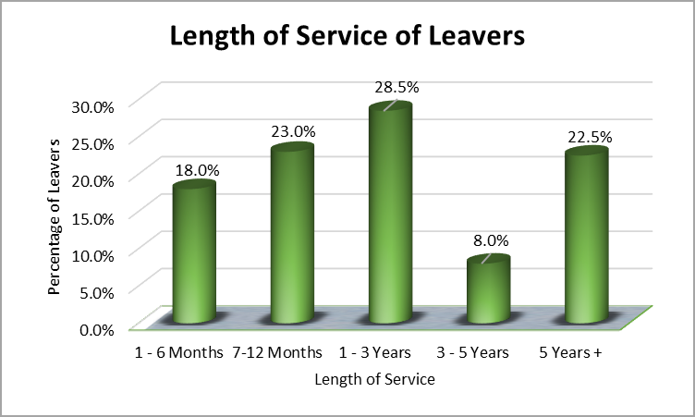
Breakdown of the length of service of leavers:

To ensure an accurate review of any trends in the length of service of leavers, the below series reviews the number of leavers proportionate to the total number of staff within each length of service parameter. Without considering the number of leavers from each staff group, unfair assumptions could be made in comparing the length of service of leavers alone. Whilst the above graph highlights that the largest proportion of leavers had between 1-3 years’ service, it fails to consider that 40% of Sancta Maria staffing fall within this length of service. Therefore, considerations have been given to include the proportion of staff that left from the total number of staff within each parameter:
Length of Service | Percentage of Leavers from Total Staff Group
1 - 6 Months | 23%
7-12 Months | 33%
1 - 3 Years | 13%
3 - 5 Years | 13%
5 Years + | 15%

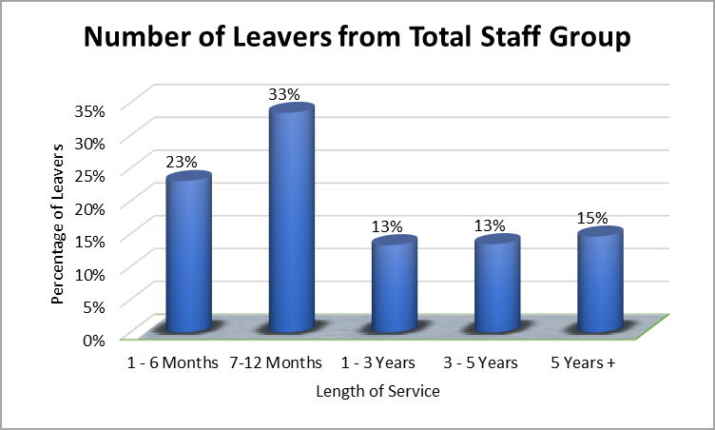
In contrast to the initial graph, this highlights that a disproportionate amount of staff are leaving with under one years’ service.
Leave Reason
Leave Reason | Number of Leavers
Career Progression | 9
No Reason Given | 5
Personal Circumstances | 5
Reduced Duties | 4
Relocation | 2
Salary & Benefits | 4
Salary & Progression | 6

Review of Induction & Development Questions
Breakdown of results from ‘Induction’ section of Exit Interview results. “To what extent do you agree or disagree with the following statements?”
Three leavers with 10+ years’ service selected Neither Agree nor Disagree based on their inability to recall any pertinent points.
Question | Strongly Agree | Agree | Neither Agree or Disagree | Disagree | Strongly disagree
Q1. I feel I had an effective Induction Process | 21% | 32% | 14% | 25% | 7%
Q2. The induction helped my integration into the team | 25% | 36% | 21% | 14% | 4%
Q3. My induction was done in a timely manner | 14% | 29% | 18% | 21% | 18%
Q4. The induction process was organised and structured | 7% | 21% | 25% | 29% | 18%
Q5. During my induction process, I… | Yes | No | Not Applicable
Went through the HMT Welcome email | 39% | 50% | 11%
Had a tour of the premises and departments | 78% | 11% | 11%
Met key team members and colleagues | 78% | 11% | 11%
Had a dedicated mentor/ 'buddy' to shadow | 61% | 29% | 11%
Received an overview of HMT and our values | 36% | 54% | 11%
Completed an induction checklist | 54% | 36% | 11%
Had the opportunity to raise any queries | 86% | 4% | 11%
Met regularly with my line manager | 68% | 21% | 11%
Timesheets explained | 89% | 0% | 11%
Had access to E-Learning and Mandatory Training | 89% | 0% | 11%

