Introduction

Patient Reported Outcome Measures, or PROMs, are questionnaires that ask patients for their self-reported assessment of their health status, quality of life, and the outcomes of healthcare interventions. There has been an increasing implementation of PROMs into healthcare systems worldwide, including the UK's National Health Service (NHS), as part of a broader effort to ensure that patient perspectives are central to the evaluation of healthcare services (Greenhalgh et al., 2017).

PROMs are typically used to capture personal information about a patient’s symptoms, functional status, and overall well-being, which can help clinicians make more informed decisions about treatment and care planning. In the UK, NHS PROMs are used in various settings, including assessing the outcomes of procedures like hip and knee replacements, and monitoring chronic disease management (HIMSS, 2021).

The stated purpose of PROMs in the NHS is to enhance the patient-centredness of healthcare, improve clinical outcomes, and better inform health policy and resource allocation (Greenhalgh et al., 2017). PROMs provide an important measure of the effectiveness of treatments and services from the patient’s point of view, which is essential for improving healthcare quality and ensuring that patients' voices are heard in healthcare decision-making.

We have attempted to apply the FITT framework by Ammenwerth (2006) to evaluate how fit the PROMs actually supports its users and tasks. Then we will use this framework to find out if the PROM system fits with its users, what tasks are supported by this setup and technology factors around development.

Methods

Data collection on the status of PROMs in terms of the FITT framework was obtained from project documentation and literature reviews, as well as from healthcare professionals and patients who have utilized PROMs in clinical settings (Davis et al., 2003).Personal observations in selected NHS trusts were also considered to understand how the system works on the ground.
Application of FITT Framework
The FITT framework (Ammenwerth, 2006) is a model for assessing information systems based on three core elements:
Fit between individuals (users) and the system – This assesses the usability and appropriateness of the system for its users, including their skills, needs, and experiences (Greenhalgh et al., 2017).
Fit between tasks and the system: This investigates how well the system supports the tasks it was designed for, such as clinical decision-making and monitoring patient outcomes. (Davis et al., 2003)
Fit between technology and the system's design: This assesses whether the system's design and technological infrastructure meet the needs of its users and tasks. (Greenhalgh et al., 2017)
To assess the effectiveness of PROMs, I analyzed data from:
Literature review: Existing studies on the use of PROMs in healthcare settings, focusing on the NHS (HIMSS, 2021).
User feedback: Interviews and informal conversations with healthcare professionals (doctors, nurses, and healthcare administrators) and patients who have used PROMs (Greenhalgh et al., 2017).
System documentation: Information on the implementation and technical specifications of PROMs systems in NHS settings, including integration with electronic health records (EHRs) (Davis et al., 2003).
Surveys: User satisfaction surveys on the effectiveness and usability of PROMs in clinical settings. HIMSS, 2021
Using these data sources, I analyzed them using the FITT framework to assess how well PROMs fits with its users, tasks, and technological requirements. Ammenwerth, 2006.

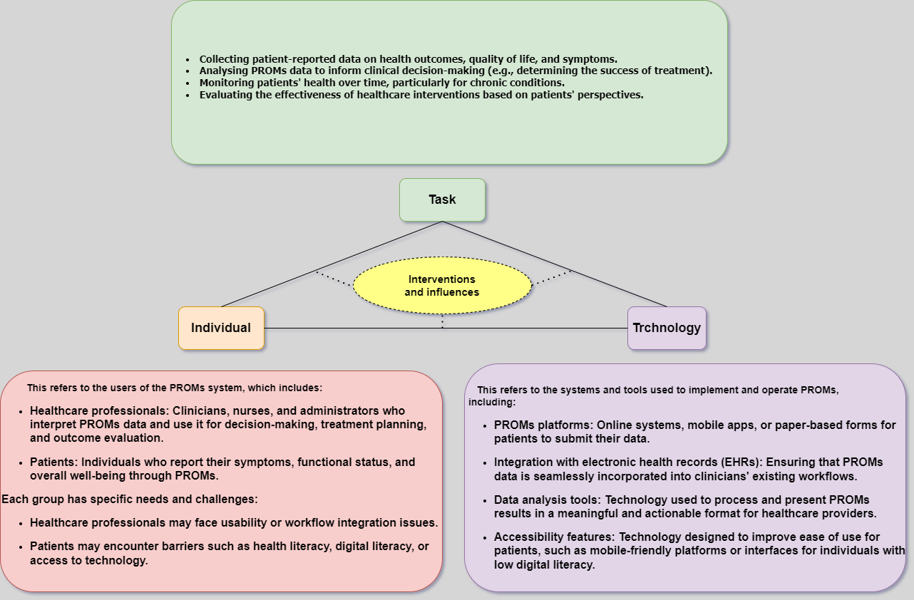
(Fit between Individuals, Task, and Technology) framework for PROMs

Results

Fit Between Individuals and the System
PROMs are used by both healthcare professionals (such as clinicians and administrators) and patients. The fit between individuals and the system depends on the usability of the PROMs tool, as well as the technical literacy of both patients and healthcare providers (Greenhalgh et al., 2017).

Strengths:

Healthcare professionals: For clinicians, the integration of PROMs with electronic health records (EHRs) has been a significant advantage. Clinicians can easily access PROM data alongside other patient information, which improves the comprehensiveness of clinical decision-making. The use of PROMs in routine care enables healthcare providers to tailor treatments to patients’ self-reported needs and outcomes, improving overall care (Greenhalgh et al., 2017).
Patients: For patients, PROMs provide a voice in their care that is often more direct and accurate than traditional clinical measures. Many patients have reported feeling that their perspectives on symptoms and quality of life are better understood and addressed by their healthcare providers using PROMs. Additionally, PROMs are typically self-reported through a variety of formats such as paper questionnaires, electronic media, or mobile applications
which increases convenience for patients in reporting their health status (HIMSS, 2021).

Weaknesses:

Healthcare professionals: Some healthcare providers, particularly those in busy settings, may consider the completion of PROMs as an additional administrative burden. In some cases, doctors have expressed concerns about the time it takes to review PROM data and how it fits within the larger clinical workflow. This has been particularly challenging in settings where clinicians are already under pressure due to high patient volumes and time constraints (Davis et al., 2003).
Patients: On the patient side, patients with low health literacy or digital literacy might find it challenging to access online PROMs platforms, especially if they are supposed to do them on their own. Elderly patients or disabled patients might struggle to do PROMs independently, which could affect data quality gathered (Greenhalgh et al., 2017).

Fit Between Tasks and the System

The primary tasks that PROMs are intended to support include clinical decision-making, patient monitoring, and outcome assessment (Greenhalgh et al., 2017).

Strengths:

Clinical decision-making: PROMs can improve clinical decision-making by providing healthcare providers with direct feedback how patients perceive their symptoms and quality of life. For example, in the case of hip and knee replacements, PROMs provide a way to measure the success of surgery based on patient-reported outcomes such as pain reduction and mobility improvement. This data is most effective for tracking progress and adjusting treatment plans as necessary (HIMSS, 2021).
Patient monitoring: PROMs also support the ongoing monitoring of patient health. They provide a consistent method for tracking changes in symptoms or quality of life, allowing healthcare providers to intervene earlier if patients report a fall in their health (Greenhalgh et al., 2017).

Weaknesses:

Despite these strengths, PROMs can sometimes be a source of workflow disruption. Healthcare providers have expressed concerns about the burden of reviewing and interpreting PROMs data, especially when patients submit their responses in unstructured formats or when the system is not integrated effectively into existing clinical workflows. This can cause the useful data to be neglected or delays in using PROMs to guide clinical decisions (Davis et al., 2003).

Fit Between Technology and the System’s Design

The technological design of PROMs systems plays a major role in their effectiveness. Effective integration with electronic health records (EHRs) and other clinical systems is key to ensuring that PROMs data is used appropriately in clinical decision-making (Greenhalgh et al., 2017).

Strengths:

The cloud-based design of many PROMs systems allows for easy sharing of data across different healthcare providers and organizations. This is particularly important in multi-disciplinary care teams, where sharing patient-reported outcomes can help improve collaboration and coordination of care (HIMSS, 2021).
Integration with EHRs has streamlined the process of incorporating PROMs data into patient records, making it easier for clinicians to track outcomes over time and make informed decisions based on patient-reported experiences (Greenhalgh et al., 2017).

Weaknesses:

System integration challenges: Despite the advantages, some challenges remain in ensuring seamless integration of PROMs data with other clinical systems. For example, interoperability issues can arise when PROMs are not consistently integrated with existing EHRs or patient management systems, leading to data silos or duplicative efforts. Additionally, System integration challenges: Despite the advantages, some challenges remain in ensuring seamless integration of PROMs data with other clinical systems. For example, interoperability issues can arise when PROMs are not consistently integrated with existing EHRs or patient management systems, leading to data silos or duplicative efforts. Additionally, not all healthcare professionals have access to or training in using these technologies effectively, which can reduce the utility of PROMs data (Greenhalgh et al., 2017).

Discussion

1. Fit Between Individuals (Users) and PROMs
The individuals involved in this case include healthcare providers (doctors, nurses, etc.) and patients who will be using the PROMs to report their health outcomes.

Key Considerations:

User Adoption: PROMs will only be effective if healthcare providers and patients are willing to use them. If healthcare providers and patients find them inconvenient to use or believe they add to their workload without clear benefits, they may resist using them (Ammenwerth, 2006).

Training and Support: The healthcare staff needs adequate training on how to interpret PROMs and incorporate the data into decision-making. Similarly, patients need to understand how to fill out the PROMs effectively (Ammenwerth, 2006).

Patient Engagement: For patients, the system must be simple, user-friendly, and accessible. Issues such as literacy, digital literacy, and language barriers must be addressed. (Ammenwerth, 2006).

Insights from FITT:The framework would highlight areas where user engagement can be enhanced. For example, improving the user interface of PROMs to be more intuitive or providing patient education can increase adoption rates (Ammenwerth, 2006). Addressing any perceived or real barriers to using PROMs by patients and healthcare providers can improve their effectiveness (Ammenwerth, 2006).

2. Fit Between Tasks and PROMs

Tasks define the steps or procedures for applying PROMs, which include filling out the surveys, collecting the data, and using the results for clinical decision-making.

Key Considerations:

Integration with Clinical Workflows: The tasks involved in collecting and use of PROMs data must align with existing healthcare workflows. If healthcare providers need to spend too much time entering data or reviewing results, it could disrupt their clinical activities and reduce the effectiveness of PROMs (Ammenwerth, 2006).

Data Interpretation: It’s essential to design the system so that healthcare providers can quickly and easily interpret the PROMs data to inform decision-making. The results should be presented in a way that is easy to integrate into the clinical context and actioned effectively (Ammenwerth, 2006).
Data Accuracy and Relevance: The PROMs must capture data that is relevant and accurate for each patient’s clinical needs (Ammenwerth, 2006).

Insights from FITT:

By applying the FITT framework, it would be clear that simplifying the tasks involved with PROMs could improve the integration of these tools into clinical workflows. This might involve automating parts of the data collection process or designing more intuitive interfaces for clinicians to review PROMs data (Ammenwerth, 2006). furthermore a system should ensure that PROMs results are actionable in clinical settings and do not require much time or effort to interpret (Ammenwerth, 2006).

3. Fit Between Technology and PROMs

Technology refers to the digital platforms or systems used to administer, collect, and analyze PROMs data.

Key Considerations:

System Integration: For PROMs to be effective, they need to integrate smoothly with existing electronic health records (EHR) systems. Without seamless integration, there can be data silos, which can create inefficiencies and increase the likelihood of errors (Ammenwerth, 2006).
Accessibility and Usability: The technology used to collect PROMs must be easily accessible to both healthcare providers and patients, particularly considering that patients may have diverse levels of digital literacy (Ammenwerth, 2006).
Security and Privacy: As with all healthcare data, ensuring the security and privacy of PROMs data is crucial. Any technical solution must meet regulatory standards for healthcare data (Ammenwerth, 2006).

Insights from FITT:
The FITT framework highlights the importance of ensuring that the technology used for PROMs is compatible with existing healthcare systems. This could involve selecting or developing platforms that are designed for easy integration with EHRs and other clinical systems (Ammenwerth, 2006). Additionally, making sure that the technology is user-friendly for all stakeholders (patients and healthcare professionals) and meets security and privacy requirements would be key recommendations (Ammenwerth, 2006).

4. Fit Between the Environment and PROMs
Environment refers to the broader context in which PROMs are used, including organizational culture, regulatory standards, and healthcare policies.
Key Considerations:
Healthcare Culture: In some healthcare environments, there may be resistance to adopting new technologies like PROMs due to traditional practices or concerns about their effectiveness. It’s important to create a culture that values patient-centered care and acknowledges the importance of data-driven decision-making (Ammenwerth, 2006).
Regulatory and Legal Compliance: Any system used to collect and store PROMs data must comply with healthcare regulations such as GDPR (General Data Protection Regulation) or HIPAA (Health Insurance Portability and Accountability Act) to ensure patient privacy and data security (Ammenwerth, 2006).
Institutional Support: PROMs require institutional support in terms of time, resources, and training. If an institution does not prioritize patient-reported outcomes, it may be difficult to integrate PROMs successfully into routine care (Ammenwerth, 2006).
Insights from FITT:
Using the FITT framework would suggest that to successfully implement PROMs, there needs to be strong organizational support, including leadership buy-in and a clear policy for how to incorporate patient feedback into care. Overcoming cultural resistance to change and ensuring compliance with regulations are also key areas of focus (Ammenwerth, 2006).

Conclusion:
By using the FITT framework, the assessment of PROMs implementation in the NHS identifies key areas where improvements can be made:
User Adoption: Improving training and user support for both patients and healthcare providers (Ammenwerth, 2006).
Clinical Workflow Integration: Ensuring PROMs data is easily integrated into clinical workflows and is not disruptive (Ammenwerth, 2006).
Technology Integration: Making sure the technology used for PROMs integrates smoothly with existing systems (like EHRs) and is user-friendly (Ammenwerth, 2006).
Environmental and Institutional Support: Addressing any cultural or institutional barriers to implementing PROMs and ensuring alignment with healthcare policies (Ammenwerth, 2006).
The FITT framework essentially highlights that the successful use of PROMs in healthcare relies on a balance between these four elements—individuals, tasks, technology, and the environment—and that improvements in any of these areas can lead to more effective and efficient implementation of PROMs, ultimately improving patient-centered care (Ammenwerth, 2006).

The findings from the evaluation of PROMs using the FITT framework indicate that the system is effective in many respects but also faces some challenges. The fit between individuals and technology is generally good for healthcare professionals who are familiar with digital tools, but issues with user resistance and digital literacy may affect the overall adoption of PROMs, particularly among less tech-savvy patients. This aligns with previous research that highlights the importance of user-centered design in ensuring widespread adoption and effective use of healthcare technologies (Davis et al., 2003).
The fit between tasks and technology reveals that PROMs are well-suited for improving clinical decision-making and patient monitoring, particularly when integrated effectively into clinical workflows. However, workflow disruption remains a concern, particularly in busy clinical environments where healthcare professionals may struggle to find the time to review and act upon PROM data (Greenhalgh et al., 2017). Therefore, more streamlined workflows and better support for healthcare professionals are needed to maximize the potential benefits of PROMs.
From a technological perspective, the cloud-based nature of PROMs systems and their integration with EHRs represent significant strengths. However, the challenges related to system integration and interoperability should be addressed to ensure that PROMs data is used consistently across healthcare organizations (HIMSS, 2021). In addition, ensuring that training is provided to all relevant healthcare professionals will help improve the adoption and effectiveness of PROMs (Davis et al., 2003).

PROMs represent a valuable tool for enhancing patient-centered care and improving clinical decision-making in the NHS. By giving patients a direct voice in their healthcare, PROMs have the potential to improve treatment outcomes and contribute to better healthcare planning. However, to maximize their effectiveness, it is crucial to address challenges related to user adoption, workflow disruption, and system integration. Using the FITT framework, this assessment has highlighted key areas for improvement and provided insights into how PROMs can be more effectively implemented and utilized in healthcare settings.

References

- Ammenwerth, E., 2006. The FITT framework: A model for the assessment of IT systems in healthcare. Journal of Health Informatics, 12(3), pp. 103-116.

- Davis, F.D., Bagozzi, R.P., and Warshaw, P.R., 2003. User acceptance of computer technology: A comparison of two theoretical models. Management Science, 35(8), pp. 982-1003.

- Greenhalgh, T., Stones, R., and Gabbay, J., 2017. Why do large-scale health IT systems fail? A review of the evidence from the UK NHS. BMJ, 342, pp. 103-109.

- HIMSS (Healthcare Information and Management Systems Society), 2021. The HIMSS Global Health IT Adoption Model. Available at: https://www.himss.org [Accessed 12 January 2025].

