

LOCATION: Swansea | LLEOLIAD: abertawe
LEVEL 4 | LEFEL 4
EXAMINATION PERIOD | CYFNOD ARHOLIADAU
MAY 2025 | MAI 2025

MODULE CODE: ACDB4002
Electrical & Electronic Principles
TIME: 2 HOURS
answer all questions

Equipment or materials required – calculator, graph paper, ruler
Adnoddau neu ddefnyddiau sydd eu hangen – cyfrifiannell

Formula sheet after questions

ANSWER ALL QUESTIONS

QUESTION ONE (20 marks)

- Calculate the resistivity of a material with a resistance of 2Ω and a cross-sectional area and length of 25 cm² and 15 cm, respectively.
(1 mark)

- The wire's length and area are 0.2 m and 0.5m², respectively. Calculate the resistivity of that wire whose resistance is 3 Ω.
(1 mark)

- A battery with a terminal voltage of 9 V is connected to a circuit consisting of four 20Ω and one 10Ω resistors all in series as shown in the figure below. Assuming the battery has negligible internal resistance calculate,
  - the equivalent total resistance of the circuit, (2 marks)
  - the current through each resistor, (1 mark)
  - the potential drop across each resistor and, (2 marks)
  - determine the total power dissipated by each resistor and the power supplied by the battery. (3 marks)

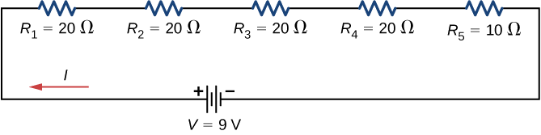
- The following figure shows resistors wired in a combination of series and parallel. We can consider R1 to be the resistance of wires leading to R2 and R3.
  - Find the equivalent resistance of the circuit. (4 marks)
  - What is the potential drop V1 across resistor R1? (2 marks)
  - Find the current I2 through resistor R2. (2 marks)
  - What power is dissipated by R2? (2 marks)

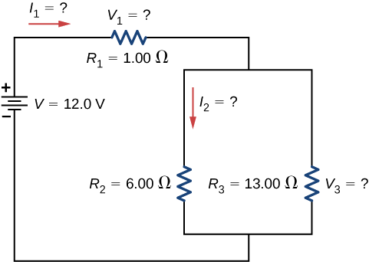

QUESTION TWO (8 marks)

- A transformer has 20 turns in its primary coil and is used to step up a 5v ac voltage to 110V. State the turns ratio and calculate how many turns would there be in the secondary coil.
(2 marks)
- Under full load conditions, the current demand in the secondary circuit is 13A. Determine the Power output rating of this transformer.
(2 marks)
- Determine the maximum load resistance that this transformer could supply.
(2 marks)
- If we assume that the transformer is only 93% efficient, estimate the current flow in the primary circuit for the conditions present in part b).
(2 marks)

QUESTION THREE (10 marks)

In the transient circuit given below, the capacitor is initially discharged. Assuming the switch closes at t=0 seconds:
- Approximately how long does it take for the capacitor to reach 1.7V?
(2 mark)
- Calculate and produce a table and graphs for both circuit current and resistive power dissipated as a function of time during a full charge cycle, assuming that the capacitor is initially fully discharged. (8 marks)
R₁=15kΩ
C₁=22µF
SW
5V DC

QUESTION FOUR (12 marks)

For the following AC circuit:
- Calculate the total circuit impedance and phase difference between the purely reactive and resistive circuit components.
(4 marks)
- Provide a fully illustrated graph of the resulting complex impedance plane diagram.
(4 marks)
- Calculate the current flowing in the circuit.
(1 mark)
- Determine the voltage drop across each component of the circuits. Show that the resulting voltages equate to the supply voltage.
(4 marks)
- Determine the resonant frequency for the circuit and comment on the resulting current flow and behaviour of the circuit at this frequency.
(2 marks)

R₁=200Ω
C₁=55µF
240V AC 50 Hz
L₁=47mH

Diwedd/End

Formulae:
$$R=ρ\frac{l}{A}$$ |  |  | $$R=\frac{V}{I}$$ |  | $$P=I×V$$
$$X_{L}=2πfL$$ |  | $$X_{C}=\frac{1}{2πfC}$$ |  | $$Z=\sqrt{R^{2}+{\left(X_{L}-X_{C}\right)}^{2}}$$
$$τ=C×R$$ |  |  |  | $$Φ=\tan^{-1}\frac{(X_{L}-X_{C})}{R}$$
$$V_{c}=V_{s}(1-e^{-\frac{t}{τ}})$$ | $$V_{c}=V_{s}e^{-\frac{t}{τ}}$$ |  |  | $$\frac{N_{p}}{N_{s}}=\frac{V_{p}}{V_{s}}$$
$$V_{R}=V_{s}e^{-\frac{t}{τ}}$$ | $$V_{R}=V_{s}(1-e^{-\frac{t}{τ}})$$ |  |  | $$P_{out}=P_{in}×Efficiency$$

