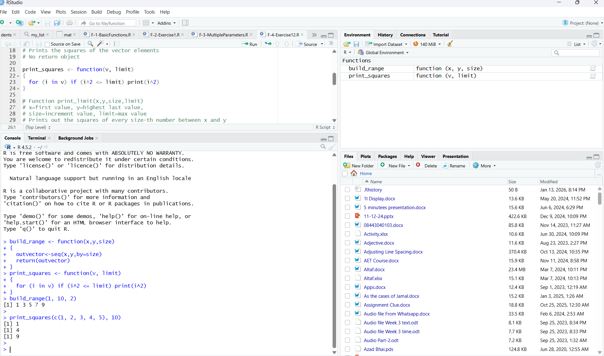
Figure 1:This screenshot shows the RStudio environment after running the R script successfully. The functions build_range and print_squares have been executed using the Source button and are now visible in the Environment panel. The Console displays the output of testing these functions. The function build_range(1, 10, 2) generates a sequence of numbers from 1 to 9 with a step of 2, and print_squares(c(1, 2, 3, 4, 5), 10) prints the squares of numbers that are less than or equal to 10. This confirms that the functions are working correctly.
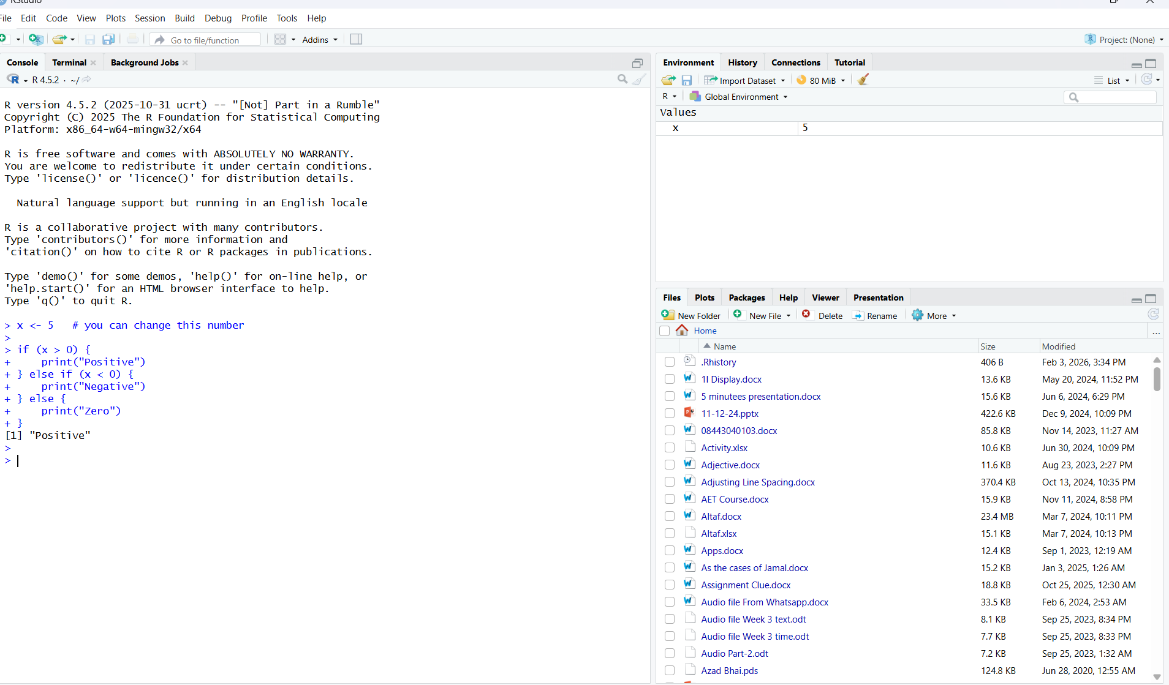
Figure 2:This screenshot shows the R console after running an if–else statement to classify a number. The value of x is set to 5, and the program correctly prints “Positive” in the console, showing that the conditional statement works properly.
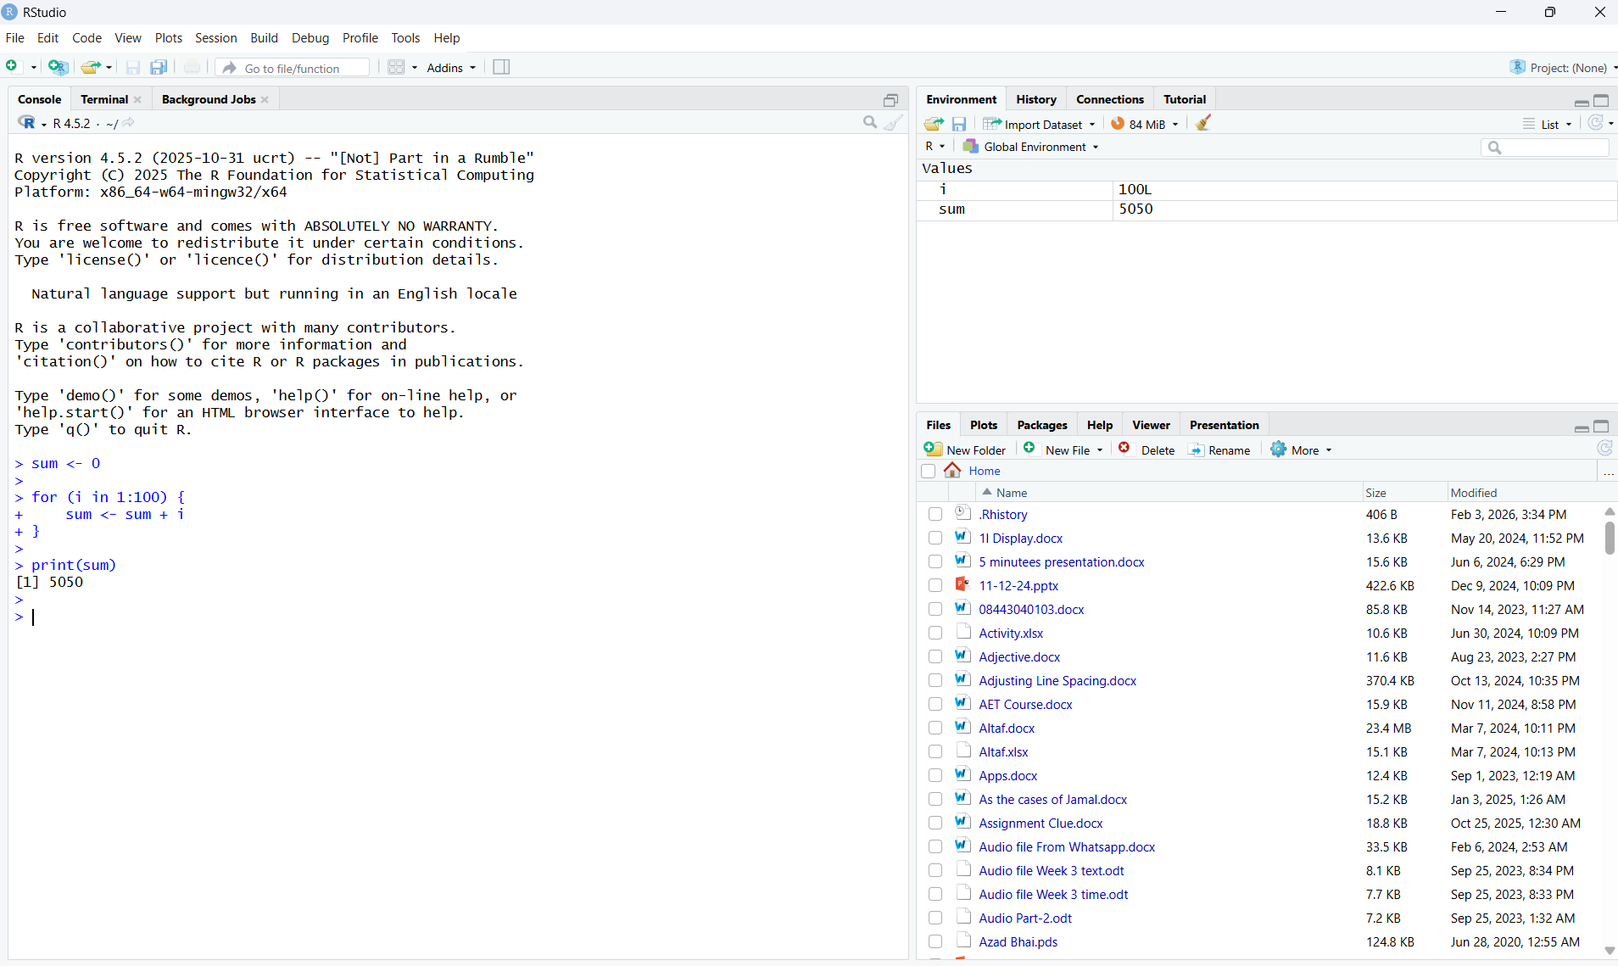
Figure 3:This code uses a for loop in R to add all numbers from 1 to 100. The final result printed in the console is 5050.
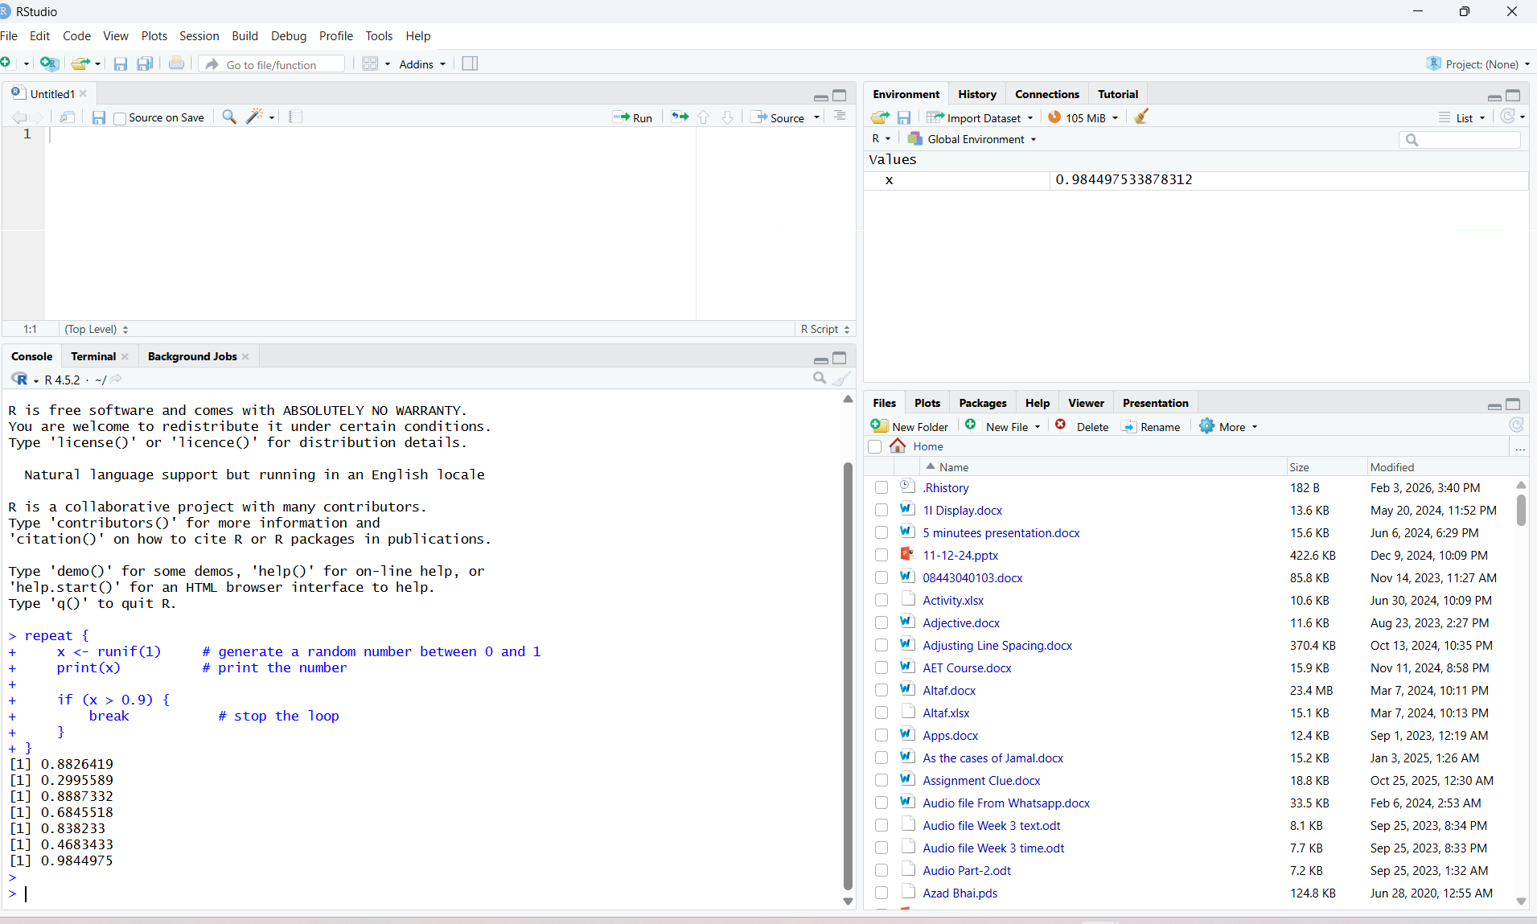
Figure 4:This code uses a repeat loop in R to generate and print random numbers between 0 and 1. The loop stops automatically when a number greater than 0.9 is generated, showing that the break statement works correctly.
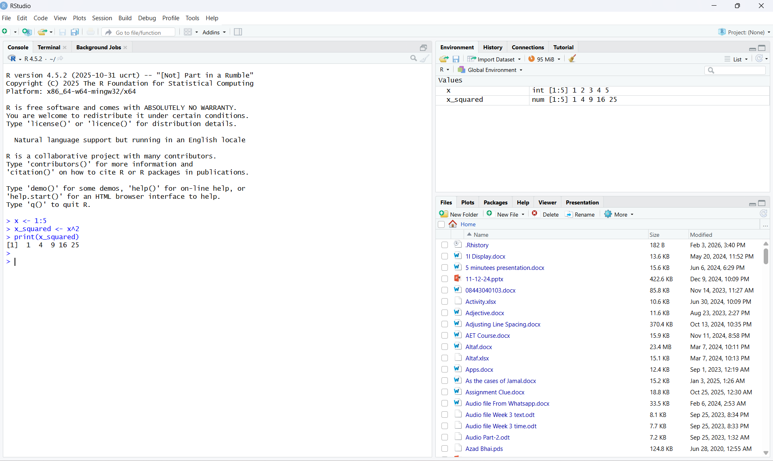
Figure 5:This code shows vectorisation in R. Instead of using a loop, the square of each number from 1 to 5 is calculated in one step using vectorised operations.

