12/08/2026
Component 2: Written assessment: Problem Analysis and Solution Development.
UNIVERSITY OF WALES TRINITY SAINT DAVID
ANALYSING AND SOLVING PROBLEMS
Module Name: Analysing and Solving Problems
Module Code: ACCA 4019
Student Name: Freddy Eduardo Carrion Iniguez
Student ID: 2518430
Group:1
Lecturer’s Name: Dr. Fahad Ahmed

Table of Contents
Table of Contents 1
1. Introduction 2
2. Deconstruct the Problem 2
2.1 MoSCoW Technique Requirement 2
2.2 Variables Identification 3
3. Proposed Solution 4
3.1 Flowchart 5
3.1.2 Flowchart Explanation 5
4. Reflection and Justification 6
4.1 Abstract thinking 7
4.2 Sub-dividing 7
4.3 Justification of solution 7
4.4 Limitation 7
4.5 Assumption 7
5. Conclusion 7
6. References 8

Introduction
In university computing courses, collaborative group work is crucial for building team skills. However, students frequently face massive coordination costs due to competing priorities like part-time employment, variable timetables, and personal commitments $CITATION Car24 \backslash l 2057$$[1]$. This report analyzes these scheduling friction points and designs a logical, generic system to eliminate timetable conflicts, maximize matching availability, and ensure project milestones are met prior to weekly submission deadlines.

Deconstruct the Problem
To build a generic solution, we must first break the problem down into manageable variables, requirements, and strict operational constraints using computational and project management frameworks.

MoSCoW Technique Requirement

By applying requirements engineering principles [2]. The system necessities are categorized to prevent scope creep and focus purely on functional survival traits:

- Must Have:
  - A centralized schedule aggregation tool showing all members' busy hours.
  - At least one shared 60-minute window identified before the weekly deadline.
  - An automated confirmation system where all members accept the designated time.

- Should Have:
  - A buffer zone of at least 24 hours between the final meeting and the actual submission deadline to accommodate unexpected delays.
  - Asynchronous backup communication channels (e.g., Slack or Microsoft Teams) to pass updates if an emergency cancels a physical meeting.

- Could Have:
  - Integration with personal digital calendars (Google Calendar/Outlook) to automatically scrap data and update changes in real time.
  - Automated alerts sent 2 hours prior to a meeting.

- Won't Have (For Now):
  - A feature to vote on the "most fun" or preferred location for meetings; the system focuses purely on time availability, not lifestyle preferences.

Variables Identification

The problem domain consists of both variable data inputs and fixed boundaries. To model the solution logically, we define the following variables:

- Meeting Duration ($M_{d}$): The minimum continuous block of time needed for an effective group session (e.g., 2 hours).

- Student Availability ($S_{a}$): A dynamic array of free/busy hourly blocks for each individual student within a 7-day week.

- University Timetable ($T_{t}$): Fixed lecture and lab slots mandated by the college infrastructure.

- Weekly Project Deadline ($D_{w}$): The absolute cutoff date and time by which the group milestone must be uploaded.

- Part-Time Work Shifts ($W_{s}$): External fixed constraints that cannot be overwritten or altered by the group.

Variables: | Description:
$M_{d}$: | The minimum continuous block of time needed for an effective group session (e.g., 2 hours).
$S_{a}$: | A dynamic array of free/busy hourly blocks for each individual student within a 7-day week.
$T_{t}$: | Fixed lecture and lab slots mandated by the college infrastructure.
$D_{w}$: | The absolute cutoff date and time by which the group milestone must be uploaded.
$W_{s}$ : | External fixed constraints that cannot be overwritten or altered by the group.

Proposed Solution

In higher education, collaborative group projects are a cornerstone of applied learning, particularly in technical disciplines like computer science and software development. However, coordinating group members effectively presents a significant logistical challenge. Students balance demanding academic timetables with part-time employment, personal commitments, and differing travel constraints. Without a structured scheduling mechanism, groups frequently experience scheduling friction, leading to missed deadlines, uneven distribution of workloads, and compromised project quality.

To address these challenges, this assessment proposes an algorithmic, automated scheduling solution designed to optimize meeting times for student project groups. By applying abstract problem-solving techniques and algorithmic logic, the proposed solution processes individual member availability, filters out non-negotiable constraints, identifies optimal meeting slots prior to project deadlines, and distributes tasks fairly.

The proposed solution functions as an algorithmic workflow modelled on basic Systems Thinking principles, viewing the student group not as isolated individuals, but as an interconnected ecosystem bound by time [3].

Flowchart

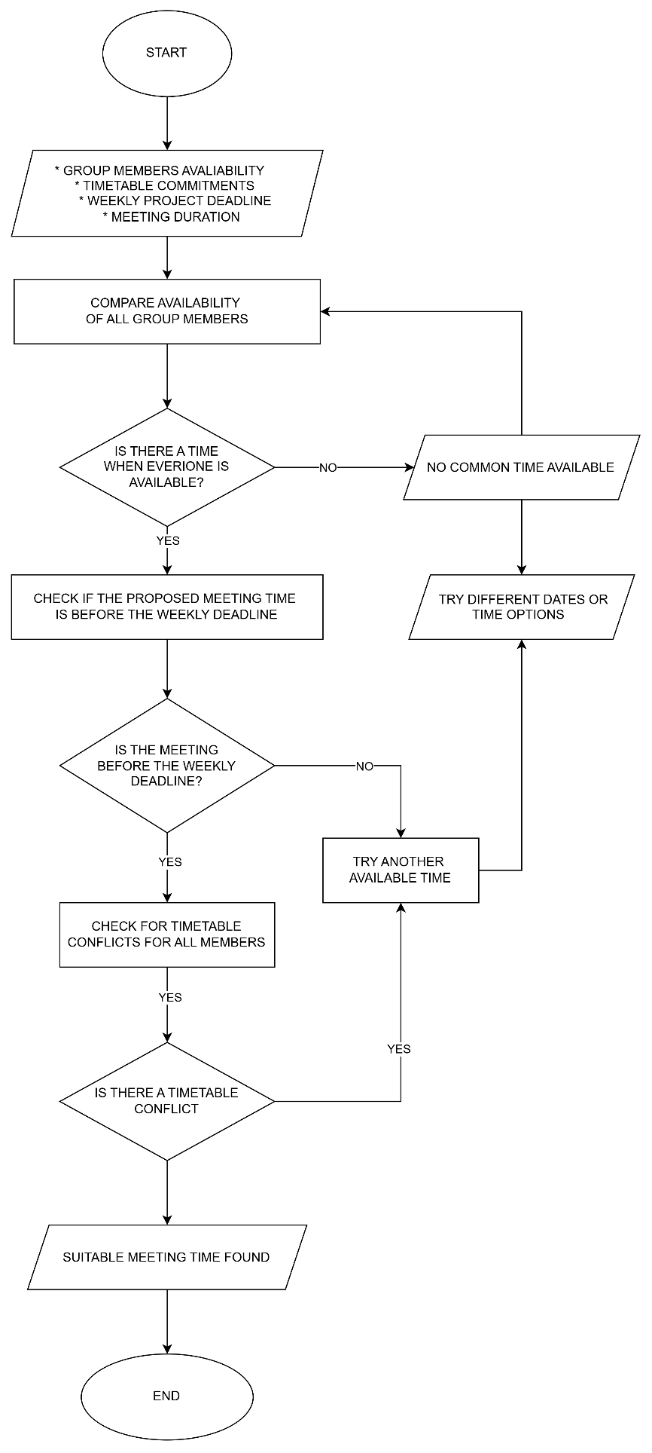

Flowchart Explanation

• Data Ingestion Phase: The process begins by collecting scheduling arrays ($S_{a},W_{s},T_{t}$) from every single group member. This step eliminates guessing and subjective opinions by capturing raw, binary data (Available vs. Busy).

• Filtering Phase: The system maps these hours onto a collective matrix. Crucially, it applies a logical filter to discard any open windows that occur after the weekly project deadline ($D_{w}$). This directly enforces your third assignment goal.

• Optimization Phase: The system scans the remaining matrix for a continuous block matching or exceeding the required meeting duration ($M_{d}$).

• Exception & Conflict Loop: If a common window does not exist due to high constraints, a feedback loop is triggered [2]. The system prompts members to review their "Could Have" personal commitments to artificially generate an open slot, preventing a complete group breakdown.

A critical decision point occurs when checking if common slots are available:

- Optimal Path (Success): If one or more common free slots are discovered, the algorithm moves forward. If multiple blocks match, it executes a secondary optimization rule: ranking options to minimize logistical friction (e.g., choosing a slot directly after a shared lecture to avoid making working students travel twice).

- Escalation Path (Conflict Resolution): If the intersection yields zero common blocks due to heavy work schedules, the system enters a fallback escalation protocol. Instead of failing, it dynamically downgrades a "Should-Have" requirement: it searches for slots where all members are available virtually rather than physically, removing travel time variables from the equation.

- Underlying Assumptions.

To guarantee functionality, the solution relies on two baseline assumptions:

- Data Honesty and Currency: It is assumed that all group members update their calendar profiles accurately and promptly at the start of each academic week.
- Equitable Flexibility: It is assumed that the baseline university timetable provides at least minimal openings outside of core instructional hours where students do not have permanent employment commitments.

By handling the data this way, the solution ensures that meetings are organized efficiently, workloads can be divided fairly during the meeting, and no group falls behind due to administrative scheduling deadlocks.

4. Reflection and Justification

Reflection and justification are essential steps in computational problem-solving. Reflection allows us to evaluate how we approach a problem, understand why certain methods work better than others, and learn from the logic we apply. Justification ensures that every design choice is backed by clear reasoning, demonstrating that the chosen solution effectively addresses the core requirements while acknowledging real-world constraints.

4.1 Abstract thinking

Abstract thinking allows us to strip away personal student details—such as why someone has a work shift or what class they are attending—and treat schedules purely as abstract binary blocks of time (0 for blocked, 1 for open). This allows the solution to work for any college team, regardless of their specific course or job profile.

4.2 Sub-dividing

By breaking down a messy, emotionally charged problem ("We can't find time to meet!") into independent, bite-sized components (Data collection $→$ Filtering $→$ Optimization $→$ Exception handling), we prevent overwhelming the group. It changes a complex scheduling headache into a simple mathematical sorting problem.

4.3 Justification of solution

An automated, calendar-driven sorting method is vastly superior to endless messaging group chats. It relies on object-oriented logic to remove human bias, ensures everyone's constraints are treated with equal weight, and guarantees that meeting slots are chronologically anchored before hard course deadlines.

4.4 Limitation

The primary limitation of this system is its reliance on absolute human compliance. If a student forgets to log a changing work shift, or inputs incorrect data, the system output fails. It cannot dynamically adapt to real-world human forgetfulness or last-minute emergencies without manual updates.

4.5 Assumption

The system assumes that all team members possess equal access to digital devices to update their schedules. It assumes that university timetables and part-time work shifts remain stable and predictable throughout the academic week.

Conclusion
By shifting away from chaotic manual communication and adopting a structured, algorithmic approach to group management, computing students can systematically neutralize scheduling barriers. Utilizing tools like the MoSCoW matrix and logical flowchart processing paths ensures fair workloads, eliminates scheduling errors, and guarantees timely submission of academic deliverables.

6. References

[1] | Carnegie Mellon University Eberly Centre, «"What are the challenges of group work and how can I address them?" Instructional Strategies,» Pittsburgh, 2024.
[2] | A. J. Highsmith, Project Management: Creating Innovative Products, Boston: 2nd ed. Boston, 2010.
[3] | C. D. Clegg and R. Barker, Method Fast-Track: A Guide to Agile Projects with MoSCoW Prioritization, Boston, 1994.
[4] | D. Kauffman and M. Kauffman, Systems 1: An Introduction to Systems Thinking, 4th ed. System Dynamics Society, 2021.

