CASE STUDY ANALYSIS

Student Name: Sana Arif

Student Number: 2116663

Lecture Name: Doreen Amundam

Module Code: BMSW5102

TABLE OF CONTENTS
Introduction 3
Discussion 3
Benefits: 4
Positive Employer Branding: 4
Employee performance enhancement: 4
Employee Engagement and Retention Has Improved: 4
Positive Employer Branding: 4
Benefits of an Individual: 5
Career advancement: 5
Increased Job Satisfaction: 5
Expanded Skill Set and Expertise: 6
Improved Self-Efficacy and Confidence: 6
Personal Development and Fulfilment: 6
Training Workshops: 7
Mentoring and coaching: 7
Job rotation/enhancement: 7
Projects & assignments: 7
E-learning and Online Courses: 8
Conference workshops and seminars: 8
Performance Assessments and Development Plans: 8
Conclusion 12
Reference List 14

Introduction
The project development plan following encompasses the tactical strategy and essential components for a project's successful implementation at Argos Company. This approach is meant to lead the company to achieve its objectives, maximising efficiency, and generating useful outcomes. By implementing this approach, Argos Company may successfully manage resources, reduce risks, and require stakeholders through the project's life expectancy. This project development plan serves as an all-encompassing roadmap, such as every factor essential to project success. It establishes the project's objectives, scope, and anticipated outcomes, ensuring alignment with the larger strategic goals of Argos Company. In addition, this approach stresses the vital role of stakeholder input, risk assessment, distributing resources, and efficient communication in guaranteeing project success. The project development plan acts as the project's foundation, supplying an in-depth understanding of what needs to be accomplished and how it will be carried out. It acts as a conversation tool, enabling stakeholders to come to an understanding of the project's goals and requirements. The plan additionally acts as a decision-making reference point, allowing project managers to look over progress, make modifications, and lessen risks.

Discussion
1) Personal growth inside a company, like Argos, could provide numerous advantages for both the company and the individuals. Here's an in-depth examination of the potential benefits of developing oneself in Argos:

Benefits:

Positive Employer Branding:

Organizations that invest in personal development are often seen as desirable employers (Putri, et al. 2021). Argos can enhance its reputation and attract top talent by promoting a culture of learning and development, thus gaining a competitive advantage in the job market.

Employee performance enhancement:
It generally helps the individual to develop their skills, course, and knowledge, helping the individual to do what they want exactly to do. Individuals may contribute to the general efficiency and profitability of the company as they develop and acquire novel abilities.

Employee Engagement and Retention Has Improved:
Argos concurs with its staff members and invests in their growth by providing potential for personal development. As a consequence, employee engagement and satisfaction with work grow, which leads to an increased rate of retention and more participated employees.

Positive Employer Branding:
Firms that promote employee growth have a reputation as desirable employers (Mora, et al. 2019). Argos could boost its perception and attract the best employees by creating a learning and development culture, offering it an edge in the job market.
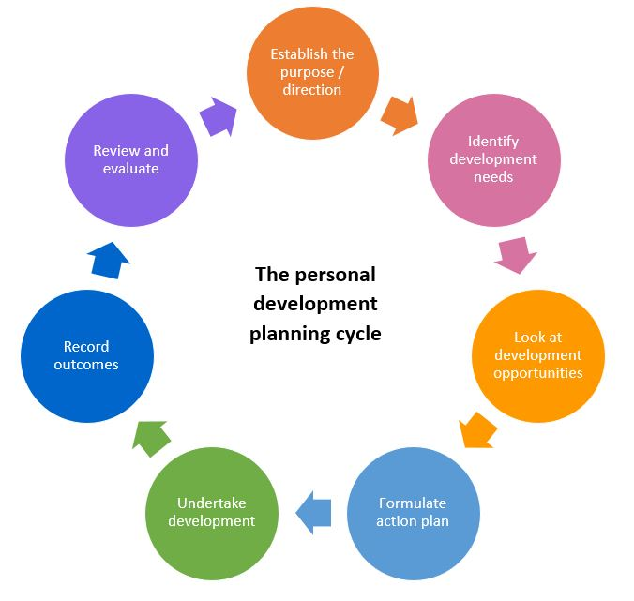
Figure 1: Planning cycle of Personal development
(Source: https://www.eventusrecruitmentgroup.com)

Benefits of an Individual:

Career advancement:
Personal development equips individuals with the knowledge and capacity necessary to advance in their current positions (Kaliky, et al. 2020). It enhances their marketability, expands their work possibilities, and improves their chances of development within Argos or afterwards.

Increased Job Satisfaction:
When employees are motivated in their growth as individuals, they are far happier with their jobs. They are more engaged, focused, and fulfilled in the job they do, which could translate to greater performance and overall wellness.

Expanded Skill Set and Expertise:
Personal growth initiatives offer individuals chances to learn new skills, expertise, and abilities (Laksana, 2021). This enables those to expand their skill set outdoors of their present tasks, improving their workplace versatility and adaptability.

Improved Self-Efficacy and Confidence:
When individuals engage in personal development activities, they gain confidence in their abilities and a sense of self-efficacy. This positive attitude can result in more initiative, creativity, and resilience, allowing people to face complications while attaining their goals.

Personal Development and Fulfilment:
Personal development involves professional skills but also personal development, self-awareness, and self-improvement. Individuals who engage in personal development activities often feel greater happiness and possess a more well-rounded perspective on life.
Personal growth initiatives at Argos may be highly helpful to both the company and the individuals involved. Argos feels that investing in its employee's personal development may lead to higher employee efficiency and productivity. Individuals become better prepared to succeed in their current roles as they gain fresh knowledge and skills, resulting in better overall organisational efficiency (Aldosemani, 2019). Personal development initiatives foster employee engagement and happiness at work, resulting in higher retention rates and more inspired staff. Argos can enhance its employer brand and recruit top talent by displaying a commitment to employee growth, offering the company a competitive advantage in the market. In addition, personal development fosters a culture of unchanged learning and modification, helping Argos to more effectively lead the ever-changing business landscape.
In addition, personal development creates a culture of steady learning and change, enabling Argos to more effectively navigate the ever-changing business landscape. Growing personally additionally broadens a person's skill set, making them more versatile and adaptable to shifting job demands (Woschank and Pacher, 2020). In addition, engaging in personal development activities increases confidence and self-efficacy, enabling individuals to take on novel challenges and pursue their goals with an upbeat mindset. Personal development, alongside professional development, encourages personal growth and self-awareness, leading to a more well-rounded and happier individual. In summary, Argos' personal development projects assist the firm by improving worker productivity, engagement, and retention, while strengthening its employer brand and adaptability. Individuals may gain from their own development in terms of academic advancement, increased job happiness, increased skill sets, improved trust, and so on.
2) When choosing development vehicles for Argos employees, it is essential that you assess how effective they are in reaching individuals' specific growth specifications. Here is a thorough evaluation of a few development vehicles that Argos might think about:

Training Workshops:
A typical growth vehicle that provides structured learning experiences that enhance sure skills or knowledge areas is training courses (Davidescu, et al. 2020). They can be helpful when bridging skill gaps or providing fresh concepts. However, to optimize their impact, training courses must be effective, relevant to the employee's duties, and have interactive and practical elements.

Mentoring and coaching:
Initiatives involve connecting employees with qualified individuals who may offer guidance, support, and opposition. Such programs promote customized development by offering the potential for personalized attention, skill development, and career help (Lee, et al. 2020). To optimize the efficiency of these initiatives, clear objectives must be developed and the right match between mentors/coaches and mentors is crucial.

Job rotation/enhancement:
Job rotation is transferring personnel across various positions or departments within a company in order to introduce them to different facets of the business. Job enrichment entails broadening the range and complexity of one's visible jobs. These learning vehicles give hands-on learning chances, improve skills, and promote cross-functional understanding. However, careful planning and coordination are necessary for seamless changes and to limit delay.

Projects & assignments:
Assigning staff members challenging projects or unusual duties can give many opportunities for development. Such programs allow employees to put their skills to use, take on novel duties, and gain experience in an assortment of areas. For maximal success and to avoid excessive workload or burnout, sufficient assistance, resources, as well as guidance should be provided.

E-learning and Online Courses:
As advances in technology, e-learning systems and online courses are increasing in appeal for self-paced learning. They offer individuals liberty and ease to gain information and skills at their own velocity (Mahapatro, et al. 2022). The benefit of these platforms, however, depends on the accuracy and relevance of the data, as well as the ability of users to stay inspired and interested in a self-directed process of learning.

Conference workshops and seminars:
Participation in outside meetings, seminars, and conferences may expose employees to business developments, best practices, and opportunities for networking (Eckel, 2020). These meetings could broaden points of view, inspire new ideas, and encourage sharing of knowledge. In order to maximize the advantages gained by participation, events should be carefully chosen to line with individuals" needs for growth and the strategic goals of the company.
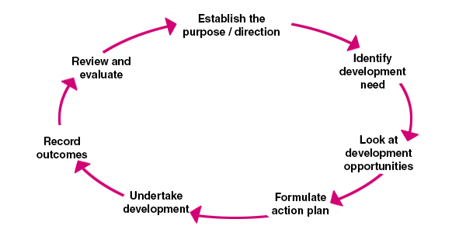
Figure 2: Personal development structure
(Source: https://www.managers.org.uk)

Performance Assessments and Development Plans:
Personal development plans (IDPs) and regular performance feedback discussions are essential for continued development. These instruments enable genuine interaction between staff and upper management, which facilitates recognition of advantages, areas for development, and particular development efforts (Bintani, 2020). However, the effectiveness of feedback and IDPs depends on communication quality, alignment with company objectives, and both sides' willingness, which follow through with the development plan.
When evaluating the development vehicles available to Argos for meeting individual development specifications, it is vital to analyze their appropriateness of them. Educational programs are one such avenue, as they may effectively address shortages in skills and teach new concepts. However, the training courses' design and relevance must be thoroughly examined to ensure that they are effective in meeting personal growth demands. Mentoring and coaching courses are another great source of customized lessons and support. These kinds of programs provide tailored attention and can help enhance specific abilities as well as give career support. However, successful accomplishment relies on defined objectives and the right matching of mentors/coaches and mentees. Job rotation and job enrichment are tools for growth which offer hands-on instruction and exposure to multiple industries. While these vehicles can help develop capacity and promote cross-functional understanding, adequate preparation and communication must occur to minimize change and assure smooth transitions. Assigning staff members challenging projects and distinctive duties is another helpful development tool that allows employees to put their skills to use while acquiring new experiences. However, appropriate support and funding are needed to secure beneficial project outcomes. E-learning tools and online courses allow for self-paced learning, but the effectiveness depends on the accuracy and relevance of the material as well as one's ability to stay engaged.
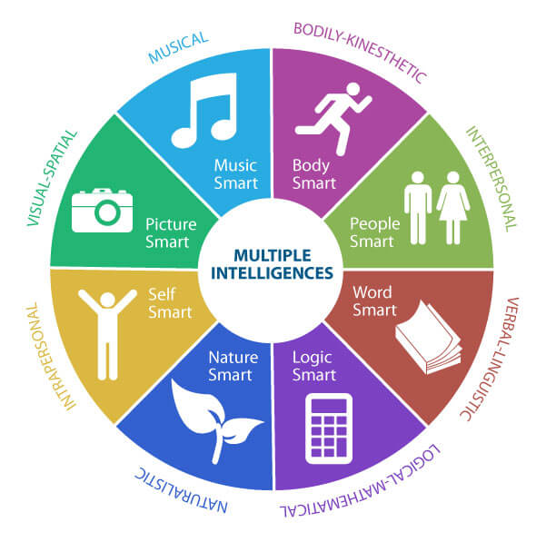
Figure 3: Step by Step Process of Personal development plan
(Source: https://scottjeffrey.com)
Individual development plans (IDPs) and regular evaluations of performance serve as essential vehicles for continued development (Weisenfelder, 2020). Their effectiveness, however, depends on the quality of interaction, alignment with company objectives, and customer commitment to follow through on growth plans. Finally, an in-depth investigation of development vehicles is necessary to ensure that Argos takes the best solutions for satisfying the distinctive growth desires of its workers. A mixture of vehicles tailored for different needs is often the most effective way for promising a complete education.
3) The personal development plan attempts to address the individual's stated needs for growth in Argos. The plan includes an array of goals and targets. In the beginning, the individual will focus on enhancing effective communication and interpersonal skills through workshops and active listening to enhance leadership qualities. They will also focus on improving their decision-making ability and solving issues via relevant coaching and education. Engaging in leadership development courses and managing cross-functional teams can assist you in building great team management skills. Second, as a way to further develop technical skills, the individual will enroll in classes and workshops to improve data analysis and reporting capacity, as well as stay up current on emerging technologies through industry events and collaborations. Third, if they want to enhance their project management talents, the individual will register for a project management course, apply effective time management tactics, and actively engage in project execution and planning (Woodrick, 2019). Finally, work-life balance and stress management indicators will be submitted that encourage personal growth and well-being, and awareness of oneself will be reinforced via journaling as well as getting feedback.
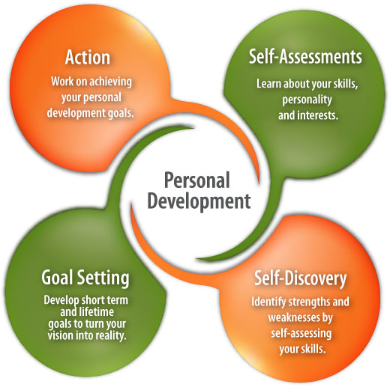
Figure 4: Major steps of Personal development plan of an Organization
(Source: https://www.careersinfood.com)
The personal development plan works to meet an individual's mentioned goals for growth while employed at Argos. The plan contains accurate goals and objectives aimed at their professional growth. To begin, the individual will focus on developing successful interpersonal and communication abilities by taking part in communication skills workshops and asking for feedback (Rasool, et al. 2020). They will also try to strengthen your decision-making and problem-solving skills by engaging in suitable educational courses and seeking guidance from experienced leaders. registering in leadership development seminars and actively seeking chances to lead cross-functional groups or projects will assist you build useful team management talents. Second, to further develop technical knowledge, the individual will sign up for online seminars and classes aimed at boosting data analysis and reporting capabilities. The personal development plan seeks to fulfil an individual's stated goals for growth while working at Argos. The plan focuses on specific objectives and goals to help individuals develop economically. To get started, the individual will go to a communication skills instruction to further develop their interpersonal abilities and seek input from colleagues to boost their communication effectiveness (Syamsudin and Supriyanto, 2019). They will additionally engage in decision-making and issue-solving workshops to further develop their analytical and critical thinking capacities.
The personal development plan is mainly meant to address the recognized growth needs of the Argos worker. The plan contains obvious goals and objectives that will assist them to grow effectively. In the beginning, the individual will participate in an extensive leadership training curriculum to improve interpersonal and communication skills. They will actively seek opportunities to utilize their skills by facilitating discussions and carrying out team meetings. They will also attend lessons and seek coaching to enhance their decision-making and problem-solving abilities (Hong, 2022). Second, in order to enhance data analysis and reporting talents, the individual will register in relevant online courses and workshops. They will attend industry conferences and work together with colleagues to keep informed on coming technologies. To foster personal growth and well-being, the individual will prioritize work-life balance by implementing effective time management techniques and engaging in stress-reducing activities outside of work. They will focus on self-reflection and self-awareness through regular journaling and seek feedback from colleagues and supervisors to identify areas for improvement (Przegon, 2023). Regular review and evaluation of the personal development plan will ensure progress tracking and necessary adjustments to align with changing needs and goals. Hence, the individual will actively seek opportunities for growth, engage in continuous learning, and take ownership of their development journey to thrive in their role at Argos. They will actively seek for tirelessly assignments and assignments that enable you to put their knowledge and develop their project oversight abilities. The plan will be assessed on an ongoing basis to track achievements and make modifications to ensure ongoing development in accordance with Argo's goals in life.

Conclusion
Choosing appropriate growth vehicles for Argos involves an exhaustive evaluation of how helpful they are in addressing individuals' different needs for growth. Relevance, practicability, modification, support techniques, and relationship to company objectives must be addressed. Individuals can use a personal development plan to fulfil their acknowledged developmental needs and seek continuing advancement and development. A well-designed plan takes specific goals and objectives into thought, which correspond to the individual's operations and ambitions within the company. Individuals could enhance their professional skills and contribute effectively to their company by focusing on areas such as managerial abilities, technical skills, handling projects capacity, as well as personal growth. Individuals whose spend time on their own growth may contribute to the overall achievement of their company, adapt to changing requirements, and survive in their roles at the company.

Reference List
Journals
Abrazaldo, D. and Jadraque, G., Information System Development Plan for Twin Palm Guest House. SSRN Electron. J., no. November, 2020, doi: 10.2139/ssrn, 3638734.
Aldosemani, T., 2019. Inservice Teachers' Perceptions of a Professional Development Plan Based on SAMR Model: A Case Study. Turkish Online Journal of Educational Technology-TOJET, 18(3), pp.46-53.
Bintani, K., 2020, August. Personal Development Plan as a Guidance and Counseling Strategy in Higher Education. In 2nd International Seminar on Guidance and Counseling 2019 (ISGC 2019) (pp. 18-22). Atlantis Press.
Davidescu, A.A., Apostu, S.A., Paul, A. and Casuneanu, I., 2020. Work flexibility, job satisfaction, and job performance among Romanian employees—Implications for sustainable human resource management. Sustainability, 12(15), p.6086.
Eckel, E., 2020. Argo Ergo Sum-I Perform, Therefore I Am: An Art-Based Community Engagement Project.
Hong, M., 2022. Evaluating the soft power of outbound student mobility: an analysis of Australia’s New Colombo Plan. Higher Education Research & Development, 41(3), pp.743-758.
Kaliky, P.I., Wance, M. and Matdoan, M.Y., 2020. The reality of government communication in hitu lama negeri development planning, Central Maluku Regency. International Research Journal of Management, IT and Social Sciences, 7(6), pp.153-160.
Laksana, S., 2021. Post pandemic Indonesian regional development planning, new normal, new orientation: The case of West Java. Jurnal Perencanaan Pembangunan: The Indonesian Journal of Development Planning, 5(1), pp.32-50.
Lee, J.Y., Rocco, T.S. and Shuck, B., 2020. What is a resource: Toward a taxonomy of resources for employee engagement. Human Resource Development Review, 19(1), pp.5-38.
Mahapatro, B.B., 2022. Human resource management. PG Department of Business Management.
Mora, L., Deakin, M. and Reid, A., 2019. Strategic principles for smart city development: A multiple case study analysis of European best practices. Technological Forecasting and Social Change, 142, pp.70-97.
Przegon, W., 2023. Draft of the Zamość development plan of 1939. Geomatics, Landmanagement and Landscape.
Putri, A.D., Ghazali, A. and Ahluwalia, L., 2021. ANALYSIS OF COMPANY CAPABILITY USING 7S MCKINSEY FRAMEWORK TO SUPPORT CORPORATE SUCCESSION (CASE STUDY: PT X INDONESIA): ANALISA KAPABILITAS PERUSAHAAN DENGAN MENGGUNAKAN FRAMEWORK 7S MCKINSEY UNTUK MENDUKUNG KESUKSESAN PERUSAHAAN (STUDI KASUS: PT X INDONESIA). Manajemen Bisnis, 11(1), pp.44-53.
Rasool, S.F., Wang, M., Zhang, Y. and Samma, M., 2020. Sustainable work performance: the roles of workplace violence and occupational stress. International journal of environmental research and public health, 17(3), p.912.
Syamsudin, S. and Supriyanto, A., 2019, January. Konsep Individual Learning Plan. In Prosiding University Research Colloquium (pp. 160-165).
Weisenfelder, J., 2020. Elects to execs: a developmental plan for student leaders.
Woodrick, W.E., 2019. Reaction to Dr. Richard P. Melia’s Presentation The Individual Written Rehabilitation Plan. JADARA, 12(2), p.6.
Woschank, M. and Pacher, C., 2020. Program planning in the context of industrial logistics engineering education. Procedia Manufacturing, 51, pp.1819-1824.

