

INTRODUCING THE MODERN WORKPLACE

Name: Krasimira Chausheva
Student ID: 2231627
Module code: LCBB4003
Module name: Introducing the Modern Workplace
Lecturer: Dr Laila Maazouz

Table of Contents

1. Introduction 3
1.1 Company Overview 3
2. The body
2.1 The business structure followed in GSK 4
2.2 Organisational Culture of GSK 4
2.3 Impact of organisational structure and culture on business performance of GSK 5
2.4 Essential nature of functions and processes of GSK 6
2.5 Role of Leadership in GSK 7
2.6 Factors that affect the differences in individual behavior 7
2.7 Employee motivation strategies 8
3. Conclusion 9
4. References 10

Introduction
The report focuses on the essential factors, which impact the working environment of GlaxoSmithKline (GSK) by highlighting its structure and culture. The role of leadership has been discussed to enhance the productivity of this company. Using business structure and effective culture enables GSK in managing its operations properly by avoiding conflict in the middle level of management.

1.1 Company overview
GlaxoSmithKline (GSK) deals in the pharmaceutical and biotechnology sector, which focuses on performance, trust, and innovation. It is headquartered in Brentford, London and is operating its functions as a multinational pharma company. The main goal of GSK is to deliver high-quality services to their customers by treating their diseases and gaining trust to enhance their productivity. The revenue of GSK in the financial year 2022 was £1,375 million British pounds (Gsk, 2022). Group turnover of GSK in the year 2022 was reported 29.3 billion British pounds and the company helped their customers by distributing vaccines and medicines during the covid-19 pandemic.
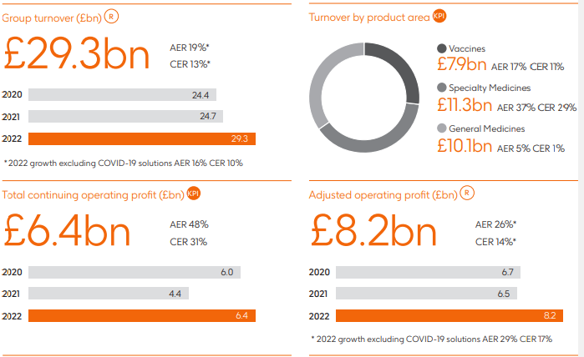
Figure 1: Annual report of GSK
(Source: Gsk, 2022)
Figure 1 shown above, provides information regarding group turnover, operating profit, adjusted operating profit, and turnover by product area of GSK. Adjusted operating profit was 8.2 billion British Pounds of GSK. There were approximately 69,400 employees working in the fiscal year 2022 (Macrotrends, 2023). However, it can be observed that the workforce declined by 22.97% in GSK (Macrotrends, 2023). GSK enables its customers in delivering quality services by helping customers suffering from diseases like HIV, and respiratory disease.

2. The body

2.1 Business structure followed in GSK.
Business structure is considered a framework of a culture that is followed in a company. All the activities are operated in a hierarchical or flat structure where functions of an organisation are being done by getting information from top management of a company. The flat organisational structure is followed in GSK. As per Tabrizi et al. (2019), a flat organisation structure involves less hierarchy along with little or no middle management. The science committee focuses on investing in research and development to deliver high-quality medicines to their patients. Policies of remuneration are facilitated by the remuneration committee of GSK. Framework for Haleon is managed by the Audit and risk committee of GSK (Gsk, 2023). The nomination and corporate governance committee helps in enhancing the operation of GSK by reviewing the size, composition, and structure of the company.

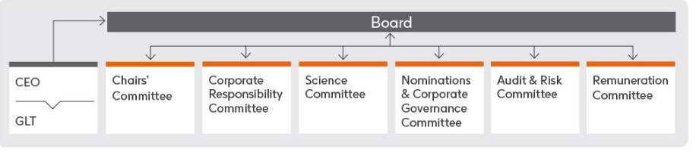
Figure 2: Structure of GSK
(Source: Gsk, 2023)
As per Figure 2 depicted above, GSK is governed by the following corporate responsibility committee, and science committee in operating their business. Management of GSK focuses on operating their functions by following their standard of corporate governance.

2.2 Organisational culture of GSK.
Workforce culture is demonstrated as a working environment in a business by focusing on their behaviours, which are affected by the values, attitudes, and beliefs of a company in its culture. The culture of GSK is to deliver high-quality services to their customers by being accountable, doing the right thing and being ambitious (Gsk, 2023). Management of GSK emphasises working effectively by rewarding their employee’s success works unitedly with science and technology to cure a disease of patients. GSK is committed to delivering quality services to its customers by serving them. According to the words of Azeem et al. (2021), organisational culture is beneficial in shaping behaviour with the help of belief, and attitude followed in a company.
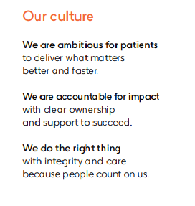
Figure 3: Culture of an organisation
(Source: Gsk, 2023)
According to Figure 3 shown above, the culture of an organisation affects human behaviour, and working relationships. Management of GSK focuses on providing a caring, safe, and inclusive environment and assisting them to operate properly in their laboratories. Being ambitious for their customers enables GSK to fulfil the requirements of their patients by delivering necessary medicines, vaccines and care for their patients. The culture of GSK is to work together by supporting their employees to enhance their brand loyalty.

2.3 Impact of organisational structure and culture on business performance of GSK
Following a flat organisational structure is helpful for GSK in managing their operations by eliminating middle management in their business. A flat structure in an organisation is useful in taking calculative risks to achieve long-term goals (Hock-Doepgen et al. 2021). A flat organisation structure enables GSK in reducing middle management and it is helpful for them in providing quality services to their patients. The governance of GSK aims to achieve their objectives by the end of 2030 by investing in its R&D to enhance the life of 2.5 billion individuals (Gsk, 2023). The board committee of GSK facilitates effective decision-making to undertake issues occurring in their company. Management is able to make effective decisions resulting in inspiring their workforce to work enthusiastically in an organised structure of a business (Shrestha et al. 2019). The capabilities of management to be able to make better decisions in order to accomplish their objectives are helpful in gaining the trust of their customers.
Supporting employees and encouraging them to work effectively is helpful in enhancing their performance and it helps in providing job satisfaction to them. The audit and risk management committee of GSK analyse their company's framework to take care of their management by reviewing their working culture. Having an effective culture in a business is useful in providing job satisfaction to their employees (Soomro and Shah 2019). GSK aims to impact the health of its patients by investing in innovation to achieve its objectives. The corporate responsibility of GSK evaluates ESG performance to provide an effective working culture in their company (Gsk, 2023). It is further helpful for GSK in enhancing their productivity by having a caring culture by using innovative technology. The culture of GSK is to do the right things by being accountable and ambitious for their customers and it enables them in achieving their organisational goals (Gsk, 2023). Therefore, it can be said that GSK works in the direction to accomplish its organisational goals by distributing quality services.

2.4 Essential nature of functions and processes of GSK
The Board of the committee of GSK facilitates flexibility in their working environment to enhance their profitability. The function of GSK is to serve their patients by delivering quality services to them with the help of maximising their capacity of delivering relevant medicines and vaccines to their patients. GSK uses a streamline supply chain in minimising cost and delivering effective quality of medicines (Gsk, 2023). Management of GSK emphasises making high-quality medicines to save the lives of their patients by treating their diseases like HIV, respiratory, and oncology. Building an effective supply chain to provide billions pack of medicines to positive impact on heath of patients (Gsk, 2023). Working to enhance the supply chain helps them in enhancing their productivity by making their strategy to improve the health of their customers. Entering into a 5-year contract along with a global logistics company named Kuehne and Nagel is useful in attaining their objectives of improving their supply chain in logistics (Fiercepharma, 2023). Providing services to customers by route of land, sea, and air while adopting integrated techniques of logistics approach enables GSK in maximising their distribution. It is further helpful in maximising the profitability of a company. Providing bonuses along with basic salary to their workforce and giving access to employee recognition programs are carried by GSK in their HRM (Gsk, 2023). The Quality Management System (QMS) of GSK enables them in operating their functions in Food and Drug Administration (FDA) to deliver quality services to their customers (Gsk, 2023). Therefore, having an effective SCM and quality management system enables GSK in attaining its goals.

2.5 Role of leadership in GSK
Leadership enables a company to operate their function by implementing appropriate measures. It is expected that an autocratic leadership style is used in their business operations. The autocratic leadership style provides absolute power to the top management in carrying out their work (Briker, Walter and Cole, 2021). Management of GSK can make independent decisions by implementing an autocratic leadership style and it helps them in making quick changes for the betterment of their company. Making decisions and applying them to accomplish good results helps can be useful for the board of directors of GSK in the completion of their project. Autocratic leadership styles are beneficial in achieving outcomes at a faster rate. The use of this leadership style can be helpful for GSK in providing minute detail to employees to complete their projects on time. However, there are some negative aspects of applying an autocratic leadership style because it neglects the participation of subordinates in decision-making capabilities.
Great Man's theory of leadership refers to the idea that leaders manage their subordinates by supporting them while facing challenges to enhance the productivity of their company. Leaders with the necessary attributes help an organisation to maximise their productivity by using their authority and power according to the Great Man theory (Razali et al. 2022). Great man theory of leadership can be used in the operations of GSK in directing their employees. It can benefit GSK in achieving its long-term goals by utilising the Great Man theory with the use of commanding perspectives.

2.6 Factors that affect the differences in individual behaviour.
Some of the factors that impact the behaviour differences in the workforce are emotional, mental and expectations. The GSK offers an online Stress to Resiliency program, mental health benefits coverage, and lunchtime stress management programming to eliminate mental health in their employees. These efforts have reduced mental illness by 60% and eliminated the leave of their workforce by 29% (Workplacementalhealth, 2023). Employees dealing with emotional breakdowns often face difficulty in carrying out their activities in contributing to their role in GSK in manufacturing medicines or vaccines. Mentally fit employees will be able to complete their tasks by working as per the strategies followed in GSK. Improvement in the mental health of workers is beneficial for an organisation in maximising their productivity along with its company (FusarPoli et al. 2021). GSK works on expectations and values to gain trust of their customers (Gsk, 2023). Workers employed in an organisation can get affected by the changes in their working behaviour.

2.7 Employee motivation strategies
Improving efficiency and boosting innovation techniques are used in GSK to motivate their employees. GSK focuses on encouraging its workforce by engaging with them and improving their efficiency to boost their business operations (Salesforce, 2023). It enables GSK in maximising their productivity by boosting the morale of their employees.
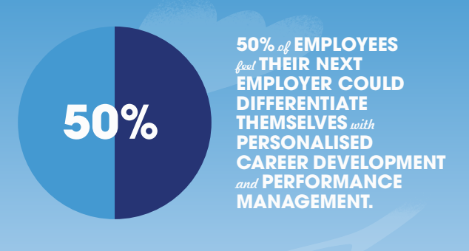
Figure 4: Motivation in Employees
(Source: Salesforce, 2023)
According to the above figure 4, the importance of motivation in the working environment of GSK is shown. GSK uses employees-centric approach to motivate their employees by modifying its HR policies (Salesforce, 2023). This approach is helpful for GSK in increasing efficiency of their workforce, and it is beneficial in making a positive impact on the organisation. Furthermore, boosting advanced technology is helpful in maximising the satisfaction of the workforce and it enables an organisation in achieving its objectives. Maslow hierarchy of needs is the process of satisfying requirements from fundamental to advanced levels. All the demands of human beings are fulfilled to achieve satisfaction such as food, safety, belonging, and self-actualisation (Numonjonovich, 2022). Basic needs are getting food, shelter, and clothes, and after that security, health, and employment. GSK motivate their workforce by encouraging them and recognising their contribution in success of their company (Gsk, 2023).
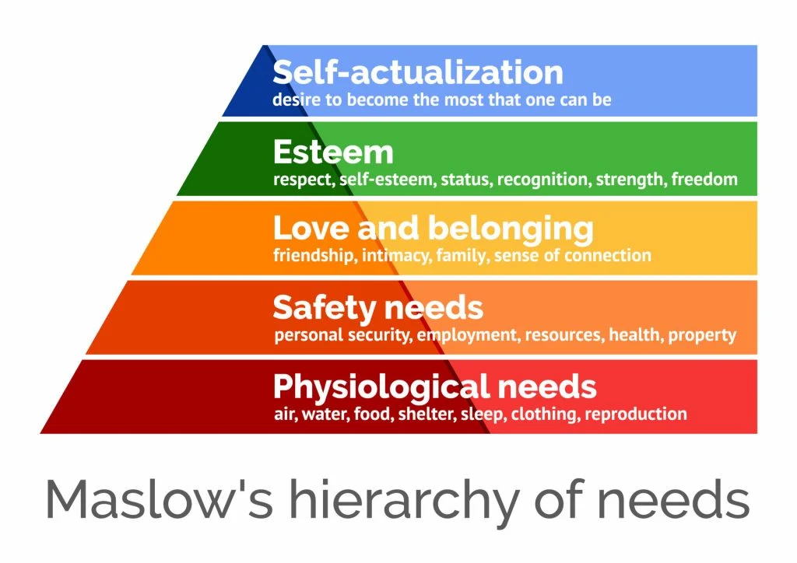
Figure 5: Hierarchical needs according to Maslow
(Source: Numonjonovich, 2022)
In the above-mentioned figure, psychological, safety, love and belongingness, esteem, and self-actualisation are Maslow’s hierarchy of needs. Employees in GSK are providing paid holidays, paid holidays, paid sick leave to fulfil their basic requirements and makes them feel satisfied (Builtin, (2023). Providing reward to their employees helps workforce to inspire and provide achieve their goals.

Conclusion
From this report, it can be summarized that the structure and culture of a company are beneficial for them, motivating employees to enhance their productivity in the context of GSK. Investing in research and development is useful for a company to enhance their productivity by adopting innovative technology. GSK delivers quality services to their patients for the treatment of HIV, respiratory, and oncology with the help of medicines and vaccines.

- References
Azeem, M., Ahmed, M., Haider, S. and Sajjad, M. (2021) ‘Expanding competitive advantage through organizational culture, knowledge sharing and organizational innovation’, Technology in Society, 66, p.101635.
Briker, R., Walter, F. and Cole, M.S. (2021) ‘Hurry up! The role of supervisors’ time urgency and self‐perceived status for autocratic leadership and subordinates’ well‐being’, Personnel Psychology, 74(1), pp.55-76.
Builtin, (2023) GSK benefits overview. Available at: https://builtin.com/company/gsk/benefits. (Accessed: 1 August 2023)
Fiercepharma, (2023) GSK turns to K+N for supplier logistics. Available at https://www.fiercepharma.com/manufacturing/gsk-turns-to-k-n-for-supplier-logistics. (Accessed: 1 August 2023)
Fusar‐Poli, P., Correll, C.U., Arango, C., Berk, M., Patel, V. and Ioannidis, J.P. (2021) ‘Preventive psychiatry: a blueprint for improving the mental health of young people’, World Psychiatry, 20(2), pp.200-221.
Gsk, (2022) Annual Report 2022. Available at: https://www.gsk.com/media/9956/annual-report-2022.pdf. (Accessed: 1 August 2023)
Gsk, (2023) Annual Report 2021. Available at: https://www.gsk.com/media/7462/annual-report-2021.pdf. (Accessed: 1 August 2023)
Gsk, (2023) Business Operations. Available at https://www.gsk.com/en-gb/careers/experienced-professionals/business-operations/#hr. (Accessed: 1 August 2023)
Gsk, (2023) Manufacturing and supply. Available at https://www.gsk.com/en-gb/careers/experienced-professionals/manufacturing-and-supply/. (Accessed: 1 August 2023)
Gsk, (2023) Our code of conduct. Available at: https://www.gsk.com/media/4800/english-code-of-conduct.pdf. (Accessed: 1 August 2023)
Gsk, (2023) Product governance. Available at: https://www.gsk.com/en-gb/responsibility/product-governance/#gsk-quality-management-system. (Accessed: 1 August 2023)
Gsk, (2023) We unite science, technology and talent to get ahead of disease together. Available at: https://www.gsk.com/media/8520/the-code-presentation-version.pdf. (Accessed: 1 August 2023)
Hock-Doepgen, M., Clauss, T., Kraus, S. and Cheng, C.F. (2021) ‘Knowledge management capabilities and organizational risk-taking for business model innovation in SMEs’, Journal of Business Research, 130, pp.683-697.
Macrotrends, (2023) GSK: Number of Employees 2010-2023. Available at: https://www.macrotrends.net/stocks/charts/GSK/gsk/number-of-employees#:~:text=Interactive%20chart%20of%20GSK%20(GSK,a%204.22%25%20decline%20from%202020. (Accessed: 1 August 2023)
Numonjonovich, M.M. (2022) ‘ECONOMIC DEVELOPMENT AND THE ROLE OF MASLOW’S HIERARCHY OF NEEDS. Web of Scientist:’ International Scientific Research Journal, 3(7), pp.5-10.
Razali, N.A., Jaes, L., Suhaimy, K.A.M., Ani, F., Nordin, S.R.A., Sabtu, M.H., Hanapi, M.S., Othman, M.F., Veloo, G. and Ariffin, F.M. (2022) ‘Mahathir Mohamad as a World-Class Leader: A View from The Great Man Theory of Leadership’, Journal of Techno-Social, 14(2), pp.45-58.
Salesforce, (2023) PERSONALISATION and THE ART of EMPLOYEE ENGAGEMENT. Available at: https://www.salesforce.com/content/dam/web/en_gb/www/pdf/form/pdf/gsk-ee-v03.pdf. (Accessed: 1 August 2023)
Shrestha, Y.R., Ben-Menahem, S.M. and Von Krogh, G. (2019) ‘Organizational decision-making structures in the age of artificial intelligence’, California management review, 61(4), pp.66-83.
Soomro, B.A. and Shah, N. (2019) ‘Determining the impact of entrepreneurial orientation and organizational culture on job satisfaction, organizational commitment, and employee’s performance’, South Asian Journal of Business Studies, 8(3), pp.266-282.
Tabrizi, B., Lam, E., Girard, K. and Irvin, V. (2019) ‘Digital transformation is not about technology’, Harvard business review, 13(March), pp.1-6.
Workplacementalhealth, (2023) GlaxoSmithKline. Available at: https://workplacementalhealth.org/case-studies/glaxosmithkline#:~:text=As%20a%20result%20of%20the,America%2C%20and%20Asia%20Pacific). (Accessed: 1 August 2023)

