Chapter 4- Data Analysis and Findings.

4.1 Introduction
The previous chapter used the Research Onion Model created by Saunders, Lewis, and Thornhill (2012). By dividing the phases, the research onion has been utilised to expedite the project design process, and it has enabled the researcher to develop a methodological strategy, approach, timeframe, and data collection processes. Following the collecting of quantitative data, this part of the dissertation will aim to present the project's conclusions and interpret the collected data.
This chapter will also discuss one of the main objectives, which was to analyse the data collected to ascertain whether there is any connection between criminal conduct and nature vs. nurture.

4.2 The survey
A copy of the original survey will be included in the appendix (Appendix A). It provides all questions asked to the members of the public and a brief introduction to the survey explaining the purpose of why it is being carried out. The survey consisted of closed questions.
The goal of closed-ended questions is to guide the respondent to provide a standardised reply that yields controlled quantitative data about your intended audience. When a question is closed-ended, the reader is encouraged to answer with one of the preset choices that is provided. True/false, yes/no, or a predetermined list of multiple-choice responses are the most popular answer styles for closed-ended questions (Bonneau, 2024).
The survey consisted of Fifty-Four closed questions, majority of the answers being Yes or No and some being a multiple-choice option. The structure of the survey was methodical. It started with questions about gender, age, ethnicity and religion. Then went into questions surrounding the ‘Nature’ aspect of the study. This is where the Somatotype theory was brought into the survey as the question focused on whether the person’s body type was Ectomorph, Endomorph or Mesomorph (Wood, 2008). The survey asked about questions about facial features and height linking to Lombroso’s theory (Brookes, 2021). Before moving onto questions surrounding ACEs and parental behaviour and mental health conditions. Wood (2018) explains that a methodical survey design will facilitate a simpler and more thorough examination of the findings.
The survey was sent out via social media and shared amongst family and friends. The survey collected one hundred and twenty responses; however not all questions were answered by those one hundred and twenty people. Some of the questions were not applicable to some people and were skipped rather than answering in the relevant box. Due to the large number of questions asked and the word count limitations for this study not all answers to each question will be analysed. For the analysis the questions which focus on genetics, parental influence, addiction and ACEs will be analysed and compared.

4.3 Data Analysis
Analysing datasets to make inferences about the information they contain is known as data analysis. To identify patterns or trends, the data must be arranged, cleaned, and examined. Consistent or comparable replies may also indicate a response to a study topic (Eldridge, 2023).
This chapter's data analysis will continuously aim to answer the research question that has been raised repeatedly throughout the project: ‘Nature Vs Nurture: Which is more influential on criminal behaviour?’.

4.4 Method for Analysis
The survey was created online through google forms. This allows you to input your questions and share the survey online. Once you have the desired number of responses it automatically puts the information received into pie charts. Pie charts simplified the data outputs, percentages were utilised as the display unit whenever possible.
Ricks (2020) explains that pie charts are an excellent tool for data visualisation. They are informational and simple to read.

4.5 Genetics: Do they influence criminal behaviour?
4.5.1 Somatotypes
As explained previously William Sheldon looked into whether people with certain body types were more likely to commit a crime. According to Sheldon, mesomorphs make up the great bulk of criminals. One reason for this is that a strong, muscular person's threatening appearance leads them to become involved in crime at a young age (Nickerson, 2022b).
With this in mind one question on the survey asked participants ‘how would you describe your body type?’. The answers were ‘Ectomorph: (lean, slender and little body fat and muscle)’, ‘Endomorph: (more stored fat and gains weight easily)’ and ‘Mesomorph: (large amount of muscle, athletic and strong)’. This question received 117 responses.
55.6% of people answered Endomorph, 30.8% answered Ectomorph and 13.7% answered Mesomorph (see Diagram 2). If we then compare this to the questions about a person’s criminal history, which also received 117 responses, 72.6% answered no to ever being arrested and 27.4% answered yes. Out of those 27.4%, only 8.5% were charged with an offence and 1.7% of those spent time in prison. (See diagrams 3, 4 and 5). With the answers provided there is no way to know how many of those who had been arrested, were of Mesomorph build. Therefore, these results do not show any link between criminal behaviour and body type. Studies to support this theory are very outdated and may not be relied on due to a bias approach explains Nickerson (2022b).

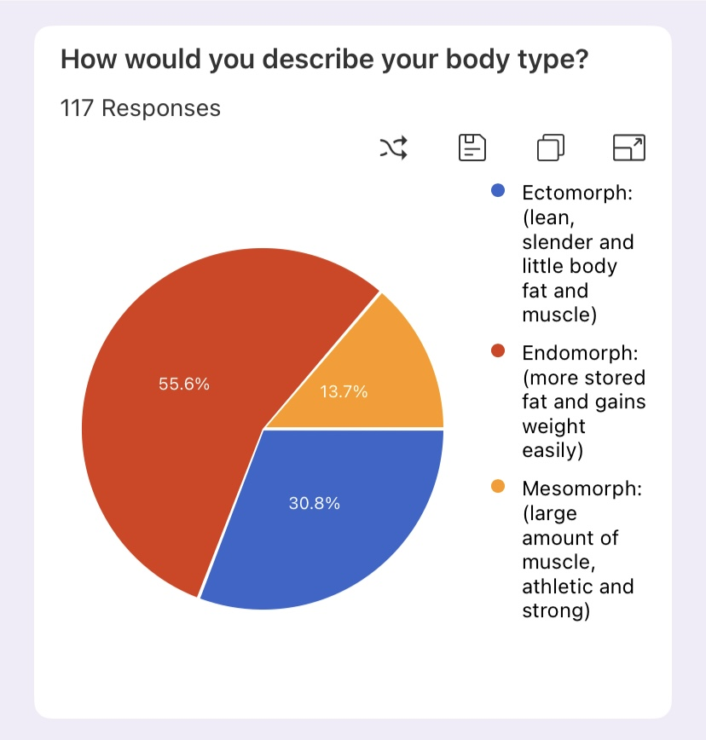

Diagram 2: Pie chart of results.

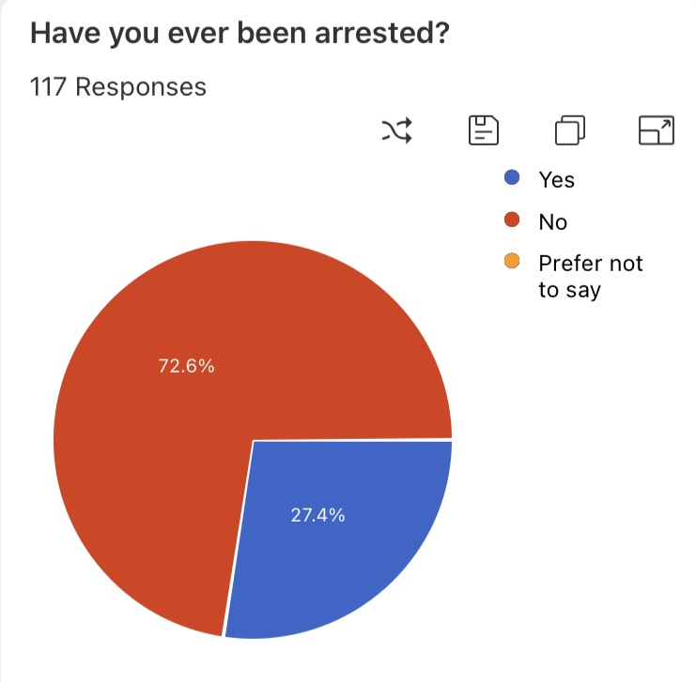

Diagram 3: Pie chart of results.

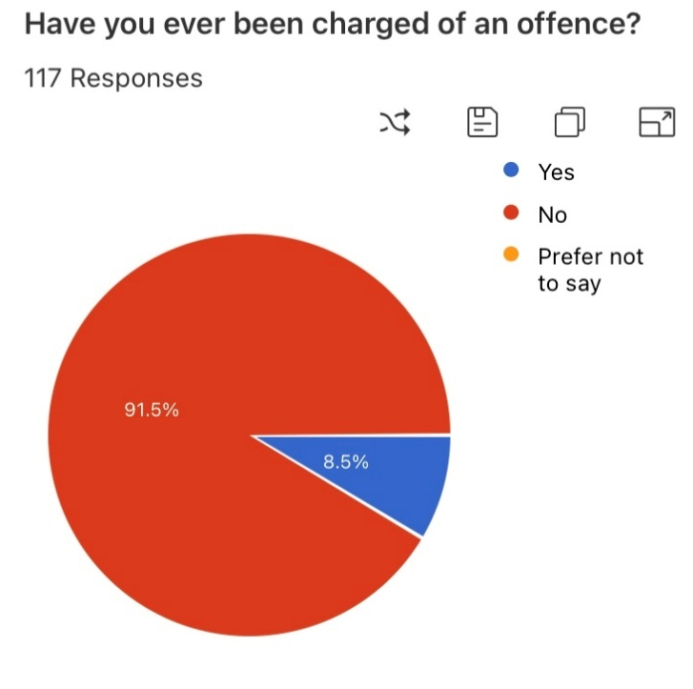

Diagram 4: Pie chart of results.

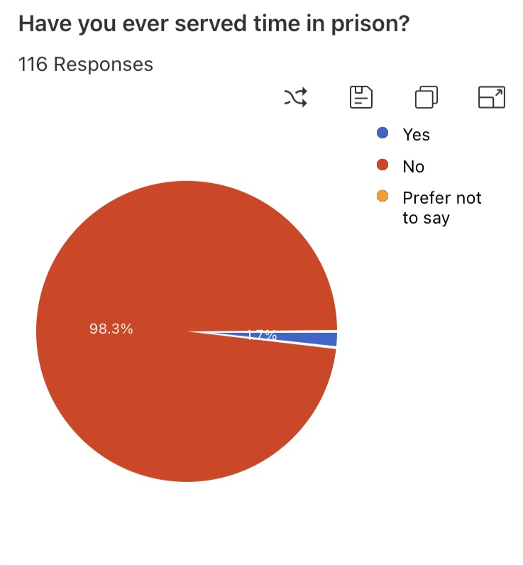

Diagram 5: Pie chart of results.

4.5.2 Is there any corelation to drug and alcohol addiction in biological parents and their children later in life?
Within some of the questions asked in the survey, it touched on whether the participants and their parents had ever suffered with drug or alcohol addiction.
One question asked, ‘Have either of your parents suffered with alcohol addiction?’, This question received 117 responses, 81.2% answered ‘No’, 16.2% answered ‘Yes’ and 2.6% answered ‘Prefer not to say’ (See diagram 6). If we compare this to the question asking, ‘Have you ever suffered with alcohol addiction?’ which also received 117 responses, 91.5% answered ‘No’ and 8.5% answered ‘Yes’. (See diagram 7). According to the percentages of the two questions, more than half of those who said that their parents had an alcohol addiction also stated they had an addiction to alcohol at some point in their life.
The survey also asked, ‘Have either of your parents ever suffered with drug addiction?’, This question received 117 responses. 88.9% of those answered ‘No’, however 10.3% answered ‘Yes’ and 0.9% answered ‘Prefer not to say’. (See diagram 8). When comparing this to the question asking the participant whether they have ever suffered with drug addiction, 88% answered ‘No’ and 12% answered ‘Yes’. The two questions received the same number of responses yet there was a 1.7% difference in the ’Yes’ answers. (See diagram 9).
These responses suggest that there is a likely correlation between parental addiction and addiction in their children.
When looking at expert sources such as the National Institute on Drug Abuse (2023) who explain that scientists have discovered that genes are frequently inherited across addiction diseases and North Jersey Recovery Centre (n.d.) who state that half of an individual's risk for addiction is influenced by their inherited genes. There is clear corelation between their research and the results of the survey.
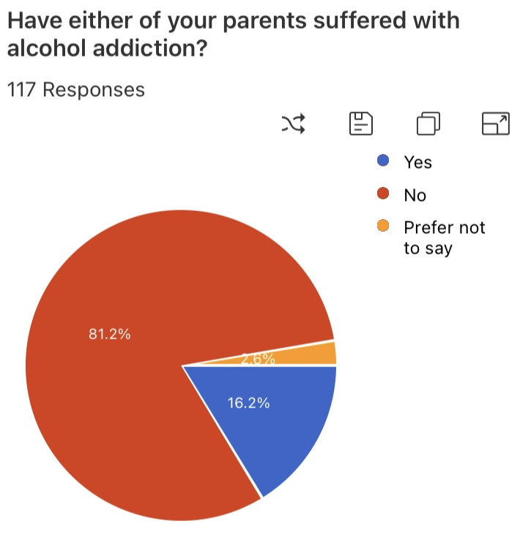

Diagram 6: Pie chart results.
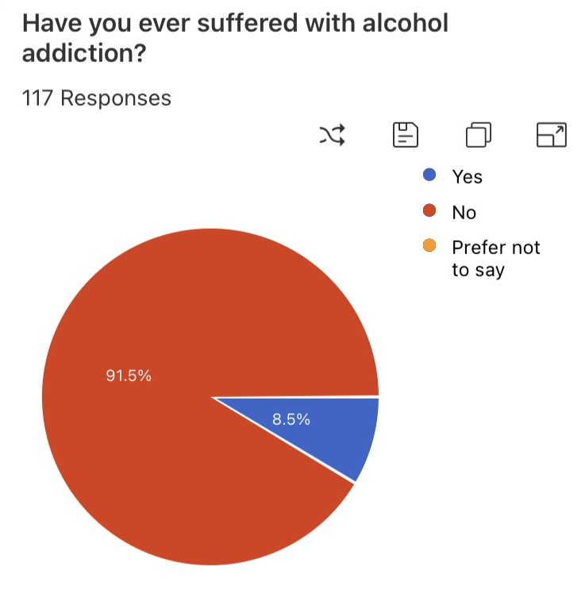

Diagram 7: Pie chart results.

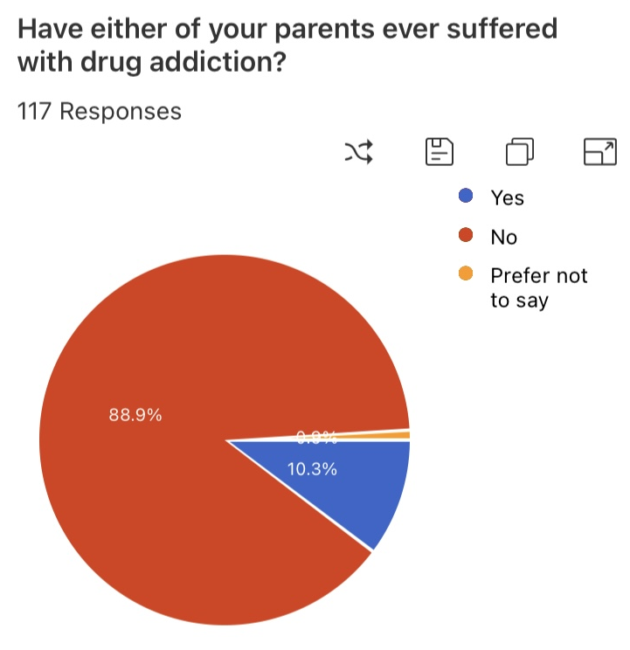

Diagram 8: Pie chart results.

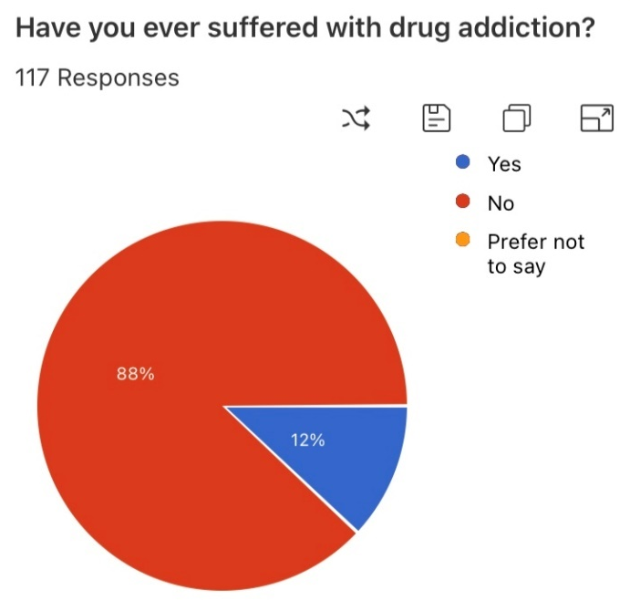

Diagram 9: Pie chart results.

4.5.3 Is there any corelation with Mental health conditions in biological parents and their children later in life?
The survey asked, ‘Have either of your parents ever been diagnosed with any mental health conditions?’. This received 117 responses, 68.4% answered ‘No’, 30.8% answered ‘Yes’ and 0.8% answered ‘Prefer not to say’. (See diagram 10). Participants were then asked, ‘Are you diagnosed with any mental health conditions?’. Out of 117 responses, 72.6% answered ‘No’, 26.5% answered ‘Yes’ and 0.9% answered ‘Prefer not to say’. (See diagram 11).
Looking at the percentage of people who answered yes to both questions there is a 4.3% difference. Meaning majority of people who stated their parents suffered with mental health conditions, have also been diagnosed with some form of Mental health themselves.
Expert studies show mental illness is most likely caused by a combination of environmental and genetic factors, although it is likely to have a genetic component. Furthermore, some mental health conditions, like depression, schizophrenia, and bipolar disorder, have a stronger genetic component than others (Wisner, 2022). Comparing these studies to the results of the survey show that there is a corelation between mental health disorders in parents and being passed to children through genetics.

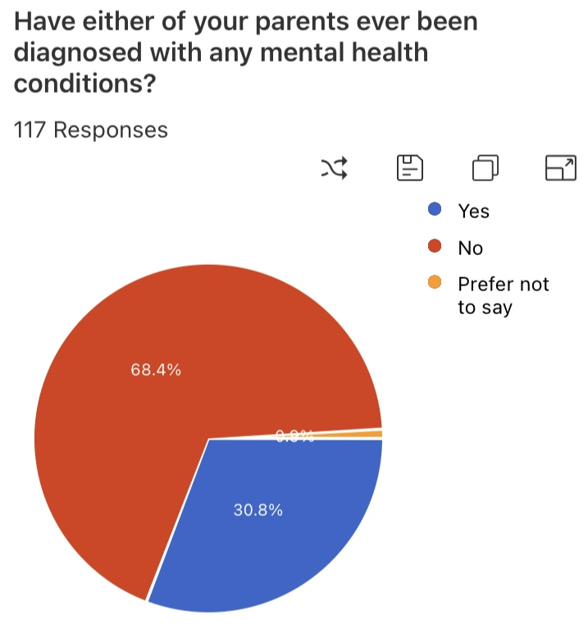

Diagram 10: Pie chart results.

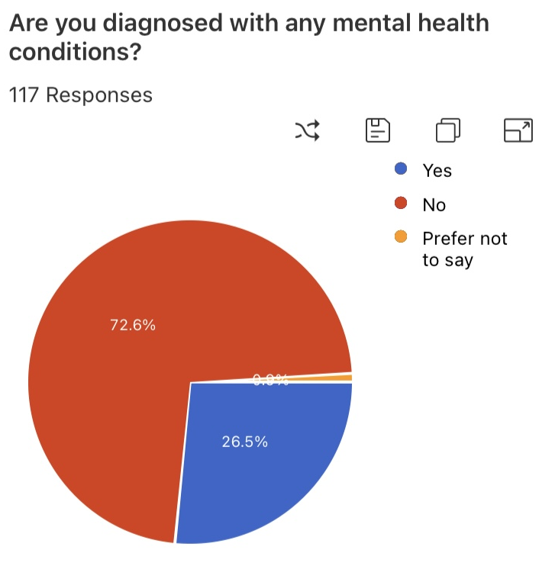

Diagram 11: Pie chart results.

4.6 Nurture: Does it have an influence on criminal behaviour?
4.6.1 Adverse Childhood Experience
As previously spoken about within this project, studies have been conducted into the effect ACEs has on someone’s life and how it can shape their decision making later in life. ACEs involve many different factors of a child’s experiences when growing up. This covers the ‘Nature’ side of the argument, and the survey attempted to ask questions surrounding as many different ACEs as possible in hope to get some definitive answers to the overall question.
The survey started by asking whether the participants whether they had any involvement with social services or been in the care system. Both questions received 117 responses, 15.4% stated that they had been involved with social services within their childhood however 7.7% of those stated that they had spent time within the care system. (See diagrams 12 and 13).

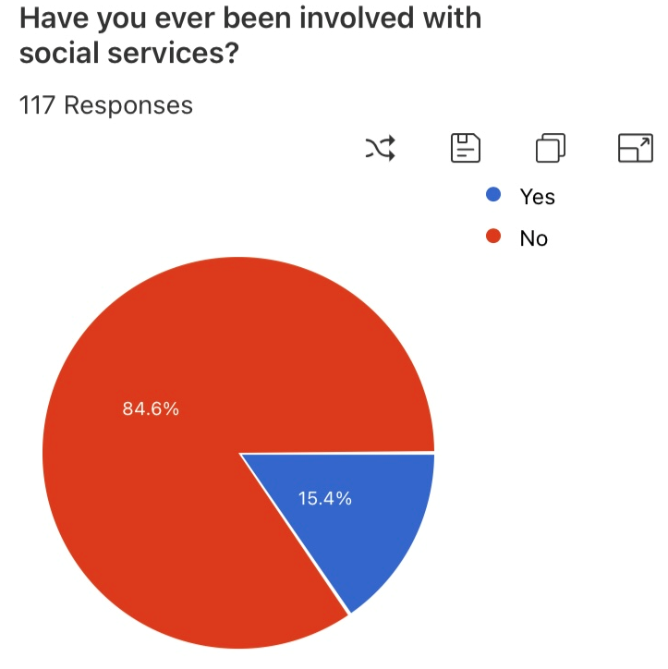

Diagram 12: Social services results.

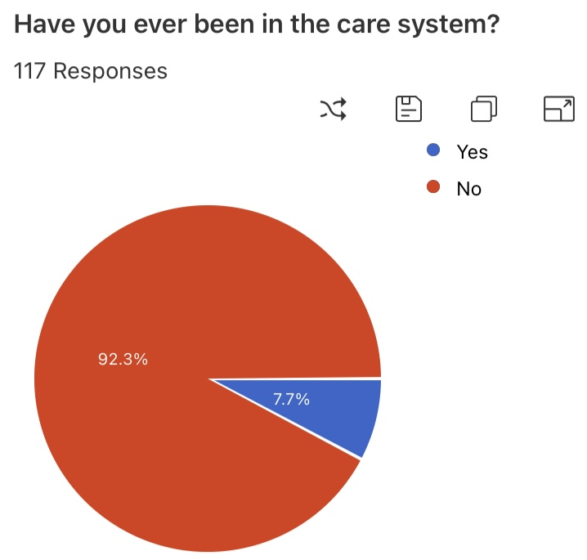

Diagram 13: Care system results.

The survey then asked questions surrounding physical, emotional, psychological and sexual abuse and asked whether they had ever witnessed domestic abuse within the home whilst growing up. These five questions received the same number of responses.
Physical abuse: 16.2% answered yes (See diagram 14)
Emotional abuse: 21.6% answered yes (See diagram 15)
Psychological abuse: 21.4% answered yes (See diagram 16)
Sexual abuse: 6.8% answered yes (See diagram 17)
Witnessing Domestic abuse: 20.5% answered yes (See diagram 18)
Looking at the statistics above it is clear that most people who had experienced one form of abuse, also experienced multiple other forms.
Comparing these percentages to the ones shown in the question relating to the participants criminal history (see diagrams 3,4 & 5) there are some corelation shown in the answers to ‘Have you ever been arrested?’, which showed 27.4% had been. Both questions received the same amount of responses results show that there may be some connection between ACEs and criminal behaviour. IF we compare this to studies which are already available you can see that there is an obvious connection between ACEs and criminal behaviour.
The Scottish Government (2018) explains that ACEs are strongly linked to criminal behaviour, according to research. Multiple ACE survivors are more likely to take risks, which can be detrimental to their health and occasionally be linked to criminal activity, supporting the findings within the survey.

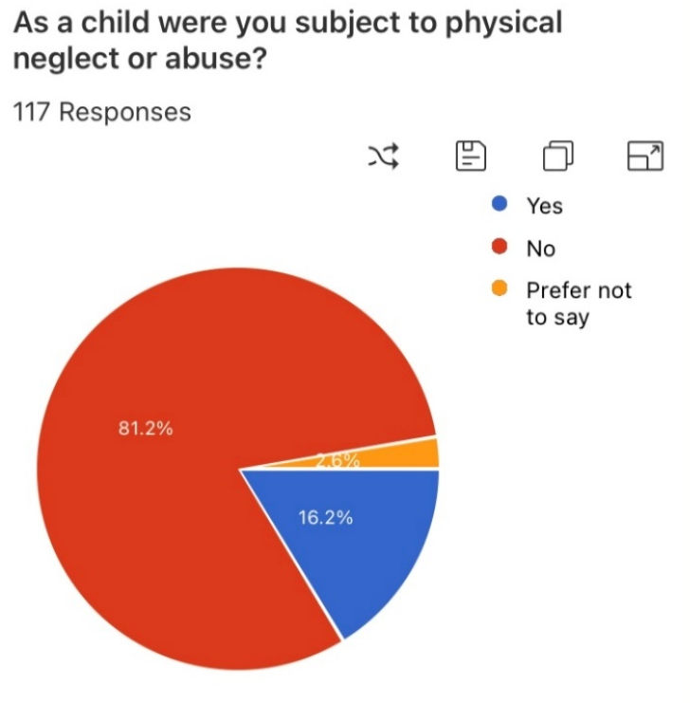

Diagram 14: Physical abuse results.

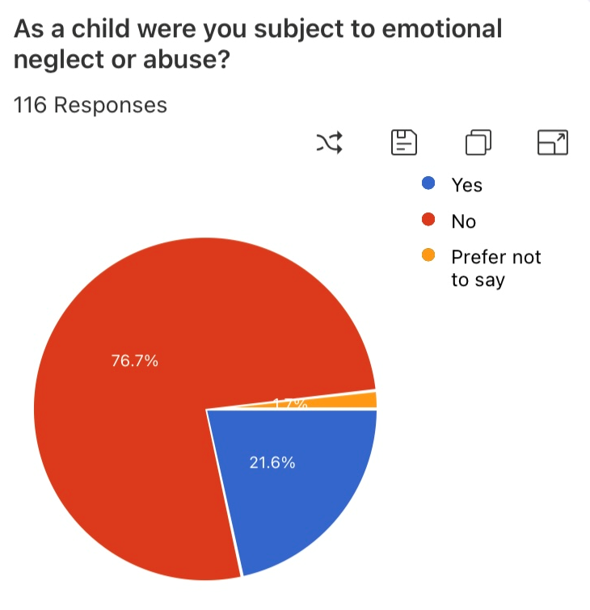

Diagram 15: Emotional abuse results.

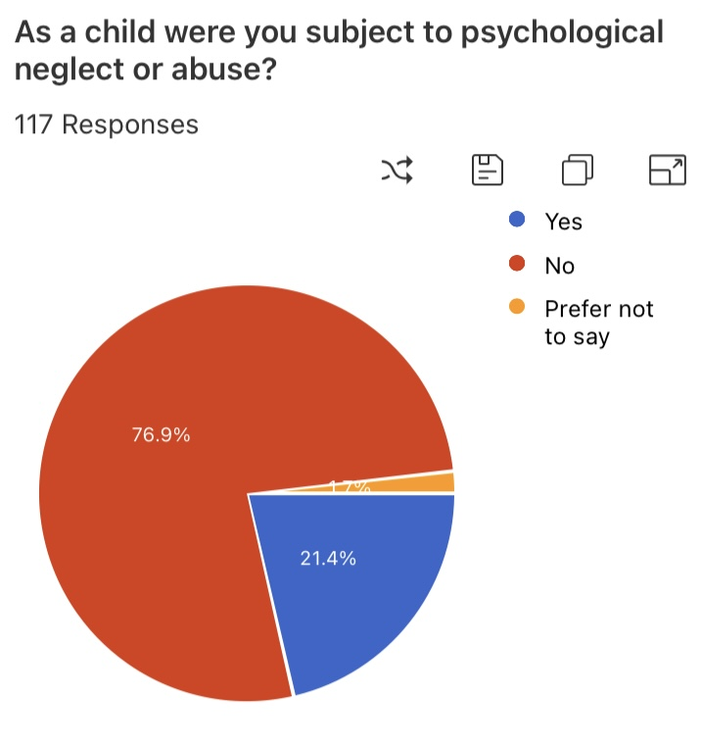

Diagram 16: Psychological abuse results.

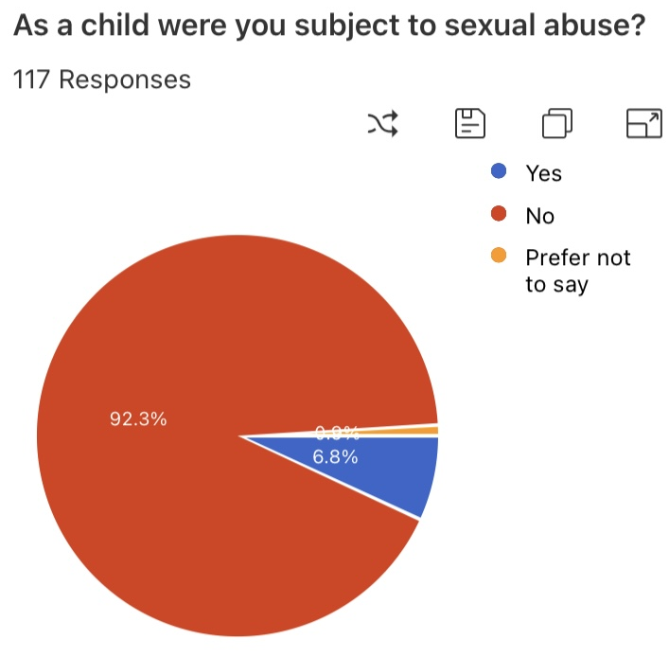

Diagram 17: Sexual abuse results.

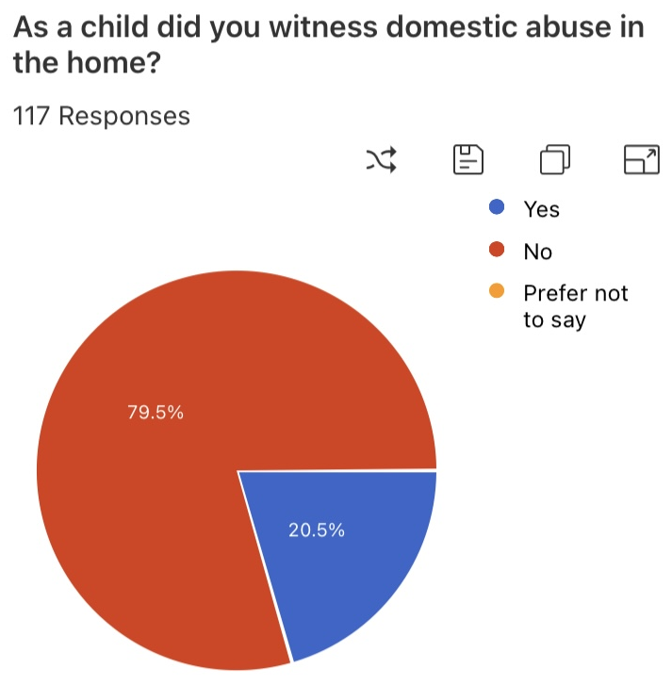

Diagram 18: Witnessing Domestic Abuse results.

4.6.2 Can behaviour exhibited by parents influence their child’s behaviour?
The survey asked questions relating to the participants parents’ criminal history. The questions were direct and did not ask for specific details. In this section we will look at the results for the questions and compare them to previous answers.
They were asked ‘Have either of your parents ever been arrested?’, 117 responses to which 19.7% answered ‘Yes’. (see diagram 19). If we compare this to the results shown in diagram 3, which received the same number of responses yet the percentage who answered ‘Yes’ was 27.4%.
They were then asked, ‘Have either of your parents ever been charged with an offence?’, to which 14.7% answered ‘Yes’ (See diagram 20). If we compare this to the results shown in diagram 4, again receiving the same number of responses yet the percentage that answered ‘Yes’ is 8.5%.
Finally, they were asked ‘Have either of your parents spent time in prison?’, to which 10.3% answered ‘Yes’ (see diagram 21). However, only 1.7% out of the 116 responses stated that they had served time in prison (see diagram 5).
Although the percentages within this section of the survey are not an exact match, there is some correlation between the two. Theories such as Besemer et al. (2017) support the findings within the survey, by stating that children who witness criminal behaviour via their parents seem to be more likely to engage in that style of behaviour themselves.

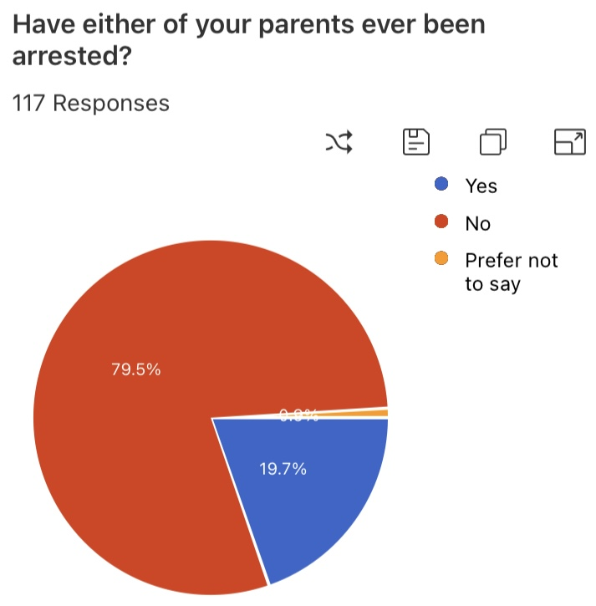

Diagram 19: Arrest of parent’s results.

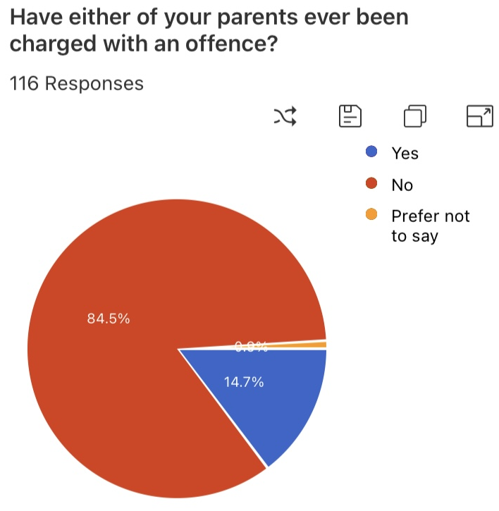

Diagram 20: Parents charged with offence results.

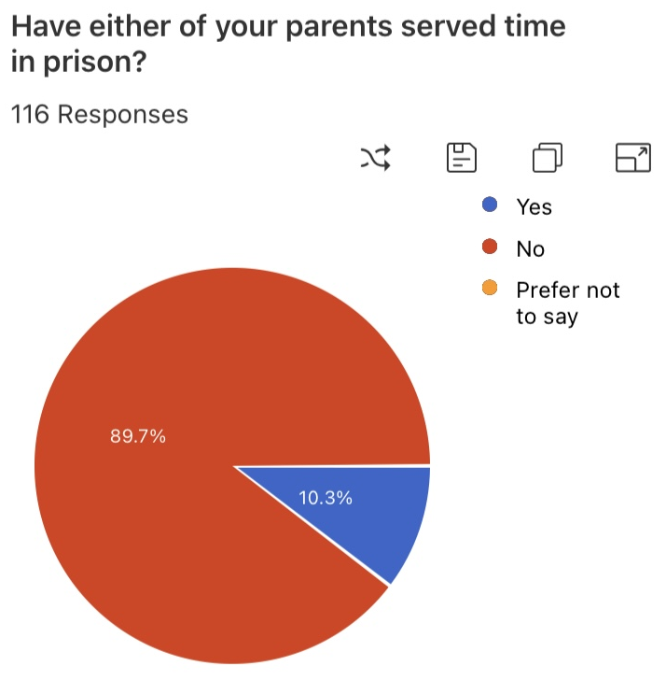

Diagram 21: parent’s time in prison results.

4.7 Conclusion
This chapter has effectively presented the research project's outcomes, which came from the quantitative survey data collecting. This chapter has addressed objective 3 which was to examine the information gathered to determine whether nature vs. nurture and criminal activity are related in any way. The following chapter will expand on this further by providing a conclusion for the research conducted in this project.

Total word count- 2,151

