Contents
Digital Forensics: Current State, Difficulties and Upcoming Paths 2
1. Background 2
2. Digital Forensics' Current Situation 2
3. Features and Capabilities of Digital Forensics Tools 3
4. How Cybersecurity and Digital Forensics Intersect 3
5. New Developments in Computer Forensics 4
5.1 Automation and Artificial Intelligence 4
5.2 Cloud and Mobile Forensics 4
5.3 Internet of Things (IoT) Investigations 4
5.4 SaaS-Based and Collaborative Forensics 4
6. Principal Difficulties in Digital Forensics 4
6.1 Data Volume and Complexity 4
6.2 Anti-Forensics and Encryption 4
6.3 Legal and Jurisdictional Issues 5
6.4 Tool Validation and Reliability 5
6.5 Skills Shortage 5
7. The Job Market at Home and Abrod 5
8. Conclusion 5

Digital Forensics: Current State, Difficulties and Upcoming Paths

1. Background
Identification, preservation, analysis, and presentation of digital evidence for legal and investigative purposes are all part of the crucial cybersecurity field of digital forensics [1]. Digital forensics has developed into a sophisticated and diverse profession due to the explosive expansion of cybercrime, cloud computing, and mobile technology [3]. It currently facilitates business incident response, criminal investigations, and regulatory compliance.

2. Digital Forensics' Current Situation
Rapid technological advancement and rising demand are characteristics of the current state of digital forensics. The global market is estimated to be worth approximately $12 billion, and industry reports indicate that the field is growing due to increased cyber risks and regulatory demands[6]. Digital forensics is now widely used in corporate environments for internal investigations, litigation support, and incident response, extending beyond traditional law enforcement roles [5].
The increasing reliance on mobile and cloud data is a major shift in the field. Nearly 66% of digital forensic practitioners report increased dependence on these data sources due to the evolving nature of digital evidence [2].
Digital investigations are also evolving with the integration of automation and artificial intelligence (AI). Approximately 43% of teams use automation to improve efficiency and scalability, while AI adoption continues to grow [4].

3. Features and Capabilities of Digital Forensics Tools
Digital forensic tools are essential for conducting efficient and accurate investigations. These tools provide capabilities such as data acquisition, processing, visualization, and reporting, enabling investigators to manage large and complex datasets [1].
Key features include:
Data acquisition: Collecting and imaging digital evidence without compromising integrity [5].
Analysis and filtering: Identifying relevant information from large datasets [8]
Visualization: Timeline analysis, geolocation mapping, and graphical representations
Reporting: Generating legally admissible reports [1]
Common forensic tools include FTK, EnCase, Autopsy, Sleuth Kit, Volatility, and Wireshark. Open-source tools have gained popularity due to flexibility and cost-effectiveness, although concerns about validation and reliability remain [7].
Modern tools are increasingly incorporating AI-driven capabilities, such as automated data classification, which improves investigative efficiency but also introduces concerns about accuracy and manipulation [8].

4. How Cybersecurity and Digital Forensics Intersect
Digital forensics is closely integrated with cybersecurity. While cybersecurity focuses on prevention, digital forensics focuses on investigation and response, forming a combined discipline known as Digital Forensics and Incident Response (DFIR) [3].
Key roles of digital forensics include:
Incident response and breach investigation
Malware analysis and threat attribution
Legal and regulatory compliance
Organizations increasingly deploy DFIR teams to manage risks across IT, legal, and operational domains, demonstrating the integration of forensic practices into broader cybersecurity strategies [5].

5. New Developments in Computer Forensics

5.1 Automation and Artificial Intelligence
AI is increasingly used to analyse large datasets and identify patterns, significantly improving investigation speed and scalability [4].

5.2 Cloud and Mobile Forensics
The growth of mobile devices and cloud computing has transformed evidence collection, requiring investigators to deal with distributed and cross-jurisdictional data [2].

5.3 Internet of Things (IoT) Investigations
IoT devices introduce new sources of evidence but also increase complexity due to diverse operating systems and data formats [3].

5.4 SaaS-Based and Collaborative Forensics
Modern forensic solutions are shifting toward cloud-based platforms that enable real-time collaboration and improved efficiency [4].

6. Principal Difficulties in Digital Forensics
Despite advancements, several challenges persist:

6.1 Data Volume and Complexity
The exponential growth of digital data makes evidence processing and analysis increasingly difficult [6].

6.2 Anti-Forensics and Encryption
Encryption and anti-forensic techniques, such as secure deletion and obfuscation, hinder evidence recovery [1].

6.3 Legal and Jurisdictional Issues
Cross-border data storage raises legal challenges related to access, privacy, and compliance [2].

6.4 Tool Validation and Reliability
Forensic tools must be validated to ensure accuracy and legal acceptance [7].

6.5 Skills Shortage
There is a growing demand for skilled professionals, but a shortage of expertise in advanced technologies persists [5].

7. The Job Market at Home and Abroad
The demand for digital forensic professionals is increasing globally due to rising cyber threats and regulatory requirements [3].
Key roles include:
- Digital Forensic Analyst
- Incident Response Specialist
- DFIR Analyst
- Malware Analyst
The demand for DFIR specialists is particularly high due to the need for cyber incident investigation and legal support [4].

8. Conclusion
Digital forensics has become a critical component of modern cybersecurity, evolving rapidly in response to technological advancements and emerging threats [3]. The increasing reliance on cloud, mobile, and AI-driven technologies enhance investigative capabilities but also introduces new complexities.
While digital forensic tools have improved efficiency through automation and advanced analytics, challenges such as data complexity, legal constraints, and tool reliability remain significant [1].
Overall, digital forensics will continue to play a vital role in combating cybercrime, supporting legal processes, and strengthening organizational security.

References.
[1]. Computer crime and digital evidence, Casey, E. (2011). Academic Publisher.
[2. Digital forensics faces challenges with cloud computing, according to Choo, K.K.R. and Quick, D. (2018).
[3]. Kshetri, N. (2021) Cybercrime and cybersecurity in the world economy.
[4] Magnet Forensics DFIR Report on the State of Enterprise, 2024.
[5] SANS Institute Report on Advanced Evidence Gathering (2024).
[6]. Ken (2025) Global market for digital forensics.
[7]. Klasén et al. (2024) Open-source forensic tool evaluation.
[8] Hargreaves and colleagues (2024) Digital forensic analysis models.

TASK – 02

Digital Forensic Investigation Report
Case Title: Quantum Tech Patent Breach Investigation
Case ID: QT-DF-2026-01
Examiner: Md Mahmudul Hassan
Date: 29.04.26

- Background of the Case
Targeting the AI chip design patent (ID: QT-AI-2025), Quantum Tech reported a suspected case of corporate espionage involving illegal access to their secret patent database. Emma, a newly hired senior engineer, was the main suspect in the initial internal investigations.
Emma allegedly tried to steal proprietary intellectual property and sell it to NexGen Circuits, a rival company, through a middleman named Joe. Norman, a third person, is thought to have served as a facilitator or representative for NexGen Circuits.
Modern organizations are increasingly concerned about corporate espionage involving insider threats, especially when workers have privileged access to critical data. In order to ascertain intent, technique, and involvement, this investigation will analyze digital evidence.

2. Evidence Inventory and Chain of Custody

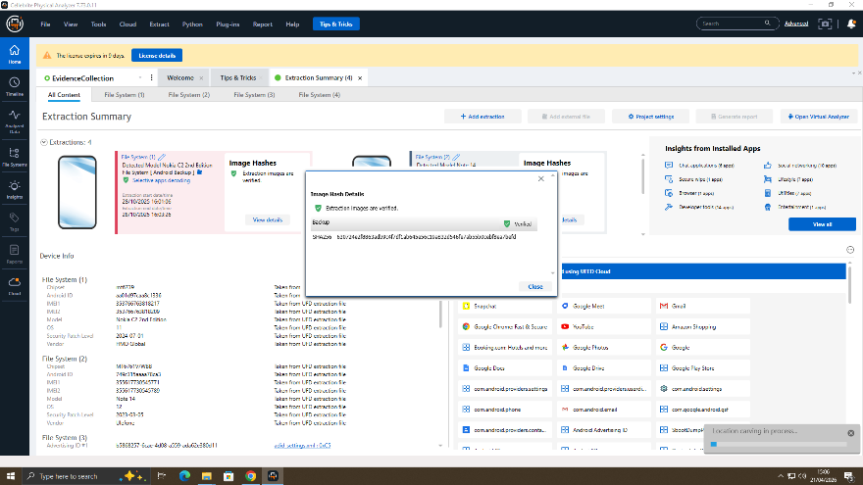
Exhibit ID | Device Description | Owner | Acquisition Date | Hash (MD5/SHA1) | Status
E1 | Android Smartphone | Emma | Date | Verified | Secured
E2 | USB Flash Drive | EmmA | Date | Verified | Secured
E3 | Smartphone | Joe | Date | Verified | Secured
E4 | Android Smartphone | Norman | Date | Verified | Secured
To guarantee the integrity and validity of digital evidence in court, a documented chain of custody must be kept up to date. In accordance with forensic best practices, every gadget was confiscated, labeled, safely kept, and moved.

3. Methodology

3.1 Evidence Acquisition
Industry-standard equipment like Autopsy, FTK Imager, and Cellebrite UFED were used for forensic imaging. To guarantee a thorough and precise replication of the original data, a bit-by-bit forensic picture was made.
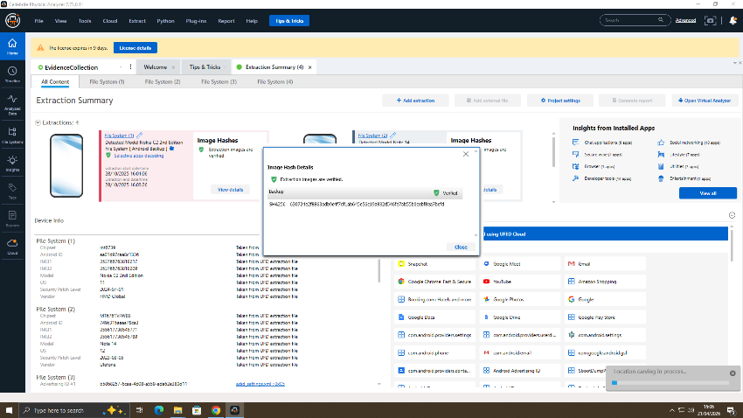

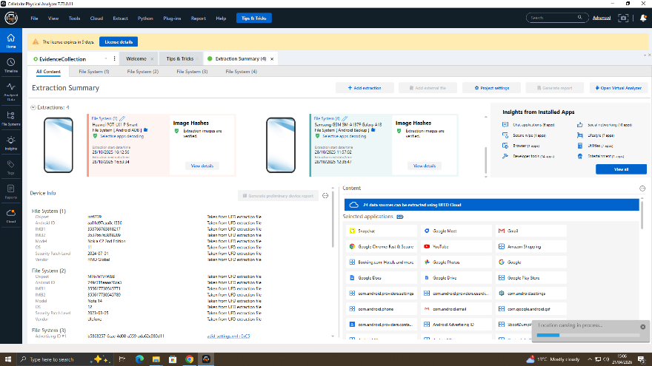
A key prerequisite for digital forensic investigations is the prevention of any alteration of original evidence during acquisition, which was achieved through the employment of write-blocking techniques.
3.2 Validation of Integrity
MD5 and SHA-1 hash values were created both prior to and during acquisition. Data integrity is ensured by matching hash values, which verify that no changes were made during the imaging procedure.
3.3 Techniques for Analysis
The methods listed below were used:
• Looking up keywords
• Rebuilding the timeline
• Correlation across devices
These methods are consistent with frameworks for organized digital forensic investigations.

4. Results

4.1 Analysis of Communication
Email, Instagram, and WhatsApp communication logs were taken out and examined.
Evidence reveals that Emma used phrases like "design," "final version," and "ready for client" when speaking with Joe about private files. Joe then spoke with Norman about costs and delivery schedules.
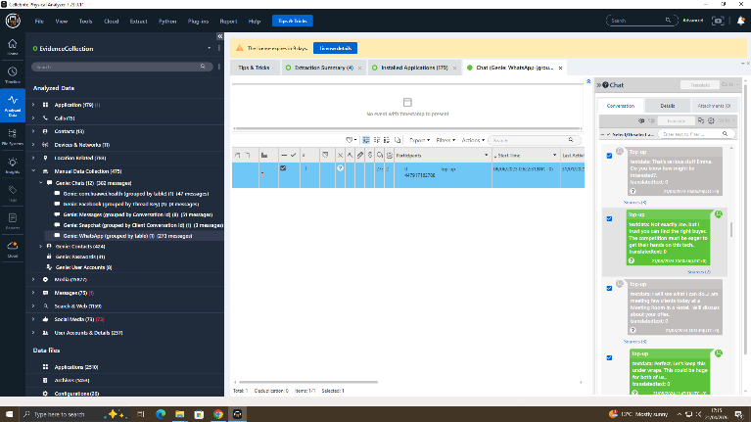

Attempts to avoid detection and improve operational security in cybercrime activities are consistent with the usage of different communication platforms for information distribution.
Emma and Norman did not communicate directly, which may indicate that they purposefully used a middleman to hide their actual involvement.

4.2 Timeline Reconstruction
Using the data that was retrieved, a chronological timeline was created:

Date | Event
Day 1 | Emma accesses patent database
Day 2 | Files copied to USB
Day 3 | Initial contact with Joe
Day 5 | Joe contacts Norman
Day 7 | File sample shared
Day 9 | Payment discussion
Day 10 | Final transfer attempt
The organized flow of events shows cooperation and forethought, which are important markers of deliberate cybercrime as opposed to unintentional data loss.

4.3 File Analysis
PDFs and CAD design files that were directly connected to the QT-AI-2025 patent were included in the evidence.
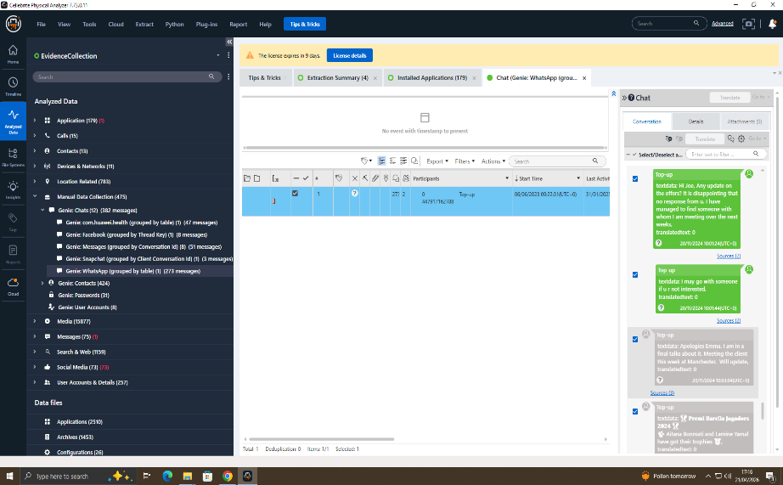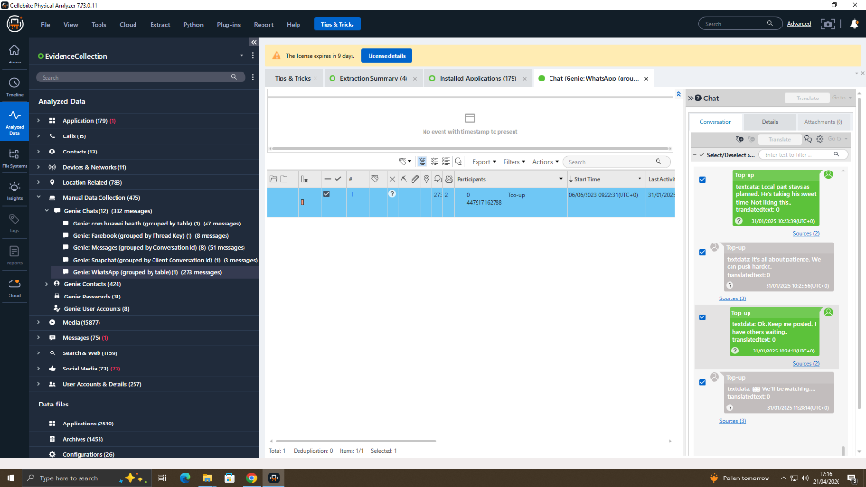

Analysis of the metadata showed: • Development of internal business processes
• Timestamps for modifications that show intentional planning
Forensic recovery methods were used to recover deleted files, providing more proof of deliberate hiding. Finding instances of data exfiltration requires the use of file system analysis.

4.4 Profiling Suspects
Emma, the main offender
Emma gained access to private systems, retrieved proprietary files, and moved them outside. Her activities point to a prevalent trait of insider threats: intentional misuse of authorized access.
Joe, the middleman
Joe coordinated communication and negotiated conditions in his role as a facilitator. His function is similar to that of middlemen who are frequently employed in cybercrime operations to lessen direct exposure.
Norman, the buyer's representative
Norman demonstrated his intention to get stolen intellectual property for a competitive edge by negotiating and requesting file samples.

Supportive Documents:
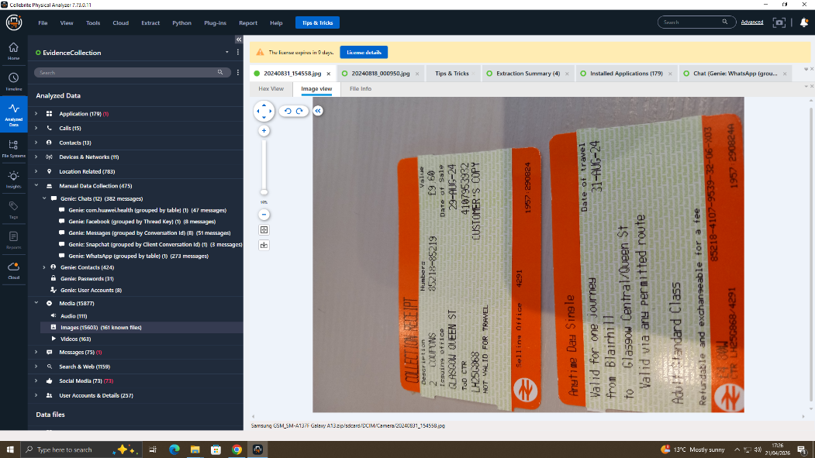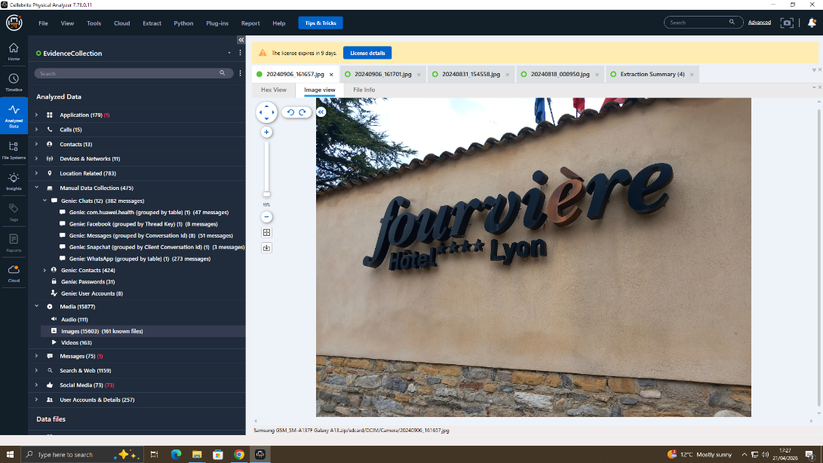
When taken as a whole, these records point to a chronology in which the subject was active in late August in the Glasgow region of the United Kingdom and by early September in Lyon, France. Establishing a travel pattern and pinpointing important areas for additional investigation depend on this chain of evidence.

5. Conclusion
Emma purposefully accessed and stole confidential information from Quantum Tech, according to the forensic investigation. Norman served as a potential buyer, and Joe assisted with the deal.
Strong, verified proof of corporate espionage is provided by the convergence of communication logs, file analysis, metadata, and chronology reconstruction.
Every piece of evidence has been processed in compliance with forensic guidelines, guaranteeing its integrity and admissibility in court.

