Paul Gauguin (1848-1903)
Gauguin spent the first part of his life and career in France (Brittany) and the second part of his life traveling to distant lands in search of a primitive paradise. Believing that the key to unleashing his creativity was to be found in faraway places not yet corrupted by civilization, he travelled to ever more remote areas in Europe, the Caribbean, and Polynesia. “To do something new,” he said, “you have to go back to the origins, to humanity in its infancy.” But on arriving at each destination he discovered that the reality he encountered was very different from the paradise he had imagined. He had envisioned each new place as a sacred world where people lived simply, freely, and without inhibitions, but he instead found complex societies with their own difficult realities. He turned to his art to capture this elusive paradise, depicting an idealized, mythic dream world. In his conversation and writings, Gauguin presented himself as fiercely opposed to the Christian Church. Nonetheless, his art was pervaded by religious themes and imagery, frequently drawing upon the Old and New Testaments for source material as well as the myths and belief systems of other cultures....this is evident even in his self portraits.

TAHITI

In Tahiti, Gauguin believed, he would find an artistic way forward by taking a step back to see “humanity in its infancy.” When he first set foot in Papeete in 1891, he found himself far from France, but even further from the paradise he had imagined. Tahiti was by then a French colony and was facing the ill effects of that status: the population had been decimated by diseases and alcohol brought by Europeans; Polynesian religious rituals were forbidden and rapidly headed toward extinction; and Gauguin witnessed the funeral of the last Tahitian king, Pomare V. “Tahiti is becoming completely French,” he lamented. “Little by little, all the ancient ways of doing things will disappear. Our missionaries have already brought a great deal of hypocrisy and they are sweeping away part of the poetry.”

Many of Gauguin’s Tahitian works hint at cultural loss. He painted melancholic Tahitian women, perhaps contemplating the vanishing of their traditional culture, a culture that Gauguin mourned but never knew. Images of a fallen Eve, her Garden of Eden transformed by Gauguin into a tropical forest, similarly evoke a paradise lost. Realizing that the Tahiti he had envisioned did not exist, Gauguin sought to create the wild paradise in his art. Images of beautiful women, luscious fruits, and richly hued landscapes depict the fertile, untainted land he had imagined. Other paintings portray a more mysterious world, filled with beauty, but also haunted by dangerous spirits and uncertainty.
In constructing the memory of an unspoiled paradise, Gauguin leaned heavily on the biblical myths of the Garden of Eden and especially the figures of Adam and Eve. He even painted a self-portrait using such symbolism.

Self portrait

The upper half of the canvas depicts the artist as a saint, a halo hovering above him as he averts his eyes from the tempting apples. But in the lower half, Gauguin appears as the tempter, holding the biblical snake between his fingers. The bold background complicates the divide, with a menacing red above and a heavenly golden yellow below. Gauguin portrays himself as a fundamentally contradictory man, saint and sinner, tempted and tempter, angel and Lucifer, civilized and savage.

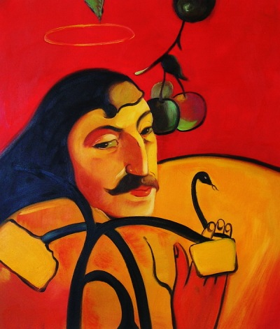

EVE
In their discussions on the work of Gauguin, art historians ponder the intense spirituality exihibited by the Breton women and his later highly sexualised images of the Tahitian female figure. ....and how Gaugin more generally reconciled his images of spirituality and sexuality.

In his recurrent figure of the “primitive” Eve, Gauguin found, above all, a physical embodiment of the natural unification of spirituality and sexuality. Historically, Western imagination conceived of biblical Eve as a reminder of, and testament to, the dangers associated with the pleasures of the flesh—a view that only complicated Gauguin’s quest for a visual unification of the spiritual and sexual realms. Once in Tahiti, Gauguin felt able to remove Eve from her traditional cultural constraints, in a gesture that constitutes a radical revision of this biblical figure; he effectively created a female nude situated in an Edenic paradise whose nakedness is meant to elicit pleasure without the sense that her overt sexuality is connected to shame and evil.

It is through the recurrent deconstructed figure of Eve that Gauguin felt able to challenge, at its biblical source, the Western notion that unabashed sexuality is sinful; he dismisses such notions through his application of a primitive, non-Western perspective.
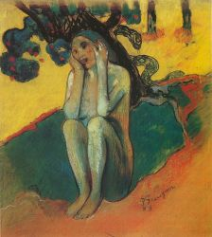
Gauguin’s Breton Eve from 1889 (while still in Brittany) is the first of many instances in which Gauguin exploits the biblical Eve as a conduit for reflections on art, women, and civilization. This new variant is presented as a crouching nude figure, clutching her head in her hands as she sits in a vague patch of space beneath what can only be assumed to be the Edenic Tree of Knowledge. Behind Eve, party obscured by the tree, hovers a threatening snake. Breton Eve’s skin is marked by an unnatural, putrid green flesh tone—a device that physically attests to her impending sin. The figure’s nudity, not common in Gauguin’s work predating his first trip to Tahiti, here serves a dual purpose—it helps to identify the figure as biblical Eve prior to the fall, while simultaneously functioning as an indication of human sexuality. When Breton Eve was first exhibited, it bore the inscription “Eve: Don’t listen to the. . . the. . . liar.”. It is clear that at this particular moment, Eve has hands clamped tightly over her ears.

In Gauguin’s revision of the traditional Eve, the artist’s attempt to rethink key elements of Christian mythology in terms of Tahitian primitivism is at once visually apparent. Indeed, it seems that the evolution of Gauguin’s Eve from Western to primitive was largely informed by his vision of Tahiti as an earthly, sexual paradise unfettered by the polluting effects of Western culture and religion. Gauguin’s dreams of this Tahitian paradise most definitely informed his Exotic Eve, which he painted in 1890, just before his departure for Tahiti.

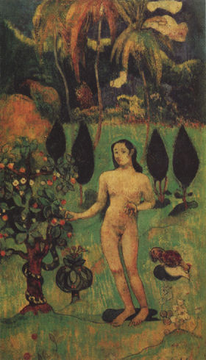

Unlike his earlier Breton Eve, Gauguin’s Exotic Eve accentuates the positive side of the temptation. In this painting, Eve, who still appears European, is depicted nude in a tropical Garden of Eden, yielding to temptation as she plucks a fruit from the Tree of Knowledge. However, instead of emphasizing the sinful nature of this act, as he did so effectively in Breton Eve, Gauguin appears more optimistic. This is made perhaps most apparent by Gauguin’s inclusion of a copulating rooster and hen on the left side of the painting. From the egg-shaped shadow cast by this pair springs egg and chick-like forms.

When read from right to left, the painting emphasizes the fruitful results of the Fall as opposed to its negative consequences. The snake represents temptation in its physical form, as Eve, picking fruit at the centre, is emblematic of the Fall. The rooster and hen symbolize sex and fertility, the importance of which is further emphasized by Eve’s gaze, which is fixed firmly upon the bird pair and their offspring. In this way, Exotic Eve is representative not of original sin, but of fertility sprung from sexuality. Thus, Eve’s surrender to material temptation is framed here in much more positive terms than those employed by Gauguin in his Breton Eve. This newly formed perspective is no doubt inextricably linked to the Tahitian paradigm Gauguin had already begun to adopt, in which sexuality was free from the shame and sin inherent in Western civilization. Still, Gauguin is unable to fully extricate Eve from the Western association of sex with sin, as evidenced by her apparent reticence and the overt biblical rendering of the scene.

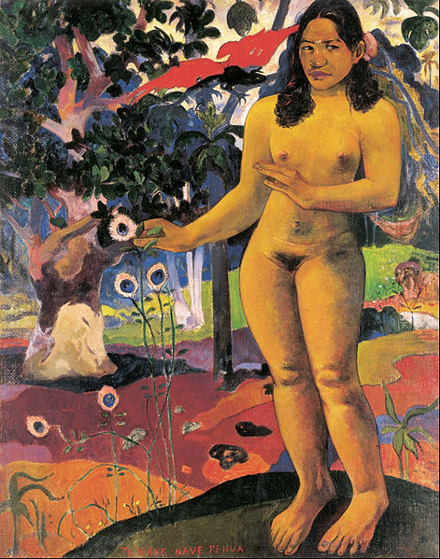
Gauguin’s first attempt at a primitive Eve, his Exotic Eve from 1890, is fully realized after his arrival in Tahiti in 1892, with his painting Te nave nave fenua. Here, Eve has become truly “native,” her setting exotically paradisiacal and her nudity finally presented boldly, free from the coyness that characterized Gauguin’s earlier nudes. This primitive, Tahitian Eve—probably modelled from Gauguin’s lover Teha’amana—is tempted not by a snake, but a black lizard with enormous red wings. Additionally, instead of plucking a piece of fruit from a tree, as Western Eve is traditionally depicted, Gauguin’s primitive Eve grasps the blossom of a fantastical flower, which most closely resembles a peacock feather....the peacock often used as a symbol of Paradise. The general framing of the scene serves to reinforce the biblical rather than Tahitian setting. Still, the painting’s overt Christian iconography is fused with a heightened, primitivized sexuality that borders, many commentators note, on animalistic. Gaugiun’s Tahitian Eve displays dark skin, black pubic hair, and is marked by unusually large hands and feet. The large hands and feet prompted contemporary critics such as Achille Delaroche to compare her to a “quadrumane”—a simian with feet adapted for use as hands. It is through this apparent animality that Gauguin attempted to remove Eve from her traditional cultural constraints and produce a figure that is at once innocent and pure and sexual.

We have to remember, of course, that this seemingly harmonious synthesis of spirituality and sexuality was predicated upon a completely racist view of Tahitian natives as intrinsically animalistic. Thus, despite his willingness to accept and incorporate Tahitian culture into his own worldview, Gauguin was ironically guilty of maintaining a distinctly Western view of the Tahitians as inferior—an attitude typical of colonialism.

This contrast between the two Eves (Western and Tahitian) emphasizes Gauguin’s belief that civilizing influences, such as the institution of marriage, tainted the Western Eve. The primitive Eve, conversely, is free from the polluting effects of Western culture and religion, enabling her to remain both spiritually pure but also sexually free.
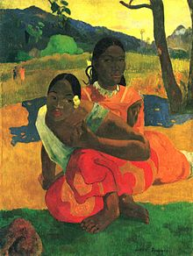
These ideas are perhaps best visually translated in Gauguin’s Nafea Faa Ipoipo (When Will You Marry?), from 1892. This painting depicts a primitive Eve in the foreground, dressed in native clothing. Behind her lurks a Westernized Tahitian woman, recognizable by her highnecked collar and missionary garb. This Westernized woman, eyes fixed on the primitive Eve as her mouth curls in a calculating smile, is meant to represent the corruption of purity that comes with a knowledge of Christianity. She poses a question to the primitive, innocent Eve, asking, “When will you marry?” as the painting’s title indicates. For her, sexual freedom is considered sinful and must be eradicated through marriage. Through this painting, Gauguin acknowledges the existence of Western cultural beliefs and practices in Tahiti, and laments its impact on the Tahitian way of life. In this way, Gauguin suggests that it is only in the absence of Western civilization’s influence that spiritual purity and sexuality can peacefully coexist.

Gauguin thus transposes the temptation of Eve to Tahiti with significant alterations. In this image, the figure of Eve hides her nakedness in shame, echoing Western depictions, but the tempter — usually a snake — here takes the form of a kneeling figure with a masklike face, perhaps the varua ino or evil spirit referred to in the title. The odd orange and green face that looms in the upper right corner of the painting may be another such spirit. The "words" of the title perhaps refer to the dried pandanus leaves that swirl around the nude figure's feet. In his journal Noa Noa, Gauguin compared these long leaves to "letters... of an unknown, mysterious language."
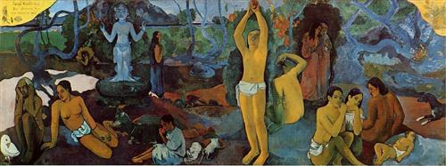

In other paintings, too, Gauguin adapts and expands the myth of Adam and Eve and the garden of Eden. Painted in 1897 and 1898, "Where Do We Come From? What Are We? Where Are We Going?" addresses Paul Gauguin's struggle with the meaning of existence. This piece, was considered by Gauguin "to be his masterpiece and the summation of his ideas" .
The painting should be viewed as a text from right to left--a suggestion imparted by the artist's own letters--with the various figures representative of questions relating to human existence. In this light, the babe at the far right signifies newborn life. The apple-picking male and the girl to his left who sits eating an apple re-enact the fable of Adam and Eve and the quest for knowledge. The old lady at the far left of the frame sits on the verge of death, unclothed as a parallel perhaps to the babe on the painting's far right. As one examines the painting, the questions that make up the artwork's title-"Where Do We Come From? What Are We? Where Are We Going?"--invite the viewer to contemplate the meaning of life with regard to the symbols Gauguin has left for us.

