Activity 2
Understand the range of HR Roles and behavioural requirements of HR professionals

Executive Summary

This report provides an overview of professionalism in the field of Human Resources (HR). It will include definitions of a professional and explain the importance of Continuous Personal Development (CPD). I will summarise the CIPD profession map and cover the knowledge skills and behaviours that can be developed to become a successful HR professional. I will conclude that there is a great importance for the need of Continuous Personal Development (CPD). Recommendations will include that HR professionals should use the CIPD Profession Map as a tool and to taylor continuous personal development and also that the professional areas are considered when undertaking new projects.

Introduction

The purpose of this report is to demonstrate my understanding of the range of HR Roles and behavioural requirements of HR professionals. This ties in with the developing professional practice in human resources unit of the CIPD level 5 award. The ever-evolving HR Function has moved away from the basic administrative duties it mainly performed in the past, with tasks based on ’best practice’ to develop people management practices for organisations. Today the focus is more on getting the best from people.

Professionalism

A professional, as defined by the Oxford English dictionary “a person who is engaged or qualified in a profession; a person who is very skilled in a particular activity” (Soanes and Hawker, 2006, p.812). One other definition of a professional is ”...occupants that are controlled to a considerable extent by a governing body which has a formal membership structure….and performance criteria that must be met” (Johns and Perkins, 2016, p.75). In essence, a professional has, works towards and refers to a well defined body of knowledge and applies it to their work. Everything is underpinned by a code of ethics or conduct that must be adhered to. In the case of HR professionals, the governing body is the Chartered Institute of Personal Development (CIPD). Membership of the CIPD demonstrates that individuals meet rigorous entry criteria and professional standards, “As well as adhering to our Code of Conduct, all professional members of the CIPD must demonstrate that they have the technical knowledge, skills, behaviours and experience outlined in our current body of knowledge - the Profession Map” (CIPD, 2019). As a HR professional, it is imperative to seek Continual Professional Development (CPD) by improving skills and knowledge from keeping up to date with changes in the CIPD community. Examples of sources of CPD could include; formal study or training, CIPD events and reading. In essence, CPD is about continuously seeking improvement.

The CIPD Profession Map

The CIPD Profession map is a valuable tool to help assess strengths, weaknesses and identify areas that need work. It details the competencies that HR professionals will need in the foreseeable future (Woodhams, Perkins and Wilkinson, 2016, p110).
In 2009 The CIPD launched the Profession Map, and have since developed the 2013 Map which sets out standards for HR professionals and outlines the activities, knowledge and behaviours needed for success (CIPD, 2015). More recently the New Profession Map was released in 2018 and was developed in collaboration with CIPD members, business leaders, industry experts, learning providers and partner organisations (CIPD, 2019). With the rapid evolution of technology, new specialisms, roles and ways of working, the Profession Map has diversified to fit today’s challenges.

Figure 1
The New 2018 Profession Map

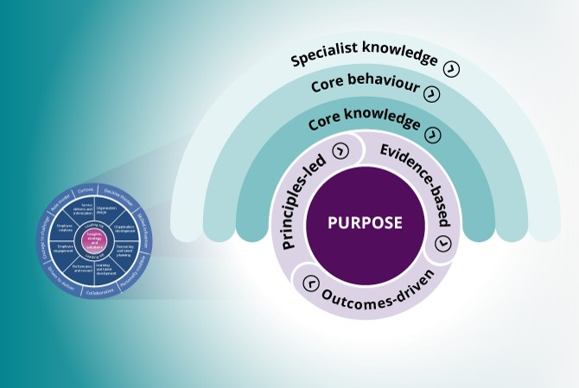

The 2013 Profession Map is however still relevant and predominantly still used by students of the CIPD. The 2013 Map takes a flexible approach as it can be adapted and used as an aid to develop HR professionals working across the HR spectrum, despite where they are in their HR journey and whether they are a generalist or a specialist. It can be used to help identify areas of personal strength or weakness. It can also be used by an organisation to diagnose areas of success and improvement; build capability; build a competency framework or development programme.

Figure 2
CIPD 2013 Profession Map
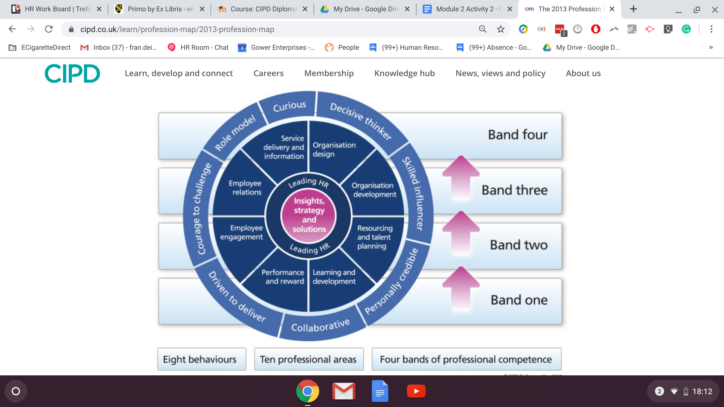

The 10 professional areas describe the knowledge and activities required for each area of expertise in order to be competent. The map revolves around 2 core professional areas; Insights, strategy and solutions; leading HR and 8 professional areas and works through four bands. Insights, strategy and solutions are the knowledge skills and behaviours required to understand your organisation in order to form strategy and solutions to meet business needs (Woodhams, Perkins and Wilkinson, p. 102). Leading HR focuses on the HR contribution and its role model leaders. The remaining 8 professional areas and their definitions are outlined in figure 3 (EV11).

Figure 3
CIPD Professional area definitions
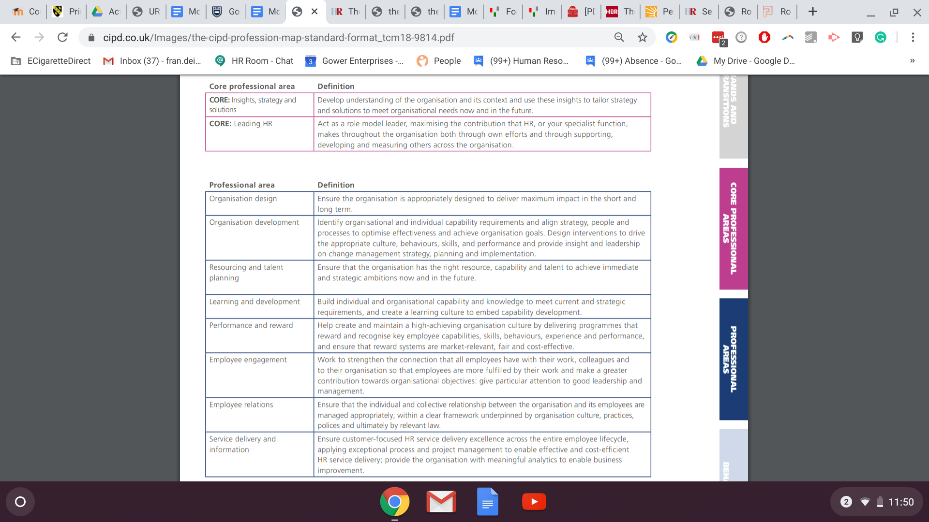
The map also describes eight fundamental behaviours that underpin good practice regardless of specialism. The behaviours are needed to carry out activities across the four bands of professional competence. The behaviours are:
- Curious-
The individual is curious, open minded and is always looking to the future, they seek positive change and ways to add value to the organisation.
- Decisive thinker-
A decisive thinker has the ability to understand and analyse data and information. They have the knowledge to identify options and make recommendations. An example of this would be an individual that makes a robust yet defendable decision based on their knowledge and understanding of the data.
- Skilled influencer-
Has the ability to influence to get the support required from colleagues or stakeholders in order to add value to an organisation. They work in pursuit of organisation value and success. A skilled influencer takes a friendly yet assertive approach yet are open, in order to create an atmosphere of trust (Johns and Perkins, 2016, p.85).
- Personally credible-
The individual builds and delivers professionalism through their HR expertise to bring value to the organisation. This is about individuals taking ownership of their CPD in order to continue to add value to their organisation.
- Collaborative-
To be collaborative the individual must work effectively and inclusively with a wide range of people. This applies to individuals inside and outside of their organisation.
- Driven to deliver-
The individual is determined and results-driven.
- Courage to challenge-
Shows confidence in challenging others despite experiencing resistance and or confrontation. A HR professional should server stakeholders and not adhere to power structures (Johns and Perkins, 2016 p71).
- Role model-
A role model leads by example and acts with integrity, whilst balancing various organisational and legal factors. A good role model has sound values and principles and acts consistently to uphold these in line with their organisation (CIPD, 2015). An example is a senior leader that is confident in their own ability and experience to mentor a person who is junior to them.
All of the above behaviours are essential for a HR professional to effectively carry out their role.

The four bands of the Profession Map outline the professional competence with clearly outlined transitions, which can be measured. It is a useful tool for those wishing to progress their HR career so it provides guidance on what they need to achieve in order to transition. Staring at Band 1, which is the start of an individuals HR career. At band 1 colleagues mainly support with administrative tasks, they often manage data and are very customer-focused.
Band 2 professionals have a clear understanding of HR issues and gives advice on HR issues on an individual or teams basis. They should be able to evaluate issues and provide effective solutions (Woodhams, Perkins and Wilkinson, 2016 p. 112).
The Band 3 professionals are usually HR Partners or consultants who address HR challenges in the medium or long term in an organisation.
Band 4 sees us at the senior leaders, they are responsible for delivering organisational strategy and often manage a specific professional area within an organisation. It is essential that they have a deep understanding of their industry and organisation.

Conclusion

In conclusion, I understand the need for Continuous Personal Development (CPD) and the strategies I can use to work on my personal development. The CIPD profession map can be used to highlight strengths and weaknesses and areas to focus on for development.

Recommendations

I recommend that all HR professionals use and regularly refer back to the CIPD profession map to taylor continuous personal development. I also recommend that the maps professional areas are considered within my organisation to underpin any projects, for example in the upcoming review of retail competencies.

References

CIPD. (2019) Explore the new Profession Map [online]. Available at https://peopleprofession.cipd.org/profession-map.

CIPD. (2015) The CIPD Profession Map – Our Professional Standards. Available at https://www.cipd.co.uk/Images/the-cipd-profession-map-standard-format_tcm18-9814.pdf.

Johns,T & Perkins, G. (2016) Developing Professional Practice, in Taylor, S. and Woodhams, C. (2016). Studying Human Resource Management. 2nd edn. London: CIPD.

Soanes, C and Hawker, S. (2006) Compact Oxford English Dictionary. Oxford: Oxford University Press.

Woodhams,C., Perkins, G. and Wilkinson, K. (2016) in Taylor, S. and Woodhams, C. (2016). Studying Human Resource Management. 2nd edn. London: CIPD.

Bibliography

CIPD. (2015) The CIPD Profession Map – Our Professional Standards. Available at https://www.cipd.co.uk/Images/the-cipd-profession-map-standard-format_tcm18-9814.pdf. [Accessed: 20 December 2019].

CIPD. (2019) Explore the new Profession Map [online]. Available at https://peopleprofession.cipd.org/profession-map [Accessed 20 December 2019].

CIPD. (2019) Setting professional standards [online]. Available at
https://www.cipd.co.uk/about/what-we-do/professional-standards [Accessed 20 December 2019].

Roper, J. (2019) The face of HR influence [online]. Available at https://www.hrmagazine.co.uk/article-details/the-face-of-hr-influence [Accessed 03 January 2020].
Soanes, C. and Hawker, S. (2006) Compact Oxford English Dictionary. Oxford: Oxford University Press.

Taylor, S. and Woodhams, C. (2016) Human Resource Management: People and Organisations. 2nd edn. London: CIPD.

Taylor, S. and Woodhams, C. (2016) Studying Human Resource Management. 2nd edn. London: CIPD.

Sparrow, S. (2013) Five HR skills to get you noticed [online]. Available at https://jobs.personneltoday.com/article/-five-hr-skills-to-get-you-noticed/ [Accessed 04 January 2020].

Activity 4
Be able to work collaboratively with others, as a member of a team or working group

Executive Summary

This report provides information on teams and their dynamics as well as detailing the importance of team work. I will discuss the theories behind the stages in team formation and team development.
Finally defining and evaluating political behaviour in order to distinguish whether it can ever benefit an organisation. Recommendations will include using the theories of team models and development when forming or leading a team.

Introduction

In order to be able to work collaboratively with others as a member of a team demonstrate I need to develop my understanding of team dynamics, behaviours and roles within teams. This will aid in the development of my skills to e This ties in with the developing professional practice in human resources unit of the CIPD level 5 award.

Teamworking

Teams are a naturally occurring phenomenon in all organisations so there is a big focus on building having or building best teams. HR professionals must work with others within the HR function and with others from different backgrounds (Johns & Perkins, 2016, p.83), therefore strong team working skills are essential. Teams and groups are found in organisations and their individuals have a social interaction in order to work towards a common goal (Watson, 2014, p.209). The two terms tend to be mutually used, however, there are both differences and similarities between them. Teamwork requires a leader able to develop a vision within the team and to utilise individual talents to achieve a goal or outcome (Giddings and Williamson, 2007, p.10). Other than working towards a common goal, effective teams tend to have certain characteristics, these include, diversity of its members, good communication, trust and respect.
A study based on cardiac surgical teams (Giddings and Williamson, 200) focused on their leadership and behaviours in order to support teamwork and found that effective team working and communication was key to patient care.

According to Belbin (2019) there 9 ‘team roles’, a successful team needs all 9 of the team role behaviours. Individuals may have more than one ‘team role’ that they identify with as a result of their personality or requirements of a team. Each role has its strengths and weaknesses outlined (see figure 1) but not every role may be required all of the time or at each stage of team development. Organisations can use the Belbin model and tests, that are available, to build a strong team or improve pre-existing teams. Based on my Belbin team type questionnaire (EV29) my primary team role is the Team worker and my secondary role is the Implementor.

Figure 1
Belbin Team Roles
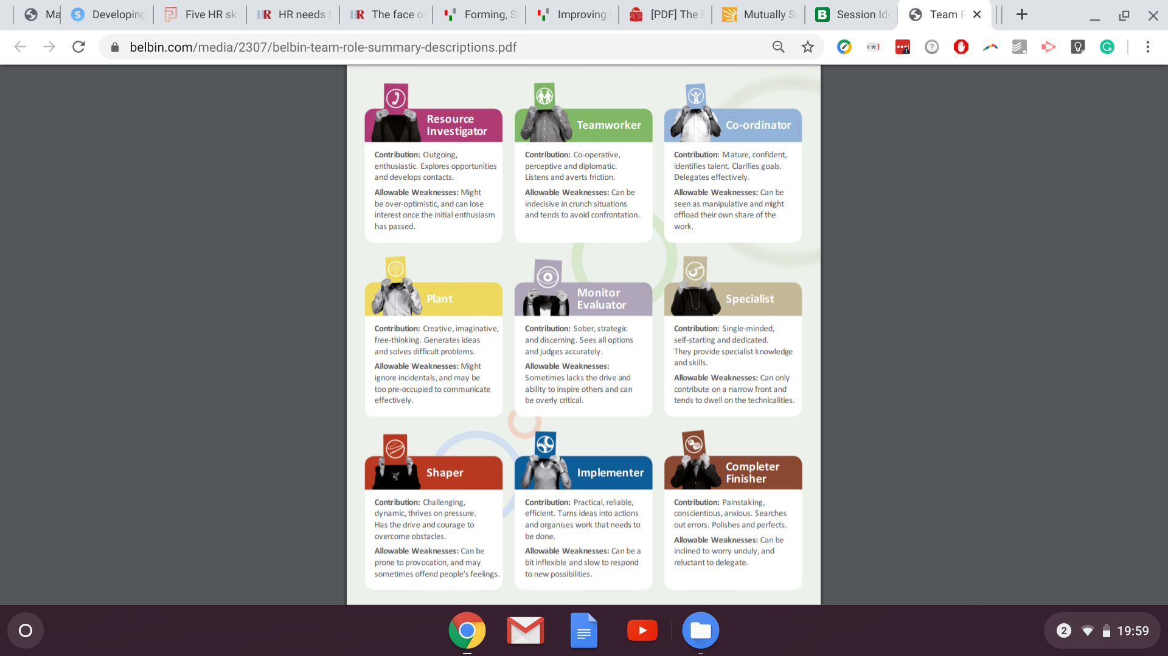

Team Dynamics

Group or team dynamics refers to the psychological or behavioural characteristics of a social group and looks at how groups form, their structure, roles, behaviours and how they function.
When a team has a positive dynamic, its members are creative and productive. In comparison, a team with poor group dynamics can encounter people's behaviour causing disruption to the task at hand. Diversity is important when building an effective team. If a team is just made up of similar individuals communication and collaboration are a positive outcome, however, with like minded individuals there is likely to be very little conflict. Little or no conflict can lead to a lack of creative thinking, whereas if there is too much conflict a team can become demotivated, disruptive and unproductive. Teams with no direction or clear objectives can develop poor dynamics, as members can struggle to understand their role in the group therefore it is important to define objectives an roles from the outset. Both leaders and team members can contribute to a negative team dynamic (Mindtools, no date).

Team Development

Tuckman's group stage theory has five stages of group development. Members of the group need to focus on issues through these stages in order to be successful in completing its objectives.
- Forming.
At this stage the team members are beginning to get to know each other and start to understand the reasons for the teams existence. They are yet to understand the nature of the project or task, the roles and major goals. Transparency and trust at this stage must be developed in order for success at later stages. Leaders at this stage should make clear the teams objectives.
- Storming.
In this stage, the team will probably experience a level of conflict as differences in views and opinions can occur. If conflict can not be effectively resolved the team will not be successful and will not, advance to the other stages.
- Norming.
Here the team recognises differences and sets out expectations and standards and agrees on goals and how to achieve them. Role and responsibilities should be shared and the team should be cooperating well. Here leaders need to keep the team focused.
- Performing.
By the performing stage the team will have matured and developed and will begin to achieve the goals set. An effective leader will monitor but not interfere with the team’s performance, except to offer praise as milestones are reached.
- Adjourning or mourning.
The final stage which was not included in Truckman’s original model relates to the completion of the project and often the disbanding of the group. Team members may experience sadness or relief in this last stage. This is the time to celebrate achievements.
Truckman’s’ theory can be used and adapted to suit developing a team within an organisation.

Organisational Politics

Politics is defined as “the political beliefs of a person or organisation;…..activities aimed at gaining power within an organisation: office politics” (Soanes and Hawker, 2006, p.787).
Armstrong (2016, p. 339) believes that political behaviour is inevitable in organisations. Managers need to be aware of political behaviour and drive it towards a common goal. Organisational politics can involve both desirable and undesirable behaviours used to achieve outcomes by either a group or individual. Political behaviour can be used to overtly or covertly to influence people to their way of thinking. This approach can be reasonably used, provided the organisation agrees that the end result is justifiable. For example, a project manager needs to meet a fast approaching deadline and may use their position and influence on their team to ensure the project is completed on time.

Political behaviour can include influencing, the “key elements are that influence is about getting the results with some degree of acceptance or co-operation.” (Yemm, 2008, p.22).
There are various approaches to influencing others, Yemm (2008) also states that there are 7 behaviours of an effective influencer; Friendliness, Empowerment, Visioning, Building alliances, Expertise and knowledge, Bargaining and Positioning. One or a combination of these can be used depending on the outcome you require. From personal experience, having been aware of and experienced colleagues using political behaviour has resulted in them competing within a project and actually meant that the work produced by both parties was of excellent quality, was able to be merged and was completed on time. However political behaviour can be deemed unhealthy and can cause breakdowns in relationships between individuals and departments.
Conclusion

A good team that works well together is the key to success in an organisation. It is important for leaders to know their teams and communicate effectively with them. Political behaviour can be acceptable and beneficial in an organisation if managed properly.

Recommendations

Having an understanding of the various models using the theories of team models and development when forming or leading a team. HR professionals and managers need to be aware of organisational politics and manage it properly.

References

Armstrong, M. (2016) Armstrong's handbook of management and leadership for HR : developing effective people skills for better leadership and management. 4th edn. London: Kogan Page.

Giddings, A.E.B and Williamson, C. (2007) The Leadership and Management of Surgical Teams. London: The Royal College Of Surgeons Of England.

Johns,T & Perkins, G. (2016) Developing Professional Practice, in Taylor, S. and Woodhams, C. (2016). Studying Human Resource Management. 2nd edn. London: CIPD.

Mindtools. (no date) Improving Group Dynamics: Helping Your Team Work More Effectively. Available at https://www.mindtools.com/pages/article/improving-group-dynamics.htm. [Accessed: 01 January 2020]

Soanes, C and Hawker, S. (2006) Compact Oxford English Dictionary. Oxford: Oxford University Press.

Watson, G. and Ressner, S. (2014) Developing skills for business leadership. London: CIPD.

Yemm, G. (2008) Influencing others - a key skill for all, in Management Services. Available at https://search-proquest-com.ezproxy.uwtsd.ac.uk/docview/234318040/fulltextPDF/7ADC61D8C7774EE4PQ/1?accountid=130472. [Accessed: 02 January 2020].

Bibliography

Armstrong, M. (2016) Armstrong's handbook of management and leadership for HR : developing effective people skills for better leadership and management. 4th edn. London: Kogan Page.

Belbin, R.M. (2010) Team Roles at Work. 2nd edn. Oxford: Elsevier Ltd.

Belbin. (2020) Belbin team roles. Available at https://www.belbin.com/about/belbin-team-roles/ [Accessed: 01 January 2020].

Giddings, A.E.B and Williamson, C. (2007) The Leadership and Management of Surgical Teams. London: The Royal College Of Surgeons Of England.

Jarrett, M. (2017) The 4 Types of Organisational Politics. Harvard Business Review. Available at https://hbr.org/2017/04/the-4-types-of-organizational-politics?autocomplete=true [Accessed 03 January 2020]

Lewin, K. (1947) Frontiers in group dynamics. Available at https://journals.sagepub.com/doi/pdf/10.1177/001872674700100103 [Accessed: 01 January 2020].

Mindtools. (no date) Improving Group Dynamics: Helping Your Team Work More Effectively. Available at https://www.mindtools.com/pages/article/improving-group-dynamics.htm. [Accessed: 01 January 2020]

Mindtools. (no date) Forming, Storming, Norming, and Performing: Understanding the Stages of Team Formation. Available at https://www.mindtools.com/pages/article/newLDR_86.htm [Accessed: 01 January 2020]

Soanes, C and Hawker, S. (2006) Compact Oxford English Dictionary. Oxford: Oxford University Press.

Stone, J.L, Aveling, E, et al. (2017) Effective Leadership of Surgical Teams: A Mixed Methods Study of Surgeon Behaviors and Functions, in The Annals of Thoratic Surgery. Available at https://www.annalsthoracicsurgery.org/article/S0003-4975(17)30065-6/fulltext. [Accessed 02 January 2020]

Taylor, S. and Woodhams, C. (2016) Studying Human Resource Management. 2nd edn. London: CIPD.

Watson, G. and Ressner, S. (2014) Developing skills for business leadership. London: CIPD.

Yemm, G. (2008) Influencing others - a key skill for all. in Management Services. Available at https://search-proquest-com.ezproxy.uwtsd.ac.uk/docview/234318040/fulltextPDF/7ADC61D8C7774EE4PQ/1?accountid=130472. [Accessed: 02 January 2020].

