Name: Lee Thomas

Student ID: 1804249

Module Course and Number: Research in Context ADAD5003

Lecturer: Louise Burston

Question: From the MESSAGE, MEDIUM, CONTEXT research strand
lectures, choose a theme, movement, or selection of artists or designers that relate to your practice or interests, and construct a 2,500-word essay. Critically assess primary themes, key writers, and relevant practitioners.

Word Count: 2729

From the MESSAGE, MEDIUM, CONTEXT research strand
lectures, choose a theme, movement, or selection of artists or designers that relate to your practice or interests, and construct a 2,500-word essay. Critically assess primary themes, key writers, and relevant practitioners.

When Sigmund Freud first began to release his theories on the subconscious and conscious mind in the early 20th century, they had a huge effect on the world of psychology as well as the artistic world. Freud argued that a lot of what happens to us from an early age gets relegated to the subconscious mind, so unlocking this subconscious by studying our dreaming would lead to us harnessing the full power of our imagination. He called it ‘psychoanalysis’. Freud encapsulated this idea in his famous quote - “Dreams are the royal road to the unconscious.” (Freud, S. (1899) The Interpretation of Dreams) - It was this idea that would kick start the Surrealist genre. Freud first began to question the psychological causes of physical effects after witnessing Jean Charcot and his hypnotist act. He noted that by affecting the subconscious mind you could convince the body to react physically. (Freud, Jonathan Lear, p27). He took this theory forward whilst working with patients with significant mental afflictions. Finding it difficult to create a dialogue with his patients he began to look to the unconscious motivations. Psychoanalysis was not a new idea however, philosophers like Nietzsche spoke about the subconscious mind. He argued that the majority of mental states are unconscious (Paul Katsafanas, Nietzsche’s Theory of Mind: Consciousness and Conceptualization) ‘Man, like every living being, thinks continually without knowing it’ (Nietzsche, The Gay Science, Vintage, 1974). Although Nietzsche and many other philosophers spoke about the Unconscious mind, it was Freud who began to conduct studies into this and create a series of books backed by scientific research that would influence the world.
Artists would begin looking to dreams and expressing them in their art, allowing them to create deeper meaning and analysis in their work. Andre Breton was one of the first major surrealist artists, publishing the Surrealist Manifesto in 1924 where he described surrealism as ‘Pure Psychic Automatism’ (https://www.tate.org.uk/art/artists/andre-breton-807). This is where Surrealism really began to take off, especially in Paris, becoming a philosophical and cultural movement. (Craven, J; https://www.thoughtco.com/what-is-surrealism-183312)
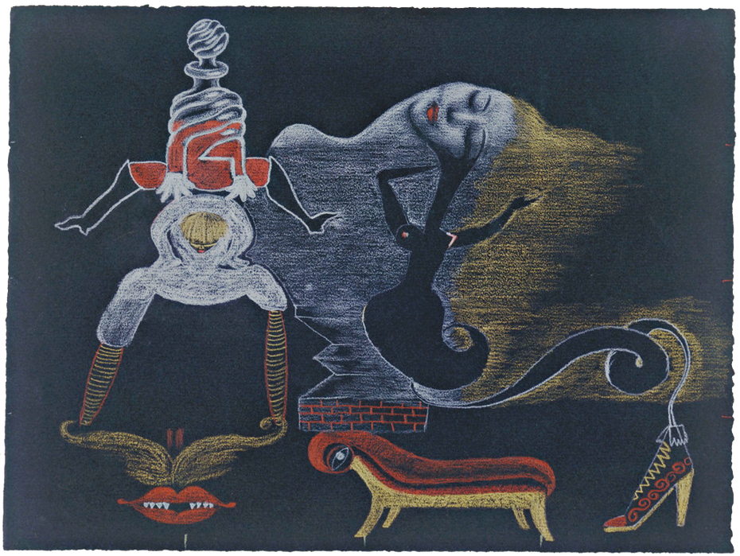
Andre Breton, Exquisite Corpse, 1933
‘The word ‘surrealist’ (suggesting ‘beyond reality’) was coined by the French avant-garde poet Guillaume Apollinaire in a play written in 1903. But it was André Breton, leader of a new grouping of poets and artists in Paris, who, in his Surrealist Manifesto (1924) defined surrealism as: pure psychic automatism, by which one proposes to express, either verbally, in writing, or by any other manner, the real functioning of thought. Dictation of thought in the absence of all control exercised by reason, outside of all aesthetic and moral preoccupation.’ (https://www.tate.org.uk/art/art-terms/s/surrealism)

This acceleration of the surrealist art movement was also partly because of the timing of these ideas, the chaos and misery of the First World War was occurring at this time and artists wanted to break from tradition and explore new ways to express themselves. Breton was working in a hospital during the first world war and became fascinated with the soldiers experiencing shell shock, which led him to an interest in psychoanalysis. (Fiona Loughnane, What Is Surrealism?, p10) Before Surrealism, a lot of art replicated the world around us, taught us lessons about the world or contained biblical themes, but surrealism began the idea of expressing your own self by looking into your psyche, an element of art that still persists to this day. It could be argued that belief in religion was beginning to decline in the early 20th century (Thomas William Heyck, (1996) The Decline of Christianity in Twentieth-Century Britain) and as the art world had been predominantly based in religion and religious expression that surrealism began to fill the void. People began to look within themselves and question reality and this gave artists a whole new perspective on the world, as well as a freer and more playful attitude towards artistic expression that artists like Breton championed.
At first, Surrealism was a literary movement. Poets like Paul Eluard (1895 – 1952) and Louis Aragon (1897 – 1982) practised automatic writing, to exercise their imaginations. Visual artists in the Surrealism movement began creating drawing games and a variety of experimental techniques.
‘For example, in a method known as decalcomania, artists splashed paint on to paper, then rubbed the surface to create patterns. Similarly, bulletism involved shooting ink onto a surface, and éclaboussure involved spattering liquid onto a painted surface that was then sponged. Odd and often humorous assemblages of found objects became a popular way to create juxtapositions that challenged preconceptions.’ (Craven, J, https://www.thoughtco.com/what-is-surrealism-183312).
These techniques relied on not overthinking what the artists were doing but instead allowing the subconscious to take over and drive the artistic expression. For example, splashing colour onto a canvas through expressive marks, one can stand back and look at what has been created, and then the subconscious mind will then piece together what it thinks it looks like, revealing something from our imagination that we ourselves may not have even been aware of. This means that each person looking at this art will see something different depending on how their individual minds analyse the artwork. This created a new dynamic between the artist and audience, revolutionising the idea of what art could do and mean. Art itself became a means of psychoanalysis.

Surrealist art did exist before this however, it just did not have a name. William Blake died in 1827 (https://www.tate.org.uk/art/artists/william-blake-39) long before Surrealism had a title, but his paintings often had surrealist themes to them. He embraced his imagination calling it "the body of God" or "human existence itself", and his work could be considered as bridging the gap between the Romantic period of the 19th century and the surrealist movement in the 20th century.

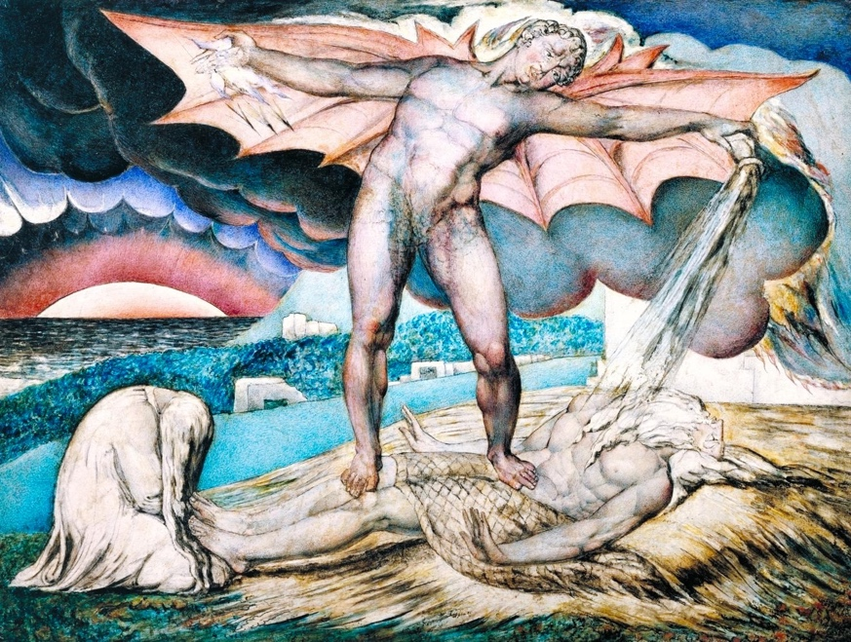
William Blake, Satan Smiting Job With Sore Boils, 1826

Giorgio de Chirico (1888-1978) founded the ‘scuola metafisica’ art movement, which greatly influenced the surrealist movement. His most well-known works feature illogical perspective and street scenes with a hallucinatory quality and could be argued as one of the earliest examples of surrealism. (Dupêcher, N (2017) https://www.moma.org/artists/1106) It would be Chirico’s paintings that would first go on to be described as ‘metaphysical’. In 1917 Chirico met Carlo Carra. They had both been wounded in the first world war and worked on paintings together while in hospital. As with Breton, both Carra and Chirico liked the freedom of expression that came with surrealism and can be cited as the first artists of the surrealism movement as we know it today. (Cowling, Elizabeth; Mundy, Jennifer (1990). On Classic Ground: Picasso, Léger, de Chirico and the New Classicism 1910–1930, p. 52.)

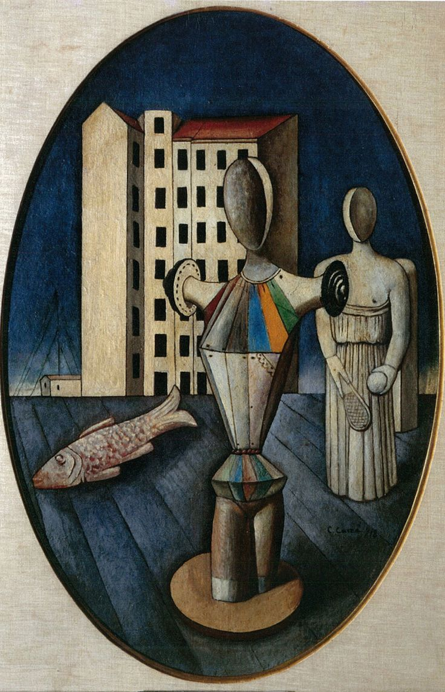

Carlo Carra, 1918, The Oval of Apparition

Dadaism was another artistic movement, that, combined with Freuds take on the unconscious mind, influenced the surrealist movement. Dadaism was also a reaction to the horrors of the first World War.
‘For us in Cologne in 1919, Dada was first of all a mental attitude . . . Our aim was total subversion. A ghastly and senseless war had cheated us out of five years of our lives. We had seen all that had been held up to us as good, beautiful and true, topple into an abyss of ridicule and shame. The work I produced in those days was not meant to please, but to make people scream’ (Schneede, E; Max Ernst, 1972)
Artists at the time wanted to break from tradition and offer a new way forward. The Dada movement first began in Zurich in the mid-1910s, invented by refugee artists and intellectuals from Europe. They ‘used absurdity as an offensive weapon against the ruling elite, whom they saw as contributing to the war.’ (Esaak, S (2019) https://www.thoughtco.com/what-is-dada-182380). The movement of Dadaism had a few basic principles. Spontaneity was a key element of Dada art, as it championed the individual and went against the oppressive rules of the system at the time. You can see how this idea would lead onto surrealist practices like Automatism. Dadaism could often be described as colourful, absurd and ‘silly’ which was a direct parallel to the harsh reality of the first world war. Marcel Duchamp (1887 – 1968) was a prominent Dada artist, although he distanced himself from the title. He disregarded a lot of art at the time as simply ‘pleasing to the eye’ and wanted his work to be ‘pleasing to the mind’. Duchamp would often employ non-conventional methods to his work –
‘To make one of his favourite pieces, 3 Standard Stoppages (3 stoppages étalon), he dropped three 1-meter lengths of thread onto prepared canvases, one at a time, from a height of 1 meter. The threads landed in three random undulating positions. He varnished them into place on the blue-black canvas strips and attached them to glass. He then cut three wood slats into the shapes of the curved strings, and put all the pieces into a croquet box.’ (https://en.wikipedia.org/wiki/Marcel_Duchamp#cite_note-10).
This feeling of free expression and experimental artistic techniques would go on to influence surrealism.

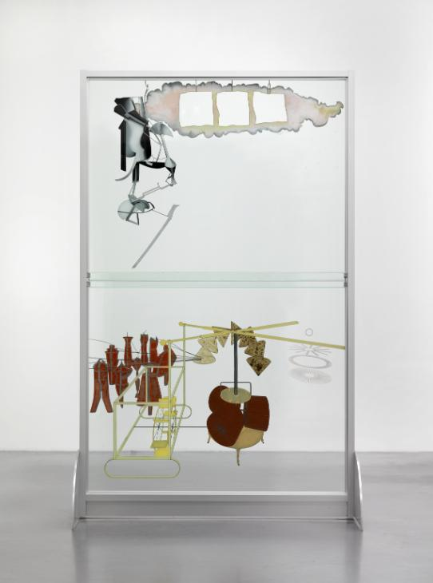
Marcel Duchamp, The Bride Stripped Bare by her Bachelors, Even (The Large Glass), 1915

Surrealism would eventually evolve, championed again by Breton, into a more dreamlike and illustrative art style. Breton published an article in 1928 called ‘La Revolution Surrealiste’ (Fiona Loughnane, What Is Surrealism?) that called for more polished illustrative art, which would eventually be completed by the likes of Salvador Dali. Salvador Dali became famous for his artwork and his equally surreal personality. He once said, “the difference between me and the surrealists, is that I am a surrealist”. (https://www.thedaliuniverse.com/en/salvador-dali) and is still one of the most famous surrealist artists. In 1929, Dali moved from Spain to Paris, the centre of Surrealism and began to expand on the dream imagery many artists started creating. He took a lot of his theory from Freud, including the painting ‘In The Accomodations of Desire’ (1929), which included ants to symbolize his powerful sexual desires. His work became very commercial and was crucial in surrealism reaching a wider audience. Dali’s painting ‘The Spectre of Sex Appeal’ was a famous example of this more dreamlike and polished approach to surrealism that also spoke of Freuds work on the Oedipus Complex, the theory that children all have an unconscious desire for the opposite sex parent and a feeling of competition for these affections with the same sex parent. (Freud, S. 1899, Interpretation of Dreams). This painting is a good example of Surrealists focusing on unconscious desires/the unconscious mind rather than the external world.

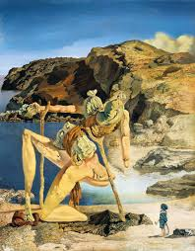
The Spectre of Sex Appeal, Salvador Dali, 1934

Another very famous artist that contributed to Surrealism was Pablo Picasso. He was close with Breton at the birth of Surrealism, who declared Picasso ‘one of ours’ in the “Revolution Surrealiste’ (https://www.pablopicasso.org/classicism.jsp) He has been attributed to a quote that greatly sums up Surrealism succinctly - “I paint objects as I think them, not as I see them”. (https://www.pablo-ruiz-picasso.net/period-surrealism.php)
His work ‘The Bathers’ has been described as Surrealist, as it features human bodies that were considered grotesque but represented a departure from rational thought to more chaotic thought, a principle of the Surrealist movement.

Another principle of Freuds theories that forged the principles of Surrealism is the idea that death is a more powerful motivating factor than any desire, and so, a lot of Surrealist artwork contained images of death and violence. As sex is another large part of Freuds theories and the artwork of Surrealism, a lot of early artwork contained violent images of women in sexual situations. Because of this it could be seen as a predominantly male expression in the beginning (What Is Surrealism?, Fiona Loughnane). However, Surrealism at the time had a fascination with the rules of gender, and this attracted a lot of female artists to the movement. They saw Surrealism as a way to express their own sexuality and gender identity. Frida Kahlo is still a well-known name who became involved in the early days of Surrealism. Early on in her life she was hospitalized for many months and began to create self-portraits. (https://sites.psu.edu/unspokenartists/2015/11/20/frida-kahlo-surrealism/) She was politically active and grew attracted to the Surrealist movement. She was also bisexual, having affairs with both men and women, so the open minded and curious approach to gender and sexuality Surrealism adopted would have been interesting to her. Andre Breton, a famous Surrealist artist admired her work and called her a Surrealist, though many argued she was strictly a Realist. The rise of feminism over the past 100 years has also brought more artists to the Surrealist movement. Penny Slinger is a modern-day artist creating surreal artwork, who believes that Surrealism is timeless, said - “As Surrealism does not conform to rational paradigms, it is uniquely suited to express the intuitive, feminine realms. As this is the time of the rise of the feminine, the surrealist mode is a good choice for 2019.” (Cohen, A (2019) https://www.artsy.net/article/artsy-editorial-artists-putting-contemporary-spin-surrealism).

Today, many Surrealist artists still look to theories of the mind but that doesn’t stop with Freud. Julie Curtiss creates Surreal artwork based on Carl Jung’s work on Archetypes – the idea that there are universal ‘patterns of thinking and classification’ (Cohen, A (2019) https://www.artsy.net/article/artsy-editorial-artists-putting-contemporary-spin-surrealism). Although she describes herself as a Surrealist she says she stand apart from her peers as she states - “It seems to me the Surrealists were more interested in the power of the unconscious to deconstruct,” she offered, “while I am interested in its power to construct.”

Surrealism is also popular with film directors, who create surreal scenes in their movies often depicting ideas of the subconscious mind. Surrealist cinema began in France in the 1920s, using shocking or absurd imagery, many of it rooted in Freud dream symbolism. When Surrealism formally began in the 1920s, movies were becoming a part of everyday life and access to equipment and funding was easier, so it is no wonder Surrealism became one of the first genres of film. David Lynch is a popular director who employs these methods. His movie Blue Velvet (1986) contains many dreamlike scenes, many of which draw inspiration from Salvador Dali the early Surrealist film, Un Chien Andalou (1929). In this film there is a scene where a palm erupts with a handful of ants, linking back to Salvador Dali’s use of ants as a symbol for powerful sexual desire. David Lynch is a keen practitioner of Transcendental Meditation, a form of meditation that relies on breathing techniques and mantras to become more connected the unconscious mind. His use of this technique may be key in helping him connect to his unconscious mind and translate that into his films.

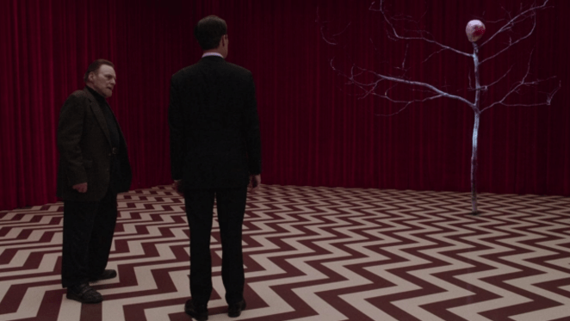
Twin Peaks: The Return, David Lynch, 2017

These days, Surrealist artwork is still popular as a genre, but the movement is not so collected as it was in the early 1900s. The main difference between todays Surrealist and the ones that created the movement, is that there used to be a shared aim or political point to Surrealism. Many of the artists were friends and spent time together, working on manifestos that showcased their principles and aims with their artwork. Today, there is a lot of artists that work for commercial gain or self-expression. However, one artist I came across while researching is Jonathan Meese. He creates chaotic, surreal imagery with anarchic themes. He says that “To fight against reality is one of the most needed tasks and issues of art,” Art destroys all politics. Surrealism is the land of total power.” (Cohen, A; (2019) https://www.artsy.net/article/artsy-editorial-artists-putting-contemporary-spin-surrealism)
With our current political climate in the UK and overseas like the current situations in Hong Kong, North Korea and Donald Trump in the USA, it seems apt for a rise once again in politically motivated surrealist works. Surrealist artists should join together and work as a force to speak against these often-brutal modern regimes.
James Jean is my favourite artist and could be classified as a modern-day Surrealist artist. He creates soft yet colourful, psychedelic dreamlike imagery that is rooted in psychoanalysis. In a recent interview he describes his inspiration as ‘unlocking the imagery that lies deep in the recesses of my mind.’ (https://www.maharam.com/stories/in-conversation-james-jean)
His work often has a hallucinatory aspect that reminds me of a fever dream, with wavy lines and hazy colour, and fantastical creatures. He is a very popular artist, having worked for the likes of Prada and Rolling Stone, Dc Comics and Atlanta Records, proving that there is still a thirst for Surrealist artists today.
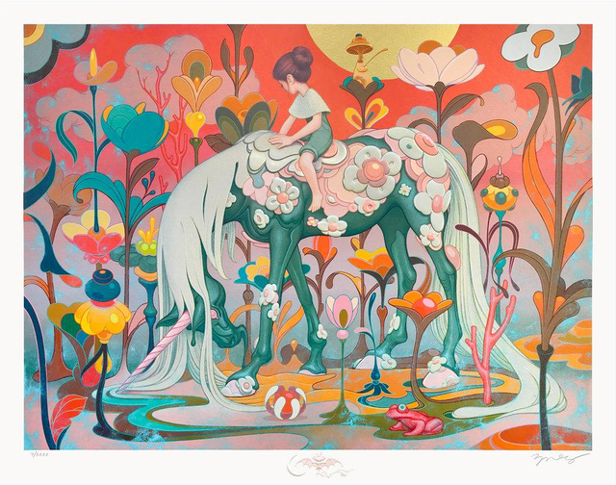
James Jean, Traveler, 2018

Bibliography

Budds, Diane; https://www.fastcompany.com/3068823/surrealism-is-back
Cohen, Alina; https://www.artsy.net/article/artsy-editorial-artists-putting-contemporary-spin-surrealism
Craven, Jackie; https://www.thoughtco.com/what-is-surrealism-183312
Dupêcher, Natalie; https://www.moma.org/artists/1106
Esaak, Shelley; https://www.thoughtco.com/what-is-dada-182380
https://www.tate.org.uk/art/artists/william-blake-39
https://www.maharam.com/stories/in-conversation-james-jean
https://www.tate.org.uk/art/art-terms/s/surrealism
https://www.tate.org.uk/art/artists/andre-breton-807
https://www.thedaliuniverse.com/en/salvador-dali
https://sites.psu.edu/unspokenartists/2015/11/20/frida-kahlo-surrealism/
https://www.pablo-ruiz-picasso.net/period-surrealism.php
https://www.pablopicasso.org/classicism.jsp
https://en.wikipedia.org/wiki/Marcel_Duchamp#cite_note-10

Cowling, Elizabeth; Mundy, Jennifer (1990). On Classic Ground: Picasso, Léger, de Chirico and the New Classicism 1910–1930, p. 52.)
Freud, S (1899). The Interpretation of Dreams, Basic Books
Heyck, Thomas William (2006). The Decline of Christianity in Twentieth-Century Britain,
Katsafanas, Paul (2005). Nietzsche’s Theory of Mind: Consciousness and Conceptualization, Blackwell Publishing Ltd
Lear, Jonathan (2015). Freud, p27, Routledge
Loughnane, Fiona. What Is Surrealism?, p10
Nietzsche, F. (1974). The Gay Science, Vintage
Schneede, Uwe (1972). Max Ernst, Oxford University Press

