Critically Assessing the Multi-Agency Approach to Safeguarding Children and Young People in Wales: Benefits, Limitations, and Future Considerations
The safeguarding of children and young people is a concern for societies worldwide, with Wales being a progressive nation in regard to child protection, being one of two countries in the United Kingdom to have a blanket ban on all types of physical punishment against children (Welsh Government, 2022a). Due to the complex safeguarding needs of many children across Wales, the Government have encouraged a Multi-Agency approach to dealing with safeguarding concerns. This essay embarks on a critical examination of the Multi-Agency approach within the context of safeguarding children and young people in Wales, covering the legislative framework, best practices, and the roles of safeguarding agencies, and how the evolution of society is creating further complex issues in safeguarding children, particularly concerning internet safety. It is key that Multi-Agency teams are up to date with technology and social media trends, due to the drastic effect the use of the internet has on young people’s mental health (UK Parliament, 2019).

While everyone is responsible for the safeguarding of children and young people, there are many designated safeguarding groups in Wales, specialising in protecting and promoting the welfare of children and young people across different aspects of health, social care and education. Local authorities have legal responsibilities for child protection and orchestrate multi-agency teams within their regions. Social services departments are often seen as the main player in safeguarding interventions, conducting assessments, providing support services, and initiating legal proceedings when necessary (WJEC, 2019). Healthcare providers, including primary care teams, hospitals, and mental health services, also have a duty to safeguard children and young people. They play a crucial role in identifying and responding to signs of abuse or neglect, providing medical assessments, and coordinating referrals to other agencies (Chambers, Cantrell, and Booth, 2021). Law enforcement agencies, such as the police, are integral to safeguarding efforts, particularly in cases of criminal exploitation, trafficking, or online abuse. Their role involves investigating allegations of abuse, gathering evidence, and ensuring the safety of children and young people at risk (Sharpling, 2015). Education professionals, including teachers, teaching assistants, school counsellors, and educational psychologists, are in a better position to build positive relationships, allowing them to identify safeguarding concerns and provide support to vulnerable children and families. They work closely with other agencies to implement safeguarding policies, and create safe and inclusive learning environments (Welsh Government, 2022b)

The Multi-Agency approach in Wales is a collaborative effort, including social services, healthcare providers, law enforcement agencies, and educational institutions (Welsh Government, 2023a). Education settings, particularly Pupil Referral Units (PRUs) work closely with a large team of professional in order to organise the correct package of support for young people. Some of the main services used are youth justice service, Team Around the Family (TAF), Youth Workers, Children and Adolescent Mental Health Services (CAMHs), Choice’s substance misuse advice and harm prevention services (Welsh Government, 2017). This approach offers numerous benefits, such as enhanced collaboration, comprehensive assessments, and tailored interventions. It enables a holistic understanding of a child's circumstances and needs, leading to more effective safeguarding measures, (Munro, 2011). However, challenges such as information sharing constraints, fragmented communication, and resource limitations hinder its full potential. Overcoming these challenges requires collaborative efforts to streamline processes, allocate adequate resources, and foster a culture of trust and cooperation (Bilson, 2022). There have been several instances in recent years where Multi-Agency Teams have collectively let children and young people down, leading to the death of a child due to documented abuse that wasn’t effectively dealt with. The Cases of Star Hobson and Arthur Labinjo-Hughes showed the importance of paper trails, and an airtight reporting system among Multi-Agency teams, with both children falling victims to abuse, partly due to the bystander effect, of individuals within the Multi-Agency, presuming that another individual was following up or investigating particular safeguarding concerns (UK Government, 2022). When Multi-Agency teams are working well together, they are able to build a fuller picture of the suspected abuse or neglect, even without a full disclosure. Working with other agencies, with effective communication and information sharing, allows a range of agencies to come together and piece together missing puzzle pieces, one agency could be holding onto the missing piece that gives enough information for a Multi-Agency Referral Form (MARF) to be submitted (HM Government, 2023). Wales has a robust legislative framework aimed at safeguarding children and young people. The Social Services and Well-being (Wales) Act 2014, Children Act 2004, and the Education Act 2002 are among the key pieces of legislation that underpin child protection efforts. These laws mandate local authorities to work in collaboration with partner agencies to safeguard and promote the welfare of children. Additionally, statutory guidance, such as "Working Together to Safeguard Children," provides a framework for effective multi-agency working and sets out best practices for safeguarding professionals (NSPCC, 2024a).

Best practices in Wales emphasise early intervention, prevention, and a child-centred approach. Multi-agency safeguarding hubs (MASH) serve as centralised points for professionals to share information, conduct assessments, and coordinate interventions. Furthermore, robust training programs ensure that professionals across sectors have the necessary skills and knowledge to identify and respond to safeguarding concerns effectively. Collaborative working arrangements, such as Local Safeguarding Children Boards (LSCBs) and Regional Safeguarding Children Boards (RSCBs), facilitate partnership working and oversight of safeguarding practices at the local and regional levels (Welsh Government, 2017). The best practices in Wales for safeguarding children link with both Bronfenbrenner's (1979) ecological systems theory (See Appendix 1) and the principles of the Future Generations (Wales) Act, (2015) (See Appendix 2) recognising the intricate relationship between environmental factors and the long-term well-being of children and future generations. The Welsh Government NEST Framework, is ensuring a whole community approach to mental health and wellbeing in children and young people, claiming that “it is easier to build strong children, than to repair broken men” (Welsh Government, 2023b). Bronfenbrenner's theory emphasises how diverse environmental factors, from immediate family dynamics to broader societal contexts, shape a child's development (Guy-Evans, 2024). Within the microsystem, Wales's emphasis on early intervention, prevention, and a child-centred approach highlights the critical role of immediate environments in nurturing a child's well-being. This aligns with Welsh Government’s promise to consider the longer-term impact of decisions on future generations, acknowledging that investments in children's development today lay the foundation for a sustainable and prosperous society in the future (Welsh Government, 2023c). Moving to the mesosystem level, multi-agency safeguarding hubs (MASH) demonstrate collaboration among professionals from various sectors, mirroring the interconnectedness of microsystems emphasised by Bronfenbrenner. Through MASH, information sharing, and intervention coordination are streamlined, promoting a holistic approach to child protection that considers the complex interactions between different environments. This collaborative effort not only safeguards children in the present but also contributes to building resilient communities capable of supporting future generations, in line with the Governments objective of promoting the well-being of future generations (Welsh Government, 2014). At the exosystem level, robust training programs ensure that professionals possess the necessary skills to address safeguarding concerns effectively, reflecting the influence of external environments on professionals' abilities to fulfil their responsibilities. By equipping practitioners with the expertise needed to navigate complex systems, these programs support the development of a competent workforce dedicated to safeguarding children and promoting their long-term well-being, aligning with the Governments focus on capacity-building for sustainable outcomes (Rose, 2024). Finally, at the macrosystem level, collaborative arrangements such as Local and Regional Safeguarding Children Boards oversee and promote effective safeguarding practices at broader societal levels. These boards facilitate partnership working and policy development, ensuring that safeguarding initiatives are informed by local needs while adhering to national standards. By fostering a culture of accountability and shared responsibility, these arrangements contribute to the creation of a supportive and protective environment for children across Wales, consistent with the Governments principles of intergenerational equity and responsibility (CYSUR, 2016).

Safeguarding agencies in Wales encounter significant challenges that affect their ability to protect and promote the welfare of children and young people effectively. One major obstacle is the restriction of limited resources, which can hinder their capacity to provide holistic support. Budgetary limitations often result in understaffing and high caseloads, placing immense strain on frontline workers and compromising the quality and suitability of services, with almost two thirds of young people’s mental health referrals, not being acknowledge by CAMHs within 4 week’s (Peskett, 2022). Additionally, Multi-Agency communication barriers and conflicting priorities among different agencies hinder seamless collaboration. This can lead to delays or gaps in information sharing, hampering the identification and response to safeguarding concerns. Cultural and language barriers present additional hurdles, particularly in engaging with diverse communities. Safeguarding agencies must navigate these differences to ensure that all individuals receive culturally sensitive and accessible support. (Feinstein et al, 2023). The complexity of cases further exacerbates these challenges, as safeguarding issues often involve intertwined factors such as substance abuse, mental health issues, and domestic violence. Addressing these complex needs requires a holistic approach, which can be difficult to achieve within existing resource constraints as well as legislative and policy changes demand constant adaptation, requiring agencies to stay ahead of evolving legal requirements and policies, while maintaining service quality (Davies and Ward, 2012).
The digital age has brought about many challenges for safeguarding agencies, particularly concerning the online safety and well-being of young people. Cyberbullying, grooming, exposure to harmful content, and the glamorisation of mental health issues are among the urgent concerns that demand modern strategies and resources. Social media platforms often spread unrealistic standards of beauty, success, and happiness, contributing to a culture where mental health struggles are sometimes romanticised or trivialised. Individuals may feel pressured to present an idealised version of their lives online, which can exacerbate feelings of inadequacy and loneliness among young people (Palmer, 2015). Additionally, the normalisation of certain behaviours associated with mental health issues without proper context or support can lead to misconceptions and self-diagnosis. Social media trends in mental health issues among young people are also alarming. Studies have shown a significant increase in anxiety, depression, and other mental health disorders among adolescents (Hermann et al, 2022). Social media provides a platform for these issues to manifest and boom, with trends like self-harm challenges and pro-eating disorder communities gaining traction among vulnerable children (NSPCC, 2024b). Likewise, the internet exposes children to gruesome and explicit content that can desensitise them to violence and emotional distress. From graphic images and videos of war and fatal accidents, to disturbing discussions of abuse publicised in detail, young minds are often inundated with content that normalises cruelty and diminishes empathy. This desensitisation not only affects their emotional well-being but also poses risks to their development and their ideology of relationships (Hern, 2024). Addressing these challenges requires a complex approach that combines education, regulation, and support systems. Digital literacy programs should be implemented to teach young people critical thinking skills, empathy, and healthy online behaviours. Safeguarding agencies must collaborate with tech companies to develop and enforce age-appropriate content guidelines and privacy settings. Additionally, mental health resources should be readily accessible online, offering support and guidance to those in need. Safeguarding agencies must remain vigilant and proactive in addressing the evolving social media domain, prioritising the well-being of young people in the digital age. By fostering a culture of digital responsibility and resilience, creating a safer and more supportive online environment for future generations (Codetoday, 2023).
In conclusion, safeguarding children and young people in Wales demands a comprehensive and collaborative approach that encompasses legislative frameworks, best practices, and an understanding of evolving risks, particularly concerning the use of social medias. The Multi-Agency approach has emerged as a vital strategy, bringing together various agencies to protect and promote the welfare of vulnerable individuals. However, challenges such as limited resources, communication barriers, and complex cases emphasise the need for continuous improvement and adaptation within safeguarding agencies. The digital age presents unique challenges, including cyberbullying, exposure to harmful content, and the glamorisation of mental health issues, which require innovative strategies and resources. Addressing these challenges requires a complex approach that combines education, regulation, and support systems to encourage digital literacy and resilience among young people. Despite these challenges, Wales has made significant steps in safeguarding children and young people, with robust legislative frameworks, best practices emphasising early intervention and prevention, and collaborative working arrangements. By prioritising the well-being of future generations and promoting a culture of accountability and cooperation, safeguarding agencies in Wales can continue to adapt and evolve to meet the complex needs of children and young people in the digital age. Safeguarding children and young people is a collective responsibility that requires ongoing commitment, collaboration, and innovation. By working together and remaining vigilant in the face of emerging risks, a safer and more supportive environment can be created for children and young people to thrive and flourish in Wales and beyond.

Appendices.

Appendix 1
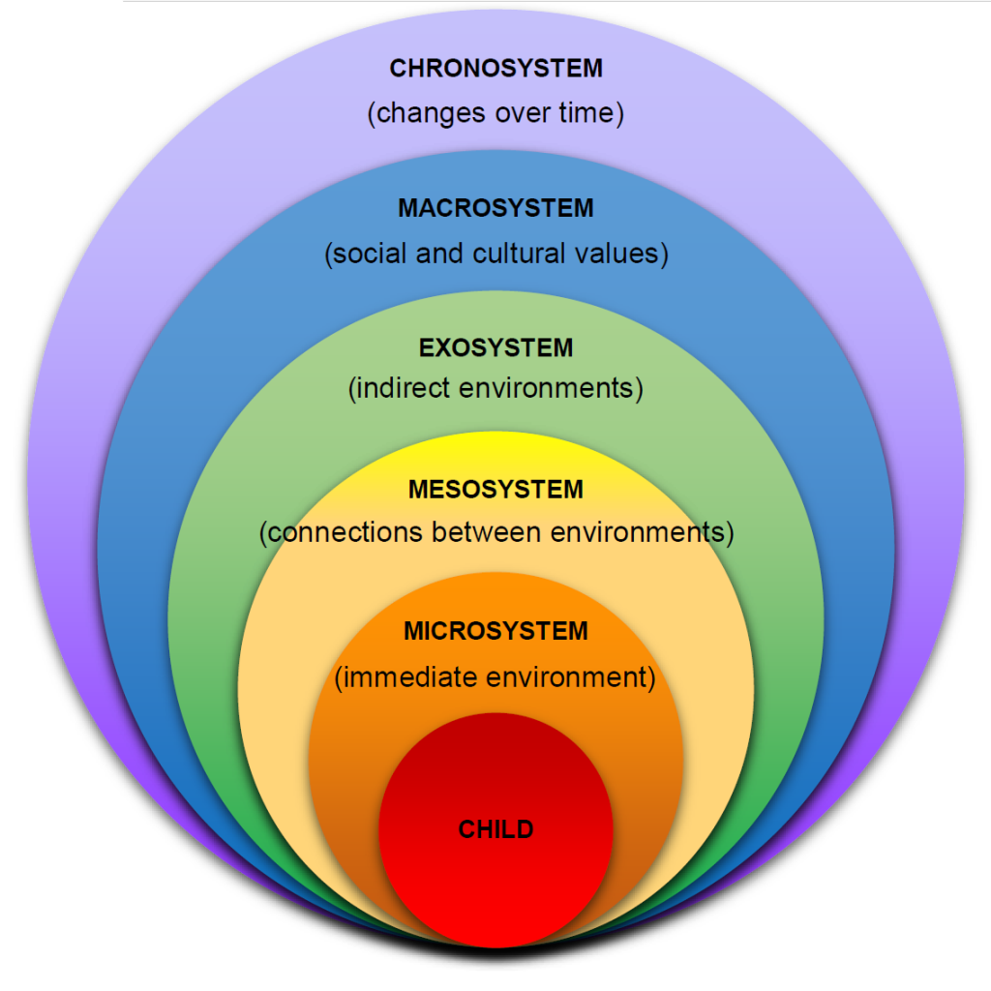
Source: (Budzyna, 2023).

Appendix 2
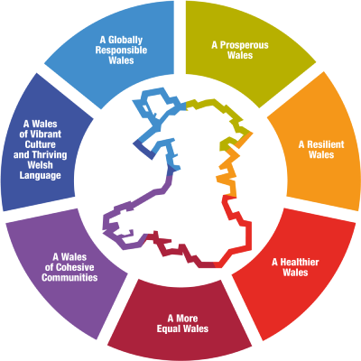
Source: (Welsh Government, ND)

Bilson, A, (2022) Why the evidence does not support multi-agency child protection units. Available at: https://www.communitycare.co.uk/2022/06/10/why-the-evidence-does-not-support-multi-agency-child-protection-units/ (Accessed on 15th April 2024)
Budzyna, D (2023). Ecological Theory. Available at: https://rotel.pressbooks.pub/whole-child/chapter/ecological-theory-2/ (Accessed on 16th April 2024).
Chambers, D, Cantrell A, and Booth, A (2021) Recognition of risk and prevention in safeguarding of children and young people: a mapping review and component analysis of service development interventions aimed at health and social care professionals. Available at: https://www.ncbi.nlm.nih.gov/pmc/articles/PMC8600929/ (Accessed on 16th April 2024).
Codetoday, (2023) Developing Digital Literacy: Navigating the Digital World with Confidence. Available at: https://www.codetoday.co.uk/post/developing-digital-literacy-navigating-the-digital-world-with-confidence (Accessed on 16th April 2024).
CYSUR, (2016) CYSUR: Mid and West Wales Regional Safeguarding Children Board Terms of Reference. Available at: https://cysur.wales/media/bnjnzmab/cysur-board-tor-approved-dec-2016-eng.pdf (Accessed on 16th April 2024).
Davies, C and Ward, H (2012) Safeguarding Children across services. Available at: https://assets.publishing.service.gov.uk/media/5a79fd2eed915d6d99f5c588/DFE-RR164.pdf (Accessed on 16th April 2024).
Feinstein, L, et al. (2023) Overcoming Behavioural & Cultural Barriers to Multi-agency Information Sharing in Children’s Social Care. Available at: https://www.education.ox.ac.uk/wp-content/uploads/2023/01/Rees-Centre-report-190723.pdf (Accessed on 16th April 2024).
Guy-Evans, O. (2024) Bronfenbrenner’s Ecological Systems Theory. Available at: https://www.simplypsychology.org/bronfenbrenner.html#:~:text=Bronfenbrenner%27s%20ecological%20systems%20theory%20views,values%2C%20laws%2C%20and%20customs. (Accessed on 16th April 2024).
Hermann, V, (2022) Feeling mentally unwell is the “new normal”. A qualitative study on adolescents’ views of mental health problems and related stigma. Available at: https://www.sciencedirect.com/science/article/pii/S0190740922002961 (Accessed on 16th April 2024).
Hern, A, (2024) Violent Online Content “unavoidable” for UK children- Ofcom finds. Available at: https://www.theguardian.com/technology/2024/mar/15/violent-online-content-unavoidable-for-uk-children-ofcom-finds (Accessed on 16th April 2024).
HM Government, (2023) Working together to Safeguard Children 2023. Available at: https://assets.publishing.service.gov.uk/media/65cb4349a7ded0000c79e4e1/Working_together_to_safeguard_children_2023_-_statutory_guidance.pdf (Accessed on 15th April 2024).
Munro, E, (2011) The Munro Review of Child Protection. Available at: https://assets.publishing.service.gov.uk/media/5a822033ed915d74e6235eaf/DFE-00010-2011.pdf (Accessed on 15th April 2024).
NSPCC (2024a) Child Protection System in Wales. Available at: https://learning.nspcc.org.uk/child-protection-system/wales/ (Accessed on 16th April 2024).
NSPCC, (2024) Content Promoting Self-Harm, Eating Disorders and Suicide. Available at: https://www.nspcc.org.uk/keeping-children-safe/online-safety/inappropriate-explicit-content/promotion-self-harm/ (Accessed on 16th April 2024).
Palmer, T (2015) Digital dangers The impact of technology on the sexual abuse and exploitation of children and young people. Available at: https://www.barnardos.org.uk/sites/default/files/uploads/digital-dangers.pdf (Accessed on 16th April 2024).
Peskett, T (2022) Figures reveal ‘appalling’ waiting times for young peoples’ mental health services. Available at: https://nation.cymru/news/figures-reveal-appalling-waiting-times-for-young-peoples-mental-health-services/ (Accessed on 16th April 2024).
Rose, E. (2024) Staff training - as Easy as Level 1,2,3…? A guide to developing a high-quality safeguarding training approach. Available at: https://safeguarding.network/content-delivery/staff-training-as-easy-as-level-1-2-3/ (Accessed on 16th April 2024).
Sharpling, D (2015) In harm's way: The role of the police in keeping children safe. Available at: https://assets-hmicfrs.justiceinspectorates.gov.uk/uploads/in-harms-way.pdf (Accessed on 16th April 2024).
UK Government, (2022) National review into the murders of Arthur Labinjo-Hughes and Star Hobson. Available at: https://www.gov.uk/government/publications/national-review-into-the-murders-of-arthur-labinjo-hughes-and-star-hobson (Accessed on 15th April 2024).
UK Parliament, (2019) House of Commons, Science and Technology committee. Impact of social media and screen-use on young people’s health. Available at: https://publications.parliament.uk/pa/cm201719/cmselect/cmsctech/822/822.pdf (Accessed on 15th March 2024).
Welsh Government (2023b) NEST Framework. Full Report. Page 1. Available at: https://www.gov.wales/nest-framework-full-report-html (Accessed on 16th April 2024).
Welsh Government, (2014) Multi-Agency Working and Information Sharing Project. Final Report. Available at: https://assets.publishing.service.gov.uk/media/5a750ddb40f0b6360e472fa5/MASH.pdf (Accessed on 16th April 2024).
Welsh Government, (2017) A Handbook for Management Committees of Pupil Referral Units. Available at: https://www.gov.wales/sites/default/files/publications/2018-11/handbook-for-management-committees-of-pupil-referral-units.pdf (Accessed on 15th March 2024).
Welsh Government, (2017) Families First. Programme Guidance. Available at: https://www.gov.wales/sites/default/files/publications/2019-07/families-first-guidance-for-local-authorities_0.pdf (Accessed on 16th April 2024).
Welsh Government, (2022a) Physically punishing children becomes illegal in Wales. Available at: https://www.gov.wales/physically-punishing-children-becomes-illegal-wales#:~:text=Under%20the%20Children%20(Abolition%20of,visitors%2C%20from%2021%20March%202022. (Accessed on 15th April 2024)
Welsh Government, (2022b) Keeping Learners Safe. Available at: https://www.gov.wales/sites/default/files/publications/2022-04/220401-keeping-learners-safe.pdf (Accessed on 16th April 2024).
Welsh Government, (2023a) multi-agency working, Research to support the Final Report of the Evaluation of the Social Services and Wellbeing (Wales) Act 2014. Available at: https://www.gov.wales/sites/default/files/statistics-and-research/2023-03/multi-agency-working-research-to-support-the-final-report-of-the-evaluation-of-the-social-services-and-well-being-wales-act-2014.pdf (Accessed on 15th April 2024).
Welsh Government, (2023c) Prevention and Early Intervention. Available at: https://www.gov.wales/sites/default/files/statistics-and-research/2023-03/prevention-and-early-intervention-research-to-support-the-final-report-of-the-evaluation-of-the-social-services-and-well-being-wales-act-2014.pdf (Accessed on 16th April 2024).
Welsh Government, (ND) The Wellbeing Of Future generations. Available at: https://www.gov.wales/well-being-of-future-generations-wales (Accessed on 16th April 2024).
WJEC, (2019) Safeguarding Children. The roles of different agencies and people involved in safeguarding the welfare of children and young people in the context of the setting. Available at: http://resource.download.wjec.co.uk.s3-eu-west-1.amazonaws.com/vtc/2018-19/HSC18-19_3-4/_multi-lang/unit01/04-agencies-and-people-involved-in-safeguarding-children.html (Accessed on 16th April 2024).

