University of Wales Trinity Saint David (UWTSD)
PROGRAMME: BA Leadership and Management
Module: LCLM6002 – Design Thinking and Innovation
Student Name: Gabriela Savity
Student ID: 2312231
Lecturer Name: Akash Puranik



Innovation & Customer Journey

Table of Contents
Part 1. 3
Summary 3
1. Introduction 3
2. Current Strategic Direction and Goals 4
3. Environmental Scan and Competitive Positioning 4
3.1 SWOT Analysis 4
3.2 Value Chain Analysis 5
3.3 PESTEL Analysis 5
3.4 Porter’s Five Forces 6
4. Strategic Growth Choices 6
4.1 Ansoff Matrix 6
4.2 Recommended Strategy 6
4.3 Strategic Frameworks 7
5. Stakeholder Analysis 7
5.1 Key Stakeholders 7
5.2 Mendelow’s Matrix 8
5.3 RACI Chart 9
7. Key Strategic Recommendations 13
Part 2. 16
1.Introduction. 16
Desirability, Viability and Feasibility Analysis 16
Viability – Business Value and Strategic Fit 17
Feasibility – Operational and Technological Capability 18
Measuring Impact and Success 18
8. Conclusion 21
References 22

Part 1.

Summary
Eurokyl Logistic Ltd is a small UK logistics provider specialising in the movement of general goods, operating with a limited workforce across two depots. While the firm is recognised for reliable and timely service delivery, it faces increasing pressure from digitally advanced competitors and rising expectations for service transparency within the logistics sector.
This report assesses Eurokyl’s strategic position using established strategic analysis frameworks and evaluates its approach to innovation and growth. The findings highlight digital capability development and customer-facing service enhancement as critical priorities for sustaining competitiveness. In response, the report proposes a digital customer portal as a strategically aligned initiative to strengthen service accessibility, operational visibility, and long-term market position.

1. Introduction
Providing general freight services together with scheduled deliveries, Eurokyl Logistic Ltd. is a company that operates within the logistics sector in the United Kingdom. Freight contracts with small and medium-sized firms and local companies are the source of its revenue. Strong customer loyalty is fostered by the company's ability to provide service that is centred on the customer and to arrange deliveries in a manner that is properly timed.
The UK logistics and freight industry is undergoing significant transformation, driven by digitalisation, sustainability requirements, and post-pandemic changes in customer expectations. According to Logistics UK (2024), over 70% of small logistics providers have begun adopting digital management tools such as GPS tracking, automated invoicing, and customer portals. Digital visibility has become a key differentiator for logistics firms, as 82% of business-to-business (B2B) clients now expect real-time tracking and automated service updates (Statista, 2024).
Economic conditions remain challenging, with rising fuel prices and inflation increasing operational costs across the supply chain (McKinsey & Company, 2024). In parallel, sustainability regulations and customer awareness are pushing logistics firms to adopt greener practices, such as route optimisation and low-emission vehicles (UK Government, 2023).
Rising customer expectations around speed, convenience, and transparency mean that digital touchpoints are no longer optional in logistics services. Deloitte (2023) argue that tools such as digital booking systems and online customer engagement platforms are now fundamental to customer retention, placing SMEs at a disadvantage if adoption lags behind larger competitors. For firms such as Eurokyl, continued reliance on operational reliability alone is unlikely to sustain competitiveness without a parallel shift towards customer-centred digital innovation.

2. Current Strategic Direction and Goals
Vision: To be the most dependable and customer-centric general goods provider in the UK.
Mission: Deliver goods on time, every time, while providing excellent customer service and operational efficiency.
Objectives:
Maintain 98% on-time delivery rate.
Expand client base by 20% over 3 years.
Implement digital logistics solutions.
Explore warehousing and e-commerce support.
Eurokyl’s strategy is primarily operationally driven, with reliability and control over service delivery positioned as the main sources of competitive strength. While this focus supports customer retention, it provides limited strategic clarity on how the firm will respond to increasing digitalisation and changing customer expectations within the logistics sector (Johnson et al., 2023). Although priorities such as incremental customer growth and selective digital adoption indicate strategic awareness, pursuing these initiatives simultaneously may place strain on limited SME resources, risking misalignment between digital development and core service performance.

3. Environmental Scan and Competitive Positioning

3.1 SWOT Analysis
Strengths: They are always on time, have good relationships with customers, have two depots, and offer flexible service.
Weaknesses: a small workforce, not many people using digital tools, relying on the local market, and not much marketing.
Opportunities: partnerships with small and medium-sized businesses, demand for timely deliveries, and the use of logistics technology.
Threats: competition from national providers, rising fuel costs, changes in the law, and a downturn in the economy.
For Eurokyl, the SWOT analysis highlights the need to protect its core strength in service reliability while addressing internal constraints that limit growth and scalability. In practice, this means prioritising digital capability development to reduce exposure to competitive and cost pressures in the wider logistics environment.

3.2 Value Chain Analysis
Inbound logistics: Vehicle and depot scheduling. This involves organising vehicle availability, planning depot timetables, and coordinating incoming shipments so that resources are ready when needed.
Operations: Freight handling, route optimization. Covers the practical movement of goods, including loading, unloading, and arranging the most efficient routes to cut down on travel time and fuel use.
Marketing & Sales: Client management and local advertising. Focuses on managing relationships with clients, building a local presence through targeted promotion, and developing approaches to attract new customers.
Service: Customer support and loyalty programs. Includes handling customer enquiries, resolving issues, and running loyalty or retention initiatives to maintain strong long-term relationships.
Technology: Minimal, potential for GPS and scheduling software. Currently used on a small scale, but there is room to introduce tools like GPS tracking or automated scheduling systems to support smoother operations.

3.3 PESTEL Analysis
The PESTEL analysis shows that Eurokyl operates within an environment shaped by rising fuel costs, regulatory change, and accelerating digitalisation. For the company, this reinforces the need to adapt operations and customer interfaces, in order, to remain compliant, cost-aware, and responsive to external pressures.
Political: UK transport regulations, Brexit adjustments. Rules around UK transport keep shifting, especially with the lingering changes from Brexit, and companies must keep adjusting to stay in line with them.
Economic: Rising fuel, inflation. Fuel costs and general price rises are putting extra pressure on budgets, making day-to-day operations more expensive than they used to be.
Social: Demand for reliable deliveries. People now expect deliveries that turn up when promised, so reliability has become something customers look for straight away.
Technological: Opportunity for logistics software. There’s a clear opening to bring in better digital tools—things like smarter routing or logistics systems—that could make the work run more smoothly.
Environmental: Pressure to reduce fleet emissions. Transport firms are being pushed to cut down on emissions, meaning cleaner vehicles and greener practices are becoming harder to ignore.
Legal: Compliance with transport and labour laws. The business must keep on top of transport rules and employment requirements to avoid running into problems with regulators

3.4 Porter’s Five Forces
Porter’s Five Forces indicate that competitive rivalry and buyer power are particularly strong within the UK logistics sector. As a result, Eurokyl must differentiate through service quality and customer experience rather than price in order, to protect its position against larger, more resource-intensive competitors.
Threat of new entrants: Medium.
Supplier power: Medium.
Customer power: High.
Threat of substitutes: Medium.
Industry rivalry: High.

4. Strategic Growth Choices

4.1 Ansoff Matrix
Ansoff’s Matrix supports Eurokyl’s focus on product and market development as lower-risk growth options that build on existing capabilities rather than pursuing resource-intensive diversification (Ansoff, 1987).
Market Penetration: Strengthen client relationships.
Product Development: Warehousing, tracking, same-day delivery.
Market Development: Expand regions, e-commerce logistics.
Diversification: SME partnerships for integrated supply chain.

4.2 Recommended Strategy
A combined product and market development strategy is recommended, focusing on the introduction of warehousing, parcel tracking, and e-commerce logistics services to extend Eurokyl’s existing offering. This approach allows the firm to leverage its operational strengths while accessing new customer segments, supporting sustainable growth without the elevated risk associated with diversification (Ansoff, 1987; Johnson, Scholes and Whittington, 2023).

4.3 Strategic Frameworks
Porter’s framework indicates that Eurokyl’s emphasis on punctuality and personalised service aligns with a differentiation strategy, which is more sustainable for SMEs than competing on cost (Porter, 2008).
Bowman’s Strategic Clock positions Eurokyl within a high-value strategy, where superior reliability and service quality justify customer preference despite competitive pressure (Johnson, Scholes and Whittington, 2023).

5. Stakeholder Analysis

5.1 Key Stakeholders
Customers: Reliable service (High power/high interest).
In logistics, customers typically exert strong influence because repeat purchasing and switching decisions are closely tied to perceived service quality (Parasuraman, Zeithaml and Berry, 1988). For Eurokyl, reliability and responsiveness are therefore not just operational targets but key drivers of retention and reputation (Christopher, 2016).
Employees: Job security, fair workload (Medium power/high interest). Employees usually show high interest because workload, fairness and job security directly affect motivation and performance (Adams, 1965; Herzberg, 1959). In a small firm, limited staffing can intensify pressure, meaning employee engagement becomes a delivery-risk issue as well as an HR concern (Boxall and Purcell, 2016).
Suppliers: Timely payment (Medium power/medium interest). Supplier relationships tend to remain stable when payment terms and basic coordination are reliable; poor payment practice, however, can damage trust and continuity of supply (Cousins et al., 2008). For Eurokyl, timely payment functions as a governance mechanism that reduces friction and protects operational flow (Cousins et al., 2008).
Owners: Profitability and growth (High power).
Owners hold structural power through capital control and strategic direction, typically prioritising financial performance and growth (Jensen and Meckling, 1976). This can create pressure for efficiency and expansion, even when operational capacity is constrained (Jensen and Meckling, 1976).
Regulators: Compliance (High power/low interest).
Stakeholder mapping is useful because it helps managers prioritise attention based on relative influence and engagement rather than treating all stakeholder demands equally (Johnson, Scholes and Whittington, 2023). Using Mendelow’s power–interest logic, Eurokyl should manage customers and regulators closely due to their high impact, keep owners satisfied through clear performance reporting, and maintain employee and supplier commitment through fair workload management and dependable commercial practices (Johnson, Scholes and Whittington, 2023; Freeman, 1984).

5.2 Mendelow’s Matrix
Stakeholder mapping is useful because it helps managers prioritise attention based on relative influence and engagement rather than treating all stakeholder demands equally (Johnson, Scholes and Whittington, 2023). Using Mendelow’s power–interest logic, Eurokyl should manage customers and regulators closely due to their high impact, keep owners satisfied through clear performance reporting, and maintain employee and supplier commitment through fair workload management and dependable commercial practices (Johnson, Scholes and Whittington, 2023; Freeman, 1984).
High Power/High Interest: Customers, Regulators.
High Power/Low Interest: Owners.
Low Power/High Interest: Employees.
Low Power/Low Interest: Suppliers.

Table 1

5.3 RACI Chart
Task | Responsible | Accountable | Consulted | Informed
Implement GPS tracking | Operations Manager | Owner | Employees | Customers
Launch warehousing service | Owner | Owner | Employees, Customers | Suppliers
Expand e-commerce logistics | Owner | Owner | Employees | Customers, Suppliers
Marketing campaign | Marketing Lead | Owner | Employees | Customers

Table 2
6. Customer Journey Map – Eurokyl Logistic Ltd
Stage | Customer Goal | Customer Actions | Eurokyl’s Touchpoints | Customer Emotions | Pain Points / Challenges | Opportunities for Improvement
1. Awareness | Find a reliable logistics provider in the UK | Search online, ask for referrals, visit Eurokyl’s website or social media | Website, social media, online reviews, word-of-mouth | Curious, cautious | Limited online presence; lack of digital ads | Improve website SEO; run Google Ads; post testimonials
2. Consideration | Compare Eurokyl with competitors | Request quotes, compare pricing and delivery terms | Email/phone contact, quotation form, sales call | Interested but evaluating | Limited-service info online; manual quote process | Add online quote calculator; clear service comparison
3. Booking / Engagement | Secure transport for goods | Book freight service via phone/email | Booking confirmation, invoice, delivery scheduling | Confident but expects clarity | Manual booking, potential miscommunication | Create online booking portal; automated confirmations
4. Delivery & Service Experience | Receive timely and safe delivery | Eurokyl collects, transports, and delivers goods | Driver interactions, delivery tracking, proof of delivery | Satisfied if on-time; anxious if delayed | Lack of real-time tracking | Add GPS tracking app with live updates; proactive alerts
5. Post-Delivery Support | Ensure satisfaction, resolve issues | Provide feedback, request invoice copy, report issues | Customer service, after-sales email, follow-up call | Appreciative if responsive | Reactive rather than proactive support | Implement post-delivery surveys; loyalty rewards
6. Relationship& Loyalty | Build long-term partnership | Re-book, refer others | CRM system, loyalty discounts, newsletters | Loyal and trusting | Infrequent engagement post-service | Launch client retention program, periodic updates

Table 3
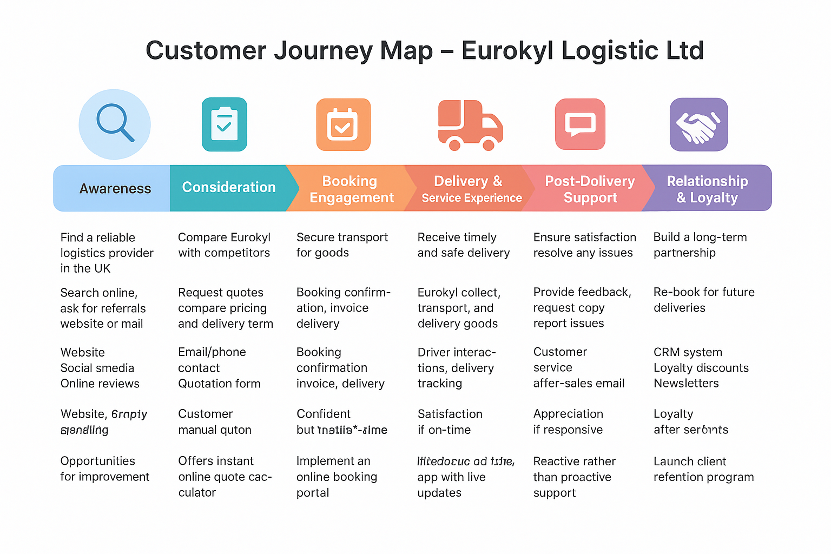

Eurokyl’s customer journey is built around reliability and personal relationships but lacks consistent digital integration across key touchpoints. The most significant pain points are manual communication, slow quotation processes, and limited online visibility — all of which reduce efficiency and transparency.
While customers perceive Eurokyl as dependable, modern expectations increasingly prioritise digital self-service and real-time tracking (Deloitte, 2023). Addressing these gaps offers a direct pathway to innovation. The next stage of this report (Part 2) proposes a Digital Customer Portal to convert these weaknesses into strategic advantages, transforming Eurokyl’s service from operationally efficient to digitally empowered and customer driven.

Insights:

• Key Strength: Being reliable and on time builds loyalty.
• Weakness: Not enough digital and marketing presence.
• Chance: Set up a customer portal with features for tracking, booking, and giving feedback.

7. Key Strategic Recommendations
• Digital Integration: GPS tracking, route optimisation, and automated scheduling.
• Service growth: warehousing and logistics for e-commerce.
• Operational Efficiency: Depot optimisation and performance monitoring.
• Stakeholder Engagement: Talking to clients and employees on a regular basis.
• Measures for sustainability: cars that use less fuel and practices that are good for the environment.
• Customer Experience: Create a digital customer portal that includes systems for tracking, booking, and giving feedback.

Table 4

Innovation Ambition Matrix – Eurokyl Logistic Ltd

Innovation Type | Focus Area | Description | Customer Journey Link | Examples / Actions | Expected Outcome
Core Innovation (Horizon 1) | Service Process Improvement | Enhancing existing logistics operations to improve punctuality and reliability. | Booking → Delivery & Service | - Implement digital booking portal  - Introduce live GPS tracking  - Automate delivery confirmations | Higher customer satisfaction, reduced delivery errors
Adjacent Innovation (Horizon 2) | New Services for Existing Markets | Expanding service offerings that complement current freight services. | Post-Delivery → Relationship & Loyalty | - Launch warehousing and short-term storage  - Offer e-commerce logistics  - Develop loyalty/CRM system | New revenue streams, increased retention
Transformational Innovation (Horizon 3) | New Business Models / Technology Integration | Creating entirely new logistics solutions or business models. | Awareness → All Stages | - Adopt AI route optimization  - Partner with green vehicle fleets  - Build Eurokyl mobile app for end-to-end service visibility | Sustainable growth, digital transformation, stronger market position

Table 5

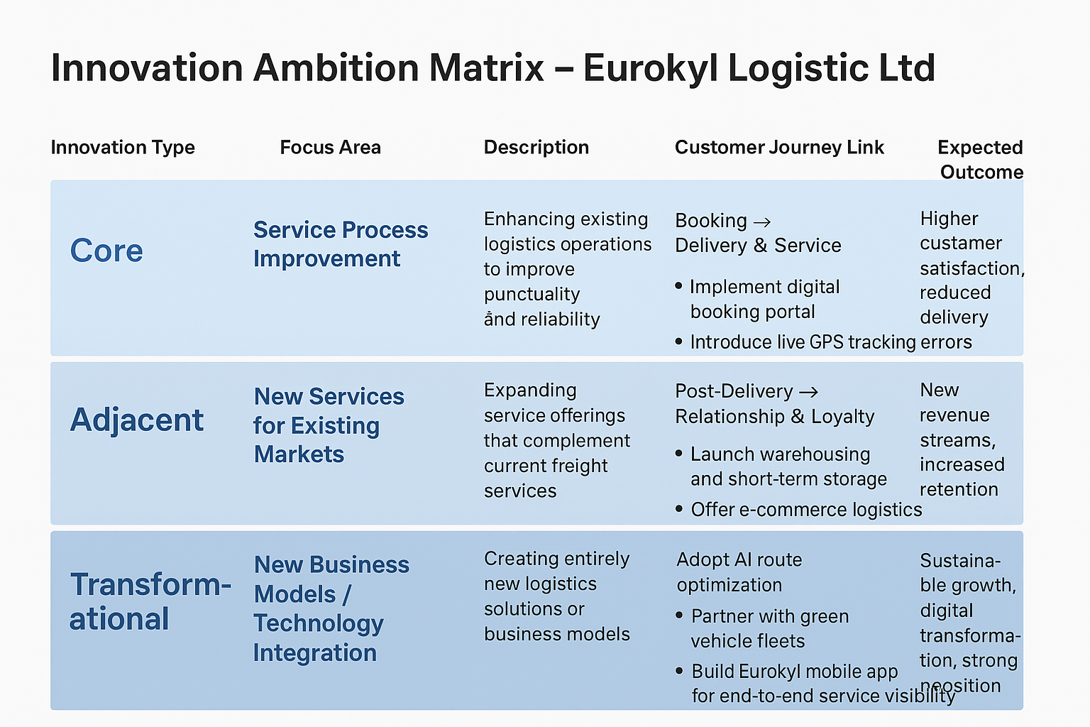

Eurokyl’s innovation portfolio is currently weighted towards Horizon 1 (core innovation), reflecting its focus on punctual delivery and customer service reliability. However, competitive pressures and digital trends in the UK logistics sector demand greater emphasis on Horizon 2 and 3 innovations.
By expanding into warehousing, e-commerce logistics, and AI-enhanced routing, Eurokyl can transition from operational efficiency to strategic agility. This approach aligns with Nagji and Tuff’s (2012) argument that sustainable growth arises from balancing core stability with adjacent and transformational innovation.
The introduction of the Digital Customer Portal centralises Eurokyl’s communication, booking, and tracking functions into a single, user-friendly system. Customers now benefit from end-to-end transparency, faster service delivery, and consistent interaction — all essential factors for loyalty and competitive differentiation in the logistics sector (McKinsey & Company, 2024). From an operational perspective, automation reduces administrative workload, while the data captured through the portal supports predictive planning and customer relationship management.
Overall, this redesigned journey transforms Eurokyl’s business model from one focused purely on operational reliability to one defined by digital innovation, customer empowerment, and strategic resilience.

Part 2.

1.Introduction.

Eurokyl’s customer journey redesign reflects a balanced innovation approach that spans incremental improvements and longer-term transformation (Nagji and Tuff, 2012). While core digital initiatives enhance service reliability, more advanced solutions offer strategic potential only if aligned with organisational capacity and customer value creation (Johnson, Scholes and Whittington, 2023). This staged approach supports digital innovation that is both strategically credible and practically achievable.

Desirability, Viability and Feasibility Analysis
For digital transformation to be effective, initiatives must balance customer desirability, organisational viability, and technical feasibility. Eurokyl can evaluate proposed solutions such as online booking, GPS tracking, customer applications, and loyalty platforms using this triadic lens to ensure that digital change delivers practical and strategic value rather than isolated technological upgrades (Brown, 2009; Johnson, Scholes and Whittington, 2023).
Desirability – Meeting Customer Needs

Eurokyl’s reputation for reliable and timely delivery represents a clear competitive strength; however, customer journey analysis highlights weaknesses in booking accessibility, delivery visibility, and post-delivery engagement. Research shows that logistics customers increasingly expect self-service booking, real-time tracking, and proactive communication, particularly within SME supply chains (Christopher, 2016; PwC, 2023). Introducing a digital booking portal and live tracking system directly addresses these expectations, improving transparency and trust.
Rather than relying on phone calls or extended email exchanges, customers increasingly expect to manage bookings through simple self-service digital systems. Real-time delivery visibility enabled by GPS tracking reduces uncertainty by allowing customers to monitor shipment progress independently, while proactive communication during delays helps maintain trust and manage expectations. In addition, personalised loyalty incentives encourage repeat usage and strengthen long-term customer relationships through a more seamless service experience.

Viability – Business Value and Strategic Fit
Digital transformation is closely aligned with Eurokyl’s strategic ambition to position itself as a reliable and customer-focused logistics provider while supporting medium-term growth objectives. The introduction of digital booking, automated confirmations, and real-time tracking improves service accessibility for SME customers, which is increasingly important in a sector where ease of use and transparency influence supplier choice (Christopher, 2016). These initiatives also support revenue growth by lowering barriers to entry for new customers and encouraging repeat usage through loyalty mechanisms, enabling Eurokyl to compete more effectively with larger logistics providers.
From an operational perspective, automation reduces reliance on manual administrative processes, allowing staff to focus on higher-value activities and improving overall efficiency. This aligns with the Balanced Scorecard perspective that internal process improvement and learning capabilities are critical drivers of long-term financial performance (Kaplan and Norton, 1996). In addition, the adoption of digital systems contributes to brand positioning by presenting Eurokyl as a modern, technology-enabled SME rather than a traditional operator. Collectively, these outcomes demonstrate that digital transformation delivers measurable strategic and commercial value while reinforcing Eurokyl’s long-term competitiveness in the UK logistics market (Johnson, Scholes and Whittington, 2023).

Feasibility – Operational and Technological Capability

As an SME, Eurokyl requires digital solutions that are scalable and cost-efficient rather than infrastructure intensive. Cloud-based logistics platforms, modular booking systems, and integrated GPS tracking can be implemented incrementally with minimal disruption, while phased staff training reduces operational risk during adoption (Kane et al., 2015; Johnson, Scholes and Whittington, 2023). This staged approach increases feasibility by aligning technological change with organisational capacity.

Measuring Impact and Success
The success of the digital initiative should be evaluated using a small set of performance measures that reflect both customer experience and operational efficiency, including customer satisfaction, booking processing time, and delivery reliability. Tracking customer retention and digital-led client acquisition further enables Eurokyl to assess whether the initiative delivers sustained strategic value rather than short-term operational gains (Kaplan and Norton, 1996; Johnson, Scholes and Whittington, 2023).

Christopher, M. (2016) Logistics and Supply Chain Management. 5th edn. Harlow: Pearson Education.

Table 6
Stage | Customer Goal | Customer Actions | Eurokyl’s Touchpoints | Customer Emotions | Pain Points / Challenges | Opportunities for Improvement | Desirability (Customer Value) | Viability (Business Value) | Feasibility (Operational Capability)
1. Awareness | Find a reliable logistics provider in the UK | Search online, ask for referrals, visit Eurokyl’s website or social media | Website, social media, online reviews, word-of-mouth | Curious, cautious | Limited online presence, lack of digital ads | Improve website SEO, Google Ads, post testimonials, active social content | Builds trust and brand visibility before first contact | Attracts new SME clients, increases qualified leads | Low-cost digital marketing campaigns, basic SEO upgrade
2. Consideration | Compare Eurokyl with competitors | Request quotes, compare pricing and delivery terms | Email/phone contact, quotation form, sales call | Interested but evaluating | Limited-service info online; manual quote process | Online quote calculator, detailed service comparison, chatbot for FAQs | Easy access to pricing and services increases likelihood of conversion | Higher conversion rate, improved sales funnel efficiency | Cloud-based quoting tools are affordable and easy to implement
3. Booking / Engagement | Secure transport for goods | Book freight service via phone/email | Booking confirmation, invoice, delivery scheduling | Confident but expects clarity | Manual booking, potential miscommunication | Launch online booking portal with automated confirmations | Customers get control, clarity, and reduced wait time | Less admin time, increased booking accuracy | Feasible with off-the-shelf logistics booking software
4. Delivery & Service | Receive timely and safe delivery | Eurokyl collects, transports, and delivers goods | Driver interactions, delivery tracking, proof of delivery | Satisfied if on-time; anxious if delayed | Lack of real-time tracking | Add GPS tracking with live updates, proactive delivery alerts | Reassures customers, reduces delivery anxiety | Reinforces reliability reputation, boosts customer satisfaction | Integrating GPS via third-party fleet management software is affordable and scalable
5. Post-Delivery | Ensure satisfaction and resolve issues | Provide feedback, request invoice copy, report issues | Customer service, after-sales email, follow-up call | Appreciative if responsive | Reactive rather than proactive support | Automated post-delivery surveys, loyalty rewards, customer service chatbots | Encourages ongoing engagement and satisfaction | Builds stronger client retention and repeat business | Survey tools and loyalty systems can be integrated into existing CRM systems
6. Relationship & Loyalty | Build long-term partnership | Re-book, refer others | CRM system, loyalty discounts, newsletters | Loyal and trusting | Infrequent engagement post-service

8. Conclusion
Eurokyl Logistic Ltd has established a strong position in the UK logistics sector through reliability, punctuality, and close customer relationships. However, this report has demonstrated that operational excellence alone is no longer sufficient to sustain competitiveness in an increasingly digitalised market. Strategic analysis revealed that limited digital capability represents a key constraint on growth, despite clear opportunities in service expansion and customer experience enhancement.
The application of the Innovation Ambition Matrix and Customer Journey Mapping showed that Eurokyl’s innovation efforts are currently concentrated on core operational improvements, with scope to strengthen adjacent and transformational initiatives. The proposed Digital Customer Portal directly addresses critical gaps in booking, tracking, and post-delivery engagement, enabling Eurokyl to align service reliability with modern expectations for transparency and convenience.
By integrating digital innovation with a Balanced Scorecard approach, the report demonstrates how customer satisfaction, internal efficiency, learning and development, and financial performance can be improved simultaneously. Overall, Eurokyl’s long-term sustainability depends on its ability to embed digital capability as a strategic enabler rather than a supporting function. Through targeted investment, workforce development, and continued customer focus, Eurokyl can evolve into a resilient, digitally enabled logistics provider capable of competing effectively within the UK market.

References

Adams, J.S. (1965) ‘Inequity in social exchange’, in Berkowitz, L. (ed.) Advances in Experimental Social Psychology. New York: Academic Press, pp. 267–299.
Ansoff, H.I. (1987) Corporate Strategy. Rev. edn. London: Penguin.
Barney, J. (1991) ‘Firm resources and sustained competitive advantage’, Journal of Management, 17(1), pp. 99–120.
Boxall, P. and Purcell, J. (2016) Strategy and Human Resource Management. 4th edn. London: Palgrave Macmillan.
Brown, T. (2009) Change by Design. New York: Harper Business.
Christopher, M. (2016) Logistics and Supply Chain Management. 5th edn. Harlow: Pearson Education.
Cousins, P.D., Lamming, R.C., Lawson, B. and Squire, B. (2008) Strategic Supply Management: Principles, Theories and Practice. Harlow: Pearson.
Deloitte (2023) Digital logistics survey: technology trends shaping customer experience. Deloitte Insights. Available at:
https://www.deloitte.com/global/en/insights/industry/transportation/logistics-digital-transformation.html (Accessed: 2 February 2026).
Freeman, R.E. (1984) Strategic Management: A Stakeholder Approach. Boston, MA: Pitman.
Herzberg, F. (1959) The Motivation to Work. 2nd edn. New York: Wiley.
Johnson, G., Scholes, K. and Whittington, R. (2023) Exploring Strategy: Text and Cases. 13th edn. Harlow: Pearson Education.
Kaplan, R.S. and Norton, D.P. (1996) The Balanced Scorecard: Translating Strategy into Action. Boston, MA: Harvard Business School Press.
Kane, G.C., Palmer, D., Phillips, A.N., Kiron, D. and Buckley, N. (2015) ‘Strategy, not technology, drives digital transformation’, MIT Sloan Management Review.
Logistics UK (2024) Logistics Report 2024. London: Logistics UK.
McKinsey & Company (2024) State of UK Transport and Logistics. Available at: https://www.mckinsey.com/industries/logistics/our-insights (Accessed: 2 February 2026).
Nagji, B. and Tuff, G. (2012) ‘Managing your innovation portfolio’, Harvard Business Review, 90(5), pp. 66–74.
Parasuraman, A., Zeithaml, V.A. and Berry, L.L. (1988) ‘SERVQUAL: A multiple-item scale for measuring consumer perceptions of service quality’, Journal of Retailing, 64(1), pp. 12–40.
PwC (2023) Digital operations in logistics: improving customer experience and efficiency. PwC.
Scott, W.R. (2014) Institutions and Organizations: Ideas, Interests, and Identities. 4th edn. Thousand Oaks, CA: SAGE.
Statista (2024) Digitalisation in the UK logistics sector. Available at: https://www.statista.com (Accessed: 2 February 2026).
UK Government (2023) Guidance for SMEs in logistics. Available at: https://www.gov.uk (Accessed: 2 February 2026).

