
APPENDIX GA36d

LEVEL 7 ASSESSMENT SPECIFICATION

Student name: | LUI Yau Hang Edward | Student ID number: | 1710335
Programme: | DBA
Module: | Qualitative Research
Module code: | SBPD7002 | Contribution to Overall Module Assessment (%): | 40
Lecturer: | Dr. Stephanie Lee | Internal Verifier:
Assignment Title: | Evaluating current research | Word count (or equivalent): | 2499
Submission deadline: | November 4, 2018 | Return date of provisional marks & written feedback: | November 25, 2018
Submission method: | All written assessments, where practical and possible, must be submitted via Turnitin unless otherwise instructed by the Lecturer. (Please DO NOT put this assessment specification into Turnitin or it will match many similarities with other students’ submissions.)  Alternative submission method (if applicable):  Late submission of the assessment will result in a late penalty mark. Penalties for late submission: Up to one week late, maximum mark of 50%. Over one week late, 0%. Only the Extenuating Circumstances Panel may approve a change to submission dates.
Academic honesty / referencing: | Academic honesty is required. In the main body of your submission you must give credit to authors on whose research and ideas your work is based. Append to your submission a reference list that indicates the books, articles, etc. that you have used, cited or quoted in order to complete this assessment.

Course: SBPD 7002
Qualitative Research
Part 1 : Evaluating current research (40%)

Declaration:
I, LUI Yau Hang, Edward (DBA Student no. 1710335 of UWTSD) declare that this assignment is all my own work and that I have acknowledged all materials used from the published or unpublished works of other people. All references have been duly cited.

Topic:
“Consumer-led experience customization: a socio-spatial approach”

Table of Contents:

Declaration and Topic |  | P.2
Table of Content |  | P.3
The Article and its Ranking |  | P.4 – P.5
The basis of critique |  | P.5
1. | Introduction | P.6 – P.7
2 | Data Collection | P.7 – P.8
3 | Methods Used  - Pros & Cons  - Suggestions for Improvement | P.8 - P.10
5 | Conclusion | P.11
6 | Reference | P.12

The Article and its Ranking

Journal of Service Management

Ranking of the critique paper
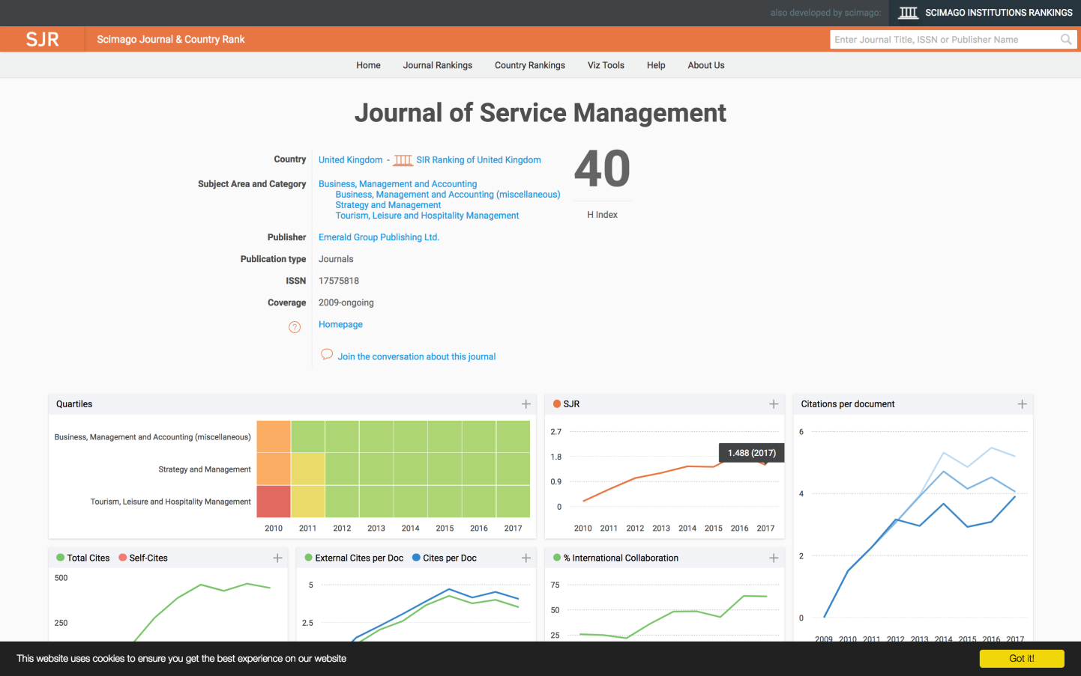

SJR 1.488 (2017)

The Basis of Critique

The main objective of this paper is to evaluate and highlight some of the pros and cons of the research work which is conducted by the authors whose names are appeared in the front page of the article as shown above. The evaluation on the subject article is discussed separately into two folds, i.e. positive and negative comments.

- Positive comments – appreciation on the literature reviews, learning new knowledge from the research, and the design of the research in achieving creditability through a well structured data collection and data analysis, coping, findings from analysis, discussion and the strengths.

- Negative comments – the style, sample size, the localities of data, the findings, rooms for improvement, other suggestions and so on.

- Introduction

The authors of this qualitative research article with the topic, “Consumer-led experience customization: a socio-spatial approach” aim to develop a consumer-centric concept on service experience customization in order to examine consumers’ experiences in terms of usage, abuse, subvert, transform…etc. of a service.

The study is conducted for theme parks in Florida, USA where online platform, face-to-face interviews, observations and content analysis of online interactions with participants are used during a period of 2 years over 80 events to collect data for analysis. The data obtained are used to propose a new consumer-centric conceptualization of experience customization. The finding is to distinguish the three modes, namely collaborative co-production; cooperative co-creation; and subversive co-creation which has been successful.

The research philosophy is co-constructed, subjective and interpretative which are clearly stated in the introduction part of the paper. The researchers are using a socio-spatial approach in response to Jaakkola et al.’s (2015) call to examine the spatial and temporal dimensions of service co-creation as consumer experiences and co-creation practice materialize across multiple spaces, rather than just within the service scope. Gronroos, 2008 suggests that mass customization maybe a useful way to conceptualize an organization’s strategic choices regarding flexible and responsive approaches to product development, marketing, operations, and customer relationship management.

Co-creation can also be regarded as an evolution of the customization philosophy, which appreciates and integrates consumer agency more broadly in its understanding of customer-organization interactions and value creation (cf. Heinonen et al., 2010, 2013; Jaakkola and Alexander, 2014). The notion of co-creation suggests that value is generated jointly between the customer and producer via the application of their own respective resources and competencies (Vargo et al., 2008). This concept presents a shift from a firm-and product-centric view to a personalized customer experience.

Co-production refers to customers’ participation in transactional and functional ways, this conforms to service design. Customer input may help to make transactions more efficient, effective and hence satisfactory (Bitner et al., 1997). Co-creation presents a higher level of customer engagement in which the value is created jointly as customer and organizations use their own skills and competencies in increasingly sophisticated ways to create new services and experiences. In this regard, co-creation has the potential of positively or negatively disruptive. These concepts are not mutually exclusive but instead these can be seen in a continuum ranging from co-production to co-creation as long as the level and complexity of customer involvement in customization increases and as the service of experience is transformed.

In summary, the concepts of co-creation and customization have distinct but complementary conceptual roles. According to Payne et al. (2008), co-creation is composed of three components: customer value-creating processes; supplier value-creating processes and encounter processes. Experiences are thus entangled with different forms of value for consumers. Value creation draws from the past and is situated the present moment, and influences the future (Ellway and Dean, 2016, p.304).

According to the above, the authors have conducted a very detail literature review on the research issues and the research gaps have been clearly identified. However, such detailed introduction is complicated by quoting different arguments from the past which confuse readers’ interests in the research topic. The detailed literature review may become a negative sign for the paper as this cause confusion to readers about the ultimate objective of the research paper.

- Data Collection

The researchers conduct the research through inductive and interpretivist approach. Observations to participants during the interviews for selected informants together with content analysis on online data from members of the group are carried out for data collection. In order to ensure credibility of the findings, triangulation is used with saturated data. This research aims at understanding the contextual nature of relationships, interdependence and shared practice in consumer behavior both in virtual and physical spaces (cf. Cova and Cova, 2002; Kozinets, 2015; Muniz and O’Guinn, 2001).

Data collection for this research is time consuming and of a very large scale of participants, as the researchers have formed form the Theme Park Fun (TPF) group in the Facebook approximately 20 months before the study and the researchers are involved in the group for online exchanges as part of the broader inductive investigative strategy to better understand how virtual and physical spaces were interconnected in the group’s practice (see Lugosi et al., 2012).

Data collection and sound recording took place during the interviews / interactions that some notes and observations have been converted in the theme park by using Smartphone Notes Pad function. About 1,000 conversations were collected over a period of two months these included pre-event planning and preparation, the coordination of activities, and post-event evaluation. However using a Smartphone for sound recording may cause interference to the sound bites when an unexpected incoming call or message is pop up. Some important words or terms may not be clearly recorded if the unexpected calls or messages are flushed in to the interviewer’s Smartphone.

Finally, the three researchers review the data from the coding schemes developed from the Facebook content analysis. It is true to say that fact-to-face interviews enhance the credibility of the finding and therefore semi-structure interviews took place after the informants were selected due to their roles and practices. The interview topics included the reasons for the group’s inception, types of events offered, and the challenges associated with the different event types, reasons for members to join and to leave the group, and clarity of roles.

- Methods Used

The empirical context for the study is a Meetup group by drawing those with the shared interest in the Theme Park visits and experiences to support the face-to-face interactions. Meetup group is a global network of consumers based in Florida, USA which extends the concept of a virtual community by providing members a mean to interact with each other offline via this electronic-to-face community. Meetup groups are across the world in 180 countries including France, Germany, Spain and Brazil. The researchers have been following this Meetup group over the course of two years in over 80 events.

At the beginning year, the TPF Meetup group consists of 200 online members, 30 of whom were actively involved in the group’s events and activities. At the close of the study, i.e. at the end of the second year, TPF have over 1,000 online members with approximately 100 active members who possess an annual pass and frequently attending the events. As stated, members of the TPF group should be in the age range of 25 to 48, and most of the members are in their mid-30s. According to the findings on occupations, spending habits, ownership of property, and other data gathered by the Principal Investigator (i.e. the PI), it is concluded that , from a socio-economic point of view, most members fall within either middle or upper-middle class income group.

3.1 The Pros and Cons

The use of the Meetup group via Facebook is an effective method to obtain over a 1,000 respondents’ details on the research issues. The data so collected from this method could even exceed the rate of respondents from the Quantitative Research method and therefore, the credibility and reliability of the research findings are high in terms of the data analysis from such larger sample size of data collection.

Under the discussion part of the paper, a diagram (Figure 2) is presented to show the contextualized, holistic view of the factors shaping the possibility for customization. The authors are trying to explain the customization do not determine the form it may take in practice, such as experiential complexity, governability, compatibility, and the mobilization of collective resources for shared (social) goals. But in fact, such diagram does not cover those related factors associated with the Theme Park Fun to demonstrate the correlations with the framework for readers’ easy understanding on the subject issues.

For ethical issue, it seems that the consent form and the briefing on the data collection is silence in the data collection content of the article.

The conclusion is well written with all main findings specifically addressed; that is three modes of consumer-led customization were articulated based on the extent to which they enhanced existing practices: cooperative co-production (non-disruptive consumer activities that modified aspects of the service space and processes in line with the organization’s proposition); compatible co-creation (creative activities that re-used organizational resources in novel ways that enhanced existing service propositions); and subversive co-creation (radically transformative acts that challenged the organization’s service and experiential propositions).

In the final part, i.e. “Implications for theory and research”, the researchers have clearly pinpointed the needs and gaps to be further studied and researched. Regarding to the management challenges associated with the modes of customization being identified in the research opens several other areas for future research. For instance, the Theme Park is a complex socio-material-temporal service context, as well as a particular type of playful experiential environment. Although some parallels can be drawn between this and other service context, not all of the practices identified in this empirical case will be possible or applicable for elsewhere.

Limitation also indicates that the US-based TPF represents a distinct consumer group, characterized by interdependence and interaction, which operates in a particular socio-cultural context. There is still scope to examine how alternative groups organized around different forms of experiential consumption. Future researchers may study how those customers related customization practices are enacted by fragmented and discontinuous configurations of consumers, or by individuals.

3.2 Suggestions for Improvement

Regarding the process of transcribing the collected data from the interviews, there would be rooms for improvement. Since all interviews are recorded digitally on a Smartphone and later on transcribed by the third Author in preparation for the data analysis, this is strange to note that all interview data are transcribed by the third author instead of each interviewer transcribing their own interviewing data. Such arrangement may raise the arguments on the level of accuracy for a third party to transcribe and understand the data so collected from the interviews which are conducted by the other two authors. This could be an improvement item to the research method in achieving a much higher credibility of the data collection process.

In addition, the coding technique could be elaborated more in this research paper by illustrating the raw data and first person experiences from the interviewees would be an added advantage and more interesting to the readers. Oppositely, the silence on the coding technique may hinder the work of data saturation and triangulation, and hence the credibility of the findings. As quoted by Lincoln and Guba (2013), the use of data triangulation helps to ensure the credibility of the research findings.

Worse still, the lack of an Analytical Framework creates difficulties for readers to fully understand the actual data obtained from the interviews and content analysis of online data is also an improvement item to the research. An Analytical Framework provides readers a clear picture of those related concerns / factors from the interviewees with theme and level of categories for effective analysis. Besides, more tables and charts could be used to illustrate the facts and figures being obtained during the data collection process. This enhances readers understanding the issues with figures and trend for easy comparison and reference.

- Conclusion

In conclusion, the article is well written with detail information and supports from different literatures. The researchers have spent a lot of time for data collection and transcribing the data to achieve triangulation. Their contributions to the academic research field are well recognized as reflected in the ranking of this paper. Certainly, consumer behavior with regard to service experience customization to construct their consumption experience is a hot topic in the research platform as this article is placing the emphasis on US interviewees on their consumption experience on the Theme Park Fun in Florida, certainly, researchers of the same interest in other countries shall conduct the same analysis to see if the findings and outcomes are the same, which would be an interesting topic to work on to identify the cultural differences on human behaviors with regard to Theme Park study.

References:

- Torres, E.; Lugosi, P.; and Orlowski, M., & Ronzoni, G.; (Feb 2018) “Consumer-led experience customization: a socio-spatial approach” Journal of Service Management; www.emeraldinsight.com/1757-5818.htm

- End -

