James Feeney
2014439
ACBA 5001-
pROJECT plANNING IN cONCSTRUCTION

Contents
Introduction 2
What Is Quality Assurance / Quality Control? 2
What is Total Quality Management? 3
Total Quality Management for Construction Projects 4
Total Quality Management applied to Procurement 5
Employee and Customer Engagement 6
Conclusion and Closing Comments 10
References 11

Introduction

Within this work, the definitions of what quality assurance and what quality control is will be looked at, along with a brief look of what this might look like in a practical application. This work will explore what total quality management is, what it means, and some of the theoretical arguments for it will be evaluated. The last part of this report will contemplate what TQM looks like within the construction industry and how it is implicated and answer the question to what approach to quality management is best for managing a project.

What Is Quality Assurance / Quality Control?

Quality Assurance or QA is the effort undertaken by companies or manufacturers to ensure the products and or services they deliver are done so without any mistake or defects. Quality Control attempts to remove any defective products or at the completion stage of a process. For clarity, QA is
‘Quality management focused on providing confidence that quality requirement will be fulfilled’ (ISO 9001, 2015)
And Quality control as,
‘Management focused on fulfilling quality requirements’ (ISO 9001, 2015)

A greater emphasis on QA and QC became vital during the first world war, when was become a mechanised affair. Production lines and number of employees were huge. Many war factories implemented the principals of piece work, whereby people incentivized by the amount of work they do. This still happens today to some extent within the construction industry. Operatives May be paid on price work. If they fix so much steel, they will be paid a certain amount, or a brick layer maybe paid per brick they get laid within a day. Henry Ford is a good example of someone who noticed that this approach to mass production could sometimes lead to poor quality products being output. Ford sort to standardise his production line and leave appointed smaller numbers of people in charge to monitor quality. Ford standardised products and employed machine inspectors to oversee quality output (Wood J, 2003).

What is Total Quality Management?

Total Quality Management or TQM is a system that looks to involve all people and processes with an organisation or project. The key word in TQM is ‘Total’. The Cambridge English dictionary defines the word total when used as an adjective as
‘To include everything’ (Cambridge University Press, 2022)
It’s no surprise then that the TQM approach relies on the efforts of managers, employees, outer efforts of an organisations supply chain, and the feedback of the customer. In most organisations today, you will see signs of TQM being implemented. Within an organisations management you may see a focus on being direct, and communicating future organisational plan and activities to employees, along with a commitment to recognising excellence, and providing constructive feedback. For employees TQM may be that training a certain number of a days a year is mandatory, and companies often have an excellence or quality team that reviews performance against objectives. Accompanied with these things is a focus on good relations with partners and suppliers, and a commitment to
‘Attain, maintain, and improve standards’ (Pries, 2013)

In Pries and Quigley 2013 publication, they outline the necessary prerequisites for the successful implementation of TQM. They are.
- Commitment- This where everyone is committed to quality improvement but should be primarily driven by managers to create an environment that will nurture quality improvements, i.e., training and support.
- Culture- having a positive culture within a company, organisation or project that is centred on delivering quality results.
- Continuous Improvement-This is an attitude whereby people don’t just stop at one improvement, but constantly look to grow and change based on the need of the customer.
- Customer focus- this looks not only at the customer outside but also internal stakeholders.
- Control-these include basic quality and delivery checks to ensure an organisation or project is delivering as intended from the inception stage. (Pries, 2013)

Dr W E Deming is arguably the key person in highlighting the need for implementing Total Quality Management. He introduced this idea in his publication ‘Out of the Crisis’ in 1982. In this work he outlined how traditional forms of quality control, based mainly on inspection type measures within a manufacturing context, had become outdated and unreliable as a sole form for managing quality. TQM tries to take a more holistic approach to how quality can be managed. Deming said,
‘Total Quality Management is also defined as a customer driven process and goals for continuous improvement of business operations. It ensures that all related work (in particular the work of the employees) is directed towards the common objectives of improving the quality of the product or the quality of the service, as well as the production or execution process of the services. However, the focus is on the evidence-based decision making, with the use of performance measures to monitor progress’ (Deming, 2000)

To summarise, this was a start of a generic framework for many different types of industry to utilise when managing the quality of whatever that industry was producing. There is no question that TQM is the now the adopted method for producing high quality standards across all sectors, and in the next section of the report, I will look to present what TQM looks like within the construction industry, and how this will be the best tool for managing quality for you the client.

Total Quality Management for Construction Projects

Within construction and many other organisations in different sectors will have a SHEQ management system in place. SHEQ is the acronym for Safety, Health, Environment, and Quality. There are separate International Standards governing these important aspects of the workplace be it construction or anywhere else. The British standards related to each are.
- Safety & Occupational Health – ISO 45001
- Environment- ISO 14001
- Quality – ISO 9001
These standards are continually reviewed and updated as necessary, and the current quality standard is the 2015 edition.
To achieve high quality outcomes, a clear process needs to be outlined from the very top of an organisation, namely an integrated business management manual. This manual will be compliant with the three standards above and will dictate all aspects of works from inception. This is the first step in adapting a TQM approach. Here is a flow chart depicting how all works, rules, policies, and procedures, and documents are formed or governed in the construction company where I work. This system of control allows there to be standardised administration and technical guidance throughout the company, culminating in a standardised, integrated approach to any works we conduct.
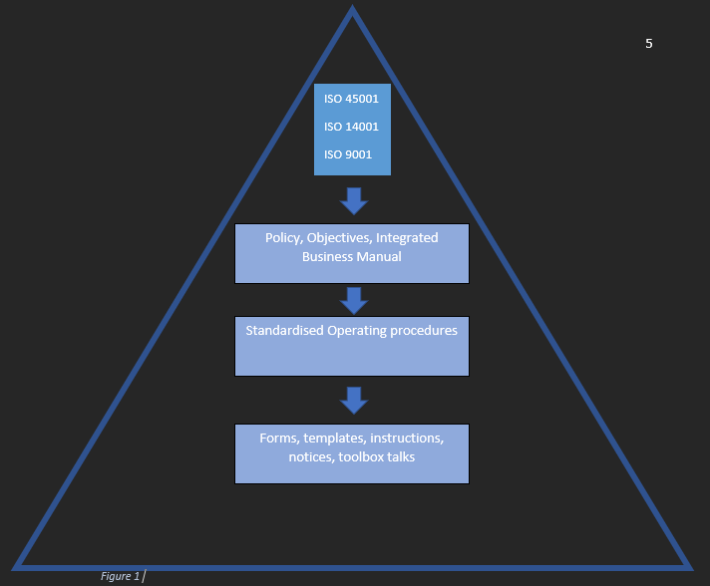

Total Quality Management applied to Procurement

A good example of how this works in practice is the way in which the companies’ suppliers are chosen. Using the standards set out above, there exists a framework for the purpose consistent supply chain management and procurement through the use of approved and evaluated suppliers. The purpose is to ensure that goods and services are purchased from suppliers of assessed capability who consistently meet the companies’ requirements. Compliance with the procedure should ensure that the products and services purchased are controlled and managed to minimise their potential impact on the quality of the products and services the company provides, i.e., large, and small concrete works from concrete frames to retaining walls, and other civil building works.

An approved supplier list is kept up to date, with suppliers being split into three categories depending on their importance to the companies end goal of delivering on a project. The categories are A, B, and C. The meaning of each is as follows.
- Category A- Category A suppliers are those that provide materials that will form a part of the final product.
- Category B- These suppliers will be those that provide products and services which aids in the manufacture of the final product.
- Category C- These will be suppliers which provide products and services not directly linked to manufacturing.
Do give examples for the company I work at; a category A supplier would be concrete and steel rebar suppliers. Category B would include things like power tools and PPE, and category C would be things like stationary or printer paper etc. When placed into one of these categories they are marked out of 10. This score depends on things like past history and performance, trial orders or sampling, recommendation from others, financial viability of that supplier’s business, as well as evidence of having ISO 9001, 14001, 45001 certifications.
This is one good example of how total quality management is of a benefit within a construction context. Every aspect of a supplier and their performance is constantly monitored and reviewed and scored using quantitative and qualitative methods.

Employee and Customer Engagement

As discussed earlier in this report, TQM is about including everything, and everybody associated with delivering a product or service. Another example of TQM within a construction industry context is how the employees and customers are included and engaged with, from the beginning to the end of a project. Within the company where I work, there is a dedicated manager whose role is to ensure that staff are communicated with, and feedback is collected continually to ensure of continuous improvement. These mainly take the form of communicating key policies through inductions, staff bulletins, on site toolbox talks, as well as weekly Health and safety meetings where observations are discussed and advice for improvement is given.

The same level of customer engagement is also afforded throughout a project. This usually takes the form of weekly site meetings, weekly health, and safety walk arounds, and at the end of the project, the customer is provided a questionnaire. This questionnaire is a way of monitoring the company’s quality of services and products as part of an ongoing improvement process. The customer is asked a series of questions, and asked to respond Excellent, very good, good, average, or poor. This exercise is not designed to lay blame for any shortfalls at any individuals door but is to document in a quantitative way the strengths and weaknesses encountered by the project team so that the lessons learned can carried forward to other projects. This again forming a part of the overall philosophy of continuous improvement. Figure two and three shows an example of these questions.
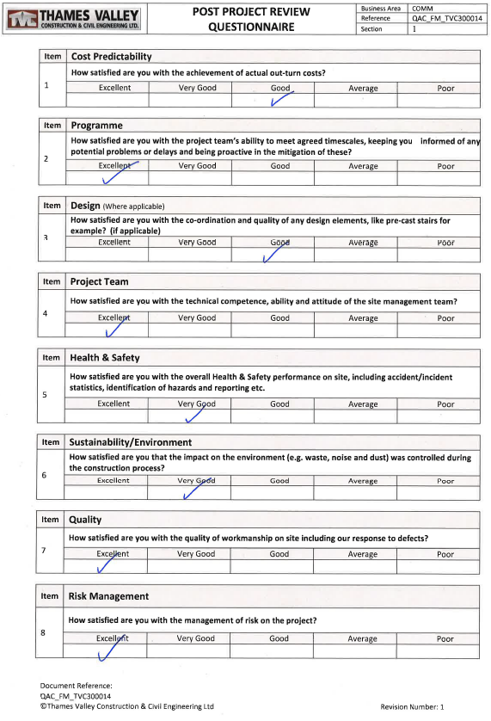
Figure 1- Post Project review Questionnaire

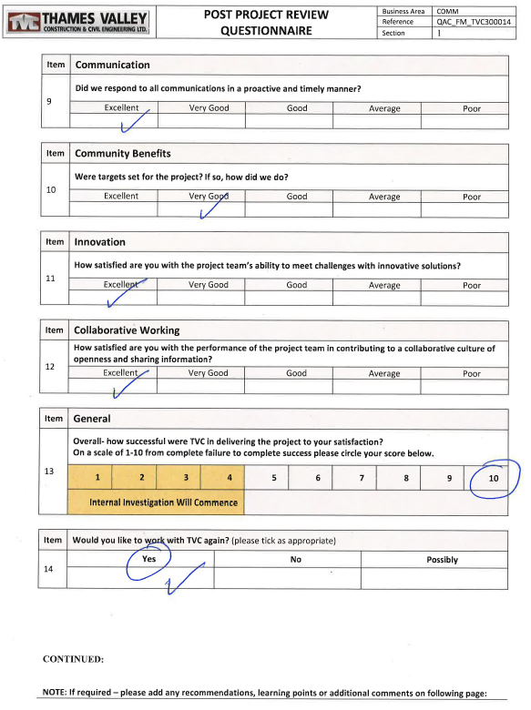
Figure 2 – Post Project review questionnaire continued.

As you can see at the end of the questionnaire, there is an opportunity for the person to provide some written feedback also, allowing both quantitative and qualitative results to be collected.

Conclusion and Closing Comments

Having looked at early forms of quality assurance and management, and international standards that most companies now look to be certified by, there is no question that the best approach to managing quality within a project is by adopting a total quality management approach. By incorporating a TQM mentality into a project, one ensures that every input into that project is looked at, thought about, and scrutinised, ensuring that a good output or product is the result. The more traditional forms of quality control that mainly relied on spot checks and human eye examination are just not robust enough to guarantee quality. Therefore, I would recommend that quality controls take the 360 approach that total quality management theories profess to, and that the international standards of ISO 45001, 14001, and 9001 are looked at carefully by those involved in the project and implemented at every level and phase of the duration of such a project. Without total quality management, how would it be possible to monitor wider impacts of constructions work, such as environmental or social implications.

References
Cambridge University Press. (2022, November 29). Cambridge Dictionary. Retrieved from https://dictionary.cambridge.org/dictionary/english/total
Deming, W. (2000). Out of the Crisis. MIT Press.
ISO 9001. (2015). Quality managment systems.
Pries, &. Q. (2013). Total quality management for project management. CRC Press.
Watkins,S and Orchsiton,N (2016) Introduction ISO 9001:2015 A Pocket Guide. IT Governance Publishing
Wood J, W. M. (2003). Henry Ford: Critiical Evaluations In Business and Management. Routledge.

