Carly North 1904917
Project Planning and Management
in the Workplace.

WBS
Project Manager (2021) states that a WBS is a work breakdown structure which is a visual, hierarchical and deliverable-oriented deconstruction of a project.
A WBS can be a helpful diagram which is used for project managers as it allows them to work backwards from the final deliverable of a project and then identify all the activities needed to achieve a successful project. All the steps of a project are outlined in the organizational chart of a work breakdown structure, which makes it an essential project management tool for planning and scheduling. The final deliverable rests on top of the diagram, and the levels below subdivide the project scope to indicate the phases, deliverables and tasks that are needed to complete the project.
Our WBS diagram identifies what we had to do to achieve our project scope which was a diagram for a Marketing strategy and developing and recruiting for skills for the work place. We then had two deliverables which was to Create a Marketing Plan and Recruit potential students. We took the deliverable out of creating a Marketing Plan by dividing them into two sub deliverables. Firstly, creating advertising Material to recruit potential students. We Created posters some Flyers and questionnaires to attract potential candidates onto joining the course. We then uploaded them onto social media. When looking at the other deliverable which was to recruit potential student’s we needed to look at the sub deliverables which was to identify interested candidates and inform them of the benefits of the course, we informed them by preparing them for the interview and the recruitment process. We informed the skills co-ordinator to arrange interviews and a selection date.
Gantt Chart
A Gantt chart is a popular type of a project manager’s tool known as a Bar Chart that illustrates a project Schedule. It was a very useful tool that helped to show all the activities that we had to take against time. Once we completed our WBS we then linked our activities within a Gantt Chart with a time frame to schedule our activities with a start and end date of completing our project. The Gantt Chart worked well for us as we only had a short time frame for our project therefor the Gantt Chart was an easy tool to check our progress by visualising our activities and our deadlines.
Network Diagram
A Network Diagram is also known as a flow diagram, which is also a graphical representation of the tasks we had to achieve in our project. The network Diagram helped us to track our progress of each stage in every activity we had to take to achieve our project by finding potential students to join the skills for the workplace course. The network diagram showed how much time was allocated for each activity that was taken.
All three tools were useful to help us complete our project as all the three tools are closely linked together.

Reference List
(Project Manager, 2021) A work breakdown structure is a visual, hierarchical and deliverable-oriented deconstruction of a project. Available at Work Breakdown Structure (WBS): The Ultimate Guide with Examples (projectmanager.com) [Accessed on June 11th at 10.50]

Slide 1
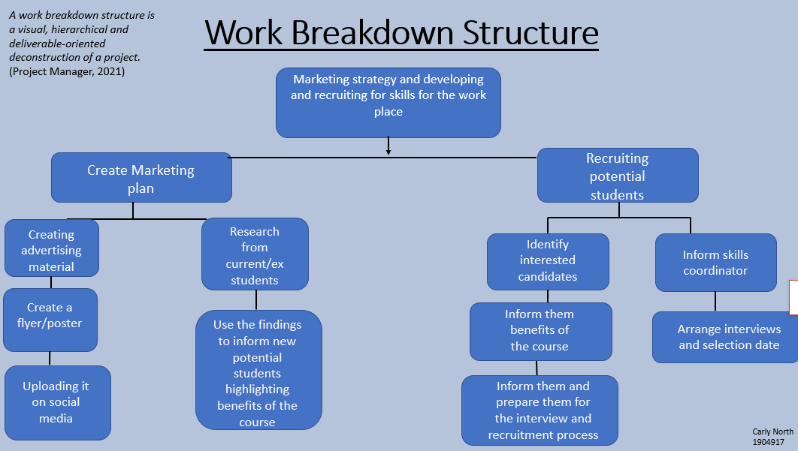

Slide 2
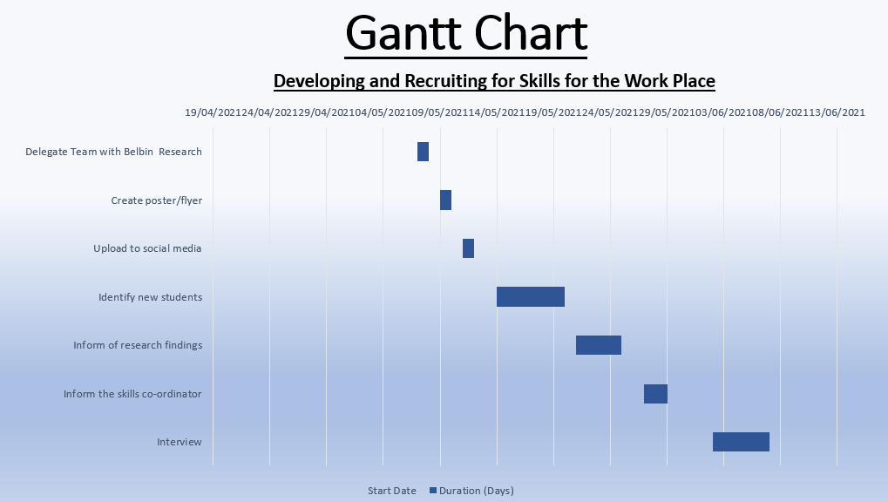

Slide 3



