Component 2 - Research Report
Student Name:
Student Number:
Lecturer Name:
BMSW4003_BIRM
Digital Skills and Research Methods.

Contents
1. Introduction 3
2. Research design 7
2.1. Research Question 7
2.2. Method 7
2.3. Ethical Considerations 7
3. Results 7
4. Discussion 7
5. Conclusion 8
6. Reference List 8
7. Appendix A – A blank copy questionnaire. 8

Introduction

This report will contain all the evidence and information we have collected to support our research question. We have created a questionnaire which was sent out to our peers to answer anonymously. The questionnaire consisted of different type of questions from how confident one is using digital tools to which digital tool is used the most frequently. Our main focus of the questionnaire was to determine “How do students use technology to collaborate at UWTSD?” Digital skills is important as a student because they are required to use it regularly within their time at university not only then but also in their normal day to day life. Students use digital skills to communicate with one another for example if a student was having any problems they would contact their lecturer via email because it is a quick and efficient way to communicate. Digital skills is also a great form of independent studying as some students believe when they self-study they tend to focus and participate more. Which will then encourage a student to work hard towards their goals. There are many other advantages as to why digital skills is important for a student, these will be discussed further within this report

Research design

Research Question

Our chosen research question was “which digital tool is most used by students at UWTSD to collaborate together?”. We believed this was a good question to gather information for as we knew we would get a range of different answers from students because there might be a student that is confident using one app whereas another might not be as confident . Everyone has different strengths and weaknesses so this was our opportunity to gather statistics enabling us to work with the results so we can find an accurate answer to our research question. Results showed a various range of answers.

Method

The main method we focused on was our questionnaire which was designed by us using Microsoft forms. We started off first by making sure the questionnaire was anonymous and getting the participant’s consent before they answered any questions. We then sent our questionnaire to our peers in class via email they were then asked to complete it and results were immediately sent back to us. Our first question we asked the participant was “how confident are you with technology?” a short simple question to give the participant an idea of what the questionnaire consists of this would also give us a brief idea on how confident one is with general technology. Our second question we asked the participant was “when collaborating with peers do you use one digital tool more than others?” this indicates how many students actually use digitals tools and if so if more than one is used. Next question asked was “which of the following apps do you feel most comfortable using in order to get in touch with your peers?” we gave them a few options to choose from to get a rough idea on which is the most used by the students to communicate with their peers. The following statement was next “please rank the following platforms from most used to least used” this was a beneficial thing to ask as we would know if students used the platforms we had in mind or any other ones this also showed the highly used platforms and the least. We then asked our peers how confident they are with some statements, we suggested a few and they would determine whether they strongly agree, agree, disagree or strongly disagree. This helped because it would give us a clear understanding of much the peers agreed or disagreed to an extent. The second to last question we asked our peers was “ how often do you use OneDrive to communicate with your peers?”. We asked this question because we believed the most used app students used to communicate with their peers was OneDrive so we needed to ask this question to find our if our hypothesis was correct or not. Lastly, the question we asked was “how old are you?” we believe this was an important question to ask because we felt as if the older generation may not use digitals as much as the younger generation because now everything is mostly technology based and they tend to have a better understanding of it.

Ethical Considerations
During the questionnaire we ensured ethical considerations were put into place, this was done by assuring consent from the peers before they filled out anything. This needed to be done as we have to keep all data and information collected kept confidential failure of doing this would result in consequences for both the student and university. Students could lose their place at the university and also lose their reputation, university could result in a rather significant fine or financial loss which will then obviously have an impact on them .Following ethical considerations avoids problems and makes sure protection is put into place.

- Results
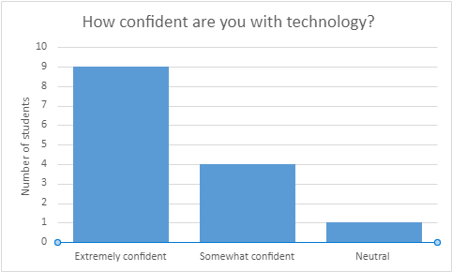
This graph shows that majority of the peers are
extremely confident in using technology however some
are only somewhat confident and one person feels like they
are neutral
.
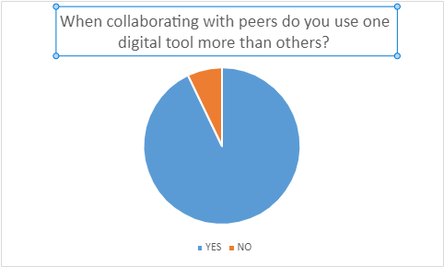
This pie chart shows that 90% of the peers use more than digital tool more than others and 10% only use one this gives us a clear understanding that numerous of digital tools are used to communicate with one another.

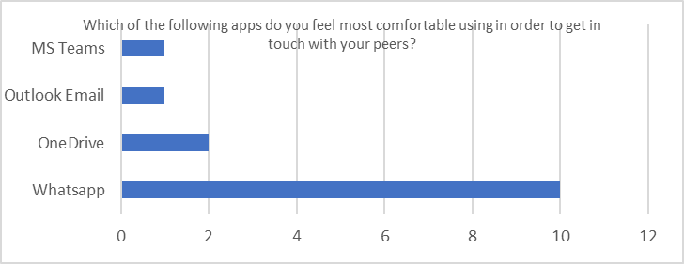
This graph shows that WhatsApp is the most popular digital tool used to communicate and MS Teams is the least popular tool used. Two people feel comfortable using OneDrive and only one person feels comfortable using Outlook Email.

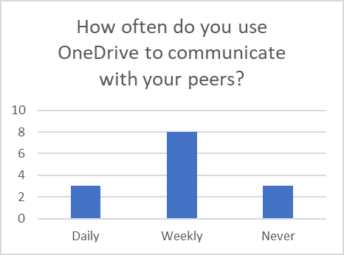
This graph shows that 8 students use OneDrive to communicate with their peers weekly whereas 2 students use it daily and 2 never use it. This shows that half of the students use it weekly whereas the other half don’t.

This graph shows that more than half of the students are aged between 25-34.

- Discussion
Our results clearly show that the most common digital used app by peers to communicate with other is WhatsApp this was shown in many of the questions we asked. Digital tool is a very common thing in work, school and universities. Research made by Teo et al (2014) show that when students use technology within their work it helps them as it has been proven to be free of effort and students that are using technology are more eager to learn as they are going out of their own way to research and gather information and not relying on the resources and materials the lecturer provide. Our results showed a clear mode as out of 14 most peers selected the same answers. This wasn’t a surprising matter to us as we know the peers in our group communicate with one another via WhatsApp as majority of us are in a WhatsApp group together. Although we gathered that Whatsapp was the most used app it shocked us a little as to how little peers used outlook considering it is the only way we can communicate with our lectures or anyone within the university campus not much students used it. Our results agree with other researchers (Forbes & Khoo 2015) stated that students need to understand the skills and knowledge of digital tools because communication technologies are becoming a very important thing in today’s society. From our last graph you can see the number of students aged between 25-34 was high as they most likely have a better understanding and better comprehension on how to work and use technology whereas the peers that are older may have less understanding as they may have not used technology as much or maybe because they weren’t taught how to use it as before technology was not that common however now nearly everything is technology based which shows that the younger generation are more developed than the elders. Nevertheless some results may contrast ideas of other researchers as Nonetheless, “in many cases, students don`t succeed in using the Internet to appropriately research and they do not know how to evaluate whether the source is adequate or credible.” (Thieman, 2008, p.360)​ our results were mainly based on the communication side of the collaboration so therefore we didn’t get much results from the research perspective but its normal for people to think that as everything we see on the internet may not be true. While using online sources you need to be careful as things can easily be edited and results may not be one hundred percent accurate. The results we gathered from the questionnaire confirmed our hypothesis as we believed that there would be one digital tool that students used more than others we also believed one digital tool will be used more frequently depending on someone’s knowledge and how developed someone’s IT skills are. Our results shocked us in a way as we didn’t expect our hypothesis to be accurate we thought our hypothesis would be the complete opposite whereas it wasn’t. Results showed students used a wide range of digital tools to communicate so that tells us most students are confident when it comes technology and digital tools because if they weren’t they would have difficulties to communicate. Our results enabled us to discuss many different things as we had quiet a lot of responses back from our peers which then helped us when it came to the results because we had a good number to work with which meant our results are more reliable, this is important because if we tried to conclude with a low number of responses it would impact the results as their wouldn’t be much to come to a conclusion with.

- Conclusion
My conclusion from our results we have gathered that even though a range of digital tools were used there was one that was used more then another. The most popular digital tool used was WhatsApp and the least digital tools used was MS Teams and Outlook email, this surprised us as we thought Outlook would be the most popular way to communicate as it commonly used a lot in universities where other students can get in contact with their peers and most importantly their lecturer. In my opinion I believe the only reason why WhatsApp was the most common used digital tool to communicate was only because most of our peers are in a WhatsApp group with majority of the class so therefore it’s a lot more easier to text on that however I personally believe that if the WhatsApp group did not exist then the most common digital tool used to communicate would have been email as it is a quick and efficient way to communicate also no ones personal details is needed such as their phone number so if you wanted to communicate with them all you were to need was their university email address. We have gathered great results from our questionnaire and proved how students use technology and digital tools to communicate with one another.

- Reference List

Amhag , L , Hellström , L and Stigmar, M. (2019)
‘Teacher Educators' Use of Digital Tools and Needs for Digital Competence in Higher Education’, pp. 203-220
Teo, T and Zhou, M. (2014)​
‘Explaining the intention to use technology among university students: a structural equation modelling approach` Journal of Computing in Higher Education, 26, pp.124–142

Thieman, G. (2008) `Using Technology as a Tool for Learning and Developing 21st Century Skills: an Examination of Technology Use by Pre-Service Teachers with their K-12 Students`, CITE, 8(4), pp. 342-363

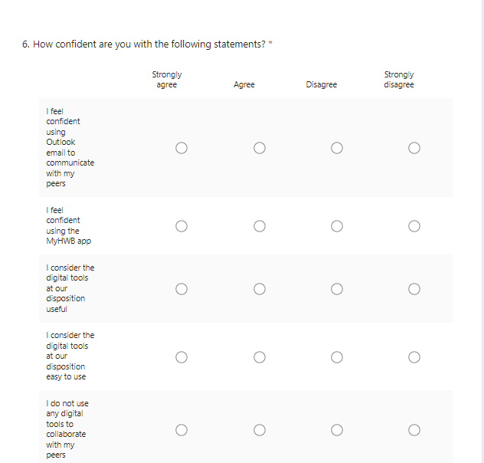
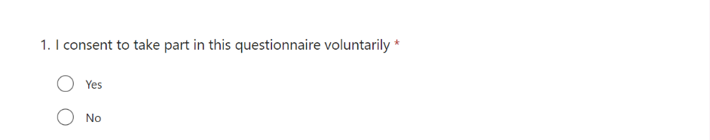
- Appendix A – A blank copy questionnaire.



