GHEORGHE ADRIAN COT
1913213

MENTAL DISORDERS and PSYCHOPATHOLOGY. BMHP6006
CHLOE HARRIES
DEMENTIA

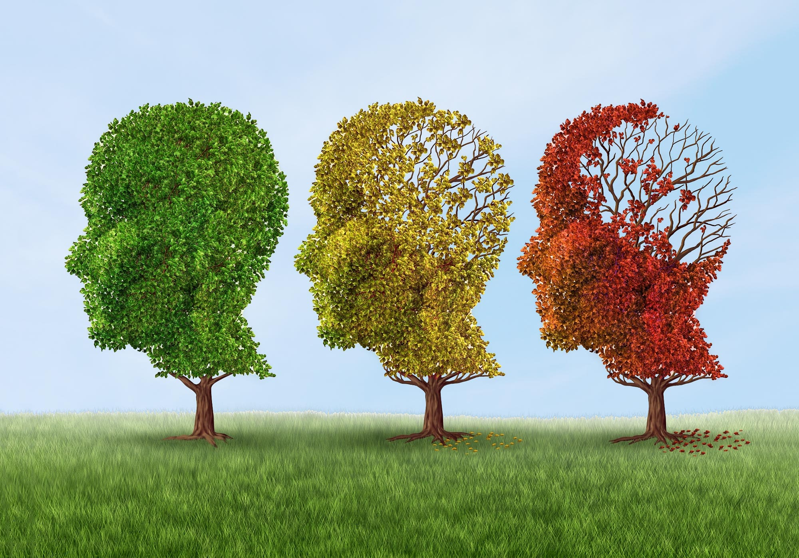

Table of contents
1 | Introduction………………………………………………………… | 3
2 | Definition and Classification……………………………………….. | 4
3 | Diagnosis…………………………………………………………….. | 8
4 | Treatment……………………………………………………………. | 10
5 | Measurement of rehabilitation……………………………………….. | 11
6 | Recommendations for future practice………………………………... | 14
7 | Conclusion……………………………………………………………. | 15
8 | References……………………………………………………………… | 16

Introduction
We are all aware that the population is ageing and that an increasing number of elderly individuals are suffering from dementia. If you work in health care, there's a high chance you're already familiar with dementia. If, on the other hand, you are a loved one of someone that has got diagnosed with dementia, you may be seeking for an explanation to dementia.
Dementia is not a natural component of the ageing process. Dementia is much more than a slip in remembering or a bout of forgetfulness; it is far more serious. Dementia is not merely a condition that impacts the elderly, but it is more frequent in them. It also affects some younger people; however, this is uncommon. When someone under the age of 65 is diagnosed with dementia, it is referred to as 'early onset dementia.'(Kitwood,1997)
Most people equate Alzheimer's disease and that of dementia, although they are not quite the same thing. Alzheimer's disease is the most frequent kind of dementia. It is, however, not the one. On the other hand, Dementia is not a mental disorder. Dementia is associated with brain damage induced by an illness. It is a physical, not a mental, ailment.
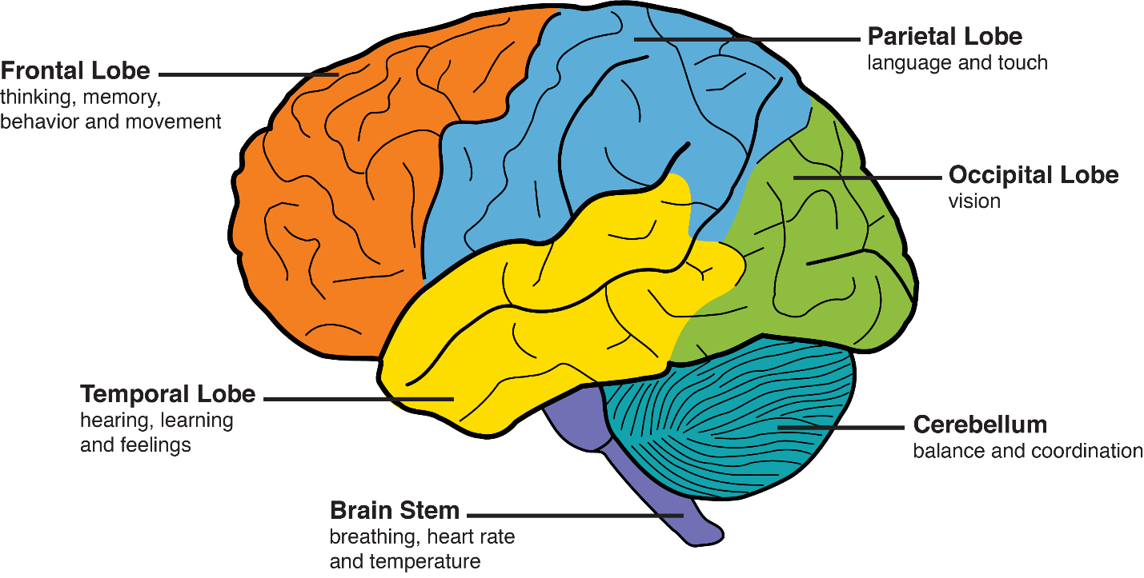
The level to which awareness is conveyed is influenced by the environment and the kind of caring relationships. There may be opportunities to increase the portrayal of some aspects of consciousness in persons with mild to severe dementia, but this should only be done if it is likely to raise the standard of living. Knowing more about alertness is essential for providing high-quality care to persons with mild to severe dementia. The most significant risk factor for dementia is age. Dementia is becoming more frequent as individuals age, but this does not imply that dementia is a natural component of aging. Dementia is a disease that affects up to 40% of adults over the age of 85.
Dementia is the world's 6th leading cause of death, as well as one of the leading causes of disability and dependency among the aged. Dementia sufferers, as well as their caregivers, family, and society in general, face physical, emotional, social, and economical consequences. Dementia is commonly misunderstood and stigmatized, causing diagnostic and treatment lags. Dementia affects around 55 million people globally, with over 60% of them living in low- and middle-income countries. As the proportion of elderly persons in the general population rises in almost every state, this figure is expected to rise to 78 million by 2030 and 139 million by 2050.
Across many situations, the etiology of dementia is unclear. Although research into what causes dementia is ongoing, the fundamental process is assumed to be connected to a build-up of proteins in the brain that interacts with how the brain operates or functioning. Frontotemporal dementia and other neurodegenerative illnesses cause aberrant protein build-up in the brain. Distinct kinds of dementia are characterized by different protein build-ups. Proteins such as beta-amyloid and tau, for instance, are linked to Alzheimer's disease, whereas alpha-synuclein is linked to Lewy body dementia. Vascular dementia can be caused by variations in the blood arteries in the brain. In a small number of instances, a changeable cause of dementia can be found and cured. These reversible are being screened for (Clare,2010).
Dementia
Definition
Dementia is described as a declining cognitive function, such as understanding, recalling, and thinking, that affects a client's daily activities and life. Certain dementia sufferers lose control of their emotions, causing their personalities to alter.
Symptoms
- Memory loss, poor judgement, and confusion are all symptoms of Alzheimer's disease.
- Talking, comprehending, and exchanging ideas, as well as reading and writing, are all difficult tasks.
- In a familiar neighborhood, roaming and becoming lost
- Having difficulty managing processing payments in a responsible manner
- Questioning over and over
- Using unusual words to refer to everyday objects
- Routine daily duties take considerably longer.
- Irrational aversion to routine activities or situations
- Experiencing illusions, hallucinations, or psychosis
- Making hasty judgments is number ten.
- Not caring about the sentiments of others
- Problems with mobility and loss of balance
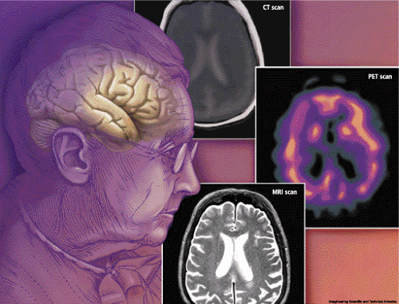

DSM-5 classification of Dementia
Dementia is classified as:
A. Prominent deterioration in one or more cognitive areas, as determined by:
There is a little deterioration in one or more cognitive domains, as evidenced by:
1. A person's or a trustworthy informant's concern about a severe deterioration, as voiced or witnessed by a therapist.
2. Significant cognitive decline, as determined by objective cognitive testing.
- Disruption of autonomy in daily tasks.
There is no interruption with freedom in daily activities, despite the fact that these tasks may need lot of time and effort, accommodations, or corrective techniques.
- Not only when you're delirious.
- Isn't justified by some other mental illness
- Identify one or more etiologic subcategories that are caused by
- Alzheimer’s disease
- Cerebrovascular disease
- Frontotemporal Lobar Degeneration
- Dementia with Lewy bodies
- Parkinson’s disease
- Huntington’s disease
- Traumatic brain injury
- HIV infection
- Another medical condition
- Multiple etiologies
(American Psychiatric Association,2013; Wetterling, Kantiz & Borgis,1996)
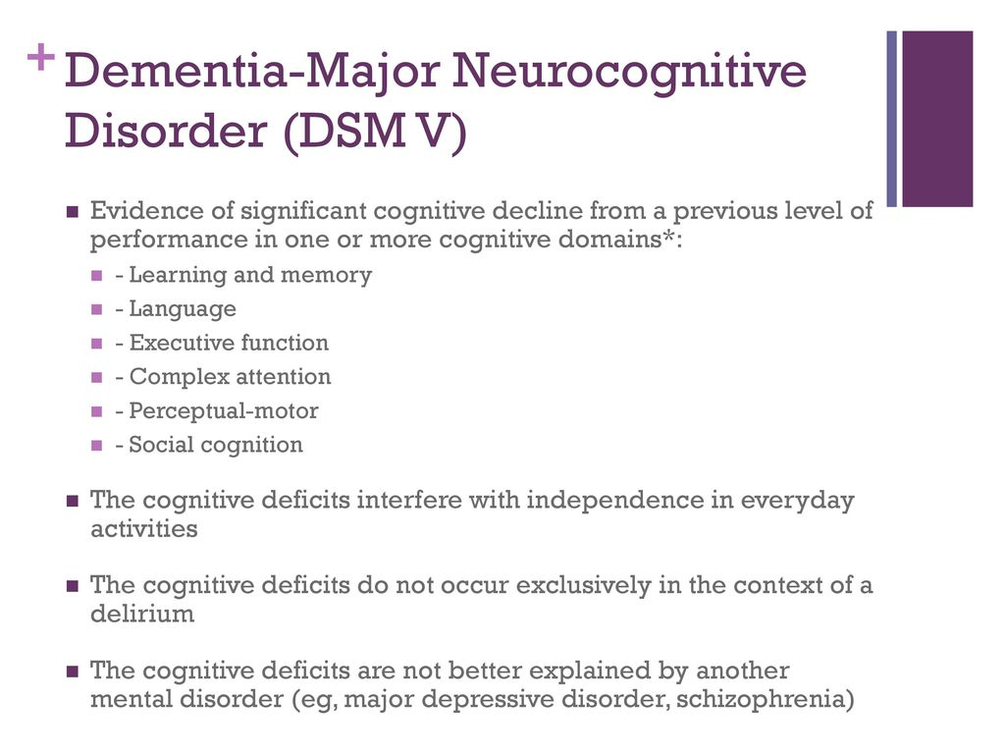
ICD-10 classification of Dementia
The diagnostic code for dementia in ICD-10is from (F00-F03). It is a disorder caused by a brain disease, usually chronic or progressive, in which numerous upper cortical capacities are impaired, including remembering, thinking, orientation, comprehension, calculation, task persistence, speaking, and judgement (WHO, 2010). The amount of awareness is obvious. Emotional control, social habits, and meaning loss are commonly linked to, and occasionally worsened by, cognitive function issues. This condition can occur as a result of Alzheimer's disease, cerebrovascular disease, and other illnesses that cause direct or indirect brain injury.
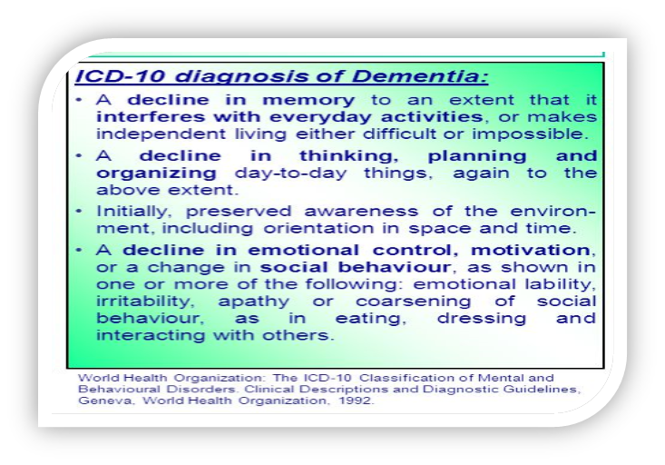

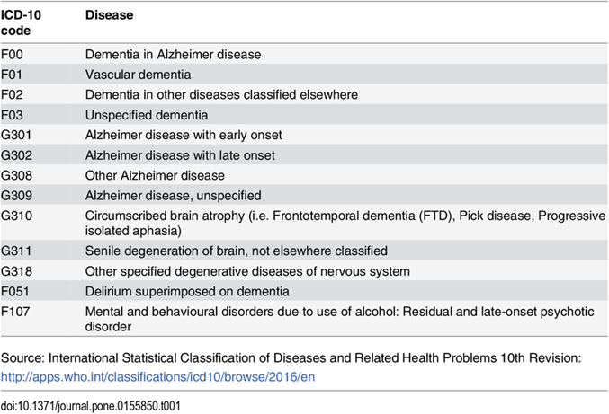

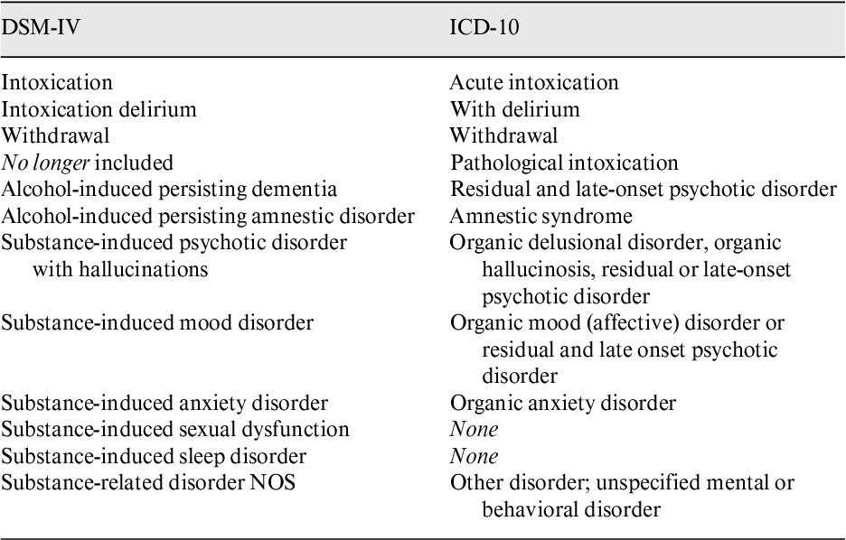
Diagnosis
Dementia and its many forms could be difficult to detect. A doctor must first examine the trend of loss of capabilities and activities, as well as assess what a client can still do to diagnose dementia. Alzheimer's disease indicators have recently been accessible to aid in diagnosis. Your doctor will review your medical history as well as do a physical examination. He or she will very definitely ask someone nearer to you about your issues. Doctors will probably do a series of tests to pinpoint problem down because no one test only can diagnose dementia.
Tests of cognitive and neuropsychology
Your capacity to think will be assessed by doctors. A variety of tests, such as recall tasks, are used to assess cognitive abilities.
Evaluation of the nervous system
Doctors will assess your recall, speech, sensory perceptions, concentration, problem-solving skills, mobility, sensations, coordination, instincts, and other abilities.
Scans of the brain
• CT or Magnetic resonance imaging (MRI)
These tests can detect signs of a haemorrhage, a bleed, a tumour, or hydrocephalus.
• X-rays and PET scans
These can reveal neural activity patterns or if the amyloid or tau proteins, which are markers of Alzheimer's disease, have accumulated in the brain.
Tests in the lab
• Laboratory tests
Simple blood tests can uncover physical problems that may affect brain function, such as vitamin B-12 deficiency or an underactive thyroid gland. The spinal fluid is often examined for infections, oedema, and symptoms of different progressive illnesses.
- Psychiatric assessment
A qualified doctor of mental health can assess if your symptoms are caused by despair or some other mental health problem. (Wilson D,2014).
Treatment
Most types of dementia cannot be cured but there are ways to manage your symptoms.
- Medications
- Cholinesterase inhibitors Donepezil (Aricept), rivastigmine (Exelon), and galantamine (Razadyne) are drugs that act by raising the amount of a chemical signal important in remembering and judgement. These drugs are used to treat vascular dementia, Lewy body dementia, and Parkinson disease dementia in addition to Alzheimer's disease. Adverse effects include nausea, vomiting, and diarrhea, as well as decreased heart rate, dizziness, and sleep difficulties.
- Memantine (Namenda) regulates GABA activity, a chemical messenger important in brain functions such as cognitive performance. Memantine is sometimes used with a cholinesterase inhibitor. Drowsiness is a common adverse effect.
- Therapies
There are several non-drug treatments for dementia which are as follows:
- Occupational therapy
- Modifying the environment (Create a harmless environment, remove all those cutlery and sharp items that might threaten safety)
- Simplifying tasks
- Lifestyle and Home remedies
- Enhancing communication
- Engaging in activities
- Encourage exercise
- Establish a night ritual (could be yoga, book reading, listening to the music, talking with family member)
- Keep a calendar
- Plan for the future
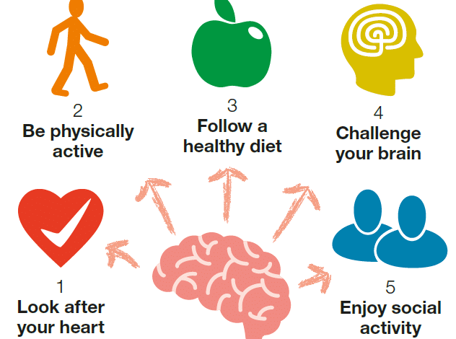
- Other therapies
- Art therapy
- Music therapy
- Pet therapy
- Aromatherapy
- Massage therapy
- Watching videos of family members
- Light exercise
- Stay active
- Spend time with family and friends
- Indulge with online community
- Alternative treatments
If you're using other prescriptions, use caution while contemplating nutritional supplements, vitamins, or herbal therapies. These cures aren't regulated, and beneficial claims aren't usually backed up by scientific evidence. While some research suggests that vitamin E supplementation may aid with Alzheimer's disease, the evidence is conflicting. High dosages of vitamin E can also be dangerous. Taking vitamin E pills is typically not advised but include vitamin E-rich foods in your diet, such as almonds, is.
- Therapy for cognitive stimulation
The National Institute for Health and Care Excellence (NICE) presently recommends it as the sole psychological dementia therapy for persons with moderate or severe dementia.
- Aducanumab therapy
The US Food and Drug Administration has given Aducanumab (AduhelmTM) expedited authorization as an Alzheimer's disease therapy (FDA). This is the first FDA-approved treatment for Alzheimer's disease that targets the illness's fundamental physiology. This treatment is only available in USA.
- Cognitive rehabilitation
It is a behavior change intervention, based on understanding of cognitive changes seen in mild to moderate dementia. It enables individuals to efficiently within their intrinsic capability and present health status and they have opportunities to participate in meaningful roles and activities.
- Prioritize good sleep
People suffering from dementia need to fulfil their sleep cycle and take proper rest for betterment and improvement of their condition
- Reminiscence therapy
It may include talking with your loved one about their birthplace, school years, work life, or hobbies. It can be done one-on-one or in groups as part of an organized therapy. The individual who began the gathering may utilize music from your beloved one's past, as well as photographs or valued items.
- Focus on good diet
Good diet plays a great role in the prevention of chronic illnesses like dementia
e.g., beans, spinach, olives, fish, beans, berry, nuts, green vegetables
(Tisher & Salardini,2019)
Measurement of rehabilitation
- Psychological testing scales are there to access and check for the severity in the symptoms of dementia.
- Clock drawing
There have been several variations of the clock drawing exam developed, each with its own grading methodology (Brodaty and Moore,1997). Typically, patients are instructed to design a clock face with digits and fingers. It's quick, doesn't need any instruction, and most rating techniques are straightforward. It only examines a small portion of the cognitive loss found in dementia, and many other illnesses (such as stroke) will have a direct impact.
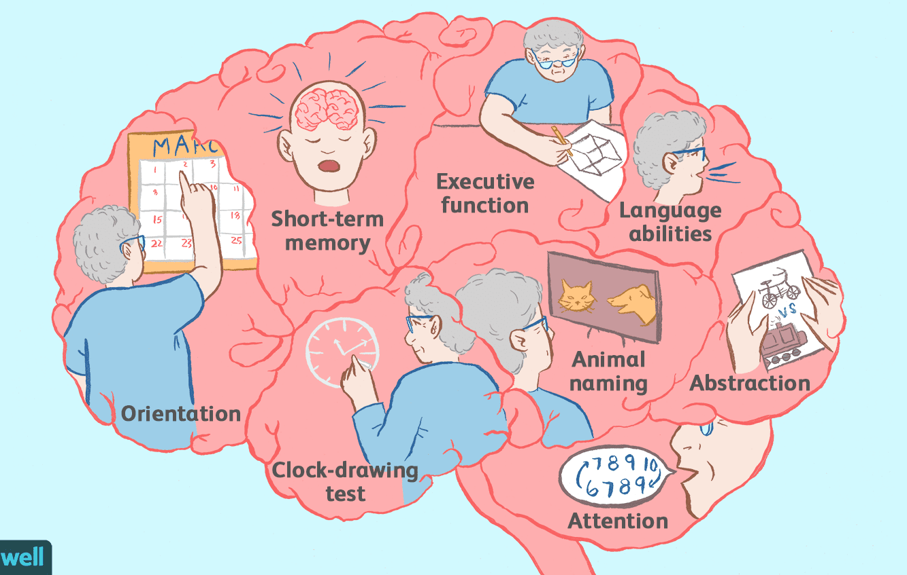
- Abbreviated mental test score
It is a scale with 10 items that was adapted from a larger scale (Hodkinson,1972). This may take 3-4 minutes to be completed and it evaluates, navigation, registration, recall and concentration and scores of 6 or less have been shown to effectively screen dementia.
Mini cog
It’s a very short 3 min test (Borson et al,2000) suitable for primary screening for dementia. It incorporated the clock drawing test adding a three-item delayed recall test.
- 6-CIT
It was created for primary care screening. It can be completed in 3-4 minutes and scores from 0-28, with a cutoff of 7/8 indicating excellent sensitivity and specificity. It's quite simple to use.
- Test your memory
It is a 10-item cognitive test designed to be self-administered under medical supervision. The maximum score is 50, at a score of 30 or below the test has good specificity and sensitivity in distinguishing dementia from non-dementia cases (Hancock and Larner,2011)
- Mini-mental state examination
The MMSE is perhaps the most well-known and commonly utilized cognition test in clinical practice across the world (Folstein et al.1975). This scale takes around 10 min to complete and may be done by physicians or researchers with no training. It evaluates cognitive abilities in the areas of direction, memory, attention, and computation, as well as linguistic and visual acuity. Patients receive a score between 0 and 30. A score of 20 to 24 indicates little dementia, a score of 13 to 20 indicates moderate dementia, and a score of less than 12 indicates chronic dementia. On average, a person with Alzheimer's disease loses 2 to 4 points on the MMSE per year. Nevertheless, its often misinterpreted as a medical method when it is only a screening test with low sensitivity (NICE,2006)
- Memory impairment screen
It is a 4-item scale takes about 5 minutes to be administered. However, it lacks executive function or visuospatial items. Its use is likely to be confined to the primary care.
- Bristol activities of daily life scale
It includes 20 daily life activities and takes 15 minutes by a clinician or expert to administer it (Bucks et al.1996)
- Neuropsychiatric inventory
It assesses the frequency and severity of a wide variety of behaviors associated with dementia, such as psychosis, restlessness, sadness, impatience, and lethargy (Cummings et al.1994). It takes a clinician 10 minutes to administer. It has high psychometric qualities and is commonly used in pharmacological studies, yet it is short enough to be considered for therapeutic usage.
- DEMQOL
It is a 31-item disease-specific instrument for assessing health-related quality of life in dementia that has been verified in the UK population and has equivalent psychometric qualities to the best current tools. It's mostly employed in scientific investigations.

- Interviews
Interviews are conducted with the people suffering from dementia and with their family members in order to select for the best rehabilitation treatment plan for the patient after the final diagnosis
- Reality orientation training
The basics of reality induction program include the person's name, as well as the day and time. They may have posted signs with such material all throughout their house. That might be too much for certain folks, or even condescending. Drop it if it isn't functioning for your beloved one.
(Laver et al, 2020)
Recommendations
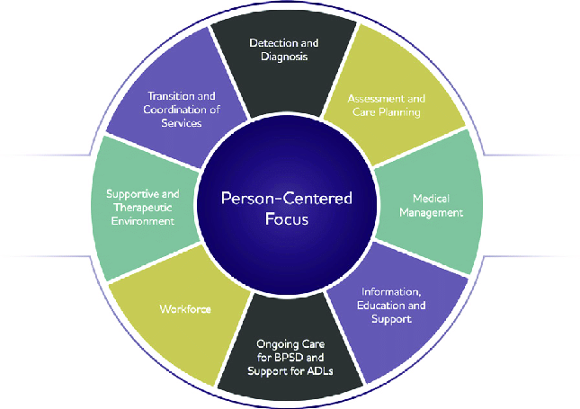
- Consider the levels of Dementia whether it’s the mild, moderate or severe dementia and devise a treatment plan accordingly. Mild dementia, which is commonly misdiagnosed, affects some aspects of memory, such as memorizing, maintaining new connections, and doing complex tasks. Moderate dementia impairs a person's ability to perform physically, make sound decisions, and interpret sensory data. Memory loss, movement issues, and loss of bladder or stool control are all symptoms of severe dementia. Each level of dementia has an impact on how others engage with the client and deal with the client's actions.
- After you've received your diagnosis, start making plans, starting to plan for house adaptations and care must begin as soon as a person is diagnosed with mild dementia or early onset dementia. Take advantage of the chance to talk about the patient's preferences while he or she is still able, even if everyone is aware that he or she may not remember anything afterwards. Replacing or covering area and throw rugs, adding security patches and locks, and potentially remodeling a washroom are among changes that should be made to the client's house. To plan for the loss of limbs, a ramp may be required to provide motorized wheelchair access into and out of the home.
- Take a break, as they manage with the everyday challenges that emerge, caretakers of dear ones with dementia typically experience significant levels of stress, worry, and sadness. Patients' behaviors tend to intensify as the disease progresses, making it tough to control, much alone watch somebody go through something like this. For a single individual, round-the-clock care might be taxing. You'll ultimately ought to take a break to recharge your batteries. Most healthcare companies will offer patients with home health care, such as a visiting nurse or somebody to care for dementia sufferers throughout the day for a certain length of time.
- Keep the distinction between day and night distinct. Dementia patients frequently feel out of control, that has a significant impact on their sleep schedule. To counteract this, assist the patient in clearly seeing the contrast. Daytime, open the blinds and curtains and put on the lamps to make the house pleasant and cheery. Lock all the doors and use low illumination at night. Install digital timers in every room but make absolutely sure they distinguish between o’clock in the morning and o'clock in the night and set alerts for critical events like eating.
- Dementia patients should be monitored carefully regarding their diets, alcohol and caffeine should be avoided and healthy food should be eaten
- If the diagnosis is not clear through one test than other tests can be used in collaboration to make an appropriate diagnosis
- Avoid stress causing situations and caregivers should also take care of this, create a peaceful happy environment for the patient with dementia as stress can aggravate the condition
- Music, book reading and watching movies should be included in the therapeutic treatment for the patients of dementia
- All types of head injuries should be avoided
- Manage blood sugar levels
- Dietary Supplements should be added in the diet of people with dementia
- Alternative treatments like acupuncture and cupping should be included in the treatment of dementia.
- Create group community talk sessions between normal people and people with dementia, enhance communication sessions.
(Shaji &Paul,2018)
Conclusions
Dementia is a neurological degenerative disorder which needs proper pharmacological and non-pharmacological interventions. Early detection can help in the better control of the symptoms and can lead to proper functioning of an individual. Caregivers need proper guidance while taking care of patients with dementia and they are also advised to take care of their physical and mental health too.
References
- American Psychiatric Association (2013). Diagnostic and Statistical Manual of Mental Disorders. Diagnostic and Statistical Manual of Mental Disorders, 5(5).
- Bernstein, A., Harrison, K.L., Dulaney, S., et al. (2019) ‘The role of care navigators working with people with dementia and their caregivers.' Journal of Alzheimer's Disease, 71(1), pp.45-55.
- Clare, L., (2010). Awareness in people with severe dementia: Review and integration. Aging and Mental Health, 14(1), pp.20-32.
- Clare L., (2017). Rehabilitation for people living with dementia: A practical framework of positive support. PLoS Med. 14(3):e1002245. Available at: doi: 10.1371/journal.pmed.1002245.
- Fazio, S., Pace, D., Maslow, K., Zimmerman, S. and Kallmyer, B., (2018). Alzheimer’s Association dementia care practice recommendations. The Gerontologist, 58(suppl_1), pp. S1-S9.
- Kales, H.C., Gitlin, L.N. and Lyketsos, C.G., (2015). Assessment and management of behavioral and psychological symptoms of dementia. Bmj, 350.
- Kitwood, T., (1997). The experience of dementia. Aging & mental health, 1(1), pp.13-22.
- Knopman, D.S. and Petersen, R.C., (2014). Mild cognitive impairment and mild dementia: a clinical perspective. In Mayo Clinic Proceedings. 89(10), pp. 1452-1459. Elsevier.
- Laver, K.E., Crotty, M., Low, L.F., Clemson, L., Whitehead, C., McLoughlin, J., Swaffer, K. and Cations, M., (2020). Rehabilitation for people with dementia: a multi-method study examining knowledge and attitudes. BMC geriatrics, 20(1), pp.1-10.
- Shaji, K.S., Sivakumar, P.T., Rao, G.P. and Paul, N., (2018). Clinical practice guidelines for management of dementia. Indian journal of psychiatry, 60(Suppl 3), pp. S312.
- Sheehan, B., (2012). Assessment scales in dementia. Therapeutic advances in neurological disorders, 5(6), pp.349-358.
- Wetterling, T., Kanitz, R.D. and Borgis, K.J., (1996). Comparison of different diagnostic criteria for vascular dementia (ADDTC, DSM-IV, ICD-10, NINDS-AIREN). Stroke, 27(1), pp.30-36.
- WHO (2010). The ICD-10 classification of mental and behavioural disorders: clinical description and diagnostic guidelines. In: World Health Organisation International, 10th ed. [online] Geneva.: World Health Organisation. Available at: https://icd.who.int/browse10/2010/en.
- Wilson, D., (2014). Quantifying the quiet epidemic: Diagnosing dementia in late 20th-century Britain. History of the Human Sciences, 27(5), pp.126-146.
- Tisher, A. and Salardini, A., (2019). A comprehensive update on treatment of dementia. In Seminars in neurology. 39(02), pp. 167-178). Thieme Medical Publishers.

