  Component One:  What are the key skills required when working in the housekeeping team? 750 words (+/- 10%)  Contribution to Overall Module Assessment: 25% | Student No: | Denis Buzdugan  2130036
 | Module Title: | Operating Hotel Facilities
 | Module Code: | BMIH4006
 | Lecturer: | Kathryn Fynn
Housekeeping is a professional job profile in the hospitality and management industry (Stoyanova-Bozhkova, 2022). The role of housekeeping in the hospitality industry is to make sure to inspect the room and provide clean and proper service by making sure the rooms are clean, and all the facilities are provided with proper management to the guests (W Fakhry et al., 2022). Housekeeping is the basic and crucial role in hospitality, as the industry aims to provide the guests with the best service, which would satisfy their stay at the hotel or restaurant by providing the core service of clean housekeeping service for the guests. The role of housekeeping is to clean and sanitize the rooms and hotel, provide clean service to the guests, clean and vacuum the floors, blankets, laundry, and carpets in the hotel, Iron the laundry and make the beds and bring clean and new linens, provide with clean and sanitize rooms and washrooms, and empty trash cans of the rooms. The main purpose of the housekeeping duties is to provide the guests with a clean and fresh service that will maintain the hotel standards and image among the targeted audience and help to lead the organization in the hospitality industry (Giousmpasoglou and Casson, 2022).

There are key skills required for housekeeping to make sure the housekeeping service of the organization satisfies the guests and meets their needs and expectations. Housekeeping skills are important for providing better and more effective service to the guest, which includes the basics of cleaning, time management the attention to detail (Khymdeit, 2022). The skills required for the housekeeping profile in the hospitality industry are Time Management, Detail-Orientation, Communication skills, Interpersonal skills, customer service, flexibility, and hard skills in housekeeping.

Time Management

The key skill required for the housekeeper in the housekeeping job profile is time management, and the housekeeper should be able to understand how to manage time and accomplish tasks on time. The housekeeper needs to accomplish various tasks and can be in charge of more than one room, and to achieve all these tasks and provide proper service in every assigned room, time management the housekeeper should be exact so that the time is allotted for every task properly in order to finish it.

Detail-Orientation
Being detail-oriented in a housekeeping job is important to be perfect at the housekeeping service, as the duties performed by the housekeeper are related to cleaning and sanitization, and the housekeeper should pay attention to every minute detail. To make sure the guests are satisfied with the room service and the hotel doesn't receive any complaints from the guests regarding cleanliness and sanitization (Hutagalung, 2022). Giving attention to every minute detail is important to give the perfect service. The housekeeper should pay attention to the minute details like changing the sheet and laundry in the room, cleaning the washrooms, and emptying the trash cans.

Communication Skills
Communication skills are essential for the housekeeping job to interact with the guests to assure that they are satisfied with the services provided by the hotel through good communication skills, the housekeeping can understand the requirements of the guests and can provide better services.

Interpersonal Skills
Interpersonal Skills are required for better housekeeping services because the housekeeper needs to work with the client to provide direct service to them and also has to coordinate with the supervisors and managers. To manage things with both the clients and the senior executives, the housekeeping should have better interpersonal skills (Shestakofsky and Kelkar, 2020).

Customer Service
The main purpose of organizations dealing in the hospitality industry is to provide their clients with the best service, which can keep their image and also lead the hospitality industry. Providing clients and guests with the best possible cleaning, food, and other basic services is important for the organization as the hospitality industry depends on customer service and customer satisfaction (Kitsios et al., 2021).

Flexibility
Flexibility in housekeeping refers to the housekeeper should have the ability to work flexible shifts as per the need of the clients and guests (Norrild and Korstanje, 2021). The housekeeper should have the skill of being flexible enough to work on the tasks assigned by the senior executives as per their needs. Being flexible can encourage the housekeeper to take on different and variety of tasks, which will help them to learn a variety of things and gain experience and implement the leanings in the improvement of the housekeeping services.

Hard Skills in the Housekeeping
Hard skills in housekeeping are necessary to accomplish the specific tasks of the housekeeping services, which are essential skills and tasks in the hospitality industry (Shereni, 2020). The hard skills required for accomplishing the housekeeping tasks are cleaning, sweeping, mopping, vacuuming, dusting, washroom and bathroom cleaning, carpet and heavy cloth cleaning, and polishing.

These skills are all essential skills required in a housekeeper if they are working for a housekeeping profile in the hospitality industry for better service for the clients and the guests.

Word Count | 750

Component Two:
Contribution to Overall Module Assessment: 25%
In this scenario – You have just been promoted to team leader for a floor within the hotel. A guest complains that on their arrival, their room had not been properly cleaned. Create an action plan and answer the following questions.

Problem | Why did it happen? | What are you going to do? | How will you prevent this from happening in the future? | What measures would you introduce to improve team effectiveness?
After the arrival of the guests, they faced a problem with the housekeeping service in the hotel, as the guests experienced the bed sheets were not changed in their check-in room. | Before the check-in time and arrival of the guests in the room, the bed sheets were supposed to be changed, and the whole bed was supposed to be made by the housekeepers, but the bed sheets were not changed because the schedule of the housekeeper in charge was overlapped. The housekeeper was in charge of another room on the same floor, and due to the schedule overlapping, the housekeeper was late for the housekeeping service, and the sheets were not changed. | As changing the bed sheets was the basic duty of the housekeeping department, the housekeeping department failed to perform its duty on time, and the guests faced the problem. The first thing that needs to be done is to set the thing right by changing the sheets and offering the best room service to the guests (Azimovna, 2022). | To prevent the same thing from happening in the future, the shifts for the housekeeping department will be scheduled thoroughly by maintaining sheets and assigning the floor and rooms to the housekeepers properly so that their schedules do not overlap and cause the same problem. To be more specific on this problem, new candidates can be hired for the housekeeping role, which will the department to assign the tasks to individual housekeepers according to the requirement and available schedule and shift. | To increase the team's effectiveness on this problem, the team should have access to the schedule and shifts of every individual housekeeper so that the department can send other housekeepers to fill instead of the assigned housekeeper.
Upon the arrival of the guests, the problem they faced was that the washroom wasn't clean, and they saw hair in the washroom. | The reason behind the washroom being uncleaned was that the housekeeper in charge of the room was new and wasn't given the instruction for cleaning the washroom and cleaning the hair from the washroom floor. | The uncleaned washrooms for the room service someone dealing in the hospitality industry are unprofessional from the hotel's end, so the right thing the organization can do is, provide the guests with another clean room and offer breakfast or lunch at the hotel as a service. | To prevent this from happening in future, the best thing will be to provide training to the new candidates and also explain the working and how the tasks are accomplished for more learning and proper work. | To improve the effectiveness of the team and improve the performance of the housekeeping department, the senior executives and managers should help the new candidates with proper guidance and training to understand the tasks and work of the housekeeping department.
The problem faced by the guests on their arrival in the room was the broken pipe and leakage from the tap in the washroom. It created difficulties for both the guests and the hotel staff as it questioned the hospitality of the organization. | The reason for the leakage from the pipes was that the bathroom pipes and taps were not checked, and maintenance was not scheduled, which missed the chance of getting to know the situation and condition of the hardware at the hotel rooms. | The guests will be given another room, and the room service will be done by bringing plumbers for examining the taps and pipes leakage. | To prevent the same thing from happening in future, constant maintenance and checking on the pipelines and taps will be scheduled regularly. The new plan of checking on the pipeline as taps and regularly maintained service will be scheduled for twice a month so that the hotel management has track of the situation of the room condition. | To improve the team's effectiveness, the hotel management can implement new strategies that can carry out the operations in the organization, which will directly not affect the team's performance but will help them to work on the housekeeping duties rather than focusing the maintenance problems which is related to the operation management of the organization.
The recent problem faced by a guest after they arrived in the hotel room was that the housekeeper wasn't well mannered and didn't provide the service properly. | The staff that was assigned the room service and housekeeping room was a newly hired intern candidate and happened to be new to the tasks, which is why the candidate was confused while accomplishing the task, which made the wrong impression of him being ill-mannered to the guests. | To work on the current problem faced by the guests, the right thing would be to apologize to the guests and clear the situation and assign an experienced person in charge of the room. It will help the hotel management in cooling down the situation and provide the best service to the guests. | To prevent this big issue from arising in the future, the human resource management of the hotel should focus on hiring candidates for jobs, or the organization should assign the hired interns to basic work, which will help them learn things from basics, which will help them in experiencing and learning tasks gradually and will help them in implementing learned things on future tasks. | The team should help the interns and assign the interns the work they are capable of according to their previous experience and learning, and this will help the interns in learning things gradually and not mess up things at an extreme level.
The problem faced by the guests was that the room they were staying in had stains on the walls, and the guests were upset that the service and room weren't as shown in the advertisements and the room was not luxurious as what they paid for. | The issue was raised because a few rooms in the hotel aren't renovated, and the condition of the room seemed worse to the guests. | To handle the situation, the guests were given a better room with a better view of the same package. | For preventing the same thing from happening in the hotel, the hotel should be renovated, and the damages should be covered up (Simonovic et al., 2021). | The problem can't be specifically pointed towards the housekeeping department, even though they are the first ones to get informed and handle the situation. The hotel management should look into the problem and explain the guests to the situation, which will help the management to gain the trust of the housekeeping department and encourage them to work efficiently.

Component Three:
Contribution to Overall Module Assessment: 50%
Your task is to create and prepare a presentation following the detailed scenario provided below.

As the floor housekeeping manager and given the recent guest complaints you need to put together a basic training presentation for your colleagues within the housekeeping team to get the best out of them, ensure that brand standard is being achieved and that Health and Safety procedures are also being followed.



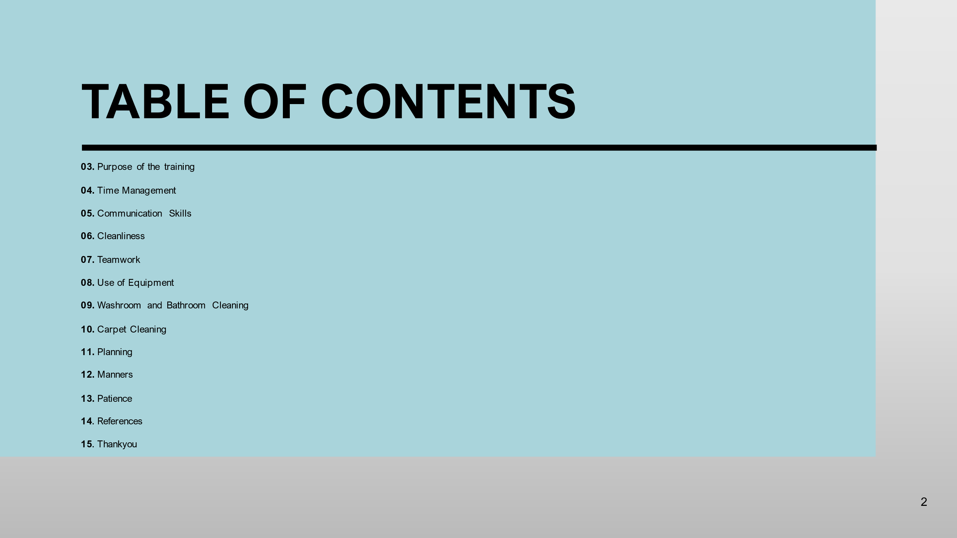

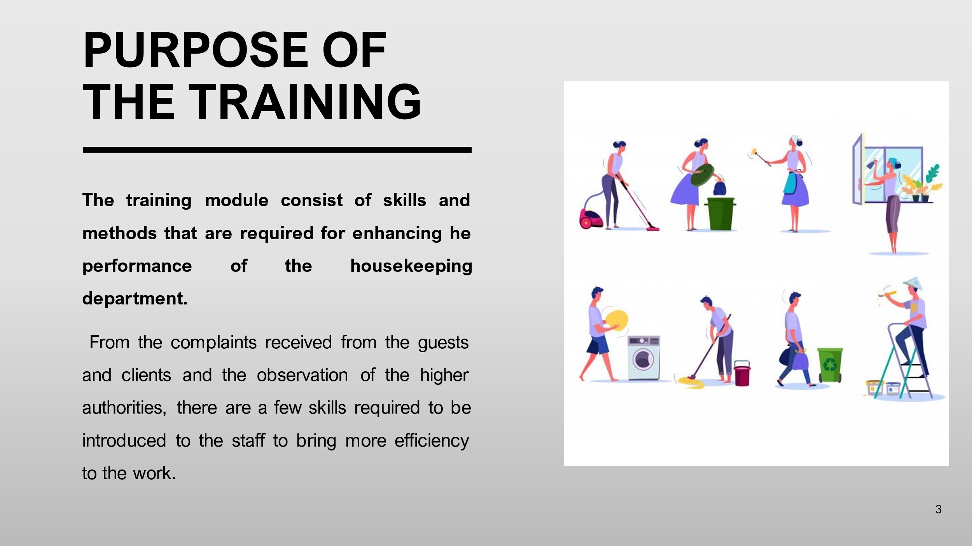

The training module consist of skills and methods that are required for enhancing he performance of the housekeeping department.

From the complaints received from the guests and clients and the observation of the higher authorities, there are a few skills required to be introduced to the staff to bring more efficiency to the work.

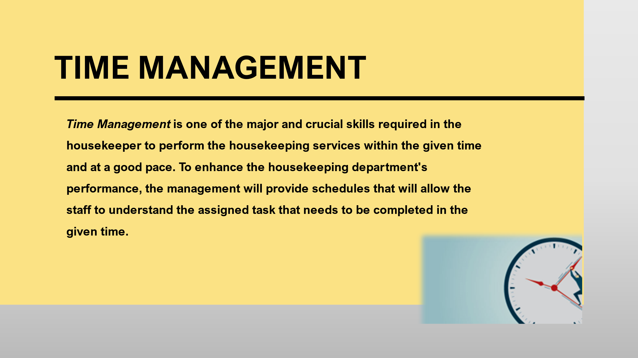
Time Management is one of the major and crucial skills required in the housekeeper to perform the housekeeping services within the given time and at a good pace. To enhance the housekeeping department's performance, the management will provide schedules that will allow the staff to understand the assigned task that needs to be completed in the given time.
Training Notes: To understand how the time should be divided for a particular task, the management will properly explain the approximate period required in completing a particular task, which will help the staff in evaluating the time they are utilizing.
The staff can refer to the schedules provided by the management and supervisors and can analyze the period given by the management, and utilize the training experience in real-time tasks.
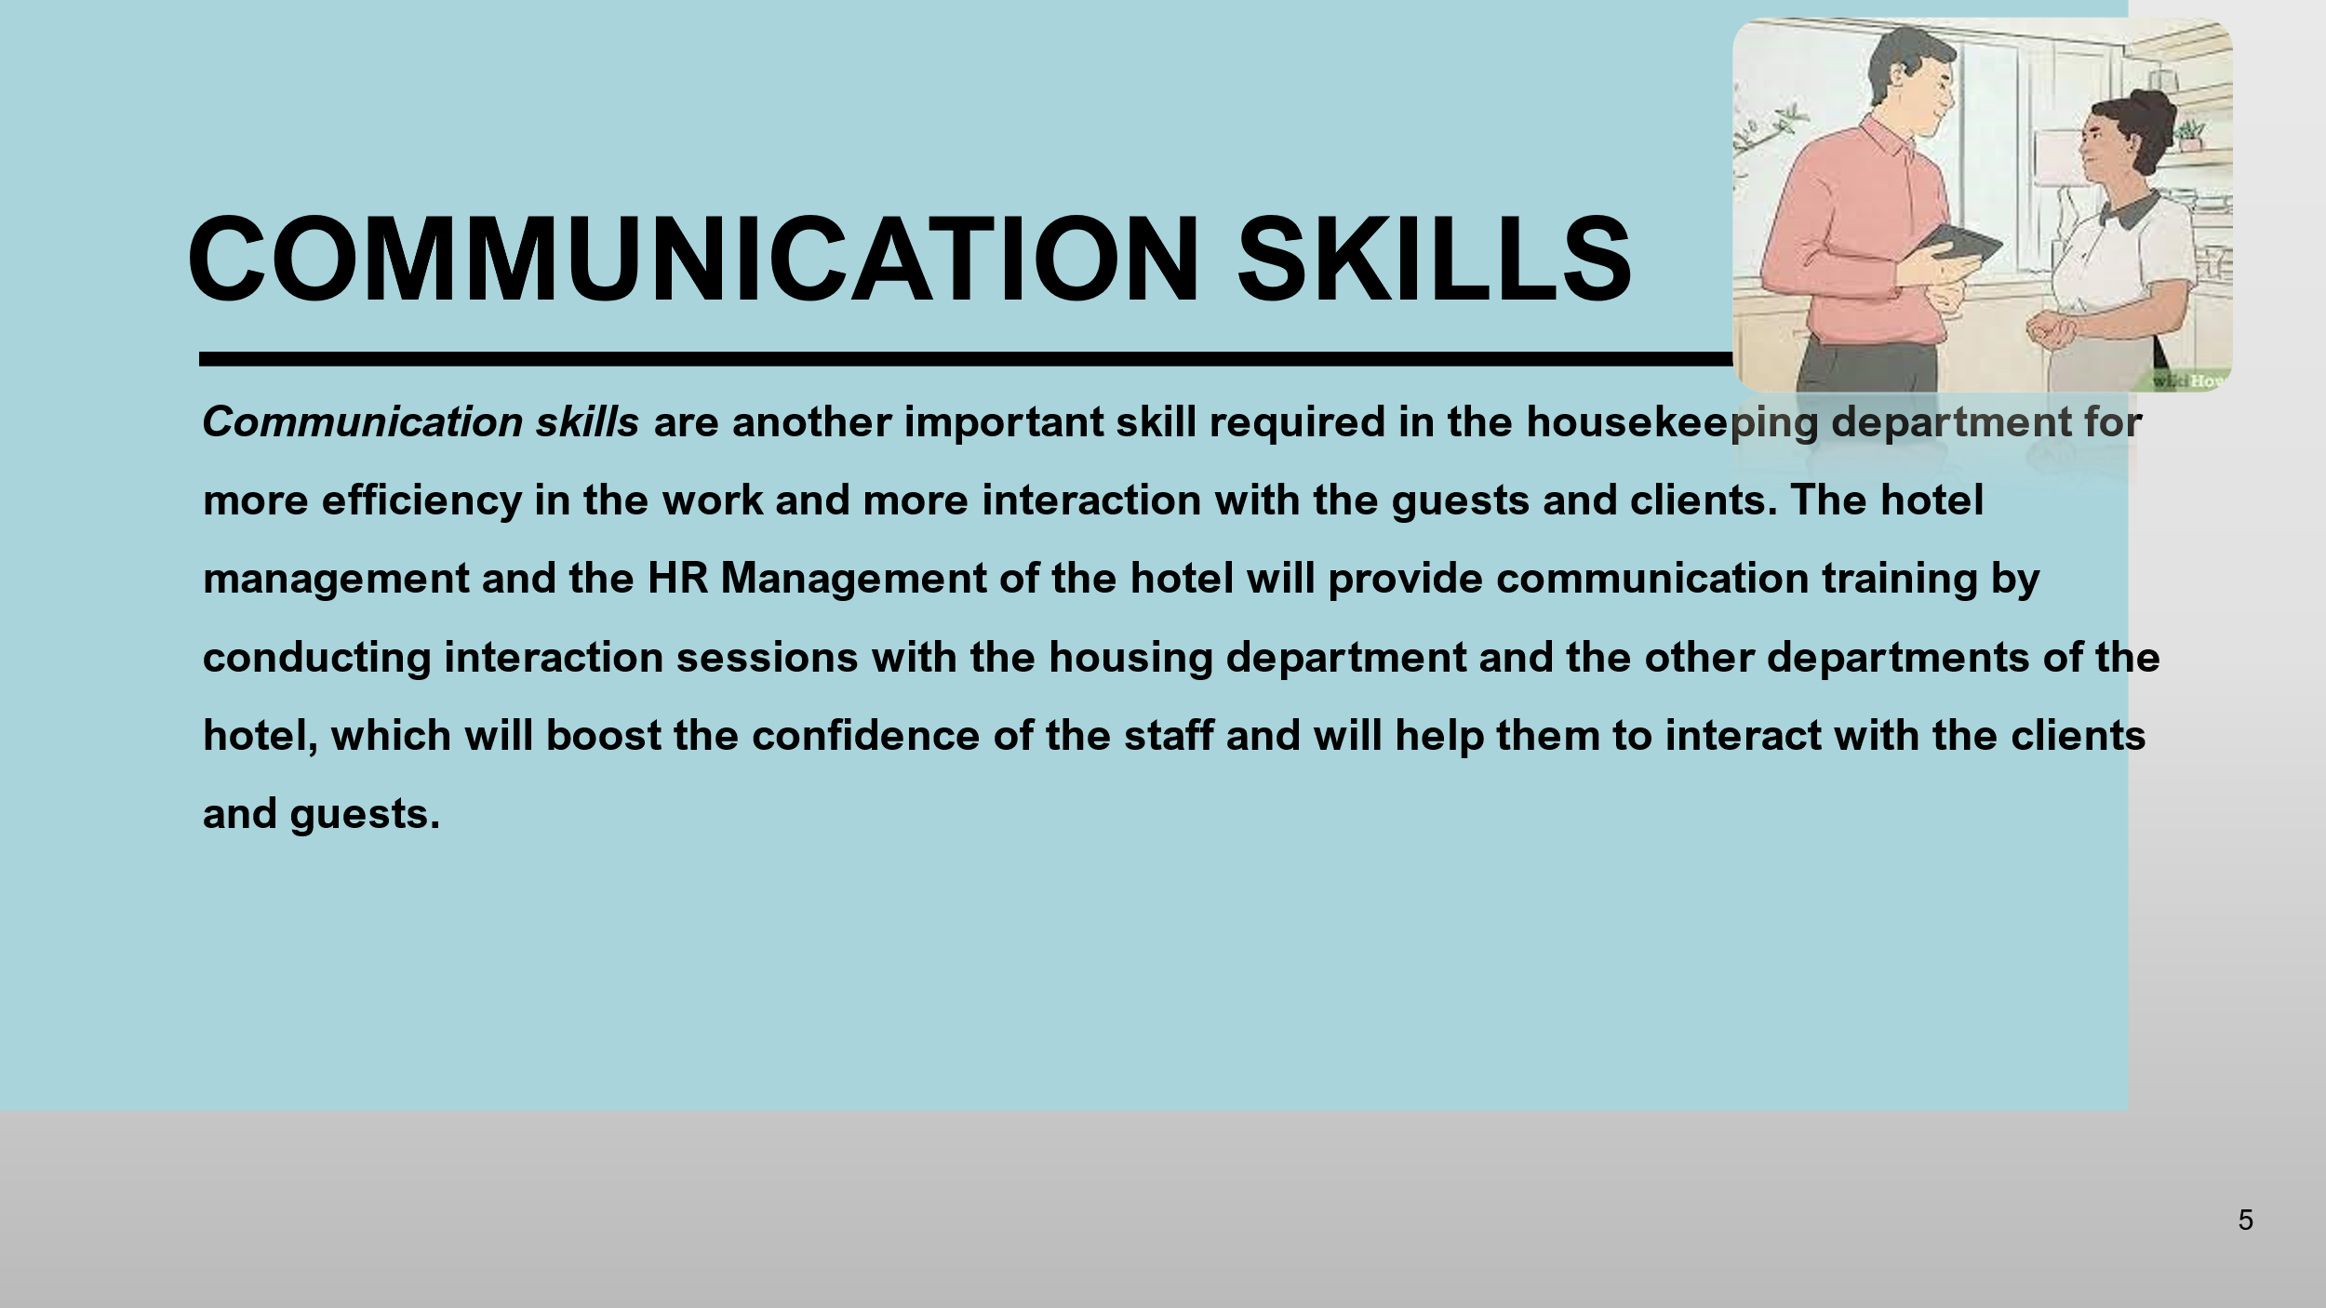
Communication skills are another important skill required in the housekeeping department for more efficiency in the work and more interaction with the guests and clients. The hotel management and the HR Management of the hotel will provide communication training by conducting interaction sessions with the housing department and the other departments of the hotel, which will boost the confidence of the staff and will help them to interact with the clients and guests.
Communication skills within the team and with the client are important to understand their requirements, and to address this, live sessions, seminars, and activities will be conducted so that everyone can participate and gradually communicate.

Training Notes: To learn communication skills, the staff will have to participate in the activities and sessions. To communicate and interact with the clients or guests, the staff will learn the basics of how to communicate on a professional level and how to address the situations through interacting with the guests in the training sessions.
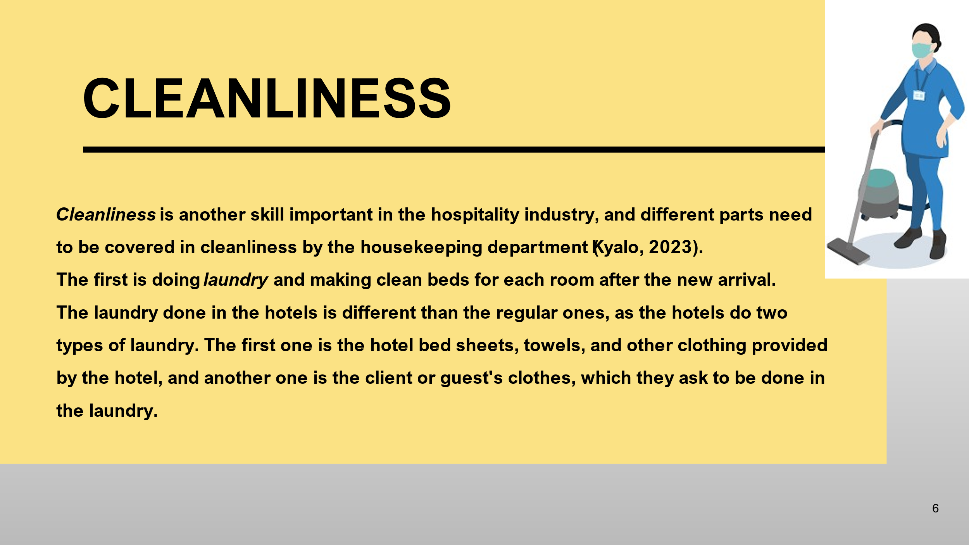
Cleanliness is another skill important in the hospitality industry, and different parts need to be covered in cleanliness by the housekeeping department (Kyalo, 2023).
The first is doing laundry and making clean beds for each room after the new arrival.
The laundry done in the hotels is different than the regular ones, as the hotels do two types of laundry. The first one is the hotel bed sheets, towels, and other clothing provided by the hotel, and another one is the client or guest's clothes, which they ask to be done in the laundry.
Training Notes: To perform these tasks, the staff will be trained on how to separately wash the hotel clothes and the client's clothes, how they are washed in separate washing machines and placed in different departments and how they are ironed. The training will focus on explaining how the client's clothes are placed to avoid them from getting mixed. From the use of detergent to the ironing of clothes, everything will be covered through practical training.
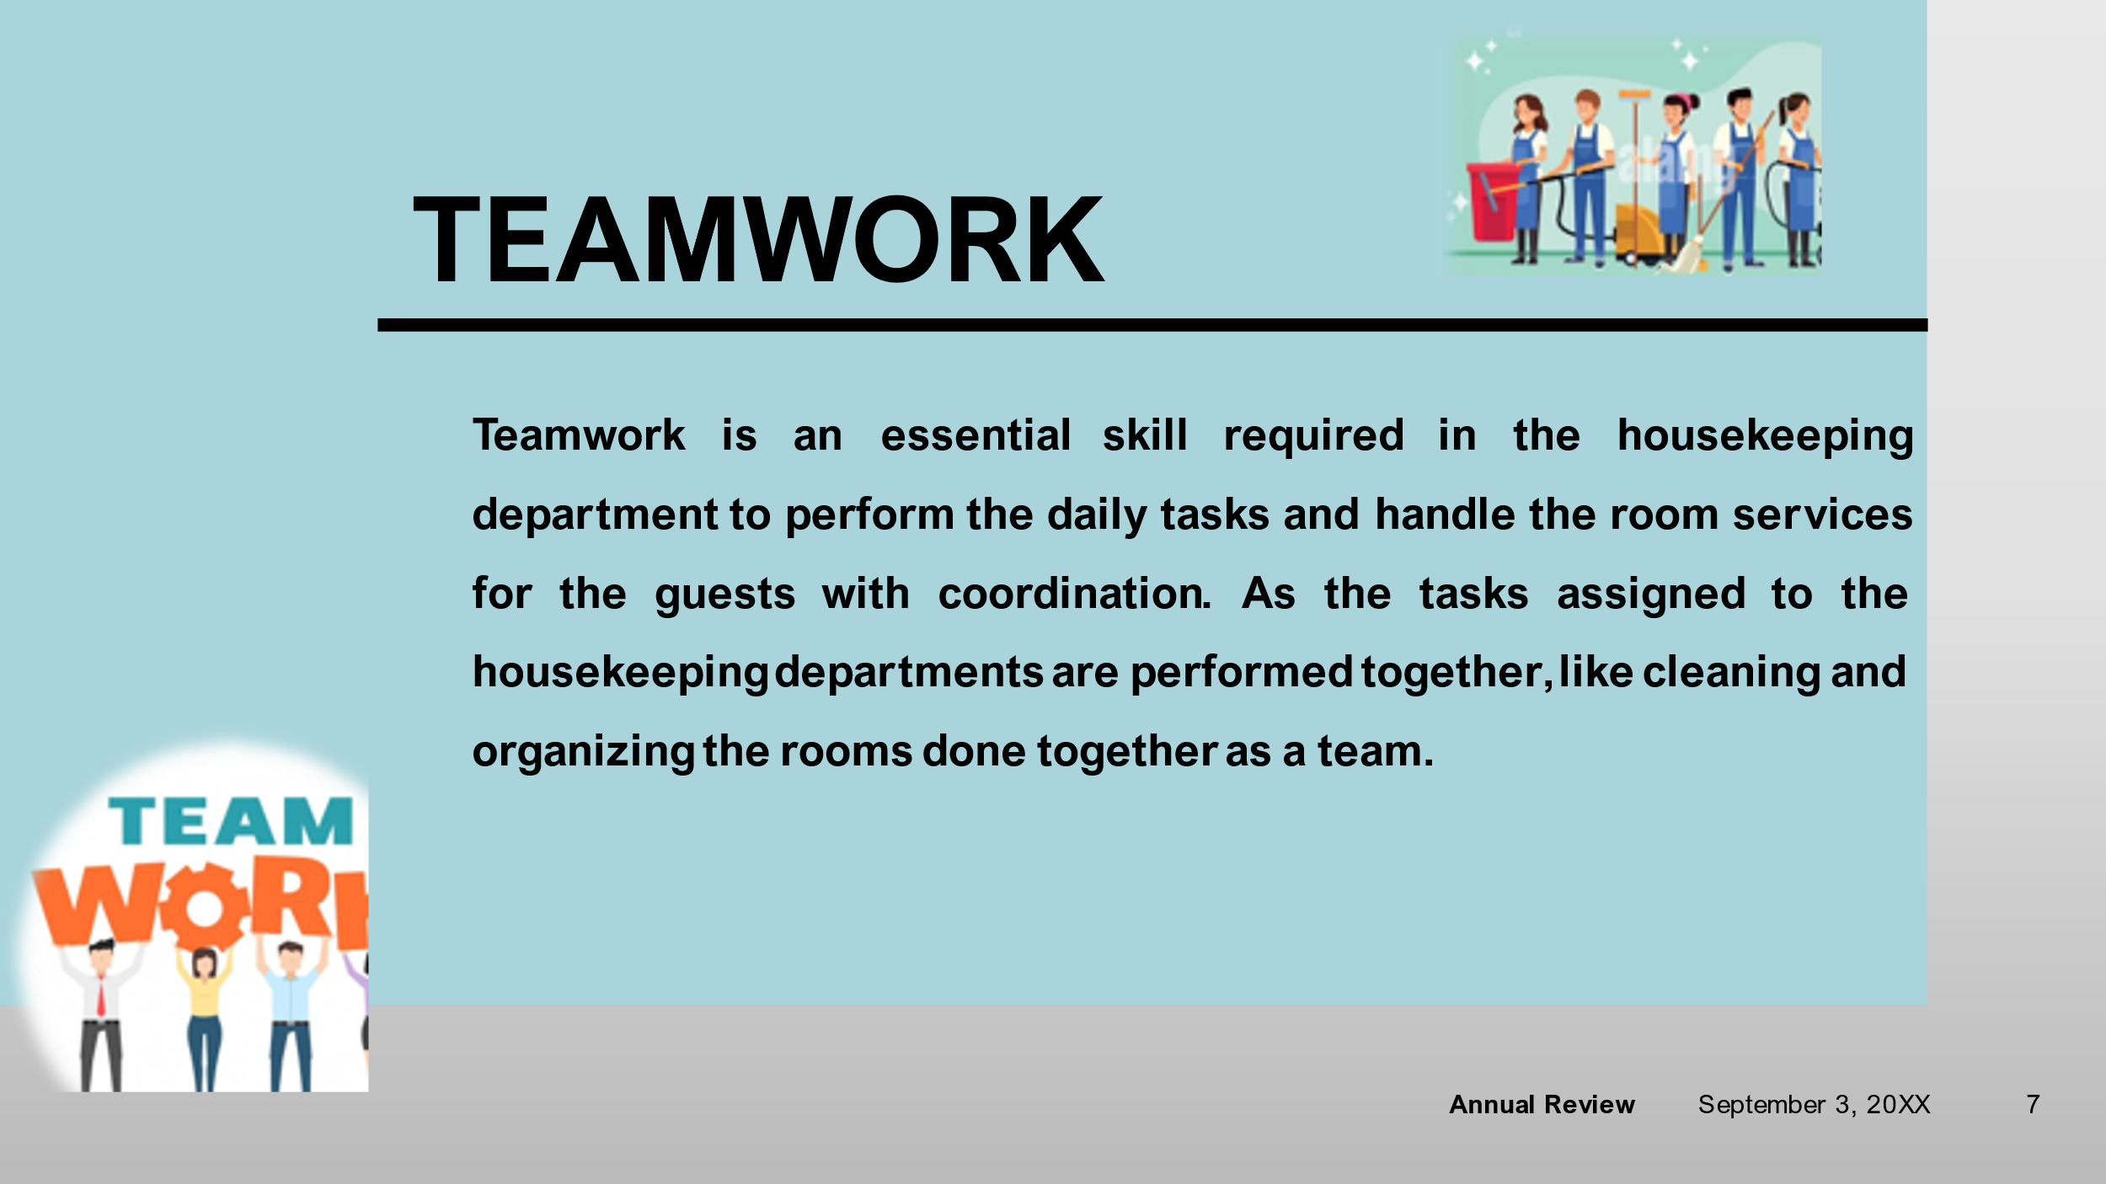
Teamwork is an essential skill required in the housekeeping department to perform the daily tasks and handle the room services for the guests with coordination. As the tasks assigned to the housekeeping departments are performed together, like cleaning and organizing the rooms done together as a team.
Training Notes: The teamwork can be enhanced by assigning the work and tasks together, which will help in improving the teamwork practically through performing the cleaning and organizing tasks which need to be completed together. To enhance the teamwork between the members of the housekeeping departments, interaction sessions will be conducted, which will enhance the communication between the members and will help them work more efficiently.
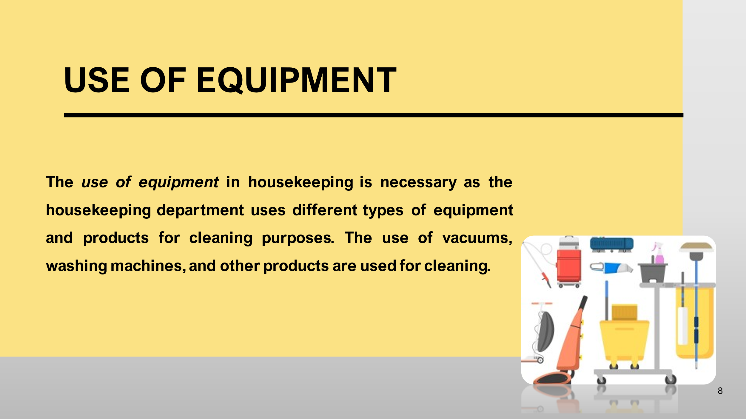The use of equipment in housekeeping is necessary as the housekeeping department uses different types of equipment and products for cleaning purposes. The use of vacuums, washing machines, and other products are used for cleaning.

Training Notes: To use the equipment properly and for long-lasting use, the housekeeping head will explain to the staff how to use the products correctly and how to maintain them to secure the property of the hotel management. The staff will use the equipment and practically understand how to use the products and how to maintain them.

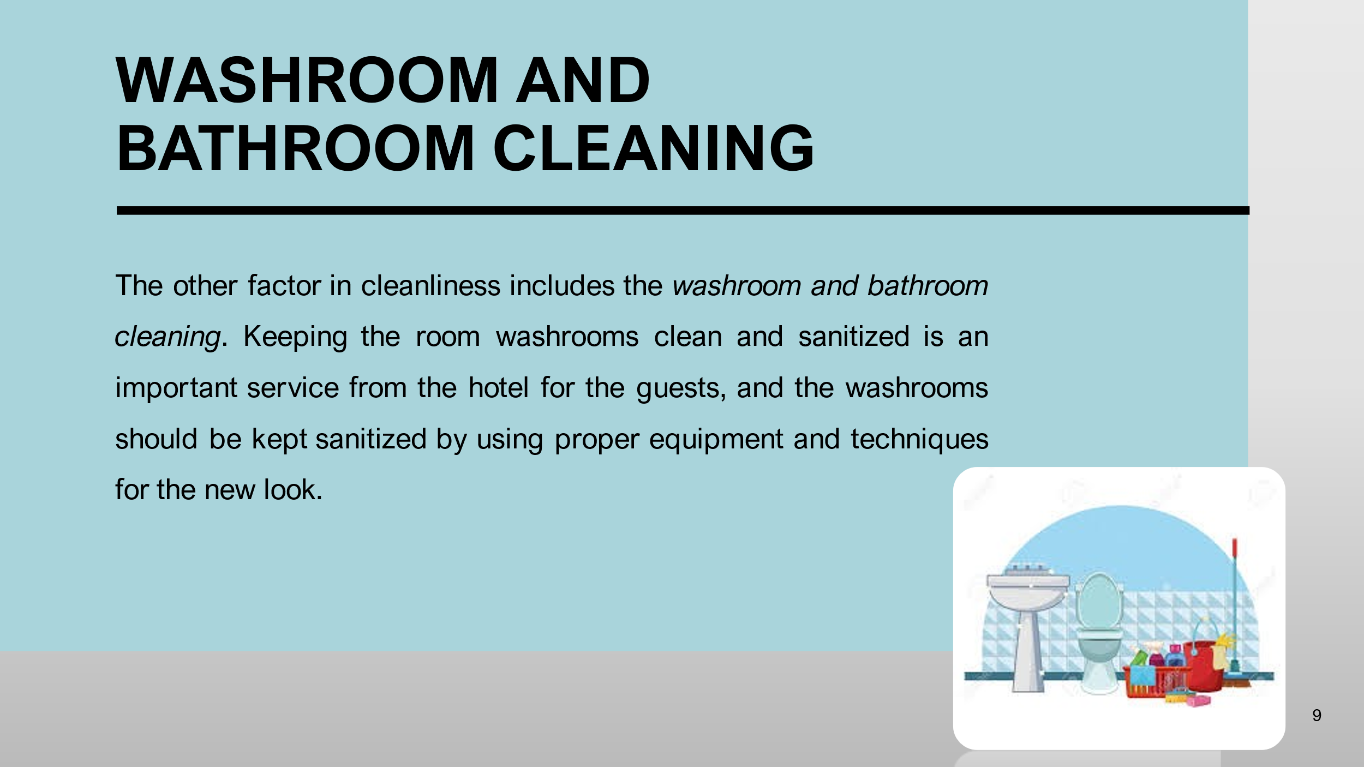
The other factor in cleanliness includes the washroom and bathroom cleaning. Keeping the room washrooms clean and sanitized is an important service from the hotel for the guests, and the washrooms should be kept sanitized by using proper equipment and techniques for the new look.
Training Notes: To teach cleaning skills to the housekeeping staff, the management focuses on explaining how to clean the washrooms and bathrooms by using the right equipment and products for cleaning. The training also follows how to keep yourself safe from harmful products and how to maintain quantity while using the products for cleaning purposes.

The other factor includes in the cleaning is carpet cleaning which is to vacuum the carpet and avoid carpet spots. The use of carpets in the rooms is common for enhancing the decor of the rooms, which is why keeping the carpet clean is important. Washing carpets are hard and consumes a lot of time and energy, which is why the carpets are cleaned through a particular technique.
Training Notes: The department head will explain to the staff the equipment and cleaning products they need to use for cleaning carpet spots and the amount of cleaning chemicals they need to use so that the quality of the carpet doesn't depreciate and also how to maintain safety while performing the carpet cleaning with the chemicals.
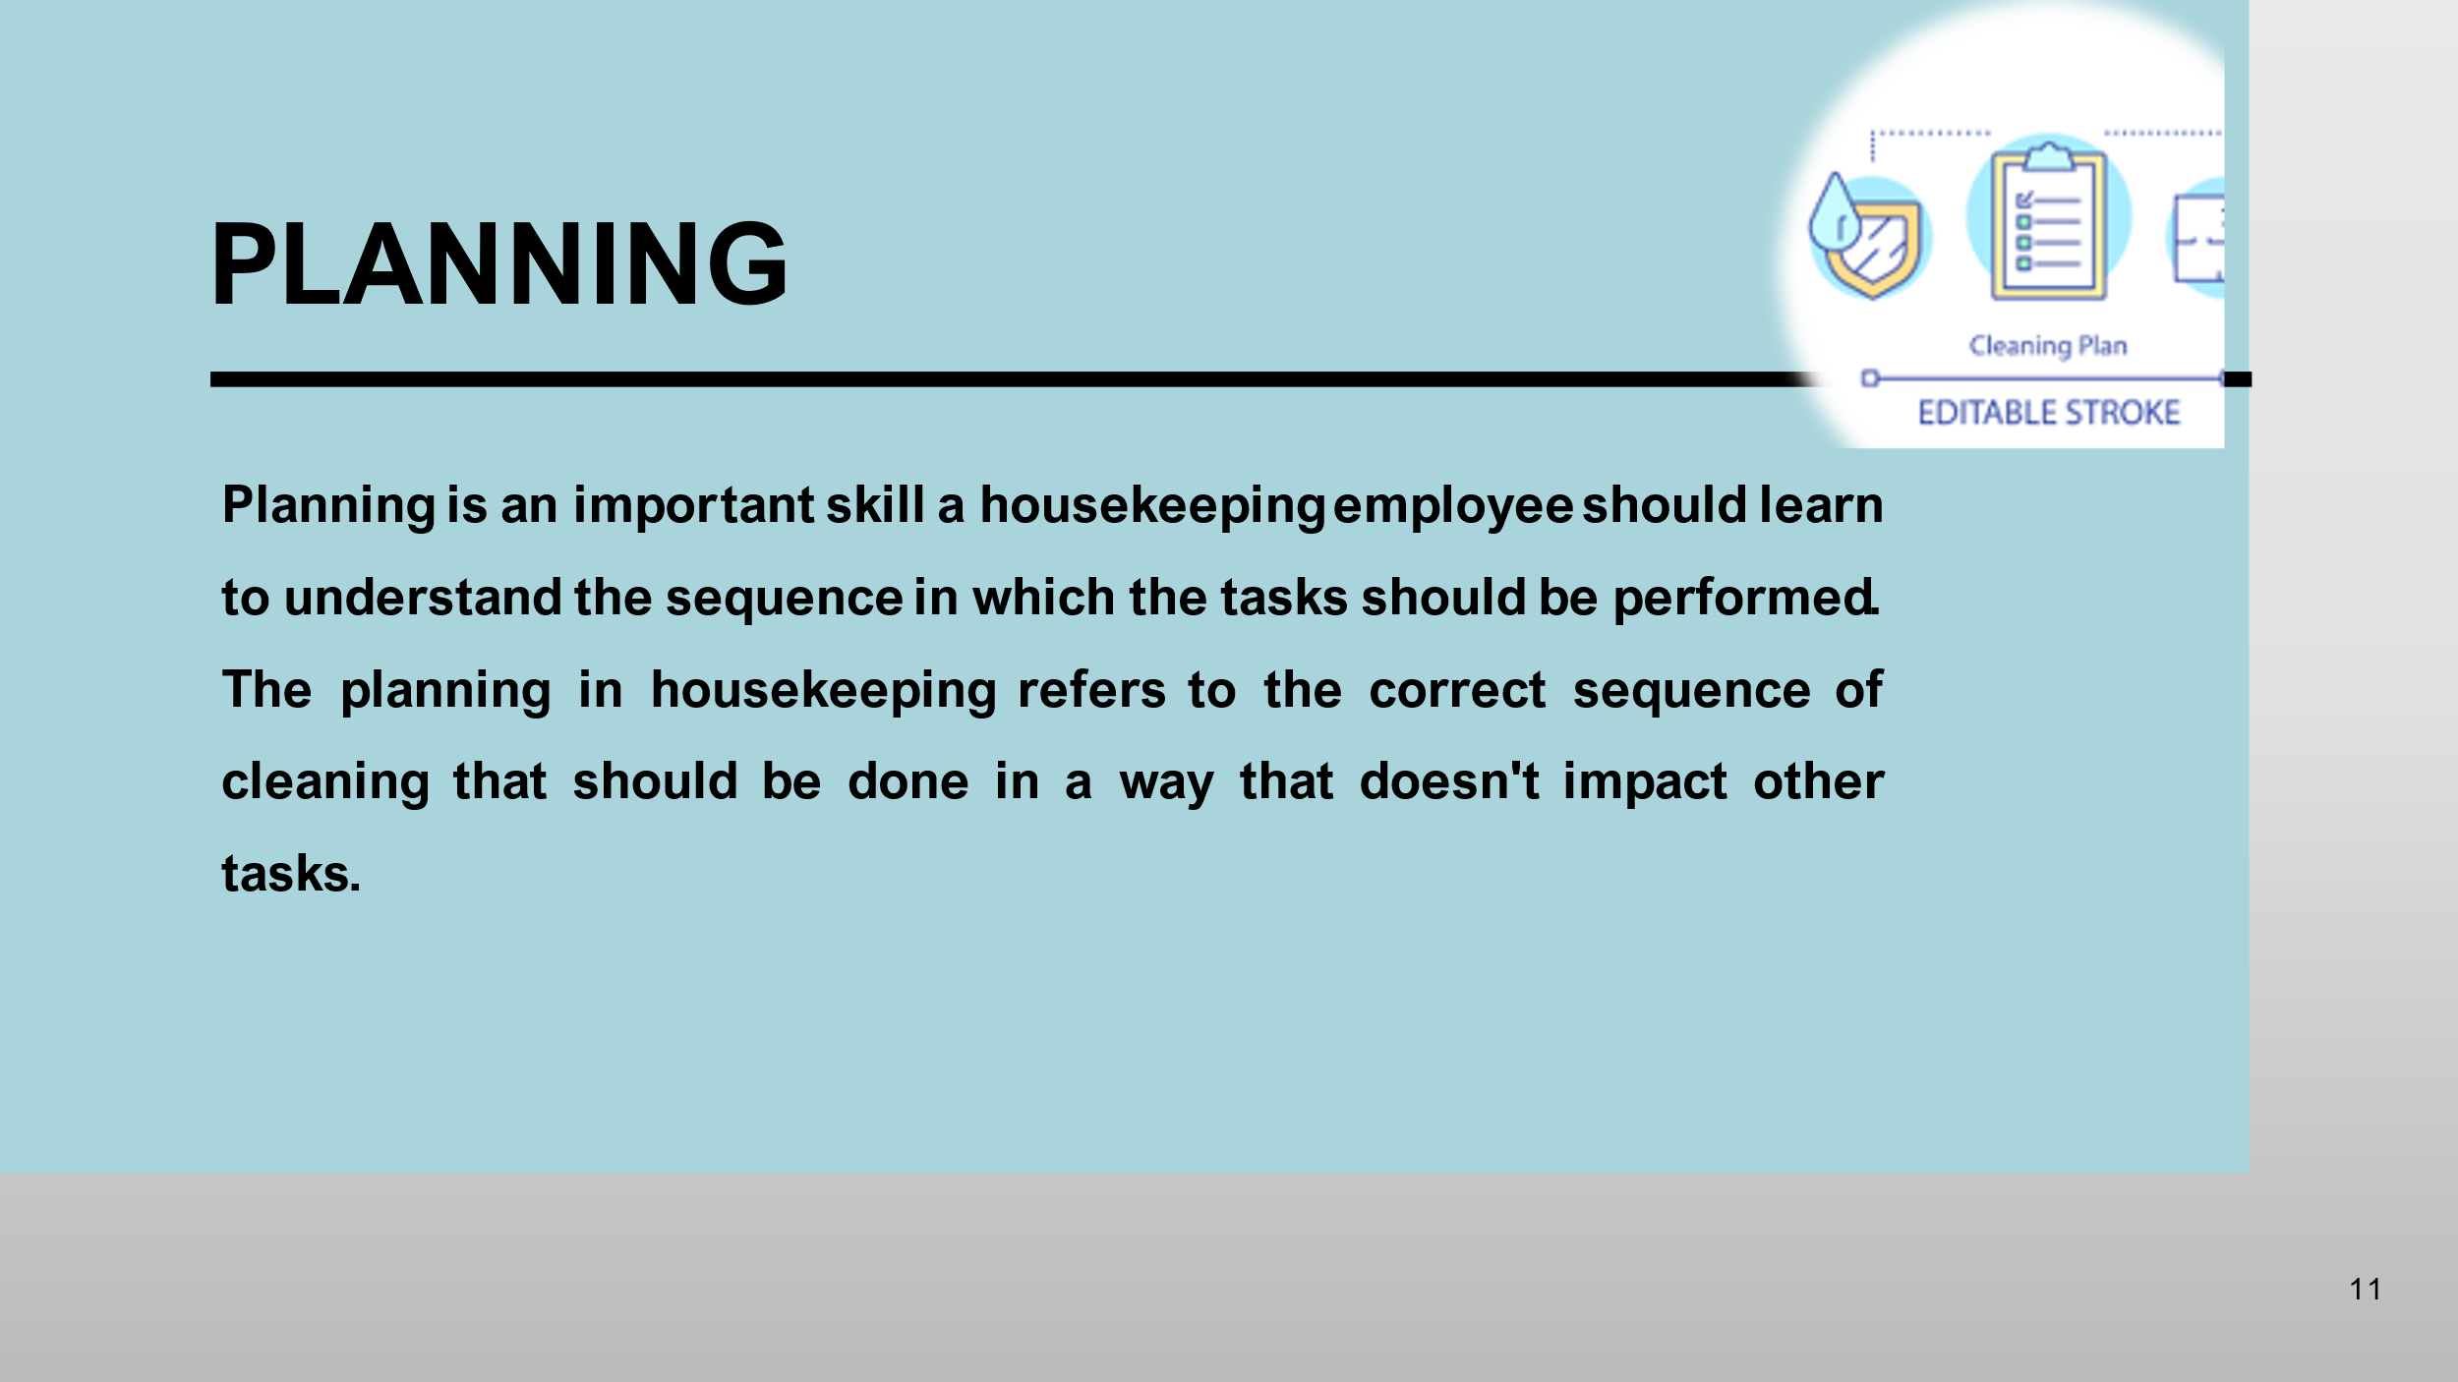
Planning is an important skill a housekeeping employee should learn to understand the sequence in which the tasks should be performed. The planning in housekeeping refers to the correct sequence of cleaning that should be done in a way that doesn't impact other tasks.
Training Notes: The housekeeping head will give the training on the cleaning tasks to be performed in which sequences, like the sweeping should be performed first and then the mopping, it will properly clean the room.
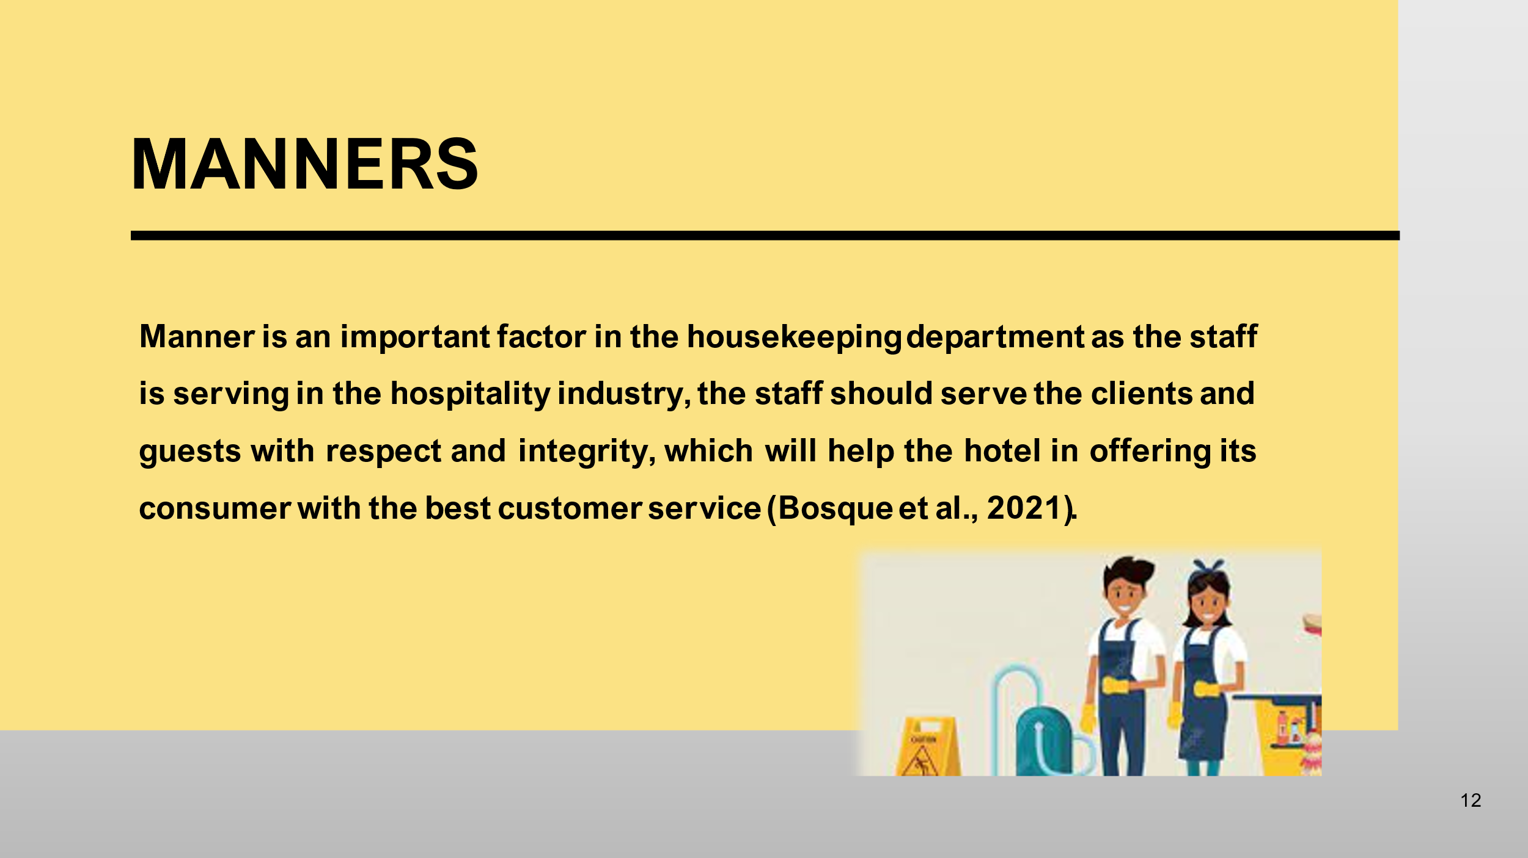
Manner is an important factor in the housekeeping department as the staff is serving in the hospitality industry, the staff should serve the clients and guests with respect and integrity, which will help the hotel in offering its consumer with the best customer service (Bosque et al., 2021).
Training Notes: The higher authorities in the housekeeping department will explain to the staff to perform the tasks ethically and with manners that can reflect the image and integrity of the organization among the consumer and will enhance its brand image.
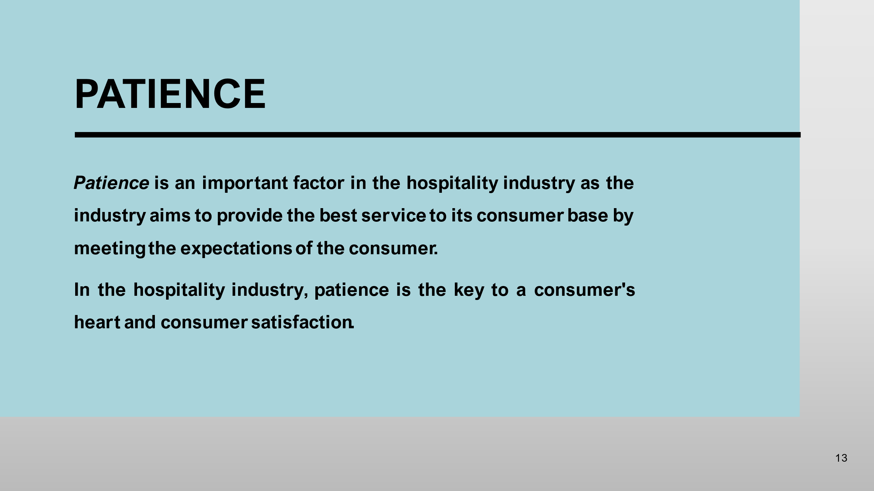
Patience is an important factor in the hospitality industry as the industry aims to provide the best service to its consumer base by meeting the expectations of the consumer.
In the hospitality industry, patience is the key to a consumer's heart and consumer satisfaction.
Training Notes: To make the staff understand the importance of patience in the hospitality industry, the trainers will provide moral training to the staff and will give an understanding of serving in the hospitality industry.

References

Stoyanova-Bozhkova, S., 2022. Managerial Roles. In Encyclopedia of Tourism Management and Marketing (pp. 123-125). Edward Elgar Publishing.
W Fakhry, B., Saad, S. and Ibrahim, Y., 2022. Factors Affecting the Turnover of Entry-Level Employees in Housekeeping Department in Five Star Hotels. International Journal of Tourism, Archaeology and Hospitality, 2(1), pp.3-16.
Bosque, J.R., Gómez-Nieto, R., Hormigo, S., Herrero-Turrión, M.J., Díaz-Casado, E., Sancho, C. and López, D.E., 2021. Molecular tools for the characterization of seizure susceptibility in genetic rodent models of epilepsy. Epilepsy & Behavior, 121, p.106594.
Giousmpasoglou, C. and Casson, G., 2022. The central role of front-line employees in the luxury accommodation product: Evidence from Australia. Journal of Tourism Research, 28(June 2022), pp.5-40.
Khymdeit, J., 2022. Project work on entrepreneurship topic: Housekeeping.
Hutagalung, V.K., 2022. HYGIENE AND SANITATION DURING THE COVID-19 PANDEMIC AT THE FOOD AND BEVERAGE SERVICE DEPARTMENT SINABUNG HILLS BERASTAGI HOTEL. SKYLANDSEA PROFESIONAL Jurnal Ekonomi, Bisnis dan Teknologi, 2(1), pp.47-54.
Shestakofsky, B. and Kelkar, S., 2020. Making platforms work: Relationship labor and the management of publics. Theory and Society, 49, pp.863-896.
Kitsios, F., Kamariotou, M., Karanikolas, P. and Grigoroudis, E., 2021. Digital marketing platforms and customer satisfaction: Identifying eWOM using big data and text mining. Applied Sciences, 11(17), p.8032.
Norrild, J.A. and Korstanje, M.E., 2021. Maids and housekeepers at luxury hotels: life stories in hotels of Buenos Aires, Argentina. International Journal of Tourism Anthropology, 8(2), pp.129-147.
Shereni, N.C., 2020. The role of technical and vocational education and training (TVET) in restoring hospitality sector specific skills in Zimbabwe: a students’ perspective. Journal of Hospitality & Tourism Education, 32(3), pp.133-141.
Azimovna, M.S., 2022. Scientific-Methodical Issues of Evaluation of Marketing Service in Hotels. Central Asian Journal of Innovations on Tourism Management and Finance, 3(10), pp.1-9.
Simonovic, S.P., Kundzewicz, Z.W. and Wright, N., 2021. Floods and the COVID‐19 pandemic—A new double hazard problem. Wiley Interdisciplinary Reviews: Water, 8(2), p.e1509.
Kyalo, J., 2023. Effect of Short Course Training on Service Delivery in the Hospitality Industry in Housekeeping and Laundry Department of Kenya Utalii College. Journal of Hospitality and Tourism, 3(1), pp.14-30.

