LCBB4004 Marketing Fundamentals
Assessment 2-Analysis and Evaluation

Internal and external analysis of Unilever

Tushara Balendran

Made by: Yustian Yuriev Mladenov(2111875)

Table of Contents
Introduction 3
External and internal analysis of Unilever 4
SWOT analysis 4
Strength 4
Weakness 5
Opportunities 6
Threats 6
Porter’s five forces model 8
The threat of new entrants in the industry 8
Rivalry among established competitors 8
Bargaining power of suppliers 9
Bargaining power of buyers 9
The threat of substitute products 9
PESTLE Analysis of Unilever on the UK 10
Political 11
Economic 11
Social 12
Technological: 12
Legal 13
Environmental 13
Conclusion 15
References 16

Introduction
Internal and external analysis is a pathway to take better strategic decisions. These are the means of exploring an organizations' strengths weaknesses so that the organization can utilize the potential opportunities as well as eliminate threats. However, through internal analysis organization can achieve a competitive advantage (Bateman and Konopaske, 2021). As competitive advantage is the product of distinctive capabilities, resources, and capabilities that can be identified by examining the internal environment thoroughly. When an organization is well aware of its strength and weakness it takes better decisions thus strategies. Moreover, it assists in proper strategy formulation, implementation, monitoring, and evaluation. Similarly in the case of external analysis examines the macro environment which includes industry and other factors. Together it helps in driving profitability, measuring volatility, and stimulating the growth of the organization. Besides all these factors that impact in decision making together makes marketing environment. Due to the Covid-19 pandemic Organization has faced an adverse situation that affected all the stakeholders related to the organization and industry. In that case, by analyzing the external environment an organization points out different strategies to reach out to customers in terms of recognizing customer preferences. In this report, the internal and external analysis will be conducted on Unilever UK. Unilever, a hundred-year-old company is well-known for consumer goods. It has more than 400 brands and a massive network of retailers. Its’ headquarter is in London, England. To name some of its famous brands are Ben & Jerry's, Dove, Knorr, Lifebuoy, Vaseline, etc. Unilever focuses on a broad range of customer needs which is evident in its product line (Unilever UK & Ireland Homepage, 2021).

External and internal analysis of Unilever
There are some well-known tools to conduct an external and internal analysis to understand the organizational as well as macro-scale factors. Among them, SWOT analysis is used largely.
SWOT analysis: SWOT analysis includes both internal and external environments. SWOT refers to Strengths, Weaknesses, Opportunities, and Threats. The first two components are regarded as internal analysis and the later components are regarded as external analysis. The main objective to conduct SWOT is identifying the areas to hone the strengths, minimize weaknesses, take advantage of the opportunities and eliminate threats (Ali and Muhammad, 2021).
Strength:
- Broad portfolio: Unilever offers a product for every range of consumers. To be precise it has more than 400 brands. Among its numerous brands, Unilever does segmentation based on income, preferences, and demographics, psychological, geographic, and behavioural. For instance, Unilever offers lifebuoy, Lux, Dove at the same time. In the case of distributing the product, two things have been noted such as hygiene and beauty. Lifebuoy is for those Consumers who are more hygiene conscious and Dove is more related to beauty lines (Unilever UK & Ireland Homepage, 2021).
- Competitive advantage: Unilever enjoys a competitive advantage due to its unique resources and capabilities compared to its competitors. Here a big portion of the credit goes to the effective marketing mix strategies. In the case of product, Unilever has divided its product into 4 categories like Food, home care, personal care and hygiene, refreshment. Unilever positioned itself as a go-to brand for everything needed for everyday life. In the case of pricing, Unilever offers a product of every range from high to low but maintains its quality. In the case of distribution, Unilever has a vast network of retailers plus outlets. Via which Unilever distributes its point to its nearest strategic points. To date, Unilever has more than 25 million retail outlets globally. Unilever spent £5.97 billion in 2020 for its marketing budget. In 2019, Unilever spent £1.02 billion on promotions. By the numbers, it is evident that Unilever emphasizes greatly on its promotion. It uses traditional as well as digital marketing for promotions (Bateman and Konopaske, 2021).
- Economies of scale: Economies of scale are via mass production. When a product is a product in huge number then the fixed cost gets spread all over and unit costs fall. Unilever achieves this by leveraging its operations and making strategic decisions effectively to maximize output, for instance, increasing manufacturing plants via synergy with different strategic partners (Christopher, 2020).
- Glocal strategies: Glocal strategy is the product of Global strategy but follows an ethnocentric approach (Clow and Baack, 2021). Unilever provides global essence based on local demands or settings. For instance, OMO, Unilever's largest detergent brand has different names in different countries. As language is an important factor when deciding on a brand name. Then again, there are products like Comfort, a complementary product of detergent which is available in the UK and some other regions because in European countries comfort and colour protection is more important but through products like OMO which is distributed in Brazil, Uruguay, cleaning has been given importance.
- Effective handling of Covid-19 pandemic: Amidst the Covid-19 pandemic Unilever has tackled its Covid-19 situation aptly. From the initiation point, it emphasized the hygiene and safety of its employees, most important retailers and distributors. Initiated Work from Home facility for as long as the situation was not in control. Other than that, Unilever donated products worth £70 million, launched campaigns like "Courage is Beautiful" to appreciate frontline individuals, invested in R&D for the vaccine, etc. All of these actions not only enhanced employee morale but also amplified brand image (Ali and Muhammad, 2021).
Weakness:
- Substitute product: FMCG is a diverse industry with many competitors. There are many products of Unilever which can be easily imitated from product development to design and packaging. For example against Unilever’s Surf and Persil, P&G got tide, against Unilever’s Knorr, Nestle got Maggie. Besides due to switching costs being low customers can switch anytime to another brand where they will get the same product (Chhabra, 2018).
- Less Diversification: Though Unilever has a strong influence on the consumer goods industry, it lacks further exploration. All its products fall under the designated category. Besides, product diversification Unilever lacks distribution diversity too. In this Covid-19 pandemic, buying habits to a great shift. In 2020, online sales have been increased approximately 61% whereas for Unilever it increased only 9%. The reason behind this can be stated less focus on online selling or online presence. In addition, the Covid-19 pandemic has decreased income to which is leading inflation even recession (Home - Office for National Statistics, 2021). This income shift will have an impact on consumer buying too.
Opportunities:
- Online presence: Amidst the pandemic consumers have moved towards online shopping and the trend is growing stronger day by day. Unilever can exploit this opportunity by creating a stronger Ecommerce channel along with a retail outlet for its product line. In this case, digital media can create a positive impact on revenue (Siagian et al, 2020).
- Focusing on digital B2B: Online purchasing trend has accelerated B2B functions especially when it is digital to maintain efficiency and quality along with convenience(Kotler and Keller, 2012). This feature focuses on businesses like small retailers, especially in emerging countries. In 2020, Unilever gained 60% of its revenue from emerging countries.
- Focusing on innovation: During the Covid-19 pandemic, Unilever has collaborated with Microbac Laboratories to bring a new mouthwash product to fight viruses and germs. Expanding the production and operations of this new product will diversify Unilever's product line.
Threats:
- Influence of pandemic: Covid-19 pandemic has impacted Unilever’s supply chain, manufacturing. It brought a change in purchasing of products which impacted distribution directly (Elliott and Partington, 2021). Though the annual revenue of 2020 was less than 2.4 % compared to 2019 it brought internal shifts such as cutting down a large portion of the innovation line.
- Variation of currency: Due to the covid-19 pandemic, currencies took a negative turn, some even depreciated. Currencies like Lira and peso have been depreciated approximately 30% against the pound sterling.
- Change in consumer preferences: During the pandemic, consumers got more aware of organic products and their benefits (Smithers, 2021). That is why the shift has been taken towards natural or Ayurveda products. Customers are taking organic products more positively than earlier which is why they are shifting towards these products. Unilever needs to track consumer preferences to minimize the threat.
Strength  - Broad portfolio  - Competitive advantage  - Economies of scale  - Glocal strategies  - Effective handling of Covid-19 pandemic | Weakness:  - Substitute product  - Less Diversification
Opportunities:  - Online presence.  - Focusing on digital B2B  - Focusing on innovation | Threats:  - Influence of pandemic  - Variation of currency  - Change in consumer preferences

Table 1: SWOT analysis of Unilever.
Source: (Siagian et al, 2020).

Porter’s five forces model
For extensive external analysis, another tool that can be used is Porters' five forces model developed by Michael Porter. The main objective of conducting this analysis is to identify an industry’s opportunities & threats by recognizing boundaries.
The threat of new entrants in the industry: This factor is mobilized by both Unilever's internal competency as well as other environmental factors. As aforementioned Unilever enjoys economies of scale due to the vast production of numerous units. Mass manufacturing or production spreads the cost evenly into every unit. Plus as an existing player in the FMCG industry, Unilever constantly improvises its product and invests greatly in its operations and service. Matching with this massive R&D investment and innovation will be difficult for a new entrant. Brand loyalty plays a significant part while deciding new entry (Kotler and Keller, 2012). Approximately 1 in 3 individuals use Unilever's product, which can be stated as firm brand loyalty for any organization. Besides, by being in the business for almost a hundred years Unilever has achieved an absolute cost advantage. It has achieved superior efficiency in operations and processes. Another factor that is slightly disadvantageous for Unilever is its' low switching cost. As other competitor offers the same product within a similar range so consumers can switch whenever they want. Which happened in a covid-19 pandemic. 35% of consumers have changed or tasted brands in the UK. So combining all of this, it can be stated that Unilever has a moderate chance of new entry of potential competitors.
Rivalry among established competitors: Rivalry takes place based on pricing, packaging, promotions, better design, customer responsiveness, etc. There are P&G, Nestle, and Colgate-Palmolive among the existing competitor of Unilever. Factors that influence existing competition are industry structure. FMCG thus Unilever is a part of a fragmented industry where no particular organization has control over the price fixation thus the market is mobilized by all the factors and stakeholders (Eltawy and Gallear, 2021). As consumer goods are comparatively difficult to differentiate that’s why rivalry becomes intense for instance there are many similar products Unilever and P&G as well as Colgate-Palmolive such as toothpaste Pepsodent, Colgate. Besides rivalry among competition also depends on customers' demand or capturing the value. In intense rivalry Organization like Unilever follows some steps to retain demand. Unilever maintains the sustainability of demand by identifying and comprehending customer wants and demands. After that, it entails a detailed strategy to reach out to customers so that it can fulfil desired needs. Followed by making a plan to implement strategies and create a profitable customer to build customer relationship marketing. If the demand is growing it works in favour of organizations like Unilever but if it declines then it creates intense competition to maintain sustained profit growth.
Bargaining power of suppliers: For establishing and maintaining suppliers Unilever launched a program named Unilever's Partner with the purpose (UPWP) amidst the Covid-19 pandemic to ensure mutual growth along with its suppliers. Unilever has a vast network of suppliers in around 190 countries all over the world (Unilever UK & Ireland Homepage, 2021). Here, the force is low because buyers like Unilever are stronger as they are few in number and purchase products in bulk amount. Besides suppliers of Unilever sells standardized product so switching cost is also lower. This is why suppliers will be unable to put pressure on Unilever.
Bargaining power of buyers: There are 2.5 billion who use Unilever’s products daily. Unilever is a global company and it covers up all range of people in a society by maintaining its quality as well. The switching cost is also low plus buyers' purchasing unit is small in number. As the change in the low unit will not affect Unilever that much. But when the number gets bigger it affects the revenue which happened during the Covid-19 pandemic and it resulted in 2.4% of lower turnover. This makes this force moderate because customer preference differs from region to region and Unilever segments its consumer-based on geography, culture, taste (Chhabra, 2018). Another factor that creates impacts the information technology. Customers can compare products on the internet anytime which can create a defection rate for Unilever.
The threat of substitute products: There are few substitutes available compared to what Unilever produces. Though organic products are emerging in the market that rate is also low. There are chances of shifting towards other competitors but the price is comparatively similar. As a brand, Unilever has a good brand image and combining other factors this force is low.

Figure 1: Porter’s five forces model of Unilever
Source: (Thompson et al, 2017)

PESTLE Analysis of Unilever on the UK
PESTLE analysis refers to the analysis of the macro-environment to understand the threats and opportunities. Since the Covid-19 pandemic, a lot of change has come.
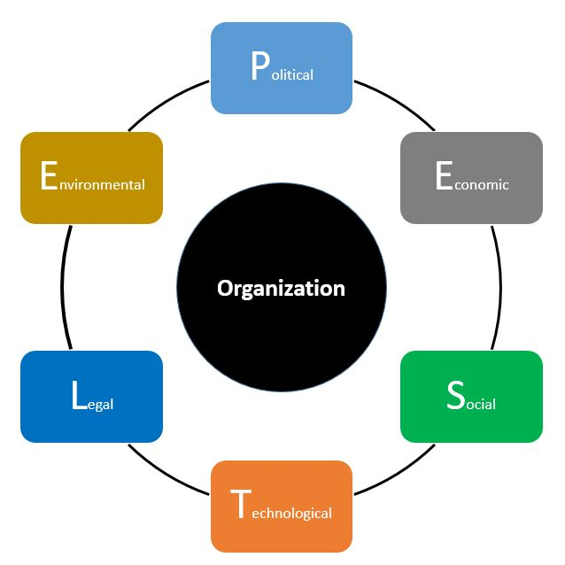
Figure 2: PESTLE analysis
Source: (Christopher, 2020)

Political: Brexit and Covid-19 pandemic together has brought a great change in the political situation of the UK. After the new rules companies will have to pay direct tax on sales under £135 that is a new formality of registering quarterly. Which will create more paperwork for Unilever. Another legislation that will be followed from 2023 is 25% of corporate tax whereas the current rate is 19% (Corporation Tax, 2021). So Unilever's costs will increase. Besides the Brexit, the government of the UK is more welcoming towards other emerging and developing countries which will create an employment pool in favour of Unilever. But due to Covid-19 employment along with income has declined which will create pressure on the social security system and Unilever's employment policy.
Economic: Due to the covid-19 economic situation has been changed a lot. In the UK, as the health system has been affected adversely it had an impact on citizens' life and resulted in income inequality. Besides a recession is being forecasted too. In 2020, A drastic change has come to the bank rate due to the covid-19 pandemic which is 0.1% which is the lowest since 1997 (Home - Office for National Statistics, 2021). It will favour Unilever's case as it will increase cash spending instead of saving and raising product prices. UK's economy is also affected by Brexit and Covid pandemic, as it caused a lower rate of pound sterling compared to the US dollar. Other than this, due to WTO tariff and trade agreements with the EU will create a challenge for corporations like Unilever which may result in an expansion of cost.
Social: In terms of social factors, some factors have been revolving around especially millennials. Awareness regarding the environment and healthy food has increased. Now, consumers are keener to consume fewer sugar products and use environmentally friendly packaging. Consumers are more aware of carbon emissions and environmental pollution. Due to a massive lockdown period in covid-19 people were aware of a better environment. So Unilever needs to focus on bringing more environmentally friendly products as well as a biodegradable or recyclable product. Another societal change brought by the Covid-19 Pandemic is the rise in the use of online shopping. From the start of the pandemic to February 2021, more than 75% of UK citizen has experienced online shopping and consumers are keen on using this method in the future (Smithers, 2021). Which shifted buying pattern from traditional to digital. So, Unilever needs to focus more on its digital activity.
Technological: As this is the era of digital marketing, to maintain profitability Unilever needs to emphasize its eCommerce side, strengthening online marketplace activity and creating features to provide customer convenience (Verhage and Visser, 2018). Where on the one side the pandemic has affected consumers' lives on the other hand it helped to boost online start-ups. In the UK, 13,257 new start-ups or companies have registered in 2020. Most of them are based on food, personal care that means a direct competitor of Unilever. Though Unilever has its data centres of 36 people which provide real-time information regarding consumers and the market, it needs to enhance the facility to cope up with these emerging companies.

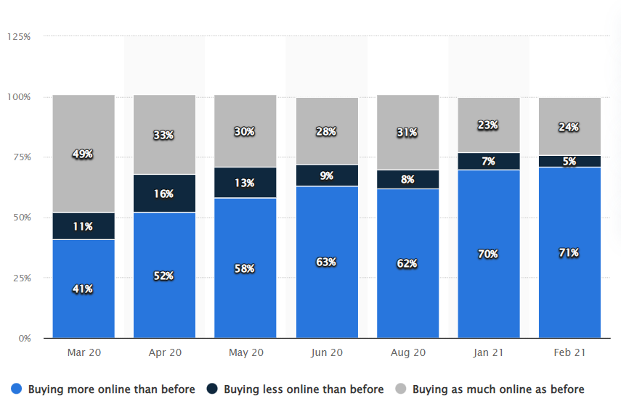
Picture 1: Change in consumer buying pattern
Source: (Smithers, 2021)
Legal: In October 2021, some will be enabled in the UK for instance increased payment of contactless transactions up to £100. This legislation will help in boosting Unilever’s online purchasing thus profit growth. Another legislation that will affect Unilever is the furlough ending law (Elliott and Partington, 2021). As the government will end the job retention program which was initiated during the pandemic followed by handing over the responsibility to the corporation to pay the employees at least 20% along with pension. This will result in restructuring the HR policies of Unilever.
Environmental: Environmental factors are the most influencing factor in any organization right now. In the UK, environmental laws' such as the Environmental protection act 1974 are abided by very firmly. The growing influence of environmental factors and their impact is mobilizing organizational strategies too. COP26 which took place in Glasgow was on climate issues and actions that should be taken to fight climate change. Unilever has taken a step towards more environmentally friendly products. Unilever's Knorr has launched a program to protect soil and save water. By this process, the soil will be recycled and regenerated. It will reduce carbon emissions too. Unilever has also mobilized its suppliers to take steps towards saving the earth.
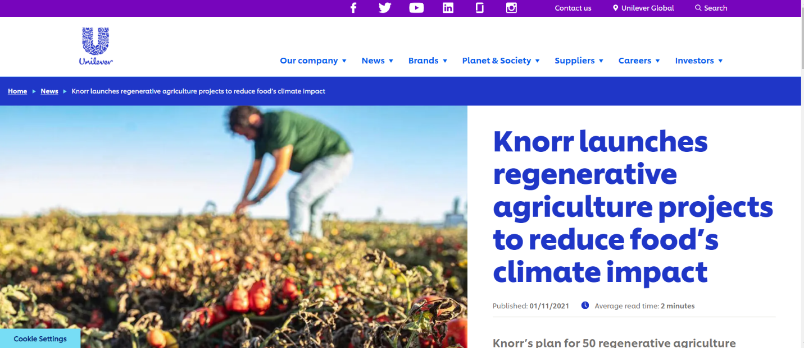
Picture 2: Unilever’s environment conscious initiative
Source: (Unilever UK & Ireland Homepage, 2021)

Conclusion
To understand an organization's potential scopes and threats internal and external analysis helps immensely. The internal analysis brings out the strength and external analysis brings forth the opportunities and threats. When an organization matches its strength to exploit opportunities it results in distinctive competency and capability which altogether creates sustained competitive advantage and profit growth. In this analysis for external situational analysis porter's five forces and PESTLE has been carried out. Through these two analyses, it's been portrayed that every aspect of the environment affects an organization intensely. It is necessary to find out which factors to exploit to increase revenue. Unilever is a global company that has consumed all over the world and offers myriads of products that are easily affected by global factors like Covid-19. This is why an immaculate examination of internal resources assists in formulating proper strategies to overcome the weakness and threats thus maintaining strategic control. In this report, an overview has been given to cover up holistic marketing approach by covering up organizational, industry, and macro-environmental factors. While decision making recognizing industry boundaries is crucial because if it is not done properly Organization may face loss even can go bankrupt. This report states all the situations in a way so that taking the decision and identifying gaps can be made easier for Unilever.

References
Ali, A. and Muhammad, K. (2021). Impact of Promotional Tools on Consumer Buying Behavior: A Case of FMCG Industry. Journal of Marketing Strategies, 3(1), pp.44-67.
Bateman, T. and Konopaske, R. (2021). Management. New York: McGraw-Hill Education.
Chhabra, D. (2018). Factors Affecting Consumer Buying Behaviour and Decision Making Process towards FMCG Products. Journal of Advances and Scholarly Researches in Allied Education, 15(6), pp.131-139.
Christopher, M. (2020). Logistics & supply chain management. Harlow: Pearson Education Limited.
Clow, K. and Baack, D. (2021). Integrated Advertising, Promotion, and Marketing Communications, EBook, Global Edition. Harlow: Pearson Education, Limited.
Elliott, L. and Partington, R. (2021). Ditching furlough scheme will add to UK’s economic woes, warn unions and firms. [online] The Guardian. Available at: <https://www.theguardian.com/uk-news/2021/sep/30/ditching-furlough-scheme-will-add-to-uks-economic-woes-warn-unions-and-firms> [Accessed 24 November 2021].
Eltawy, N. and Gallear, D. (2021). Exploring supply chain agility in the FMCG industry. International Journal of Technology Management, 86(1), p.44.
GOV.UK. (2021). Corporation Tax. [online] Available at: <https://www.gov.uk/corporation-tax> [Accessed 24 November 2021].
Kotler, P. and Keller, K. (2012). Marketing management. Boston [Mass.]: Pearson.
Ons.gov.uk. (2021). Home - Office for National Statistics. [online] Available at: <https://www.ons.gov.uk/> [Accessed 24 November 2021].
Siagian, H., Jade, K. and Tarigan, Z. (2020). The role of affective leadership in improving firm performance through the integrated internal system and external integration FMCG Industry. International Journal of Data and Network Science, pp.365-372.
Smithers, R. (2021). Pandemic prompts doubling of online grocery shoppers in UK. [online] The Gaurdian. Available at: <https://www.theguardian.com/business/2020/aug/20/pandemic-prompts-doubling-of-online-grocery-shoppers-in-uk> [Accessed 24 November 2021].
Thompson, J., Scott, J. and Martin, F. (2017). Strategic Management. Andover: Cengage.
Unilever. (2021). Unilever UK & Ireland Homepage. [online] Available at: <https://www.unilever.co.uk/> [Accessed 24 November 2021].
Verhage, B. and Visser, M. (2018). Marketing fundamentals. Groningen: Noordhoff Uitgevers.

