  - Developing Professional Practice
  - 14 November 2018
  - Kirsty Baker
  - CIPD Membership No. 53316037

Word count (2860 words)
I declare that this assignment is my own work and that any information obtained from books and other sources have been appropriately referenced.


Signed

Date 14/11/2018

Table of Contents

Introduction 3
- Activity 1
  - Evaluate what it means to be a HR Professional 4-6
  - Evaluate what it means to be a HR Professional – The CIPD Profession Map 6-7

- Activity 2
  - Group Dynamics 8-9
  - Conflict Resolution Methods 9-10

- Activity 3
  - Project Management: Implementing a HR System within LBS 11
  - Influencing, Persuading and Negotiating 12

- Activity 4
  - CIPD Self-assessment 13-14
  - My Personal Development Plan 15

- Reference List 16-17
- Appendices 18

Introduction
This report outlines my response to Developing Professional Practice activities. Included within the report are examples from my current role and underpinning theory. The specific areas covered in this report are the CIPD Profession Map, Group Dynamics, Conflict Management, Project Management, Problem Solving and Negotiating, Persuading, Influencing techniques. At the end of the report I have conducted self-assessment of my HR skills and knowledge with use of the CIPD self-assessment tool, backed up with a personal development plan to improve on certain areas through use of SMART objectives.

- Activity 1
1.1 Evaluate what it means to be a HR Professional
To be a HR professional in the 21st century, continuing personal development (CPD) must be on the top of your agenda (Watson and Reissner, 2014 quoted in Perkins and Woodhams 2016, p .109).It is reasonable to say that to be a HR professional, it is essential to be a member of the CIPD. The CIPD states that being a member of the CIPD, you are required to demonstrate your commitment to CPD and may be asked to submit evidence to show this (CIPD,N.D(a). According to (Cheary,2018) a HR CIPD qualification is one of the few qualifications that will increase your employability within HR in 2018. This statement suggests that it is desirable to have a CIPD qualification to become a HR professional within the competitive career market.
Element of professionalism | Description | Reference
Body of expert knowledge and skills | Based on specialised training or education | Gilmore and Williams 2007
Self-regulation | The prescription of standards of performance | Farndale and Brewster 2005
Situational judgement | Applying expertise to specific circumstances, while often resolving conflicts of interest between multiple stakeholders; drawing on both knowledge and ethical competence | Arnold and Stern 2006
Service orientation | The importance of trust and quality of service in professional relationships with clients | Van Rensburg et al 2011; Fournier 1999; Duska et al 2011; Barker 2009
Whilst reviewing a research report conducted by the CIPD as featured below figure 1. The report compares the views of around 3,000 HR practitioners that conclude with elements of professionalism, which were found to be: body of expert knowledge and skills, situational judgement, service orientation and Continued Personal Development, to name a few. These elements are also reinforced within the CIPD Profession Map as displayed in figure 3. Hence supporting the importance of each element desired to be a HR professional.

Figure 1. CIPD profession checklist (CIPD,2017)

Helen Floor, the Managing Director of 1-1 Recruitment Group also states that in her primary dealings with recruiting HR Professionals, there is a collation of repetitive qualities that her HR candidates possess and all have in common as HR practitioners. According to Helen, HR Practitioners all want to solve problems, challenge assumptions, partner other business functions and champion employee (Floor,2018). Her views on what it means to be a HR Professional are also backed up within the contents of the CIPD profession map. I have compared the two in the diagram labelled figure

Helen Wood | CIPD Map
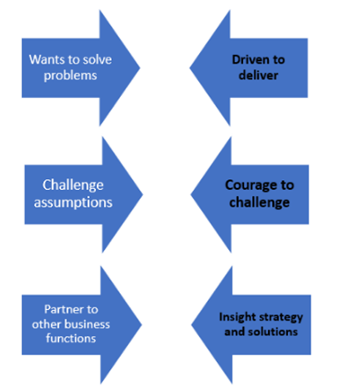
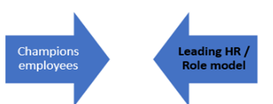
Figure. 2 Comparison diagram created via smart art

  - Evaluate what it means to be a HR Professional - The CIPD Profession Map
CIPD is responsible for setting clear expectations about the role of HR, equipping practitioners with a set of ethical guidelines that clearly define what the profession stands for. (CIPD,2013, p.2(a) Therefore, CIPD have designed a Profession Map that captures eight behaviours, ten professional areas of HR and four bands of professional competence that provide a framework for HR Professionals to aim to achieve. Whether they are in band one (emerging level) or band four (exceeding level) there is always scope to continuously progress in different areas of the map. The Map provides a clear pathway for progression. The 2 inner cores and 8 behaviours apply to all HR Professionals, whereas the 10 professional areas may only apply to different HR specialists, I.e. Recruitment specialists may be a band 4 in resourcing and talent planning and a band 1 in learning and development.
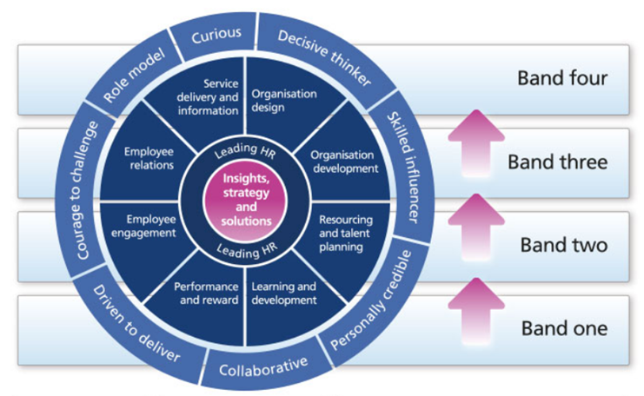
Figure. 3 CIPD Profession Map (CIPD,2013(a)
I have chosen to look more in depth at the importance of decisive thinking, service delivery and information and curious within HR. In my CIPD profession map assessment results I have scored relatively high in these areas of the map as seen in Figure 4, placing me in band 4 in these behaviours and band 3 in the specialist area. I feel confident that I apply these daily in my role as HR Advisor. (Evidence. 1 HR Advisor Job Description)

Decisive Thinker
The CIPD Map describes decisive thinking as “Demonstrates the ability to analyse and understand data and information quickly. Uses information, insights and knowledge in a structured way to identify options, make recommendations and make robust, defendable decisions” CIPD (2013(b). The CIPD also states the contra-indicators are someone who focuses on symptoms rather than causes. This supports the need for decisive thinking in HR in relation to complaints and grievances. Without finding the cause, complaints and grievances may not be fully resolved in the correct way and could escalate further without proper resolution of the root cause. Also, HR would need to make a robust, and justifiable decision which could not be done without understanding, analysing and using information.
Service Delivery and Information
The CIPD Map describes Service Delivery and Information as “Customer-focused HR service delivery and excellence across the entire employee lifecycle, applying exceptional process and project management to enable effective and cost-efficient HR service delivery; provide the organisation with meaningful analytics to enable business improvement.” This is important in HR for ensuring that the delivery of HR service and information to leaders, managers and staff within the organisation is accurate, efficient, timely and cost-effective and that human resource data is managed professionally (CIPD N.D(b). It is important to achieve a good standard of service delivery and information in HR if you wish to be a member of the CIPD, the code of conduct expected is to apply professional high standards of relevance, accuracy and timeliness in the information and advice they provide to stakeholders. (CIPD,N.D(d) It is also important for HR to be able to effectively project manage ad hoc HR projects to aid with business improvement (Perkins and Woodhams,2016,p.79)
Curious
The CIPD Map describes being Curious as” future-focused, inquisitive and open-minded; seeks out evolving and innovative ways to add value to the organisation.” This is important to HR professionals because HR is an important role in organisations where we see and recognise opportunities or problems (Workology,2017). As backed up by (Sebag-Montefiore,2016) who also claims Curiosity is essential in HR. It pays to be inquisitive about the impact of the organisation’s culture and business outcomes as understanding how the business operates enables the identification of opportunities for improvement. One of the contra-indicators for being curious is someone who takes immediate information at face value and fails to ask questions (CIPD,N.D(c) This statement supports the importance of being curious in HR, specifically in relation to HR tasks such as the disciplinary processes where the investigation process is important and probing questions need to be asked to properly investigate information and not accept all information at face value. Therefore, it is necessary for HR professional to be curious. (ACAS,N.D)

2.0 Activity 2
2.1 Group Dynamics
“Group dynamics is the study, analysis and understanding of the behaviours and psychology surrounding group interactions.” (HRZONE,N.D) There are a number of different factors that can affect a groups dynamics, these include:
- Nature of the individuals in the group
- The Leadership style
- Group Structure
- Power struggles
- Communication and structures
(Perkins and Woodhams,2016,p.84)
During my current role as HR Advisor, I worked within a group for the launch of a new Annual Appraisal Scheme. The team was made up of the L&D Director, L&D Manager, HR Manager and HR Advisor. We faced challenges in the early stages of brainstorming ideas for the annual reviews as the team was made up of too many ‘Plants.’ According to Belbin’s 9 team roles theory, teams will perform at their best when there are clear defined roles and the team is made up of a mix of action, thought and people orientated individuals (Mindtools,N.D). Belbin’s 9 roles are featured below in Figure.7. This implication proved to be difficult on agreeing ideas and communication, which also proved to be timely as there were too many creative ideas put forward to consider and a lack of a ‘finisher’ or a ‘implementer’ to take charge and make a decision, and progress the idea into a practical action. Belbin defines a ‘finisher’ as someone who pushes the team to complete projects on time with no errors and an implementer as someone who turns the groups concepts into practical ideas (Mindtools,N.D). Hence relating to the above group dynamics, we faced the challenge of the communication within the group and the struggle of the group structure. I.e. all ‘Plants’ and all come from a similar background / nature of department.
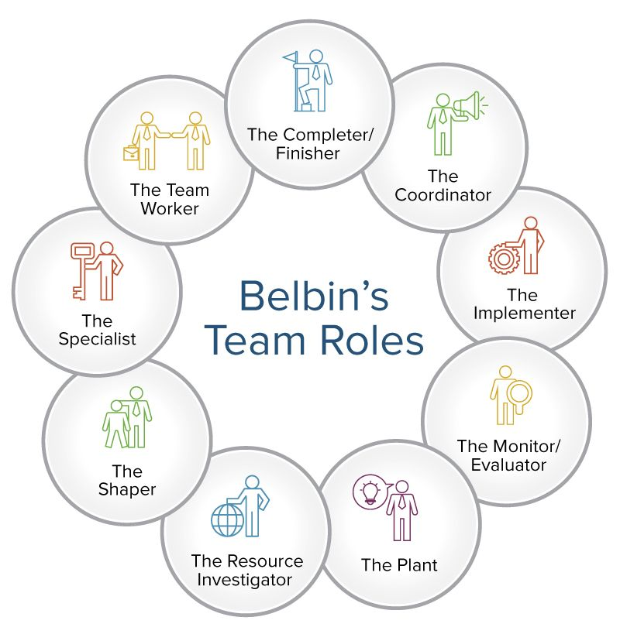
Figure.5 Belbin’s 9 team roles (Smartsheet,N.D)
2.2 Conflict Resolution Methods
According the Thomas-Kilmann questionnaire on conflict management styles, I scored the highest as being compromising (Evidence 2 Thomas-Kilmann Results). Thomas-Kilmann defines compromising as intermediate in both assertiveness and cooperativeness with the objective of seeking a quick middle-ground position. I also scored moderately high on accommodating. Thomas-Kilmann defines accommodating as neglecting your own concerns to satisfy the concerns of the other person. (Trainer, 2010)
One example of a conflict situation that I have managed in my current role as a HR Advisor is where there was a breakdown in communication with an Employee and the Line Manager. I approached this conflict through compromising resolution. I arranged a meeting to mediate between the two persons involved and used active listening between both parties to air both parties concerns and resolve the issues surrounding the lack of communication. There was a middle ground position met where both parties agreed to meet every Friday afternoon to communicate sales progress from the previous week and plan for the week ahead.
Another example of a conflict that I have managed in my current role would be when my Line Manager and I were in disagreement during the project outlined in Activity 3. The HR Manager had booked annual leave for 3 weeks towards the end of the project, during the execution stage. She wanted to delay the progress of the project whilst she was away not to miss training being provided by the external training provider. After trying to negotiate the timescales to progress whilst she was away and offer that she could have in house training upon return she was reluctant to agree. Therefore, I resolved the conflict by being accommodating and postponed the training until her return.

3.0 Activity 3
3.1 Project Management: Implementing a HR System within LBS
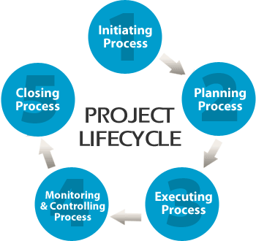
The most recent project I have managed is still on going. To summarise, I was tasked with improving the Time and Attendance recording procedure for the Company. I researched different suppliers that offered a digitalised Human Resources System (HRIS) and compared the best value for money in terms of costs v services. I collated the research information and put forward a proposal to the board of Directors and they agreed the purchase of the Softworks system that I recommended from drawn conclusions from my research report. This drew a close to the initiating stage as featured below in Figure.6. I then entered the planning stage of the project with the supplier Softworks. I produced a timeline excel chart for the project plan. I then liaised directly with the supplier to plan and ensure the system spec was built suitable for the Company structure. I collated and imported all HR data to be uploaded. I also teamed up with IT to support the installation of the new clock machines and also arranged system training for stakeholders. As per the project timeline (Evidence 3 Project Management Chart) I have sent out Companywide communications throughout the different stages of the project and updated the progress chart to ensure we stayed on target for delivery of the new system. I teamed up with the L&D department and Softworks to arrange system training for all system users. We are now entering the executing stage where we are piloting the new system in 3 of our branches to resolve any system issues that may arise during this piloting period. We have planned to fully execute by February 2019. For the monitoring and controlling stage we will be running our old manual system alongside the new system for a further 4 weeks to ensure that we are monitoring the progress of adapting to our new system and not missing any information in the process. For the Closing stage we are planning to conduct an employee survey on staff views of the new system and rate the efficiency.
Figure.6 Project Lifecycle (Change, N.D)

The Project Management Skills I have used in the above project are:
- Managing a timeline
- Managing people/resources
- Ensuring stakeholders are in the communication loop
- Developing change management plans
(UpstartHR,2015)
  - Influencing, Persuading and Negotiating
The first problem we encountered during the above project was obtaining agreement from the Board of Directors to fund this project. Therefore, we presented a proposal for purchasing our suggested Time and Attendance system to improve the efficiency of recording time and attendance for the Company. We heavily relied on evidence and data to support our viewpoint on the benefits of purchasing the system. As explained in persuasion techniques in Figure. 8. (Evidence.6 Board proposal notes).
Another problem we faced was resistance to change from Branch Managers. They adopted an Us vs Those agenda. (Barnett,1997) Viewing the new system as helping HR only with decreasing workload, and increasing the Managers workload. This conflict was overcome by influential communications addressing sharing the vision of Company and individual benefits for all in a friendly memo and also providing and relevant training provided on the new system to help the managers understand how to use the system for their own benefits and that it would save them time on manual tasks that they do weekly. (Evidence 5-5.1 Influence comms and testimony)
Lastly, we negotiated the cost of the supplier as we discovered that our Head Office would be moving and we would need the additional cost of an extra clock machine, licenses and set up fees. Therefore, we negotiated a lower cost to cover this new challenge that had arisen. We did this by achieving a win-win negotiation as they had retained our custom without losing us to a cheaper competitor and we achieved our discounted system as set out. I have used negotiating skills previously when negotiating % of fees when instructed to use an agency for recruiting a specialist role within the Company. On the phone I used the affirmation of power as I believed to hold more power over the negotiations in these scenarios as a consumer of the products being offered, and the expected outcome that they would decrease the price to keep the sale. As also evident in Figure 8.

Skill | Purpose | Technique | Reference
Persuading | Convince audience to agree on view/topic. | Evidence, factual data, supportive argument, emotive language. Rhetorical questions. | BBC, N.D
Influencing | Aim to get people on board with idea. | Deliver message via friendliness, vision and empowering. | Yemm,2008 quoted in Perkins & Woodhams, 2016 p.84
Negotiating | Win-Win agreement. Both parties gain. | Positive, constructive discussions. Clear goals set, expected outcomes, affirm power and relationships. | Perkins & Woodhams, 2016,p.85

4.0 Activity 4
  - CIPD Self-assessment
I have undertaken the CIPD profession map self-assessment to evaluate my HR skills, knowledge and specialist areas during my current role as HR Advisor. As you can see from my results featured below in Figure.7 I am exceeding in the 6 behaviours and some key segment areas such as employee relations and service delivery and information. The areas I have chosen for improvement are Performance and Reward where I am only emerging (Band 1) I believe would be beneficial for my personal development within HR as I have not had the opportunity to explore performance and reward schemes as of yet. I have also chosen Resource and Talent Planning as I am increasingly becoming the sole co-ordinator of the Companies recruitment strategy I believe it will be extremely important for me to develop further in this area to become more strategic in resourcing and strive to be involved in the strategy side of recruitment and talent planning to progress from delivery only. Lastly I have chosen Driven to Deliver where I am in (Band 3). It would be beneficial for me to improve on this aspect of the map to reach my full potential as a HR Advisor and stakeholder satisfaction I would like to achieve Band 4.
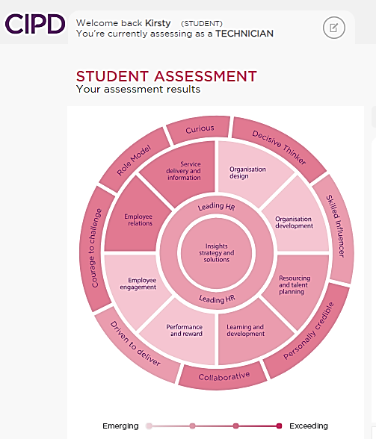
Figure.7 CIPD Self-assessment Results (CIPD,2018)
According the Honey and Mumford Learning Style Questionnaire, I strongly prefer the Theorist and Reflector styles of learning and have a moderate preference for Pragmatic approach to learning. (Evidence 8. Honey and Mumford Results) Therefore, in my personal development plan I will include learning approaches based around the above results to maximise my development. My Personal Development Plan actions will include theory based learning; practical experiences and hands on projects with feedback to continue my development. I have further explored the pros and cons of my results in the table below.
Learning Style | Theory | Pros and Cons
Theorist | Learns by theory behind the actions. They need  models, concepts and facts in order to learn.  Prefer to analyse and synthesise information. | Pro’s  - Decisions based on theory and facts.  - Highly knowledgeable  - Structured approach  Con’s  - Fails to act impulsively without concept  - Doesn’t work well without structures
Reflector | Learns through observing scenarios and reviewing what happened before commenting or acting.  Likes to consider all possible outcomes before making a decision. | Pro’s  - Cautious and thoughtful in actions.  - Low risk approach to decision making.  Con’s  - Doesn’t work well to tight deadlines.  - Doesn’t like to lead groups.
Pragmatic | Prefers to trial new ideas to learn from experience.  Look for new ideas to apply with hands on approach to problems. Enjoys feedback from an expert. | Pro’s  - Experience based learning  - Can improve from feedback given.  - Hands on approach  Con’s  - Doesn’t like a lot of theory based learning.  - Struggles without clear guidelines.

Figure. 9 Learning Styles Pro’s and Con’s table. (Rosewell,2005)

  - My Personal Development Plan
I have produced a personal development plan using the CIPD development plan template to cover my 3 chosen areas for improvement from the CIPD Profession Map. There are 5 actions to be completed from December 2018 to May 2019 in reference to Performance and Reward, Resource and Talent Planning and Driven to Deliver. (PDP Evidence 9)

5.0 Reference List
ACAS (N.D) Carrying out Investigations in the workplace http://www.acas.org.uk/index.aspx?articleid=5507 Accessed: 14/11/2018
Barnett E. (1997) Managing conflicts in systems development. Hospital Materiel Management Quarterly pp 1-6
BBC (2018) GCSE Revision https://www.bbc.com/bitesize/guides/zpr49j6/revision/2 Accessed: 14/11/2018
Cheary, M. (2018) ‘The top courses to help you get hired April 2018’ https://www.reed.co.uk/career-advice/top-courses-help-you-get-hired-april-2018/ Accessed: 14/11/2018
CIPD Report (2017) ‘HR Professionalism – What do we stand for’ https://www.cipd.co.uk/Images/hr-professionalism-what-do-we-stand-for_2017_tcm18-17960.pdf page 6
Accessed: 14/11/2018
CIPD (2013(a) The Profession Map https://www.cipd.co.uk/learn/career/profession-map/2013-profession-map Accessed: 14/11/2018
CIPD (2013(b) The CIPD Profession Map Downloadable Format file:///C:/Users/Kirsty/Downloads/the-cipd-profession-map-standard-format_tcm18-9814.pdf Accessed:14/11/2018
CIPD (N.D(a) ‘About CPD’ https://www.cipd.co.uk/learn/cpd/about Accessed:14/11/2018
CIPD (N.D(b) CIPD Profession Map Behaviours https://www.cipd.co.uk/learn/career/profession-map/behaviours Accessed: 14/11/2018
CIPD (N.D(c) Professional Areas Factsheet accessed: 11/11/2018 https://www.cipd.co.uk/learn/career/profession-map/professional-areas Accessed: 14/11/2018
CIPD (N.D(d) Code of Professional Conduct https://www.cipd.co.uk/Images/code-of-professional-conduct_tcm18-14510.pdf Accessed: 14/11/2018
Helen Woods (2018) People Management Magazine https://www.peoplemanagement.co.uk/voices/comment/become-successful-hr-professional
Accessed: 14/11/2018
HR ZONE (N.D) What Are Group Dynamics https://www.hrzone.com/hr-glossary/what-are-group-dynamics Accessed: 14/11/2018
Miller-Merrell, J. (2017) ‘How Intellectual Curiosity is Critical for Your Success in HR’ https://workology.com/intellectual-curiosity-hr/ Accessed: 14/11/2018
Mind Tools (N.D) ‘How Understanding Team Roles Can Improve Team Performance’ https://www.mindtools.com/pages/article/newLDR_83.htm Accessed: 14/11/2018
Perkins, G. and Woodhams, C. (2016) ‘Developing Professional Practice’ CIPD (ed 2) Studying Human Resource Management, p. 79,84,85, London: CIPD
Perkins, G. et al (2016) ‘Developing the knowledge and skill of the HR Professional’ CIPD (ed 2) Studying Human Resource Management, p. 109, London: CIPD
Rosewell, J. (2005) ‘Learning Styles’ https://www.open.edu/openlearn/ocw/pluginfile.php/629607/mod_resource/content/1/t175_4_3.pdf Accessed: 14/11/2018
Search (2018) Project Management http://www.search.org/solutions/public-safety-emergency-communications/project-management/ Accessed: 14/11/2018
Sebag-Montefiore, L. (2016) ‘The Curios HR Professional’ https://10eighty.co.uk/curious-hr-professional/ Accessed:14/11/2018
Trainer, J. (2010) Thomas-Kilmann Conflict Mode Instrument Report https://www.skillsone.com/Pdfs/smp248248.pdf Accessed: 14/11/2018
Tutorials Point (N.D) ‘Individual and group behaviour’ https://www.tutorialspoint.com/individual_and_group_behavior/five_stage_model_group_development.htm Accessed: 14/11/2018
UpstartHR (2015) Ultimate Guide To Project Management https://upstarthr.com/hr-project-management-ultimate-guide/ Accessed: 14/11/2018

6.0 Appendices
1. HR Advisor Job Description
2. Thomas-Kilmann Questionnaire Results
3. Project Management Timeline Chart
4. Stakeholder Communications Email
5. Influencing Communication Email
5.1 Influencing Email Testimony – HR Manager
6. Board Proposal Draft Notes – Persuading Evidence
7. CIPD Self-assessment Results
8. Honey and Mumford Questionnaire Results
9. Personal Development Plan

