
Applied Leadership and Management in the Workplace
Module Assignment Submission
Student Name: | Nicola Powell
Student Number: | 2433701
Module No: | BMSK5011
Module Title: | Developing Workplace Critical Thinking

Statement of Confirmation of Authenticity
By the act of making this submission, the student declares that this is the work of the student named above. The work has not, in whole or in part, been knowingly presented elsewhere for assessment, or where assessment has been built on a previous assessment, this has been identified. Where materials have been used from other sources it has been properly acknowledged. If this statement is untrue, the student acknowledges that an assessment offence has been committed.
Attention is drawn to the plagiarism and unfair practice policies of both the University and of ILM.

Contents
1. Introduction 4
2. Defining Critical Thinking in the Workplace 5
3. Discriminating Between Beliefs, Attitudes and Values 6
4. Critical Assessment of Personal Beliefs, Attitudes and Values 6
5. Workplace Application: Problem Definition Framework 7
6. Critical Thinking in Practice – Five Workplace Scenarios 7
Scenario 1: Repeated Missed Appointments 7
Scenario 2: Client Complaint Escalation 7
Scenario 3: Engineer Resistance to New System 7
Scenario 4: Unequal Workload Distribution 7
Scenario 5: Emergency Job Prioritisation 8
7. Bias and Its Impact on Workplace Decision Making 8
7.1 Identification of Personal Bias: Affinity Bias 8
7.2 Root Cause Analysis (5 Whys) 8
7.3 Theoretical Perspective 8
7.4 Impact of Bias 8
7.5 Critical Reflection 9
7.6 Strategies to Mitigate Bias 9
7.7 Conclusion 9
8. Environmental Analysis (PESTLE) in Operational Scheduling 9
8.1 Political and Legal Factors 9
8.2 Economic Factors 9
8.3 Social Factors 9
8.4 Technological Factors 9
8.5 Environmental Factors 10
9. Critical Thinking Tools in Operational Scheduling 10
9.1 The 5 Whys 10
9.2 Ishikawa Fishbone Diagram 11
9.3 Mind Mapping 12
9.4 Grid Analysis 13
9.5 Integration and Reflection 13
9.6 Conclusion 13
10. Belbin Team Roles Analysis (Resource Investigator and Coordinator) 14
10.1 Resource Investigator (RI) 14
10.2 Coordinator (CO) 15
10.3 Integration of RI and CO Roles 15
10.4 Link to Beliefs, Attitudes and Values 15
10.5 Conclusion of Section 15
11. Management Theories and Their Application to Operational Scheduling 16
11.1 Systems Theory 16
11.2 Contingency Theory 16
11.3 Comparative Analysis 16
11.4 Integrated Application 17
11.5 Influence of Beliefs, Attitudes and Values 17
11.6 Conclusion 17
12. Ethical Decision Making 17
13. CRAAP Test 18
14. Reflection 18
15. Conclusion 19
References (APA 7th Edition) 20
Appendices 21
1. Belbin Team Roles Analysis question air 21

1. Introduction
Critical thinking is a core competency within modern organisational environments, particularly in operational roles that require continuous problem-solving, decision making, and stakeholder coordination. In complex and dynamic settings, such as operations scheduling within the water and air hygiene industry, managers must navigate competing priorities including compliance, efficiency, client expectations, and workforce wellbeing. This requires not only technical competence but also the ability to critically evaluate information, challenge assumptions, and make balanced, ethical decisions.
This report explores the development of workplace critical thinking within my role as an Operations Scheduling Manager responsible for managing engineers remotely. It critically examines the impact of my beliefs, attitudes, and values on workplace behaviour and decision-making, recognising that these internal factors significantly influence how problems are interpreted and resolved. The report also evaluates the role of cognitive bias and ethical considerations, highlighting how self-awareness contributes to more objective and effective decision-making.
In addition, the report applies a range of critical thinking frameworks and tools, including the 5 Whys, Ishikawa diagrams, PESTLE analysis, and the CRAAP test, to demonstrate structured approaches to problem solving within an operational context. Practical workplace examples are used throughout to illustrate how these tools support more informed and reflective decisions.
Furthermore, the report critically analyses two contemporary management theories. Systems Theory and Contingency Theory and evaluates their relevance to my role. While both provide valuable insights, the report argues that Contingency Theory is most applicable to my decision-making approach due to the dynamic and unpredictable nature of operational scheduling, while Systems Theory supports a broader understanding of organisational interdependencies.
The inclusion of the Belbin Team Role analysis, identifying my strengths as a Resource Investigator and Coordinator, further supports reflection on how my behavioural tendencies influence leadership style and decision making. Overall, this report demonstrates how the integration of theory, practical application, and critical self-reflection contributes to the development of effective workplace critical thinking and continuous professional growth.

2. Defining Critical Thinking in the Workplace
Critical thinking is widely recognised as a key competency within modern organisations, enabling individuals to analyse information, evaluate evidence, and make reasoned decisions. It involves not only problem solving but also the ability to question assumptions, interpret data, and consider alternative perspectives (Facione, 2015). In a workplace context, critical thinking goes beyond routine decision making by requiring reflective judgement and the ability to adapt to changing circumstances.
In my role as an Operations Scheduling Manager, critical thinking is essential due to the complexity and unpredictability of daily operations. Scheduling engineers remotely involves balancing multiple variables, including resource availability, client priorities, travel logistics, and compliance requirements. This requires both analytical thinking, to assess data and plan effectively, and reflective thinking, to evaluate decisions and learn from outcomes.
Furthermore, critical thinking is closely linked to professional judgement, particularly in situations where there is no clear or immediate solution. According to Halpern (2014), effective critical thinkers are able to apply both logical reasoning and experience to make informed decisions under pressure. In practice, this means moving beyond reactive responses and adopting a more structured and proactive approach to problem-solving.
Developing workplace critical thinking therefore involves not only the use of analytical tools but also increased self-awareness, enabling individuals to recognise how their beliefs, attitudes, and values influence their decisions. This is particularly important in operational roles, where the quality of decision making has a direct impact on performance, compliance, and team effectiveness.

3. Discriminating Between Beliefs, Attitudes and Values
Understanding the distinction between beliefs, attitudes, and values is essential for self-awareness and behavioural development.
- Beliefs: Cognitive assumptions or perceptions about reality (e.g., engineers perform better with autonomy)
- Attitudes: Emotional responses or predispositions towards situations (e.g., frustration towards repeated lateness)
- Values: Core principles guiding behaviour (e.g., accountability, client focus)
Rokeach (1973) identifies values as the foundation of behaviour, while attitudes are shaped by both beliefs and values. In my role:
- Belief: Efficiency improves with structured planning
- Attitude: Proactive approach to problem-solving
- Value: Accountability and client satisfaction
The interaction of these elements directly influences decision making, communication, and leadership style.

4. Critical Assessment of Personal Beliefs, Attitudes and Values
My beliefs, attitudes, and values play a central role in shaping my workplace behaviour and decision making as an Operations Scheduling Manager. My belief system has traditionally been driven by performance, efficiency, and meeting SLA targets, leading to a structured and task oriented approach to scheduling. While this has supported operational effectiveness, it has also highlighted limitations when addressing more complex, people focused challenges.
This can be understood through Cognitive Dissonance Theory, developed by Leon Festinger (1957), which explains the psychological tension that arises when an individual’s beliefs conflict with their actions or values. In my role, this is evident when the drive for efficiency conflicts with my values of fairness and team wellbeing, creating a need to reassess and adjust my decision making approach.
My values strongly align with organisational expectations, particularly accountability, client focus, and engagement. However, critical reflection has identified that an overemphasis on efficiency can sometimes undermine these values, particularly in relation to equitable workload distribution. My attitudes towards problem solving are proactive and solution focused, supporting effective decision making under pressure, but can also lead to rapid decisions without fully considering alternative perspectives.
Through critical reflection, I have recognised the importance of balancing operational efficiency with ethical and people centred considerations. This includes increasing awareness of how my beliefs influence judgement, remaining open to challenge, and ensuring my values are consistently reflected in fair and objective decision-making.

5. Workplace Application: Problem Definition Framework
Effective critical thinking begins with defining the problem:
Example: Missed SLA Deadlines
- Nature: Delays in scheduling engineers to complete compliance tasks
- Scope: Affects clients, engineers, and internal teams
- Impact: Financial penalties, reduced client trust, operational backlog
This structured definition ensures clarity before implementing solutions.

6. Critical Thinking in Practice – Five Workplace Scenarios

Scenario 1: Repeated Missed Appointments
Problem: Engineers missing scheduled jobs
5 Whys Analysis:
- Why missed? → Poor route planning
- Why poor planning? → Overbooking
- Why overbooking? → Pressure to meet targets.
- Why pressure? → KPI-driven culture
- Why KPI focus? → Management expectations
Decision: Introduced realistic scheduling buffers
Insight: My value of accountability initially led to overloading schedules.

Scenario 2: Client Complaint Escalation
- Why complaint? → Delayed service
- Why delay? → Engineer unavailable
- Why unavailable? → Poor communication
- Why communication gap? → Lack of system updates
- Why no updates? → Process inconsistency
Decision: Implemented real time update protocols

Scenario 3: Engineer Resistance to New System
- Why resistance? → Lack of training
- Why no training? → Time constraints
- Why constraints? → Operational pressure
- Why pressure? → High workload
- Why workload high? → Resource shortage
Decision: Introduced phased training

Scenario 4: Unequal Workload Distribution
- Why unequal? → Manual scheduling bias
- Why bias? → Familiarity with certain engineers
- Why familiarity? → Communication preference
- Why preference? → Comfort zone
- Why comfort? → Habit
Decision: Introduced automated allocation tools

Scenario 5: Emergency Job Prioritisation
- Why prioritised? → Urgency
- Why urgent? → Compliance risk
- Why risk? → Legal requirement
- Why legal importance? → Health safety
- Why safety critical? → Public risk
Decision: Created priority classification system

7. Bias and Its Impact on Workplace Decision Making
Bias is an inherent aspect of human cognition and can significantly influence workplace decision-making, particularly in fast-paced operational environments. According to Daniel Kahneman (2011), cognitive biases arise from mental shortcuts (heuristics) that enable quick decisions but can reduce objectivity. In my role as an Operations Scheduling Manager, where decisions are often made under pressure, this increases the risk of unconscious bias affecting judgement.

7.1 Identification of Personal Bias: Affinity Bias
A key bias I have identified is affinity bias, where individuals favour those, they communicate with more frequently or feel more comfortable with.
Workplace Example
I observed that I was allocating more complex or desirable jobs to engineers who were more responsive and easier to communicate with. While this initially appeared to be based on performance, critical reflection revealed that familiarity and convenience were influencing my decisions.

7.2 Root Cause Analysis (5 Whys)
- Why were certain engineers favoured? → Easier communication
- Why did this matter? → Reduced workload and increased efficiency
- Why prioritise efficiency? → Pressure to meet SLAs.
- Why rely on certain individuals? → Trust and familiarity
- Why familiarity? → Unconscious preference
This demonstrates how operational pressure can reinforce biased decision-making.

7.3 Theoretical Perspective
Kahneman (2011) distinguishes between System 1 thinking (fast, intuitive) and System 2 thinking (slow, analytical). In scheduling, reliance on System 1 thinking increases susceptibility to bias, as decisions are made quickly without full evaluation.

7.4 Impact of Bias
Bias can have several consequences:
- Operational: Unequal workload distribution and inefficiencies
- Team Dynamics: Perceived favouritism and reduced morale
- Organisational: Misalignment with values such as fairness and accountability
This behaviour conflicted with my own values of accountability, engagement, and fairness.

7.5 Critical Reflection
This experience challenged my initial belief that prioritising efficiency was always the best approach. It highlighted the need to balance operational performance with fairness and transparency. My attitude has shifted towards more reflective decision making, reinforcing values of objectivity and inclusivity.

7.6 Strategies to Mitigate Bias
To reduce bias, I have implemented:
- Data driven decision-making to ensure objectivity.
- Standardised processes for workload allocation
- Regular reflection to challenge assumptions.
- Feedback from engineers to identify perceptions of fairness.
These strategies support more consistent and ethical decision making.

7.7 Conclusion
In conclusion, bias is an unavoidable but manageable aspect of decision making. Through critical reflection and the use of structured approaches, I have improved my awareness of how bias influences my behaviour. This has enabled more balanced, fair, and effective decision making, strengthening both team performance and alignment with organisational values.

8. Environmental Analysis (PESTLE) in Operational Scheduling
Environmental analysis is essential for effective decision making, as external factors directly influence operational processes. The PESTLE framework (Johnson et al., 2020) supports structured evaluation of key influences, enabling more informed and proactive scheduling decisions.

8.1 Political and Legal Factors
Compliance requirements, such as health and safety regulations and Legionella control, must be prioritised.
Critical Thinking:
Decisions must ensure compliance while balancing operational demands.

8.2 Economic Factors
Budget constraints and costs (e.g., fuel) affect resource allocation.
Critical Thinking:
Requires balancing efficiency with service quality and workload management.

8.3 Social Factors
Workforce expectations, including fairness and engagement, influence performance.
Critical Thinking:
A people centred approach supports long term effectiveness.

8.4 Technological Factors
Scheduling systems improve efficiency but may introduce risks.
Critical Thinking:
Decisions must combine data with professional judgement.

8.5 Environmental Factors
Sustainability considerations include reducing travel and emissions.
Critical Thinking:
Encourages long term, responsible decision making.

9. Critical Thinking Tools in Operational Scheduling
Critical thinking in the workplace is strengthened through the use of structured analytical tools that support objective, evidence based decision making. In my role as an Operations Scheduling Manager, these tools are essential for managing complexity, reducing bias, and improving operational efficiency in a fast paced, remote environment.
According to Paul and Elder (2014), critical thinking tools enable individuals to break down complex problems, challenge assumptions, and reach reasoned conclusions. This is particularly important in scheduling, where decisions must balance efficiency, compliance, and workforce wellbeing.

9.1 The 5 Whys
The 5 Whys technique is used to identify the root cause of a problem through iterative questioning (Ohno, 1988).
Application
I have used this tool to analyse issues such as missed appointments and communication breakdowns, enabling me to move beyond surface level problems.
Evaluation
- Strengths: Simple, quick, effective for operational issues
- Limitations: Can oversimplify complex problems and rely on subjective answers
While valuable, I recognise the need to combine it with broader tools to avoid linear thinking.
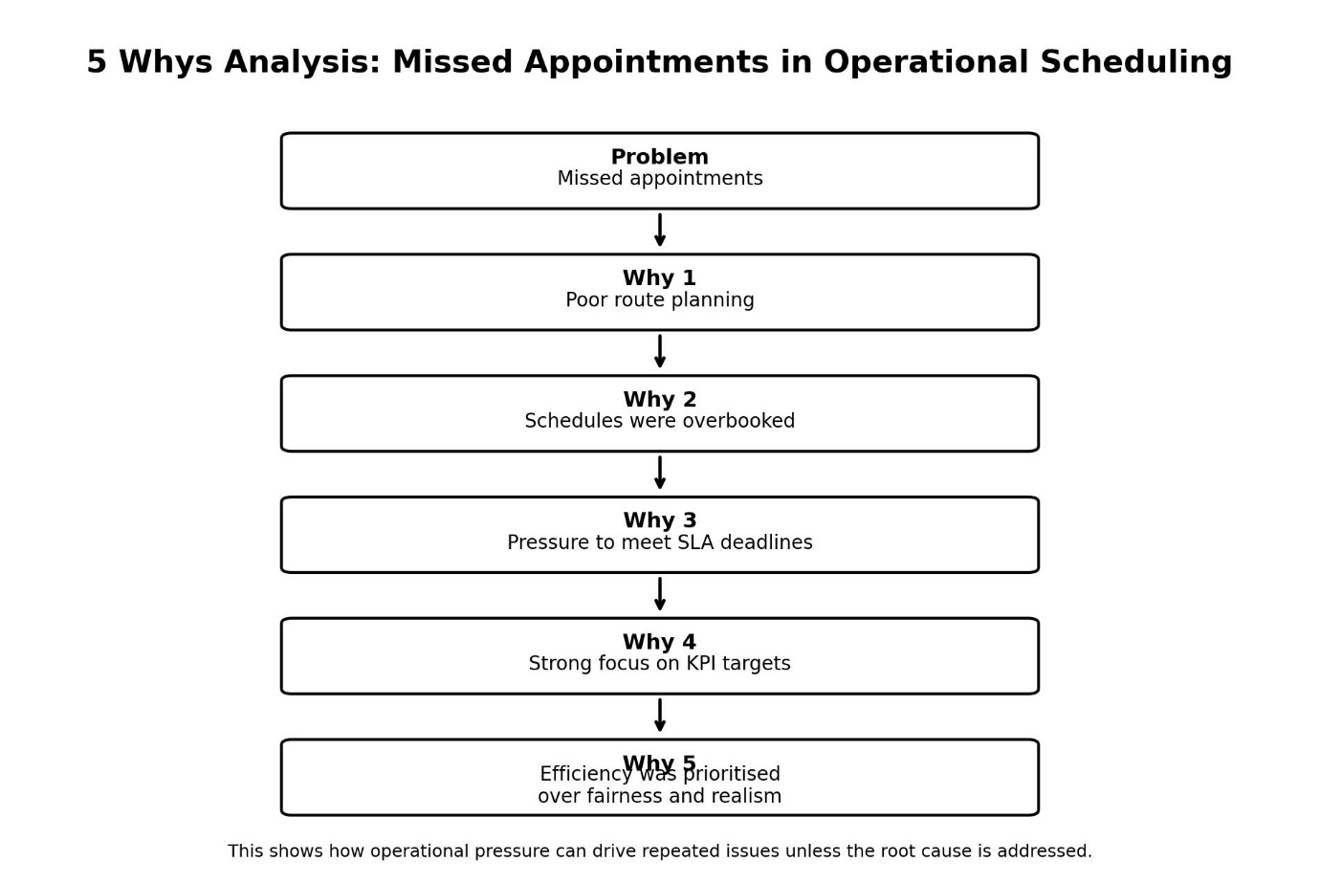

9.2 Ishikawa Fishbone Diagram
The Ishikawa diagram identifies multiple causes of a problem across categories such as people, process, and technology (Ishikawa, 1985).
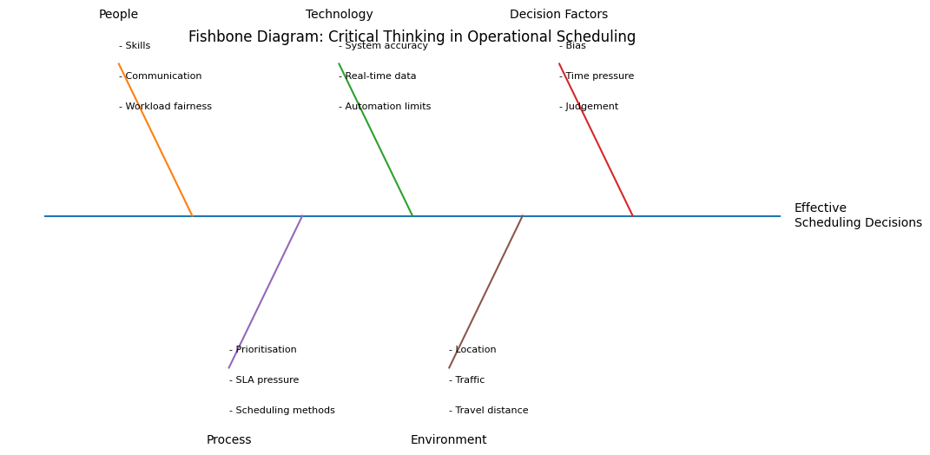
Application
Used to analyse SLA breaches by identifying contributing factors across different operational areas.
Evaluation
- Strengths: Encourages holistic thinking and reduces oversimplification
- Limitations: Time-consuming and can become complex
This tool aligns with Systems Theory, highlighting interdependencies within scheduling processes.

9.3 Mind Mapping
Mind mapping is used to visually organise ideas and explore potential solutions (Buzan, 2018).
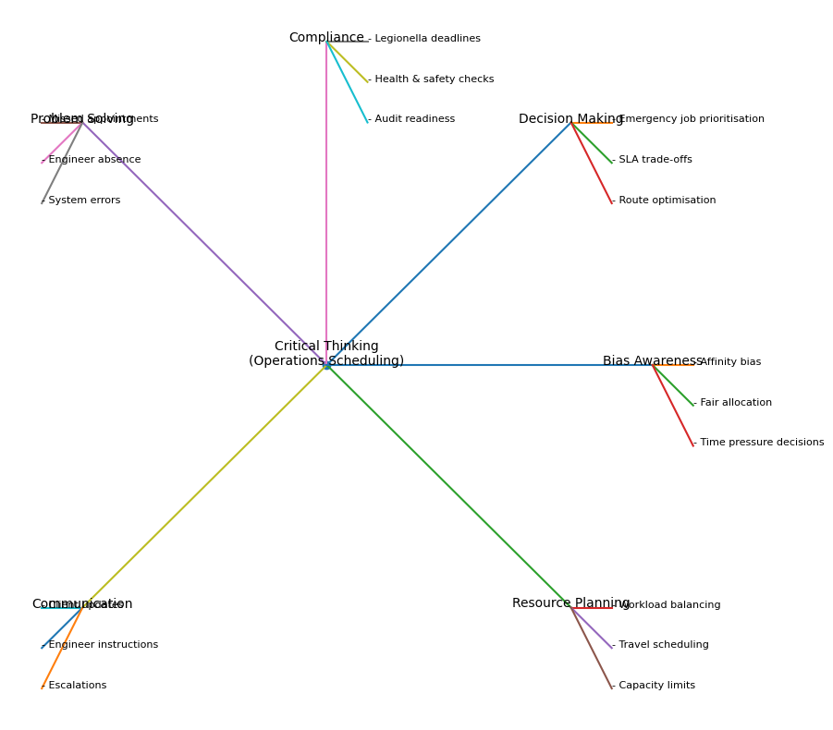
Application
Useful in early-stage planning, such as workload distribution or identifying risks.
Evaluation
- Strengths: Encourages creativity and broad thinking
- Limitations: Lacks structure and requires follow-up analysis
It supports idea generation but must be combined with more structured tools.

9.4 Grid Analysis
Grid analysis evaluates options against defined criteria to support objective decisions.
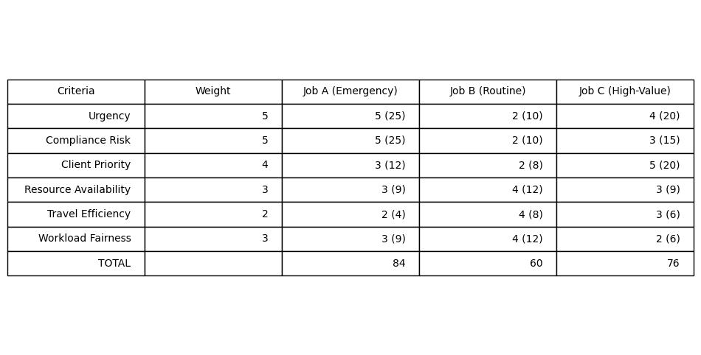
Application
Used when prioritising jobs or allocating limited resources.
Evaluation
- Strengths: Promotes objectivity and reduces emotional bias
- Limitations: Dependent on chosen criteria and weighting
This tool has helped reduce bias, although I recognise that criteria selection can still reflect personal judgement.

9.5 Integration and Reflection
In practice, I combine tools to enhance decision-making:
- Mind Mapping - explore ideas.
- Ishikawa - identify causes.
- 5 Whys - determine root cause.
- Grid Analysis - evaluate solutions.
This integrated approach improves both the depth and objectivity of my decisions.
The use of these tools has also influenced my development:
- Beliefs: Shift towards evidence based decision making
- Attitudes: Greater openness to alternative perspectives
- Values: Increased emphasis on fairness and objectivity

9.6 Conclusion
Critical thinking tools are essential for effective operational management, providing structure and reducing bias in complex decision making. However, their effectiveness depends on appropriate application and awareness of their limitations.
By integrating these tools into my role, I have developed a more reflective, balanced, and consistent approach to decision making, demonstrating the practical application of workplace critical thinking.

10. Belbin Team Roles Analysis (Resource Investigator and Coordinator)
The Belbin Team Role model (Belbin, 2010) identifies how individuals behave within teams based on their strengths and preferred working styles. Following completion of the Belbin questionnaire, my results indicated a combination of Resource Investigator (RI) and Coordinator (CO) roles. These roles are highly relevant to my position as an Operations Scheduling Manager, particularly within a remote management context.

10.1 Resource Investigator (RI)
The Resource Investigator is characterised by strong communication skills, enthusiasm, and the ability to explore opportunities and build external relationships.
Application to My Role
In my role, this is reflected through:
- Regular communication with clients and internal stakeholders
- Proactively identifying scheduling solutions to meet client demands
- Exploring alternative options when faced with operational challenges (e.g., reallocating engineers, adjusting routes)
Strengths
- Strong networking and relationship building
- Ability to think creatively under pressure.
- Adaptability in dynamic situations
Limitations
However, Belbin (2010) notes that RIs may:
- Lose focus after initial enthusiasm.
- Over rely on external input rather than internal analysis
Critical Reflection
In practice, I have recognised that while my proactive communication supports client satisfaction, it can sometimes lead to over promising solutions before fully assessing internal capacity. This highlights the need to balance enthusiasm with critical evaluation.

10.2 Coordinator (CO)
The coordinator role is associated with leadership, delegation, and the ability to bring teams together to achieve shared objectives.
Application to My Role
This is particularly evident in:
- Allocating work to engineers based on skills and availability.
- Managing remote teams and ensuring alignment with organisational goals
- Facilitating communication between different departments
Strengths
- Strong organisational and delegation skills
- Ability to maintain focus on objectives.
- Promotes team collaboration and clarity.
Limitations
Potential weaknesses include:
- Risk of over delegation
- Being perceived as controlling or overly directive
Critical Reflection
I have identified that my Coordinator tendencies can sometimes lead to over reliance on delegation without sufficient follow up, particularly in a remote environment where visibility is reduced. This has reinforced the importance of maintaining consistent communication and accountability.

10.3 Integration of RI and CO Roles
The combination of RI and CO roles creates a balance between:
- External focus (RI) – engaging with clients and identifying opportunities.
- Internal coordination (CO) – managing resources and ensuring delivery.
This dual role is particularly beneficial in operational scheduling, where success depends on both stakeholder engagement and efficient execution.

10.4 Link to Beliefs, Attitudes and Values
My Belbin roles have influenced my workplace behaviour in several ways:
- Beliefs: Confidence in collaboration and communication as key drivers of success
- Attitudes: Proactive and solution focused approach
- Values: Emphasis on teamwork, accountability, and client satisfaction
However, critical reflection has highlighted the need to:
- Balance enthusiasm with realism
- Ensure fairness in delegation.
- Maintain objectivity in decision-making.

10.5 Conclusion of Section
In conclusion, the Resource Investigator and Coordinator roles align closely with the demands of my position as an Operations Scheduling Manager. While these roles provide significant strengths in communication, leadership, and problem solving, critical self awareness is essential to mitigate their limitations.
By understanding and reflecting on these roles, I have developed a more balanced approach to managing both people and processes, enhancing my overall effectiveness and supporting the development of workplace critical thinking.

11. Management Theories and Their Application to Operational Scheduling
Management theories provide structured frameworks that support critical thinking and decision making in complex organisational environments. In my role as an Operations Scheduling Manager, Systems Theory and Contingency Theory are particularly relevant due to the interconnected and dynamic nature of scheduling operations. This section critically evaluates both theories and examines their application within my role.

11.1 Systems Theory
Systems Theory, developed by Ludwig von Bertalanffy (1968), views organisations as interconnected systems where changes in one area impact others.
Application to My Role
Scheduling decisions affect multiple elements, including engineers, clients, compliance, and operational performance. For example, reallocating an engineer to an urgent job may resolve one issue but create delays elsewhere, highlighting interdependence.
Evaluation
- Strengths: Promotes a holistic, strategic perspective and awareness of interdependencies
- Limitations: Can be complex and impractical in time-sensitive situations
Reflection
While my Coordinator tendencies align with this theory, I recognise that fully applying it is not always feasible in fast paced environments, requiring simplification of decisions.

11.2 Contingency Theory
Contingency Theory, associated with Fred Fiedler (1967), suggests that effective management depends on situational factors rather than a single best approach.
Application to My Role
Operational scheduling is highly dynamic, requiring flexibility to respond to emergencies, staff availability, and client demands. Decisions must often be adapted in real time.
Evaluation
- Strengths: Encourages adaptability and reflects real-world complexity
- Limitations: Can lead to inconsistency and reliance on subjective judgement
Reflection
My Resource Investigator traits align with this theory, supporting adaptability. However, I recognise the need to balance flexibility with consistency to maintain fairness and transparency.

11.3 Comparative Analysis
Aspect | Systems Theory | Contingency Theory
Focus | Interdependence | Situational flexibility
Strength | Strategic insight | Practical adaptability
Limitation | Complexity | Inconsistency
Systems Theory supports long term planning and understanding of organisational impact, while Contingency Theory is more effective for day to day decision making. In practice, relying solely on one approach is insufficient.

11.4 Integrated Application
Effective scheduling requires a combination of both theories:
- Systems Thinking - used in planning, process improvement, and workload forecasting.
- Contingency Thinking - used in responding to immediate operational challenges.
This integrated approach enables both structure and flexibility, enhancing decision making effectiveness.

11.5 Influence of Beliefs, Attitudes and Values
My approach to these theories is shaped by my personal framework:
- Beliefs: Shift from purely efficiencydriven decisions to recognising the need for flexibility
- Attitudes: Greater openness to adapting decisions based on context
- Values: Balancing accountability (structure) with client focus (adaptability)
Different managers may interpret these theories differently depending on their own values, highlighting the importance of critical evaluation.

11.6 Conclusion
In conclusion, Contingency Theory is more directly applicable to my role due to the dynamic nature of operational scheduling, while Systems Theory remains valuable for strategic planning and understanding organisational interdependencies.
The integration of both approaches supports more balanced, effective decision making and reflects the development of advanced workplace critical thinking.

12. Ethical Decision Making
Ethical decision making is a critical component of workplace critical thinking, particularly in operational roles where decisions directly impact employees, clients, and regulatory compliance. It involves making fair, transparent, and responsible choices that align with both organisational standards and professional integrity (Treviño & Nelson, 2016).
In my role as an Operations Scheduling Manager, ethical decision making is essential when balancing competing priorities such as client demands, engineer workload, and legal obligations. For example, under pressure to meet deadlines, it may be tempting to overload engineers or prioritise certain clients unfairly. However, ethical practice requires ensuring fair workload distribution, honesty in communication, and adherence to compliance standards.
Ethical decision making also supports trust and accountability within the team, particularly in a remote working environment where visibility is limited. It requires conscious reflection to avoid bias and ensure that decisions are justified, consistent, and aligned with organisational values.
Ultimately, applying ethical principles enhances both decision quality and professional credibility, reinforcing the importance of integrity within critical thinking processes.

13. CRAAP Test
- Currency
- Relevance
- Authority
- Accuracy
- Purpose

The CRAAP test is a critical thinking framework used to evaluate the reliability and quality of information based on Currency, Relevance, Authority, Accuracy, and Purpose (Blakeslee, 2004). In an operational environment, where decisions are often based on data, client information, and regulatory guidance, applying the CRAAP test ensures that information used is both credible and appropriate.
In my role, this is particularly important when interpreting scheduling data, reviewing client requirements, or responding to regulatory updates. For example, relying on outdated compliance guidance or inaccurate system data could result in poor decision making and potential legal risk. By critically assessing the source and validity of information, I can ensure decisions are evidence based rather than assumption driven.
Additionally, the CRAAP test supports accountability by enabling me to justify decisions with reliable evidence, reducing the influence of bias and improving overall decision quality within a fast-paced operational setting.

14. Reflection
Through the development of this report, I have gained a deeper understanding of how my beliefs, attitudes, and values shape my workplace behaviour and decision making. Initially, I recognised a strong focus on efficiency and performance; however, critical reflection has highlighted the importance of balancing these with fairness, ethical responsibility, and team wellbeing.
The application of critical thinking tools, management theories, and frameworks such as PESTLE and the CRAAP test has strengthened my ability to make more structured and objective decisions. I have also become more aware of personal biases and the need to actively challenge assumptions to ensure balanced outcomes.
Importantly, this process has shifted my approach from reactive problem solving to more proactive and reflective decision making. Moving forward, I aim to continue developing my critical thinking by integrating both analytical tools and self awareness, ensuring my decisions remain aligned with organisational values while supporting both operational effectiveness and team engagement.

15. Conclusion
This report has demonstrated that developing workplace critical thinking is essential for effective performance within an Operations Scheduling Manager role. By critically analysing the distinction between beliefs, attitudes, and values, it is evident that these internal factors significantly influence decision making, behaviour, and leadership style. Through reflection, I have recognised that while my approach was initially driven by efficiency and performance, it has evolved to incorporate fairness, ethical responsibility, and a more balanced consideration of both operational and human factors.
The application of critical thinking tools such as the 5 Whys, Ishikawa diagrams, and grid analysis has enabled more structured and objective decision-making, reducing reliance on intuition and minimising the impact of bias. Additionally, frameworks such as PESTLE and the CRAAP test have strengthened my ability to evaluate external influences and information quality, ensuring decisions are informed, compliant, and contextually appropriate.
In relation to management theories, this report has critically evaluated both Systems Theory and Contingency Theory. While Systems Theory provides valuable insight into the interconnected nature of organisational processes, it is Contingency Theory that is most relevant to how I make critical decisions in practice. This is due to the dynamic and unpredictable nature of operational scheduling, where decisions must often be made quickly in response to changing circumstances such as emergency jobs, resource availability, and client demands.
Contingency Theory aligns closely with my decision making approach, as it allows for flexibility and adaptability, enabling me to tailor decisions based on situational factors rather than applying a fixed method. This is particularly important in a remote management environment, where variables are constantly shifting and require immediate judgement. However, critical reflection has also highlighted the importance of balancing this flexibility with consistency and fairness to avoid perceived bias or inconsistency in decision making.
Furthermore, my Belbin roles as a Resource Investigator and Coordinator support this contingency based approach, as they enable both adaptability in problem solving and structured coordination of resources. This combination reinforces my ability to respond effectively to complex operational challenges while maintaining oversight of broader organisational objectives.
Overall, the integration of critical thinking frameworks, ethical considerations, and management theory has enhanced my ability to make informed, balanced, and effective decisions. Moving forward, I will continue to develop my critical thinking by combining the flexibility of Contingency Theory with the holistic awareness of Systems Theory, ensuring that my decisions are both responsive and strategically aligned. This will enable me to improve both operational performance and team engagement, demonstrating ongoing professional development in line with organisational values.

References (APA 7th Edition)
Armstrong, M. (2020). Armstrong’s handbook of management and leadership: Developing effective people skills for better leadership and management (6th ed.). Kogan Page.
Belbin, R. M. (2010). Team roles at work (2nd ed.). Routledge.
Blakeslee, S. (2004). The CRAAP test. California State University, Chico.
Brookfield, S. D. (2012). Teaching for critical thinking: Tools and techniques to help students question their assumptions. Jossey-Bass.
Buzan, T. (2018). The mind map book (2nd ed.). BBC Active.
Cottrell, S. (2017). Critical thinking skills: Effective analysis, argument and reflection (3rd ed.). Palgrave Macmillan.
Dewey, J. (1933). How we think: A restatement of the relation of reflective thinking to the educative process. D.C. Heath.
Ennis, R. H. (2011). Critical thinking: Reflection and perspective (Part I). Inquiry: Critical Thinking Across the Disciplines, 26(1), 4–18.
Facione, P. A. (2015). Critical thinking: What it is and why it counts. Insight Assessment.
Festinger, L. (1957). A theory of cognitive dissonance. Stanford University Press.
Fiedler, F. E. (1967). A theory of leadership effectiveness. McGraw-Hill.
Halpern, D. F. (2014). Thought and knowledge: An introduction to critical thinking (5th ed.). Psychology Press.
Ishikawa, K. (1985). What is total quality control? The Japanese way. Prentice Hall.
Johnson, G., Scholes, K., & Whittington, R. (2020). Exploring corporate strategy (12th ed.). Pearson.
Kahneman, D. (2011). Thinking, fast and slow. Penguin Books.
Kotter, J. P. (2012). Leading change. Harvard Business Review Press.
Mintzberg, H. (2009). Managing. Berrett-Koehler.
Northouse, P. G. (2018). Leadership: Theory and practice (8th ed.). Sage.
Ohno, T. (1988). Toyota production system: Beyond large-scale production. Productivity Press.
Paul, R., & Elder, L. (2014). Critical thinking: Tools for taking charge of your learning and your life (3rd ed.). Foundation for Critical Thinking.
Porter, M. E. (2008). Competitive strategy: Techniques for analyzing industries and competitors. Free Press.
Robbins, S. P., & Judge, T. A. (2017). Organizational behavior (17th ed.). Pearson.
Rokeach, M. (1973). The nature of human values. Free Press.
Schön, D. A. (1983). The reflective practitioner: How professionals think in action. Basic Books.
Senge, P. M. (1990). The fifth discipline: The art and practice of the learning organization. Doubleday.
Von Bertalanffy, L. (1968). General system theory: Foundations, development, applications. George Braziller.
Treviño, L. K., & Nelson, K. A. (2016). Managing business ethics: Straight talk about how to do it right (7th ed.). Wiley.

Appendices

Belbin Team Roles Analysis question air

