

Strategic Marketing Environment Analysis: Comparative Study of Market Pioneer Nike and Market Follower Anta Sports

Student Name: Jubel Ahmed
Student ID: 2432469

Programme: Master of Business Administration
Module Name: Marketing Management
Module Code: LCMB7024

Lecturer’s Name: Dr Tola Odugbsesan

Work Count: 2532

Term 1

Table of Contents
1. Introduction 3
2. Task 1: Critical Analysis of the Macro Marketing Environment 4
2.1 Macro Marketing Environment 4
2.2 Analysis of Macro Factor 1: Economic Factors 5
2.2.1 Impact on the Pioneer Organisation (Nike) 5
2.2.2 Impact on the Follower Organisation (Anta Sports) 6
2.3 Analysis of Macro Factor 2: Socio-cultural Factors 7
2.3.1 Impact on the Pioneer Organisation (Nike) 7
2.3.2 Impact on the Follower Organisation (Anta Sports) 7
3. Task 2: Strategic Responses of Pioneering and Follower Organisations 9
3.1 Pioneering Organisation’s Strategic Responses (Nike) 9
3.2 Follower Organisation’s Strategic Responses (Anta Sports) 11
4. Conclusion 13
5. References (Not included in the word count) 14

1. Introduction
The marketing environment refers to any external and internal forces that influence the capability of a firm to create, offer, and market its products (Singh and Kakkar, 2025; Kotler et al., 2020). It is categorised into micro and macro dimensions with macro environment comprising of broad forces like economic, socio-cultural, technological, political, legal, and environmental factors that are not under control but very important in strategic planning (CIPD, 2025). The management of marketing requires that the firms need to analyse these forces in a systematic manner to capture the opportunities, reduce risks, and ensure that the strategies are in line with the changing consumer preferences.
In the international sportswear and athleisure market, the fast pace of technological advancement, the increase in health awareness, and the shift in lifestyle patterns have redefined consumer demands, becoming a competitive force and sources of product differentiation (McKinsey and Company and World Federation of the Sporting Goods Industry, 2025). Nike, being the first, has led the innovation of products globally with the use of high-performance shoe models, such as the Vaporfly and the Alphafly, as well as the Jordan brand ecosystem, using its first mover status (NIKE, Inc., 2025). As the follower, Anta Sports has grown both domestically and in the regions in terms of acquisition and multi-brand portfolio strategies reaching out to mass-performance and luxury lifestyle consumers in China (ANTA Sports Products Limited, 2025a).
This report aims to perform a Marketing Environmental Analysis of Nike and Anta Sports, focusing on the effects of the main macro-environmental variables on the selected product lines and customer groups, and assess how these two companies address the strategic response to their competitors to retain their competitiveness and customer base development.

2. Task 1: Critical Analysis of the Macro Marketing Environment

2.1 Macro Marketing Environment
PESTLE framework is an analytical instrument that helps analyse the external forces along six evaluations: political, economic, socio-cultural, technological, legal, and environmental. It can help companies see opportunities and threats until they significantly impact sales, distribution, or competitive advantage (Zindros and Afroditi, 2024). PESTLE associates environmental changes with strategic decision-making as opposed to market changes as isolated phenomena in dynamic industries like sportswear/athleisure, which is fundamental to firms like Nike and Anta Sports (CIPD, 2025).
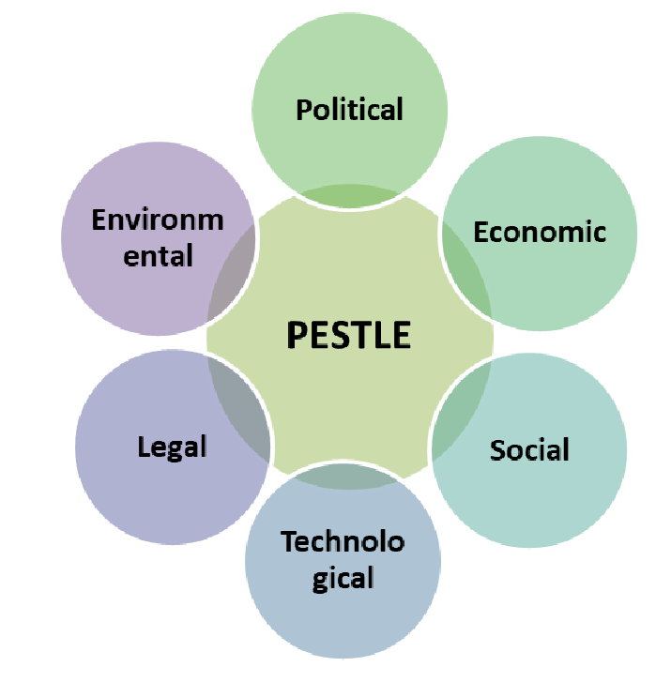
Figure 1: PESTLE Analysis (Source: Zindros and Afroditi, 2024)
To carry out this analysis, Economic and Socio-Cultural factors have been selected as the most strategically important to Nike and Anta Sports. Pricing, expansion of global market, consumer buying power, and high-value products are economic factors that influence their high-value products (Vaporfly, Alphafly, Jordan), specifically, and the domestic mass-performance and premium products of Anta. Demand trends are influenced by socio-cultural shifts, such as the increase in health awareness, the adoption of athleisure and consumption by lifestyle, which affect product adoption, brand positioning, and market responsiveness both on the global and local level (McKinsey and Company and World Federation of the Sporting Goods Industry, 2025).

2.2 Analysis of Macro Factor 1: Economic Factors

2.2.1 Impact on the Pioneer Organisation (Nike)
In the case of Nike, economic factors are both threats and opportunities, as the global income is subjected to currency variations, regional GDP dynamics, and purchasing power of consumers. Footwear will occupy the greatest portion of the global sportswear market estimated at US$855.3 billion as of 2033 (Market.us, 2024).
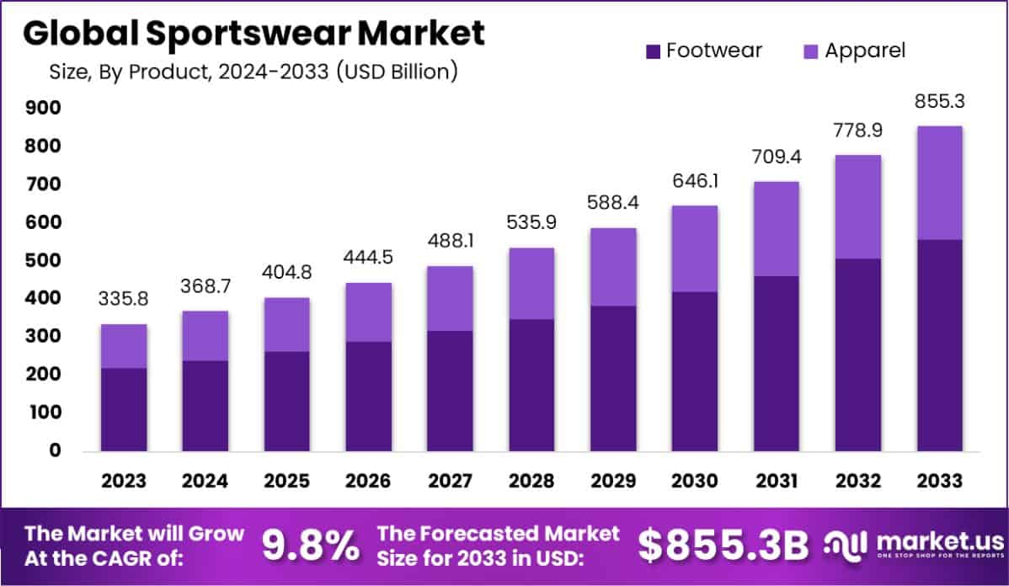
Figure 2: Global Sportswear Market (Source: Market.us, 2024)
In the case of Nike, economic factors are both threats and opportunities, because the global revenue is strongly dependent on currency variations, local GDP, and the buying power of consumers. Premium product lines, including Vaporfly and Alphafly running shoes and the Jordan brand, are strongly sensitive to disposable income in major markets. This exposure is reflected in the revenue generated by Nike in FY2025 where men and women footwear generated US$23.216-billion and Jordan Brand men generated US 7.270-billion (NIKE, Inc., 2025). These luxury goods play a very important role in ensuring brand prestige and profitability. Meanwhile, economic forces, such as weaker consumer spending in certain locations, are a threat; Nike recorded an 11% decrease in NIKE Brand footwear revenue on a currency-neutral basis in FY2025, and digital sales declined in key markets. This implies that economic volatility may swiftly decrease demand of premium lines. In general, Nike competitive advantage is determined by economic forces, which affect pricing strategy, regional disposition, and focus on premium products, requiring ongoing investment in innovation and market responsiveness as a barrier to differentiation (Wessel et al., 2025).

2.2.2 Impact on the Follower Organisation (Anta Sports)
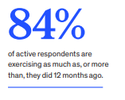
Figure 3: Active lifestyle as a socio-cultural demand driver (Source: McKinsey & Company and World Federation of the Sporting Goods Industry, 2025)
Socio-cultural change is a big opportunity to Nike. Growing health awareness, activities, and active lifestyle usage drive performance and lifestyle products, including Pegasus, Vaporfly/Alphafly running shoes, and the Jordan ecosystem. Figure 3 indicates that 84 percent of active consumers report exercising just as much or more than last year, which supports the need of high-performance footwear and women training apparel (McKinsey & Company and World Federation of the Sporting Goods Industry, 2025). In 2024, Anta ranged an e-commerce revenue of 21.8 percent, with the share of total group revenue of 35.1 percent, and R&D spending amounted to RMB2 billion, which allowed the company to develop products quickly and respond to the market (ANTA Sports Products Limited, 2025a). Such investments make Anta more flexible and adaptable in the domestic channels. Nonetheless, dependence on one national economy also poses a risk of regional declines or shifts in consumer behaviour. Compared to Nike, the economic potential of Anta is more geographically concentrated, and local strength cannot enable a competitive position, but global expansion is constrained by economic and operational factors (Goworek and McGoldrick, 2024).
Finally, the economic factors critically effects both companies shaping their prices, product focus, responsiveness of market and consumers while acting as a source of risk and opportunity for global strategies.

2.3 Analysis of Macro Factor 2: Socio-cultural Factors

2.3.1 Impact on the Pioneer Organisation (Nike)
In the case of Nike, the socio-cultural change is a significant opportunity because sportswear is purchased not only to do something but also to show identity, status and lifestyle. Utilitarian, hedonic and symbolic benefits all affect both the intention to purchase and the willingness to pay in sportswear markets, and this fact explains why the performance running footwear lines like Pegasus, Vaporfly and Alphafly and the Jordan ecosystem remain strategically strong among runners, basketball consumers, and sneaker enthusiasts (Vizcaino and Kettunen, 2023). This has become more cemented with active lifestyles being increasingly ingrained in daily consumption: 84% of active consumers indicate engaging in exercise as much or more frequently than they did one year ago, which has bolstered performance footwear and women training product demand over more casual fashion products (McKinsey & Company and World Federation of the Sporting Goods Industry, 2025). The risk though is that Nike has been functioning within much more observable symbolic categories, therefore they have a greater level of scrutiny on cultural authenticity, inclusivity and alignment of values. Socio-cultural advantage thus supports Nike in maintaining premium differentiation, although it raises reputational risk in the case of brand meaning and consumer expectations mismatch.

2.3.2 Impact on the Follower Organisation (Anta Sports)
Socio-cultural change presents an even more localised opportunity to Anta Sports. An increasing health consciousness, daily athleisure and greater sensitivity to local brands favour ANTA brand against value-conscious mass performance consumers, and FILA China against fashion-sport demand premium urban consumers.
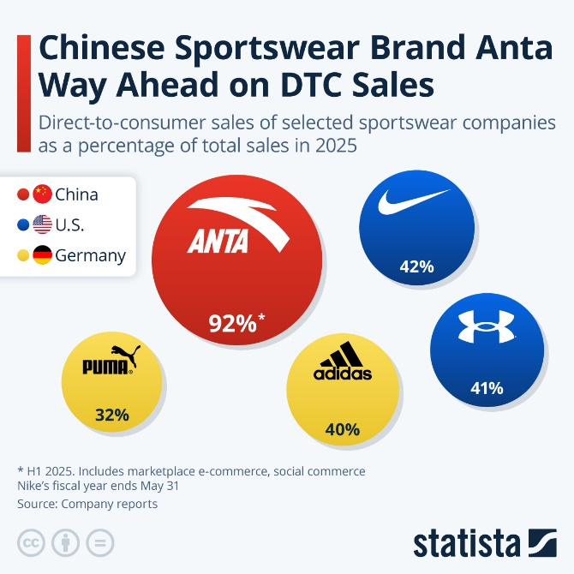
Figure 4: Chinese Sportswear Brand Anta Way Ahead on DTC Sales (Source: Statista, 2026)
Figure 4 is a channel measure but also shows the fit of Anta to modern Chinese purchasing behaviour: direct-to-consumer share was 92% in 2025, significantly surpassing Nike (42%), which would allow the company to align more with the local preference to pursue local shopping experience along brand-managed and social shopping paths (Statista, 2026). This provides Anta with more flexibility in its domestic market as compared to Nike. The primary weakness is that this strength remains strongly domestic cultural fit, that is, the socio-cultural advantage of Anta, which is strong in China but less transferable abroad, limits its ability to extend to a broader market.
The sportswear market is also made or formed by economic and socio cultural forces which poses both opportunities and risks. Premium product strategy is led by global economic uncertainty and lifestyle and regional competitiveness by cultural alignment by Anta; Nike is led by the domestic economic growth. Knowing these helps pioneers and followers to adjust pricing, products and channels, which guarantees long-term differentiation, responsiveness, and strategic alignment in changing markets (Goworek and McGoldrick, 2024).

3. Task 2: Strategic Responses of Pioneering and Follower Organisations
The strategic measures of Nike and Anta Sports are innovation, differentiation and portfolio-based strategies that have helped the two companies to adjust to economic and socio-cultural challenges and retain competitive advantage.

3.1 Pioneering Organisation’s Strategic Responses (Nike)
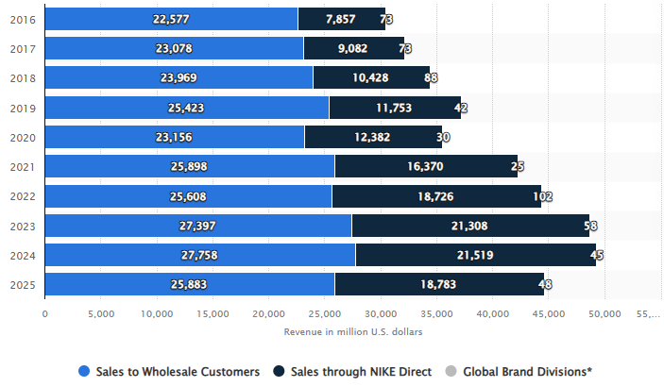
Figure 5: Nike's revenue worldwide from the fiscal years of 2016 to 2025, by sales channel (Source: Statista, 2025)
The strategic reaction of Nike to the economic and socio-cultural pressures observed in Task 1 can be seen as an effort to maintain dominance over high-end product ecosystems and maintain scale. By 2026, Nike has significantly increased its direct channel over time: sales via NIKE Direct are going to rise by 2025 to US$18.8 billion, again despite a decline in 2024, whereas wholesale continues to play a US$25.9 billion role in 2025 (Statista, 2026). This implies that Nike has never given up on wholesale, but selectively applied direct-to-consumer to manage launches, pricing discipline and consumer data in high-value markets such as Jordan among basketball and sneaker fans and premium running footwear among performance runners (NIKE, Inc., 2025).
In Figure 6, Nike can be best described as a broad differentiator, not a cost leader, based on Porters Generic Strategies. It does not focus on selling at lower prices as its reaction to economic change but rather on innovation, exclusivity and brand meaning to add perceived value. It can be seen in individual product lines like Pegasus (everyday runners), Vaporfly/Alphafly (performance runners who want speed and racing credibility), and the Jordan line (consumers who are driven more by cultural association than sporting utility). Social-cultural changes to athleisure and identity-based consumption also facilitate the growth of Nike in women training and lifestyle segments, where differentiation is based on design credibility and emotional appeal in addition to functionality. Porter would describe this strategy to enable Nike to minimise direct price competition by competing on uniqueness in a wide market base (Mailani et al., 2024).
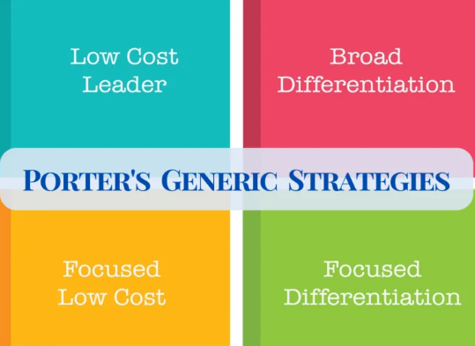
Figure 6: Porter’s Generic Strategies (Source: Strategic Management Insight, 2025)
More importantly, there are distinct strengths but apparent boundaries to this reaction. The advantage is enhanced control of the customer path with SNKRS, Nike Membership and own retail that enhances personalisation, launch management and loyalty. According to omnichannel literature, this kind of control would enhance customer value through the integration of brand experience, data and convenience in a better way than fragmented channel systems (Zhang, Chen and Jiao, 2025). Nevertheless, the 2025 performance of Nike demonstrates that differentiation is expensive and execution-intensive. NIKE Direct revenue was down 13% and digital sales were down 20% with the company registering a drop in revenues in Men, Jordan Brand, Women and Greater China with a decrease in gross margin to 42.7. This implies that the Nike strategy is still strong, but its success relies on maintaining product momentum and cultural relevance, where slow innovation or craters in digital traffic exposes that same premium model to discounting, channel disequilibrium and diminished market responsiveness (NIKE, Inc., 2025).

3.2 Follower Organisation’s Strategic Responses (Anta Sports)
The reaction of Anta Sports to the economic and socio-cultural challenges outlined in Task 1 can be interpreted as a portfolio-oriented competitive strategy, but not that of a single brand. Figure 7 implies that Anta has reached the highest level of sporting-goods firms in the world based on market capitalisation, yet its competitiveness is not anchored on scale only. The company, instead, employs its Single-focus, Multi-brand, Globalisation strategy to align various product lines with various consumer segments: the ANTA brand is available to mass-performance consumers and is sold in such categories as running, basketball and training, FILA caters to higher-end fashion-sports buyers, and Descente and Kolon Sport are sold to higher-end outdoor and specialist consumers (ANTA Sports Products Limited, 2025a). This is important because the follower does not strive to beat Nike with a single uniform offer; it evolves to occupy several price-value points in the same market.
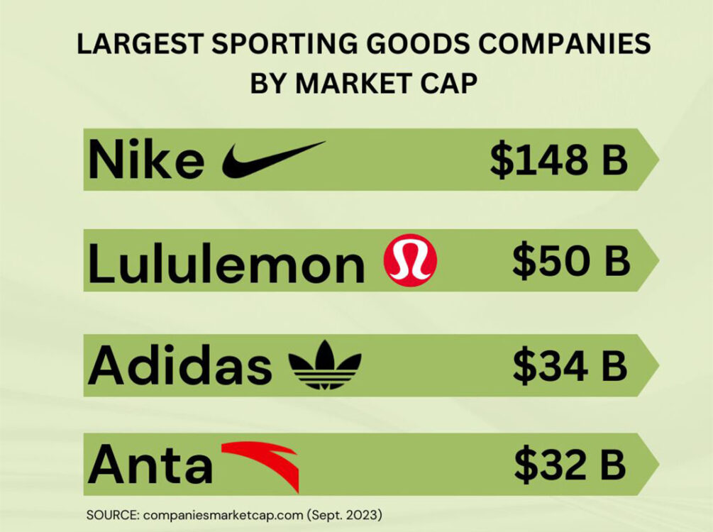
Figure 7: Largest Sporting Goods Companies (Source: (Nice Kicks, 2026)
Anta cannot be easily defined as either of the pure types of strategies at group level using Porters Generic Strategies. At brand level, though, its reason is more obvious. ANTA core brand is closest to a generic low-cost or best-value approach, providing affordable performance products to the value-conscious Chinese market, whereas FILA China and high-end outdoor brands are positioned in closer proximity to focused differentiation, combining greater design influence, retail experience and brand image to high-income urban market segments (Nice Kicks, 2026). The model by Porter is hence helpful, though only when considered individual brand roles of Anta and not of the entire group (Mailani et al., 2024). This aligns with brand-portfolio theory, which opines that companies can achieve competitive advantage by allocating different functions to brands rather than compelling a single brand to cater to all segments (Barrenechea Fernández, 2025).
The positive sides of this response can be reflected in operating results. In 2024, ANTA brought in RMB33.52B, FILA brought in RMB26.63B, and all other brands brought in RMB10.68B, with e-commerce revenue expanding 21.8 percent and accounting 35.1 percent of total revenue (ANTA Sports Products Limited, 2025b). This means that it is highly flexible to local digital purchasing behaviour and evolving socio-cultural tastes. There is a limit to the strategy, however. Multi-brand structure increases the cost of coordination and poses the risk of disproportionate brand meaning, particularly in the non-Chinese world where domestic channel strength and cultural familiarity are lower. Omnichannel research proposes that channel tighter control could enhance customer value, yet it makes execution more complex between brands and formats (Zhang, Chen and Jiao, 2025). On the whole, the reaction of Anta is strategically effective to maintain competitiveness, but this benefit is stronger in China than in the global market.

4. Conclusion
This report indicates that Nike and Anta Sports have different opportunities and threats in the sportswear/athleisure market because of the economic and socio-cultural aspects. Nike enjoys a high world recognition brand and high demand of its products but is exposed to currency and consumer expenditure changes in major markets. Anta uses domestic economic development and cultural fit to reinforce its mass-performance and premium services in China, however, its competence is less competitive globally. One of the suggestions that Nike can do to reduce economic volatility is diversity with its regional presence and focus on digital interactions. In the case of Anta, increased brand awareness and modifying socio-cultural policies in foreign markets can lead to the decrease in reliance on local demand and more global competitiveness. The above measures will enable both the companies to continue gaining sustainable competitive advantage in being responsive to market dynamics.

5. References (Not included in the word count)
ANTA Sports Products Limited (2025a) Annual report 2024. Hong Kong: ANTA Sports Products Limited. Available at: https://www1.hkexnews.hk/listedco/listconews/sehk/2025/0331/2025033100649.pdf
ANTA Sports Products Limited (2025b) ANTA Sports achieves another record high with revenue exceeding RMB70.8 billion in 2024, a 13.6% year-on-year increase. Press release, 19 March. Available at: https://ir.anta.com/en/news_detail.php?id=144313
Barrenechea Fernández, F., (2025). Building Effective Branding Strategies. From Foundational Elements to Market Success. From Foundational Elements to Market Success (January 14, 2025). https://papers.ssrn.com/sol3/Delivery.cfm?abstractid=5217847
CIPD (2025) PESTLE analysis. London: Chartered Institute of Personnel and Development. Available at: https://www.cipd.org/en/knowledge/factsheets/pestle-analysis-factsheet/
Goworek, H. and McGoldrick, P., (2024). Retail marketing management. BoD–Books on Demand.
Kotler, P., Armstrong, G., Harris, L. and Piercy, N. (2020) Principles of marketing. 8th European edn. Harlow: Pearson.
Mailani, D., Hulu, M.Z.T., Simamora, M.R. and Kesuma, S.A., (2024). Resource-based view theory to achieve a sustainable competitive advantage of the firm: Systematic literature review. International Journal of Entrepreneurship and Sustainability Studies, 4(1), p.1.
Market.us (2024) Sportswear market: Global market by product, end-user, distribution channel, region and companies 2024–2033. Market.us. Available at: https://market.us/report/sportswear-market/
McKinsey & Company and World Federation of the Sporting Goods Industry (2025) Sporting Goods 2025: The new balancing act: Turning uncertainty into opportunity. Available at: https://www.mckinsey.com/~/media/mckinsey/industries/retail/our%20insights/sporting%20goods%20industry%20trends/2025/sporting-goods-2025-the-new-balancing-act-turning-uncertainty-into-opportunity-v3.pdf (Accessed: 25 March 2026).
NIKE, Inc. (2025) Annual report 2025 (Form 10-K). Beaverton, OR: NIKE, Inc. Available at: https://s1.q4cdn.com/806093406/files/doc_financials/2025/ar/Nike-Inc-2025_10K.pdf
Singh, A. and Kakkar, A., (2025). Marketing in the age of hyper-personalisation: Lessons from analytics-driven brand success. Applied Marketing Analytics, 11(1), pp.72-86.
Statista (2025) Nike’s revenue worldwide from the fiscal years 2016 to 2025, by sales channel. Statista. Available at: https://www.statista.com/statistics/888725/nikes-revenue-by-sales-channel-worldwide/?srsltid=AfmBOorCGIUH3S0s1UBSgv7N8i3fzmJf70bt3MXZHLVvZ9qrbZQdl4K5
Statista (2026) Chinese sportswear brand Anta way ahead on DTC sales. Statista. Available at: https://www.statista.com/chart/24457/direct-to-consumer-sales-in-the-sportswear-industry/?srsltid=AfmBOor8Dhzdf7Ojcm_5DJZo8BDE8o7F-HoPe6RU7Qb3ILapqonbjqyx
Strategic Management Insight (2025) Porter’s three generic strategies. Available at: https://strategicmanagementinsight.com/tools/porters-three-generic-strategies/
Vizcaino, N. and Kettunen, E., (2023). How do the Female Attitudes Towards Sustainable Branding Influence Purchase Intention in the Sportswear Industry: A qualitative study of women aged 20-50. https://www.diva-portal.org/smash/get/diva2:1763924/FULLTEXT01.pdf
Wessel, L., Mosconi, E., Indulska, M. and Baiyere, A., (2025). Digital transformation: Quo vadit?. Information Systems Journal, 35(4). https://onlinelibrary.wiley.com/doi/pdf/10.1111/isj.12578
Zhang, Q., Chen, J.L., Li, G. and Jiao, X., (2025). Digital transformation and tourism performance: A systematic literature review and research agenda. Tourism Economics, p.13548166251383186. https://journals.sagepub.com/doi/pdf/10.1177/13548166251383186
Zindros, Stelios and Anagnostopoulou, Afroditi. (2024). Assessing the Macro-Environmental Factors Affecting Innovative Last-Mile Delivery Solutions. Transport and Telecommunication Journal. 25. 1-10. 10.2478/ttj-2024-0001. https://www.researchgate.net/publication/378276568_Assessing_the_Macro-Environmental_Factors_Affecting_Innovative_Last-Mile_Delivery_Solutions

