Lowri Jones
1801539
Applied Computing
Information Engineering

Table of Contents
Relationship Diagram. 3
All Reports. 3
Books In Stock. 3
Customer. 4
Mailing List. 4
All Forms. 5
All Books. 5
Books In Stock. 6
Customer. 7
Main Menu. 7
Orders. 8
Staff. 9
Evidence of SQL used. 9
Tables in SQL view. 9
Author table. 9
Books Table. 9
Orders Table. 10
Customer Table. 10
Table for the books in stock. 10
Supplier table. 10
Evidence of working. 11
User Guide. 11
Forms. 11
How to use the menu driven form. 11
How to add a new customer order into the database. 12
How to enter a new customer or book into the database. 13
How to delete data. 14
Reports. 15
How to view the mailing list report. 15
How to print the mailing list report. 16
Tables. 17
How to input data into your tables. 17
Evaluation. 17

Relationship Diagram.

All Reports.

Books In Stock.
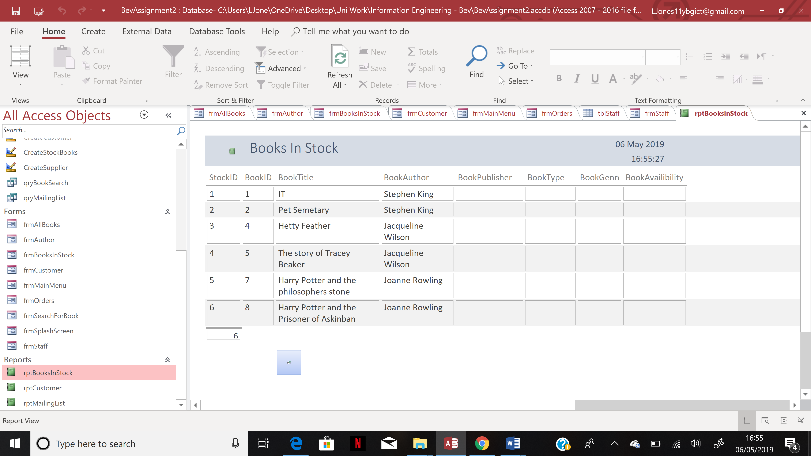

Customer.
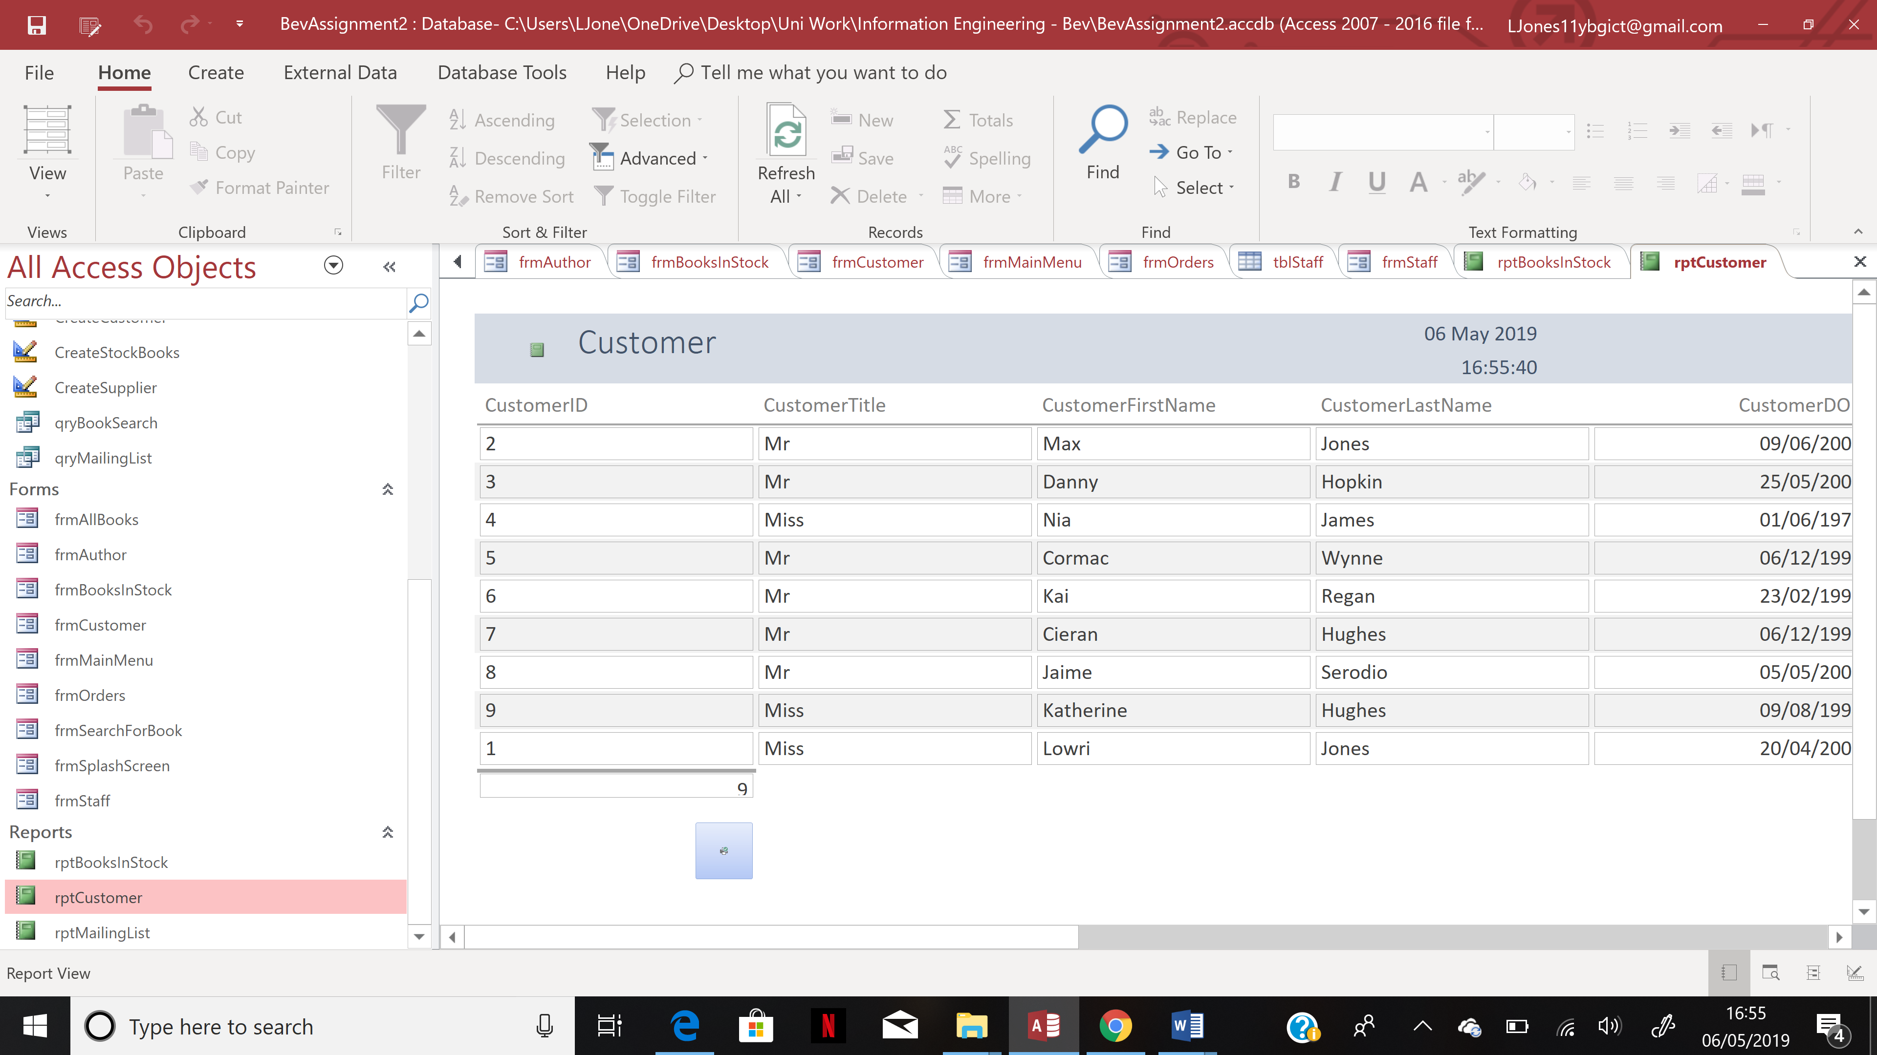

Mailing List.
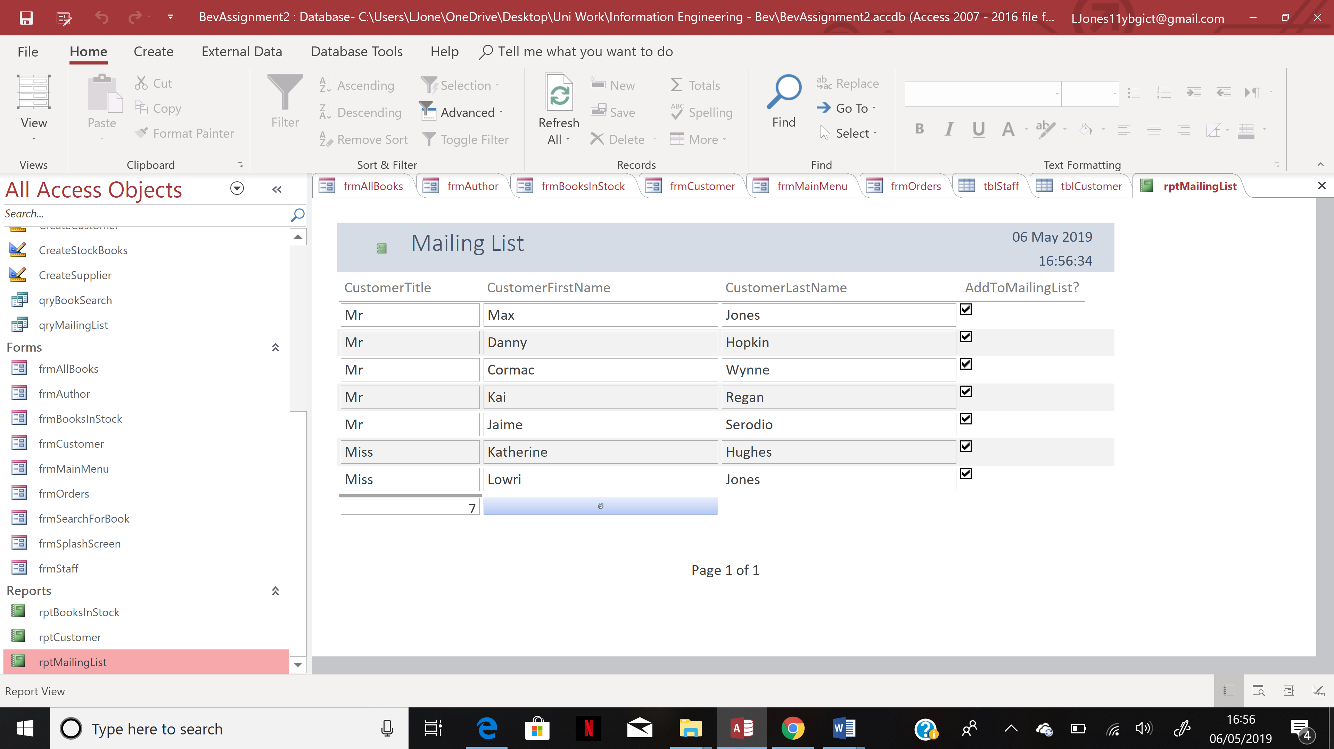

All Forms.

All Books.
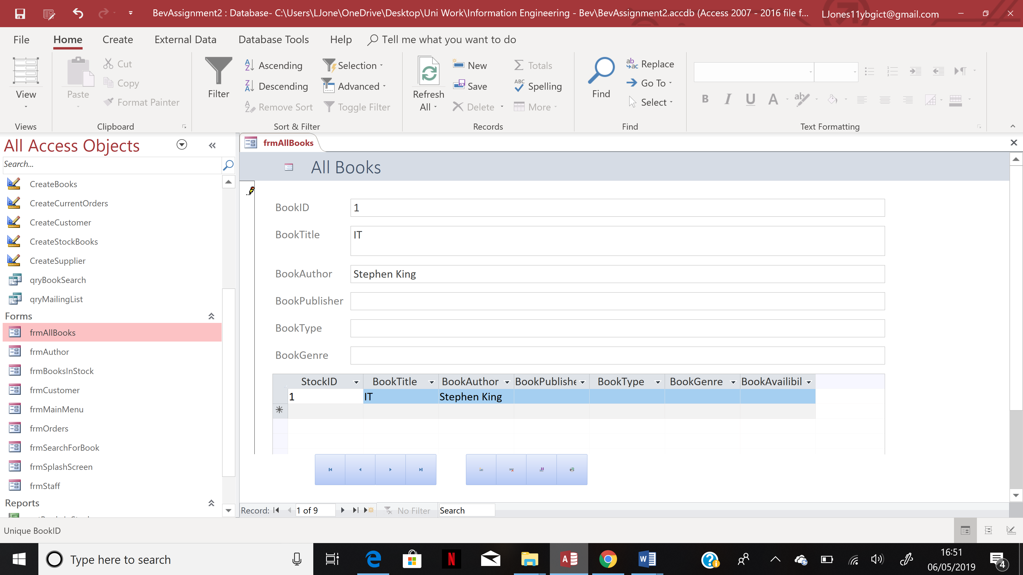
Author.
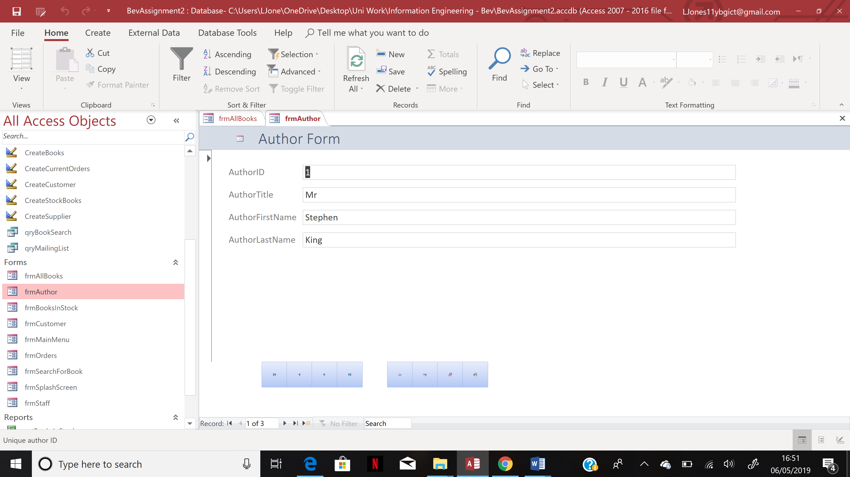

Books In Stock.
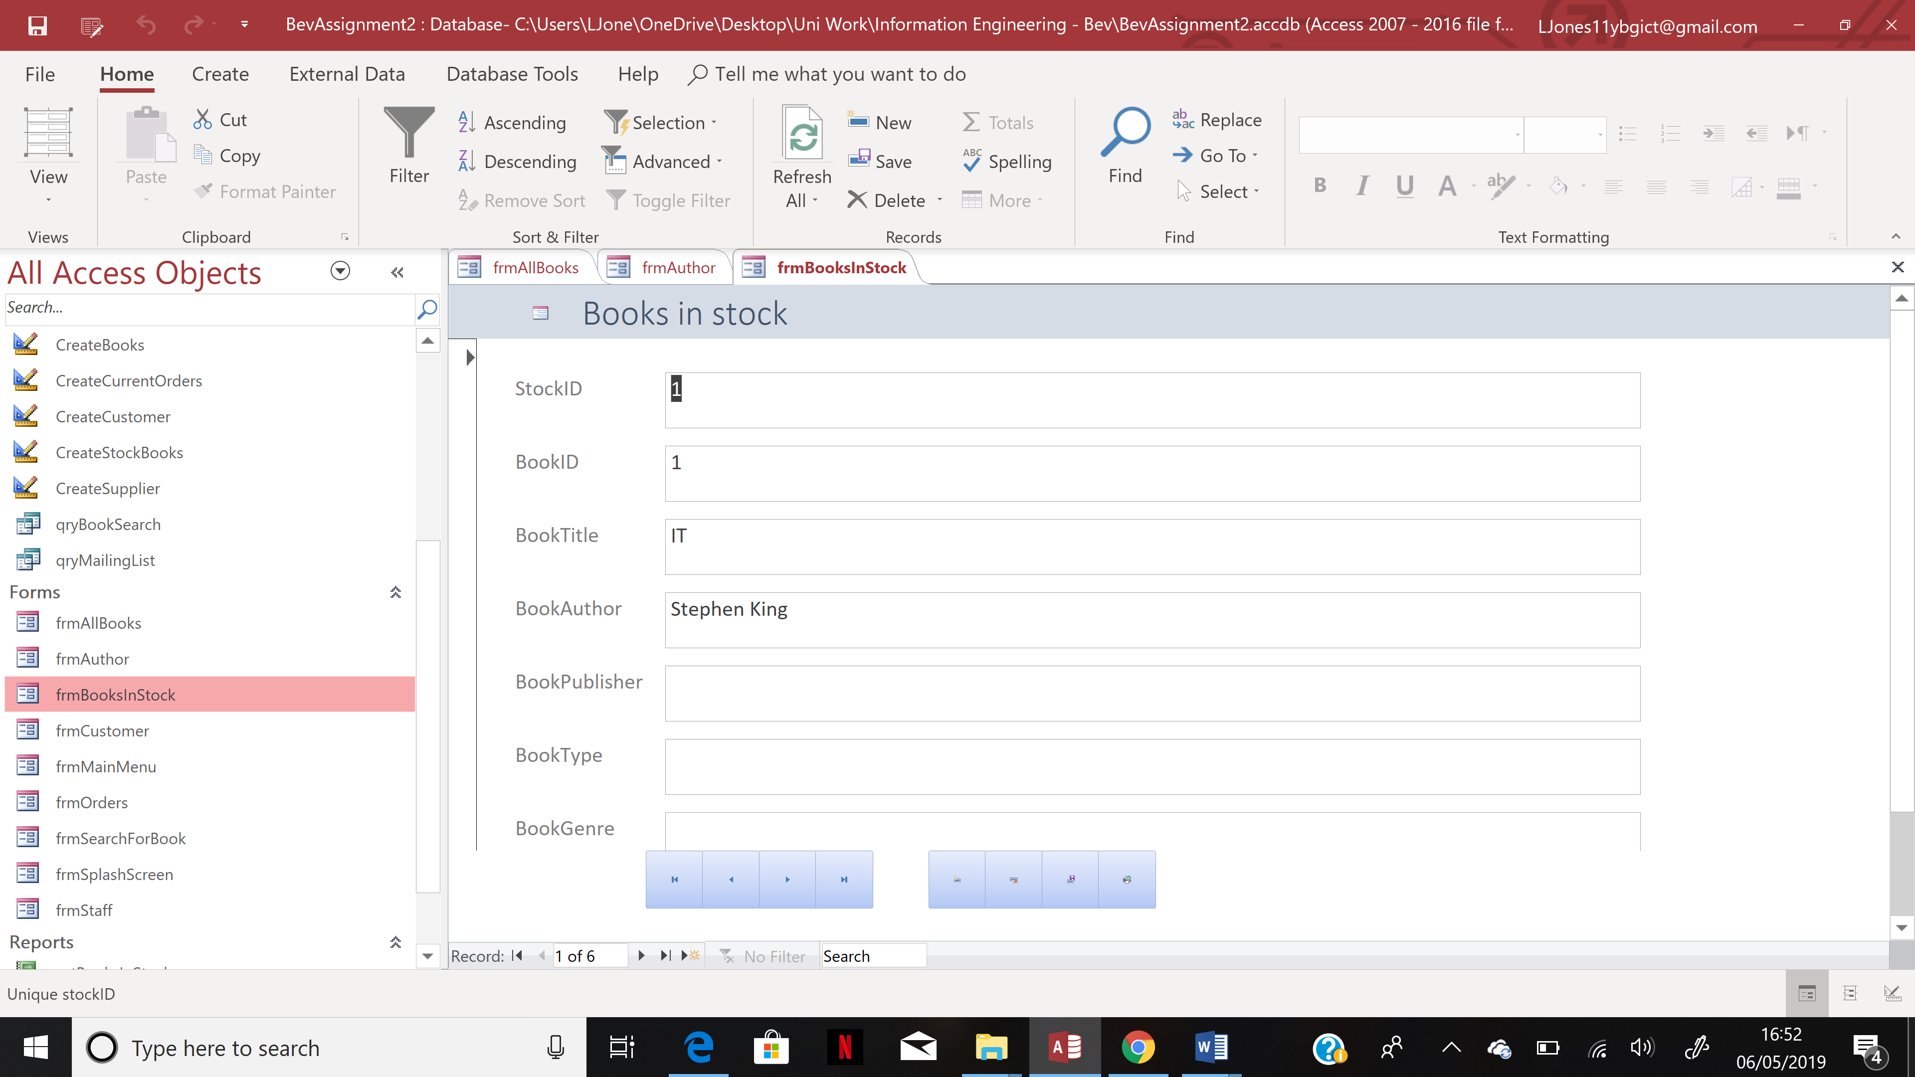

Customer.
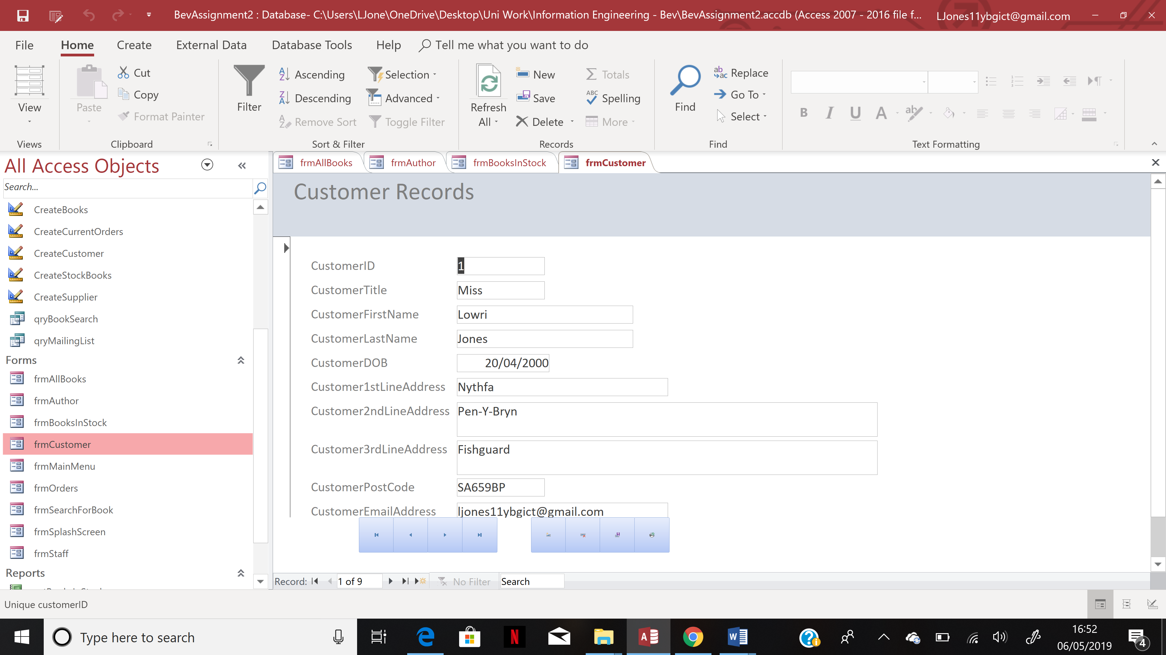

Main Menu.
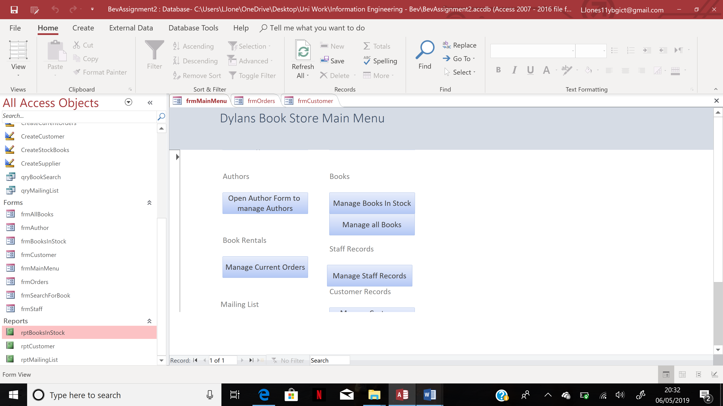
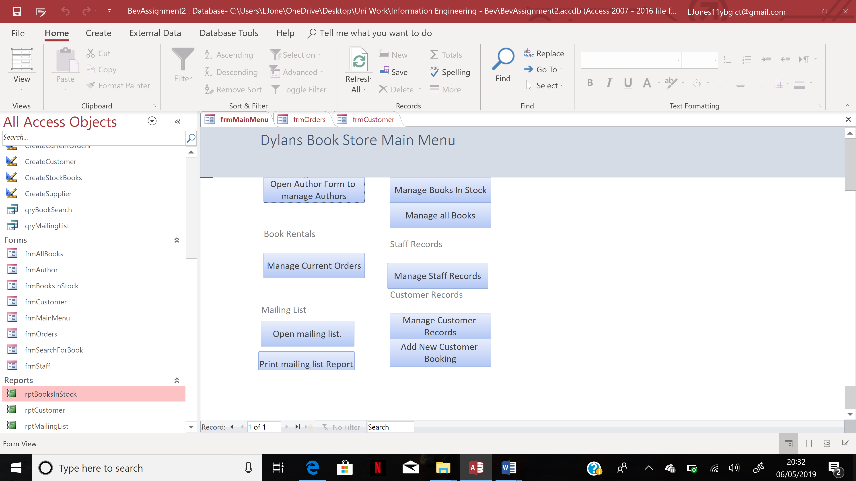

Orders.
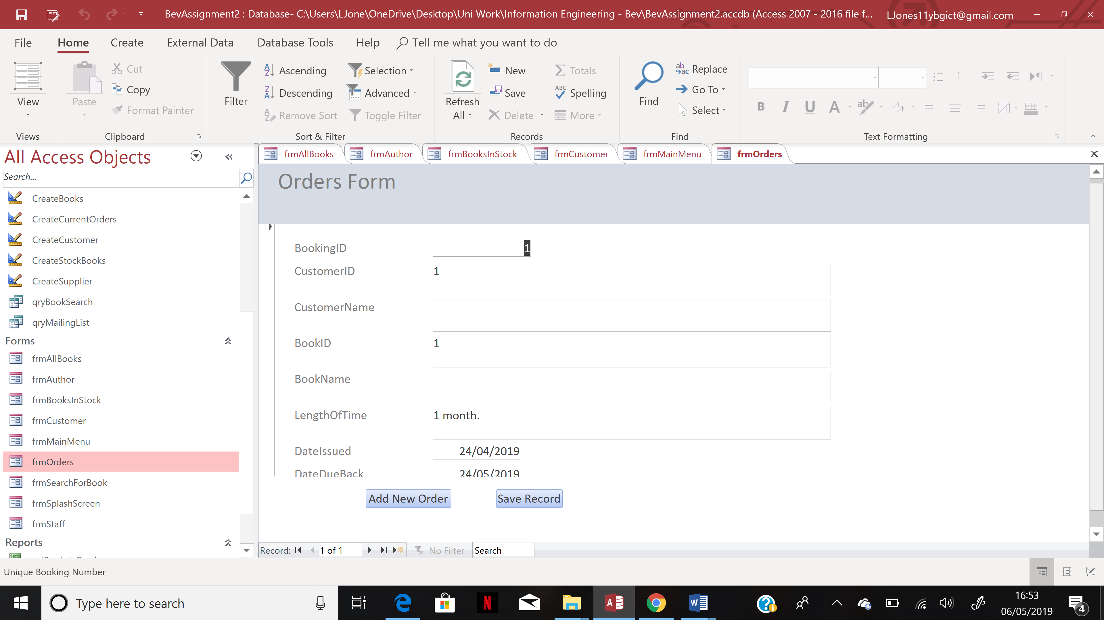

Staff.
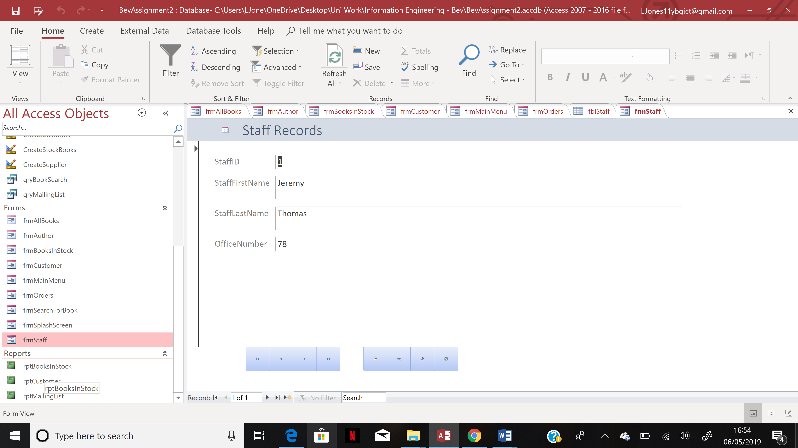

Evidence of SQL used.

Tables in SQL view.

Author table.
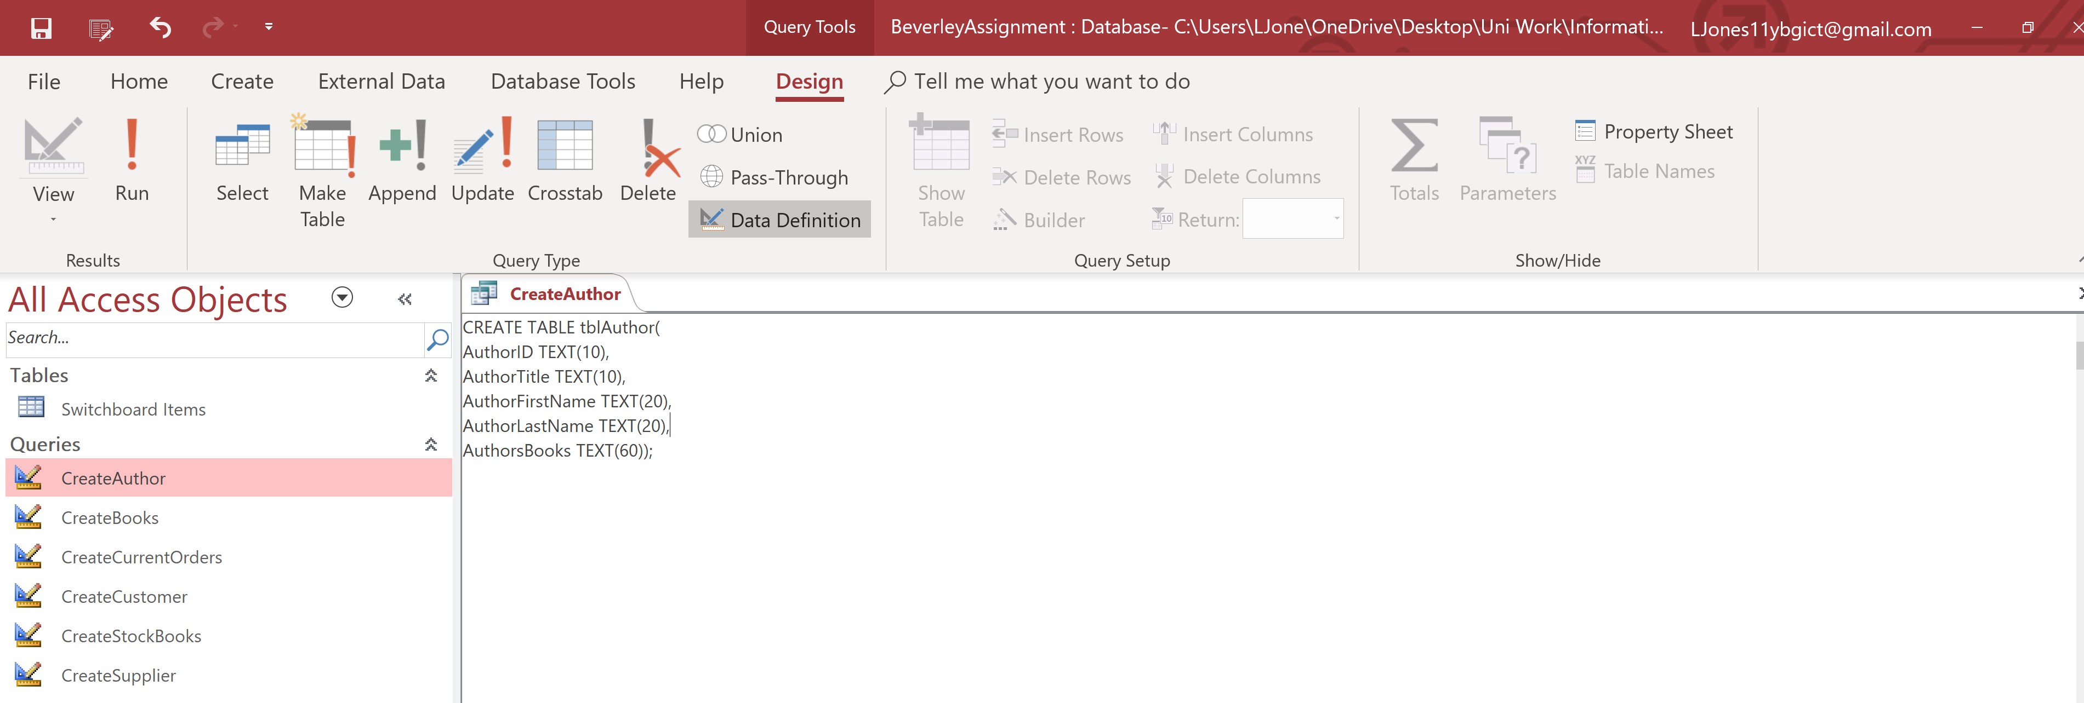

Books Table.
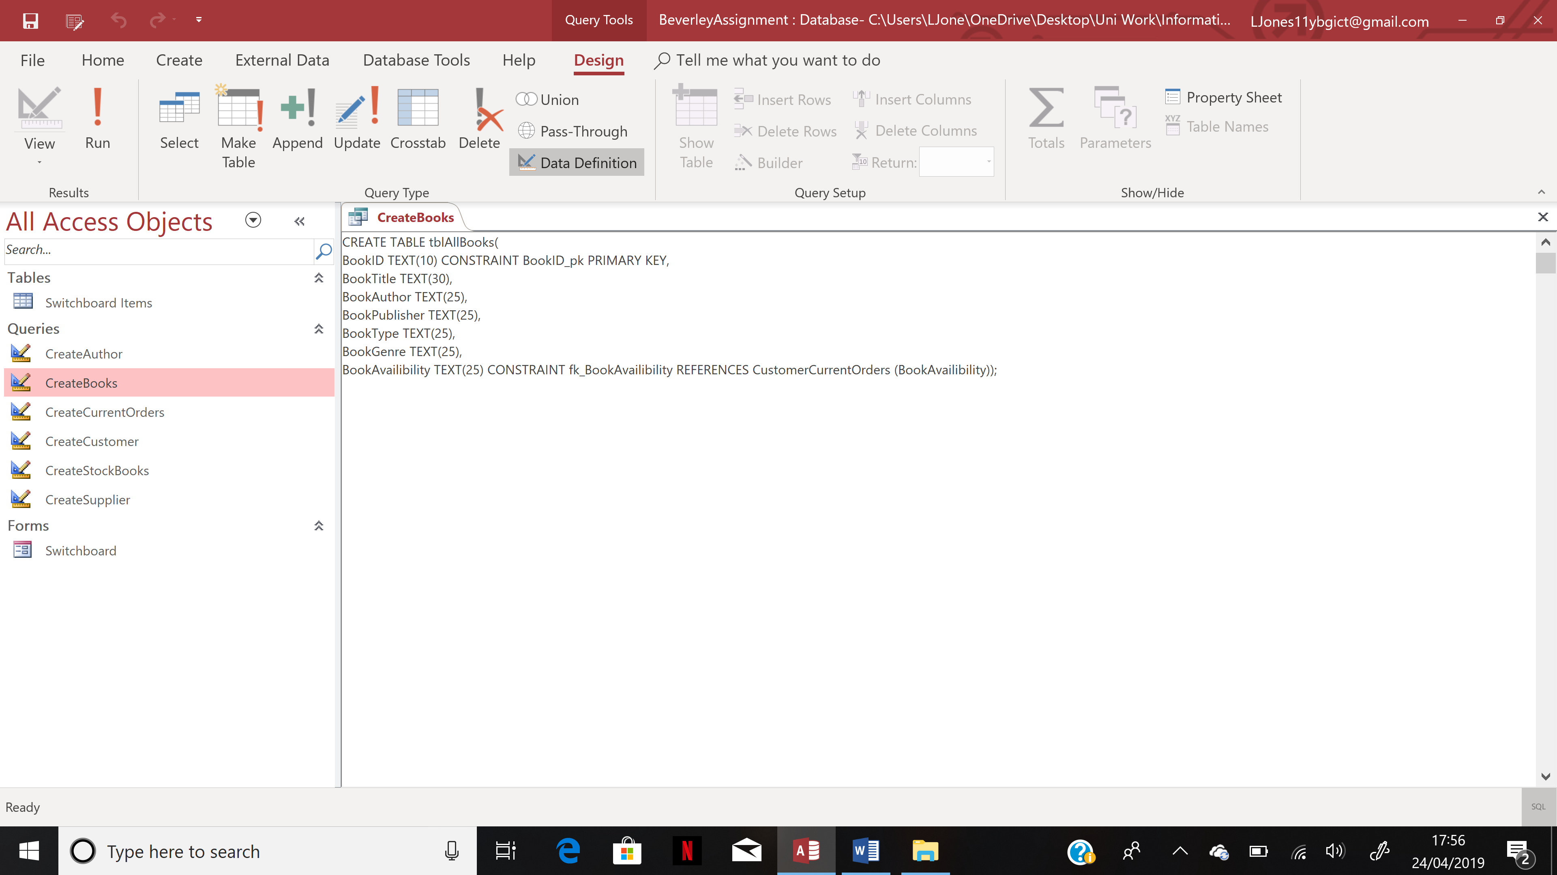

Orders Table.
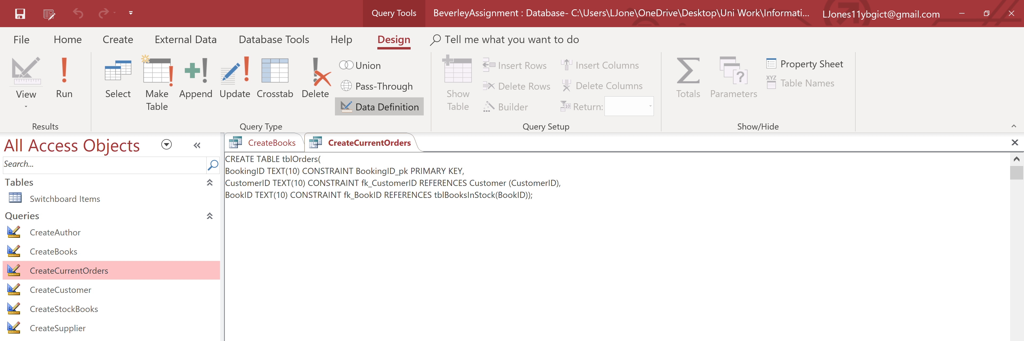

Customer Table.
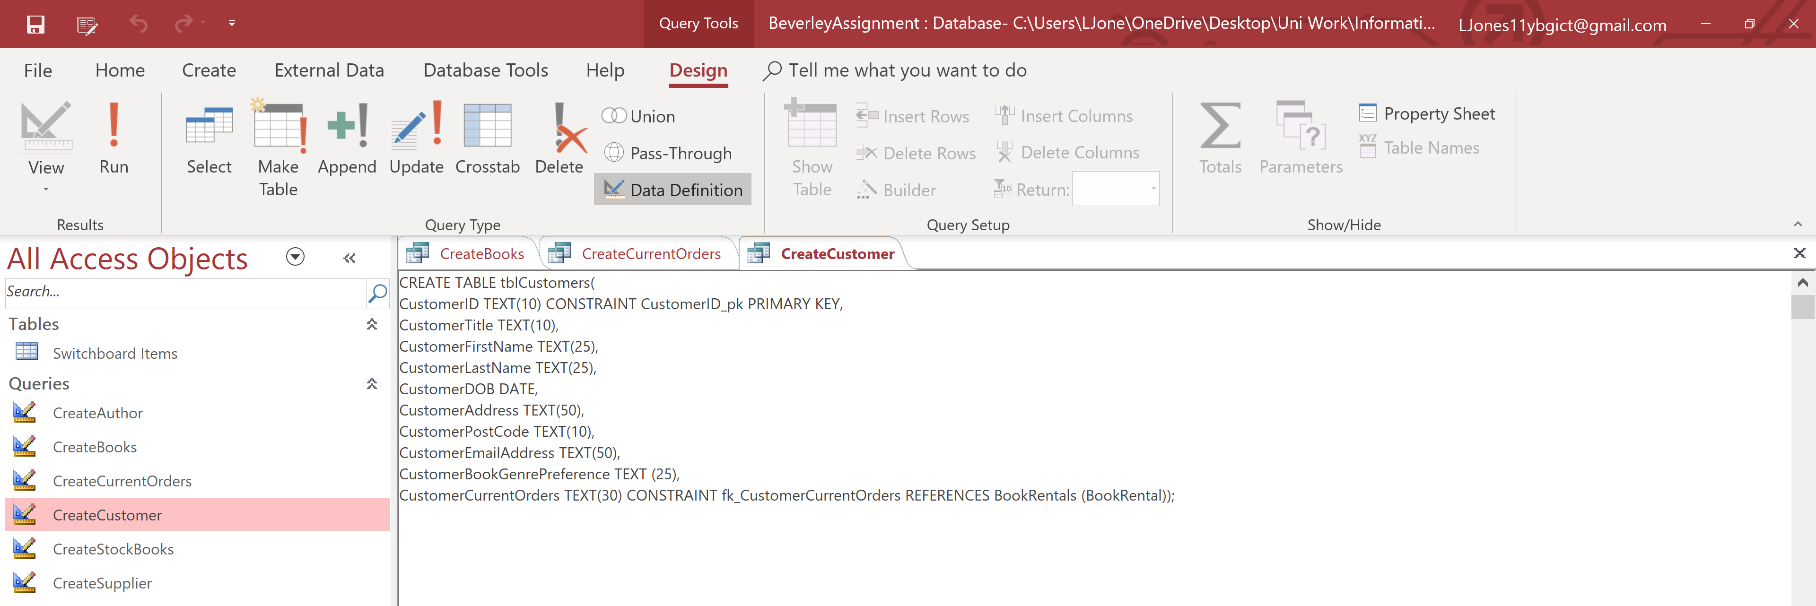

Table for the books in stock.
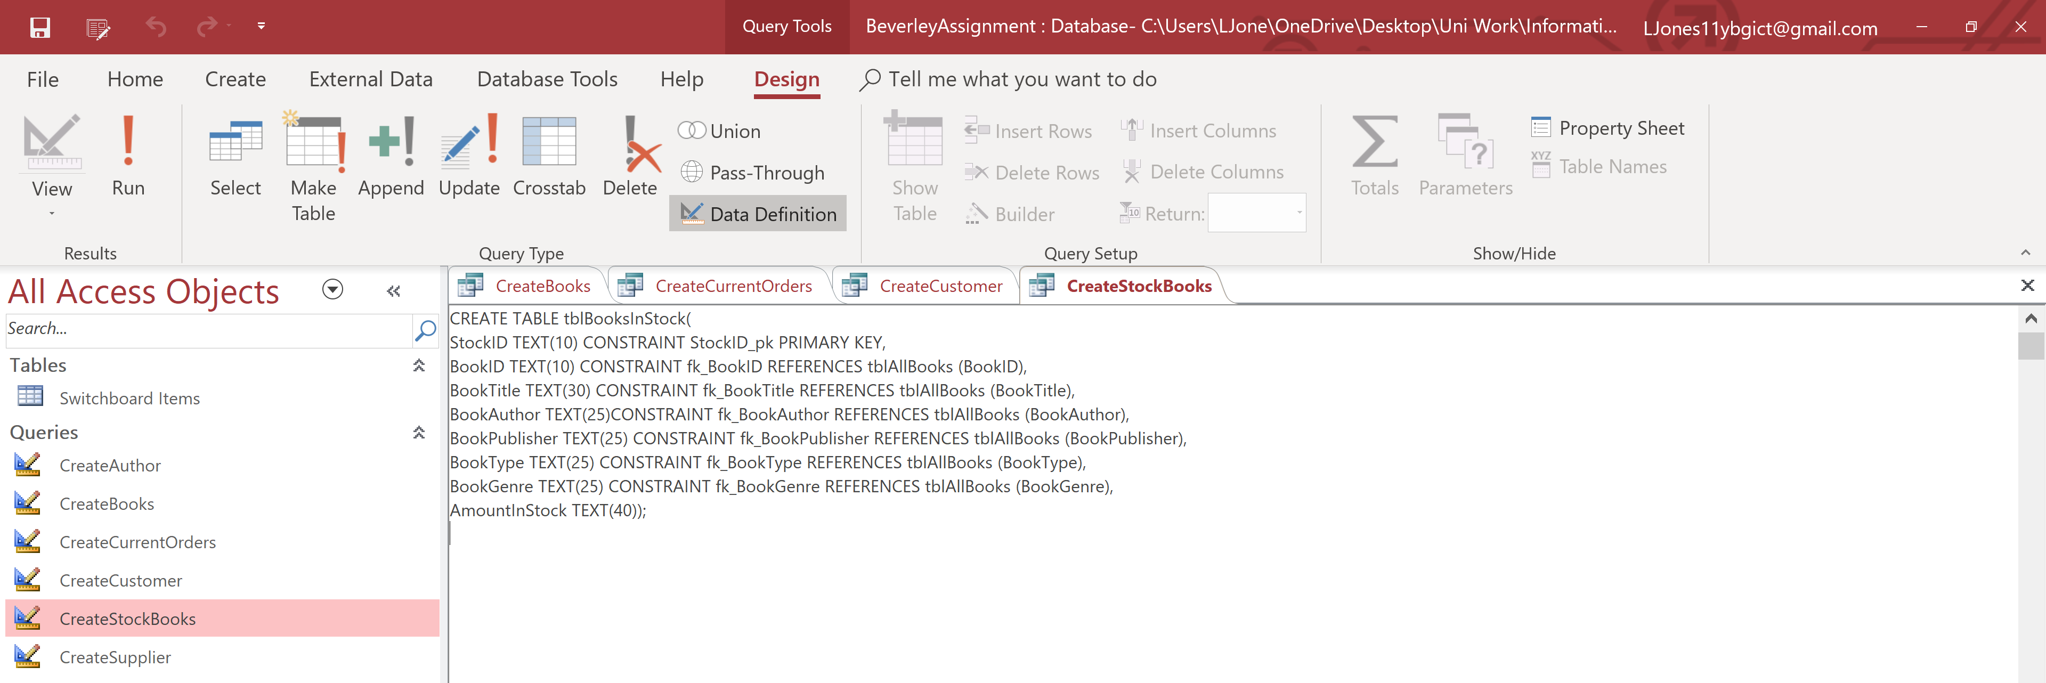

Supplier table.
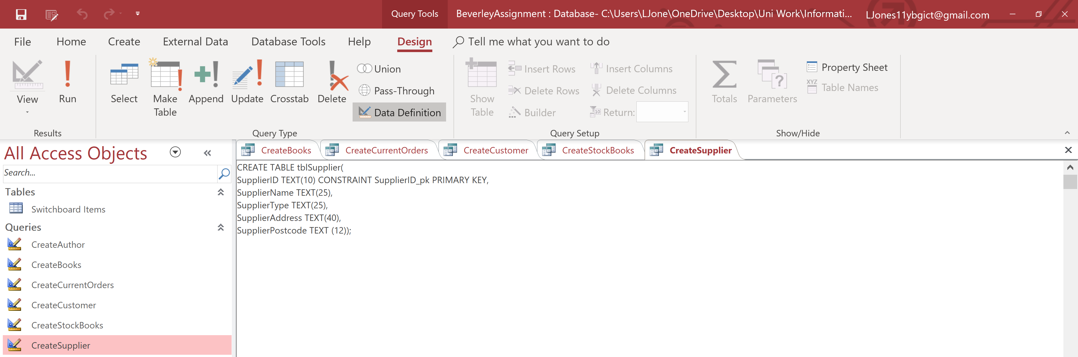

Evidence of working.
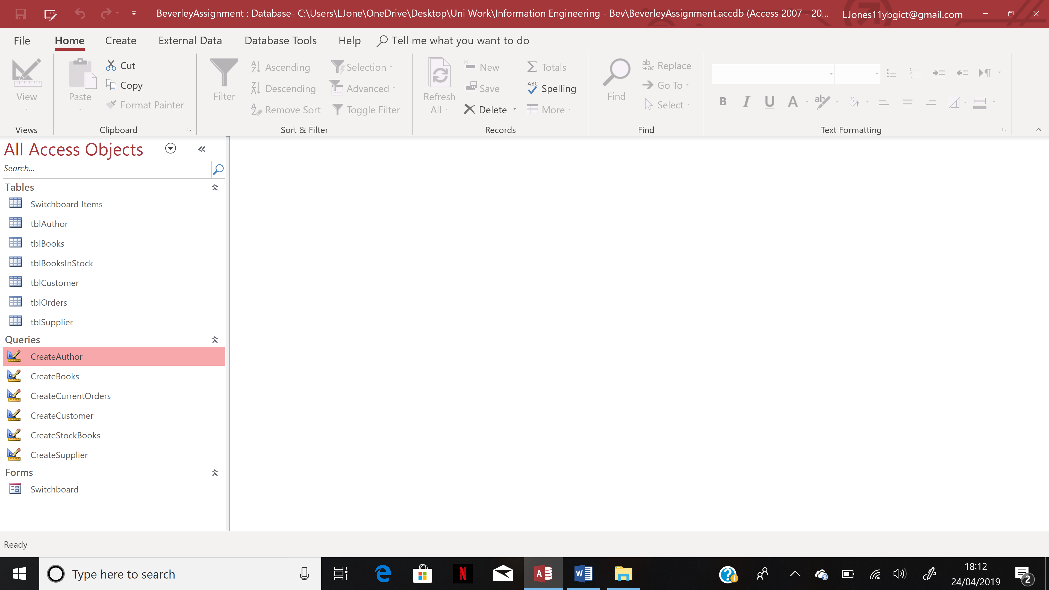

User Guide.
Hello and welcome to your user guide based on your new Dylan’s Book Store Database. I have made this user guide for you to understand how to use all different aspects of your new database.

Forms.

How to use the menu driven form.
As you notice when you firstly open up your new database, the first screen you are greeted with is the Main Menu. There are seven different options on your main menu which will take you to 7 important places within the database such as to the author form, the orders form and adding new records. If you wanted to navigate to one of these places in the database through the main menu you would simply click onto one of the navigation buttons which will take you right there. Below is a screenshot of the main menu working.

How to add a new customer order into the database.
To add a new order into the database you would firstly click onto the button that says ‘Add new customer booking’.
After youd do this, you would be shown to customer booking screen where you can then locate the ‘Add new record’ and ‘Save’ buttons at the bottom of the form to simply add and save a new order. Once you have done this, the new record will be saved into the bookings form.
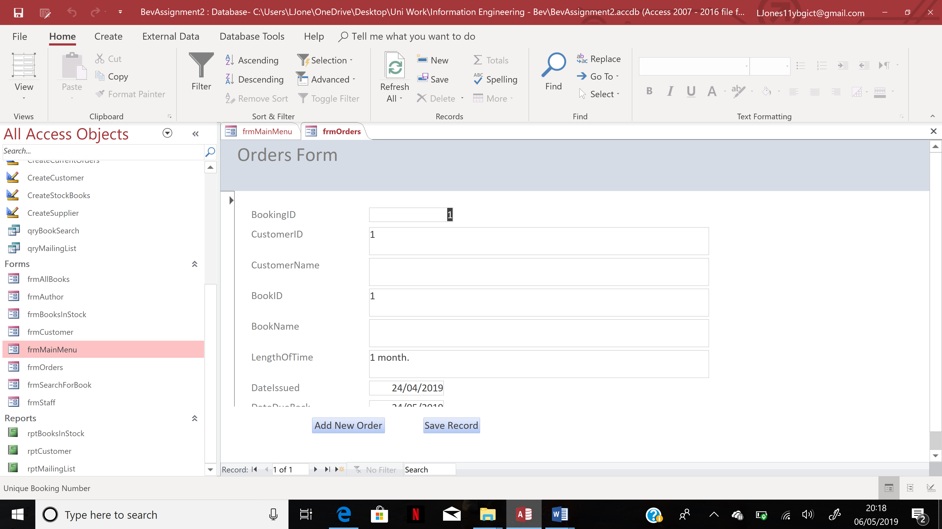

How to enter a new customer or book into the database.
In order to enter either a new customer or book into the database you must firstly click onto the option you would like from the main menu. Below is an example for adding a new book into the database.
After you have opened the correct form, you will notice that there are a series of navigation buttons at the bottom of the screen. The one you are looking for is the ‘Add’ button.
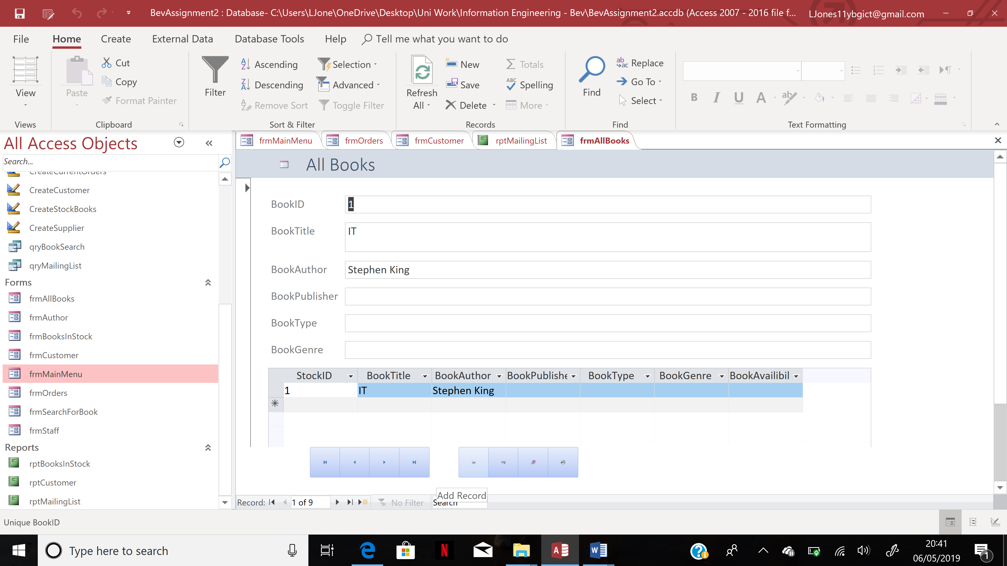
Once you have clicked this button you can then enter all details into the blank form. When you are ready to save this new record you can click onto the save button also in the list of navigation buttons.
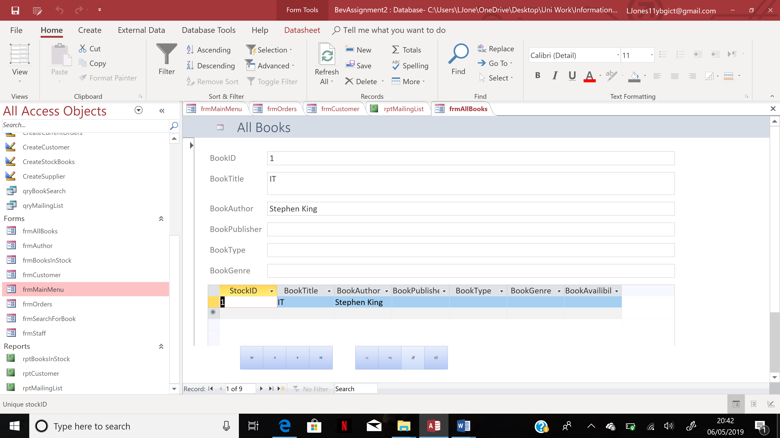
Once you have clicked onto this button, your new record will be saved into the correct form.s

How to delete data.
If a customer no longer comes to your library and you want to delete them from your database this can be done in a few small steps. Firstly you’d go to your main menu and click onto the navigation button which says to manage customer records.
Once you’re on your customer records form, you must firstly find the record you want to delete. Once this has been found, you can simply look to the navigation buttons at the bottom of the report and click onto the delete button. Once this has been done, your record will be deleted from the database.
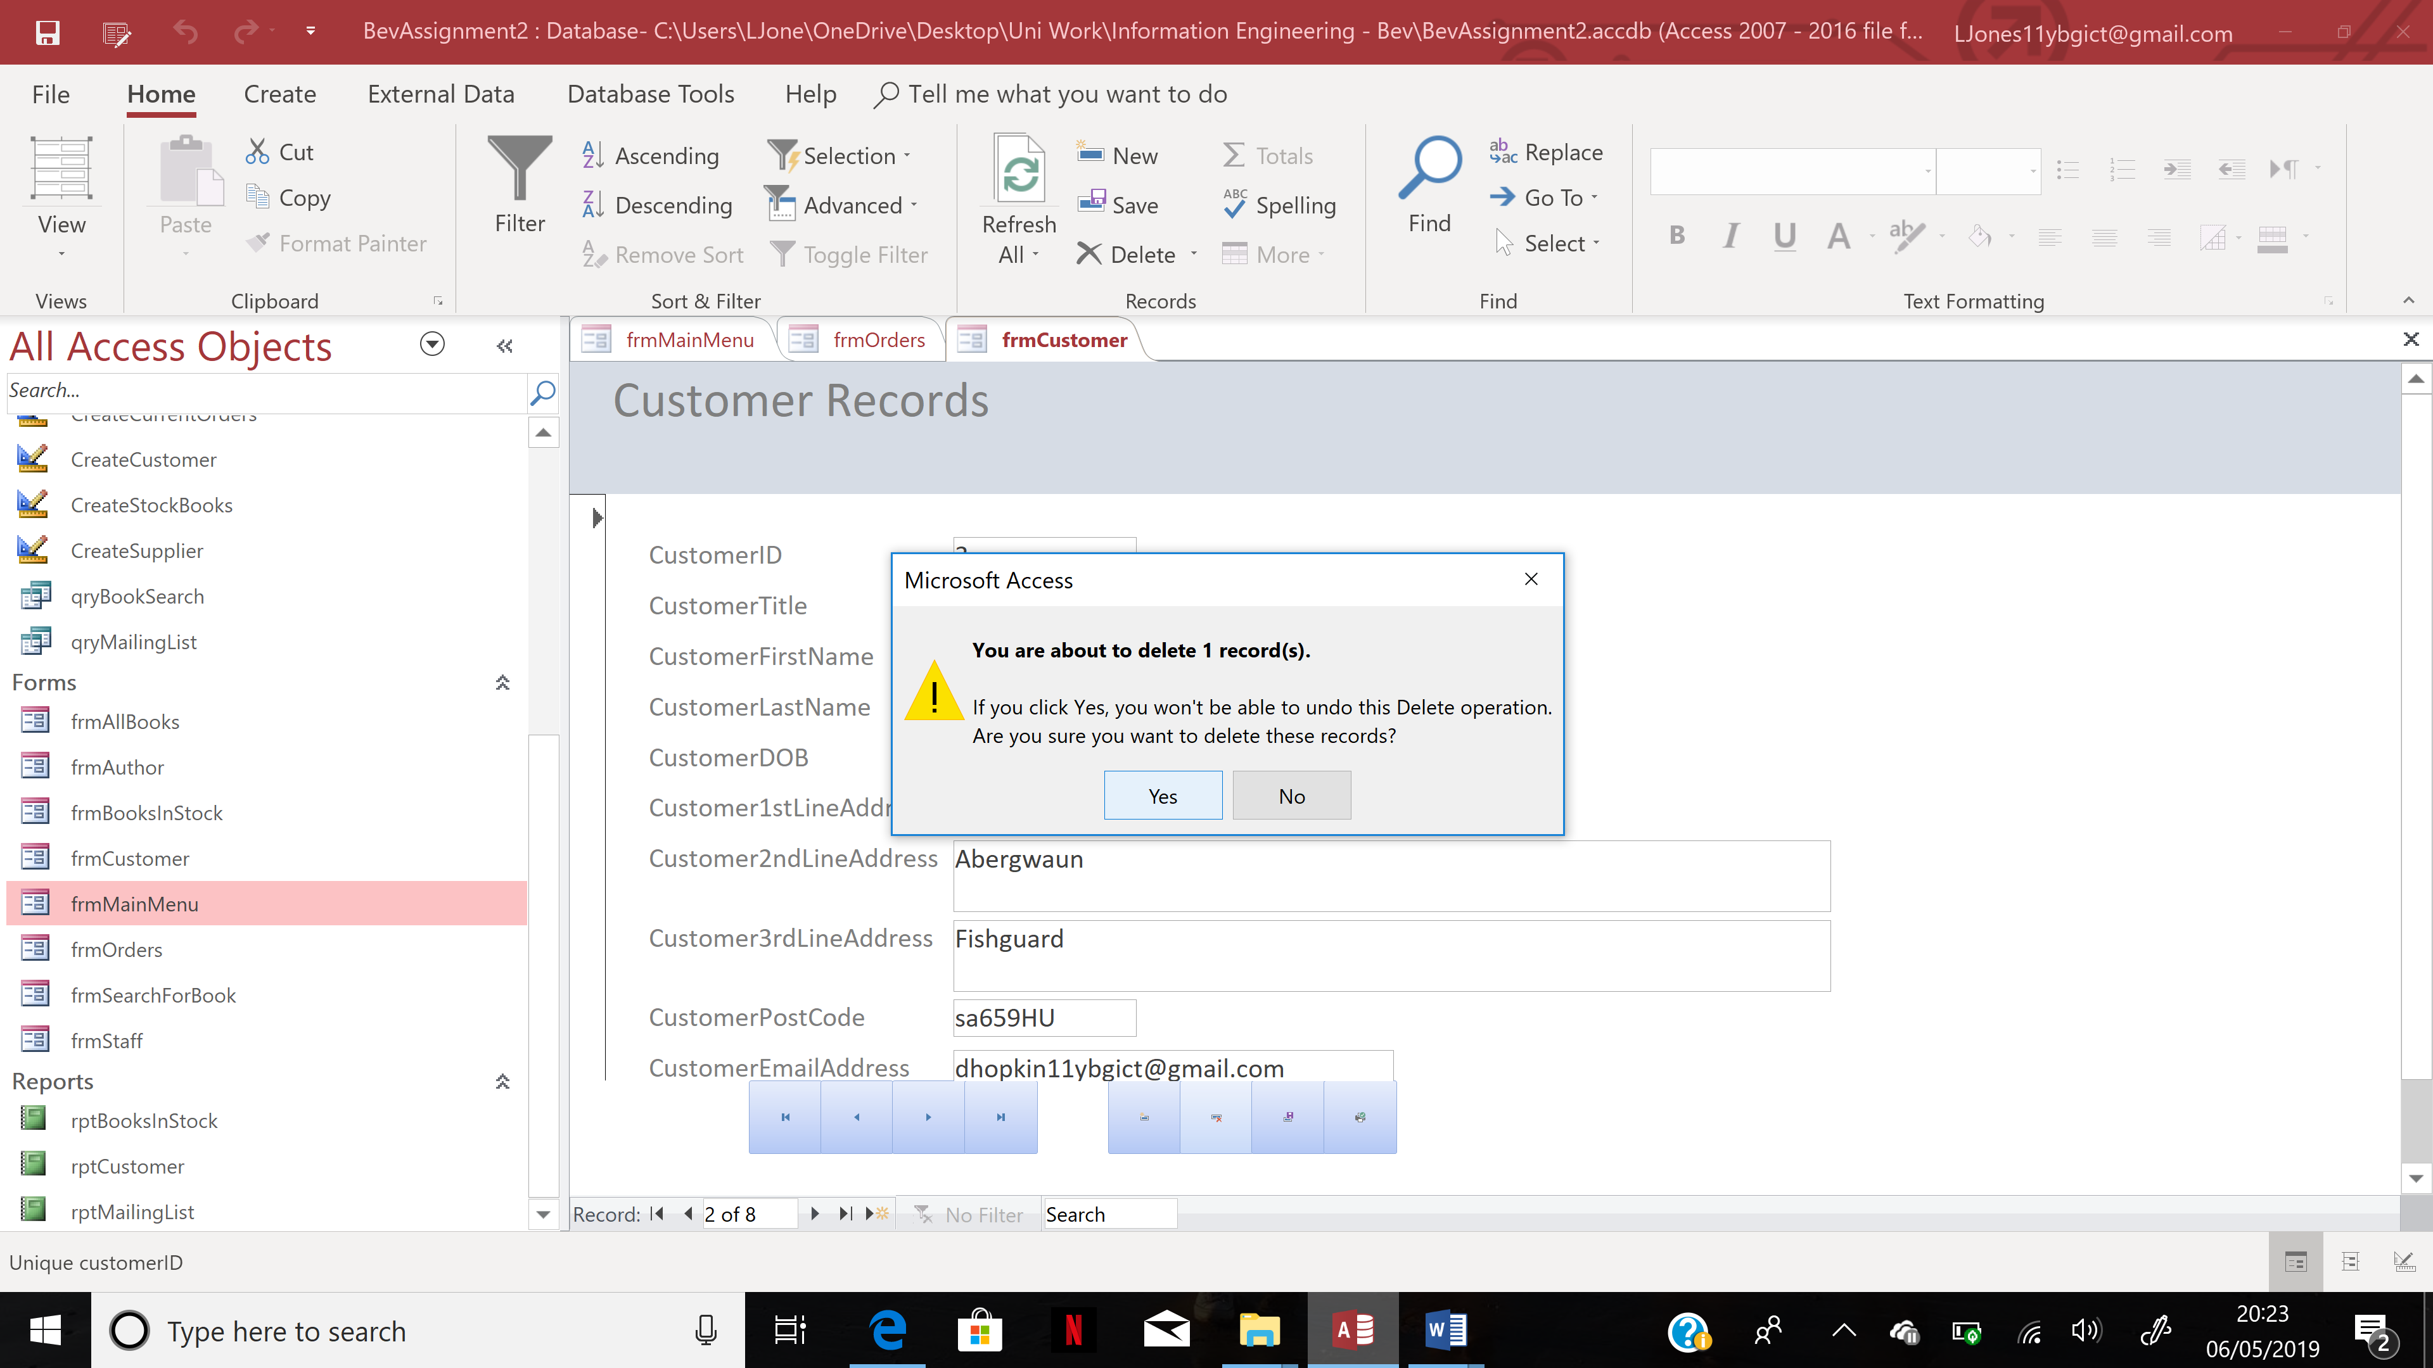

Reports.

How to view the mailing list report.
In order to view the mailing list report, you must firstly open the main menu form once again and locate the navigation button which says ‘open mailing list’. After you have done this, you will be greeted by the mailing list from your database.
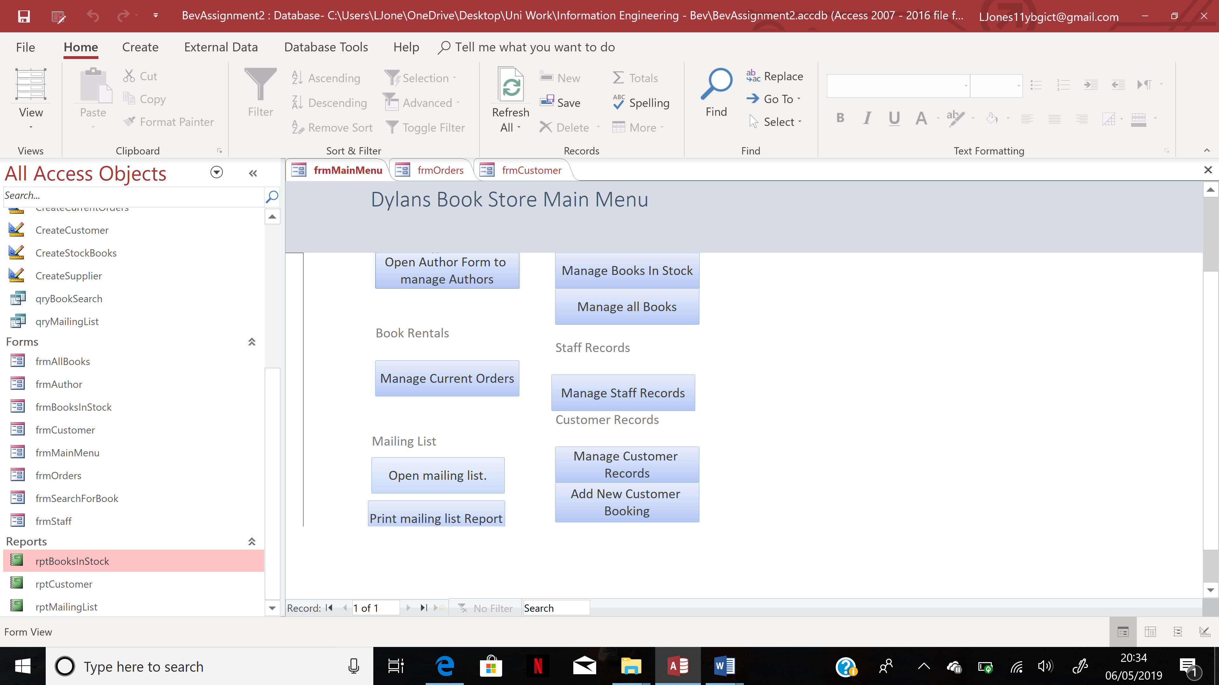
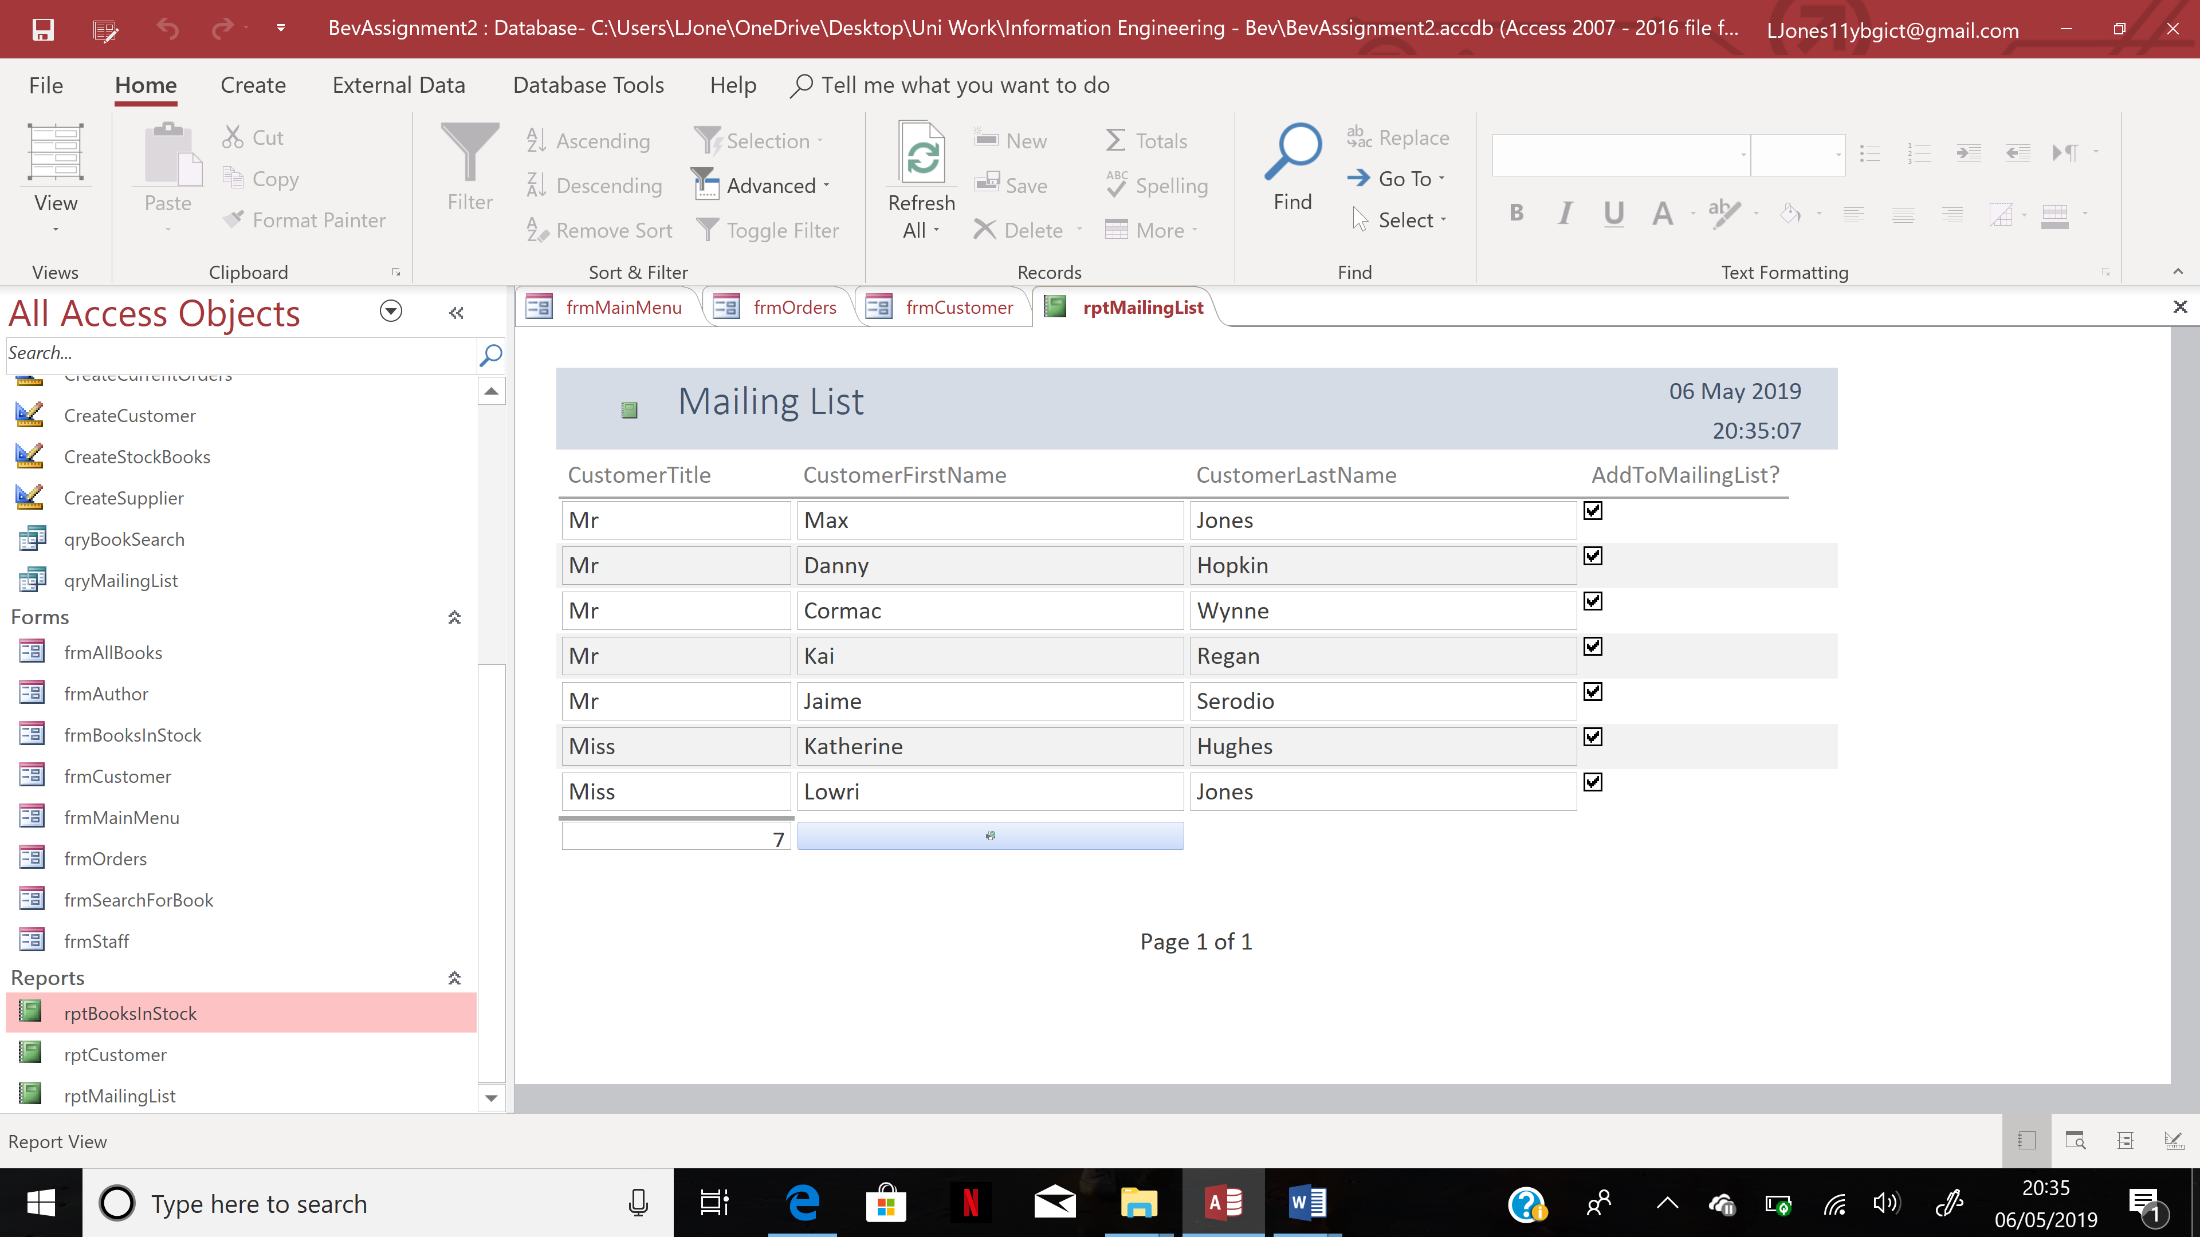

How to print the mailing list report.
To print the mailing list report, you must simply click onto the navigation button on the main menu which says ‘print mailing list report’. Once you have clicked onto this button, you will be greeted with all of the printing details.
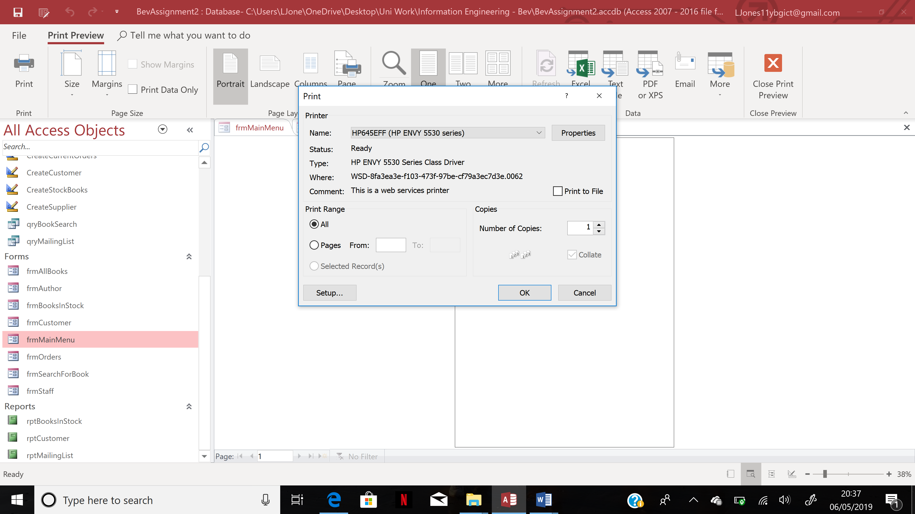

Tables.

How to input data into your tables.
In order to input data into the tables in your database, you must firstly open up the tables in your database and click onto the table you want to input some more data into and simply enter the data.

Thank you so much for choosing us to create your new Dylan’s Book Store database, I hope you are happy with your new database.

Evaluation.
I have created a very unique menu driven database for the Dylan’s Library. I have included Tables, Queries, Forms and Reports which will help the user keep everything organised.

