A Research Paper Focussing On:

Plastics In Concrete

Module Code – ACBA5022

Word Count Required – 2500 (+/- 10%
Word Count: 2750

Prepared for:
- Nantel

Created By:
E. Evans (2211009)

Submission Deadline – 7th January 2024

Table of Contents
1. Consideration of Plastic Inclusion into Concrete and Mortar Mixes 3
1.1 Introduction 3
2. Evaluation of The Use of Plastics as an Aggregate Replacement In Concrete Mixes 4
2.1 Brief Introduction 4
2.2 Research Evaluation 4
2.3 Conclusion 8
3. Evaluation of The Use of Plastics as a Reinforcement Material in Mortar Mixes 8
3.1 Brief Introduction 8
3.2 Research Evaluation 9
3.3 Conclusion 10
References 12

Table of Figures
Figure 1: Shredded plastic materials used in Cogent Engineering 2023 Case Study 5
Figure 2: Slump samples carried out by Cogent Engineering 2023 with & without plastics 6
Figure 3: Plastic materials used by University of Palermo Italy 2024 6
Figure 4: Recycled aliphatic polyamide 6 (nylon 6) used by University of Salerno Italy 2020 9
Figure 5: Three point bending setup from University of Salerno 2020 10

1. Consideration of Plastic Inclusion into Concrete and Mortar Mixes

1.1 Introduction
With the increasing growth of plastic use and the construction industry being constantly under scrutiny for being a significant contributor to environmental degradation, there has been a prompt interest in research to seek new alternatives to the traditional practices in the construction industry which relies heavily on natural aggregates such as crushed stone, gravel, sand and other forms which are quarried and processed into its final form for use. (Greenspec, 2024) The extraction of these aggregates can and will lead to habitat destruction, resource depletion and environmental pollution with 15-20% share of the construction industry’s waste/greenhouse gas emissions coming from fine and coarse aggregates, while 80% of the construction industries share of global waste and carbon dioxide is contributed by the manufacture and transportation of cement concrete alone (Leeds Beckett University, 2022). With the many issues presented, there is an innovative approach and idea of replacing natural aggregates by repurposing waste plastic that will aid in combatting the vast amount of waste in landfills and costs burdened by depositing the waste in other methods.
This research paper will explore and feature recent methods and developments over the past eight years, focussing on the use and application of waste plastics in concrete and mortar with examples and evaluation of case studies from both national and international research. There will also be discussion on the issues and limitations that may be present when working and implementing plastics in concrete, how these limitations can be alleviated and improved to achieve a suitable and sustainable end product. There will also be discussion and evaluation of the plastics functionality, practicality and future efficiency potential in the application of aggregates and as reinforcement for mortars.

2. Evaluation of The Use of Plastics as an Aggregate Replacement in Concrete Mixes

2.1 Brief Introduction
To begin the evaluation process, we can analyse case studies and research proposals to gain a better understanding why there is a focus on the replacement of natural aggregates and how they compare, as well as any problems that arise and how to solve them. Firstly, the need for this investigation into alternative sources for aggregates Is outlined as the construction industry is a key CO2 contributor with 80% of the construction sectors share being made up of the manufacturing, transportation and formulation of cement concrete alone, while the fine and coarse aggregate ingredients account for 15-20% share of the construction industries waste and greenhouse gas emissions. The construction industry is estimated to produce around 5 billion tonnes of CO2 globally and the highest contributor is said to be from the concrete process estimating 4.1 billion tonnes per year and meanwhile the quarrying, transportation and crushing/extraction of around 20 billion tonnes of sand, gravel and aggregates for the formulation of cement concrete/road construction account for around one billion tonnes of additional CO2 emissions per year. Setting aside the pollution aspect of the quarrying and formulation of concrete, there is also a very pressing concern of natural aggregate depletion and environmental concerns behind these practices, as once they are depleted there is no replenishing. (Leeds Beckett University, 2022)

2.2 Research Evaluation
A comprehensive study focussing on the properties of concrete using different types of recycled plastics as an aggregate replacement gives us a detailed view that we can analyse and gain more knowledge on the possibilities of plastic inclusion within concrete applications. This study undertaken by members of Cogent Engineering, examined the quality of concrete using Polyethylene Terephthalate (PET) and Polypropylene (PEP) as possible aggregate replacements. During this comparison the researchers replaced up to 15% of the aggregates with the plastic substitute and conducted several laboratory tests to fully determine and analyse the plastics ability in comparison to the natural aggregate. Such tests focussed on workability, unit weight, modulus of elasticity, compressive strength, indirect tensile strength (splitting) and flexural strength to gain a broad perspective of how the plastic reacts in comparison. A finite element was also produced to simulate the flexural beam test using the modulus of elasticity obtained from the experimental tests to further examine the behaviour of normal concrete, PET and PEP concrete. (Cogent Engineering, 2023)
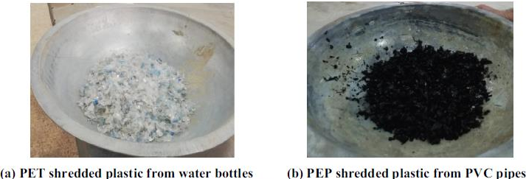
Figure 1: Shredded plastic materials used in Cogent Engineering 2023 Case Study
In this study a slump test was carried out that identified that the workability of the concrete improves with increasing PET content but deteriorates with increasing PEP content. (Rabar & Hunar, 2019) had reported in their study that plastic with a smooth texture can improve the properties of concrete such as reduction in friction for better workability and irregular shapes PEP shapes can increase the interaction between the mixed contents further causing a decrease in slump. This experiment tested for compressive strength which showed that replacing the fine aggregates with PET significantly reduced the compressive strength compared to the same replacement percentage of PEP, while the compressive strength can be reduced much more effectively with PET there was also a note that the decrease in splitting strength was more noticeable when PEP was introduced in comparison with PET. The modulus of elasticity test identified very useful data that shown that except for the mixtures containing 5% PEP, by increasing plastic content the modulus of elasticity was reduced because of the nature of the plastics used, such as the smooth surface of the PET and PEP products and both required a shorter time to flow compared to their natural aggregate counter part that had a rough surface. When observing the results of the flexural beam test there was no indication of a relationship between the percentage of plastic content and the modulus of rupture, for both concrete groups a reduction in the modulus of rupture was observed and the mixtures containing the PET were identified as being the lowest modulus of rupture while the PEP exhibited higher values. The finite element allowed for reliable estimation of the failure mode and identified the first cracks in both the normal and plastic concrete with acceptable differences. The finite element model produced different moduli of elasticity and different flexural resistances that agreed with the experimental results and indicated a good behaviour for the plastic concrete. (Rabar & Hunar, 2019)
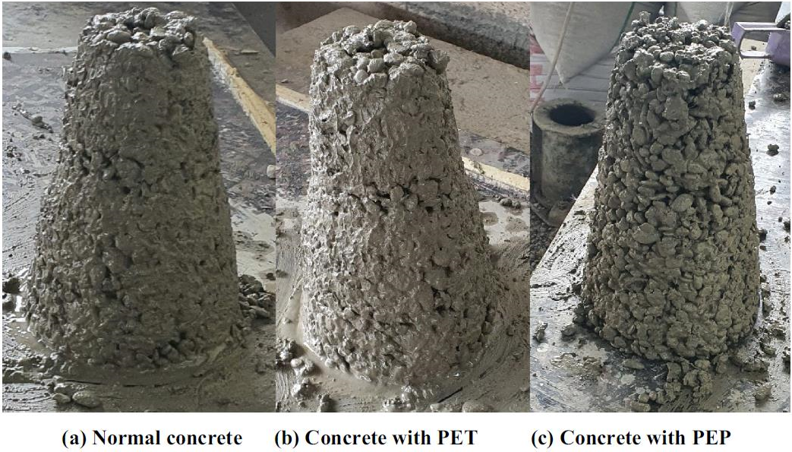
Figure 2: Slump samples carried out by Cogent Engineering 2023 with & without plastics
In another case study that focussed on Polyethylene (PE), Polypropylene (PP) and Polyvinyl Chloride (PVC) initially identifying there may be some contamination and impurities to the samples due to the recycling process possibly containing other substances such as metal and wood fragments, the researchers used shredded plastic flakes of such sizes to determine whether they would reach the same outcomes and further found that in general the concretes workability and mechanical performance are decreased when recycled plastic is added into the mix in comparison to the natural aggregate, although on the other hand it can also gain advantages and useful qualities such as insulation against heat due to their thermoset properties, low density was identified through testing which can be advantageous for applications where reduced weight concrete needs to be utilised for lightweight and non-structural components in building projects. (University of Palermo Italy, 2024) Plastics are also documented to be favourable for their high durability, high ratio of strength to weight, low density, long life span, less effected by chemicals and have relatively low cost to manufacture. (Liverpool John Moores University, UK, 2020)
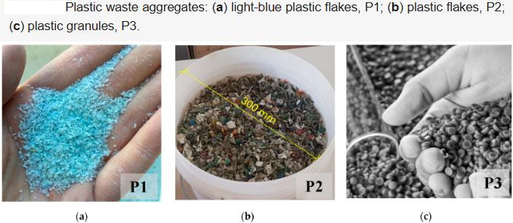
Figure 3: Plastic materials used by University of Palermo Italy 2024
Throughout the research studies there has been complications of the bond between the plastic materials and the cement, research and processes have been undertaken to identify the causes of these issues and how to solve and improve their capability for stronger adhesion. With regard to both plastic reinforcement material and aggregate replacement there are still the issues present such as the dielectric property found in all types of plastic materials which possess high electrical resistivities (Ohring, 1995) this inhibits the movement of electrons and generates polarisation within the product when exposed to the external electrical field. Studies also suggest that the reduction in compressive strength was due to the poor adhesive strength between the plastics and the cement paste due to the hydrophobic properties of the plastics and therefore effected limited water diffusion into the concrete which is necessary for the hydration of the cement. It has been suggested through research that the poor bond and higher air content within the plastic concrete are key indicators for lower performance of concrete, which is believed to be that plastic aggregates have a chemical reaction behaviour with the concrete that reduces its performance under both the durability and the mechanical tests. The bond strength can be significantly influenced by means of treatment, size, surface texture and shape of the plastic introduced into the mix which will affect the performance of the concrete. (Liverpool John Moores University, UK, 2020)
There has been a significant interest in the research of different types of treatment for the plastic aggregate in order to improve its ability to bond to the concrete and produce a viable solution. There are innovative methods that have been identified such as the suggestion of microwave type irradiation, to critically assess this method we can focus on a study that carried out this microwave radiation treatment to enhance the strength of recycled plastic concrete. The study included three recycled plastic types as replacement for aggregates and were found to have a decrease in contact angle measurements of the treated PET aggregates and indicated a decrease in the hydrophobicity property which resulted in an increase in the surface wetness of the plastic. The treatment was shown to have modified the surface of the plastics and identified micro swelling on the surface of the PET which resulted in a smoother surface. The evidence shown that the Interfacial Transition Zone (ITZ) indicated that modifications of the plastic aggregate reflected on the bond strength of the ITZ and demonstrated strong contact of the PET mix of concrete. Although the treatment was found to decrease the workability of concrete, the water absorption was improved due to the improvement in ITZ interfaces. This method can be an option to consider as a surface treatment but shows not as effective in the strength application as well as possible implications of cost, pre-treatment process, difficulty of application to large quantities and may be a difficult task when considering that each type of plastic has its own dielectric constant. (Liverpool John Moores University, UK, 2020)

2.3 Conclusion
To critically asses the potential of waste plastics as a partial replacement for aggregates the researcher focussed on methods of using a range of different plastic materials and within the studies it was evaluated that due to the bonding issues there would need to be a significant focus on treating the plastic before inclusion into the concrete mix, once this had been implemented it continued to improve some aspects of the mix and offered its own characteristics to be utilised in practical and functional applications such as eco friendly construction, where some building projects are aiming or bound to sustainability targets and certifications. While the studies revealed that the plastic replacement was not to be used as a load bearing material due to its physical and mechanic performance being poor even when the bond is substantially better, there are other uses that can be taken advantage of for future efficiency within the construction industry, these can be applications such as concrete interior partition walls, prefabricated panels, drainage elements and possibly the most advantageous being footways and bike paths, which can be more durable alternatives and with regards to cost. This research identifies the issues that are presented and the fact that plastic can not be a full replacement, but can impose great reduction on waste, pollution and allowing the natural aggregates to be less depleted in the long run.

3. Evaluation of The Use of Plastics as a Reinforcement Material in Mortar Mixes

3.1 Brief Introduction
To critically assess the possibilities of using recycled waste plastic as a potential reinforcement material within concrete mortars we can seek out case studies and research that performed testing and evaluations, such as the option of using recycled nylon fibres which were obtained from waste fishing nets. The purpose of this study was to focus on the tensile reinforcement in cement mortars as it is documented that concrete is well known for its compressive strength but lacks tensile strength, this is always reinforced by the addition of steel rebar which offers the tensile strength needed. Within this study there was also a focus on the tensile behaviour of unconditioned and alkali cured recycled fibres obtained from manual cutting of waste fishing net filaments, the initial evaluation of this material as a potential comes from the increased pollution of fishing nets in the ocean and the fact that plastic fishing nets are non-biodegradable which leaves a troubling issue of the disposal of these materials and the harm it has on the marine ecosystems let alone the pollution that comes from the disposal. (University of Salerno Italy, 2020)
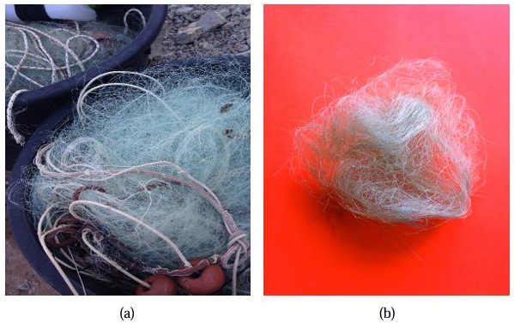
Figure 4: Recycled Aliphatic Polyamide 6 (nylon 6) used by University of Salerno Italy 2020

3.2 Research Evaluation
This study carried out independent testing but also relied on other studies and information to compare and improve their own testing, from their tests and data they were able to analyse the behaviour of the material within the concrete and determine the functionality, practicality and future efficiencies within the construction industry. The researchers opted for the nylon fish net specimen which is formally named as Aliphatic Polyamide (Nylon 6) and is known for its thermo-mechanical properties such as its compressive and tensile strengths, toughness, specific heat capacity, thermal conductivity, thermal expansion and hygrometric shrinkage. (University of Salerno Italy, 2020) This was to be treated with an alkali treatment which is a chemical process that modifies the molecular structure of the fibres to improve their mechanic properties and adhesion to polymer matrices, this is often used to reinforce thermoplastics and thermosets. This process aims to improve the surface of the fibre resulting in improved bonding and lowering surface tension, this is advantageous as it is renewable, readily available, biodegradable, cost effective, recyclable and has a lower density which makes the process virtually pollution free meaning a lower carbon footprint. This process involves the material being submerged in the chemical for a period of time to allow proper alterations and curing within the specified parameters.
Within this study there were tensile tests carried out that identified a slight mass loss within the mix but demonstrated adequate resistance to chemical attacks while being treated with the alkali solution for maximum results. The compression test yielded a decrease in compressive strength and flexural tests outlined significant improvement in tensile strength and toughness compared to the non-reinforced material, as well as suffering minor drying shrinkage, the advantages of the plastic reinforced material were balanced by the slight reductions of tensile strength, max load bearing capacity and modulus of elasticity. The bending and compressive tests identified the nylon fibres offer a considerably more effective resistance to cracking and although the effects of reinforcing plastic fibres in compression have been debated in research, this study acknowledges that the highly deformable plastic might be assuming the role of the voids in the cement mortar when the compressive forces are applied. With the sufficient stiffness and length of the fibre it can increase the lateral tensile strength of the composite material and further enhance the overall reinforcement of the mortar mix compared to the unreinforced mix. (University of Salerno Italy, 2020)
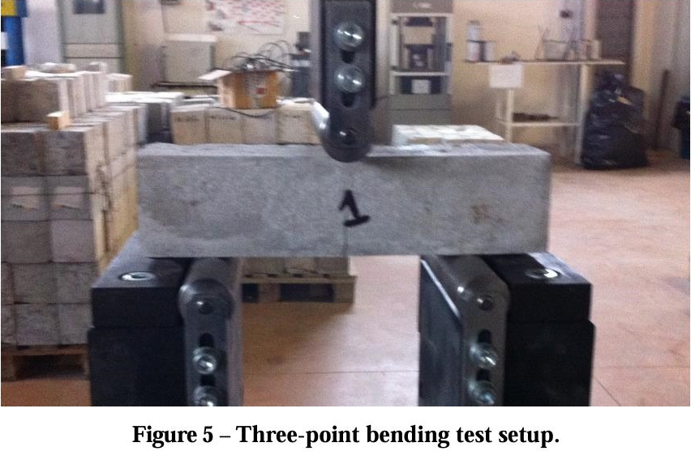
Figure 5: Three point bending setup from University of Salerno 2020

3.3 Conclusion
There has been a lot of focus on utilising different forms of waste plastic to reduce pollution, waste and recyclability of materials such as recycled PET bottles into resin to produce polymer-mortar or polymer concrete, there is also a method of introducing PET fibre to improve the ductility of the concrete and reduce cracking caused by plastic shrinkage. There is a method that has tried recycling flakes from PET bottles and using them directly as a binder, but the more interesting and more practical, functional and most advantageous for its future efficiency proven by terms of tests is the inclusion of waste plastic fibres within concrete in examples such as the waste fishing net Aliphatic Polyamide 6 (nylon 6). This material poses advantages in a few aspects especially since the material genre is mainly non-biodegradable, so finding mass use for the material is a big result for pollution and waste issues. The research undertaken by (University of Salerno Italy, 2020) focussed on this as well as evidence from other studies and compared the waste fishing net fibres alongside alkali treated fibres to get a fully working concept that proved a very useful mortar with the correct length and mix. This material suggested in research that it was a safe use as a reinforcement material and can even be utilised for repair applications of concrete structures. The main issue with plastic material is the bind to the cement mix and with the application of an alkali treatment there was noticeable differences of bind and performance of the plastic material within the mortar, the biggest note from this research in terms of benefits is that the recycling of waste fishing nets in this study and application do not require any energy consuming processes such as material re-polymerisation or extrusion and they will simply need to be collected, washed and properly cut to length required which further reduces cost, energy consumption and reinforces the construction industries attempt to reduce its carbon footprint and waste. This research has been stated to provide a basis for a multiscale mechanical modelling of cement materials incorporating recycled nylon reinforcements.

References
Alan Nantel, 2024. Lecture Notes. [Online]
[Accessed 12 2024].
Cogent Engineering, 2023. Mechanical properties of concrete using different. [Online]
Available at: https://www.tandfonline.com/doi/full/10.1080/23311916.2023.2243735#abstract
[Accessed 19 12 2024].
Greenspec, 2024. Aggregates for Concrete. [Online]
Available at: https://www.greenspec.co.uk/building-design/aggregates-for-concrete/
[Accessed 09 12 2024].
Leeds Beckett University, 2022. Investigating Polymer as a Replacement for Fone and Coarse Aggregate in Concrete. [Online]
Available at: https://eprints.leedsbeckett.ac.uk/id/eprint/10507/1/AComparativeStudyInvestigatingTheFeasibilityAndPotentialOfUtilisingPolymerDemolition%26GlassWasteAsAPartialReplacementForFineAndCoarseAggregateInConcretePV-NADIR.pdf
[Accessed 18 12 2024].
Liverpool John Moores University, UK, 2020. The influence of incorporating plastic within concrete and the potential use of microwave curing. [Online]
Available at: https://www.sciencedirect.com/science/article/abs/pii/S2352710220334574#:~:text=Highlights&text=Plastics%20unable%20to%20chemically%20interact,aggregates%20and%20the%20cement%20matrix.
[Accessed 19 12 2024].
Minde, P. K. M. P. J., 2024. Comprehensive review on the use of plastic waste in sustainable concrete construction. [Online]
Available at: https://link.springer.com/article/10.1007/s43939-024-00126-1
[Accessed 08 12 2024].
Ohring, M., 1995. Engineering Materials Science. [Online]
Available at: https://www.sciencedirect.com/topics/engineering/dielectrics#:~:text=Dielectrics%20are%20materials%20possessing%20high,than%20simple%20isolation%20of%20components.
[Accessed 20 12 2024].
Rabar & Hunar, 2019. Use of recycled plastic in self-compacting concrete: A comprehensive review on fresh and mechanical properties. [Online]
Available at: https://www.sciencedirect.com/science/article/abs/pii/S2352710219327548?via%3Dihub
[Accessed 19 12 2024].
Sofi, B. J. a. A., 2017. Study on Mechanical Properties of Concrete Using Plastic Waste as an Aggregate. [Online]
Available at: https://www.researchgate.net/publication/319014786_Study_on_Mechanical_Properties_of_Concrete_Using_Plastic_Waste_as_an_Aggregate
[Accessed 19 12 2024].
University of Modena Italy, 2023. Waste Plastic and Rubber in Concrete and Cement Mortar: A Tertiary Literature Review. [Online]
Available at: https://www.mdpi.com/2071-1050/15/9/7232
[Accessed 08 12 2024].
University of Palermo Italy, 2024. Integrating Plastic Waste into Concrete: Sustainable Solutions for the Environment. [Online]
Available at: https://www.mdpi.com/1996-1944/17/14/3408
[Accessed 19 12 2024].
University of Salerno Italy, 2020. Recycled nylon fibers as cement mortar reinforcement. [Online]
Available at: chrome-extension://efaidnbmnnnibpcajpcglclefindmkaj/https://arxiv.org/pdf/1409.7258
[Accessed 20 12 2024].

