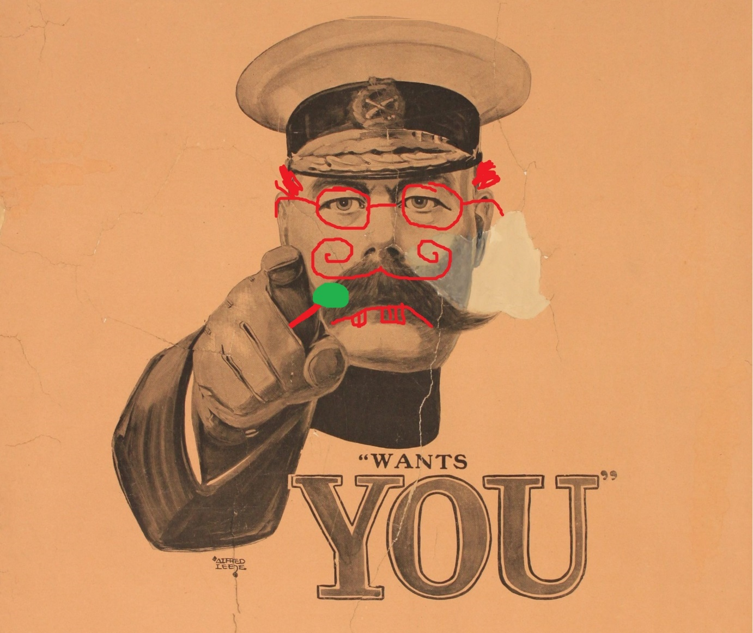
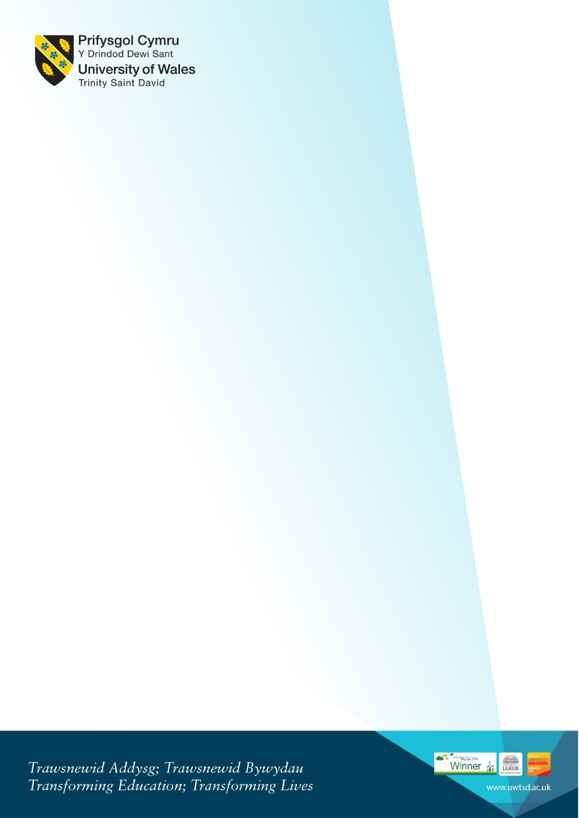
2-5pm, Founders Library. Snacks will be provided.
Contact Jordan Edwards for further details. Phone 07000 000000, email.uwtsd@.co.uk
Featuring talks on Religion, Evacuees, Etc Etc Etc Etc and Wargaming
WAR IS FUN

