

Application Development
  - Javasscript/Jquery-enabled website report
Thomas Howells | HND Applied Computing | 3/1/2021
Contents
Introduction 2
Javascript Evidence 3
Misc 9
Conclusion 10
References 11
Bibliography 18

Introduction
This report is going to cover how the student managed to develop a website using JavaScript features that allow for user interaction. It will include screenshots and annotated code to show evidence of understanding. The subject being covered within the webpage will be the Star Wars Series ‘The Mandalorian’. This is since the student is fond of the fictional Star Wars Universe.

Javascript Evidence
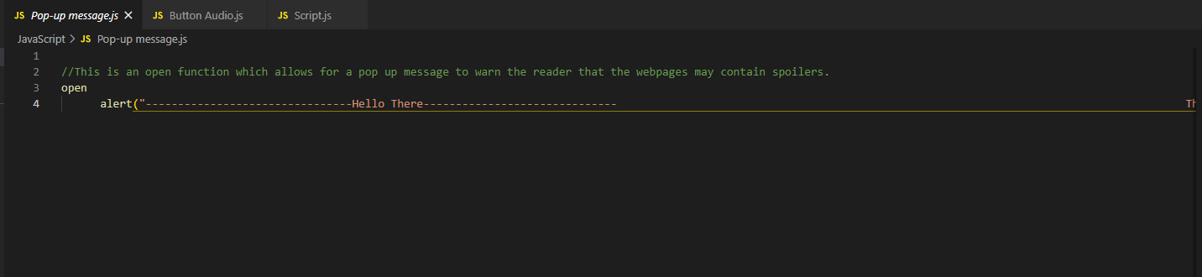
Figure 1- Evidence of 1st JavaScript insert.

As seen in Figure 1 there is an insert of JavaScript. This JavaScript was simple it writes as there was not a lot of code that had to typed. The code was written due to lots of trial and error.
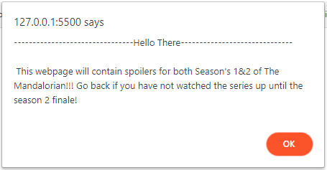
Figure 2- The 1st JavaScript applied to the Index.html.

Figure 2 is the evidence that the pop-up message does indeed work. The JavaScript was only linked to the Index.html page as it is the main home page that the user will open the website up to. This JavaScript could have been edited in a way that log in information would have to been required but as it is a fan website, there would be no use to have login credentials so instead the code was written to warn people that the website contains spoilers.
The code in Figure 3 is an example again of simple JavaScript. When the ‘function’ was activated(in this case by button) it would change the code that was tagged with the ‘id=”Mando” ’ to a bigger font size, the colour of the text to yellow and the background to black. The student had also inserted code that would play the Star Wars theme song once the button on Index.html and been pressed. [1]
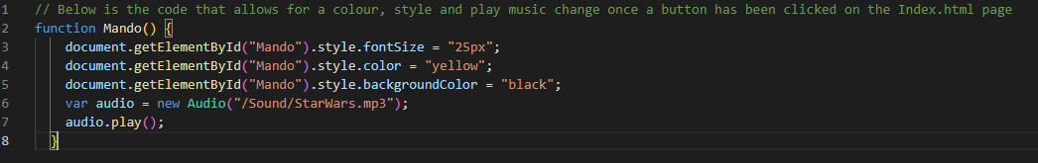
Figure 3- The next set of code that covers the ‘Easter Egg’ button on Index.html.

The reason for this code was to give the user of the webpage a feel of nostalgia as once the button was clicked it would change everything on the page to resemble the classic Star Wars opening crawl. This would be the dynamic change that the student wanted for their webpage as it was fun but also nostalgic for them. The student knew how to produce this code due to wschools.com having example code showing how to change the font size on their ‘Style fontSize Property’ tab. The student had seen the potential in the code and had written his on in a way that he could have all Font size, Colour and Background Colour all in the same executable function.[2]
The play audio code was researched, and the student had found the code that would best suit them and their web design. A forum was found called StackOverflow.com with multiple sources of information that would aid the student in producing the code that would play audio. [3]

Figure 4 shows the webpage once the button has been pressed. The audio will also play once the button has been pressed but cannot be shown in an example on in this document.
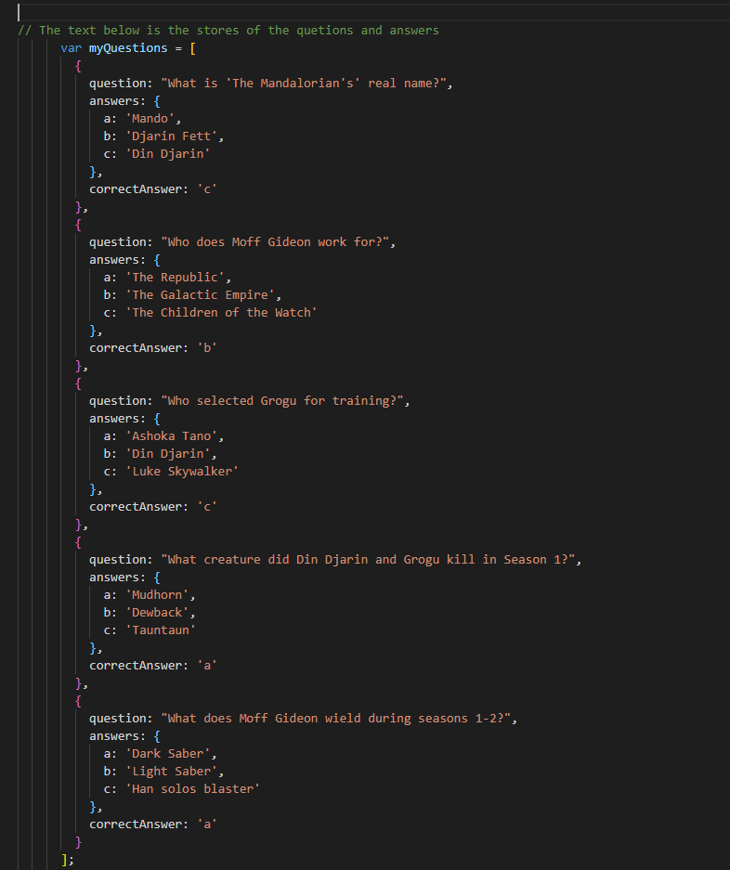
Figure 5- JavaScript written questions and answers that links to Quiz.html.

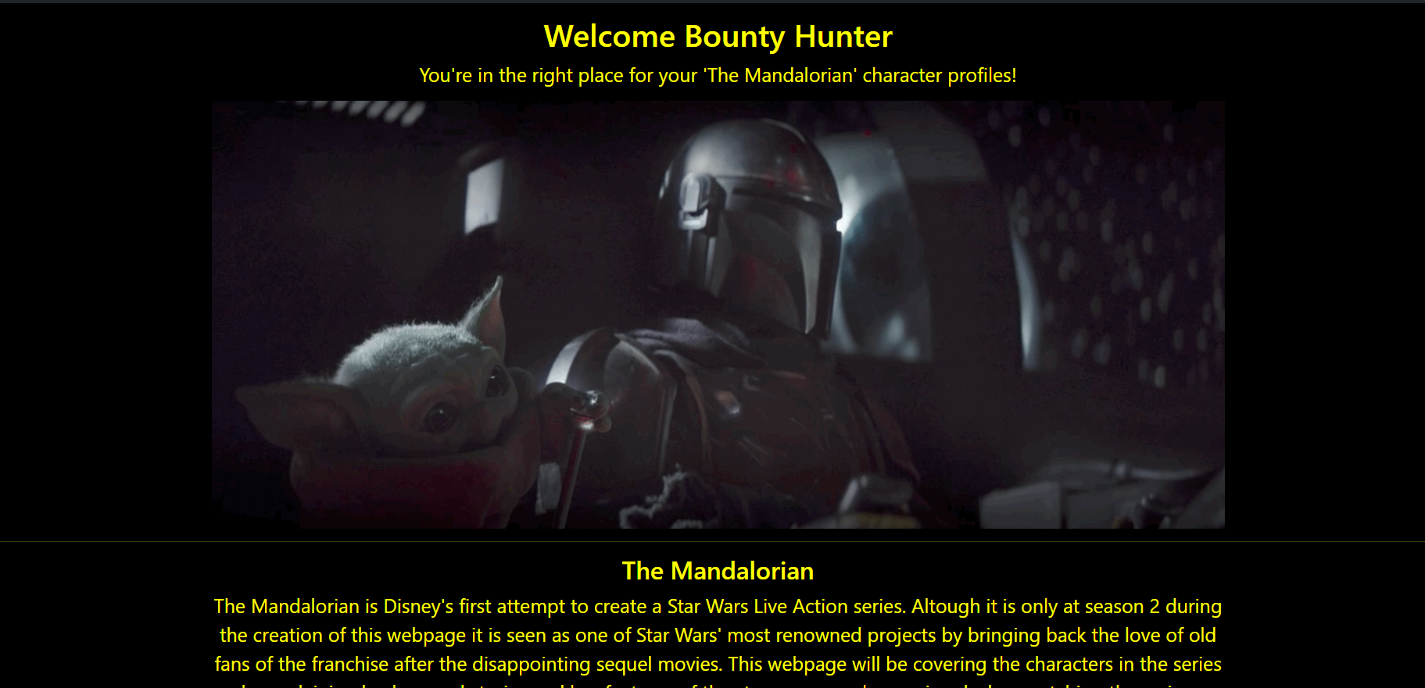
Figure 4- An example of the JavaScript that applies once the button is pressed on Index.html.

A quiz was made using JavaScript elements for the final page of the website. It had a maximum of 5 questions all varying in difficulty that could be answered by Star Wars The Mandalorian fans. It can be seen in Figure 5 that all the questions and answers were stored and ready to display.
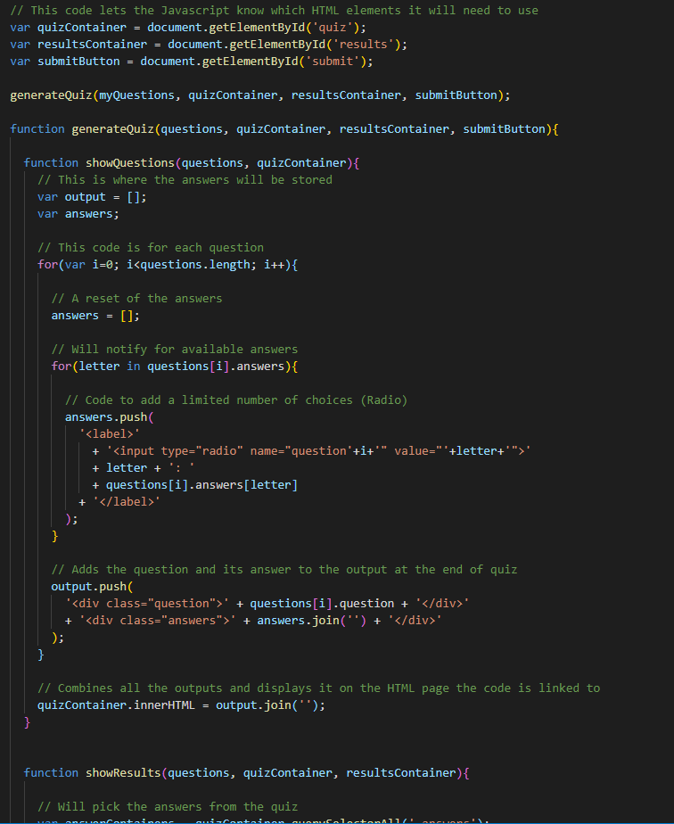
Figure 6- JavaScript code that links to Quiz.html.

Figure 6 displays a lot of code that is responsible for their own individual processes and overall, one big process being the complete quiz.
The student followed along his sources and researching and put together a Quiz using this code as it did what was expected. The Quiz could have been made a lot harder due to the possibilities with coding being endless but as the Quiz was only covering a handful of pages filled with information it did not have too as complex as it could have been. Features such as a Quiz reset button, images and interactive tiles were in the original idea of the Quiz but as the student came to producing the code for this, but then they had realised it was not essential.

Figure 7 displays the final piece of code that was produced for the Quiz to run correctly. As it can be seen, this is the code that covers whether the answered questions are right or wrong, the number of questions answered right out of the 5, and the colours that display on the questions answered correctly and incorrectly.
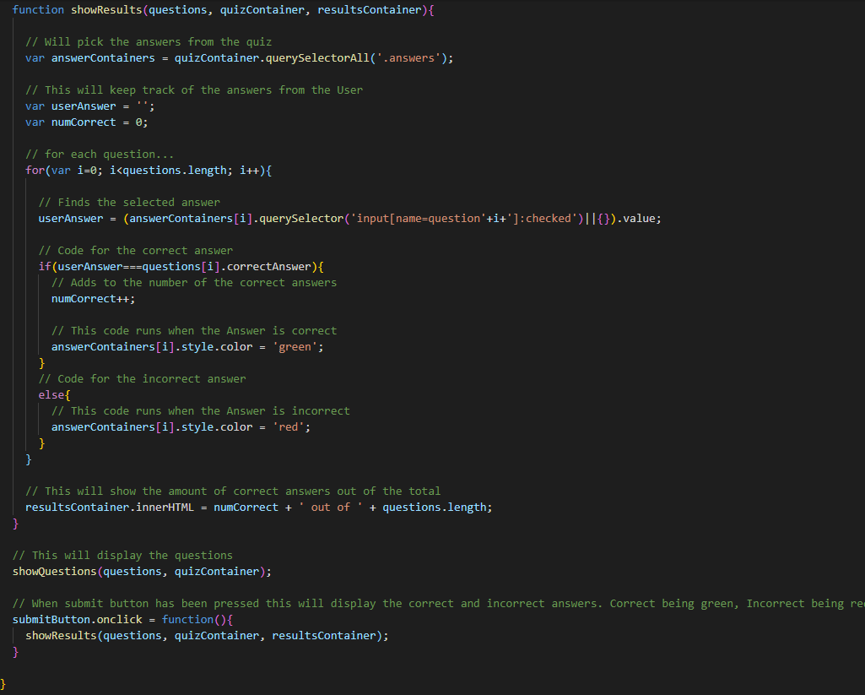
Figure 7- Final piece of JavaScript code that links to Quiz.html.

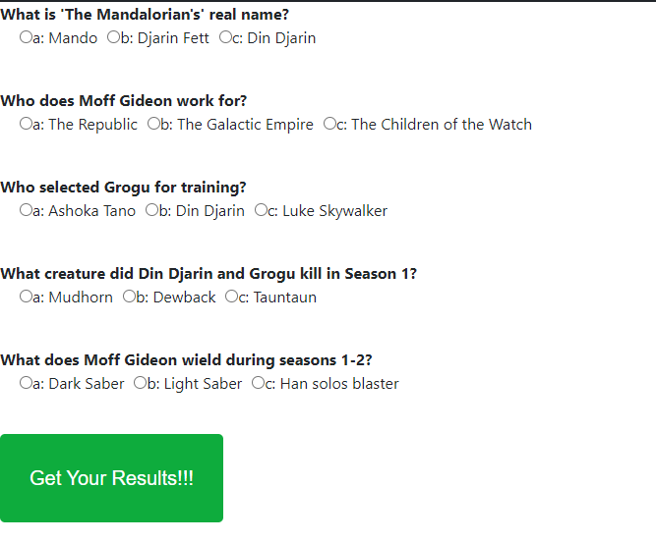
Figure 8- What the Quiz displays like on Quiz.html.

Figure 8 just shows what the Quiz looks like when Quiz.html is opened in a browser.

Misc
The base webpage used a Bootstrap Navbar. The student was more than capable of making a Navbar that would have served the same purpose, but the student felt like they could show the evidence of JavaScript elsewhere. The evidence of bootstrap allowing the student to use the code and framework is on the front page of the website as it states that it is an opensource.[8]
The webpage follows Star Wars The Mandalorian. It has profiles on a handful of the main characters that is filled with the useful information. It serves the purpose that the student had set out for it in the first place.
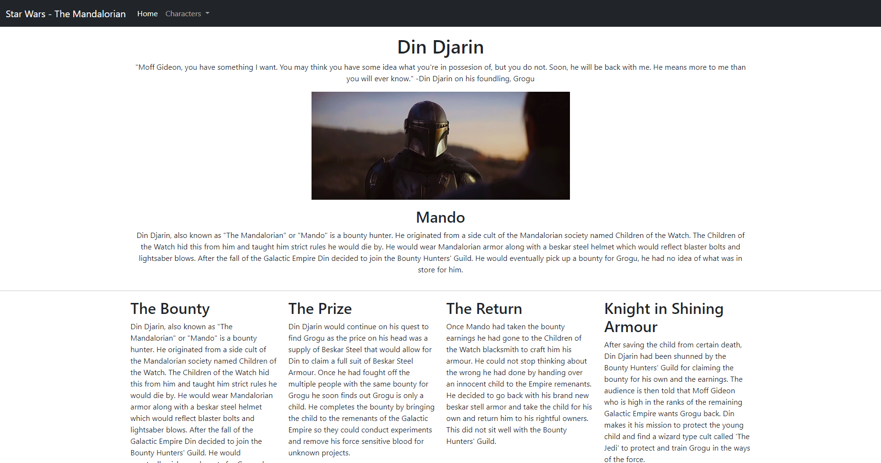
Figure 9- An example of one of the character profiles

Figure 9 is an example of one of the character profiles with both the Navbar, Containers and Text inside. Under the Characters dropdown on the Navbar it displays Din Djarin, Grogu, Moff Gideon and Quiz. This is all that is needed in order to navigate the webpage. All the Character profiles are the same layout but Home(Index.html) and Quiz(Quiz.html) are completely different.

Conclusion
The webpages from the student’s point of view were a success and they had been produced in a way that they did not want anything else from it. The student feels as if this report and the creation of the website has helped refine the skills used to make webpages. The use of all HTML, CSS and JavaScript has improved since the last webpage that had been made by the student.

References
Front Page Image- Gadgeon.com. 2021. Custom Application Development | Application Management Services. [online] Available at: <https://www.gadgeon.com/iot-services/application-development/> [Accessed 17 January 2021].
Figure 1- 1st use of JavaScript.

Figure 2- The 1st JavaScript applied to the Index.html.

Figure 3- The next set of code that covers the ‘Easter Egg’ button on Index.html.

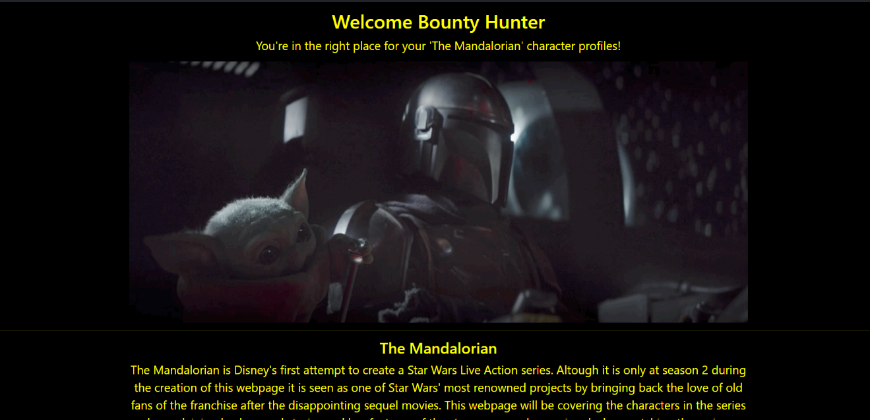
Figure 4- An example of the JavaScript that applies once the button is pressed on Index.html.

Figure 5- JavaScript that links to Quiz.html

Figure 6- JavaScript code that links to Quiz.html.

Figure 7- Final piece of JavaScript code that links to Quiz.html
Figure 8- What the Quiz displays like on Quiz.html.

Figure 9- An example of one of the character profiles

Bibliography
[1] Internet Archive. 2021. Star Wars Theme Song By John Williams : Free Download, Borrow, and Streaming : Internet Archive. [online] Available at: <https://archive.org/details/StarWarsThemeSongByJohnWilliams> [Accessed 27 January 2021].
[2] W3schools.com. 2021. HTML DOM Style fontSize Property. [online] Available at: <https://www.w3schools.com/jsref/prop_style_fontsize.asp> [Accessed 27 January 2021].
[3] audio?, H., S., R. and Smolyanin, K., 2021. How to play audio?. [online] Stack Overflow. Available at: <https://stackoverflow.com/questions/9419263/how-to-play-audio> [Accessed 27 January 2021].
[4] Simplestepscode.com. 2021. How to make a simple JavaScript quiz | Simple Steps Code. [online] Available at: <https://simplestepscode.com/javascript-quiz-tutorial/> [Accessed 27 January 2021].
[5] Wookieepedia. 2021. Gideon. [online] Available at: <https://starwars.fandom.com/wiki/Gideon> [Accessed 27 January 2021].
[6] Wookieepedia. 2021. Din Djarin. [online] Available at: <https://starwars.fandom.com/wiki/Din_Djarin> [Accessed 27 January 2021].
[7] Wookieepedia. 2021. Grogu. [online] Available at: <https://starwars.fandom.com/wiki/Grogu> [Accessed 27 January 2021].
[8] Mark Otto, a., 2021. Introduction. [online] Getbootstrap.com. Available at: <https://getbootstrap.com/docs/5.0/getting-started/introduction/> [Accessed 27 January 2021].

