In what ways do you think that the detail of decoration contributes to the quality of British architectural design.

British architecture today is very limited with the aspect of individuality, decoration isn’t thought of as an equal or even an important point to designing today, buildings are repeated with the same design for simplicity and have a consistent uniformity to them, they are not considered in a direction of quality just the thought of does the building work? And does it stand up? People are no longer finding buildings such as houses interesting as each build is almost identical, other buildings are again beginning to reach the same point with being made of similar materials and having similar purposes not giving a unique factor of design and decoration, whilst considering the past builds of British architecture each building shows their own personal touch be that the aesthetic look including materials, their type of column or if they choose to have a colour scheme pattern and design such as images being painted on walls. Some buildings are still stood today making and proving them to have a quality aspect. I will include the types of decoration detail that are used today and have also previously been associated in design, along with a variety of building examples, followed by my personal opinion on the matter and conclusion.

Types of decoration that is considered in recent and past British architecture and its quality aspect.

Buildings from the 1990’s forward consist of the needs that people desired such as traditional features the idea was aimed for new builds to reflect older buildings using materials such as the mock timber framing, rendered walls, and cottage features. The present-day shows a different style concentrating more on the needs of sustainability rather than the decoration of buildings. The decoration used in today's period is common materials, such as timber clad and exposed steelworks as oppose to patterned figures, designs, and strong columns, etc. Personally, this show a point to the loss of quality in today’s designing, the act of decoration in the past shows time and precision and the choice of material today shows a quick solution for an aesthetically pleasing building, showing the lack of creativity used to develop these builds and form their own unique feature.
Past decoration within architecture form from different styles of architecture from different times in Britain, for example, English gothic or decorated which started in England around 1180, the terms used to describe the period (middle pointed, curvilinear, geometric, etc) refer to the shape of window heads and window tracery, which became more elaborate and decorated, buildings didn’t change radically, rather the decorated was an evolution not as opposed to revolution. decoration from this period include forms such as roof construction with hammerhead beams and similar types of design, these decorations are often found in buildings such as cathedrals and churches, often a place that resembles empowerment, other decoration, and designs that are defined from English gothic are pointed-arched, vaulted roofs, buttresses, large windows, rose windows and spires, as these elements are not popular in today’s design, you could argue that the form of architecture has developed over the years and could argue that in fact, both types of architecture today and in the past show a form of quality to their designs with the concentration of different aspects. Another noticeable facet of secular architecture was, in fact, the decoration of material with the growth of solidly built stone houses again not popular in today’s architecture but then was a sign of class and wealth, as people were able to afford to build in less perishable materials, even most are stood standing today.
Another period that targeted decorations, one of their most important design features is the English Baroque period. The period began in Britain after the architect Christopher Wren began redesigning buildings and churches in this form of architecture after the 1666 fire of London incident. In this period limestone and slate were often used as exterior finishes to these buildings, and granite in the colours grey and red were interior specifics in the design. It had to be a conservative appearance within the designs and could be described as traditional and strict. In comparison to other types of baroque architecture found in other European constructions, this would be classed as weak, showing the essence of smaller movement in less dynamic frames, for example, other European countries would target colour and patterns, English baroque consisted of the usual and common colour of construction with no added stucco or paint, suggesting the different aesthetic look within the different styles, this could be shown as a lack of quality with the simplicity and lack of creativity used within the style in comparison with other European countries, as stated previously the colour stuck to the construction colour pallet whereas the effort driven in baroque architecture elsewhere shows a well thought out process of colours and patterns to create a decorative piece of art in addition to a strong stood and powerful piece of architecture. The decorative elements in this style was consistent with Palladian architecture, and the classical orders, therefore used classical figures, column shells, and pilasters, and symmetry, clustered chimneys and double-hung windows, churches in England consisted of Latin crosses, facades had a decorative touch such as columns, moulding, and arches, the designs often included a decorative central dome as it emphasized the intersection of the points of the cross. The style followed French designs with and ornamented interior such as laborious and overly decorated rooms with the intention of showing wealth within the design, it was common to include features during the period with painting, furniture and sculptures (such as dolphins, fish scale, griffins, and marquetry). Typically, the style of English baroque is complex, and somewhat contradictory, although by encountering the features and style used within it evokes a desire of emotional states of appeal, by introducing its dramatic ways. Qualities associated with the style are usually grand, showing the richness of the build along with the building being full of drama, movement, emotional exuberance and a tendency to blur distinctions between the various arts.
Similarly, the renaissance period known as the Elizabeth era consists of congruent designs to baroque, they both use similar materials such as paints and sculptures to emphasis their style. It reached England in the early 16th and 17th centuries. This style of architecture usually only formulated with buildings needed to be of high class and quality, you would usually find the style around upper-class houses, manors, and castles, the materials used were stone and expensive brick types to ensure its durability, it focused with symmetrical designs along with geometric flooring, with towers forming on each side of the building, as a form of power and show an elegance appearance. The building types would usually form of a square and rectilinear shapes with the asymmetrical towers alongside, this would hint the evolution of medieval fortified architecture. The Elizabethan era consisted of building with large windows located on their facade, this is something that has carried on throughout the years of architecture with development within the decoration of today's buildings with big open glass windows, along with pattered steel structure frames forming, (although this is rare and usually only generates in buildings of high value and of the meaning), this is also a form of showing the development and a continuous strip of quality throughout the years in architecture with this form of design.

British buildings that target decoration, and their individuality that still stand today.

Rarely present architects use forms of decoration, but when it is used it’s as an advertisement to make their builds prominent, this usually comes from builds that are of high value, and have a priority to look and be of quality to the community an example of this would be the Glamorgan building in Cardiff, this building was built in 1911 and is currently grade 2 listed, and the form of decoration shown on the building is not ordinarily used in today’s architecture. The building includes strong Corinthian columns that support the building as well as endure its aesthetically pleasing and acquired look, this forces the building to look powerful, and full of an endowment. The interior shows similarly effective decorations with sealing cornice plaster, again as an element of quality with time and precision being visibly shown. Unconnected to the building itself but part of architecture stands 2 sculptures named Minerva representing the mining, and the other named Neptune, which stands within a chariot, this sculpture represents navigation. These sculptures show an additional example of the decoration that the building holds. The building shows refined architectural spaces, the survival of fittings including panelling, chambers, and seating, these bring the building to life showing all quality aspects from the biggest of decoration the most minute such as plaster carving and seat decorations.
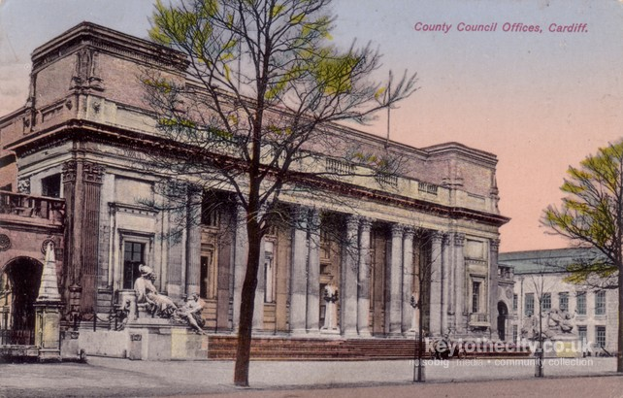
Another example locally of a considered highly decorative build is Pontypridd tabernacle, this is a sub classical building, with a gable entry, it was built in 1861 and is still standing today. The building's art of decoration and power comes from its exterior design, the building includes a symmetrical structure with pedimented and gable ends and shows the essence of coining along the outskirts of the build. The building's quality shows a strong and lasting case as the building continues to be in use (a museum). 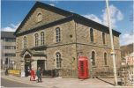
Furthermore, highly decorated builds include St Marks church in Brithdir, this building was built around the same time as the Pontypridd tabernacle. The building shows its element of gothic touches, it contained asymmetrical windows, round-arched lancet windows, a 2 tier bellcote, and a rounded head arch and buttresses, although this wasn’t the decorative idea behind the building, the building was constructed of brick, local grey/green ashlar stone, and contained slate roofs, the reasoning for this is that the Architect had the design of the building sprouting from the ground rather than being placed there. This shows the Architects thinking behind the process showing time and quality being shown behind the scenes of this building to ensure it reached the goal of communicating this information to the public. The interior also contained rendered walls in colours that represented chancel, such as reds, blues, and creams, the sealing was a plain cornice style, the chancel was groin vaulted. The doors were made from a style called art nouveau, they were made from oak and contained a mother-of-pearl decoration. The interior also contained sculpturist forms some of which include angels and doves. This building is well known for its quality and design of both interior and exterior, I feel this contributes to the quality of British architecture, it’s a strong withholding building that has been well thought out and processed and looks aesthetically pleasing also.
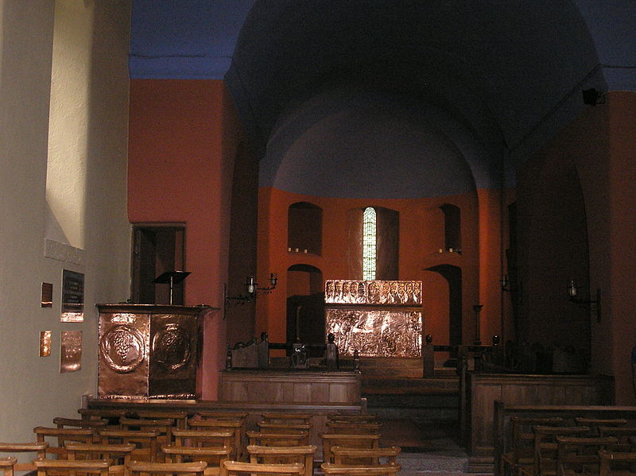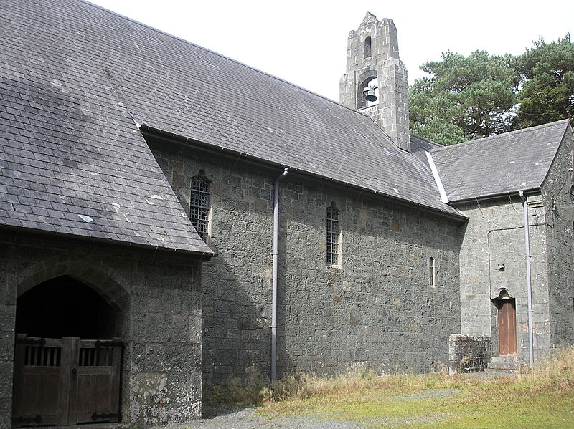
The Guild hall constructed in 1934 is another decorative designed building, it shows an innovative design along with its unique factors that emphasis the building, to the point where its features were widely copied during its 2-decade completion. The buildings success and quality is shown through the functionality of the building, with only undergoing a few minor amendments over the years but with the building itself still keeping its original form of character as its “approach to modernism”. The building is of neoclassical style, constructed from Portland stone, brick, and concrete, it also has small-pane windows made of metal and lead rainwater goods with decorated hopper heads. The tower is one of the main features to pull attention with its octagonal panelled dome, corner antefixes, and arches with an inset pair of columns. Additionally, the interior is Wales finest of its period, with minute if not unaltered formal areas, it contains a vaulted gilded coffered ceiling, flooring with marble patterning with an Egyptian style bronze gating, a roman Doric style antechamber again with the coffered barrel-vaulted ceiling, in the lobby, there are Australian walnut fluted ionic columns, there shows a crossbanding style to the main hallway along with patterned wall art containing the leek and a goat upstairs. The building has been listed as grade 1 as one of two in Swansea this contributes to the quality of the building by demonstrating a successful and pleasurable building with its decorative interior and exterior shell of holding back the decoration within.
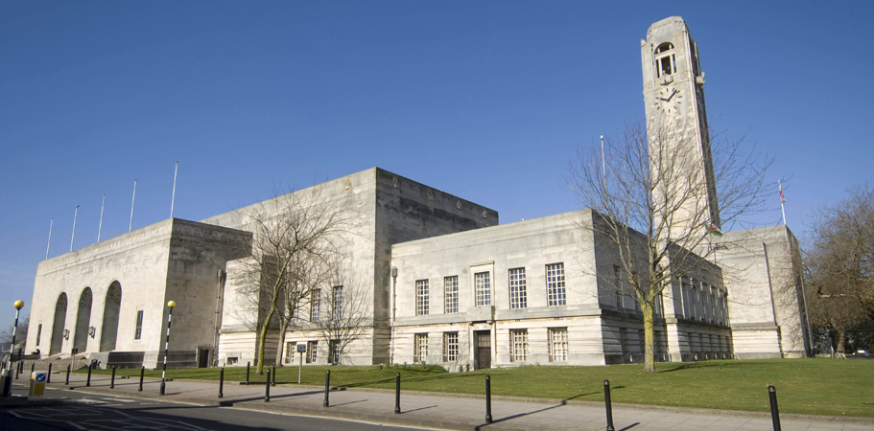
St Pauls cathedral is another, building targeted for its decoration. A Baroque-style building built in 1675, with its inspiration forming from Palladio. The decoration of the building includes its feature dome on the exterior of the building. The front west of the building shows a tower on each side of the dome with Corinthian columns taking effect throughout the centre of the building. The building is two storeys of ashlar masonry surrounded by a balustrade above the cornice. As for the interior of the building the Corinthian pillars take stand along with the smooth surface of the domes, this punctuates the division between the spaces. The domes and apse extend the full width of the nave and aisles and is supported by pendentives rising between arches. Within the building contains a decorative feature of sculptures and paintings which help bring this building to life. The decoration of this building contributes outstanding quality with its unique structure and interior.

There are buildings due to their expectancy of high quality and time precision that have unable to have been finished, such as Westminster abbey, it’s one of the capitals most recognizable landmarks and doesn’t seem to appear unfinished, the building is, in fact, missing a dome/tower but when Wren, Nicholas Hawksmoor, and William Dickinson put forward and application the changes were never added. Similarly, the cathedral of Westminster was supposed to contain a monument to the east of the building towering over the abbey and palace themselves. The cathedral had been left with no finishes on the mosaics, today there still is no evidence of decoration on some parts of the building as Architect John Bentley passed away before the finishing. The National-Monument-of-Scotland is also a build never finished due to its lack of funds. From this information gathered its clear to see that quality within decoration is hard to produce due to cost, and due to the time of the building itself.

Today’s advancements and its effect of quality

The quality of the buildings is quite different today in comparison to the past. Past quality consisted of designing, building and sculpting by hand, whereas today this is done through the art of technology. Machinery is used widely now to produce and construct unique artefacts that look handmade such as columns and cornice etc. A designer and textile artist named William Morris used the quotes” The thing which I understand to be real art is the expression by man of his pleasure in labour” “Nothing in which is made by man will be ugly, but will have its due form, and its due ornament, and will tell the tale of it making and the tale of its use.” “The craft of building is done by hand”. Personally, the use of machinery shows a lack of quality within the arts of architecture, proven that buildings today is targeted to last roughly 100 years, whereas past builds are still standing today.

Comparison between todays decoration and past decoration (conclusion)

It seems that although architecture today does contain some amenity with decoration, the past dating back to the 1500s was considered to have more decoration given the time era it was designed. Today we not only have the trouble of designing buildings to look and be aesthetically pleasing but we also have a duty to design sustainable builds, to keep up with our environment, these features to make a sustainable build are now considered our form decoration, and time and concentration is needed within this process to ensure a successful and quality filled building. Therefore, personally, decoration contributes a big factor to the quality of architecture today, it’s just that our form of decoration has adapted due to our climate to make a better and more sustainable build for our future, and building quality has minorly been affected due to our technology updates with less precision and hand designing being taken into action.

Reference

Banister F. (1962), A History of Architecture on the Comparative Method (seventeenth edition), Athlone Press, University of London
(Accessed: 9th March 2020)

Brangwyn. (N/A) The history. Brangwyn.
http://www.brangwyn.co.uk/about/the-building/
(Accessed 10th March 2020)

Britannica. (2019) Baroque art and architecture. Encyclopaedia Britannica.
https://www.britannica.com/art/Baroque-art-and-architecture
(Accessed: 4th March 2020)

British listed building. (N/A) Former Glamorgan county hall. British listed buildings.
https://britishlistedbuildings.co.uk/300013738-former-glamorgan-county-hall-castle#.Xmq04y2ca1t
(Accessed: 8th March 2020)

British listed building. (N/A) listed buildings in wales. British listed buildings.
https://britishlistedbuildings.co.uk/wales#.Xmq41y2ca1t
(Accessed: 9th March 2020)

British listed building (N/A) Swansea new guildhall. British listed buildings.
https://britishlistedbuildings.co.uk/300014594-swansea-new-guildhall-uplands#.Xmq6WS2ca1u
(Accessed: 10th March 2020)

Cadw. (N/A) Full report of listed buildings. Cadw.
http://cadwpublic-api.azurewebsites.net/reports/listedbuilding/FullReport?lang=en&id=16008
(Accessed: 9th March 2020)

Coflein. (N/A) Pontypridd museum, formerly tabernacle welsh Baptist chapel, brew road, bridge street. Coflein.
https://coflein.gov.uk/en/site/10151/details/pontypridd-museum-formerly-tabernacle-welsh-baptist-chapel-berw-road-bridge-street
(Accessed: 8th March 2020)

Designergirlee. (2011) English renaissance architecture. Designergirlee.
https://designergirlee.wordpress.com/2011/02/25/english-renaissance-architecture/
(Accessed: 7th March 2020)

Friends of Friendless churches. (2010) Outside brithdir. Friends of friendless churches.
https://web.archive.org/web/20110701071208/http:/www.friendsoffriendlesschurches.org.uk/CMSMS/index.php?page=outside-brithdir-2
(Accessed: 8th March 2020)

Home and antiques. (2017) British house styles across the ages. Homes and antiques.
https://www.homesandantiques.com/interiors/homes/discover-500-years-of-british-homes/
(Accessed: 2nd March 2020)

Morris.W. (N/A) biography of William Morris. The art story.
https://www.theartstory.org/artist/morris-william/life-and-legacy/#nav
(Accessed: 10th March 2020)

Muir.J. (2019) Pontypridd area. Welsh chapels and churches.
http://freepages.rootsweb.com/~glamorgan/history/rhondda/pontypridd/index.html
(Accessed: 11th March 2020)

Pjposullivan. (2013) File. Exterior of St marks church, Brithdir. Wikimedia.
https://commons.wikimedia.org/wiki/File:Exterior_of_St_Mark%27s_Church,_Brithdir,_Gwynedd.JPG
(Accessed: 11th March 2020)

Pjposullivan. (2013) File. Interior of St marks church, Brithdir. Wikimedia.
https://commons.wikimedia.org/wiki/File:Interior_of_St_Mark%27s_Church,_Brithdir,_Gwynedd.JPG
(Accessed: 11th March 2020)

Ross. D. (N/A) English gothic- Decorated period. Britain express.
https://www.britainexpress.com/architecture/decorated.htm
(Accessed: 2nd March 2020)

Study. (N/A) English baroque architecture: characteristics & examples. Study.com.
https://study.com/academy/lesson/english-baroque-architecture-characteristics-examples.html
(Accessed: 4th March 2020)

Summerson.J. (1983), Architecture of Britain 1530–1830, The Pelican History of Art, Penguin Books.
(Accessed: 9th March 2020)

Telegraph. (2019) Amazing buildings you didn’t know were unfinished. The Telegraph.
https://www.telegraph.co.uk/travel/galleries/spectacular-buildings-you-would-never-guess-are-unfinished/national-monument-of-scotland/
(Accessed: 10th March 2020)

Ukessays. (N/A) Architecture of the English renaissance history essay. Ukessays.
https://www.ukessays.com/essays/history/architecture-of-the-english-renaissance-history-essay.php
(Accessed: 7th March 2020)

Unknown. (1927) Glamorgan building, Cardiff. Postcards from the past.
http://www.keytothecity.co.uk/postcard.php?Id=6&CityId=1
(Accessed: 11th March 2020)

Vivian.G. (N/D) Brangwyn hall. Art Uk.
https://artuk.org/visit/venues/brangwyn-hall-7566
(Accessed: 11th March 2020)

Bibliography

Greer. G. (2011) The English renaissance: the rebirth of refinement. The Guardian.
https://www.theguardian.com/artanddesign/2011/sep/10/renaissance-architecture
(Accessed: 7th March 2020)

Keyser.H. (2014) 21 designs for the great tower of London that never was. Mental floss.
https://www.mentalfloss.com/article/58012/21-designs-great-tower-london-never-was
(Accessed: 9th March 2020)

Rentoul.J. (2015) the top ten: unrealised and unfinished buildings. Independent.
https://www.independent.co.uk/arts-entertainment/architecture/the-top-ten-unrealised-and-unfinished-buildings-10234560.html
(Accessed: 10th March 2020)

Study. (N/D) Italian Baroque architecture: characteristics & Examples. Study.com. https://study.com/academy/lesson/italian-baroque-architecture-characteristics-examples.html
(Accessed: 4th March 2020)

Welsh newspapers. (1889) the Pontypridd chronicle and workman’s news. Welsh newspapers.
https://newspapers.library.wales/view/3810666/3810671/36/edward%20davies
(Accessed: 8th March 2020)

Word Count- 2,779 (including quotes and titles)

https://www.homesandantiques.com/interiors/homes/discover-500-years-of-british-homes/
https://www.britainexpress.com/architecture/decorated.htm
https://study.com/academy/lesson/english-baroque-architecture-characteristics-examples.html
https://www.britannica.com/art/Baroque-art-and-architecture
https://www.ukessays.com/essays/history/architecture-of-the-english-renaissance-history-essay.php
https://designergirlee.wordpress.com/2011/02/25/english-renaissance-architecture/
https://britishlistedbuildings.co.uk/300013738-former-glamorgan-county-hall-castle#.Xml37i10e1s
http://www.keytothecity.co.uk/postcard.php?Id=6&CityId=1
https://coflein.gov.uk/en/site/10151/details/pontypridd-museum-formerly-tabernacle-welsh-baptist-chapel-berw-road-bridge-street
http://freepages.rootsweb.com/~glamorgan/history/rhondda/pontypridd/index.html
https://web.archive.org/web/20110701071208/http://www.friendsoffriendlesschurches.org.uk/CMSMS/index.php?page=outside-brithdir-2
http://cadwpublic-api.azurewebsites.net/reports/listedbuilding/FullReport?lang=en&id=16008
https://britishlistedbuildings.co.uk/wales#.Xmpn4C2ca1s
https://commons.wikimedia.org/wiki/File:Interior_of_St_Mark%27s_Church,_Brithdir,_Gwynedd.JPG
https://commons.wikimedia.org/wiki/File:Exterior_of_St_Mark%27s_Church,_Brithdir,_Gwynedd.JPG
http://www.brangwyn.co.uk/about/the-building/
https://britishlistedbuildings.co.uk/300014594-swansea-new-guildhall-uplands#.Xmpw1y2ca1t
https://artuk.org/visit/venues/brangwyn-hall-7566
Fletcher, Banister (1962), A History of Architecture on the Comparative Method (seventeenth edition), Athlone Press, University of London
Fletcher, Banister (1962), A History of Architecture on the Comparative Method (seventeenth edition), Athlone Press, University of London
Summerson, John (1983), Architecture of Britain 1530–1830, The Pelican History of Art, Penguin Books, ISBN 978-0-14-056003-9
https://www.telegraph.co.uk/travel/galleries/spectacular-buildings-you-would-never-guess-are-unfinished/national-monument-of-scotland/
https://www.theartstory.org/artist/morris-william/life-and-legacy/#nav

