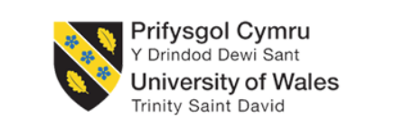
By: Harvey Merrett
2204827

Engineering management assignment.
ACHA5012-ACHA5007

Project Planning

Contents
- Introduction- page 1
- Roles and responsibilities- page 2
- A list of overall group tasks and associated timings- page 3
- A detailed list of my tasks to contribute towards the project- page 4
- Milestones-page 5
- Concerns of risk-page 6
- Gantt chart- page 7

Introduction- Page1
In this report I will be explaining the roles and responsibilities of our group project that I took part in for my motorcycle engineering BEng degree. It will include many factors such as roles and responsibilities such as task duration, goals and so on.
The focus of group project was to gain more power and increase the aerodynamics of the universities race bike which is a Honda NSF-250 ridden by Ian Henshaw. All of the different students were assigned certain roles to take part on the motorcycle which this report will explore in further detail.

Roles and responsibilities- page 2
There are eight students who were assigned roles and responsibilities for work on the NSF-250. These consist of:
Oska – Rear set
Megan – Alternative fuels and fuels calcs
Harry – Yokes, adjustable rear suspension
Aaran – Fuel tank relocation
Ed – Airbox design
Jake – Intake redesign
Myself - Front fairing reconstruction
Olly – Fuelling maps/engine strategies. Secondary injector and bellmouth
The roles of the project were chosen through a group discussion and interest in reference to what the lecturers would also have liked us to have got done for the project. In many aspects of making the project motorcycle faster there were many opportunities I would have chosen but due to my experience with motorcycles and also being a mechanic for work the front fairing reconstruction had interested me the most.
Taking reference from the Belbins model which is, Belbin Team Roles is a methodology for developing successful teams. Belbin is an evidence-based, data driven approach to improving team performance. This approach is unique for examining and understanding how individuals contribute, interrelate and behave and how best to maximize the strengths of each individual in the team. I would say that I share a few characteristics of the provided team roles. For example, I feel that I am a resource investigator meaning I am excellent at communicating and putting my feedback across which corresponds to the work that has implemented the design of the fairing. Secondly, I feel that I have a high drive and very high motivation to complete the task at hand and to do it to the best of my ability. Second to this it means my patience is very low and I end up rushing into the project. Third and finally I feel that I am a plant as I feel that I can be imaginative and creative towards the project as I show the passion to do well. All these three complement each other well meaning I am creative and like to share my input which tie in well with my project manager and my colleagues.
There are several roles and responsibilities within the group project which allow us to collaborate as a team. For example, Olly is our project lead meaning all progress, updates and issues need to be relayed back to him so he can record the progress given to us. This is an easy way for u us to also maintain our progress as all our information will be recorded by one person. Everybody in the project has a certain role to maintain and improve their chosen area of expertise. These are considered as the end goal of the project and all work will eventually tie together.

 | IMPEMENTER | COORDINATOR | SHAPER | PLANT | RESOURCE INVESTIGATOR | MONITOR EVALUATOR | TEAM WORKER | COMPLETE FINISHER
LOW 0-33% | 0-6 | 0-6 | 0-8 | 0-4 | 0-6 | 0-5 | 0-8 | 0-3
AVERAGE 33-66% | 7-11 | 7-10 | 9-13 | 5-8 | 7-9 | 6-9 | 9-12 | 4-6
HIGH 66-85% | 12-16 | 11-13 | 14-17 | 9-12 | 10-11 | 10-12 | 13-16 | 7-9
VERY HIGH 85_100% | 17-23 | 14-18 | 18-36 | 13-29- | 12-21 | 13-19 | 17-25 | 10-17
Average  score | 6.1 | 7.57 | 6.7 | 5.8 | 7.57 | 7.57 | 7 | 7.1

Overall group tasks and timings-page 3
There are many overall group tasks with associated timing to ensure that everything is running smoothly. We all have individual roles but it also helps that we have weekly meeting to give everyone updates on our part of the group project and to give feedback to one another including our project lead.
For example, we all need to be able to ensure we are working as coherent as possible because this may have a knock on affect on the rest of the project. For example, if I do not ensure that the correct research for the design of the new front fairing is put in place, it will have a significant affect on the design of the air intake. Our timings are all planned out and documented throughout a Gantt chart.
The roles of myself and my colleagues are as shown:
Name: | Roles: | Tasks: | End:02/04/2025
Olly | Bellmouth and injector mapping | - Install new ecu  - Optimize fuel mapping  - Secondary injector RD&T
Oska | Rear-set design and development | - Design research  - CAD development  - Testing and fitting
Harry | Adjustable offset yokes | - Analyse OEM yokes  - Custom yoke design  - FEA testing  - Testing and fitting
Jake | Intake development | - Research  - Prototyping  - Production
Harvey(myself) | Fairing reconstruction and | - CAD/3D scanning  - Prototyping  - Production  - Realworld testing  - Monitoring and adjustments
Megan | Alternative fuels and injection | - Alternative fuels and injection research  - Apply research  - Monitor
Aaron | Fuel tank development | - Research  - Prototyping  - Production  - Testing
Ed | Airbox development | - CAD drawings  - Futher development  - Prototyping  - production

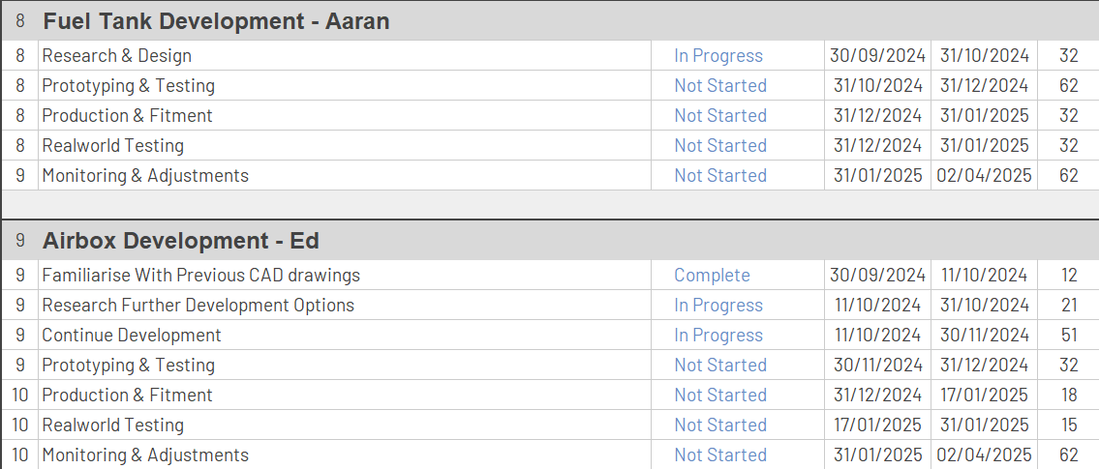
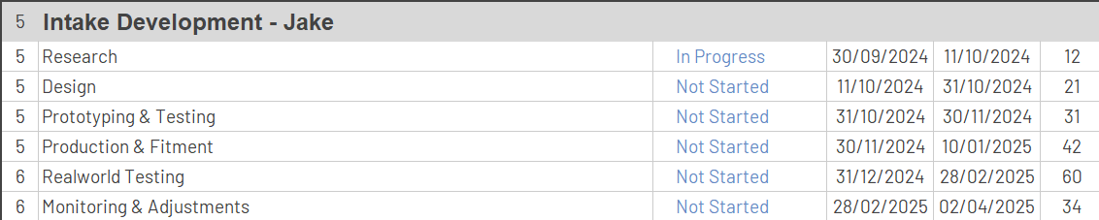
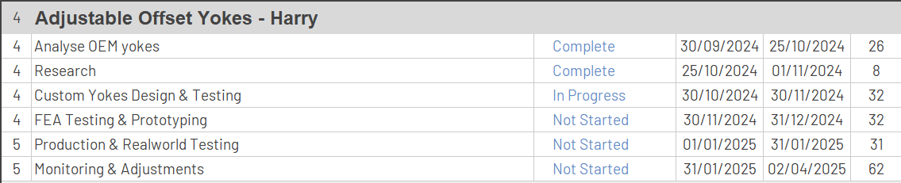
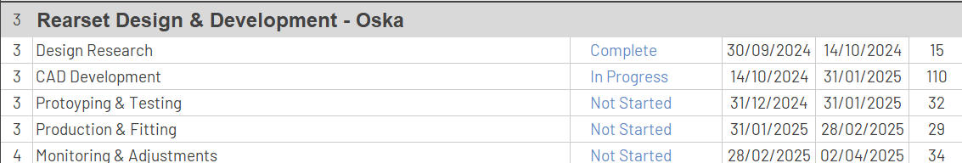
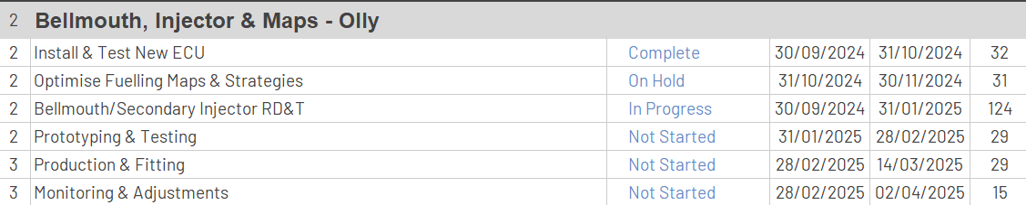
Here we have all the group timings associated with the project. These are for all of the colleagues involved including myself and helps us to identify what work needs to be done in an adequate amount of time. Not only does it help track our short term goals it also helps us to maintain the progress that we have made which makes it easier to track our trajectory for the rest of the group project per individual. Timings are also important as it allows resource allocation to take part easier. Resource allocation. For example it allows work to be evenly distributed around the group. This prevents overloading or leaving important tasks that have not been completed to the end. It also helps to mitigate any chance of frisk between the group project and identify any clear delays or obstacles early.

My tasks-page 4
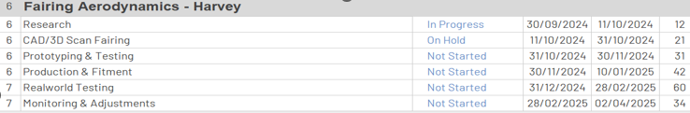

My tasks vary throughout the project as the role I have taken has a very wide range of skills that need to be put into the job. For example, research as whole has been completed and a rough idea of what I would like to make has been brainstormed and designs gave been written down. Next is to scan the old fairing that we have in the workshop as prototyping to find all the correct measurements. This will allow us to make a prototype of the front fairing and really keep the costs down.
After production of the real world sample will take place. This would mean purchasing a new fairing for the NSF and making modification myself to ensure that it replicates the prototype. A good reason for this aswell is that the current fairing has crash damage so I have been given permission to freelance and embrace my engineering skills.
Bill of materials
Item: | Cost: | Duration:
Front fairing(New) | £185 | Entirety
3D SCAN | £500 | 1 day
CAD surface modelling | £60/hr | 3 days
Sandblaster | £200 | 1 day
Fitting | £60/hr | 1 day

Here is a bill of materials that I believe should be charged for this task. This is a rough guide of todays current rates and how much the general public would most likely be charged for this task. These prices have been taken from advice of professionals and lecturer guidance.
The bill of materials also helps companies or anyone using the services of the group project team to have a clear understanding of costs and services to be used for the project. This also helps with goals as its another way of tracking progress financially and to see how much revenue the company will be taking in.
Not only do all these points help with tracking my generic goal for the group project but it also ties into the overall project as people can work off the work I have done. You may ask how? The way that these are measured is via SMART targets.
- S: specific- is the task at hand specific to myself?
- M: measurable- how can I measure that the task to ensure I was successful?
- A: agreed/ achievable- Is the task agreed to be achievable and possible to complete?
- R: realistic- is it a realistic task to complete given costs and skill?
- T: time- is the time given realistic and able to achieve to completion?

Significant milestones-page 5
There are many milestones in this group project and I will highlight some of the important ones to you. I feel like the main milestone as a team would be to produce a faster race bike for the university. This will be achieved by hopefully having produced a faster yet more comfortable rave motorcycle for ian Henshaw to ride. We are taking the motorcycle to pembrey race circuit in 2025 to test the modifications that we have done to the machine to see if we have improved.
These would be able to be tracked by having many different areas of improvement. For example, lap time should increase due to the suggested increase in power that the modifications should make. Second to this comfortability.
My gateway objective is in relevance to a drag coefficient. As it’s a measurable task it fits in the gateway objective. The main goal is to lower the co efficient of drag making the motorcycle more aerodynamic meaning it will be bale to slip stream better and have less wind resistance.

• Create a high-fidelity 3D model of the current fairing using CAD software and 3D scanning technology.
• Modify the design based on research insights to incorporate drag-reducing features (e.g., smoother contours, reduced frontal area).
• Simulate airflow around the updated design using CFD to predict Cd improvements
• Gather baseline aerodynamic data for the current fairing design using CFD simulations or wind tunnel results.
• Study aerodynamic principles and existing fairing designs to identify key factors influencing drag.
• Research materials and surface finishes that could improve airflow.

- • Manufacture physical prototypes of the updated fairing design.
- Conduct wind tunnel tests and real-world trials to measure drag reduction performance.
- Iteratively refine the design based on test data to optimize aerodynamics.
•

• Monitor fairing performance during extended use.
• Address any unforeseen aerodynamic issues, material wear, or design flaws.
• Deploy the fairing in real-world scenarios (e.g., vehicle testing).
• Measure real-world Cd values and cross-validate with simulation/wind tunnel data. Check the progress
• Assess secondary factors, such as stability and fuel efficiency, influenced by drag reduction.

Areas of concern-page 6
Areas of concern should always be a big and strong talking point for anything in a group project. Not only allow everyone to have a voice in the group project but it also helps to raise any problems that may affect the functionality or dynamic of the task at hand.
One area of concern that I have is to do with the main aerodynamic side of the new fairing that we will implementing to the motorcycle. Of course, we have a prototyping stage but within the stage we will not have a functional motorcycle to run with all the new modifications. We do have a track day in February, but this will already be out of season and time for the modifications. The main concern being we have “real world” testing meaning for road use. Even though the aerodynamic properties of the front faring should be increased there is not a true hurdle to see if it has been increased, in partnership with this we also do not have access to a wind tunnel meaning we will not be able to tell the key areas hindering airflow and slipstream and which is producing optimum flow.
One way that I feel like this flaw could be increased is by comparing the fairing side by side in a wind tunnel to see which one has better aro properties. This will mitigate the risk of reducing the aero and making the overall speed of the motorcycle slower.
The next area of concern I have is that the current fairing we are using currently has crash damage and is not usable. We are going to be scanning a new fairing for the production and modifications. If there has already been any prototyping on the current fairing it will be easy to miss as there are many parts of the fairing. Second to this it means that it will make it easier to spot, possibly increasing the possibilities of doing something wrong and spotting it in the prototyping and testing phase. This will of course give us more time constraints during the prototyping phase possibly delaying us even more.
The best way in my opinion to eliminate this would be to scan the new fairing In CAD straight away or try to get the old CAD drawings to eliminate the possibility sooner so I do not hit this road block.

Summary and Gantt chart-page 7
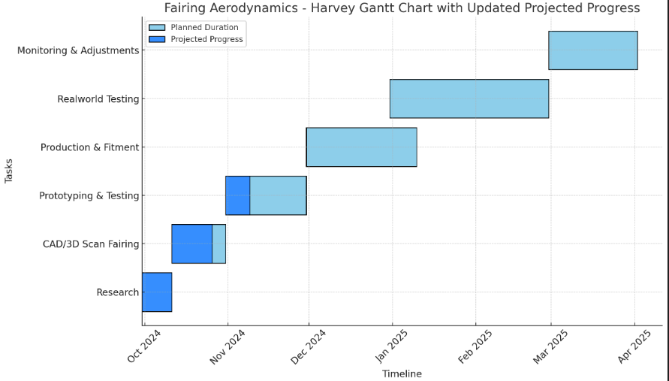
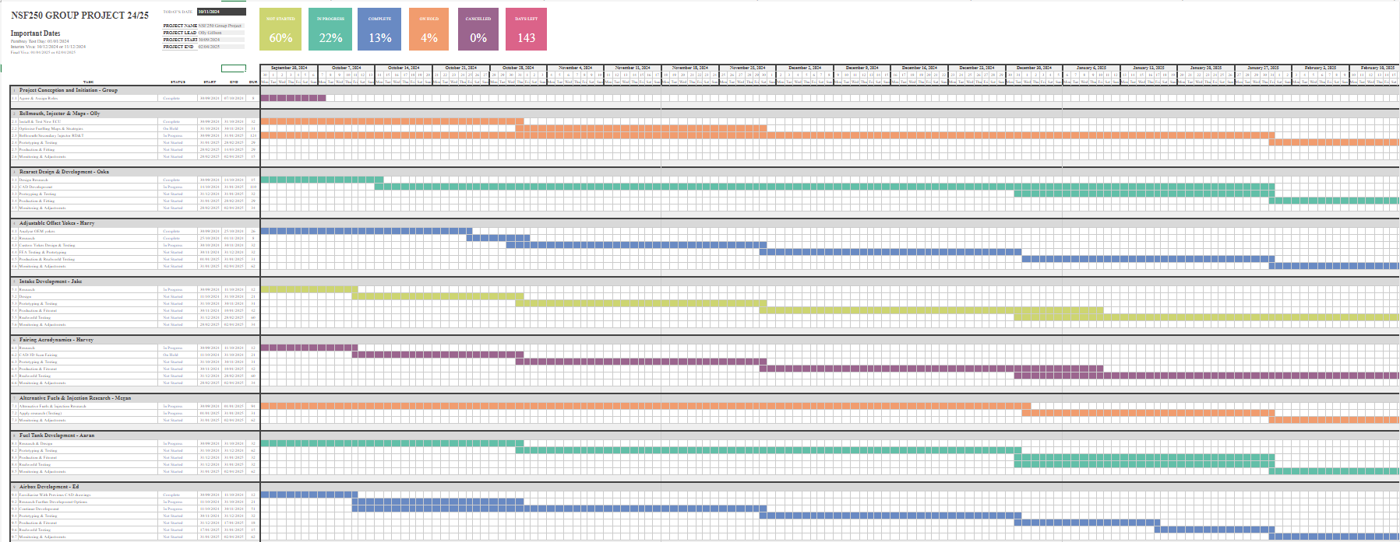

Here we can see 2 Gantt charts, the first one being the overall view Gantt chart for the whole project produced by all of the team members. Not only does it give us good tracking, but it also gives us an opportunity to track our data more easily. It also allows us to see our milestones and identify our gateway objectives through the project. It allows us to keep track of all the timings for the important parts of the tasks given to us by our project manager

