Daniel valentin ungureanu

LCBB6006

BA (Hons) Business Management

Table of Contents
Introduction 4
Literature Review 4
Main Analysis 6
Negotiation Style Cultural Differences. 6
Real Business Case Examples 7
Strategic Strategies of breaking the Barriers. 8
Conclusion 10
References 11

List of Figures
Figure 1: Comparative Analysis of Cultural Dimensions 4
Figure 2: Step-by-Step Comparison of American and Chinese Business Negotiation Styles 5
Figure 3: Comparative Case Summary of Strategic Approaches and Outcomes 7
Figure 4: Key Strategic Measures for Enhancing Cross-Cultural Negotiation Effectiveness 8

Introduction
International negotiation has become an important element of business communication in an ever more globalised economy. The most complicated and important strategic relations can be observed between the American and Chinese firms where the cultural differences often influence the outcomes of negotiations (Purba, 2021). These distinctions are not usually confined to language and they affect values, communication styles, expectations and approach to relationship building. Both countries are key players in the world economy hence their negotiations can be used as a powerful way to analyze the issues of intercultural challenges in business. The purpose of this essay is to critically discuss the influence of cultural differences on the way of negotiation between American and Chinese companies in relation to various norms that determine the dialogue, trust, and decision-making. The essay examines the approaches of international managers to overcome these barriers by using the known theories of intercultural communication, as well as referring to the actual real-life case studies. It will discuss it through review of some theory related, a specific analysis of cultural tensions in negotiations and how it applies to the management.

Literature Review
The interaction of cultural intelligence and strategic adaptation as well as communication competence has become a topic of interested scholarly inquiry into the international business negotiations. Ahmed et al. (2025) focus on this crossroads by discussing negotiations between the American and Chinese technology companies by stating that cultural intelligence (CQ) is critical to support trust and flexibility in the highly cross-cultural surrounding. They hypothesize that effective negotiators do not just show sensitivity of cultural norms, but also a skill in changing the process of communication to fit, at least temporarily, such needs as the low-context directness of the American companies and the high-context communication peculiar to the Chinese.
Alipour (2021) provides a theoretical enrichment with a comparison between Long-Term orientation by Hofstede and future orientation dimension on GLOBE. In his analysis, he notes that the Chinese business culture, in which focus is placed on perseverance and delayed gratification, is in contrast to that of American preference of short-term outcomes. This divergence has a big impact on the time and expectations of the negotiations which would lead to confused approaches unless cultural awareness is practically used.

The article by Bartosik-Purgat and Rakowska (2023) presents practical experience that Polish companies have when communicating with Chinese and American partners. Their results support the ideas that Chinese negotiations place more emphasis on building relationships (guanxi) and unspoken understanding, whereas the American professionals prefer being direct, structured and short-term results. This discrepancy introduces the necessity of strategic accommodation where strictness to one style of origin can give rise to a recurrence of conflict or collapse of any negotiation. What the authors are also keen on bringing out is that language misunderstanding usually occurs not because of the language, but because of different cultural inclination in trust, time, and decision making authority.
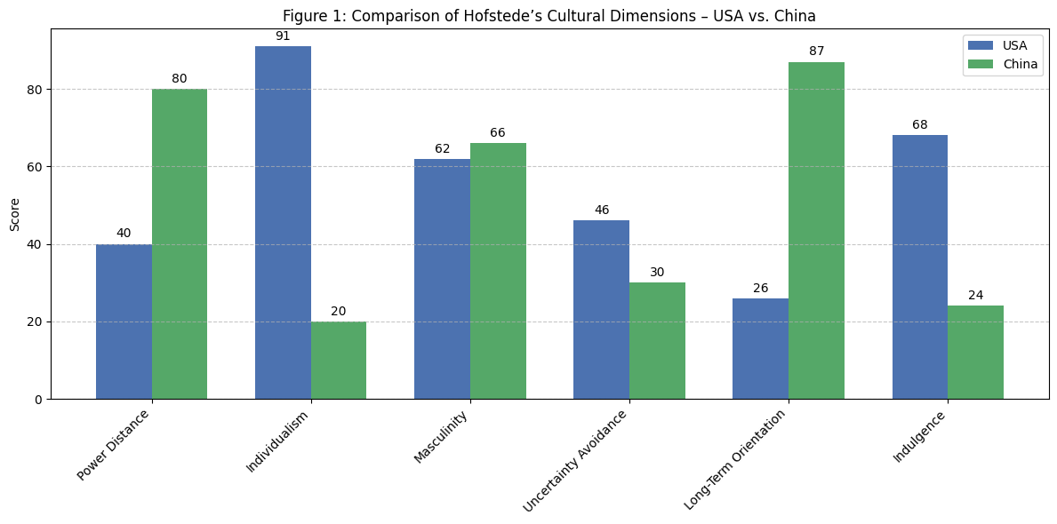
Figure 1: Comparative Analysis of Cultural Dimensions
Source: Self-Made (Adapted From: (Alipour, 2021)
Although Begum (2021) pays attention to the cultural dimensions in global negotiations, she also emphasizes the spheres of soft skills, including empathy, flexibility, and cultural awareness. These characteristics correspond with those attributes of effective negotiators, which supports the assumption that interpersonal competence is as important as strategy in today cross-cultural business situations.
Lastly, Zhou et al. (2024) explore the semantic and cultural complexity in the Chinese communication, especially in the case of decoding culture-specific vocabulary in the negotiation process. They state that what would make negotiation successful is both the translation accuracy as well as the cultural resonance, or the capacity to read in-between what is going on under the perspective of values and history shaped context. Their writing points to the harmfulness of even minor misunderstandings of culturally tied phrases and words in terms of eroding confidence and halting negotiations.
Collectively, these views show that, successful cross-cultural negotiation, especially between American and Chinese companies, does not only depend on procedural approach but also rich cultural literacy, flexibility, and continuous enhancement of competence.

Main Analysis

Negotiation Style Cultural Differences.
The cultural backgrounds of negotiating business between American and Chinese companies are usually more profound as the values of the civility and the communication philosophy differ. The American negotiating style is mostly described as task-oriented, individualistic, and direct, in which efficiency, straightforwardness, and goal-oriented conversation is greatly appreciated. Chinese negotiators, in their turn, approach negotiations in a relationship oriented, collectivist and implicit way with harmony, mutual respect and indirect communication being key elements.
The high- and low-context theory of communication developed by Edward Hall (1976) is an effective explanation of these differences. According to Hall, United States is a low-context culture, which is direct and in which the meaning is contained more in what is said (Leotescu, 2023). On the other hand, China is high-context culture and most of the communication is based on understanding, non-verbal communication, and contextual awareness. This difference is the cause of misunderstanding on its part: what Americans view as clear and effective can be viewed by Chinese colleagues as hostile and rude.

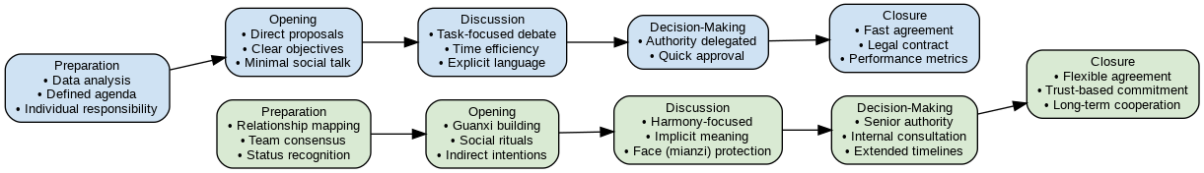
Figure 2: Step-by-Step Comparison of American and Chinese Business Negotiation Styles
Source: Self-Made (Adapted From: Purba, 2021)
These two opposite practices are further defined by the cultural dimensions described by Geert Hofstede (2010). As an example, the Individualism vs. Collectivism index assesses the U.S. as having one of the highest scores on individualism whereas China appears to be more of a collectivistic nation (Guo et al., 2023). At the negotiation table, the implication here is that the American professionals are likely to make demands with respect to their own standpoints and insist on merit-grounded results, and the Chinese negotiators are more likely to focus on group unity and long-term relationship collaboration. Moreover, Power Distance, which indicates the acknowledgment of unequal power relations, is greater in China which implies a more very hierarchical negotiation process which respects senior decision-makers. Americans on the other hand tend to be more egalitarian in the negotiation process, which might not suit Chinese requirements to deference and formality (Zhang et al., 2021).
Such cultural differences make it clear that there is a risk of miscommunication in business relations, especially when both parties believe that their style of conduct is universal or the best. Such communication styles may be adapted to and thus recognised to help in establishing mutual trust and negotiating success.

Real Business Case Examples
One of the most successful cross-cultural negotiation cases can be the penetration of Walmart in China. Firstly, Walmart has faced a lot of cultural opposition particularly on matters relating to supply chain standardisation and pricing measures. The American style of negotiation of the company based on contracts, timelines and control of operations did not uphold with local demands which focused on guanxi (long-term relationships), flexibility and localised practices. Walmart later adjusted to the situation by decentralising its decision-making and making it more liberal to Chinese partners. This move realized the importance of having local relationships and served to curb the initial tensions in the negotiation process.
On the contrary, the unsuccessful alliance of Danone and Wahaha, a Chinese beverage company shows how cultural incompatibility may cause conflict. Although it was a joint venture, the French management of Danone was working according to the Western business mind, with the aim of insisting on the clarity of the laws, the contracts and control. Being an enterprise founded on the Chinese business culture, Wahaha anticipated more freedom and appreciated informal agreements in place of strict rules and regulations. Priority miscommunication and inconsistent assumptions regarding brand ownership and control grew into an open scandal and ultimate failure of the collaboration. The main problems were the lack of compatibility of expectations, distrust, and ineffective communication, which was enhanced by the lack of negotiation practices that were culturally adaptive.
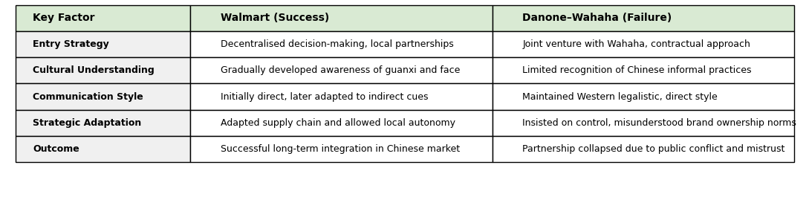
Figure 3: Comparative Case Summary of Strategic Approaches and Outcomes
Source: Self-Made (Adapted From: Guo et al., 2023)
The two instances also emphasize the consequences of being either unsuccessful or successful in making sense of the cultural landscape in the negotiation process. In the case of Walmart, the adaptation resulted in the long-term stability. Rigidity and cultural insensitivity caused irreparable break down in the case of Danone. In both examples, the problem of cultural misunderstanding went further than that of translation or good manners, it was entrenched in the unspoken rules, patterns of communication and alternative perceptions of power and collaboration.

Strategic Strategies of breaking the Barriers.
As a means to cope with the stress of intercultural negotiation, strategic interventions facilitating cultural fluency and flexibility in the field of communication are becoming a serious investment issue in companies. Among the most popular approaches is cross-cultural training, whereby the managers are supplied with the knowledge of the foreign practices, customs, business conduct; and communication procedures. Such programs are typically characterized by simulations, role plays, cultural immersion, which contribute to helping the participants to identify and appreciate cultural norms without any ethnocentric credibility. In the case of the U.S.-China reflections, it may include training on high-contextual communication, the Chinese notion of face (mianzi), and instructions regarding hierarchy within the Chinese business environment.
The other possible strategy is the use of bilingual or bicultural negotiators, as they are not just translators but a cultural interpreter. Such people are able to arbitrate in cases of varying anticipations, explanation of subtle meanings and to avoid misunderstanding before it goes out of given proportions. Culture sensitivity can be used about tones when they are negotiation and timing as well as other subtle expressions like making indirect refusals which foreign managers would not perceive.
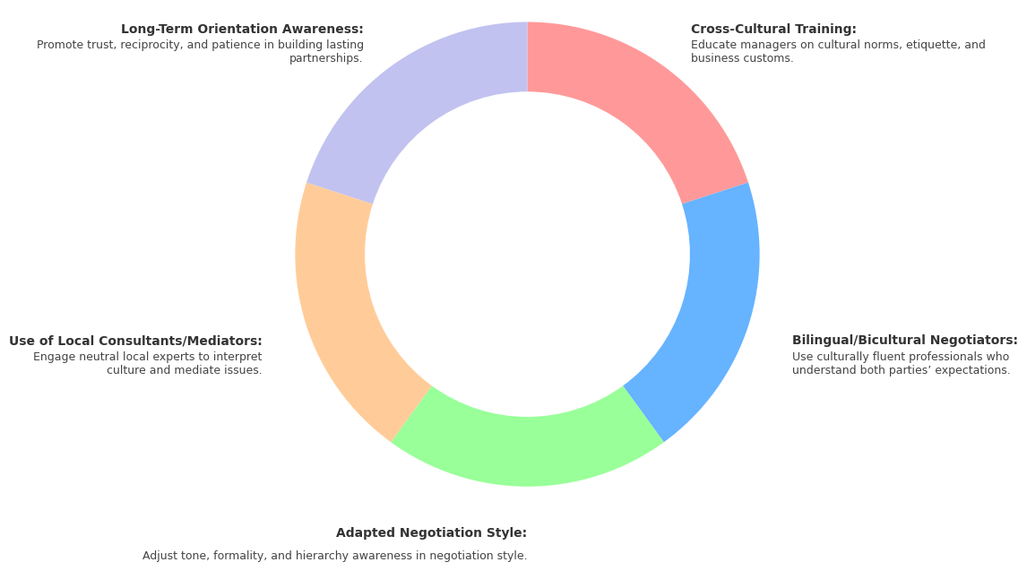
Figure 4: Key Strategic Measures for Enhancing Cross-Cultural Negotiation Effectiveness
Source: Self-Made (Adapted From: Bartosik-Purgat and Rakowska, 2023)
It is also advantageous to companies that can adapt their negotiation styles instead of using their own. As an illustration, the US companies dealing with the Chinese might lengthen their negotiation process, not choose intensive methods, and take part in social ceremonies that establish a relationship of trust. Signs that demonstrate cultural competence and goodwill may include the focus on the importance of adhering to hierarchy (e.g., talking to the oldest member of the group first or giving time to internal group cohesion).
Another strategic action is the application of third-party mediators or local consultants. These people add plausibility, cultural understanding, and impartiality, which regularly facilitate the process of smooth transitions in complicated or worsted negotiations (BENAMARA, 2024). Their participation is a sign of readiness to learn and work in the local cultural contexts.
Lastly, it is important to know Long-Term Orientation, which is one of the concepts of the Hofstede model. Negotiators in China tend to respect long-term relationships as opposed to the short-term benefits. Being aware of this might enable Western companies to work on building trust, reciprocity and consistency without necessarily thinking of short-term outcomes or strict deliverables. Developed mutually beneficial strategies will lead to more sustainable partnerships because the companies will make their strategies more focused on negotiation and credible due to the alignment of the long term between partners.

Conclusion
The nature of negotiation between American and Chinese companies is fashioned on the basis of strong cultural discrepancies, especially on the basis of communication style, decision-making and relationship-building styles. The use of intercultural theories, i.e., dimensions developed by Hofstede and the context framework developed by Hall, illustrates the impact of these differences on the negotiation patterns and possible misunderstandings. These barriers can be overcome with the help of strategic versatility, which is achieved by training the culture, the flexibility of negotiation styles, and the use of mediators, all of which are discussed with the help of real business cases. In the case of international managers, cultural intelligence should be developed not as an option, but as a necessity when it comes to the need to maintain global relationships. Subsequent studies could be interested in understanding the impact of new digital communicational media on intercultural negotiations, in particular, as online spaces transform the perceptions of trust, tone, and context in cross-border settings.

References
Ahmed, F., Saha, A., Abdullah At Tasrif and das, J. (2025). Cultural Intelligence and Strategic Adaptation: Unpacking the Dynamics of Successful International Business Negotiations Between U.S. and Chinese Technology Firms. Pacific Journal of Business Innovation and Strategy, [online] 2(3), pp.5–13. doi:https://doi.org/10.70818/pjbis.2025.v02i03.065.
Alipour, A. (2021). What matters for the future? Comparing Globe’s future orientation with Hofstede’s long-term orientation. Cross Cultural & Strategic Management, ahead-of-print(ahead-of-print). doi:https://doi.org/10.1108/ccsm-08-2020-0163.
Bartosik-Purgat, M. and Rakowska, W. (2023). Cross-cultural business-to-business communication – the experiences of Polish companies with the Chinese and Americans. International Journal of Emerging Markets, 1(1). doi:https://doi.org/10.1108/ijoem-01-2022-0013.
Begum, S. (2021). A Literature Review on Implications of Cultural Dimensions on International Business Negotiations: Special Reference to China, Japan and United States. [online] papers.ssrn.com. Available at: https://papers.ssrn.com/sol3/papers.cfm?abstract_id=3990226.
BENAMARA, C. (2024). The Evolving Role of International Mediators in Complex Peace Processes: A Multidimensional Analysis of Strategies, Challenges, and Outcomes in the 21st Century. Unipd.it. [online] doi:https://hdl.handle.net/20.500.12608/77425.
Guo, J., Jiang, Y., Lin, S. and Pang, W. (2023). Individualism and Collectivism as Predictors of Creative Potentials and Real-Life Creativity in China and US. pp.1–12. doi:https://doi.org/10.1080/10400419.2023.2217028.
Leotescu, G.S. (2023). Communicating Meaning across High- and Low- Context Cultures – a Comparative Analysis. Buletinul Stiintific al Universitatii Politehnica din Timisoara, Seria Limbi Moderne, [online] (22), pp.5–13. Available at: https://www.ceeol.com/search/article-detail?id=1217598.
Purba, A.R. (2021). THE EFFECTS OF GLOBALIZATION ON INTERNATIONAL COMMUNICATION IN THE WORLD BUSINESS. SSRN Electronic Journal. doi:https://doi.org/10.2139/ssrn.3962731.
Zhang, Z.-X., Liu, L.A. and Ma, L. (2021). Negotiation beliefs: Comparing Americans and the Chinese. International Business Review, 30(5), p.101849. doi:https://doi.org/10.1016/j.ibusrev.2021.101849.
Zhou Huili, Wang Minna and Xixi, S. (2024). CULTURAL DEPTH IN BUSINESS COMMUNICATION: EXPLORING THE INTERPRETATION OF CHINESE CULTURE-SPECIFIC TERMS IN CROSS-CULTURAL NEGOTIATIONS. Journal of Business Innovation, [online] 9(1), p.1. Available at: http://www.unimel.edu.my/journal/index.php/JBI/article/view/1787.

